

ASSET VERIFICATION AND RECORDING TOOL KIT


Plot 31, Bukoto Street
P.O Box 7657, Kampala, Uganda
+256 (0) 39 2000216/0772525235
email: cpa@cpa.ug

www.cpa.com

August to September 2026

VERIFICATION DETAILS

NAME OF THE REGION: | EASTERN REGION
SUB-REGION: | BUSOGA REGION
Name of Local Government | MAYUGE DISTRICT LOCAL GOVERNMENT
VERIFIER PARTICULARS
Full name | KIYUBA SALIMU
Contact/ email and Telephone | 0755215778, kiyubasalimu@gmail.com
Supervisor/ Sub team leader | NANDUDU SULAINA
Name | WANDERA SOLOMON
Contact | 0708153235, wanderasolo@gmail.com
Date of submission

HEALTH CENTRES
INFORMANT INTERVIEW/DISCUSSION GUIDE (INCHARGE OR RESPONSIBLE PERSON)

Name of Health Centre: MUGGI HEALTH CENTRE III
1a | Does the Facility have a record of all assets provided under UgIFT.  (Obtain a record and verify if it has the costs and numbers supplied | YES
1b | If Not ask how many were supplied and when.

2 | How does this facility Maintain (repair/service/replace) the assets provided under Ugift  - It is maintained by the facility officials in charge. For example of recent the facility covered the mattresses with capilas

3 | Does the facility take regular record about functionality/ or breakdown of the assets provided? | - Yes they do.  - In case of blockage, the one Mariam Jidudu said that they normally use a counter book to record all equipment broken.

4 | How has the UgIFT support helped in service delivery in the area, any issues, challenges and any recommendations for better program implementation. | - BENEFITS  - The UgIFT has consistently helped in supplying health equipements to the facility and this has eased admissions hence managing the overwhelming at the facility.  - It has also helped in the accommodations of staff by building staff quarters near the facility. This has reduced absenteeism at the facility since officials are ever present at the facility.  - It also minimumly increased the health workers at the facility hence reducing the overwhelming health to patient ratio.  - It has also helped in good sanitation because of the increased number of assets at the facility like the placenta pits, pit latrines and bathrooms for patient.  - Labor wards and available equipement for labor such as labor beds and labor suits have created enough space for mothers in labor hence reducing congestion.  - Because of the available equipement, and assets the facility can now handle overwhelming admissions hence reducing unnecessary referrals. However, the facility has always hard issues and challenges which include:  - The Lab is generally very small hence causing delay in service.  - Inadequate inventory store at the facility and has forced the facility to improvise the men’s ward into a store and the men are now admitted together with ladies in the same female ward.  - Theft and threats attributed to lack of a perimeter fence. Hence putting health officers and patients at stake.  .  RECOMMENDATIONS  - We recommend a perimeter wall to be installed at the facility since they lack one to improve on the security  - We also recommend that the OPD facility be increased to reduce the overwhelming daily admissions at the facility.
11

PROCEED TO VERIFICATION AFTER THIS DISCUSSION

Health centre checklist

NAME OF LG MAYUGE DISTRICT LOCAL GOVERNMENT.
NAME OF HEALTH FACILITY : MUGGI HEALTH CENTER III

Equipment/ Item | Department | Asset Number | Item  Description |  | Life in Months | Tag Number ( engrave no.) | Date Of Purchase | Date Placed In Service | Recoverable cost | Cost | Acc Dep Cost | Net Book Value | Ytd Deprn | Equipment status | Remarks
B.P. Machine, Digital | health |  | It is white in color model 2088C with a black surface and a rectangular screen |  |  | Engraved OPD | 14/04/2025 | I6/05/2025 |  | 672,000 |  |  |  | Received 2 and all still functioning. | All the 2 that were received were verified and are all functioning
B.P. Machine (Aneroid wall mounted) | health |  | It has a gauge, white in color, with a black metallic base mounted on the wall |  |  | Not engraved | 14/04/2025 | I6/05/2025 |  | 672,000 |  |  |  | All functioning | All the 2 received were verified and are all functioning well
Autoclave 20 Liters.,Duo Operated | health |  | Silver cylindrical stainless bowl with a round top and black handles with a gauge. |  |  | Not engraved | 14/04/2025 | I6/05/2025 |  | 728,000 |  |  |  | good status and functioning | 1 received and verified
Bowl, Kick | health |  | Standard silver steel medical bowl with mobile kick stand |  |  | Not engraved | 14/04/2025 | I6/05/2025 |  | 224000 |  |  |  | functional | Received  and verified
Bowl Stand | health |  | Tall Silver like basin with 5 wheel stands, silver in color. Stainless in nature with a ring stand |  |  | Not engraved | 14/04/2025 | I6/05/2025 |  | 560000 |  |  |  | Well-functioning | 6 bowls received and all verified,3 stands and also verified
Counting chamber Neubauer- Improved | health |  | It’s a clear glass improved device with silver etched grid and 2 transparent covers slips in blue plastic case. |  |  | Not engraved |  |  |  | 336000 |  |  |  |  | 2 received, verified, in use.
Cupboard Steel, Lockable | health |  | Large, Grey in color with double door, lockable in nature |  |  | Not engraved | 14/04/2025 | 05/07/2025 |  | 8042840 |  |  |  | functioning | 5 verified and all functioning`
Drip Stand | health |  | 5 wheels with a straight vertical stand and locks adjustable in nature |  |  | Not engraved |  | I6/05/2025 |  | 1,600,000 |  |  |  | functioning | 8 received and verified
ESR Stand | health |  | A standard metallic grey metal with adjustable leveling for holding tubes. |  |  | Not engraved | 14/04/2025 | I6/05/2025 |  | 280,000 |  |  |  | functional | Not verified, not seen
Examination Couch | health |  | 4 silver stands with a black soft sponge mattress with a lifter. It is a bed |  |  | Not engraved | 14/04/2025 | I6/05/2025 |  | 2,352,000 |  |  |  | functioning | 3 received and verified
Examination light,LED | health |  | Tall, white /silver adjustable goose neck lamp with 5 white wheel |  |  | Not engraved | 14/04/2025 | I6/05/2025 |  | 1,904,000 |  |  |  | functional | 2 received and verified
Glucometer | health |  | White in with a strip tiny hand held plastic device |  |  | Not engraved | 14/04/2025 | I6/05/2025 |  | 224,000 |  |  |  | 1 functioning and 1 not functioning | All verified
Haemoglobin Meter, Digital | health |  | Small, White in color and rectangular in shape with 3 buttons and a square screen |  |  | Not engraved | 14/04/2025 | I6/05/2025 |  | 8,000,000 |  |  |  | functioning | All (2)verified
Height Meter | health |  | A tall vertical metallic stand, silver in color with flat base and sliding head and height scale. |  |  | Not engraved | 14/04/2025 | 05/07/2025 |  | 448,000 |  |  |  | functional | I verified and in use
Instrument Trolley | health |  | Silver in color with 2 partitions and 4 black wheels. Stainless steel trolley |  |  | Not engraved | 14/04/2025 | I6/05/2025 |  | 1,900,000 |  |  |  | functioning | 2 received and 1 verified
Microscope Binocular | health |  | White in color and a black base.  With dual eye piece |  |  | Not engraved | 14/04/2025 | I6/05/2025 |  | 6,000,000 |  |  |  | functioning | 1 seen and functioning
Otoscope | health |  | Small, white handheld touch like type with a cone tip for ear examination |  |  | Not engraved | 14/04/2025 | I6/05/2025 |  | 392,000 |  |  |  | functioning | Verified but just kept
Patient Screen | health |  | Tall white fabric, foldable metal partition equipement. 4 wheels with a black soft sponge mattress, 2 handles. |  |  | Not engraved | 14/04/2025 | I6/05/2025 |  | 3024,000 |  |  |  | functioning | 8 seen and verified
Patient Trolley | health |  | Large silver metal with 4 wheeled stretcher bed. |  |  | Not engraved | 14/04/2025 | I6/05/2025 |  | 1900,000 |  |  |  | functioning | 2 verified and functioning
Refrigerator, Basic | Health |  | Medium sized, Grey in color with 2 compartments , the lower one bigger than the upper one |  |  | Not engraved | 14/04/2025 | I6/05/2025 |  | 2,240,000 |  |  |  | functioning | 1 verified and functioning
Stethoscope | Health |  | Black in color with 2 rubber flexible tube |  |  | Not engraved | 14/04/2025 | I6/05/2025 |  | 3136000 |  |  |  | All functioning | 8 verified
Stop Watch | health |  | Handheld digital timer with start, stop and reset function |  |  | Not engraved | 14/04/2025 | I6/05/2025 |  | 448,000 |  |  |  | functional
Stretcher | Health |  | It’s a bed with 4 black wheels ,two rails and black soft sponge |  |  | Not engraved | 14/04/2025 | I6/05/2025 |  | 2,240,000 |  |  |  | All Functioning | 3 seen and verified
Stove, Gas | health |  | White in color, 6kg(stabex) with 4 metallic banners |  |  | Not engraved | 14/04/2025 | I6/05/2025 |  | 504,000 |  |  |  | working | 1 seen and verified
Weighing Scale with Height Meter, Adult | health |  | Tall,White in color, automated with a height and a guage. With a black rectangular base in nature |  |  | Not engraved | 14/04/2025 | I6/05/2025 |  | 3,000,000 |  |  |  | functioning | 2 seen, verified and functioning
Weighing Scale, Infant | health |  | It’s a digital scale with a small white plastic tray |  |  | Not engraved | 14/04/2025 | I6/05/2025 |  | 1,456,000 |  |  |  | functioning | 2 received and verified
Weighing Scale, Toddler | health |  | Medium, white tray size about 60cm by 30cm |  |  | Not engraved | 14/04/2025 | I6/05/2025 |  | 1,456,000 |  |  |  | functional | 2 received and verified
Wheel Chair | health |  | Medium, Black in color, foldable chair, with 2 back wheels, 2 foot pads and 2 handles |  |  | Not engraved | 14/04/2025 | I6/05/2025 |  | 2,016,000 |  |  |  | All functioning | 3 seen and verified
Medical Waste Bin | health |  | Medium sized bins ,Blue in color wrapped with polythene bags  And a round top with silver handle |  |  | Not engraved | 14/04/2025 | I6/05/2025 |  |  |  |  |  | 19 functioning out of 20 | 1 is faulty
 |  |  |  |  |  |  |  |  |  | 1,209,600
Wall Clock | health |  | Round and white in color with figures running from 1 to 12 and placed on the wall |  |  | Not engraved | 14/04/2025 | 05/07/2025 |  |  |  |  |  | 3 functioning | All verified, seen and functioning
 |  |  |  |  |  |  |  |  |  | 224,000
Diagnostic Equipment Set for MCH | health |  | It is a small silver instrument carried in metallic case |  |  | Not engraved | 14/04/2025 | I6/05/2025 |  |  |  |  |  | All functioning | 3 seen and verified
 |  |  |  |  |  |  |  |  |  | 784,000
Diagnostic Equipment Set for OPD | health |  | Small, silver metallic bin instruments. Carried in silver case |  |  | Not engraved | 14/04/2025 | I6/05/2025 |  |  |  |  |  | functioning
 |  |  |  |  |  |  |  |  |  | 560,000
Glassware Set, Laboratory, Basic | health |  | Small, transparent glass containing, beakers, test tubes, measuring cylinder, slides and petri dishes |  |  | Not engraved | 14/04/2025 | I6/05/2025 |  |  |  |  |  | functional
 |  |  |  |  |  |  |  |  |  | 1,456,000
Hollow Ware Set, Treatment | health |  | Medium silver stainless steel. scissor in nature |  |  | Not engraved | 14/04/2025 | I6/05/2025 |  |  |  |  |  | Functioning but stored | 2 sets received, verified but kept(not being used)
 |  |  |  |  |  |  |  |  |  | 11,226,153
Instrument Set, Dressing | health |  | Small metallic silver steel scissors |  |  | Not engraved | 14/04/2025 | I6/05/2025 |  |  |  |  |  | Functioning | 7 received and verified
 |  |  |  |  |  |  |  |  |  | 1,904,000
Instrument Set, Basic ENT |  |  |  |  |  |  |  | I6/05/2025
 |  |  |  |  |  |  |  |  |  | 3,024,000
Instrument Set, Suture | health |  | Small size stainless steel, silver in color containing needle holder, scissors and forceps for suturing wounds |  |  | Not engraved | 14/04/2025 | I6/05/2025 |  |  |  |  |  | functional
 |  |  |  |  |  |  |  |  |  | 1,848,000
Pulse Oximeter, Hand held | health |  | Small portable size, white and blue color with finger probe for measuring oxygen saturation and pulse |  |  | Not engraved | 14/04/2025 | I6/05/2025 |  |  |  |  |  | functional
 |  |  |  |  |  |  |  |  |  | 2,688,000
Bed, Adult Patient with Mattress | health |  | Standard single beds with black mattress, grey metallic frame and manually adjustable. |  |  | Not engraved | 14/04/2025 | I6/05/2025 |  |  |  |  |  | functional | Not received
 |  |  |  |  |  |  |  |  |  | 1,800,000
Bed, Pediatric Patient, With Mattress | health |  | White in color with blue soft sponge blue mattress |  |  | Not engraved | 14/04/2025 | I6/05/2025 |  |  |  |  |  | functioning | 4 seen and verified
 |  |  |  |  |  |  |  |  |  | 5,600,000
Bedside Locker | health |  | It’s a cabin 2 compartments with a bigger one down and a small one down, grey in color and 4 stands |  |  | Not engraved | 14/04/2025 | I6/05/2025 |  |  |  |  |  | functioning | 10 Seen, functioning, and verified
 |  |  |  |  |  |  |  |  |  | 5,040,000
Cupboard, Instrument | health |  | It’s a large cabin, white/grey in color with a metallic glass door |  |  | Not engraved | 14/04/2025 | I6/05/2025 |  |  |  |  |  | functioning | 2 seen and received
 |  |  |  |  |  |  |  |  |  | 1,008,000
Delivery Bed, Hydraulic Manual | health |  | It is an adjustable bed.  Model H7 with peach mattress and a drip stand |  |  | Not engraved | 14/04/2025 | I6/05/2025 |  |  |  |  |  | functioning | Only 1 , seen , verified and functioning
 |  |  |  |  |  |  |  |  |  | 7,840,000
Oxygen Therapy Apparatus, Mininum 45L cylinder | health |  | Large metallic cylinder with a pressure gauge and a regulator on top |  |  | Not engraved | 14/04/2025 | I6/05/2025 |  |  |  |  |  | Functioning but not being used. | 2 received and verified but not being used
 |  |  |  |  |  |  |  |  |  | 2800,000
Resuscitator Manual, Infant, with all Mask sizes | health |  | Medium clear silicon bag with large masks |  |  | Not engraved | 14/04/2025 | I6/05/2025 |  |  |  |  |  | Functioning but not in use | Received 15,  Not using any of them
 |  |  |  |  |  |  |  |  |  | 896,000
Resuscitator Manual, Adult, with all mask sizes | health |  | A light handheld silicone device, transparent bag with blue valve |  |  | Not engraved | 14/04/2025 | I6/05/2025 |  |  |  |  |  | functional | Not seen
 |  |  |  |  |  |  |  |  |  | 851,200
Suction Apparatus, (Electric) | health |  | It is an electric pump ,White, with 2 bags of water and a guage.  Model COO1-A with 4 wheels |  |  | Not engraved | 14/04/2025 | I6/05/2025 |  |  |  |  |  | functioning | 1 seen and verified
 |  |  |  |  |  |  |  |  |  | 2,688,000
Nebulizer, Ultrasonic | health |  | Small tabletops size with white color ultrasonic with adult and child mask set |  |  | Not engraved | 14/04/2025 | I6/05/2025 |  |  |  |  |  | functional
 |  |  |  |  |  |  |  |  |  | 392,000
Oxygen Concentrator, Duo Flow | health |  | Medium size,Grey,2 handles on top and a cylinder also on top. With outlets and wheels at the bottom |  |  | Not engraved | 14/04/2025 | I6/05/2025 |  |  |  |  |  | functioning | All seen and verifies
 |  |  |  |  |  |  |  |  |  | 11,000,000
Bench | health |  | Black soft sponge with brown wooden stands |  |  | Not engraved | 14/04/2025 | I6/05/2025 |  |  |  |  |  | functioning | All seen and functioning
 |  |  |  |  |  |  |  |  |  | 1,120,000
Disinfection Buckets | health |  | Normal buckets with rounded tops and silver handles |  |  | Not engraved | 14/04/2025 | I6/05/2025 |  |  |  |  |  | functioning | 3 seen and functioning
 |  |  |  |  |  |  |  |  |  | 403,200
Baby Cot | health |  | Small,Silver in color, transparent plastic infant bed, rectangular in shape mattress with rails |  |  | Not engraved | 14/04/2025 | I6/05/2025 |  |  |  |  |  | functioning | 2 seen and verified
 |  |  |  |  |  |  |  |  |  | 5,600,000
Diagnostic Equipment Set for Ward | health | Not verified | A portable metric kit containing stethoscope, clinical thermometer, torch, and plastic materials. |  |  | Not engraved | 14/04/2025 | I6/05/2025 |  |  |  |  |  | functional
 |  |  |  |  |  |  |  |  |  | 2,184,000
Hollow Ware Set, Ward | health |  | Kidney dish like dishes medium in size |  |  | Not engraved | 14/04/2025 | I6/05/2025 |  |  |  |  |  | functioning | Received 7,  Using 1,  Keeping 6
 |  |  |  |  |  |  |  |  |  | 11,424,000
Instrument Set, Delivery | health |  | Medium silver steel set with scissors, gauze wire, cord cramps in a tray |  |  | Not engraved | 14/04/2025 | I6/05/2025 |  |  |  |  |  | functioning | Received 1.  Using it
 |  |  |  |  |  |  |  |  |  | 2,856,000
Instrument Set, Stitch Removing | health |  | Small silver steel tray with scissors and fourceps |  |  | Not engraved | 14/04/2025 | I6/05/2025 |  |  |  |  |  | functioning | Seen and verified
 |  |  |  |  |  |  |  |  |  | 1,344,000
MVA Kit | health |  | Small white plastic manual vacuum aspirator kit |  |  | Not engraved | 14/04/2025 | 05/07/2025 |  |  |  |  |  | Using 3 keeping 5 | Seen 8 but using 3
 |  |  |  |  |  |  |  |  |  | 2688,,000
Stool, Laboratory | health |  | They are 4 with each having 5 wheels and black in color |  |  | Not engraved | 14/04/2025 | I6/05/2025 |  |  |  |  |  | Functioning | 2 seen and verifies
 |  |  |  |  |  |  |  |  |  | 672,000
Penguin Sucker | health |  | Small white rubber bulb |  |  | Not engraved | 14/04/2025 | I6/05/2025 |  |  |  |  |  | functioning | 1 verified
 |  |  |  |  |  |  |  |  |  | 285000
Fetoscope, Dopplar | health |  | Silver in nature, cylindrical with a round top and base |  |  | Not engraved | 14/04/2025 | I6/05/2025 |  |  |  |  |  | functioning | 2 verified
 |  |  |  |  |  |  |  |  |  | 672,000
Bubble CPAP |  |  |  |  |  |  |  |  |  |  |  |  |  |  | Not verified coz not received
 |  |  |  |  |  |  |  |  |  | 24,000,000
Centrifuge (Electric) | health |  | Small white plastic bench top digital machine |  |  | Not engraved | 14/04/2025 | I6/05/2025 |  |  |  |  |  | functioning | 1 verified
 |  |  |  |  |  |  |  |  |  | 336,000
Kangaroo Mother Care Chair | health |  | A large fabric reclining mother chair |  |  | Not engraved | 14/04/2025 | I6/05/2025 |  |  |  |  |  | functional | 1 verified and in used
 |  |  |  |  |  |  |  |  |  | 1,344,540
Haemoglobin Meter, Sahli | health |  | Small black box kit |  |  | Not engraved | 14/04/2025 | I6/05/2025 |  |  |  |  |  | functioning | 1 seen
 |  |  |  |  |  |  |  |  |  | 8,000,000
Delivery Bed | health |  | Metallic bed model H7 with a peaky matress, 4 wheels and drip stand |  |  | Not engraved | 14/04/2025 | I6/05/2025 |  |  |  |  |  | functioning | 1 verified and functioning
 |  |  |  |  |  |  |  |  |  | 7,840,000
Examination light | health |  | Has a bulb on top with 5 wheels  Tall and mobile goose neck |  |  | Not engraved | 14/04/2025 | 05/07/2025 |  |  |  |  |  | functioning | 1 seen and functioning
 |  |  |  |  |  |  |  |  |  | 1,904,000
Instrument set, ENT Basic for HCIII | health |  | Small tray, silver steel containing otoscope, ear syringe, turning fork. |  |  | Not received | 14/04/2025 | I6/05/2025
 |  |  |  |  |  |  |  |  |  | 2,016,000
Bag Valve mask (Ambu Bag), Neonatal | health |  | White, with yellow valve and a glass with white masks |  |  | Not engraved | 14/04/2025 | I6/05/2025 |  |  |  |  |  | functioning | 14 verified
Incubator |  |  |  |  |  |  |  |  |  |  |  |  |  |  | Not received
Office Chair | health |  | Black in color, swinging in nature with 5 black wheels |  |  | Not engraved | 14/04/2025 | I6/05/2025 |  |  |  |  |  | functioning | 7 verified and seen
 |  |  |  |  |  |  |  |  |  | 1,050,000
Desk |  |  | Woolen, brown in color with metallic stands and shelves. |  |  | Not engraved | 14/04/2025 | I6/05/2025 |  |  |  |  |  | Functioning | 4 seen and verified
 |  |  |  |  |  |  |  |  |  | 840,000
Filing Cabinet |  |  | Standard 4-drawer size, grey metallic color, |  |  | Not engraved | 14/04/2025 | 05/07/2025 |  |  |  |  |  | functional
 |  |  |  |  |  |  |  |  |  | 1,680,000
Non Residential Buildings
Water tanks |  |  | cylindrical, one raise and one on ground, |  |  | Not engraved |  |  |  |  |  |  |  | functional
Hashpit |  |  | it is a cemented circular pit |  |  | Not engraved |  |  |  |  |  |  |  | functional
plasenta pit |  |  | square cemented pit with a square coffee brown metallic cover).  Pit latrines(4 stances with a metallic door and coffe brown + yellow in color) |  |  | Not engraved |  |  |  |  |  |  |  | functional
Staff Quarters |  |  | One block with 2 partitions, colored coffee brown and yellow |  |  | Not engraved |  |  |  |  |  |  |  | Functional and in use

ASSET VERIFICATION BRIEF REPORT

HEALTH CENTER: MUGGI HEALTH III,

DATE 24TH/8/2026.

CONDUCTED BY WANDERA SOLOMON AND KIYUBA SALIMU

Introduction.
This brief report presents the findings of the physical asset verification exercise conducted at Muggi health center III on 24TH/8/2026. The team was warmly welcomed bsy respondent, Mrs. Gidudu Mariam who was the focal person in this exercise (facility in charge).

Findings.
Key assets including all medical assets, furniture and buildings were physically verified and found present. However, those that were not physically verified were not received i.e. incubator, ESR Stand, Counting chamber Neubauer, Bowl, Kick.etc.
All the items were found to be functional and in good physical condition. However, it was observed that some of the equipment are currently stored and not yet in active use. This is due to the ongoing arrangements for installation and ward set up. Despite being stored, the equipment handling was paramount i.e., items were kept safely, well arranged and protected from dust and damage

Challenges.
Almost all the assets were not engraved thus making the verification exercise very hard because we could not establish whether what we verifying was for Gift of not.
Limited storage space. The facility is facing a challenge of inadequate storage space for newly received equipment. This has led to congestion, difficulty in accessing specific items quickly and a risk of accidental damage if not handled carefully.
The facility has inadequate accommodation for staff. The available staff quarters are not sufficient to accommodate all the critical staff required to be within the facility premises especially maternity and night duty staff

Recommendation.
Provide an additional storage space or expedite installation and distribution of the equipment to decongest the store.
Construct additional staff quarters to accommodate and retain critical staff foe effective 24hr delivery.
Engravement on the assets should be done immediately as soon they receive the equipment for accountability.

Conclusion.
The asset verification exercise was successfully completed with full staff from Mrs Gidudu Mriam. All critical assets were verified, are functional, in good condition and well handled.
Addressing storage and staff accommodation challenges will greatly improve service delivery and asset management.

BUKENDI HEALTH CENTRE III

PhysicalVerification Pictures.

The table below illustrates some physical status of the verified assets with photographic evidence for: BUKENDI HEALTH CENTRE III

Physical verification photos

MUGGI HEALTH CENTRE III STAFF QUARTERS(1 BUILDING WITH TWO ROOMS )  AND A 5000 LITRE WATER TANK | 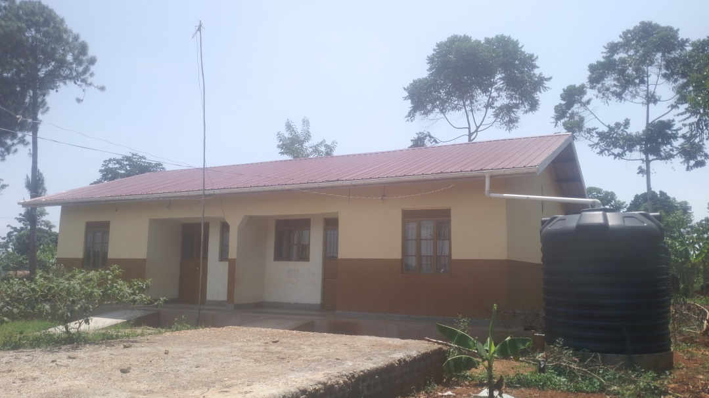
TOILETS/LATRINES  ENGRAVED “MALE” AND “FEMALE” | 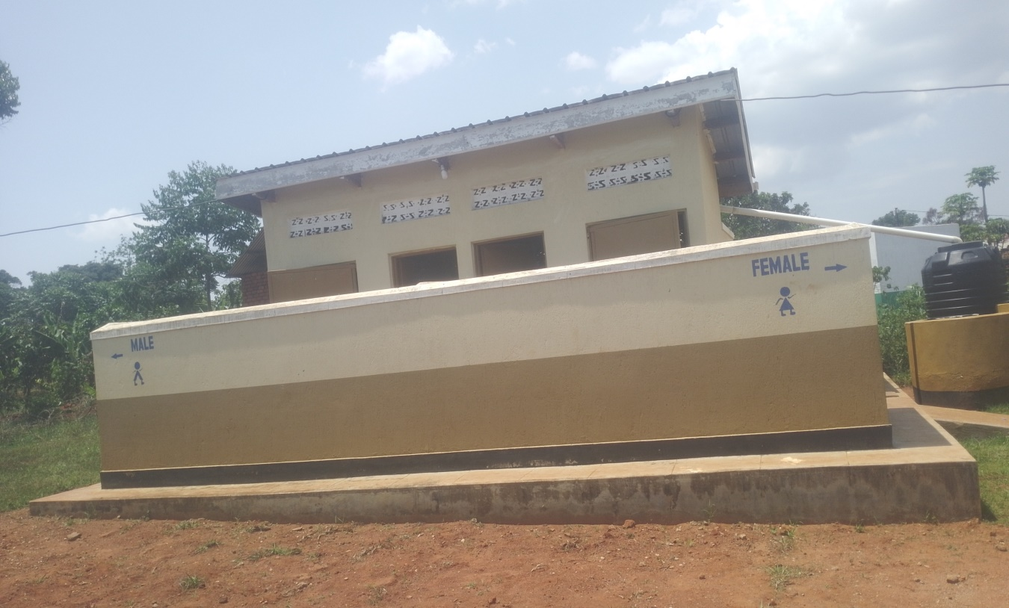
UN ENGRAVED PLACENTA PIT BUILDINIG AT MUGGI HCII | 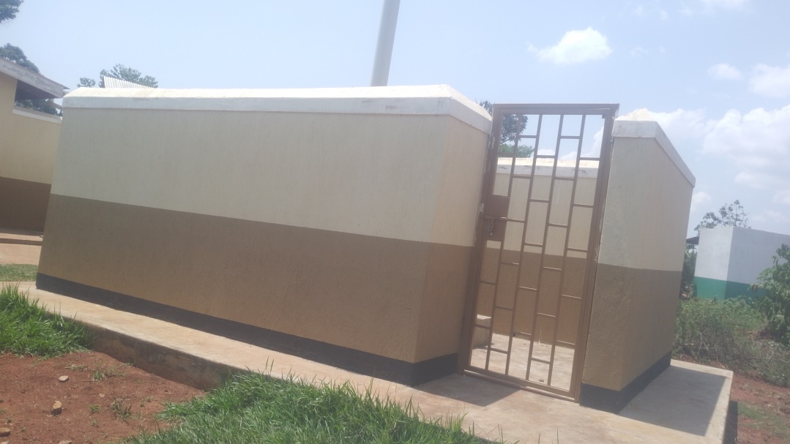
INSIDE VIEW OF THE PLACENTA PIT BUILDING | 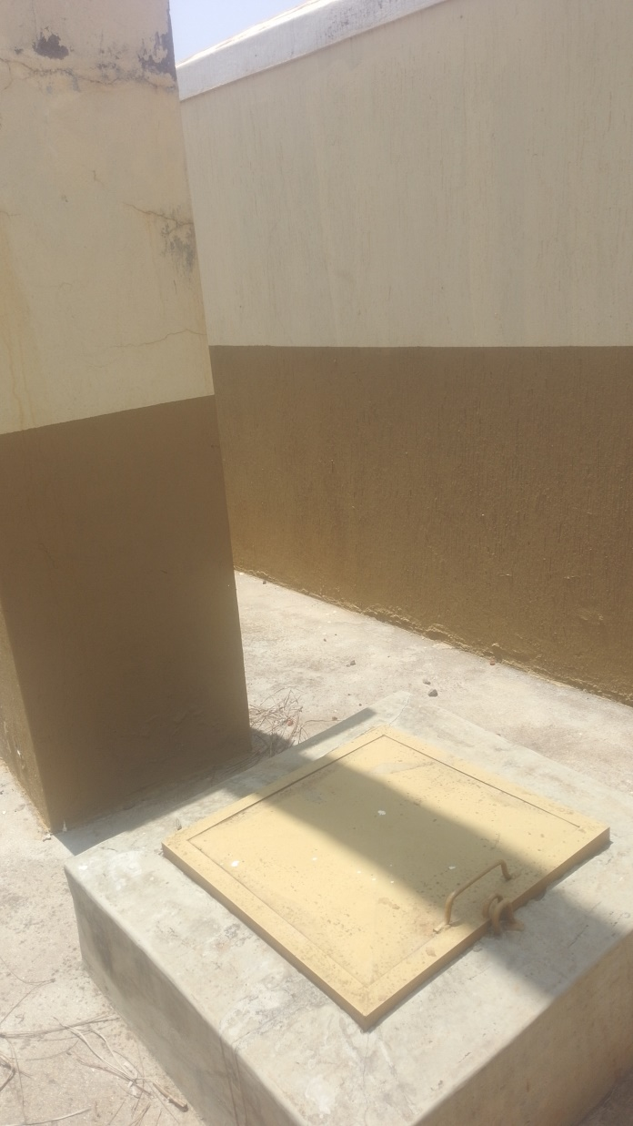
A HASH PIT AT MUGGI HEALTH CENTRE III  NOT ENGRAVED | 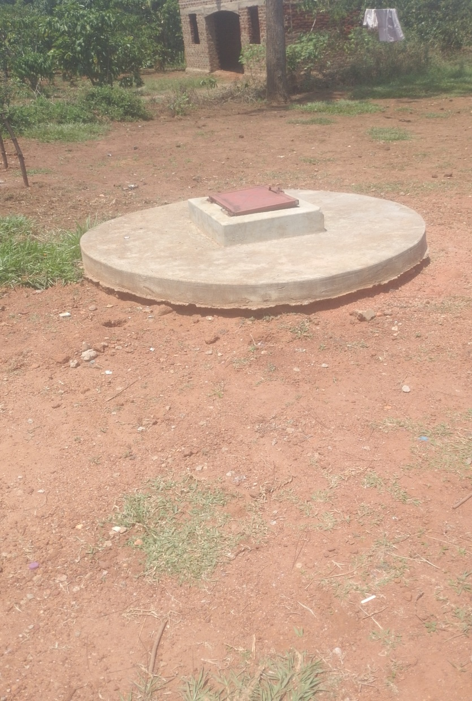
WALL CLOCK  NOT ENGRAVED | 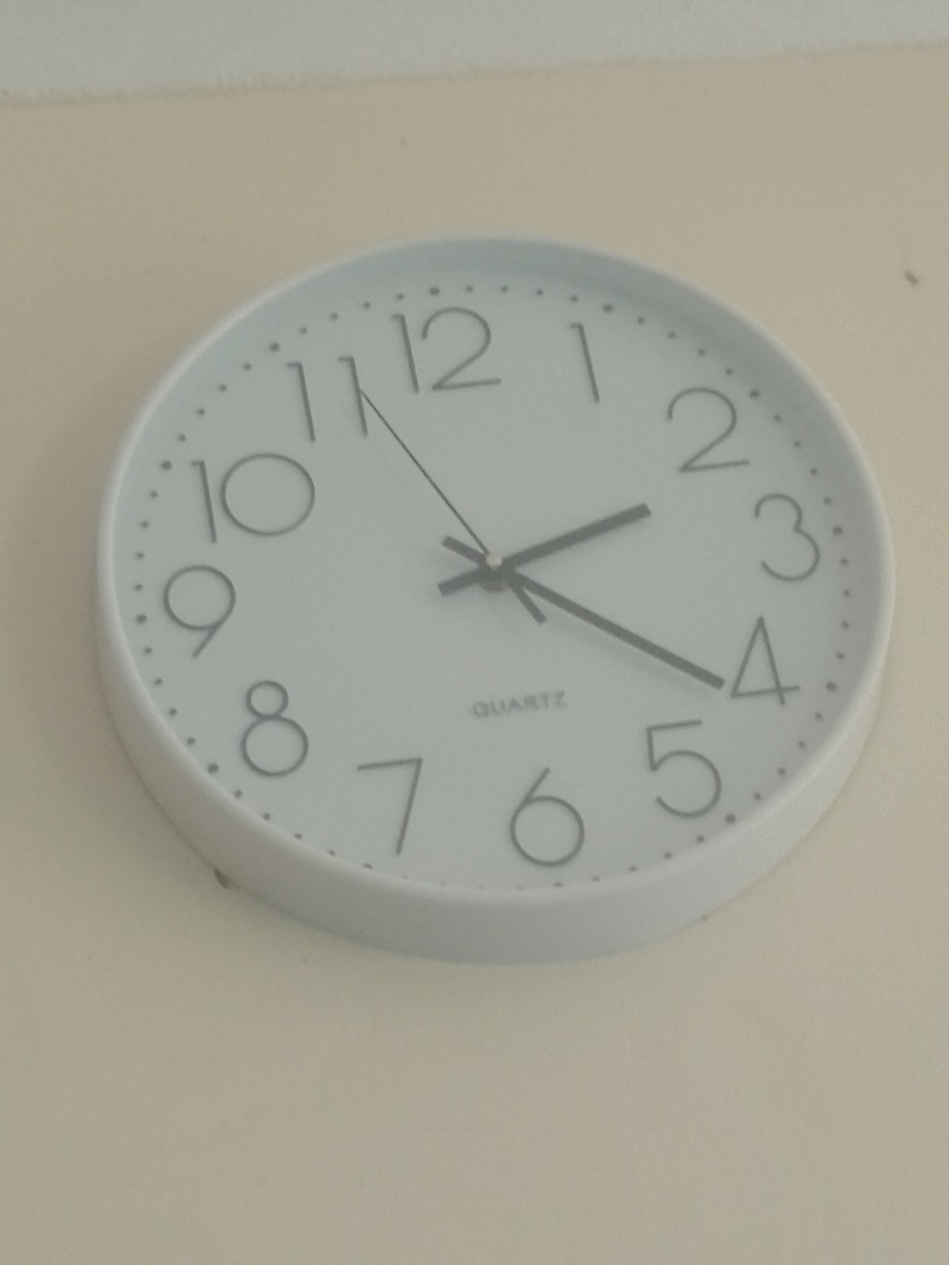
STETHOSCOPE  NOT ENGRAVED | 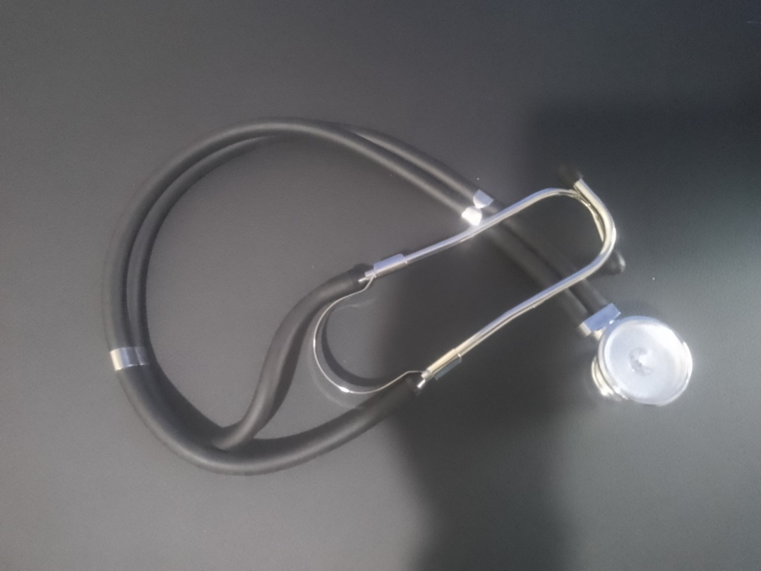
A WELL FUNCTIONING BP MACHINE ANEROID AT MUGGI HC III  NOT ENGRAVED | 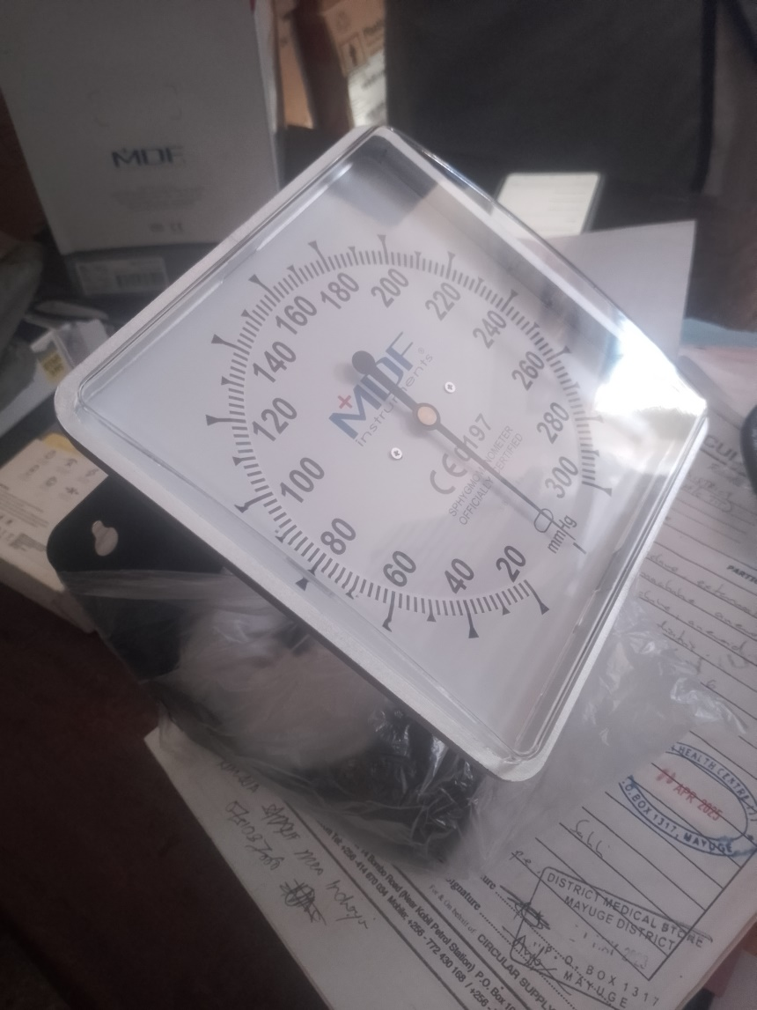
WELL FUNCTIONING BP MACHINE DIGITAL  NOT ENGRAVED | 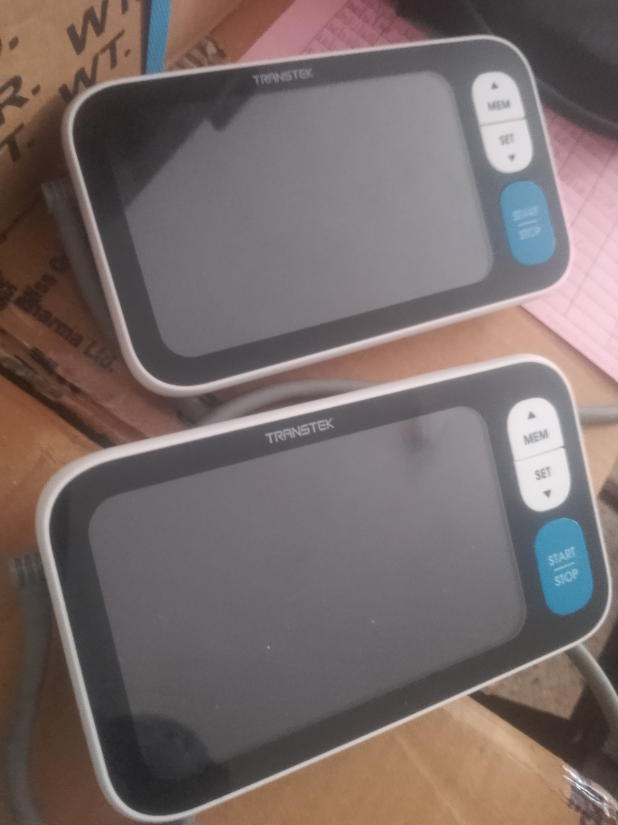
AUTOCLAVE.  WELL FUNCTIONING  NOT ENGRAVED | 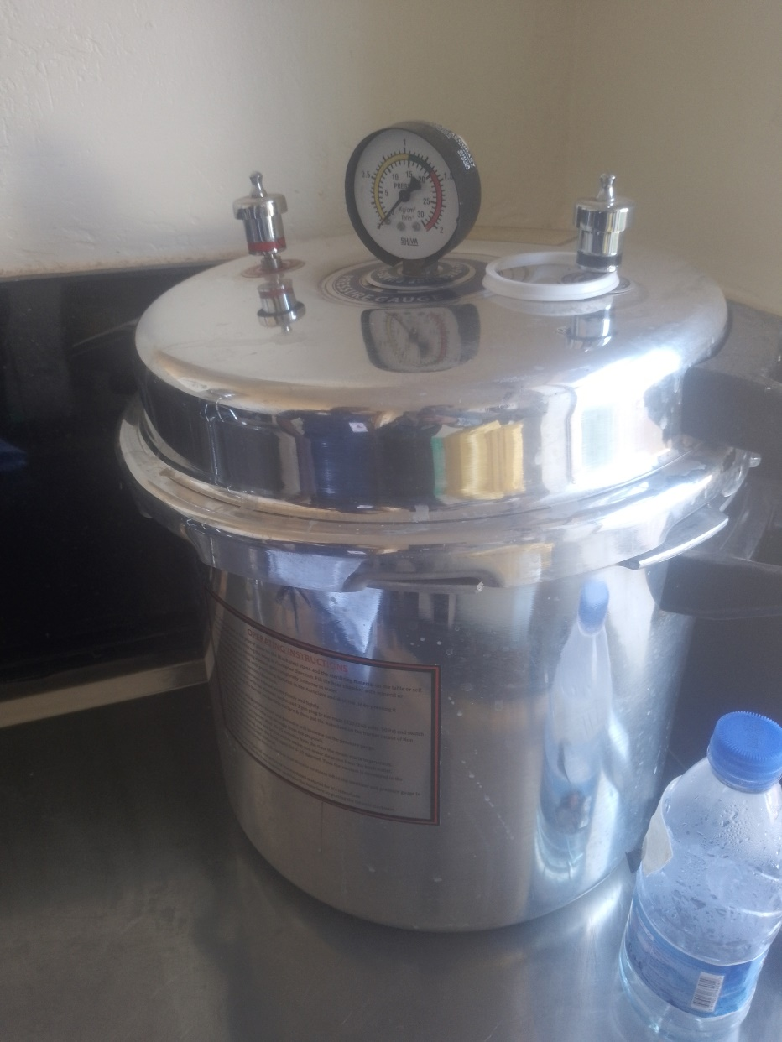
WEIGHING SCALE INFANT AT MUGGI HC III  NOT ENGRAVED | 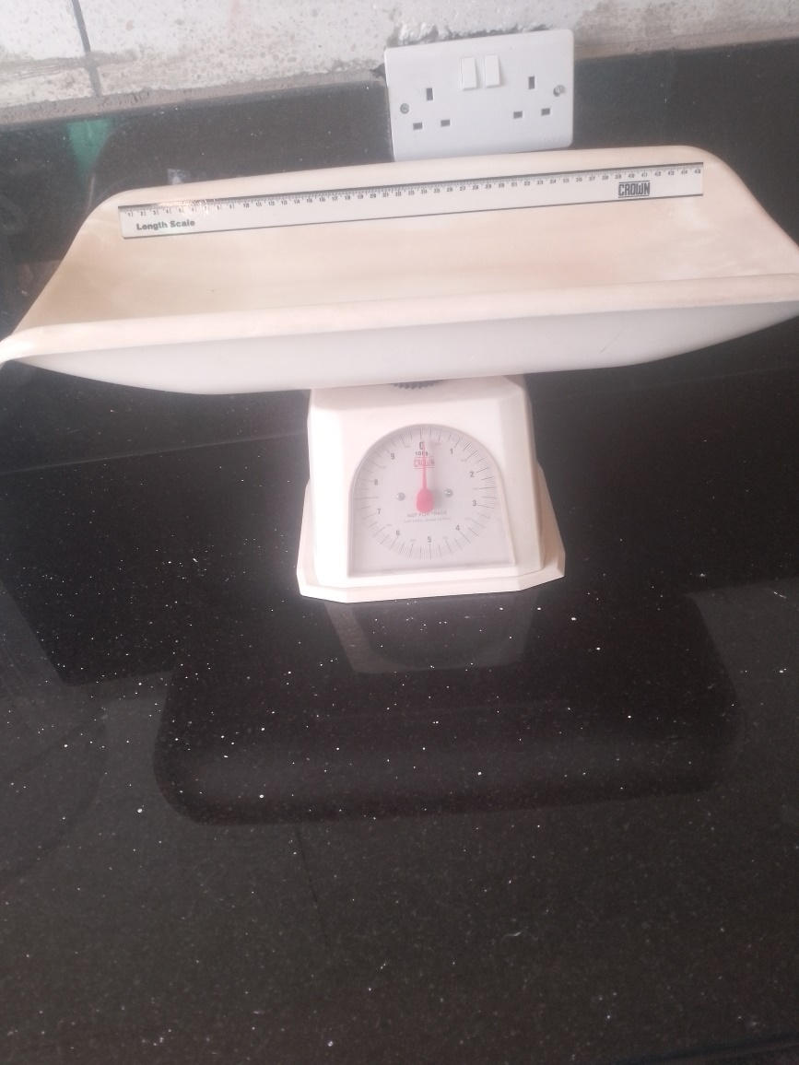
CENTRIFUGE | 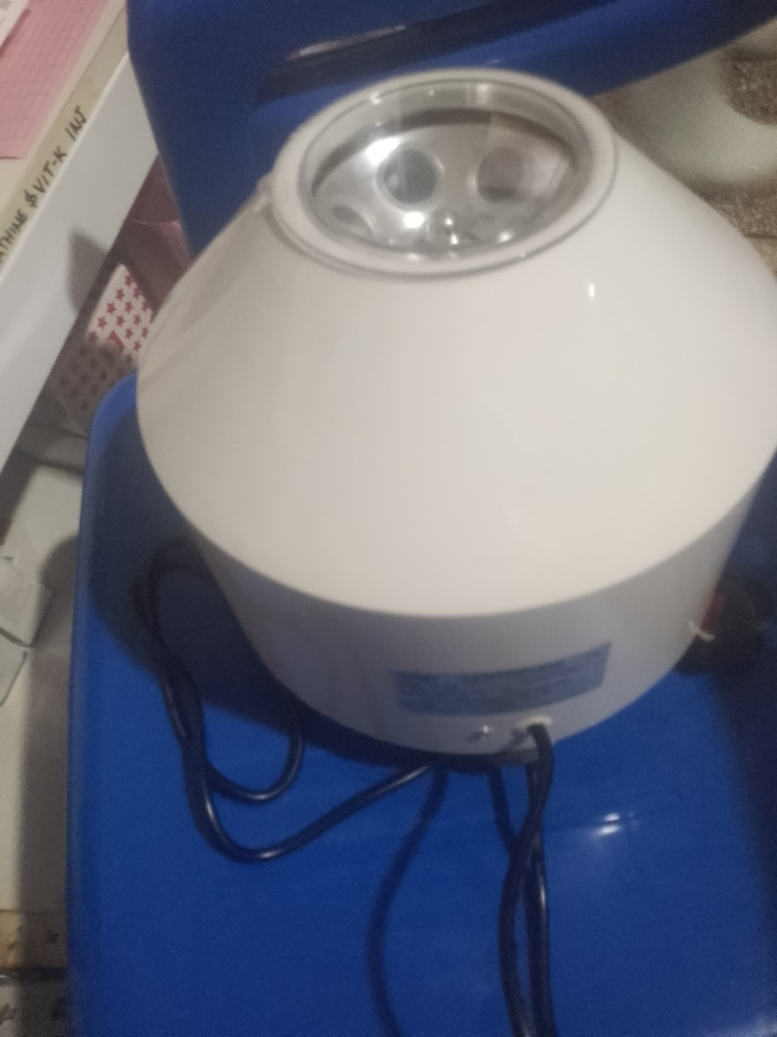
A SUNCTION APPARATUS ON THE LEFT AND AN OXYGEN CONCETRATOR ON THE RIGHT.  BOTH UN ENGRAVED AND B | 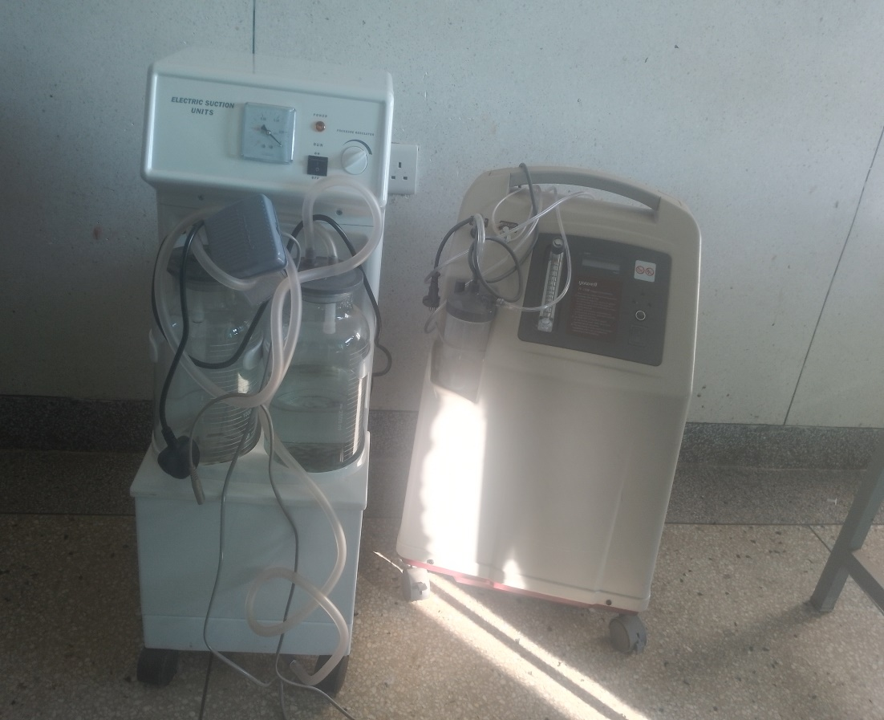
WEIGHING SCALE ADULT | 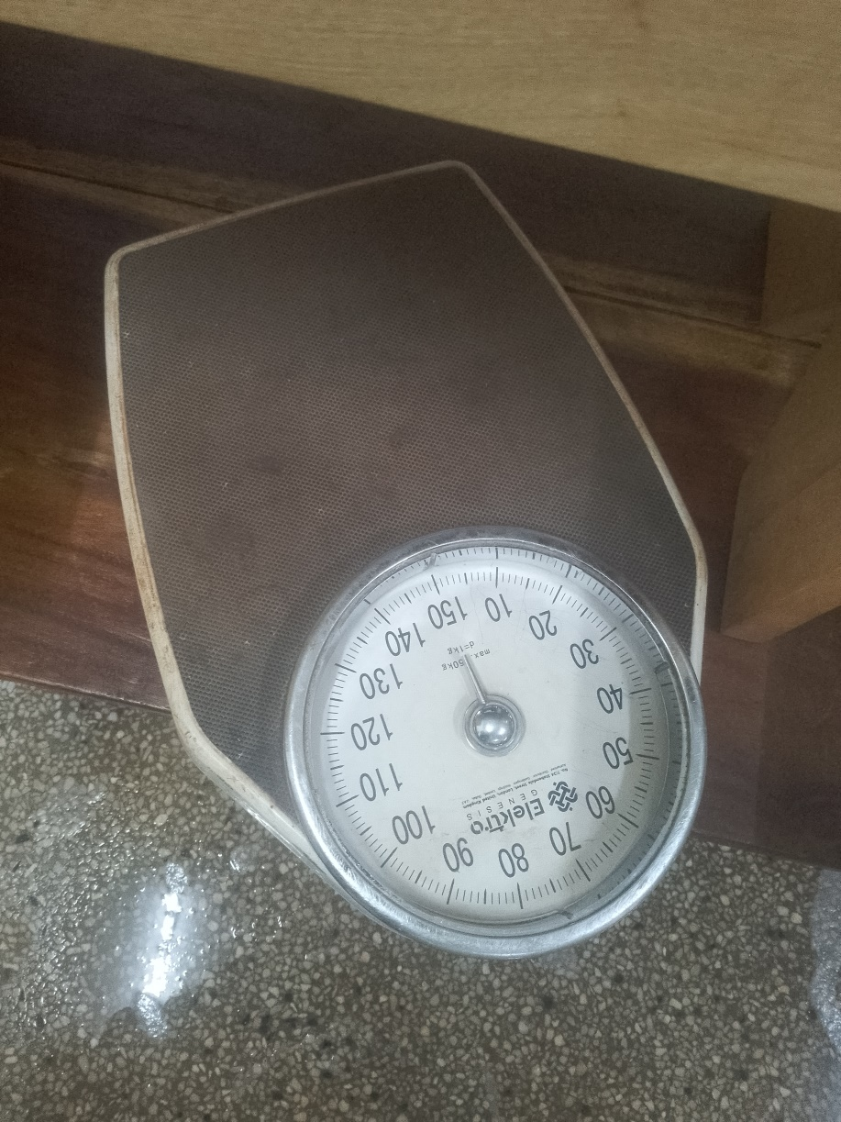
GLUCOMETER  NOT ENGRAVED | 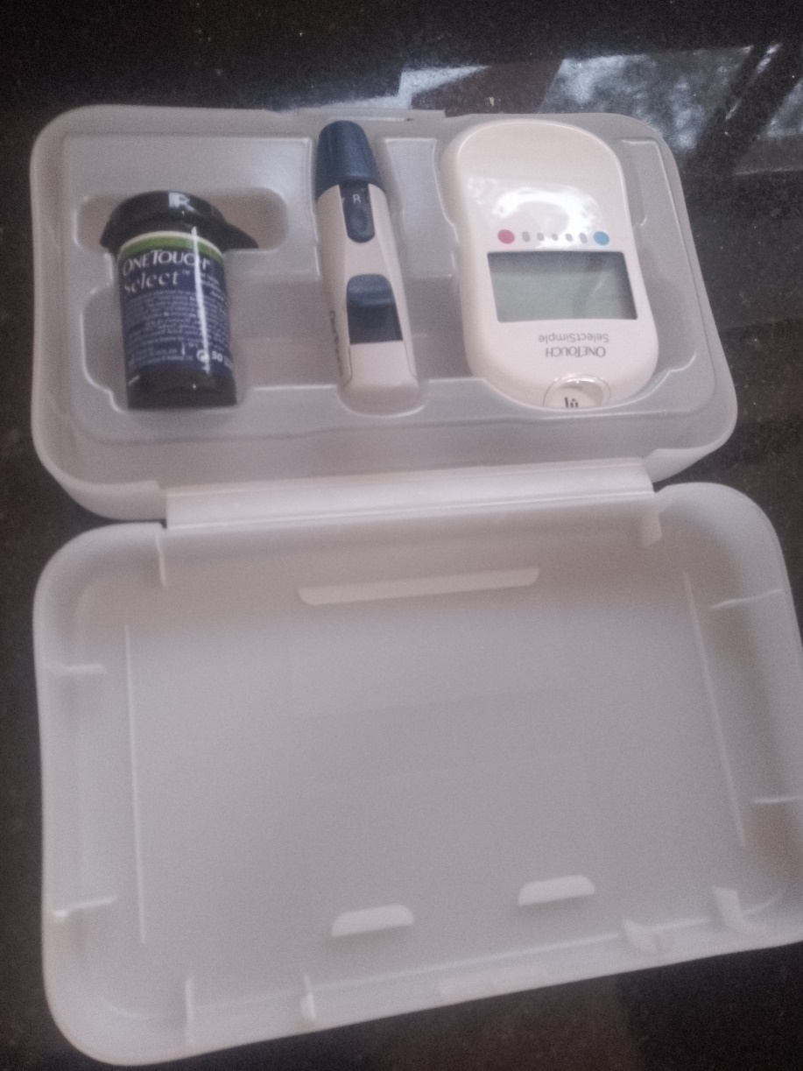
OTOSCOPE  NOT ENGRAVED | 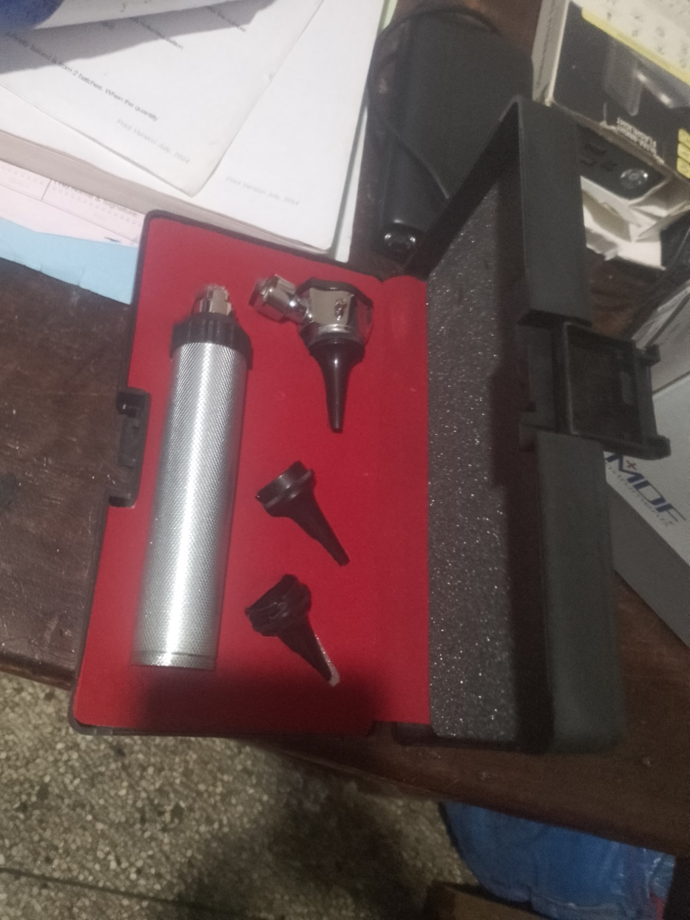
EXAMINATION LIGHT  NOT ENGRAVED | 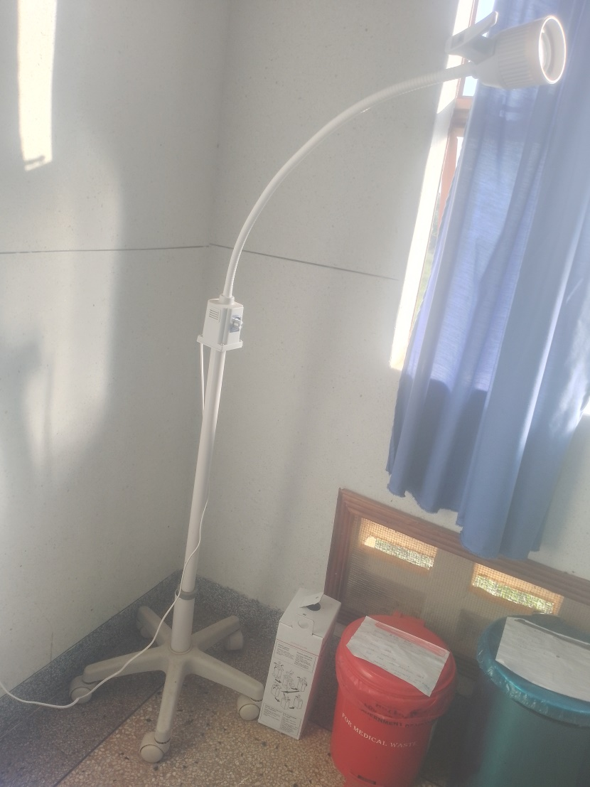
LAB STOOLS  NOT ENGRAVED | 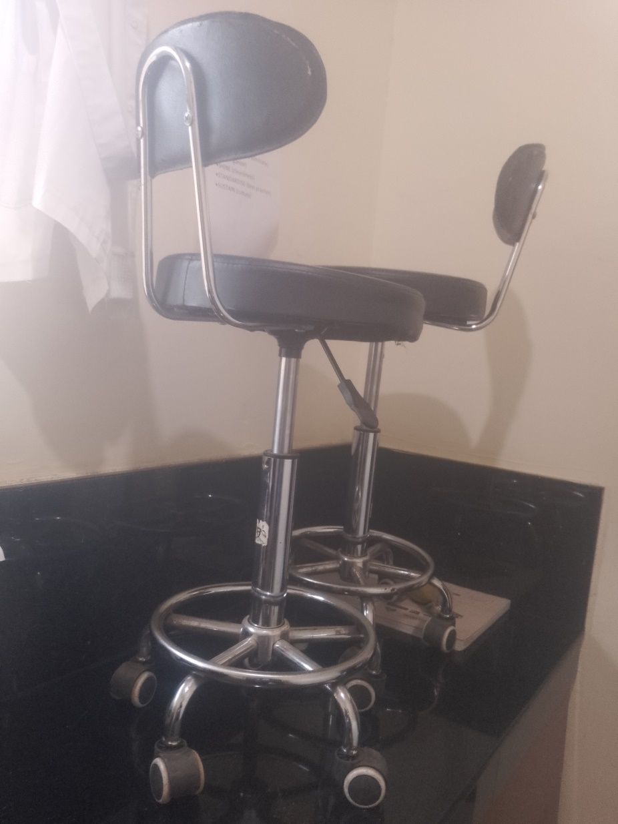
A SAMPLE OF THE BABY COTS AT THE FACILITY  NOT ENGRAVED | 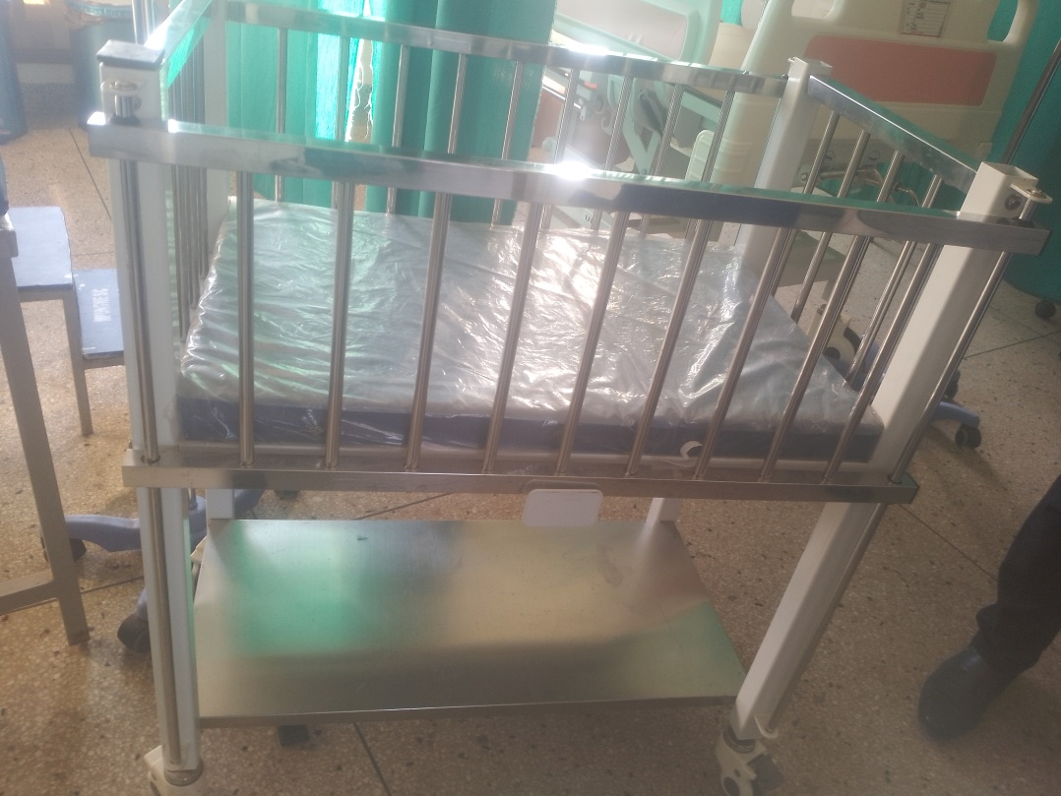
A SAMPLE OF THE EXAMINATION COUCH AT MUGGI  NOT ENRAVED | 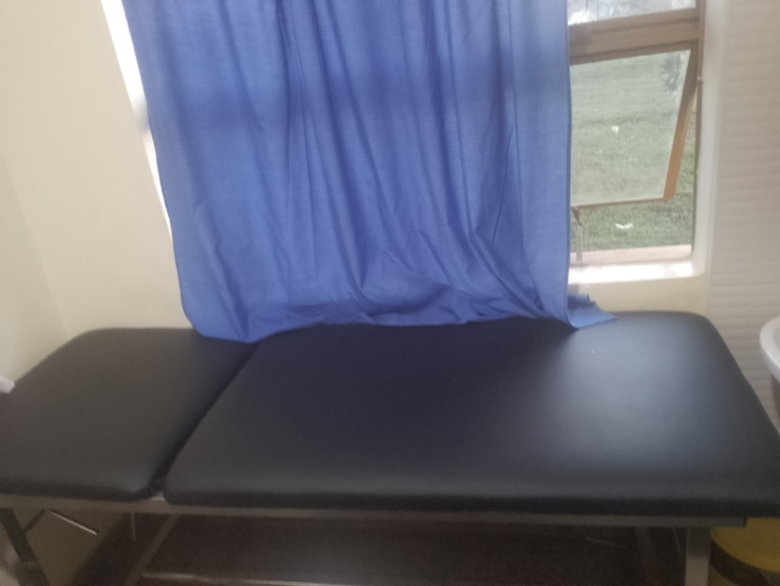
DELIVERY BED  NOT ENGRAVED | 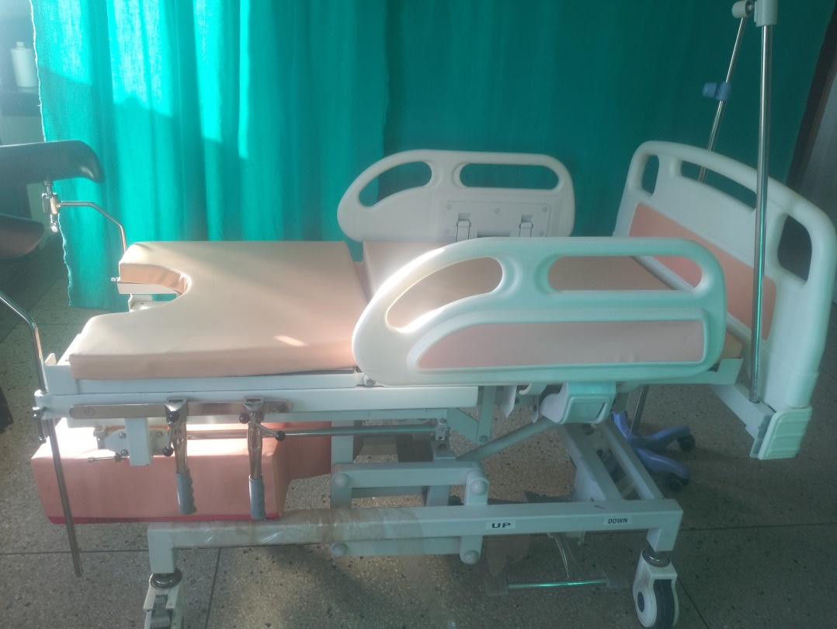
PATIENT STRETCHER  NOT ENGRAVED | 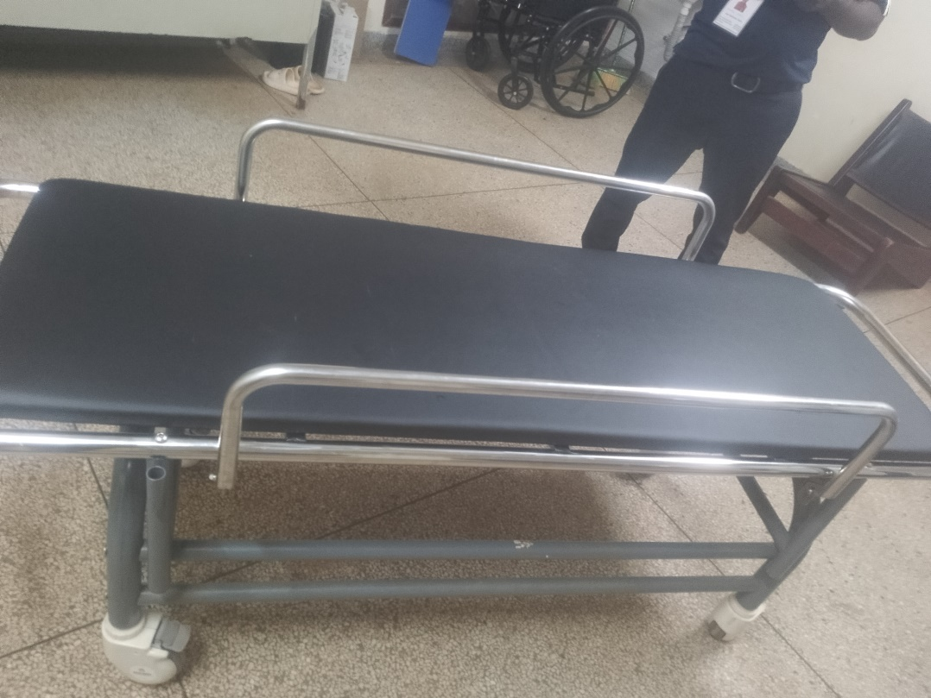
PATIENT SCREENS  NOT ENGRAVED | 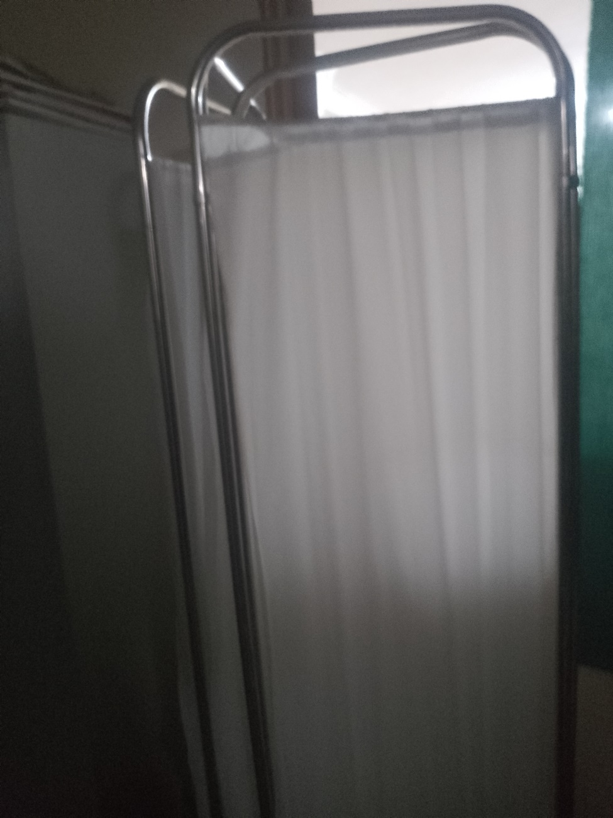
BOWL STAND  NOT ENGRAVED | 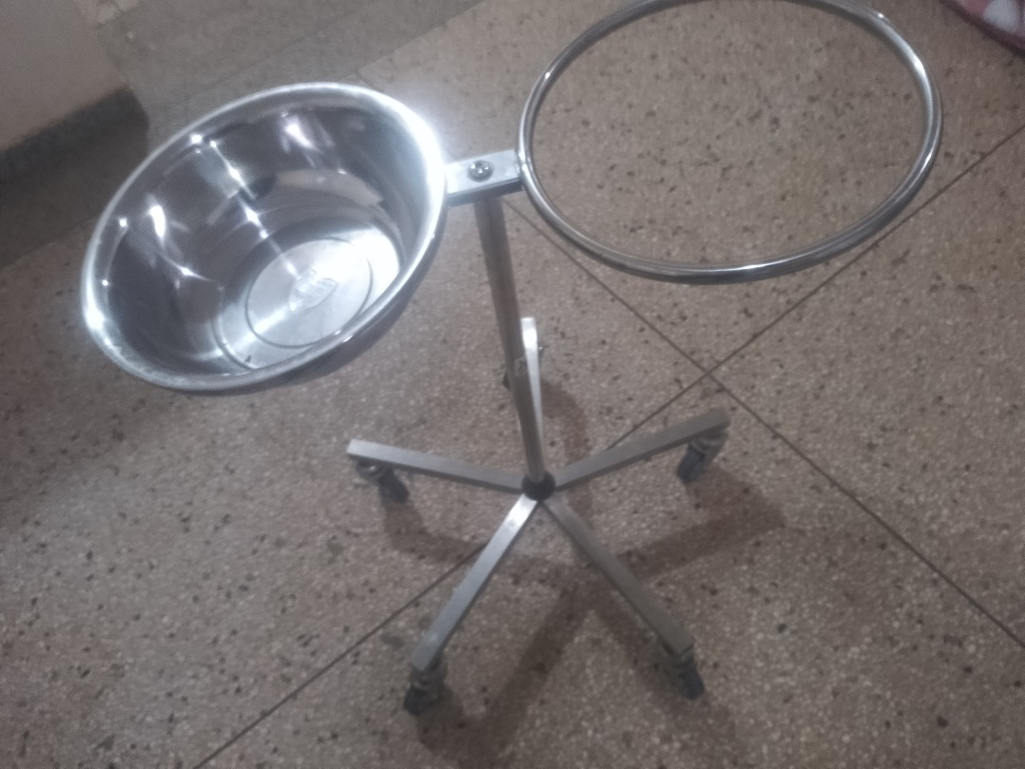
SAMPLE OF THE RECEIVED DESKS  NOT ENGRAVED | 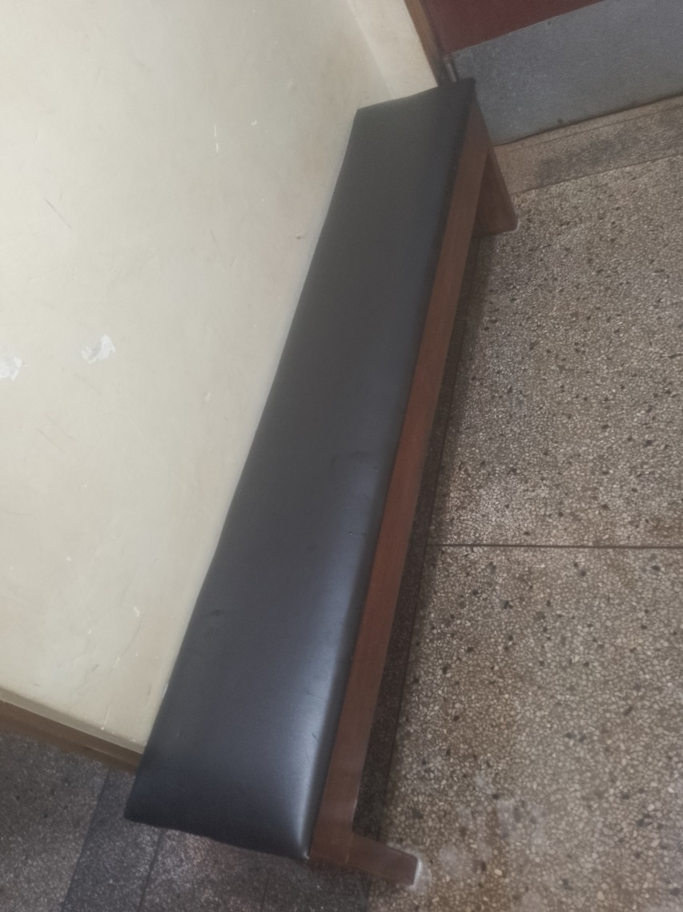
KANGAROOO MOTHER CHHAIR  NOT ENGRAVED | 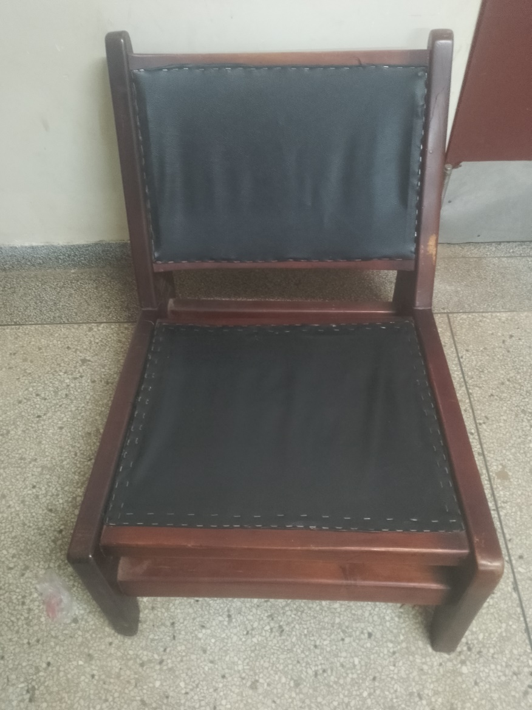
A SAMPLE OF OFFICE CHAIRS | 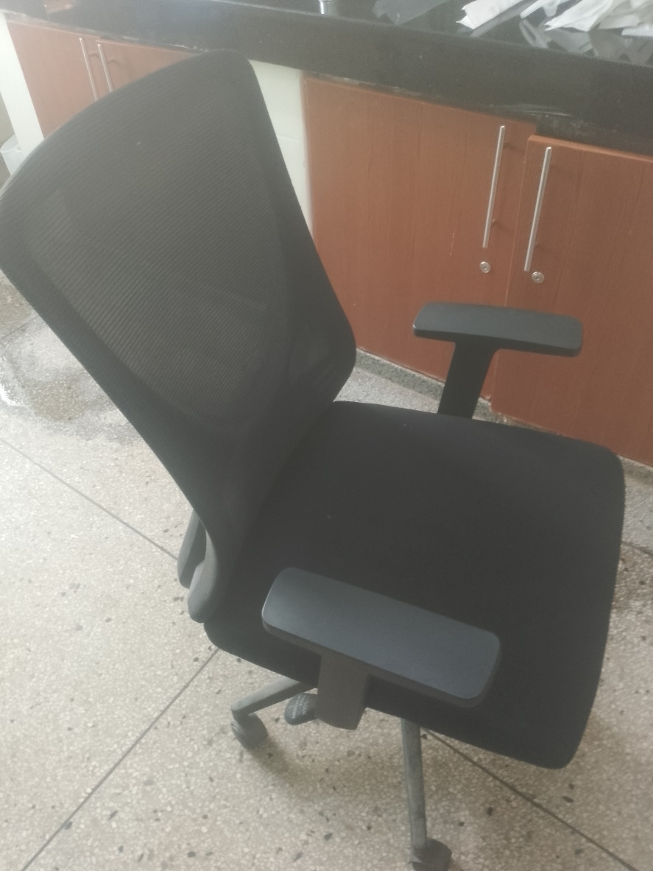
MUGGI STORE  (CONGESTED WITH NO SPACE LEFT FOR ADDITION/STORAGE OF OTHER ASSETS) | 