

ASSET VERIFICATION AND RECORDING TOOL KIT


Plot 31, Bukoto Street
P.O Box 7657, Kampala, Uganda
+256 (0) 39 2000216/0772525235
email: cpa@cpa.ug

www.cpa.com

August to September 2026

VERIFICATION DETAILS

NAME OF THE REGION: | EASTERN REGION
SUB-REGION: | BUSOGA
Name of Local Government | MAYUGE DISTRICT LOCAL GOVERNMENT
VERIFIER PARTICULARS |  | VERIFIER PARTICULARS
Full name | KIYUBA SALIMU
Contact/ email and Telephone | 0755215778, kiyubasalimu@gmail.com
Supervisor/ Sub team leader | NANDUDU SULAINA
Name | WANDERA SOLOMON
Contact | 0708153235
Date of submission

HEALTH CENTRES
INFORMANT INTERVIEW/DISCUSSION GUIDE (INCHARGE OR RESPONSIBLE PERSON)

Name of Health Centre: NKOME HEALTH CENTRE III

1a | Does the Facility have a record of all assets provided under UgIFT.  (Obtain a record and verify if it has the costs and numbers supplied | Yes
1b | If Not ask how many were supplied and when.

2 | How does this facility Maintain (repair/service/replace) the assets provided under Ugift  - Minor maintenance such as cleaning, servicing, simple repairs and replacement of basic parts is done by the facility staff of nkombe itself. However, for sophisticated and complex medical equipment such as BP machine can not be handled by the facility. A report is made to the DHO. The DHO then organizes the regional medical equipment workshop team from jinja to come and repair

3 | Does the facility take regular record about functionality/ or breakdown of the assets provided? | Yes,  They have an inventory book where they record the break downs

4 | How has the UgIFT support helped in service delivery in the area, any issues, challenges and any recommendations for better program implementation.  HOW UGIGT HAS SUPPORTED IN SERVICE DELIVERY  - It has improved the quality of health service delivery at NKOMBE Health centre III because most of the admissions e.g maternity  - It has increased the capacity of the facility to handle more patients at once i.e they can handle pediatrics, adults and pregnant mothers  - It has also improved infection prevention and control through provision of sterilization trays and trolleys  - It has motivated health workers through better accommodation and working environment  CHALLENGES  - Lack of training for specialized equipment. Health workers at the facility have not been adequately trained on how to operate and and some of the sophisticated equipment supplied. This has led to under utilization and risk of damage  - The facility has limited space for safe storage of newly supplied equipment and furniture. This causes congestion  - Delayed maintenance and repair. Maintenance of sophisticated equipment takes too long. After reporting ti the district, it takes weeks or months for the regional workshop team from jinja to come and fix the equipment, this has affected service delivery while waiting  - Inadequate staffing. The number of staff at NKOMBE is not enough compare to the increasing number of equipment, new blocks and patient load that came with ugift support  RECOMMENDATIONS  - Provision of adequate storage space. The facility need s additional storage space to keep equipment safe to avoid damages and congestion  - Strengthening maintenance system. A clear and faster maintenance response system should be put on place. The district should have a direct contact person and the jinja regional workshop should do a regular preventive maintenance regular visit to the facility not only when the equipment breakdown  - Organize on job training for the staff on how to operate clean and handle all specialized equipment supplied

PROCEED TO VERIFICATION AFTER THIS DISCUSSION

Health centre checklist

NAME OF LG: MAYUGE DISTRICT NAME OF HEALTH FACILITY: NKOMBE HEALTH CENTRE III

Equipment/ Item | Department | Asset Number | Item  Description | Life in Months | Tag Number ( engrave no.) | Date Of Purchase | Date Placed In Service | Recoverable cost | Cost | Acc Dep Cost | Net Book Value | Ytd Deprn | Equipment status | Remarks
B.P. Machine, Digital | health |  | It is white in color model 2088C with a black surface and a rectangular screen |  | Not engraved | 10th/02/2022 | 24/Aug/2023 |  | 672,000 |  |  |  | Good and functional. | 2 received, verified, in use.
B.P. Machine (Aneroid wall mounted) | health |  | It has a gauge, white in color, with a black metallic base mounted on the wall |  | Not engraved | 10th/02/2022 | 15/11/2025 |  | 672,000 |  |  |  | Good and functional. | 2 received, verified, in use.
Autoclave 20 Liters.,Duo Operated | health |  | Silver cylindrical stainless bowl with a round top and black handles with a gauge. |  | Engraved  NKOMBE HCCIII | 10th/02/2022 | 24/Aug/2023 |  | 156,000 |  |  |  | Good and functional. | 1 verified,1 in use
Bowl, Kick | health |  | Standard silver steel medical bowl with mobile kick stand. |  | Not engraved | 10th/02/2022 | 24/09/2025 |  | 224000 |  |  |  | Good and functional | 1received verified, in use.
Bowl Stand | health |  | Standard double bowl size with 2 bowls |  |  | 10th/02/2022 | 24/Aug/2023 |  | 840000 |  |  |  | Good and functional | 3 received verified,in use.
Counting chamber Neubauer- Improved | health |  |  |  |  |  |  |  |  |  |  |  |  | Not received
Cupboard Steel, Lockable | health |  | Standard grey metallic steel cupboard with lockable double door and adjustable shelves. |  | Engraved  NKOMBEHCCIIMOH/MAYUGE DLG | 10th/02/2022 | 24/09/2025 |  | 3217136 |  |  |  | Good and functional | 6 received, verified and in use`
Drip Stand | health |  | It is a Grey metallic drip stand with adjustable heights, 4 hooks on top with 5 castor wheels for mobility. |  | Not engraved | 10th/02/2022 | 15/11/2025 |  | 1,800,000 |  |  |  | Good and functional | 9 received, verified, in use.
ESR Stand | health |  | A standard metallic grey metal with adjustable leveling for holding tubes. |  | Not engraved | 10th/02/2022 | 15/11/2025 |  | 280,000 |  |  |  | Good and functional | One received, verified, in use.
Examination Couch | health |  | A standard grey metallic frame table with black mattress on top, adjustable with a handle. |  | Not engraved | 10th/02/2022 | 16/06/2026 |  | 3,136,000 |  |  |  | Good and functional | 4 received, verified, in use.
Glucometer | health |  | A small black portable machine with screen and test strips . |  | Engraved  Nkombe HCIII | 10th/02/2022 | 16/06/2026 |  | 896,000 |  |  |  | Good and functional | 2 received, verified,1 in use.
Haemoglobin Meter, Digital | health |  | A small portable handheld device, white and grey plastic with screen on top. |  | Not engraved | 10th/02/2022 | 16/06/2026 |  | 8,000,000 |  |  |  | Good and functional | 2 received, verified, 1 in use.
Height Meter | health |  | A tall vertical metallic stand, silver in color with flat base and sliding head and height scale. |  | Not engraved | 10th/02/2022 | 16/06/2026 |  | 896000 |  |  |  | Good and functional | 1 receive, verified and in use
Instrument Trolley | health |  | Medium sized, Grey in color with 2 compartments , the lower one bigger than the upper one |  | Not engraved | 10th/02/2022 | 15/11/2025 |  | 3,800,000 |  |  |  | Good and functional | 4 received, verified and in use.
Microscope Binocular |  |  | A black and grey metallic device with double eye pieces on top, round base, lenses, knob. |  | Engraved  NKOMBE HCIII | 10th/02/2022 | 24/Aug/2023 |  | 6,000,000 |  |  |  | Good and functional | 1 received verified and in use.
Otoscope | health |  | A small handheld black plastic device, torch like shape with light head on top and pocket sized. |  | Not engraved | 10th/02/2022 | 24/Aug/2023 |  | 392,000 |  |  |  |  | 1 received but Verified, in use.
Patient Screen | health |  | A metallic folding frame, blue cloth, 3- panel, stands on 4 wheels. |  | Not engraved | 10th/02/2022 | 24/Aug/2023 |  | 1890,000 |  |  |  | Good and functional | 5 received, in use and verified
Patient Trolley | health |  | A rectangular stainless steel frame, silver metallic with 2 selves, 4 wheels with 2 lockable, medium sizes with a push handle. |  | Not engraved | 10th/02/2022 | 24/Aug/2023 |  | 950,000 |  |  |  | Good and functional | 1received verified and in use.
Refrigerator, Basic | Health |  | Medium size upright electric device, grey metallic outer body with single door and selves. |  | Engraved  Nkombe HCIII | 10th/02/2022 | 24/Aug/2023 |  | 2,240,000 |  |  |  | Good and functional | 1 verified and in use.
Stethoscope | Health |  | Black in color with 2 rubber flexible tube |  | Not engraved | 10th/02/2022 | 24/Aug/2023 |  | 3,136,000 |  |  |  | Good and functional | 8 received, verified and 1 in use.
Stop Watch | health |  | Handheld digital timer with start, stop and reset function. |  | Not engraved |  |  |  | 224,000 |  |  |  | Good and functional | 1 received verified. in use.
Stretcher | Health |  | It’s a bed with 4 black wheels ,two rails and black soft sponge |  | Engraved  NKOMBE HCIII | 10th/02/2022 | 24/Aug/2023 |  | 4,480,000 |  |  |  | Good and functional | 2 received, verified and in use.
Stove, Gas | health |  | It’s a burner gas with a gas cylinder and regulator. |  | Not engraved | 10th/02/2022 | 24/Aug/2023 |  | 1008,000 |  |  |  | Good and functional | 1 received verified. In use.
Weighing Scale with Height Meter, Adult | health |  | Tall, White in color, automated with a height and a gauge. With a black rectangular base in nature |  | Engraved  NKOMBE HCIII | 10th/02/2022 | 24/Aug/2023 |  | 3,000,000 |  |  |  | Good and functional | 2 received verified, in use
Weighing Scale, Infant |  |  | It’s a digital scale with a small white plastic tray |  | Not engraved | 10th/02/2022 | 24/Aug/2023 |  | 1,456,000 |  |  |  | Good and functional | 2 received, verified 1 in use.
Weighing Scale, Toddler | health |  | A standard white and light blue electronic device with a large tray, LCD display, height rod. |  | Not engraved | 10th/02/2022 | 24/Aug/2023 |  | 728000 |  |  |  | Good and functional | 1 received verified, in use.
Wheel Chair |  |  | Medium, Black in color, foldable chair, with 2 back wheels, 2 foot pads and 2 handles |  | Engraved  NKOMBE HCIII | 10th/02/2022 | 24/Aug/2023 |  | 2,016,000 |  |  |  | Good and functional | 4 revived , in used and verified
Audio Visual Equipment | health |  |  |  |  |  |  |  |  |  |  |  |  | Not received, not verified.
Medical Waste Bin | health |  | Medium 20litre, plastic bin with a footpad. |  | Engraved  NKOMBE HCIII | 10th/02/2022 | 24/Aug/2023 |  | 4032000 |  |  |  | Good and functional | 20 received, in use all verified
Wall Clock | health |  | A round white dial device, black numbers and hands, plastic body with glass cover and wall hanging. |  | Engraved  NKOMBE HCIII | 10th/02/2022 | 24/Aug/2023 |  | 224,000 |  |  |  | Good and functional | 4 received, all in use and all verified
Diagnostic Equipment Set for MCH | health |  | Small, portable, black bag that contains BP machine, thermometer, torch, tape measure. |  | Not engraved | 10th/02/2022 | 24/Aug/2023 |  | 1176000 |  |  |  | Good and functional | 2 received,1 in use and verified.
Diagnostic Equipment Set for OPD | health |  | Small portable, silver metal tools for general OPD examination. |  | Not engraved | 10th/02/2022 | 24/Aug/2023 |  | 560,000 |  |  |  | Good and functional | 2 received, verified and1 in use.
Glassware Set, Laboratory, Basic | health |  | Small, transparent glass containing, beakers, test tubes, measuring cylinder, slides and petri dishes |  | Not engraved | 10th/02/2022 | 24/Aug/2023 |  | 1,456,000 |  |  |  | Good and functional | 2 received, verified and 1 in use.
Hollow Ware Set, Treatment | health |  | Medium set containing kidney dishes, gallipots, instrument trays and bowls |  | Not engraved | 10th/02/2022 | 24/Aug/2023 |  | 7484102 |  |  |  | Good and functional | 2 received, verified and 2 in use.
Instrument Set, Dressing | health |  | Small set, sliver, metallic tray containing scissors, forceps, needle holder. |  | Not engraved | 10th/02/2022 | 24/Aug/2023 |  | 6664000 |  |  |  | Good and functional | 2 received, verified and 1 in use.
Instrument Set, Basic ENT | health |  | It’s a set, silver in color stainless steel with standard size instruments. |  | Not engraved | 10th/02/2022 | 24/Aug/2023 |  | 1,008,000 |  |  |  | Good and functional. | 1 received, verified.1 in use.
Instrument Set, Suture | health |  | A set silver in color, stainless steel containg needle holder, suture scissors, galley pot, dressing bowl for suturing wounds . |  | Not engraved | 10th/02/2022 | 24/Aug/2023 |  | 1,848,000 |  |  |  | Good and functional | 3 received, verified,1 in use
Pulse Oximeter, Hand held | health |  | Small portable size, white and blue color with finger probe for measuring oxygen saturation and pulse |  | Not engraved | 10th/02/2022 | 24/Aug/2023 |  | 2,688,000 |  |  |  | Good and functional | 2 received, verified, in use.
Bed, Adult Patient with Mattress | health |  | Standard single beds with black mattress, grey metallic frame and manually adjustable. |  | Engraved  NKOMBE HCIII | 10th/02/2022 | 24/Aug/2023 |  | 1,800,000 |  |  |  | Good and functional | 10 verified and in use.
Bed, Pediatric Patient, With Mattress | health |  | White in color with blue soft sponge mattress, white metallic frame and side rails. |  | Engraved  NKOMBE HCIII | 10th/02/2022 | 24/Aug/2023 |  | 4480000 |  |  |  | Good and functional. | 5 received, verified and in use verified
Bedside Locker | health |  | Small lockers silver in color with one drawer and cupboard with a shelf and door for storage of patient items |  | Engraved  NKOMBE HCIII | 10th/02/2022 | 24/Aug/2023 |  | 5,040,000 |  |  |  | Good and functional.. | 10 received, verified.
Cupboard, Instrument | health |  | A tall upright metallic device, white and grey, double glass doors on top, double metal doors. |  | Engraved  NKOMBE HCIII | 10th/02/2022 | 24/Aug/2023 |  | 1,008,000 |  |  |  | Good and functional | 1 received, verified and in use.
Delivery Bed, Hydraulic Manual | health |  | A large metallic bed device, blue mattress top with adjustable backrest and leg rests and side rails. |  | Not engraved | 10th/02/2022 | 24/Aug/2023 |  | 7,840,000 |  |  |  | Good and functional | 1 received, verified and in use
Oxygen Therapy Apparatus, Mininum 45L cylinder | health |  | A tall green metallic gas cylinder device, with regulator, a gauge on top and a tubing. |  | Engraved  NKOMBE HCIII | 10th/02/2022 | 24/Aug/2023 |  | 2800,000 |  |  |  | Good and functional | 2 received, verified and not in use because of lack of power.
Resuscitator Manual, Infant, with all Mask sizes | health |  | A small handheld silicone device, transparent bag with blue valve. |  | Not engraved | 10th/02/2022 | 24/Aug/2023 |  | 448,000 |  |  |  | Good and functional | 1 received, verified and 1 in use.
Resuscitator Manual, Adult, with all mask sizes | health |  | A light handheld silicone device, transparent bag with blue valve. |  | Not engraved | 10th/02/2022 | 24/Aug/2023 |  | 425,600 |  |  |  | Good and functional | 1 received, verified and 1 in use
Suction Apparatus, (Electric) | health |  | It is an electric pump, White, with 2 bags of water and a guage.  Model COO1-A with 4 wheels |  | Engraved  NKOMBE HCIII | 10th/02/2022 | 24/Aug/2023 |  | 2,688,000 |  |  |  | Good and functional | 2 received, verified and not in use.
Nebulizer, Ultrasonic | health |  | Small tabletops size with white color ultrasonic with adult and child mask set |  | Not engraved | 10th/02/2022 | 24/Aug/2023 |  | 392,000 |  |  |  | Good and functional | 1 received, verified and not in use
Oxygen Concentrator, Duo Flow | health |  | Medium size, Grey, 2 handles on top and a cylinder also on top. With outlets and wheels at the bottom |  | Engraved  NKOMBE HCIII | 10th/02/2022 | 24/Aug/2023 |  | 5,500,000 |  |  |  | Good and functional | 1 received, verified and not in use
Bench | health |  | Long backless wooden bench with solid hard wood. |  | Engraved  NKOMBE HCIII | 10th/02/2022 | 24/Aug/2023 |  | 1,120,000 |  |  |  | Good and functional | 4 received, verified and in use
Disinfection Buckets | health |  | A set of large plastic buckets, blue in color with lids. |  | Engraved  NKOMBE HCIII | 10th/02/2022 | 24/Aug/2023 |  | 134400 |  |  |  | Good and functional | 2 received, verified and in use
Baby Cot | health |  | A small metallic infant bed device, white steel frame, with transparent sides on 4 wheels with mattress. |  | Engraved  NKOMBE HCIII | 10th/02/2022 | 24/Aug/2023 |  | 2,240,000 |  |  |  | Good and functional | 2 received, verified and in use
Diagnostic Equipment Set for Ward | health |  | A portable metric kit containing stethoscope, clinical thermometer, torch, and plastic materials. |  | Not engraved | 10th/02/2022 | 24/Aug/2023 |  | 1456000 |  |  |  | Good and functional | 2 received, verified and 2in use.
Hollow Ware Set, Ward | health |  | A large steel set, silver color containing kidney dish, bowl and tray of different sizes on a tray. |  | Not engraved | 10th/02/2022 | 24/Aug/2023 |  | 7616000 |  |  |  | Good and functional | 2 received, verified and 2 in use.
Instrument Set, Delivery | health |  | A medium steel set, silver color containing scissors, forceps, cord clamps, kidney dish in a steel tray. |  | Not engraved | 10th/02/2022 | 24/Aug/2023 |  | 4,760,000 |  |  |  | Good and functional | 5received, verified and 1in use.
Instrument Set, Stitch Removing | health |  | Small size 3 pieces, silver steel tray with stitch scissors, kidney dish and toothed forceps |  | Not engraved | 10th/02/2022 | 24/Aug/2023 |  | 2240000 |  |  |  | Good and functional | 5 received, verified and 1 in use.
MVA Kit | health |  | Small white plastic manual vacuum aspirator kit with syringe 4-12mm cannula for evacuation. |  | Not engraved | 10th/02/2022 | 24/Aug/2023 |  | 3360000 |  |  |  | Good and functional | 5 received, verified and 1 in use.
Stool, Laboratory | health |  | Standard size, high, silver with 5 wheels and black in color |  | Engraved  NKOMBE HCIII | 10th/02/2022 | 24/Aug/2023 |  | 2016000 |  |  |  | Good and functional | 3 received, verified and in use
Penguin Sucker | health |  | Small white rubber bulb for newborn suction. |  | Not engraved | 10th/02/2022 | 24/Aug/2023 |  | 285000 |  |  |  | Good and functional | 3 received, verified and 1 in use
Fetoscope, Dopplar | health |  | Handheld pocket size, white in color with a screen, display and speaker. |  | Not engraved | 10th/02/2022 | 24/Aug/2023 |  | 672,000 |  |  |  | Good and functional | 2 received, verified and 1 in use
Centrifuge (Electric) | health |  | Small white plastic bench top small size digital machine |  | Engraved  NKOMBE HCIII | 10th/02/2022 | 24/Aug/2023 |  | 168000 |  |  |  | Good and functional | received, verified and not in use
Kangaroo Mother Care Chair | health |  | A large fabric reclining mother chair with silver metallic frame. |  | Engraved  NKOMBE HCIII | 10th/02/2022 | 24/Aug/2023 |  | 1,344,540 |  |  |  | Good and functional | 1 received, verified and in use
Radiant Infant Warmer |  |  | . |  |  |  |  |  |  |  |  |  | Not seen | Not received, not verified.
Haemoglobin Meter, Sahli | health |  | Small black box kit, hand held with 2 tubes |  | Not engraved | 10th/02/2022 | 24/Aug/2023 |  | 8,000,000 |  |  |  | Good and functional | 2 received, verified and 1 in use.
Delivery Bed | health |  | It is a manually adjustable bed.  Model H7 with peach mattress and a drip stand, grey metallic frame for delivery position. |  | Engraved  NKOMBE HCIII | 10th/02/2022 | 24/Aug/2023 |  | 7,840,000 |  |  |  | Good and functional | 1 received, verified and in use
Examination light | health |  | It is medium size, white in color, with mobile stand base and a led . |  | Not engraved | 10th/02/2022 | 24/Aug/2023 |  | 1,904,000 |  |  |  | Good and functional | 2received, verified in use
Instrument set, ENT Basic for HCIII | health |  | It’s a set stainless tray with a lid, silver and perforated containing equipment for ENT |  | Not engraved | 10th/02/2022 | 24/Aug/2023 |  | 2,016,000 |  |  |  | Good and functional | 2 received verified, 1 in use
Bag Valve mask (Ambu Bag), Neonatal | health |  | White, with yellow valve and a glass with white masks |  | Not engraved | 10th/02/2022 | 24/Aug/2023 |  |  |  |  |  | Good and functional | 10received, verified and 2 in use
Office Chair | health |  | Black in color, swinging in nature with 5 black wheels |  | Engraved  NKOMBE HCIII | 10th/02/2022 | 24/Aug/2023 |  | 1,050,000 |  |  |  | Good and functional | 7received, verified and in use
Desk | health |  | Wooden office desk with cabinet, brown in color.t |  | Engraved  NKOMBE HCIII | 10th/02/2022 | 24/Aug/2023 |  | 1400000 |  |  |  |  | 5received,verified and in use.
Filing Cabinet |  |  | Standard 4-drawer size, grey metallic color, |  |  | 10th/02/2022 | 24/Aug/2023 |  | 5040000 |  |  |  | Good and functional | 6 received, verified and in use
Non Residential Buildings
Water tanks |  |  | cylindrical, one raise and one on ground, |  | Not engraved |  |  |  |  |  |  |  | Good and functional | 2 received, verified and in use
Main block |  |  | One main block with men ward, pediatric ward, OPD ward, offices, maternity ward while the store is in the old block |  |  |  |  |  |  |  |  |  | Good and functional | 1 block verified and in use however very small for efficient service delivery.
Hash pit |  |  | it is a cemented circular pit) ,placenta pits,(square cemented pit with a square coffee brown metallic cover). |  | Engraved  “Hash pit” |  |  |  |  |  |  |  | Good and functional | 1received, verified and in use
Pit latrines |  |  | 4 stances with a metallic door and coffee brown + yellow in color |  | Engraved  “Abakyala”  “Abami” |  |  |  |  |  |  |  | Good and functional | verified and in use
Staff Quarters |  |  | Coffee brown and yellow color block with 2 bed rooms/units. |  | Engraved  “Staff Quarters” |  |  |  |  |  |  |  | Good and functional 0ne block | verified and in use

ASSET VERIFICATION BRIEF REPORT

HEALTH CENTER: NKOMBE HEALTH III,

DATE 24TH/8/2026.

CONDUCTED BY WANDERA SOLOMON AND KIYUBA SALIMU

Introduction.
This brief report presents the findings of the physical asset verification exercise conducted at JAGUZI health center III on 26TH/8/2026. The team was warmly welcomed by respondent, (facility in charge).

Findings.
- Key assets including all medical assets, furniture and buildings were physically verified and found present. However, those that were not physically verified were not received i.e. incubator,Radiant Infant Warmer, Audio Visual Equipment.etc.
- All the items were found to be functional and in good physical condition.
- Other organizations also supply the same equipment hence causing asset congestion at in the store and the facility at large
- It was observed that some of the equipment are currently stored and not yet in active use.
- Workers are not well trained, and can not use sophisticated equipment
- Limited storage space. The facility is facing a challenge of inadequate storage space for newly received equipment. This has led to congestion, difficulty in accessing specific items quickly and a risk of accidental damage if not handled carefully.
- The facility has inadequate accommodation for staff. The available staff quarters are not sufficient to accommodate all the critical staff required to be within the facility premises especially maternity and night duty staff.
- There is also supply of many sophisticated equipment that is beyond HCIII capacity which has been kept unused for over a year occupying space.

Challenges.
- Some assets were not engraved thus making the verification exercise very hard because we could not establish whether what we verified was for Gift of not.
- The focal persons were not well versed or had little knowledge of the equipment hence hindering the verification exercise.
- The district failed to give us the asset register and so was the DHO, we only relied on the documents/ deliveries provided by the facility.

Recommandation.

Provide adequate storage and improve sanitation, provide additional storage space with shelves, or expedite installation and use of equipment to decongest stores, the facility should also improve general cleanliness, proper waste segregation and dusting to protect equipment.
- Training of health workers, the DHO and the implementing partners should conduct comprehensive training for all health officers on operation, handling and preventive maintenance of equipment and provide user manuals.
- Limit the supply of many equipment and ensure needs based supply.the supply of equipment should be based on facility needs assessment and capacity.
- Immediate engraving of assets should be done immediately upon receipt with source of funding and asset codes for easy identification during verification.
- The focal persons should be fully oriented on all medical equipment to effective support verification and management.
- The district and DHO should always maintain and provide an update asset register during the verification.
- Consider construction of more staff quarters to accommodate and retain critical staff for effective 24hr service delivery.

Conclusion.
The asset verification exercise was successfully completed with full staff support. All critical assets were verified, are functional, in good condition and well handled.
Addressing storage and staff accommodation challenges will greatly improve service delivery and asset management

Physical Verification Pictures.
The table below illustrates some physical status of the verified assets with photographic evidence.
Physical verification photos for NKOMBE HC III

NKOMBE HCIII  ENRAVEMENT FORMAT | 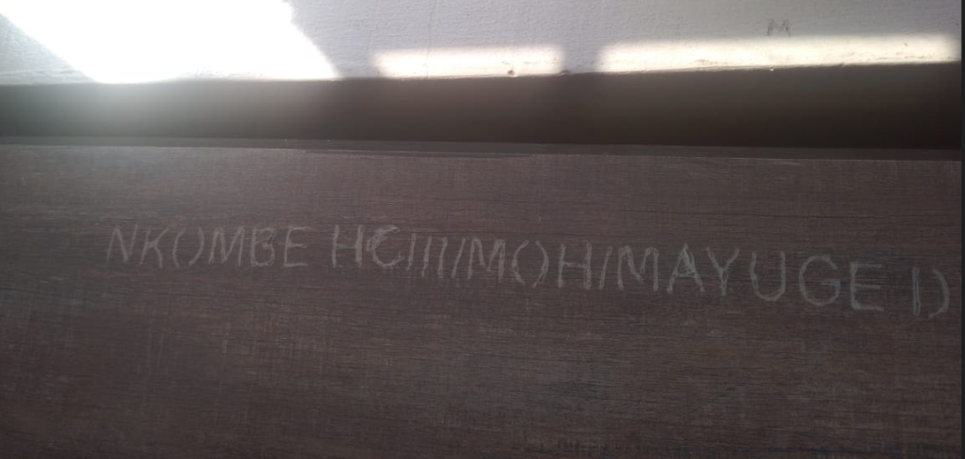
MAIN BLOCK WITH 2 TANKS BEHIND IT  (1 ONE GROUND AND THE OTHER RAISED ON METALLIC STANDS) | 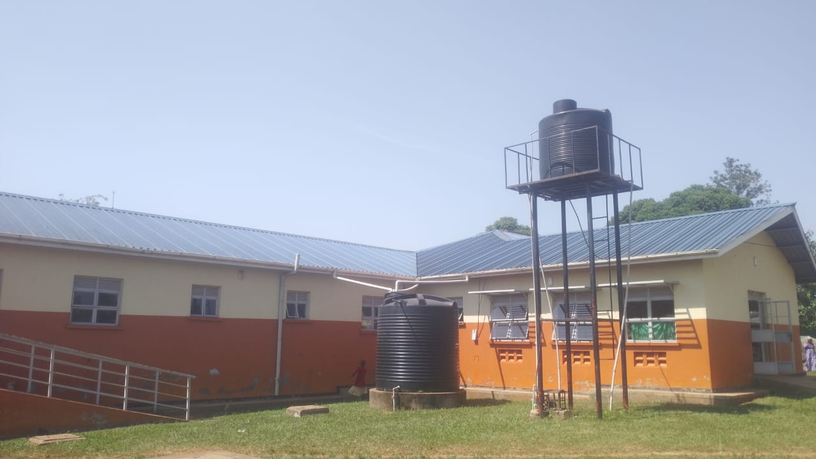
STAFF QUARTERS  ENGRAVED(STAFF QUARTERS) | 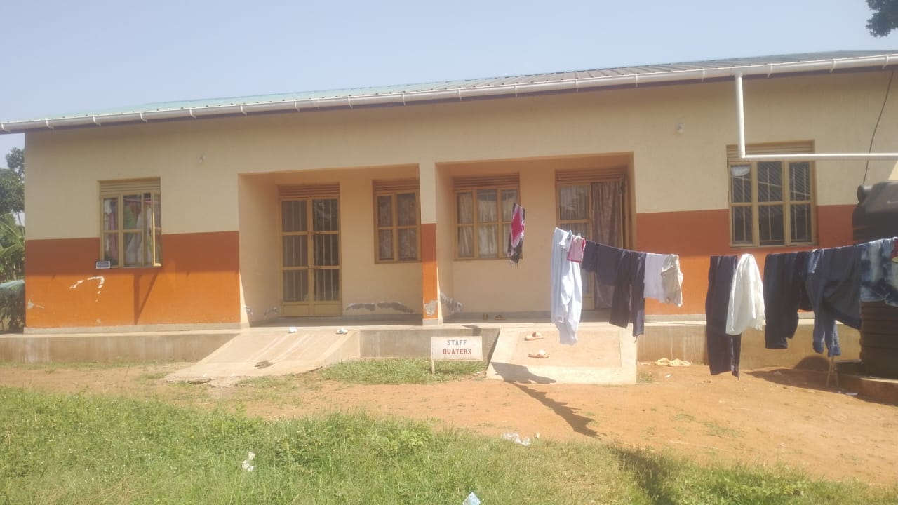

4 STANCE LATRINES ENGRAVED (ABAKYALA, ABAMI) | 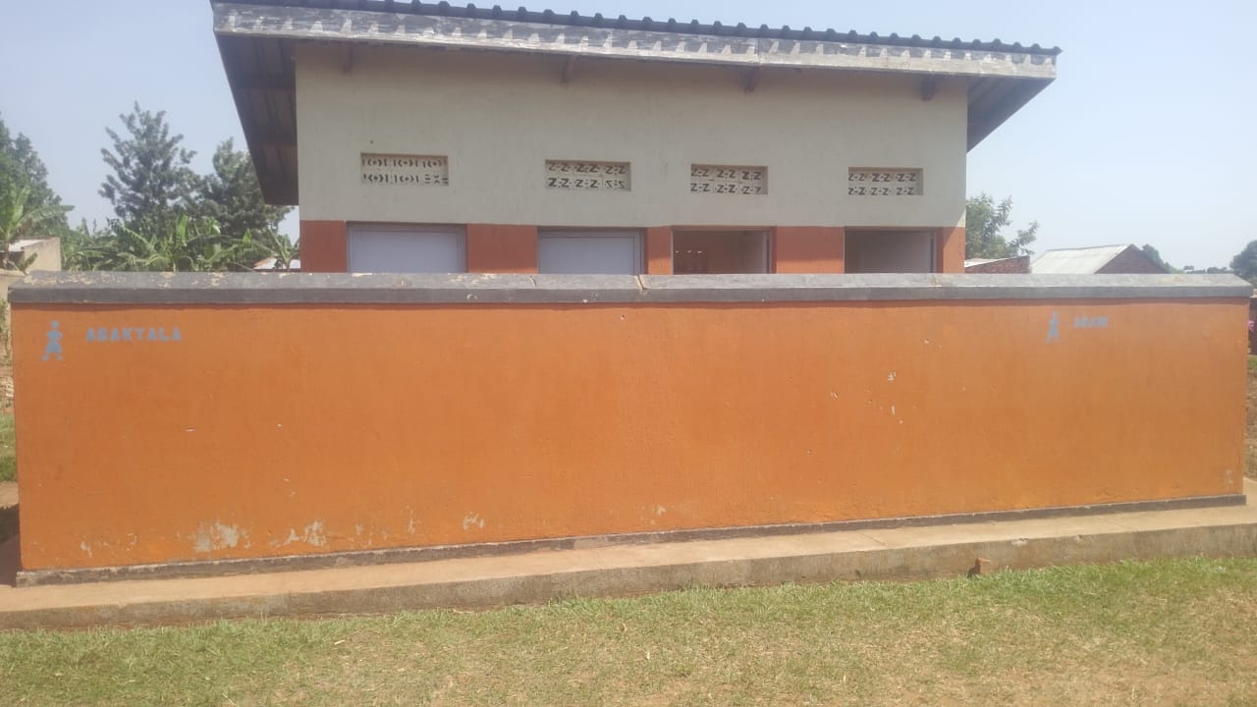
METALLI WASTE BINS | 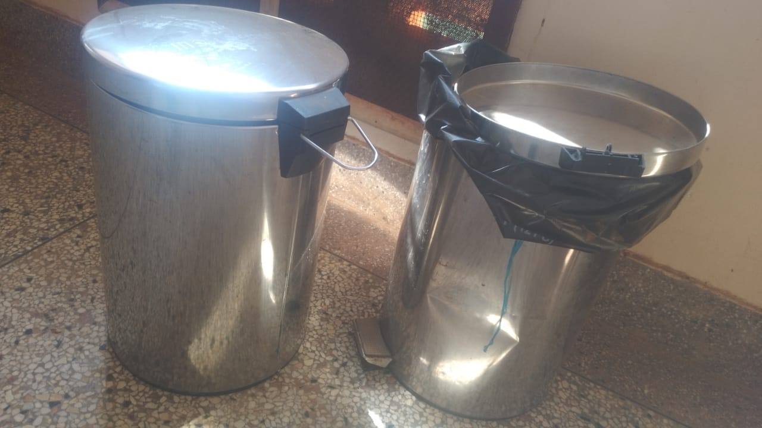
NKOMBE HEALTH CENTRE III STORE | 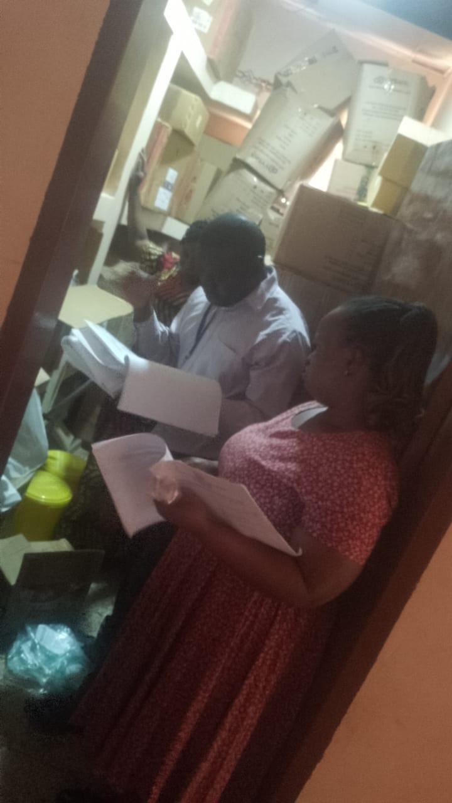
METALLIC FILLING CABINET | 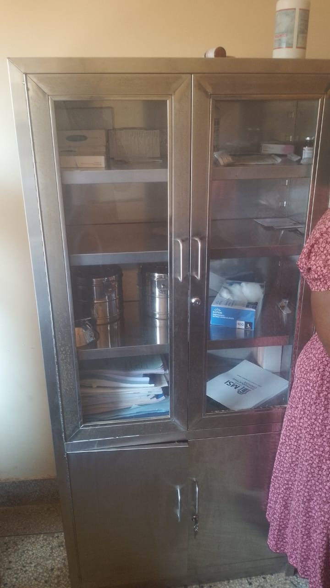
NON ENGRAVED  EXAMINATION LIGHT | 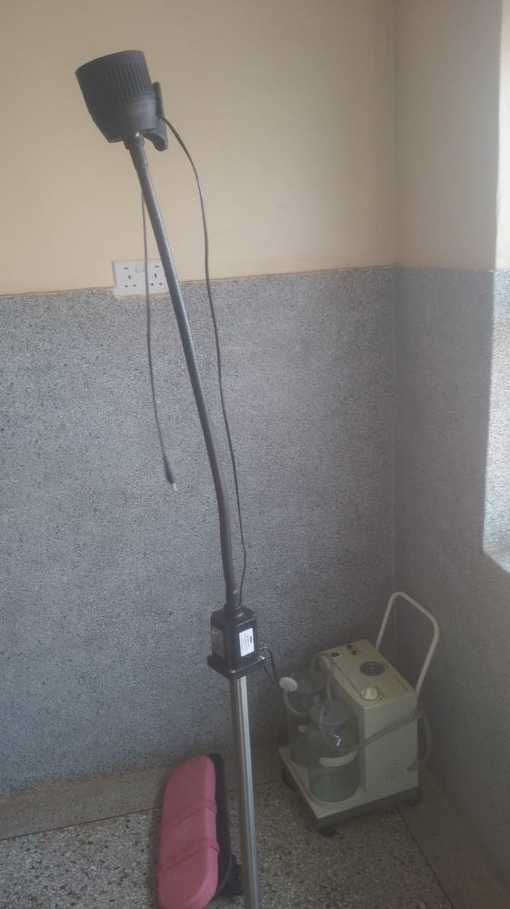
WELL ENGRAVED AND FUNCTIONING SUNCTION APPARATUS  “ ENGRAVED NKOMBE HCIII” AT THE TOP | 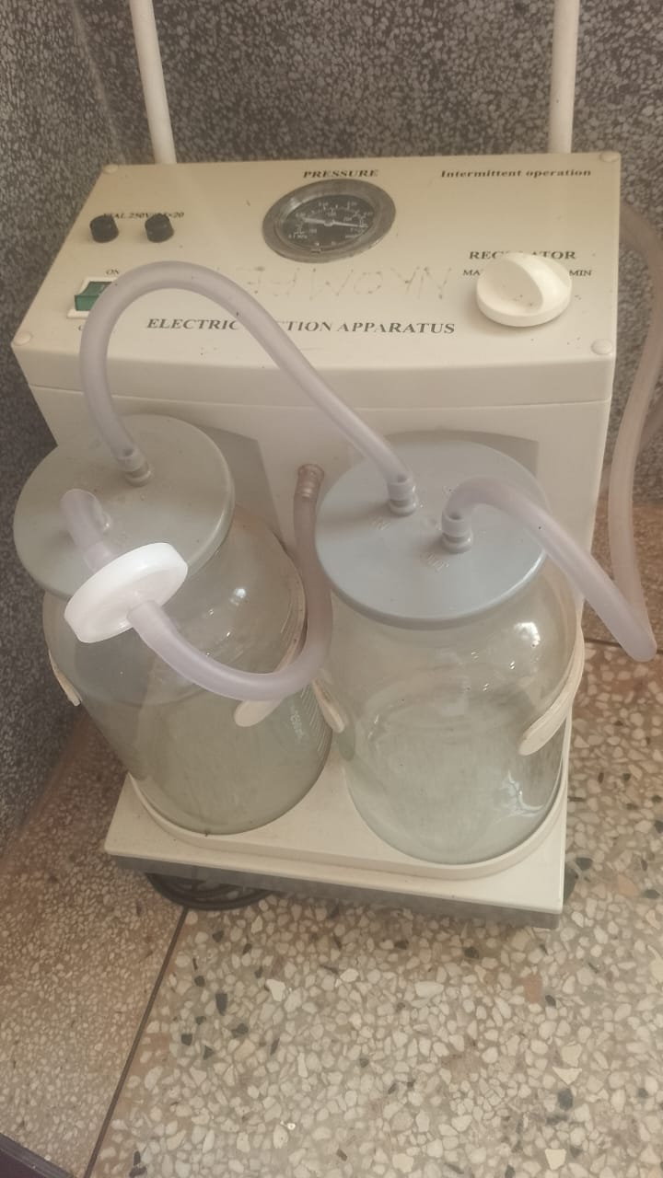
CUPBOARD ENGRAVED  (NKOMBE HCIII/MOH/MAYUGE DLG) |  | 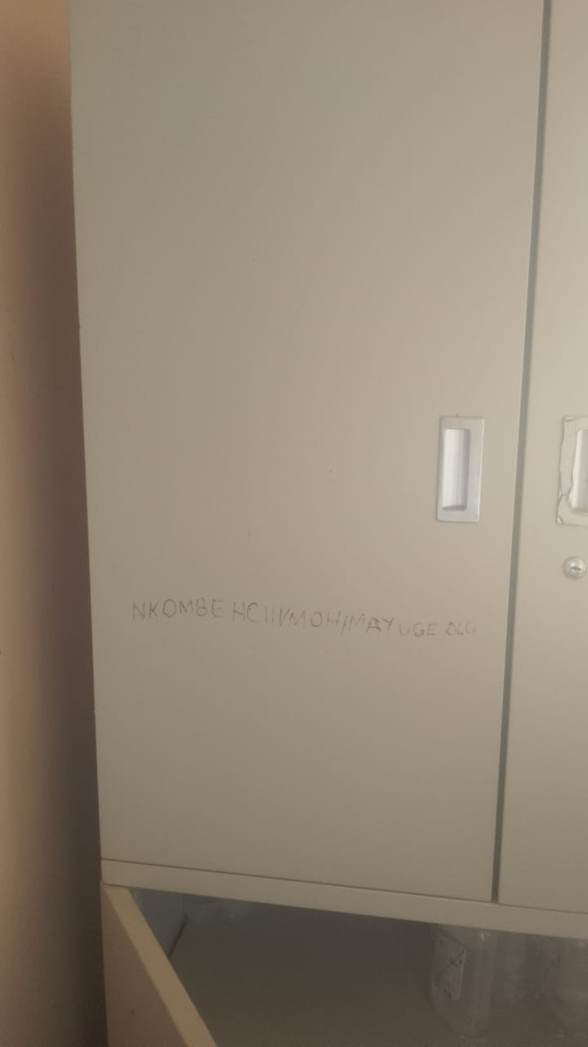
A SAMPLE OF THE RECEIVED PATIENT SCREEN |  | 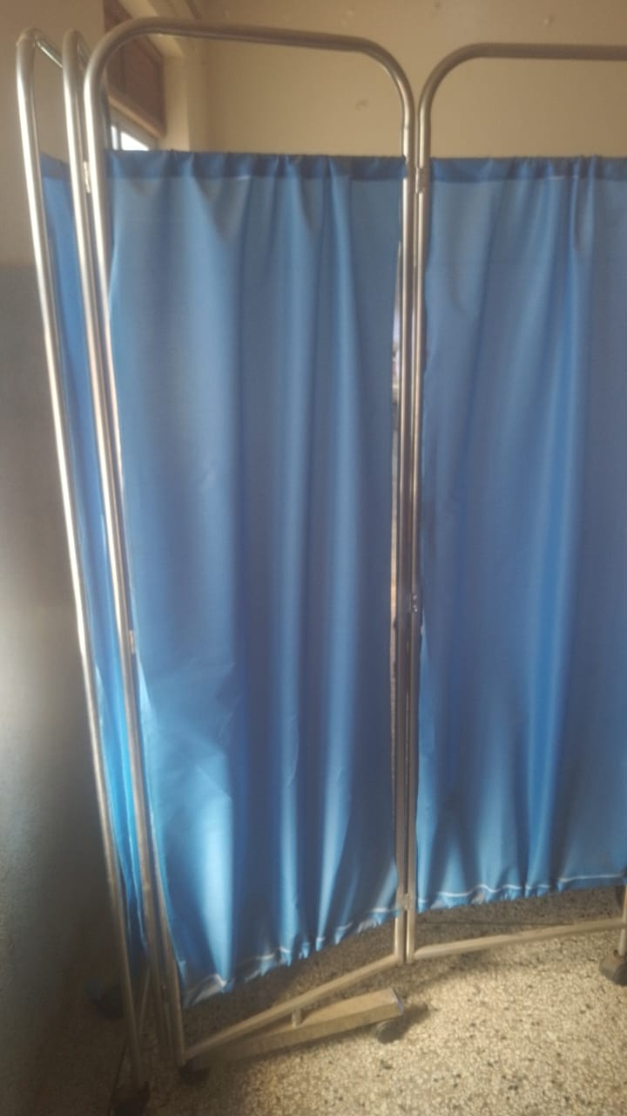
A DOUBLE BOWL STAND  NOT ENGRAVED |  | 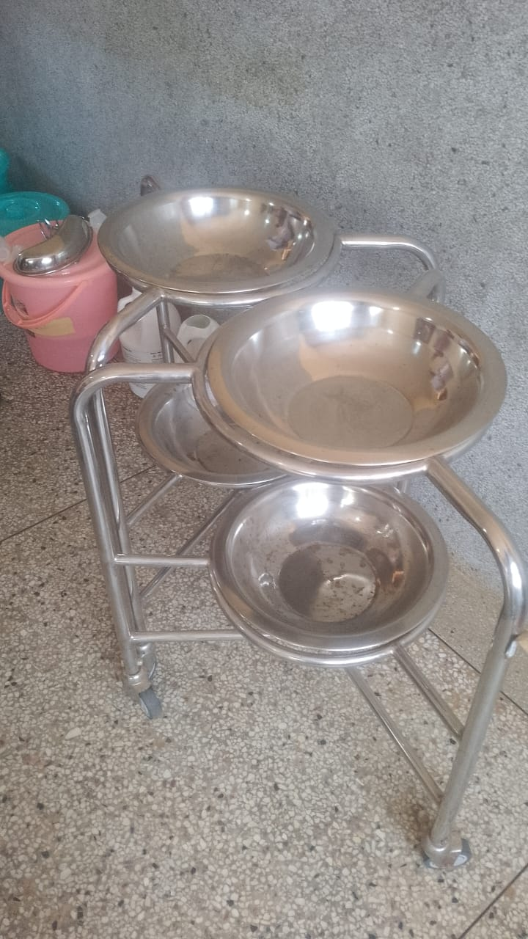
DVD ENGRAVED  NKOMBE HCIII |  | 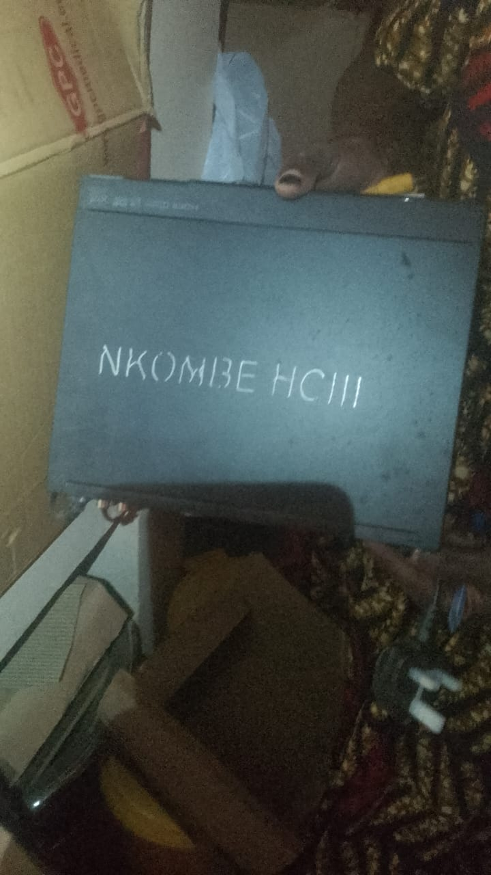
WELL ENGRAVED WALL CLOCKS. ENGRAVED NKOMBE HCIII |  | 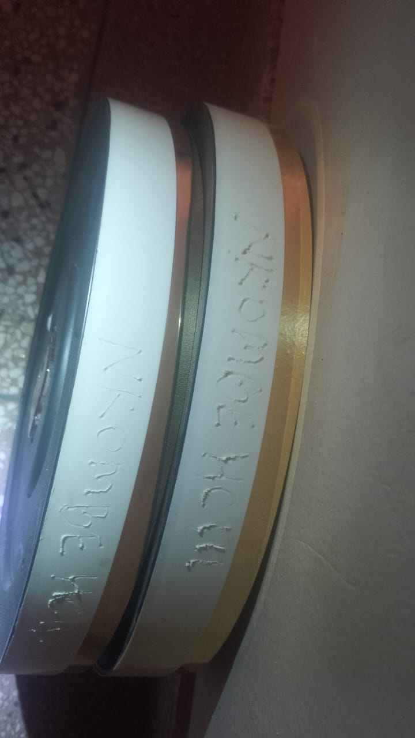
DIAGNOSTIC EQUIPEMENT FOR MCH  NOT ENGRAVED  AND NOT IN USE |  | 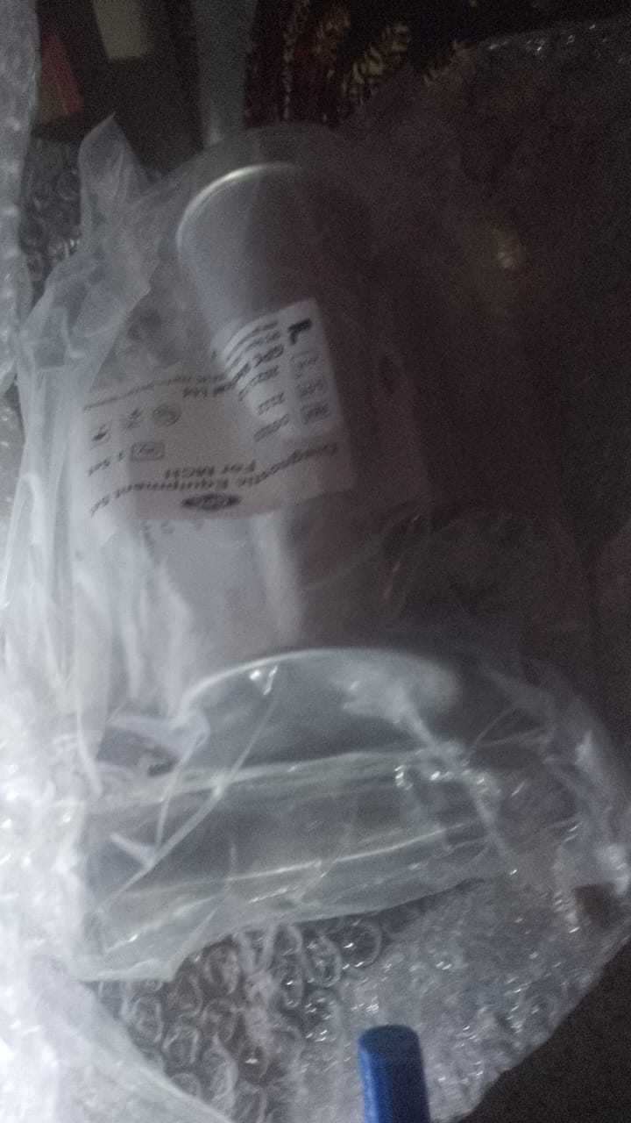
WELL ENGRAVED PEDIATRIC BEDS  ENGRAVED  NKOMBE HCIII/MOH/MAYUGE DLG) |  | 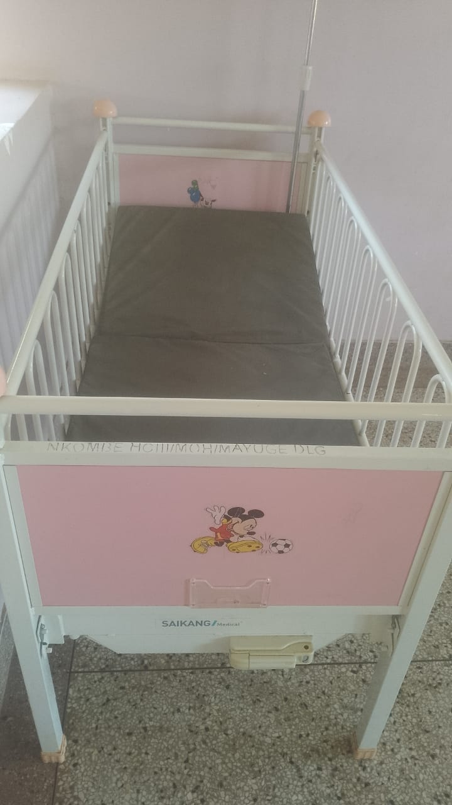
DELIVERY BED.  ENGRAVED NKOMBE HCIII/MOH/MAYUGE DLG) |  | 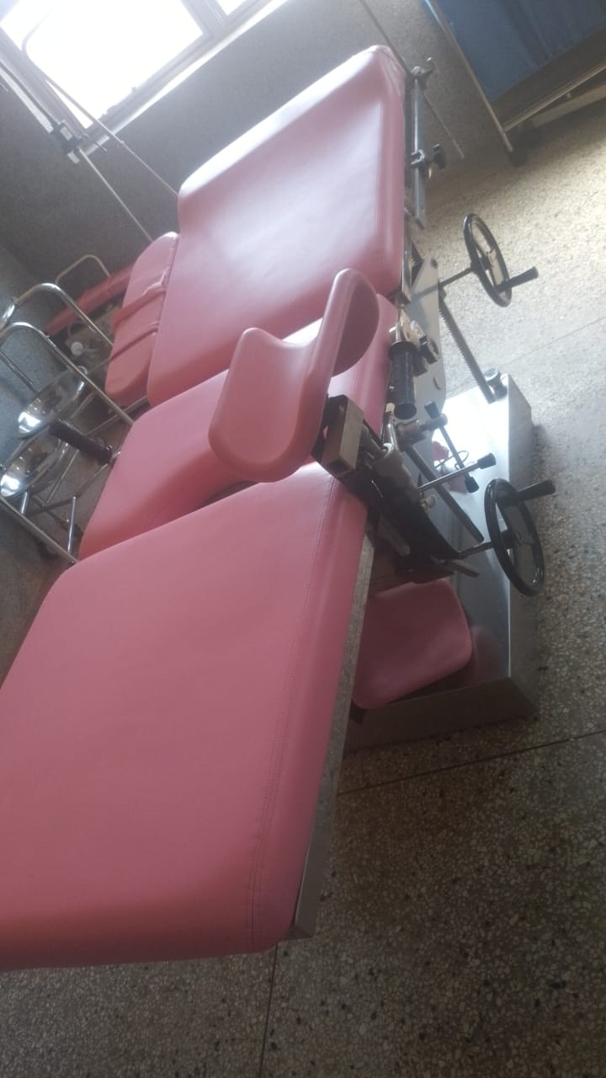
A SAMPLE OF THE BABY COTS  NOT ENGRAVED |  | 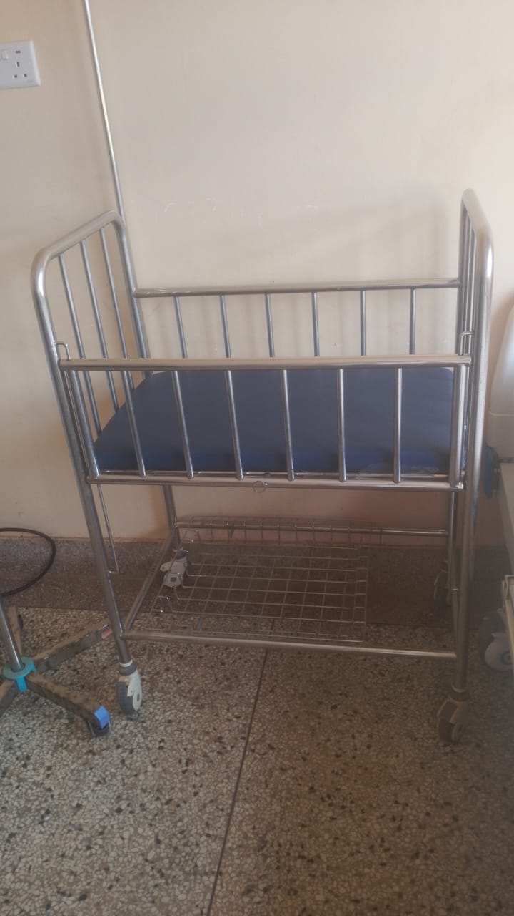
EXAMINATION BED |  | 