
CONSULTANCY SERVICES TO VERIFY AND RECORD ASSETS UNDER THE UGIFT PROGRAMME
REF: MOFPED/UGIFT/CONS/25/26/00015
ASSET VERIFICATION REPORT
SUBMITTED BY:

Plot 31, Bukoto Street
P.O Box 7657, Kampala, Uganda
+256 (0) 39 2000216/0772525235
email: cpa@cpa.ug
www.cpa.com
6 October 2026
Financial reporting date 30 September 2026

Table of Contents
Executive summary 5
Priority actions 6
1 Introduction and background 7
1.1 Introduction 7
1.2 Background to the verification 7
1.3 Justification 8
1.4 Objectives of the assignment 8
1.5 Scope of Work 9
1.6 Expected deliverables 9
2 Approach and methodology 10
2.1 Preparation 10
2.2 Pilot Test 10
2.3 Data collection 10
2.4 Quality assurance 11
2.5 Asset categories, condition, use and identification 11
2.6 Financial analysis and Valuation 11
2.7 Analysis and reporting 11
2.8 Challenges and Limitations to the assignment 11
3 Findings 13
3.1 Overall results 13
3.2 National level Ministries and Agencies results 22
3.3 MDA specific results 23
3.3.1 Ministry of Finance, Planning and Economic Development 23
3.3.2 Ministry of Works and Transport 24
3.3.3 Ministry of Education and Sports 25
3.3.4 Ministry of Agriculture, Animal Industry and Fisheries 27
3.3.5 Ministry of Health 28
3.3.6 Office of the Prime Minister 29
3.3.7 Ministry of Water and Environment 30
3.3.8 Ministry of Gender, Labour and Social Development 31
3.3.9 National Environment Management Authority 32
3.3.10 Public Procurement and Disposal of Public Assets Authority 32
3.3.11 Office of the Auditor General (OAG) 33
3.3.12 Ministry of Local Government 34
3.3.13 Ministry of Lands, Housing and Urban Development 35
3.4 Results from blood banks 37
3.4.1 Arua Regional Blood Bank 37
3.4.2 Hoima Regional Blood Bank 38
3.4.3 Soroti Regional Blood Bank 39
3.5 Local Government level results 41
3.6 Health Centres 41
3.6.1 Availability of the assets 41
3.6.2 Asset condition and functionality 42
3.6.3 Asset marking and Identification 44
3.7 Seed Secondary Schools 47
3.7.1 Availability of the assets 47
3.7.2 Asset condition and functionality 48
3.7.3 Asset marking and Identification 48
3.8 Financial Value of school assets 49
3.9 Completion Status of Facilities 50
3.10 Field Observations, 52
3.11 Location and Name changes 52
3.12 UgIFT support to service delivery 53
3.12.1 Gaps and Challenges 53
4 Asset management 55
4.1 Maintenance and repairs 55
4.2 Obsolete and Unserviceable Assets 56
4.3 Missing and Unrecorded Assets 56
5 Recommendations 58
5.1 Actions to address the reported service gaps 59
Appendices 60
Appendix A Financial reconciliation and valuation limitations 60
Extent of existing cost estimates 61
Appendix B Service date exceptions and supporting evidence 61
Rules for an approved register correction 62
Appendix C Definitions used in the analysis 63
Principal references 64
Appendix D Programme list exception roster 64
Appendix E Documented outstanding works and handover 66
Appendix F Facility interview scope and denominators 71
Appendix G Asset reconciliation examples 71
Appendix H Photographic schedule 72
Appendix I Land records and ownership evidence 75
Appendix J Additional assets and classification checks 76
Appendix K Financial analysis by asset type 77
MoFPED 77
MoWT 79
MoES 79
MAAIF 80
MoH 81
OPM 81
MoWE 81
MoGLSD 82
NEMA 82
PPDA 83
OAG 83
MoLG 84
MoLHUD 84
Arua Regional Blood Bank 84
Hoima Regional Blood Bank 86
Soroti Regional Blood Bank 87
Health centres 88
Schools 90

List of acronyms
GOU Government of Uganda
HC Health centre
ICT Information and communications technology
IFMIS Integrated Financial Management Information System
KCCA Kampala Capital City Authority
LGFC Local Government Finance Commission
MAAIF Ministry of Agriculture, Animal Industry and Fisheries
MDA Ministry, department or agency
MoDVA Ministry of Defence and Veteran Affairs
MoES Ministry of Education and Sports
MOES Ministry of Education and Sports (as engraved)
MoFPED Ministry of Finance, Planning and Economic Development
MoGLSD Ministry of Gender, Labour and Social Development
MoH Ministry of Health
MOH Ministry of Health (as engraved)
MoLG Ministry of Local Government
MoLHUD Ministry of Lands, Housing and Urban Development
MoPS Ministry of Public Service
MoWE Ministry of Water and Environment
MoWT Ministry of Works and Transport
NEMA National Environment Management Authority
OAG Office of the Auditor General
OPM Office of the Prime Minister
PforR Program-for-Results
PPDA Public Procurement and Disposal of Public Assets Authority
RCU Reform Coordination Unit
TELA Teacher Effectiveness and Learner Assessment
UBTS Uganda Blood Transfusion Services
UgIFT Uganda Intergovernmental Fiscal Transfer
UGX Uganda shillings
UPS Uninterruptible power supply

Executive summary
The findings show a substantial stock of UgIFT assets supporting health care and secondary education, alongside equipment and buildings requiring attention. Facilities reported improvements in their services, but unfinished works, equipment out of use and weaknesses in asset identification limit the benefits. The report sets out the action needed to maintain the assets, complete outstanding works and resolve errors in the financial and custody records.
A total of 229,024 asset records were identified. Schools account for 145,256 and Health Centres for 63,432. A further 16,663 relate to ministries and agencies, 602 to regional blood banks, 3,067 to hospitals under local governments and four to other local-government locations. The total includes items whose receipt, classification or programme assignment still requires confirmation. These cases must be resolved before the full population can be certified as physically verified UgIFT assets.
Overall, 215,504 items (94.1%) are classified Functional and 13,520 (5.9%) Faulty, with the same numbers recorded as in use and out of use, respectively. Reasons for non-use include lack of power, unfinished buildings, missing parts and insufficient training. These require different responses. Usable tag details are unavailable for 178,695 items, making identification and custody checks a substantial task.
Facilities reported improvements in services following UgIFT support. Of 284 health-centre respondents, 238 (83.8%) reported at least one benefit, including improved maternity services, access to care and use of equipment. Of 193 school respondents, 144 (74.6%) reported benefits such as better learning conditions and access to secondary education. These are the facilities’ accounts of changes in their services; the exercise did not measure how much of each change was caused by the programme.
The programme list contains 629 distinct facility entries. Supporting returns account for 590, while 39 have discrepancies requiring reconciliation. The reviewed evidence identifies at least 70 facilities with incomplete works and 13 others awaiting handover or commissioning. Some facilities were operating while particular buildings or supporting structures remained unfinished. Completion, handover and readiness for use therefore need to be confirmed separately.

Priority actions
MoFPED and the responsible institutions should first confirm when assets were placed in service. Of 201,066 full service dates, 3,345 precede programme approval on 27 June 2017. A further 27,958 entries contain partial dates or text, which cannot be accepted as exact service dates. The review also found 787 purchase dates later than the recorded service date. These findings overlap. Each affected date should be checked against receipt, acceptance or commissioning records, together with the asset’s ownership and programme assignment.
Where a full service date cannot be supported, retain the reported period or status in the supporting records and leave the exact-date field blank until it is confirmed. A purchase date or the programme start date should not be used to fill the gap. Approve supported corrections before migration to IFMIS and recalculate depreciation and net book value where the corrected dates affect them.
Available recorded costs total UGX 996.813 billion, with costs missing for 1,086 records. Net book value remains unresolved for 23,016 records. For the 180,730 recognized records with complete accounting figures, cost of UGX 760.987 billion less accumulated depreciation of UGX 165.185 billion gives a net book value of UGX 595.802 billion at 30 September 2026. Net book value is the recorded cost remaining after depreciation; it does not measure the asset’s market value or physical condition.
Cost evidence also needs review. Costs for 166,593 items were estimated by comparison with similar assets. These account for 82.44% of available recorded cost. Of 298 construction-in-progress entries, 275 have zero cost and four have no cost recorded. The recorded amounts therefore cannot establish the full value of unfinished works. Obtain the supporting expenditure or valuation records, resolve missing amounts and approve changes before treating the balances as a verified programme valuation.
Facility managers, local governments and the responsible ministries should give priority to essential equipment, reliable power and water, user training and outstanding buildings. Keep an action list naming the item or facility, the responsible officer and the agreed completion date. Assess faulty items for repair, replacement or disposal, and review the 22,161 fully depreciated records still marked in use. Reconcile delivery, transfer and custody records before concluding that an asset is missing. The recommendations and appendices provide the specific cases and follow-up required.

1 Introduction and background

1.1 Introduction
This report presents the findings of the UgIFT asset verification undertaken by the Ministry of Finance, Planning and Economic Development as part of programme closure activities. It sets out the status of the assets provided by the programme to the targeted national institutions responsible for supporting the implementation of the programme, Blood Banks and local governments specifically targeting Seed Secondary Schools and health facilities upgraded from Health Centre II to Health Centre III.

1.2 Background to the verification
The Uganda Intergovernmental Fiscal Transfers (UgIFT) Programme is a government programme implemented through a Programme-for-Results (PforR) launched and aligned with the broader IGFT Reform Programme (2015). UgIFT 1.0 began with US$200 million in FY2017/18, supporting Education and Health. This was later expanded through additional financing of US$300 million, including US$240 million in credit and US$60 million in grants, with US$50 million from the IDA Refugee Support Window, expanding beyond Education and Health to water and Environment and Agriculture (micro-scale irrigation) making the overall funding total of US$500 million.
The Intergovernmental Fiscal Transfer Reform Programme (IGFT RP) was revised in 2020 to align with the Third National Development Plan (NDP III 2020/21 - 2024/25), and to directly contribute to Four (04) Programmes i.e. Human Capital Development; Public Sector Transformation; Natural Resources, Environment, Climate change, Land and Water Management; and Development Plan Implementation.
Overall, the development objective of the UgIFT Programme was to: “Improve the adequacy, equity, and effectiveness of financing and the oversight, management, and delivery of Local Government services in Education, Health, Water and Environment, and Agriculture (micro-scale irrigation), including refugees and their host communities”.
Specifically, the Programme sought to:
- Increase the adequacy and predictability of fiscal transfers to Local Governments for service delivery;
- Improve the equity and transparency of allocation mechanisms through the introduction of formula-based transfers;
- Strengthen performance incentives and accountability systems for Local Governments; and
- Expand access to quality education and health infrastructure, particularly in under-served areas.
The UgIFT Programme had four components aimed at strengthening the intergovernmental fiscal transfer system while supporting investments in service delivery infrastructure. These included;
Component 1: Reform of the Intergovernmental Fiscal Transfer System
This supported the design and implementation of a reformed fiscal transfer framework based on objective and transparent allocation criteria. This resulted into introduction of formula-based grants - Revised allocation formulas reflecting population, infrastructure gaps, and service delivery needs.
Component 2: Education Infrastructure Development
This component financed the construction and upgrading of education facilities, particularly government secondary schools in under-served sub-counties. This involved construction and equipping of new secondary schools - classrooms, laboratories, administration blocks, sanitation facilities, teachers’ houses, furniture and ICT equipment in the different local governments.
Component 3: Health Infrastructure Development
This supported investments in health facilities to improve access to primary health care services at the local level. The major outputs under the component were construction and upgrading of health centers - Staff accommodation, sanitation facilities and provision of medical equipment.
Component 4: Local Government Performance and Institutional Strengthening
This aimed at strengthening LG capacity in planning, budgeting, procurement, and infrastructure management. Under this component, annual Local Government Performance Assessments have been undertaken across the 176 LGs, capacity building and technical support strengthened monitoring and reporting systems.
The Programme was implemented through a clearly defined results framework that connected actions and incentives across three levels of government to strengthen service delivery outcomes. The programme came to an end on 31 December 2025. The following areas of support describe the following outputs under the different components; current asset and facility findings are presented later in this report.
- Budget Support
- Education: 196 of 259 Seed Secondary Schools are complete of which 189 are operational.
- Health: 354 of 373 health facilities, upgrades/new constructions (HC II to HC III) are complete.
- Water and Environment: 758 - piped water systems, 5,398- point water sources, 7,082 water supply systems rehabilitated, 325 designs completed, and 256 sanitation facilities in the targeted service units.
- Agriculture (Micro-scale Irrigation): Over 6,235 irrigation systems were installed (4,843 hectares under irrigation), 632 irrigation demonstration sites in 135 LGs set up.
- Refugee intervention: 51 primary schools and 35 health facilities in refugee hosting districts (RHD) were transitioned and integrated into the LG service.
- Blood Banks: Regional Blood Banks in Arua and Hoima were completed and commissioned while Soroti Regional Blood Bank was rehabilitated.
2. Grant management
Assets for institutional strengthening and retooling including ICT equipment and vehicles were provided. The Ministry of Finance, Planning and Economic Development (MoFPED) through PFM Coordination Unit (RCU) manages the Government of Uganda counterpart funding of the programme to support the grant management component of the UgIFT programme. The grant management supports in financing of Central Government actions intended to achieve programme objectives and Disbursement Linked Indicators (DLIs). To this end, MoFPED through RCU supported MDAs to acquire different assets meant to support programme implementation.

1.3 Justification
The UgIFT programme came to an end on 31st December 2025. As part of the programme’s closure activities, MoFPED, through RCU, commissioned an end-of-programme asset verification exercise to take stock of the assets procured under the programme and to establish where those assets were, how they were being used as part of the processes to hand them over to government for sustainability purposes.

1.4 Objectives of the assignment
The objective of the assignment was to undertake verification and recording of all assets acquired under the UgIFT Programme. Specifically, the assignment intended to;
- Identify and verify the existence of the assets
- Verify the assets condition and status: specifically, the condition on functionality, usage/performance and location among others
- Assess financial management aspects: residual value of the investments/hardware/tools for purposes of financial reporting for project closure
- List the assets that are obsolete, unserviceable and require disposal
- Develop a computerized database of the investment/hardware/tools to facilitate recording of new deployed assets/investments.
- Undertake PFM Assessment on Asset Management practices (including sustainability, Operations and Maintenance) of the UgIFT implementing LGs

1.5 Scope of Work
The assignment covered institutions at national and local government level that directly implemented the UgIFT programme through coordination, support and implementation. At local government level, the study focused on upgraded health facilities and Seed Secondary Schools that received assets under the programme. Health Centers and other local-government assets are also reported separately.
Specifically, the assignment involved the following tasks;
- Verification of the Asset’s Records of targeted ministries departments and agencies and local governments
- Physical and Functional Verification of assets
- Data Consolidation for generation of a single data base of assets provided by the program
- Generation of an IFMIS ready Asset Register for Integration, and Migration into IFMIS
- Review of the UgIFT Asset Management Practices

1.6 Expected deliverables
Key expected outputs of the consultant include:
- Report with the list and current status of assets acquired under the programmes;
- An automated up-to-date assets data base of UgIFT Investments across MDALGs;
- Report on the estimated value of assets under the programme as well as operations and maintenance arrangements;
- IFMIS-Ready Asset Register and Data Migration Report
- Report on functionality of assets relating to systems investments;
- Report on Assessment of Asset Management Practices, Risks and recommendations.

2 Approach and methodology
The verification exercise was conducted using a participatory and consultative process and implemented in three interlinked phases: Preparatory and inception phase, Data collection phase and the report writing phase.

2.1 Preparation
After signing of the contract, the assignment commenced with an entry meeting on 28th May 2026. During this meeting, the Client specified target MDAs to be visited, the LG stakeholders to be reached as well as the documents to be reviewed. The Inception phase was completed and the inception report submitted on 18th June, 2026 which provided an agreed scope, approach and work plan for the exercise.

2.2 Pilot Test
The team also undertook a pilot test in Wakiso District Local Government, with verification carried out at Buloba Health Centre III and Sumbwe Seed Secondary School. During the pilot test, it was found out that, among others, there are cases of mismatches of facility names, that UgIFT assets can be integrated into the general LG asset register. This facilitated improving the design of the data collection process including; design of data collection tools, determining the timeline for data collection and estimated costs.

2.3 Data collection
This exercise was undertaken in two phases first at National level and later at the Local government level.
National level: Physical visits to verify assets provided by the programme at the national-level was completed on the 19th of August 2026. This covered 15 MDAs including; Ministry of Works and Transport (MoWT); Ministry of Education and Sports (MoES); Ministry of Agriculture, Animal Industries and Fisheries (MAAIF); Ministry of Health (MoH); Office of the Prime Minister (OPM); Ministry of Water and Environment (MoWE); Ministry of Gender, Labour and Social Development (MoGLSD); Local Government Finance Commission; National Environment Management Authority (NEMA); Public Procurement and Disposal of Assets Authority (PPDA); Office of the Auditor General (OAG); Ministry of Public Service (MoPs); Ministry of Lands, Housing and Urban Development (MoLHUD); Ministry of Local Government (MoLG) and Ministry of Finance, Planning and Economic Development (MoFPED). Additionally, three Blood Banks of Hoima, Arua and Soroti were covered.
Local government level: The local government verification targeted UgIFT upgraded or constructed Health Centres and Seed Secondary Schools. The programme reconciliation list contains 629 distinct entries: 371 Health Centres and 258 schools under 160 recorded local government names. The process began with training of field teams prior to the actual field verification.
Training of field teams: A total of 85 Research Assistants (RAs) and 7 Regional Supervisors were trained. The training took place from 21st to 23rd August 2026 while physical verification started on the 24th of August 2026. During the asset verification, the RAs visited Seed Secondary Schools, Health Centres and Blood Banks.
Physical verification: This exercise commenced on the 24th of August 2026 and was completed on 17th September 2026. The local government physical verification involved entry meetings with the LG leadership at the LG headquarters for authorization and review of reports relating to UgIFT assets, key informant interviews with the technical teams especially the Chief Administrative Officers, Finance Officers, District Health Officers and District Education Officers. Thereafter, the RAs proceeded to the facilities for physical verification of the assets.
At local government level, the programme list had 629 facilities: 371 Health Centres and 258 Seed Secondary Schools. The list recorded 547 facilities (87.0%) as complete and 82 (13.0%) as ongoing. The ongoing works were more common among Seed Secondary Schools (63, or 24.4%) than among Health Centres (19, or 5.1%).

2.4 Quality assurance
Regional supervisors checked daily field activity and reviewed the completed tools. The central technical team carried out spot checks and helped resolve operational questions. Teams compared institutional asset information with the items and explanations provided during visits, while supervisors referred matters requiring clarification to the team leader and field coordinator.

2.5 Asset categories, condition, use and identification
Asset categories: Each entry in the Asset Register represents one recorded unit. The analysis covers buildings, ICT equipment, transport equipment, furniture and fittings, medical, laboratory and research equipment, other classified assets, items outside fixed-asset classification and unclassified entries. Assets are grouped by the institution or beneficiary to which they are attributed.
Condition and use: Condition and use were reported for each asset during the verification. A working asset is one recorded as functional and in use. An asset recorded as faulty was reported as not working and not in use. This included assets that were broken down or damaged. An asset that was new and in store was recorded as functional but not in use. Additionally, an asset that was held elsewhere, not yet delivered or awaiting power installation, completion of buildings or trained users, was also recorded as functional but not in use.
Identification: An asset is properly identified when carried a UgIFT programme marking. However, there were other assets that had no UgIFT marking but the officers on ground identified them as UgIFT assets.

2.6 Financial analysis and Valuation
The Government of Uganda Asset Accounting Policies and Guidelines 2023 was used to determine as the policy basis for determining recorded values, depreciation and net book values. Financial values are reported as at 30th September 2026. Straight-line depreciation was applied where the required information was available.

2.7 Analysis and reporting
Analysis and reporting was done through triangulation of the literature from different policy, Planning and Financial documents including: Government of Uganda Asset Accounting Policies and Guidelines 2023; asset registers; asset records at national and local government levels; physical inspections; discussions with facility managers; photographs and asset counts for each institution.

2.8 Challenges and Limitations to the assignment
- Difficult terrain and poor physical accessibility of facilities: Physical accessibility presented a significant operational challenge especially for facilities located in areas characterised by difficult terrain and limited transport accessibility such as Bwesumbu HC III, Bwesumbu Seed School, Buhuhira and Kabingo in Kasese District. In addition, accessing facilities within the Island was difficult, time consuming and expensive. This led the teams to overshoot the anticipated time for data collection.
- High transportation cost: Given the national wide coverage, the rising fuel prices led to high field costs. The field teams spent more money than was anticipated. The costs were extra ordinarily higher for island facilities like Kalangala, Buvuma, Mayuge among others. For instance, Kalangala had 3 facilities with long distance on water that required hiring a private boat since it was not a common route to the transporters and outside the ferry schedules. A similar situation was encountered in Buvuma and Namayingo districts.
- Poor record keeping: In many LGs and facilities, there were no clear records about the assets delivered under UgIFT. The LGs and the facilities had incomplete or missing UgIFT asset registers which delayed data collection. Subsequently, the teams took longer in such facilities identifying the assets as most of these were not engraved with the UgIFT identifiers while others were not engraved at all. In addition, the field teams encountered situations where some Assets could not be physically accessed especially for schools since it was holiday time.

3 Findings
This section presents results of the verification exercise based on the specific objectives. The results are presented in different results levels indicating availability of assets, asset condition and functionality, asset marking and identification and the financial analysis in each subsection.

3.1 Overall results
This section provides an overall view of the UgFT asset status combining both National level agencies and schools and health centres.
- Overall asset availability
A total of 228,800 assets are recorded across the targeted MDAs, beneficiary Blood Banks, Upgraded Health Centres and Seed Secondary School. These include vehicles, laptops, printers, desktop computers, projectors, cameras, furniture (desks, chairs, tables and stools), UPS systems, digital phones, paper shredders, tablets and clinical equipment, among others.
Overall, the Seed Secondary Schools hold the majority of assets 63.4% (145,256), followed by Health Centres with 27.7% (63,432). MDAs hold 7.3% (16,663) and regional Blood Banks with 0.3% (602). In addition, some assets were found to have been reallocated by LGs from Health Center to hospitals such as Rukoki general hospital in Kasese Municipality. Hospitals hold 3,067 assets (1.3%) and other local-government locations hold four (less than 0.1%).

Figure 1: Distribution of assets
Source: Primary data analysis
- Overall asset Condition and functionality
Overall, 215,280 assets constituting 94.1% were classified as functional and in use, while 13,504 (5.9%) were classified as faulty and out of use. The detailed analysis of asset condition is indicated in table 1.
Table 1: Overall condition of UgIFT assets and functionality
Institution | No. of Assets | Functional |  | Faulty and not in use | % functional
Institution | No. of Assets | In use | In store | Faulty and not in use | % functional
MoFPED | 458 | 458 | 0 | 0 | 100.0%
MoWT | 87 | 71 | 16 | 160 | 100.0%
MoES | 10,783 | 10,783 | 0 | 0 | 100.0%
MAAIF | 2,045 | 2,045 | 0 | 0 | 100.0%
MoH | 51 | 50 | 0 | 1 | 98.0%
OPM | 10 | 7 | 0 | 3 | 70.0%
MoWE | 2,939 | 2,939 | 0 | 0 | 100.0%
MoGLSD | 10 | 10 | 0 | 0 | 100.0%
NEMA | 6 | 6 | 0 | 0 | 100.0%
PPDA | 5 | 5 | 0 | 0 | 100.0%
OAG | 20 | 20 | 0 | 0 | 100.0%
MoLG | 13 | 13 | 0 | 0 | 100.0%
MoLHUD | 12 | 12 | 0 | 0 | 100.0%
Health centres | 63,432 | 57,759 | 0 | 5,673 | 91.1%
Seed Secondary Schools | 145,256 | 137,465 | 0 | 7,791 | 94.6%
Blood Banks | 602 | 578 | 0 | 24 | 96.0%
Hospitals on LG books | 3,067 | 3,055 | 0 | 12 | 99.6%
Other LG locations | 4 | 4 | 0 | 0 | 100.0%
Total | 228,800 | 215,280 | 16 | 13,504 | 94.1%
Source: Primary data analysis
As indicated in table 1 above, most of the deployed assets were already in service while some were in store and still in good condition but not in use. This was attributed mainly to some localized challenges such as power, incomplete structures, untrained staff, among others. Some assets were broken mainly furniture in Seed Secondary Schools and require repair.
Verification also noted that 13,520 assets, mainly in seed secondary schools and Health Centres, were classified as faulty and out of use. Some were awaiting installation or the facility itself was not yet ready. Notable among the facilities include Lungulu Seed Secondary School in Nwoya District where desktop computers, a printer and UPS units were still boxed because the school was waiting for power connection. At Nansanga Seed Secondary School in Budaka, 27 of 28 desktop computers remained packed for lack of reliable power.
Figure 2 shows the reasons for non-deployment of some of the assets even when they were found to be in good condition.

Figure 2: Reasons for equipment not in use reported by facilities (156 respondents; multiple responses)
Source: Primary data analysis
In addition, broken desks and stools were in classrooms and stores at Seed schools in Namisindwa and Napak. At Arua Regional Blood Bank, six blood pressure machines were recorded as damaged or not functional. The information above is depicted in some of the photos presented below.
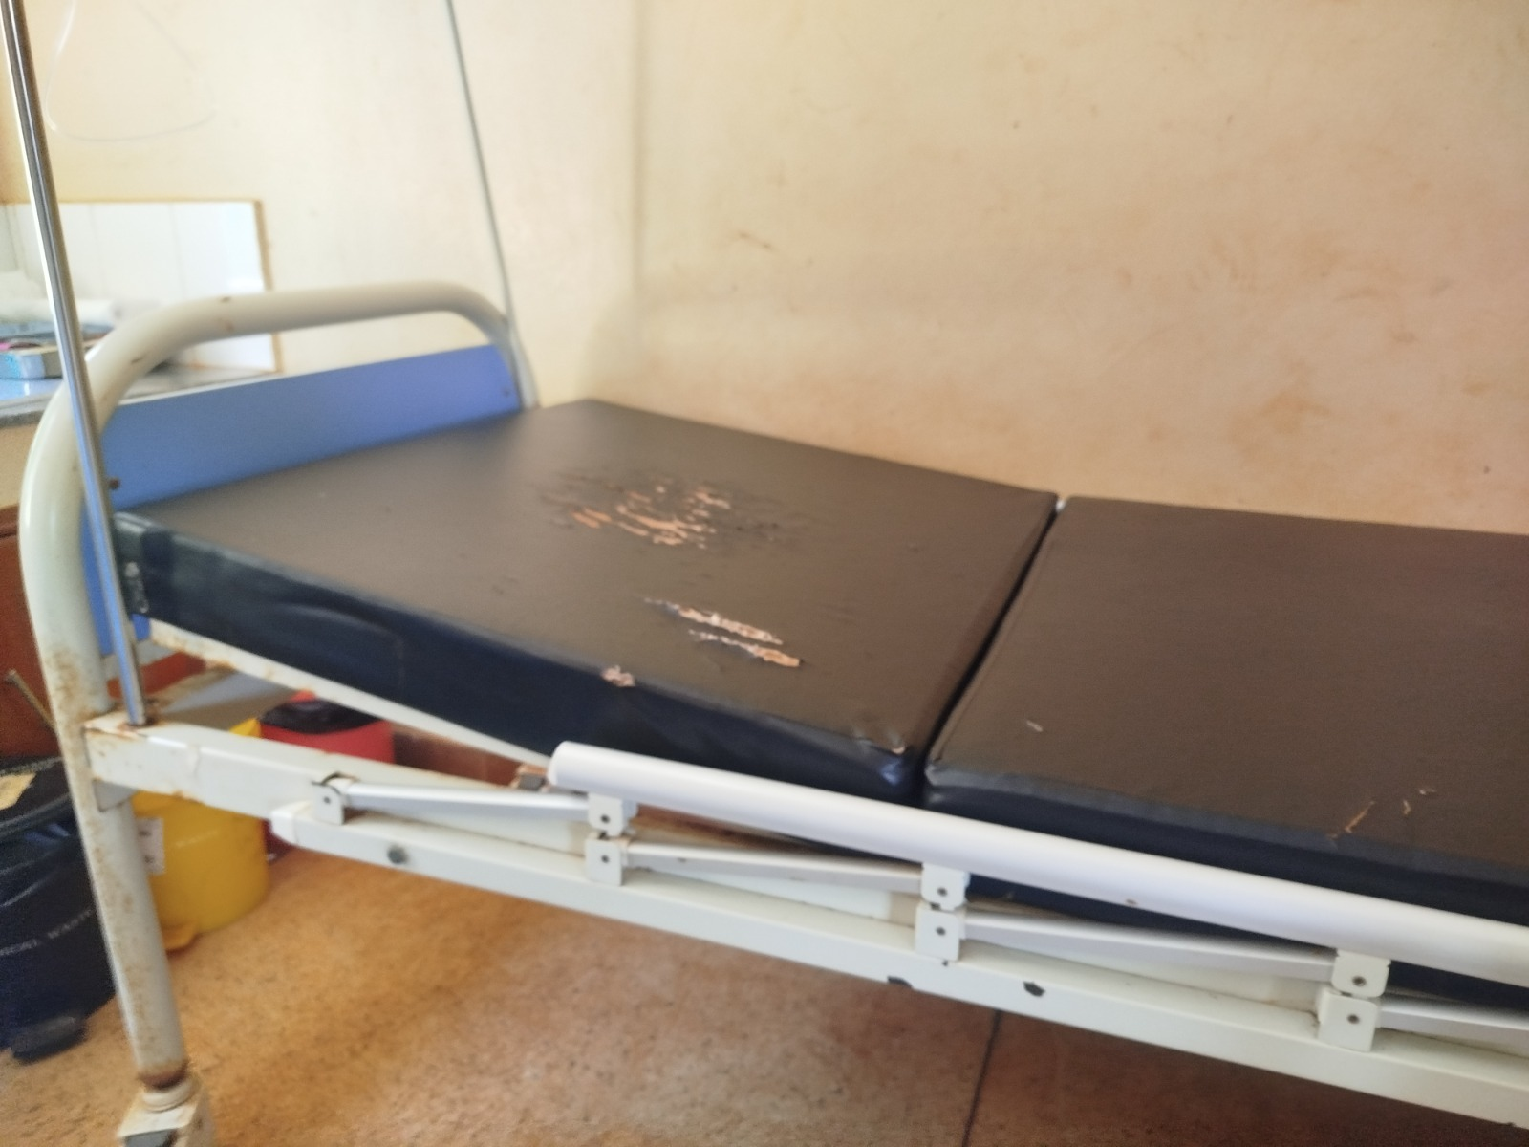 | 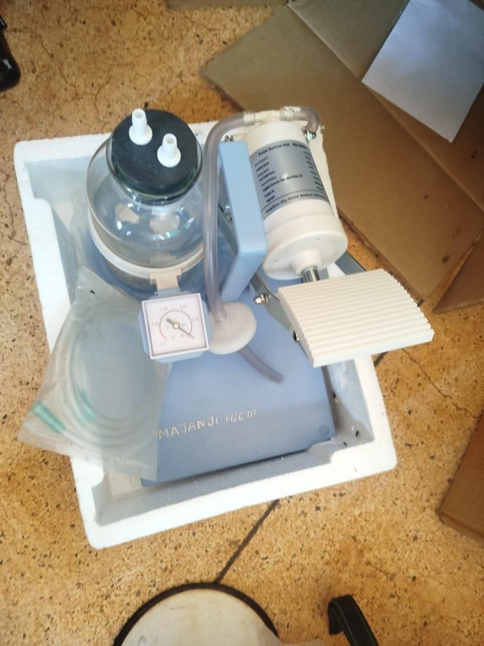
Delivery bed with a torn mattress cover at a health centre, Busia District (Bukedi) | Pedal suction unit marked MAJANJI H/C III still in its packing, recorded as not in use for lack of technical knowledge, Majanji Health Centre III, Busia District (Bukedi)
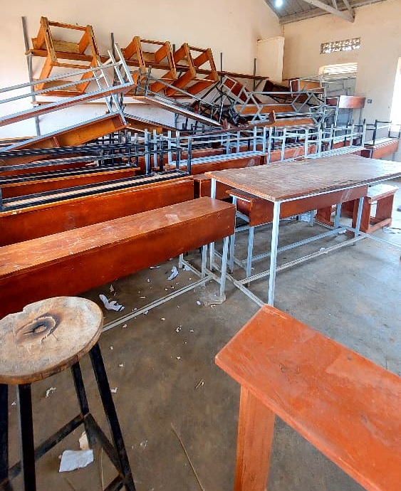 | 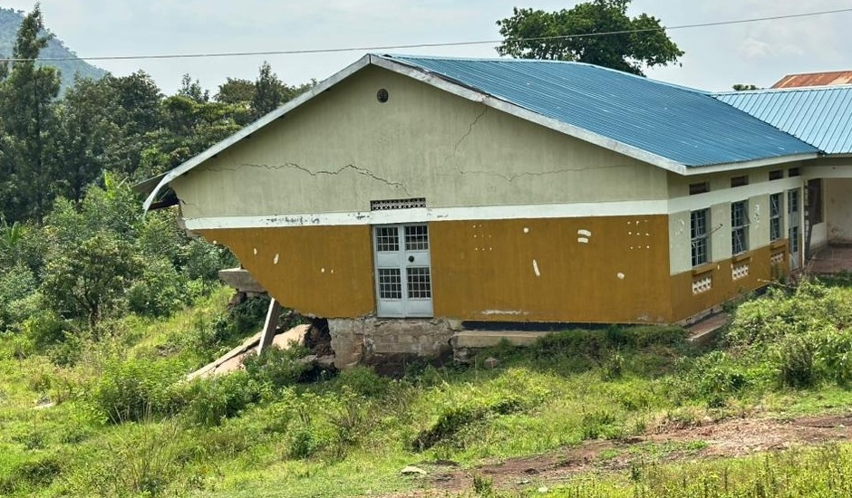
Stacked desks, chairs and stools, some recorded as broken and none engraved, at Napak Seed Secondary School, Napak District (Karamoja) | Cracked health centre block above collapsed ground, Bulambuli District (Bugisu)
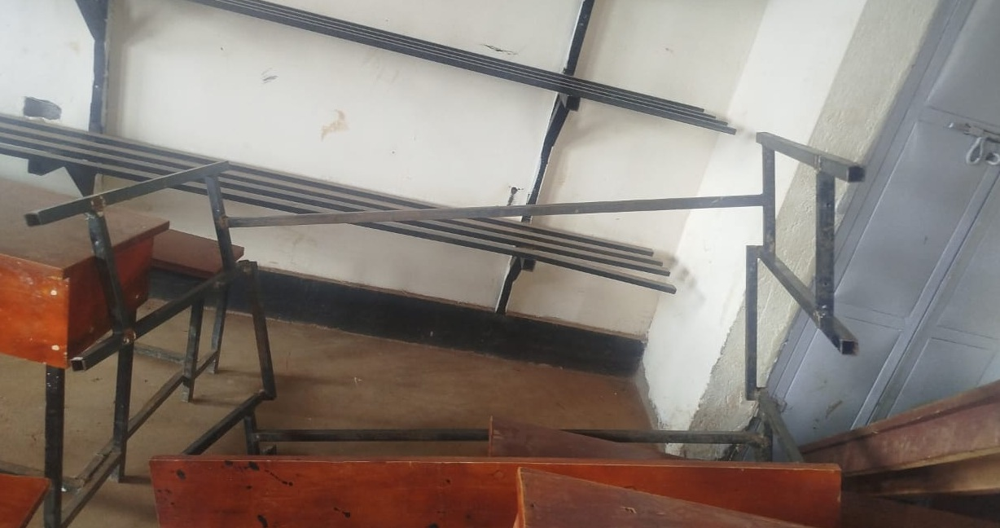 | 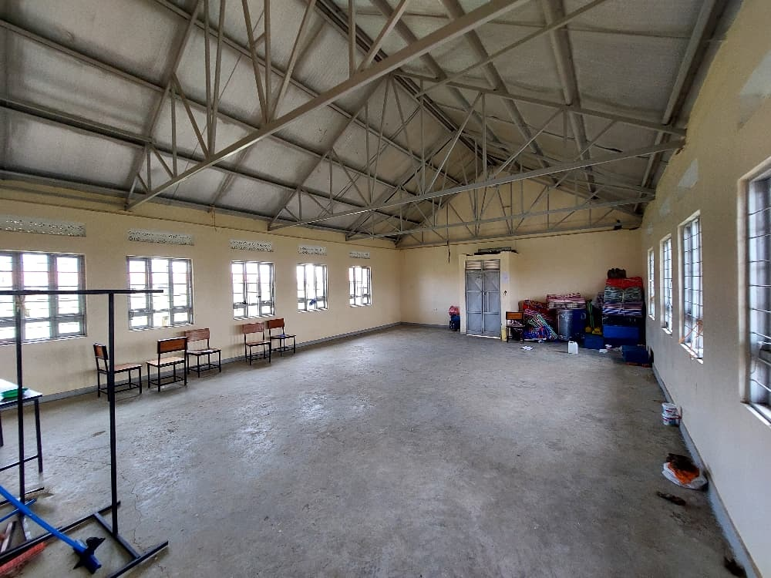
Broken desk frame at a seed secondary school, Namisindwa District (Bugisu) | Empty ICT and library block with a few chairs and items kept in one corner at Iriiri Seed Secondary School, Napak District (Karamoja), not yet in use while the school remained with the contractor
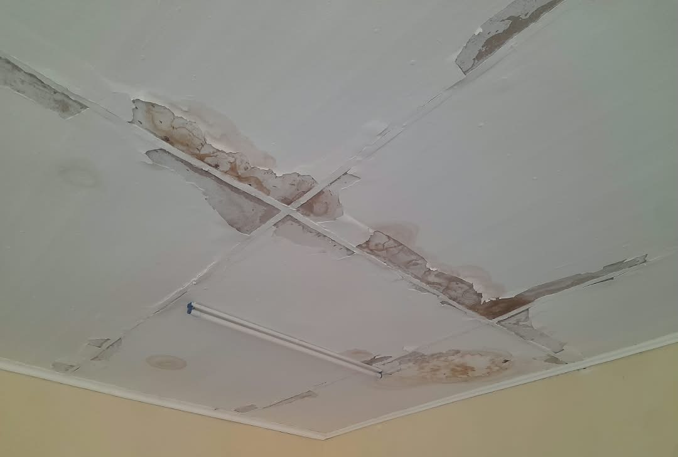 | 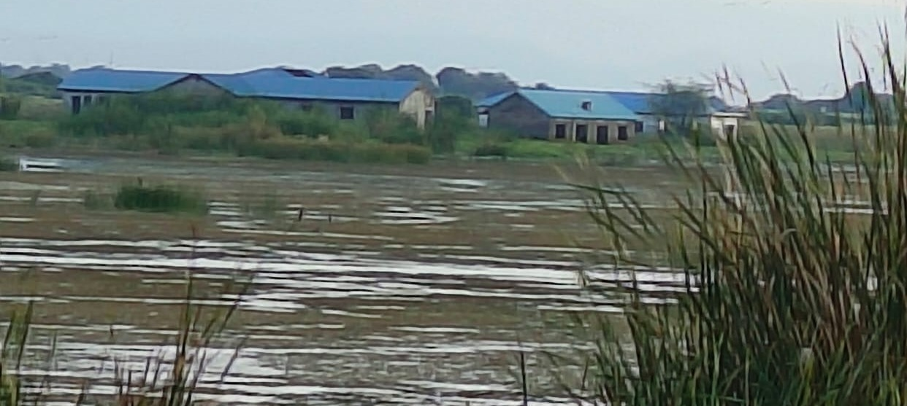
Stained and peeling ceiling at a health centre, Sironko District (Bugisu) | Flood-affected older health facility at Butiaba, Buliisa District (Bunyoro)
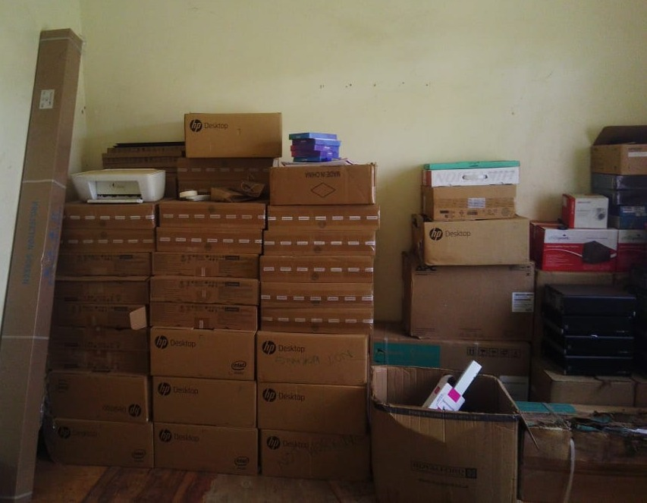 | 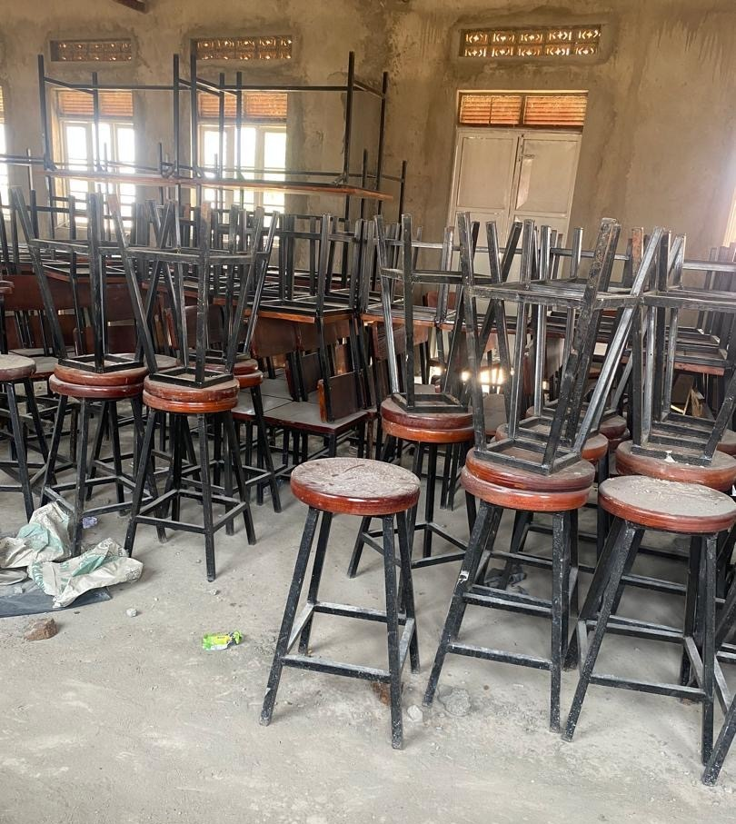
Desktop computers, a printer and UPS units still boxed in the store at Lungulu Seed Secondary School, Nwoya District (Acholi), awaiting a power connection for installation | Laboratory stools and desks stored and not yet in use at Butungama Seed Secondary School, Ntoroko District (Tooro), where the school buildings were still under construction
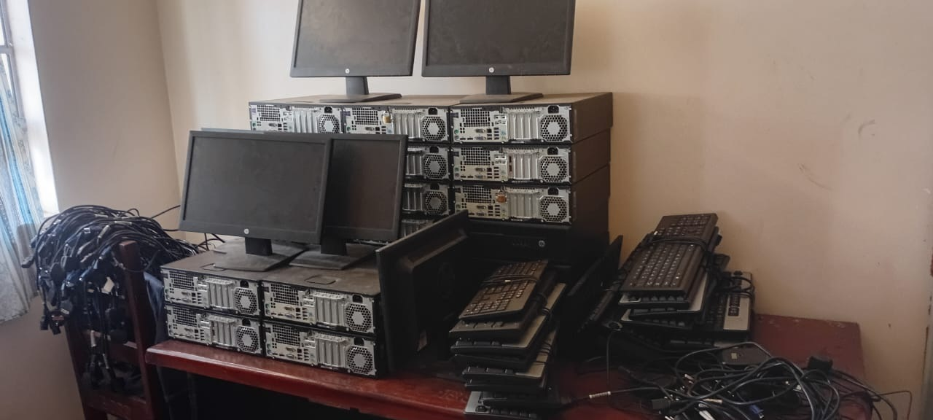 | 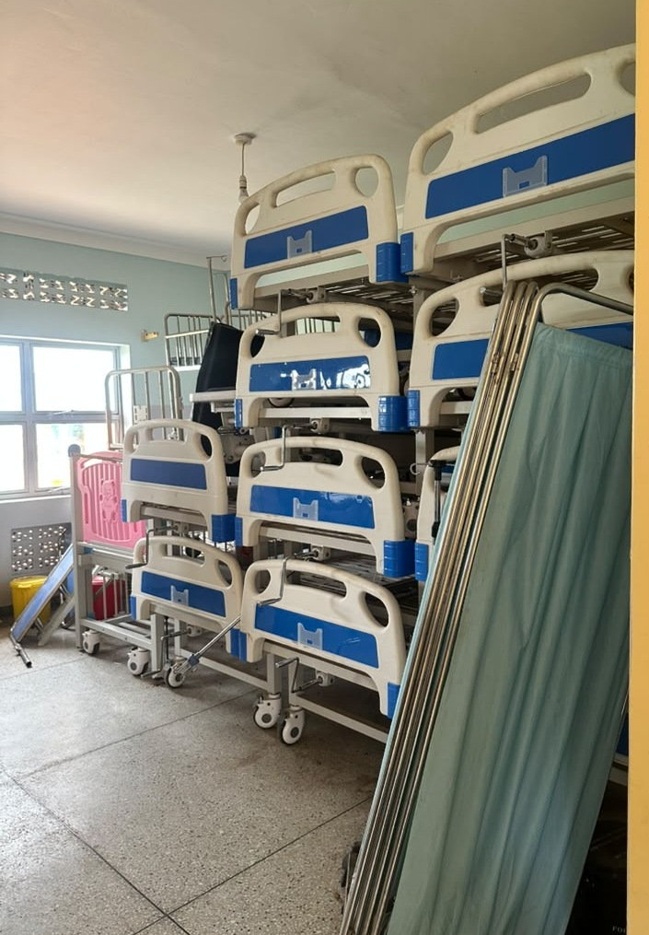
HP computer sets stacked in store with cables still bundled and not installed at Bumufuni Seed Secondary School, Bulambuli District (Bugisu) | beds and screens stacked in storage at a health centre, Kagadi District (Bunyoro)
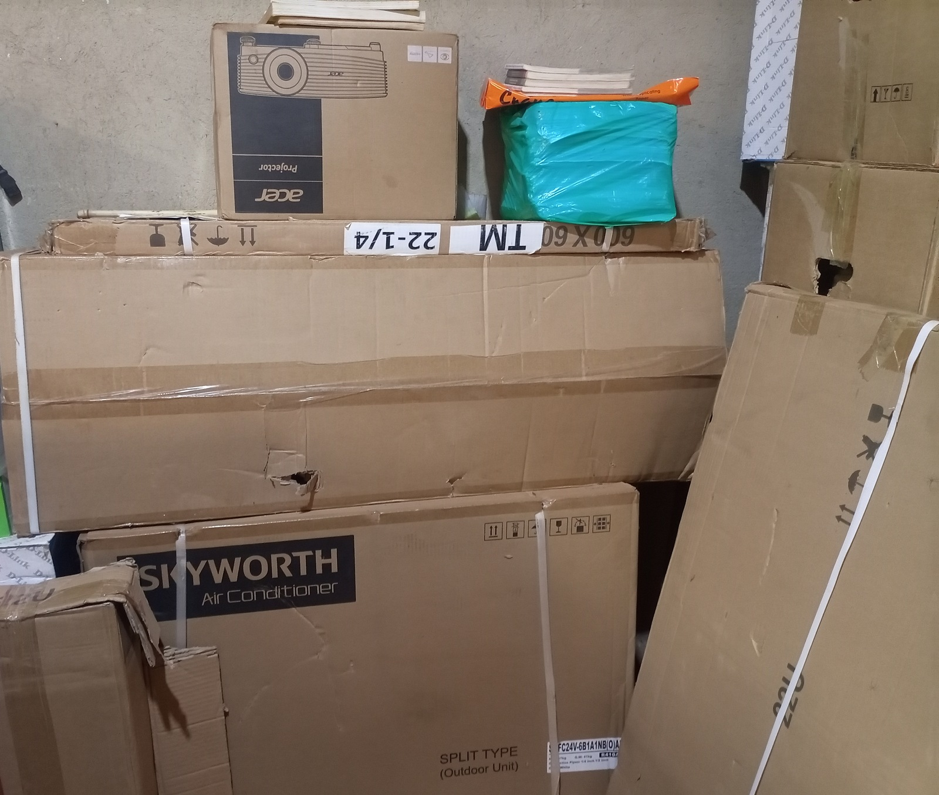 | 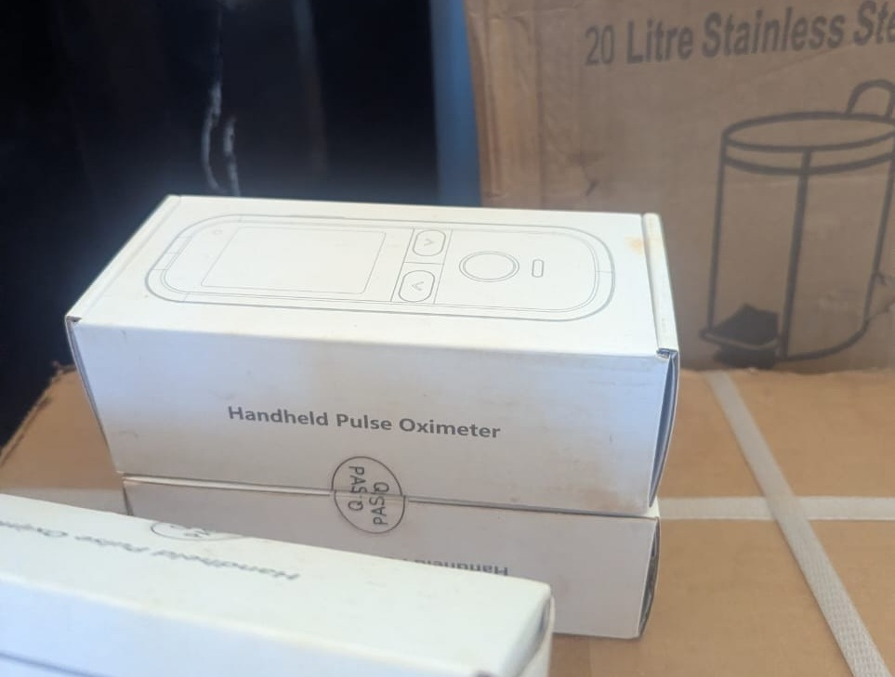
Boxed projector, air conditioner and other equipment in store at King Solomon Seed Secondary School, Kagadi District (Bunyoro), kept boxed because the school was still under construction | Boxed handheld pulse oximeters at Kibiri Health Centre III, Makindye-Ssabagabo Municipal Council (Buganda), where equipment was still being arranged after the facility opened on 31 August 2026

- Asset Marking and Identification
The verification revealed that 50,329 (22.0%) of the assets had usable identifiers and 178,695 (78.0%) had no usable identifier recorded. Of all assets, 22,253 (9.7%) had identifiers containing UgIFT or UGFT as a form of identification.
Identification varied at the different asset locations. Identifiers are recorded for 30.3% of MDA records, 24.5% of school records and 15.0% of health-centre records. Among the MDAs, the Ministry of Education and Sports accounts for most of the ministry assets without usable identifiers, and these were mainly the TELA handsets and tablets. The details of asset identification are provided in figure 3.

Figure 3: Asset marking and Identification
Below are some of the photos depicting the different markings and identification engravements of assets across the institutions
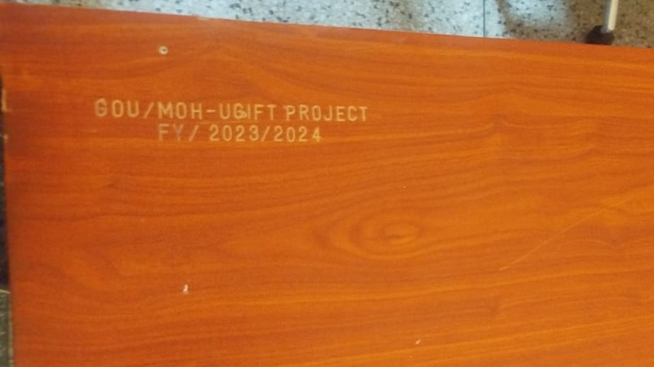 | 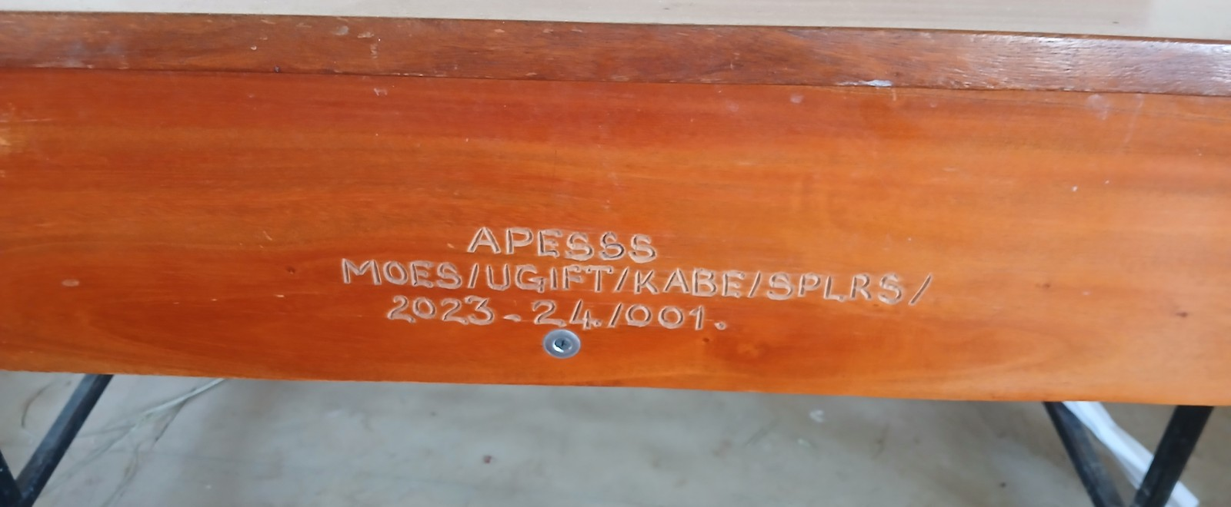
Engraving reading GOU/MOH-UGIFT PROJECT FY/2023/2024 on a desk at Namwaya Health Centre III, Tororo District | Engraving reading APESSS MOES/UGIFT/KABE/SPLRS/2023-24/001 on a desk at Aperikira Seed Secondary School, Kaberamaido District
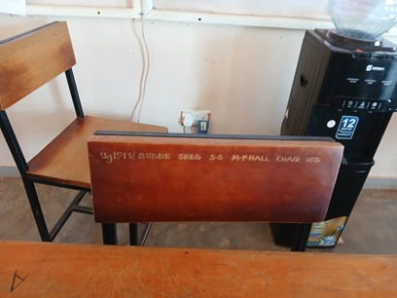 | 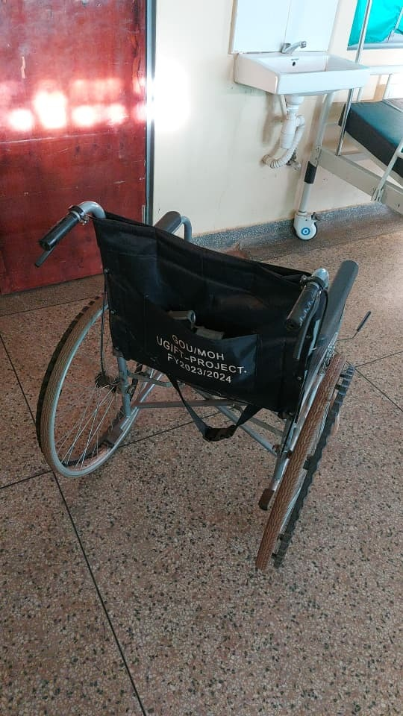
Chair engraved UgIFT/ BUDDE SEED S.S M-PHALL CHAIR with a serial number at Budde Seed Secondary School, Butambala District | Wheelchair backrest marked GOU/MOH UGIFT-PROJECT. FY2023/2024 at Kalemungole Health Centre III, Moroto District
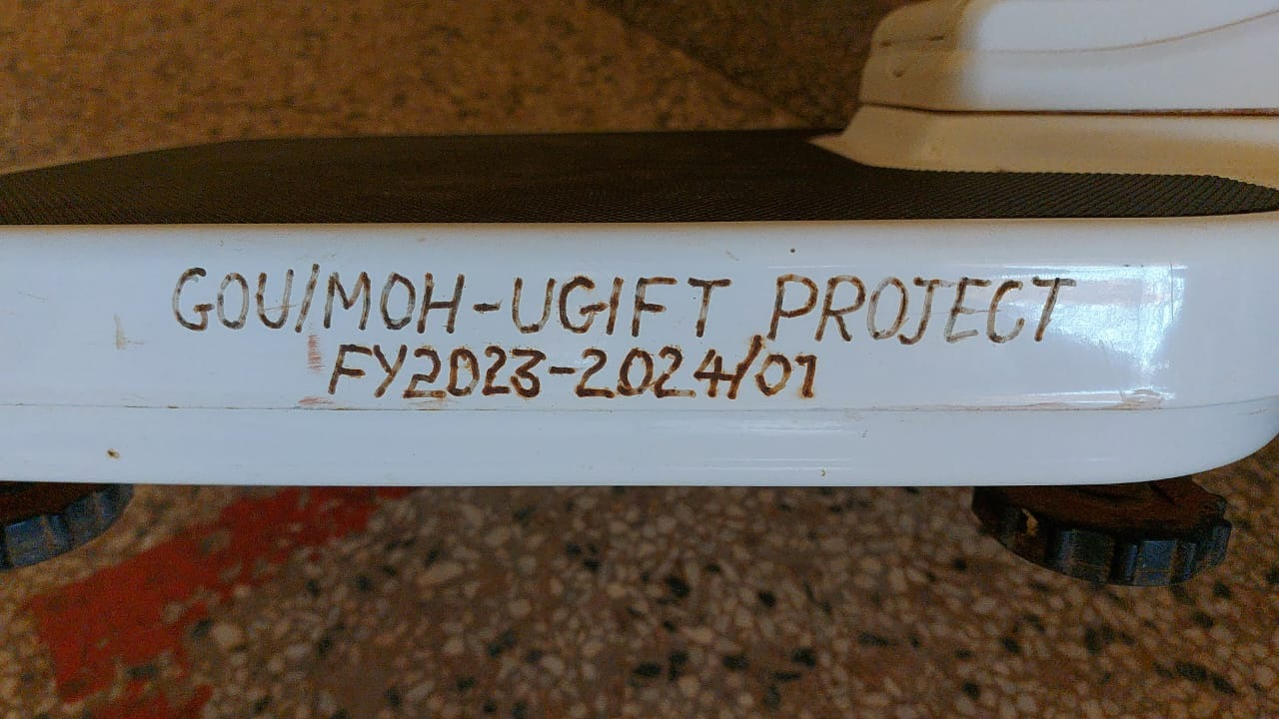 | 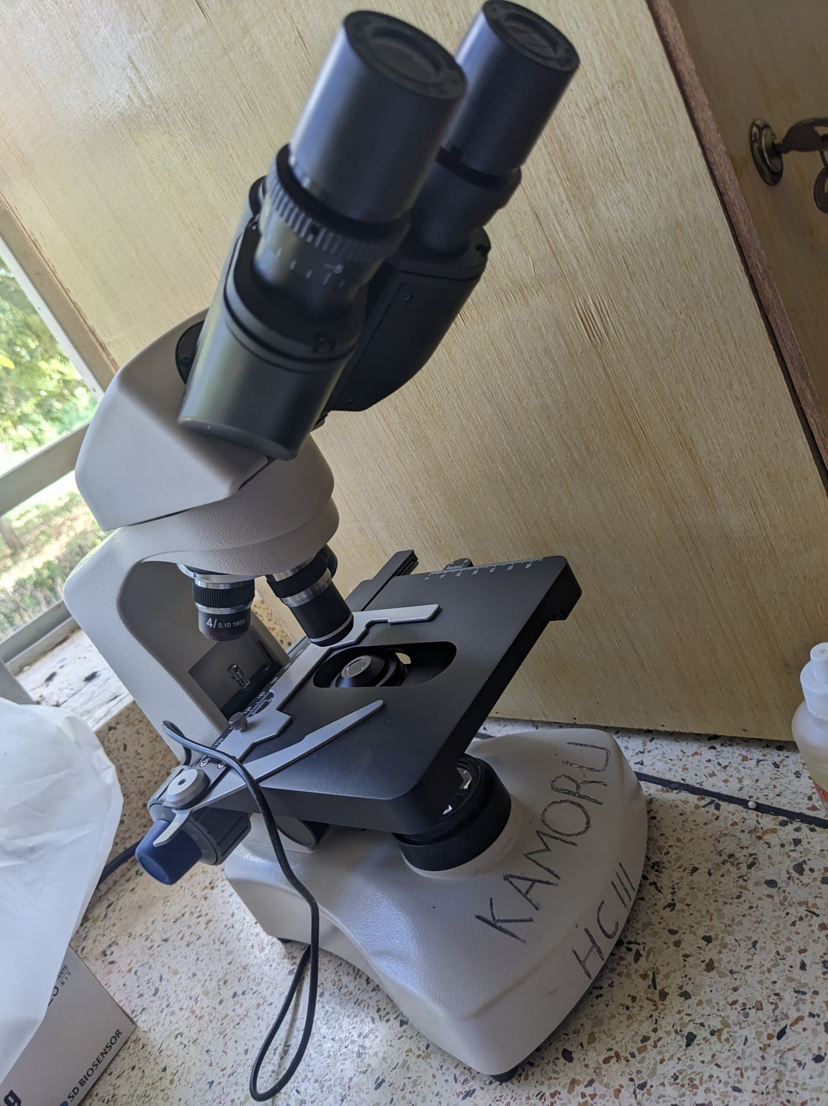
Engraving reading GOU/MOH-UGIFT PROJECT FY2023-2024/01 on a weighing scale at Kalemungole Health Centre III, Moroto District | Microscope marked KAMORU HC III by hand at Kamoru Health Centre III, Kotido District
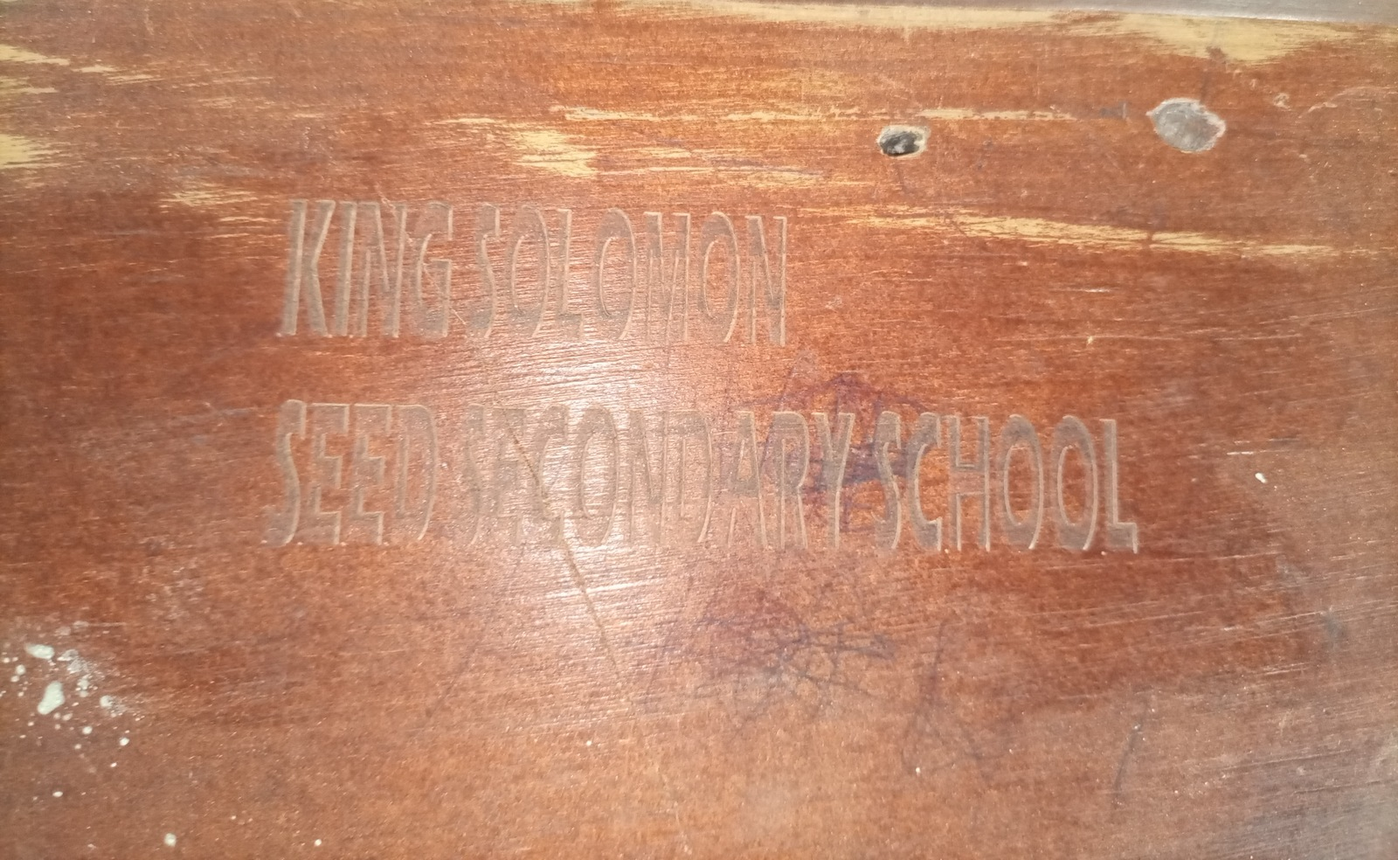 | 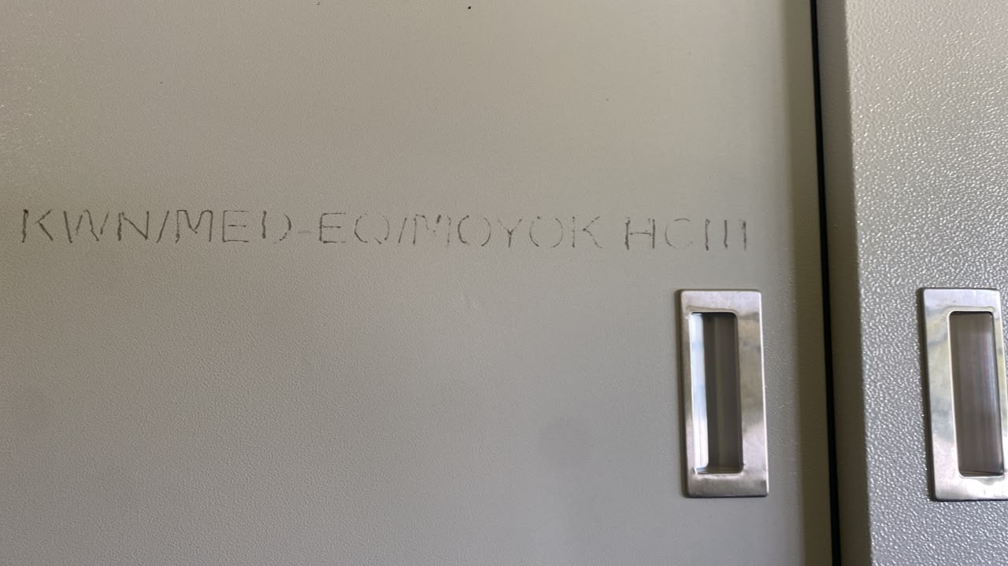
Engraving reading KING SOLOMON SEED SECONDARY SCHOOL, without a UgIFT marking, on furniture at King Solomon Seed Secondary School, Kagadi District | Engraving reading KWN/MED-EQ/MOYOK HCIII on a steel cupboard at Moyok Health Centre III, Kween District

- Financial analysis
Overall, the 229,024 assets across the different institutions had an available recorded value of UGX 996,812,628,890. Based on the straight-line depreciation method, available accumulated depreciation was UGX 165,185,197,307 and available net book value was UGX 595,801,587,531 as at 30th September 2026. Recorded values vary by institution, with MDAs at UGX 32,054,743,836, Blood Banks at UGX 1,503,720,926, Seed Secondary Schools at UGX 700,242,561,371; Health Centers at UGX 260,692,452,291, hospitals and other local-government assets account for the remaining UGX 2,319,150,466 as indicated in table 2.
Table 2: Overall Recorded asset value and net book value
Asset category | Recorded cost (ugx million) | Accumulated depreciation (ugx million) | Net book value (ugx million) | % NBV
Schools | 700,242.561 | 104,574.530 | 394,241.709 | 79.0%
Health centres | 260,692.452 | 39,211.095 | 189,403.577 | 82.8%
Ministries and agencies | 32,054.744 | 19,787.511 | 10,265.925 | 34.2%
Hospitals on LG books | 1,888.015 | 778.948 | 912.033 | 53.9%
Regional blood banks | 1,503.721 | 553.689 | 826.632 | 59.9%
Other LG locations | 431.136 | 279.424 | 151.712 | 35.2%
Total | 996,812.629 | 165,185.197 | 595,801.588 | 78.3%

Table 2 further indicates that the net book value represents 78.3% of the recorded costs of the assets that was determined by the STL method.

3.2 National level Ministries and Agencies results
Asset availability at Ministries and Agencies: The exercise recorded 16,663 assets of the different categories across all the thirteen asset-holding Ministries and agencies. In terms of categorization, the exercise recorded 15,192 ICT equipment items including desktop computers, laptops, tablets and Uninterruptible Power Supply (UPS) units, 77 transport items, 99 furniture and fittings, 48 other classified assets, 1,235 items outside fixed-asset classification and 12 unclassified entries.
By location, most MDA assets (94.6%) were at MoES, MoWE and MAAIF while PPDA was found with only five assets including three Lenovo think pad Laptops, one HP Laser Jet Color Printer and one Samsung Galaxy tablet as indicated in the table below.
MDA | Assets
Ministry of Finance, Planning and Economic Development (MoFPED) | 458
Ministry of Works and Transport (MoWT) | 87
Ministry of Education and Sports (MoES) | 10,783
Ministry of Agriculture, Animal Industry and Fisheries (MAAIF) | 2,045
Ministry of Health (MoH) | 260
Office of the Prime Minister (OPM) | 10
Ministry of Water and Environment (MoWE) | 2,939
Ministry of Gender, Labour and Social Development (MoGLSD) | 10
National Environment Management Authority (NEMA) | 6
Public Procurement and Disposal of Public Assets Authority (PPDA) | 5
Office of the Auditor General (OAG) | 20
Ministry of Local Government (MoLG) | 13
Ministry of Lands, Housing and Urban Development (MoLHUD) | 27
Total | 16,663
Table: UgIFT Assets available at each of the verified MDAs
MDA asset Condition and functionality: At MDA level, apart from Ministry of Health that had one double cabin boarded off and three broken laptops at the Office of the Prime minister, the rest of the assets 16,643 (99.9%) were in good condition and were in use. The Ministry of Education and Sports held 10,783 of these assets, mainly TELA handsets and tablets and were all in use at the different schools across the country. LGFC and MoPS indicated that they never received UgIFT assets.

Asset marking and Identification: At MDA level, there were 16,663 asset records, of which 5,045 (30.3%) had UgIFT identifiers, with 4,925 assets (29.6%) bearing UgIFT or UGFT in the tag field and 120 (0.7%) carrying another identifier. The majority of assets, 11,618 (69.7%), had no usable tag recorded. The figure 5 shows the identification status of the assets at the different MDAs.

Figure 5: Asset marking and Identification at MDAs
Financial value of assets: recorded costs total UGX 32,054,743,836 across 16,651 of 16,663 records. Accumulated depreciation totals UGX 19,787,511,232 and net book value totals UGX 10,265,924,979 at 30th September 2026. Net book value remains unavailable for 96 records. Table 2 also identifies unavailable amounts.

3.3 MDA specific results

3.3.1 Ministry of Finance, Planning and Economic Development
Asset availability: The ministry keeps a UgIFT asset register and the consolidated register for all MDAs that received UgIFT assets. A total of 458 assets were recorded at the ministry including 230 ICT items, 99 furniture and fittings, 21 transport items, 37 other classified assets, 65 items outside fixed-asset classification and six unclassified entries. The main items were office chairs and desks, desktop computers, tablets and 20 Toyota Hilux double-cabin pickups.
Condition and functionality: All 458 assets (100.0%) were recorded as functional and in use, and none was classified as faulty.
Reports described spoilt keyboards and UPS units, computers that freeze and laptop losses. The affected quantities and individual assets were not specified, so the number of broken or lost items could not be established. The asset manager should identify the affected items and reconcile the damage and loss reports.
Marking and identification: A total of 282 assets (61.6%) had usable identifiers and 176 (38.4%) had no usable tag recorded. Of all 458 assets, 247 (53.9%) had UgIFT or UGFT in the tag field and 35 (7.6%) carried another identifier. The 20 double-cabin pickups were identified by their registration numbers rather than UgIFT tag text. These tag-field counts do not confirm physical engraving.
Financial Value of assets: The recorded value of the ministry's UgIFT assets is UGX 6,204,318,000. Accumulated depreciation is UGX 4,312,193,629 and net book value is UGX 1,785,677,771 at 30 September 2026. Net book value remains unavailable for 20 records. Table 3 presents the category breakdown.
Table 3: Recorded costs and available accounting values at MoFPED
Asset category | Recorded cost (ugx million) | Accumulated depreciation (ugx million) | Net book value (ugx million) | % NBV
ICT equipment | 1,350.105 | 1,011.732 | 238.731 | 19.1%
Furniture and fittings | 137.037 | 96.069 | 40.968 | 29.9%
Outside fixed-asset classification | 6.564 | 0.000 | 0.000 | n/a
Other classified assets | 159.987 | 158.377 | 1.610 | 1.0%
Transport equipment | 4,550.385 | 3,046.016 | 1,504.369 | 33.1%
Unclassified | 0.240 | 0.000 | 0.000 | n/a
Total | 6,204.318 | 4,312.194 | 1,785.678 | 29.3%

3.3.2 Ministry of Works and Transport
Asset availability: The Ministry did not provide a UgIFT Asset Register. The MoWT register contained 87 assets, of which 69 ICT items were mainly desktop computers, monitors, uninterruptible power supply (UPS) units, video-conferencing equipment, printers and photocopiers; one Toyota Hilux pickup; sixteen items outside fixed-asset classification; and one unclassified entry. The sixteen items outside fixed-asset classification were keyboards. The unclassified entry was entered as Ministry of Local Government, as presented in Table 6.
Table 6: Assets verified at MoWT
Asset category | Assets
ICT equipment | 69
Outside fixed-asset classification | 16
Transport equipment | 1
Unclassified | 1
Total | 87
Condition and functionality: All the assets were functional and in use.
Marking and Identification: Of the 87 assets, 79 (90.8%) had usable identifiers, with 77 (88.5%) having UgIFT or UGFT in the tag field and two (2.3%) carrying another identifier; eight (9.2%) had no usable tag recorded.
Financial Value of assets: The recorded value was established as UGX 455,932,376. Accumulated depreciation is UGX 326,484,882 and net book value is UGX 115,311,494 as at 30th September 2026 as presented in Table 4.
Table 4: MoWT asset values by category
Asset category | Recorded cost (ugx million) | Accumulated depreciation(ugx million) | Net book value(ugx million) | % NBV
ICT equipment | 259.914 | 137.001 | 108.778 | 44.3%
Transport equipment | 196.018 | 189.484 | 6.534 | 3.3%
Total | 455.932 | 326.485 | 115.311 | 26.1%

3.3.3 Ministry of Education and Sports
Asset availability: The verification at the Ministry of Education and Sports (MoES) established that the ministry had 10,783 assets. All the assets are ICT equipment and these include 9,324 TELA handsets, 1,001 tablets (976 of them inspection tablets), 456 laptops, a photocopier and a printer. The breakdown of these assets is shown in Figure 7. Teacher, Effectiveness and Learner Achievement (TELA) is the system, financed by UgIFT, that the ministry uses to monitor attendance and performance in schools; the handsets and inspection tablets are deployed in local governments and remain MoES assets.
All the 10,783 assets (100.0%) are recorded as functional and in use. All the 456 laptops are recorded as functional and in use. Table 5 presents condition and use.
Table 5: Condition and use of assets for MoES
Condition | No. of Assets | Proportion
Functional | 10,783 | 100.0%
Faulty | 0 | 0.0%
Total | 10,783 | 100.0%

Marking and Identification: Of the 10,783 assets, 458 (4.2%) had UgIFT or UGFT in the tag field, while 10,325 (95.8%) had no UgIFT tag recorded. None of the handsets or tablets carries an engravement mark.

Table 6: Identification of assets for MoES
Identification | No. of Assets | Proportion
Engraved UgIFT | 458 | 4.2%
Not engraved | 10,325 | 95.8%

Financial Value of assets: The recorded value is UGX 14,925,128,359, the highest among the MDAs. Accumulated depreciation is UGX 10,607,476,704 and net book value is UGX 4,317,651,655 as at 30th September 2026. Table 7 presents the category breakdown.
Table 7: Recorded costs and available accounting values at MoES
Asset category | Recorded cost (ugx million) | Accumulated depreciation(ugx million) | Net book value(ugx million) | % NBV
ICT equipment | 14,925.128 | 10,607.477 | 4,317.652 | 28.9%
Total | 14,925.128 | 10,607.477 | 4,317.652 | 28.9%

3.3.4 Ministry of Agriculture, Animal Industry and Fisheries
Asset availability: The team recorded UgIFT assets at the Ministry of Agriculture, Animal Industry and Fisheries (MAAIF) and established that it held 2,045 assets. These included 1,236 ICT equipment items, two transport items and 807 others, comprising 797 outside fixed-asset classification, five other classified assets and five unclassified entries. The ICT items were mainly 819 tablets, 211 computers (162 desktop CPU entries and 49 laptops), 149 monitors and 21 printers.
Asset condition and functionality: All 2,045 assets (100.0%) are recorded as functional and in use. All 211 computers and 819 tablets are recorded as functional and in use. Table 8 presents condition and use of asset.
Table 8: Condition and use of assets at MAAIF
Condition | No. of Assets | Proprotion
Functional | 2,045 | 100.0%
Faulty | 0 | 0.0%
Total | 2,045 | 100.0%

Asset Marking and Identification: Of the 2,045 verified assets, 1,232 (60.2%) are engraved, 1,228 (60.0%) with the UgIFT marking while 4 (0.2%) had other engravement marks, and 813 (39.8%) were not engraved.

Table 9: Recorded tag content of assets at MAAIF
Identification | No. of Assets | Proportion
Engraved UgIFT | 1,228 | 60.0%
Other identifier | 4 | 0.2%
Not engraved | 813 | 39.8%

Financial Value of assets: The recorded value was UGX 2,856,556,593. Accumulated depreciation is UGX 1,380,059,505 and net book value is UGX 1,403,429,899 as at 30th September 2026. Table 10 presents the category breakdown.
Table 10: Recorded costs and available accounting values at MAAIF
Asset category | Recorded cost (ugx million) | Accumulated depreciation(ugx million) | Net book value(ugx million) | % NBV
ICT equipment | 2,278.449 | 952.109 | 1,326.341 | 58.2%
Outside fixed-asset classification | 72.467 | 0.000 | 0.000 | n/a
Other classified assets | 8.000 | 5.467 | 2.533 | 31.7%
Unclassified | 0.600 | 0 | 0 | 0
Transport equipment | 497.040 | 422.484 | 74.556 | 15.0%
Total | 2,856.557 | 1,380.060 | 1,403.430 | 50.4%

3.3.5 Ministry of Health
The verification at the MoH did not find the Ugift Asset Register but relied on the list provided by the Ministry of Finance, Planning and Economic Development.
Asset availability: A total of 51 assets were recorded. Of the 51 assets, 31 were classified as ICT equipment, 16 as transport equipment (motor vehicles and motorcycles), four as other classified assets. The Ministry’s other items include two heavy-duty binding machine and two CC20240 paper shredders. as indicated in Figure 9

Figure 9: Assets verified at MoH
Asset condition and functionality: The assets recorded as functional and in use were 50 (98.0%). Only one asset, a double-cabin pickup, was recorded as faulty and not in use.
Asset Marking and Identification: Out of the 51 assets, 24 (47.1%) were engraved while 27 (52.9%) were not engraved. There were 14 (27.5%) assets with UgIFT markings and 10 (19.6%) with other identifiers.
Financial Value of assets: The MoH assets had a recorded value of UGX 879,893,642. Accumulated depreciation value was UGX 406,599,572 and net book value was UGX 287,726,201 as at 30th September 2026. Table 11 presents the category breakdown.
Table 11: Recorded costs and available accounting values for MoH
Asset category | Recorded cost (ugx million) | Accumulated depreciation (ugx million) | Net book value (ugx million) | % NBV
ICT equipment | 211.927 | 109.806 | 102.122 | 48.2%
Transport equipment | 663.136 | 294.379 | 183.189 | 38.4%
Other classified assets | 4.831 | 2.415 | 2.415 | 50.0%
Total | 879.894 | 406.600 | 287.726 | 41.4%

3.3.6 Office of the Prime Minister
The Assets Register for the Office of the Prime Minister was not obtained and no list of assets was provided. The verification relied on the listing obtained from the Ministry of Finance, Planning and Economic Development.
Asset availability: Office of the Prime Minister received 10 assets which were all HP laptop computers
Condition and functionality: Seven assets (70.0%) were recorded as functional and in use. Three (30.0%) were recorded as faulty and out of use.
Marking and identification: All the ten laptops (100.0%) had UgIFT or UGFT in the tag field.
Financial Value of assets: The recorded value of these computers in OPM was UGX 53,535,300. Accumulated depreciation is UGX 48,181,770 and net book value is UGX 5,353,530 as at 30 September 2026. Table 12 presents the category breakdown.
Table 12: Recorded costs and available accounting values at OPM
Asset category | Recorded cost (ugx million) | Accumulated depreciation (ugx million) | Net book value (ugx million) | % NBV
ICT equipment | 53.535 | 48.182 | 5.354 | 10.0%
Total | 53.535 | 48.182 | 5.354 | 10.0%

3.3.7 Ministry of Water and Environment
Asset availability: The Asset Verification at the Ministry of Water and Environment found out that the ministry keeps a general register which does not conform to IFMIS Standards. The register recorded 2,782 assets, of which 2,782 were classified as ICT equipment. The assets received by the Ministry included 2,368 tablets, of which 2,344 were Euron tablets; computers and related monitors, keyboards and UPS units; and 31 laptops. The Ministry also received sixteen real-time kinematic GPS machines
However, other assets were received which included; seven survey units described as ground-penetrating radar equipment, 3 Samsung Galaxy Tab S9 tablets, 2 Lenovo Think Book notebooks, 1 Kyocera heavy-duty copier, 1 Huawei 65-inch infrared screen and 1 UPS unit.
Asset condition and functionality: The findings further indicated that 2,756 assets (99.1%) were recorded as functional and in use, 26 (0.9%) were functional and in store, and none was classified as faulty.
Asset Marking and Identification: The ministry received a total of 2,782 assets, of which 2,740 (98.5%) were engraved, 2,707 (97.3%) with UgIFT markings and 33 (1.2%) with other markings; 42 (1.5%) were not engraved.
Financial Value of the assets: The recorded value was UGX 3,773,982,079. Accumulated depreciation is UGX 2,092,642,121 and net book value is UGX 1,535,627,440 as at 30th September 2026. Table 13 presents the category breakdown.
Table 13: Recorded costs and available accounting values for MoWE
Asset category | Recorded cost (ugx million) | Accumulated depreciation (ugx million) | Net book value (ugx million) | % NBV
ICT equipment | 3,773.982 | 2,092.642 | 1,535.627 | 42.3%
Total | 3,773.982 | 2,092.642 | 1,535.627 | 42.3%

3.3.8 Ministry of Gender, Labour and Social Development
Asset availability: The Asset Verification at the Ministry of Gender, Labour and Social Development found out that the ministry keeps a UgIFT asset register which had ten UgIFT assets. These comprised eight Lenovo computers, including four ThinkBook laptops, and two Samsung tablets. Figure 11 presents the UgIFT assets recorded for MoGLSD.
Asset condition and functionality: The findings further indicate that all ten UgIFT assets (100.0%) were recorded as functional and in use.
Asset Marking and Identification: A total of Eight Lenovo ThinkPad Laptops (80.0%) were properly engraved with the UgIFT markings and the Two Samsung Tablets (20.0%) were not engraved.
Financial Value of the assets: The findings pointed out that the recorded value to be UGX 46,180,000. Accumulated depreciation is UGX 13,260,000 and net book value is UGX 14,860,000 as at 30th September 2026. Table 14 presents the category breakdown.
Table 14: Recorded costs and available accounting values for MoGLSD
Asset category | Recorded cost (ugx million) | Accumulated depreciation (ugx million) | Net book value (ugx million) | % NBV
ICT equipment | 46.180 | 13.260 | 14.860 | 52.8%
Total | 46.180 | 13.260 | 14.860 | 52.8%

3.3.9 National Environment Management Authority
Asset availability: National Environment Management Authority (NEMA) had six ICT items: four computers, a printer and a heavy-duty photocopier. Figure 12 presents the asset categories.
Condition and functionality: All six assets (100.0%) were recorded as functional and in use.
Asset marking and identification: One asset (16.7%), the heavy-duty photocopier, had UgIFT or UGFT in the tag field while the other five (83.3%) had no usable tag recorded.
Financial value of Assets: The recorded value is UGX 46,824,409. Accumulated depreciation is UGX 32,841,273 and net book value is UGX 13,983,136 as at 30th September 2026. Table 15 presents the category breakdown.
Table 15: Recorded costs and available accounting values for NEMA
Asset category | Recorded cost (ugx million) | Accumulated depreciation (ugx million) | Net book value (ugx million) | % NBV
ICT equipment | 46.824 | 32.841 | 13.983 | 29.9%
Total | 46.824 | 32.841 | 13.983 | 29.9%

3.3.10 Public Procurement and Disposal of Public Assets Authority
Public Procurement and Disposal of Public Assets Authority (PPDA) did not provide a Ugift Asset Register. The verification relied on the information obtained from the Ministry of Finance, Planning and Economic Development.
Asset availability: A total of 5 assets were verified in PPDA; these were 3 Lenovo ThinkPad laptops, a Samsung Galaxy tablet and an HP printer.
Asset condition and functionality: All the five assets (100.0%) were recorded as functional and in use.
Asset marking and identification: All five assets (laptops, a tablet and a printer) had UgIFT engravement.
Financial Value of assets: The recorded cost was UGX 30,153,500. Accumulated depreciation is UGX 13,066,516 and net book value was UGX 17,086,984 as at 30th September 2026. Table 16 presents the category breakdown.
Table 16: Recorded costs and available accounting values for PPDA
Asset category | Recorded cost (ugx million) | Accumulated depreciation (ugx million) | Net book value (ugx million) | %NBV
ICT equipment | 30.154 | 13.067 | 17.087 | 56.7%
Total | 30.154 | 13.067 | 17.087 | 56.7%

3.3.11 Office of the Auditor General (OAG)
Asset availability: Evidence gathered during the verification confirmed that OAG had no UgIFT asset register rather a list which indicated 20 assets; 18 of which were ICT items (16 laptops and 2 printers) and 2 pickup vehicles. The above information is depicted in figure 14.

Asset condition and functionality: All 20 (100.0%) were in good condition and in use.

Asset marking and Identification: Six (30.0%) were properly engraved with the UgIFT markings and 14 (70.0%) were not properly engraved with UgIFT markings. The engravement was carrying the office's own asset code or vehicle registration number for the two pickups

Figure 14: Assets verified at OAG
Financial value of Assets: The assets were worth UGX 388,773,680. Accumulated depreciation was UGX 111,591,545 and net book value is UGX 277,182,135 as at 30th September 2026. Table 17 presents the category breakdown.
Table 17: Recorded costs and available accounting values for OAG
Asset category | Recorded cost (ugx million) | Accumulated depreciation (ugx million) | Net book value (ugx million) | % NBV
ICT equipment | 228.774 | 71.592 | 157.182 | 68.7%
Transport equipment | 160.000 | 40.000 | 120.000 | 75.0%
Total | 388.774 | 111.592 | 277.182 | 71.3%

3.3.12 Ministry of Local Government
Asset availability: The asset verification at the Ministry of Local Government (MoLG) found that the ministry kept a UgIFT asset register and had 13 UgIFT assets; one double-cabin pickup and 12 ICT items. The ICT assets comprised of 6 computers, 4 computer peripherals and 2 heavy duty photocopiers. Figure 15 presents the UgIFT assets verified for MoLG.

Figure 15: Assets verified at MoLG
Asset condition and functionality: The findings further indicate that all thirteen assets (100.0%) were recorded as functional and in use.
Asset marking and identification: Out of the 13 assets, eight (61.5%) were engraved while five (38.5%) were not. Of the eight assets that were engraved, 7 (53.8%) were engraved with a UgIFT markings while one was not. In terms of ICT equipment which formed the bulk of assets, 3 (50.0%) were engraved and 3 (50.0%) were not engraved while 1 (7.7%) carried another identifier.

Financial Value of assets: The findings pointed out the recorded value to be UGX 343,320,450. Accumulated depreciation was UGX 284,670,827 and net book value was UGX 54,649,623 as at 30th September 2026. Table 18 presents the category breakdown.
Table 18: Recorded costs and available accounting values for MoLG
Asset category | Recorded cost (ugx million) | Accumulated depreciation (ugx million) | Net book value (ugx million) | %NBV
ICT equipment | 94.800 | 36.151 | 54.650 | 60.2%
Transport equipment | 248.520 | 248.520 | 0.000 | 0.0%
Total | 343.320 | 284.671 | 54.650 | 16.1%

3.3.13 Ministry of Lands, Housing and Urban Development
Asset availability: The findings from the verification exercise indicate that MoLH &UD had 27 UgIFT assets. These include 25 Honda motorcycles and two other entries described as Accessories (12 Helmets).

Figure 16: Assets verified at MoLHUD
Additionally, the ministry received survey equipment and other motorcycles that it gave out to local governments.
Asset condition and functionality: All the 27 assets (100.0%) were recorded as functional and in use, and none was classified as faulty.
Asset marking and Identification: All the 27 (100.0%) were not engraved with UgIFT markings. Thirteen (48.1%) had other identifiers and fourteen (51.9%) were not engraved. It was also noted that the motorcycles did not have the UgFT labelling but were identified by their registration numbers only.
Financial Value of assets: The findings further indicate the recorded value to be UGX 487,349,999. Accumulated depreciation was UGX 123,840,000 and net book value was UGX 340,559,999 as at 30th September 2026. Table 19 presents the category breakdown.
Table 19: Recorded costs and available accounting values for MoLHUD
Asset category | Recorded cost(ugx million) | Accumulated depreciation (ugx million) | Net book value (ugx million) | %NBV
Transport equipment | 483.750 | 123.840 | 340.560 | 73.3%
Non fixed assets | 3.600 | 0.000 | 0.000 | n/a
Total | 487.350 | 123.840 | 340.560 | 73.3%
.

3.4 Regional Blood Banks
UgIFT financed the construction of the Arua and Hoima regional blood banks, which were completed and commissioned, and the rehabilitation of Soroti Regional Blood Bank. The three Blood Banks operate under Uganda Blood Transfusion Services (UBTS) and were verified.
Asset availability: The blood banks held a total of UgFT asset base of 602 fixed assets inclusive of the Assets at the Uganda Blood transfusion services. The exercise verified all assets at the three regional blood banks as follows. Arua Regional Blood Bank held 324 assets, Hoima Regional Blood Bank had 163 and Soroti Regional Blood Bank had 115 assets.

Asset Condition and functionality: Assets at the regional blood banks were generally recorded as functional and in use: 578 (96.0%) had that status. Only Arua Regional Blood Bank had faulty assets, accounting for all 24 (4.0%) faulty assets in the three-bank total.

Asset Marking and Identification: Of the 602 regional blood-bank assets, 76 (12.6%) had UgIFT engravement and 526 (87.4%) were not engraved. Of the engraved, 26 (4.3%) carried UgIFT markings and 50 (8.3%) carried a none UgIFT engravement.
Financial aspects: The recorded asset value was UGX 1,503,720,926 and the net book value as at 30th September 2026 was UGX 826,632,084. Accumulated depreciation was UGX 553,688,842. Table 20 presents the blood-bank financial values.
Table 20: Recorded value and net book value: Blood banks
Asset category | Recorded cost (ugx million) | Accumulated depreciation (ugx million) | Net book value (ugx million) | % NBV
Arua Regional Blood Bank | 1,153.115 | 472.399 | 557.316 | 54.1%
Hoima Regional Blood Bank | 312.991 | 48.561 | 264.430 | 84.5%
Soroti Regional Blood Bank | 37.615 | 32.729 | 4.886 | 13.0%
Total | 1,503.721 | 553.689 | 826.632 | 59.9%

3.4.1 Arua Regional Blood Bank
Asset availability: Arua Regional Blood Bank held a total of 324 assets.
Asset Marking and identification: Twenty-six assets (8.0%) have identifiers containing UgIFT or UGFT, 48 (14.8%) have another identifier and 250 (77.2%) have no usable identifier. Physical engraving still requires confirmation.
Asset condition and functionality: Out of 324 assets at Arua regional blood bank, 300 (92.6%) were classified as functional and in use, while 24 (7.4%) were classified as faulty and not in use.
Financial value of assets: The recorded asset value was UGX 1,153,114,971. Accumulated depreciation value was UGX 472,399,460 and net book value UGX 557,315,511as at 30th September 2026. Table 21 gives the category breakdown of values.
Table 21: Asset categories for Arua Regional Blood Bank
Asset category | Recorded cost (ugx million) | Accumulated depreciation (ugx million) | Net book value (ugx million) | % NBV
Medical, laboratory and research appliances | 57.612 | 41.213 | 16.400 | 28.5%
Furniture and fittings | 192.104 | 99.390 | 92.715 | 48.3%
ICT equipment | 91.478 | 41.308 | 50.170 | 54.8%
Other classified assets | 261.024 | 142.271 | 118.753 | 45.5%
Outside fixed-asset classification | 123.400 | 0.000 | 0.000 | n/a
Transport equipment | 240.000 | 124.000 | 116.000 | 48.3%
Buildings and structures | 187.496 | 24.218 | 163.278 | 87.1%
Total | 1,153.115 | 472.399 | 557.316 | 54.1%

3.4.2 Hoima Regional Blood Bank
Asset availability: The verification team established that, Hoima Regional Blood Bank had a total of 163 assets.
Asset Marking and identification: No asset was engraved with UgIFT marking. Two assets (1.2%) had other identification marks and 161 (98.8%) were not engraved at all.
Asset condition and functionality: All 163 assets at Hoima Regional blood bank were functional and in use.
Financial value of assets: The recorded asset value was UGX 312,990,807. Accumulated depreciation value was UGX 48,560,694 and net book value was UGX 264,430,113 as at 30th September 2026. Table 22 gives the category breakdown.
Table 22: Asset categories for Hoima Regional Blood Bank
Asset category | Recorded cost (ugx million) | Accumulated depreciation (ugx million) | Net book value (ugx million) | % NBV
Medical, laboratory and research appliances | 54.192 | 37.973 | 16.219 | 29.9%
Other classified assets | 6.840 | 3.544 | 3.296 | 48.2%
Furniture and fittings | 0.520 | 0.338 | 0.182 | 34.9%
Buildings and structures | 251.439 | 6.705 | 244.734 | 97.3%
Total | 312.991 | 48.561 | 264.430 | 84.5%

3.4.3 Soroti Regional Blood Bank
Asset availability: Soroti Regional Blood Bank held 115 assets.
Asset Marking and identification: None of the 115 assets were engraved.
Asset condition and functionality: All the asset were functional and in use.
Financial value of assets: The recorded asset value was UGX 37,615,148. Accumulated depreciation value was UGX 32,728,688 and net book value was UGX 4,886,460 as at 30th September 2026. Table 23 gives the category breakdown.
Table 23: Asset categories at Soroti Regional Blood Bank
Asset category | Recorded cost (ugx million) | Accumulated depreciation (ugx million) | Net book value (ugx million) | % NBV
Medical, laboratory and research appliances | 32.599 | 28.131 | 4.468 | 13.7%
ICT equipment | 4.416 | 4.048 | 0.368 | 8.3%
Furniture and fittings | 0.600 | 0.550 | 0.050 | 8.3%
Total | 37.615 | 32.729 | 4.886 | 13.0%

Figure 16A shows some of the assets verified at regional blood banks.
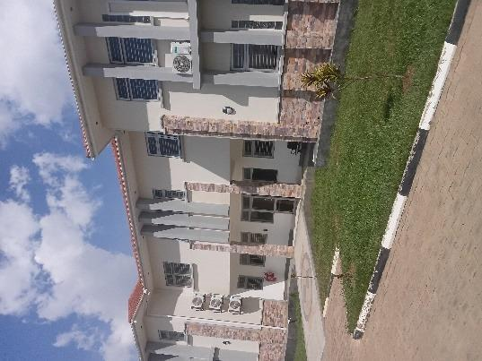 | 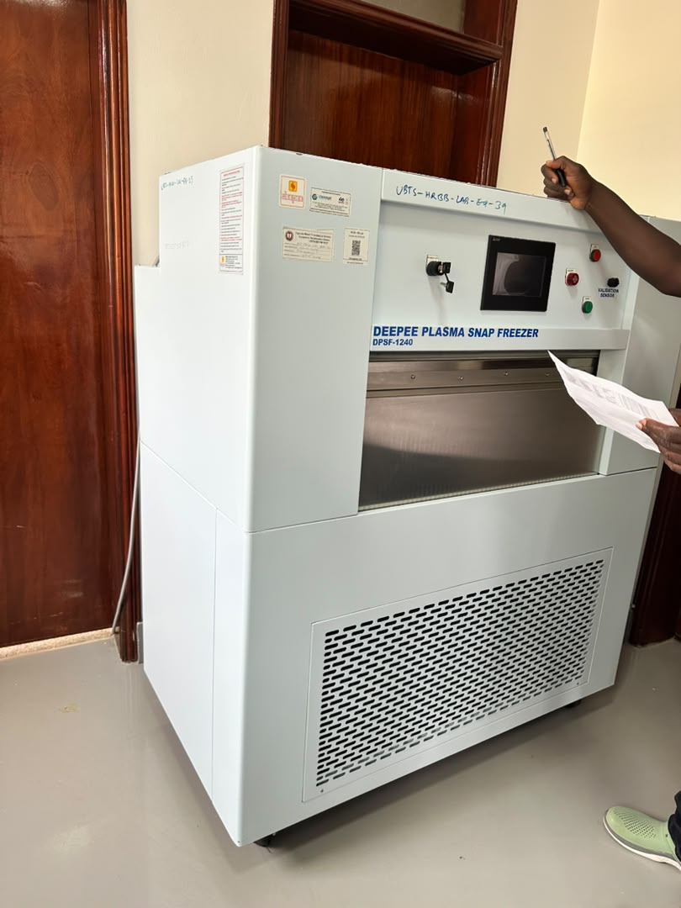
Blood-bank building at Arua Regional Blood Bank, Arua City | Plasma snap freezer at Hoima Regional Blood Bank, Hoima City.
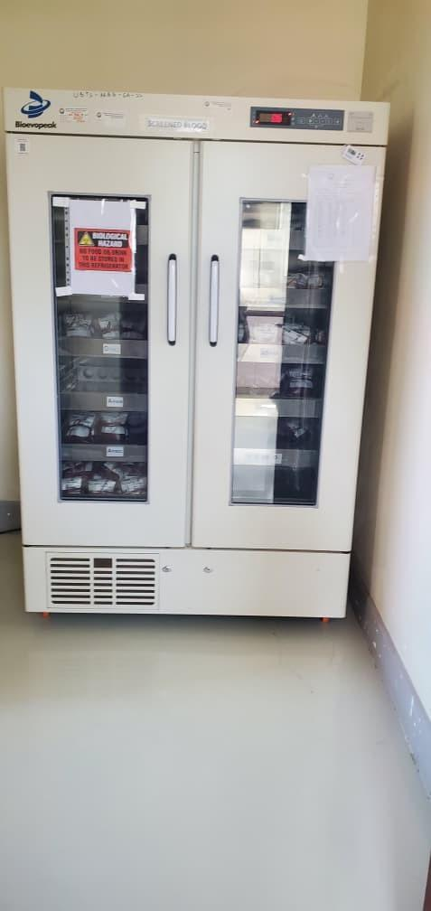 | 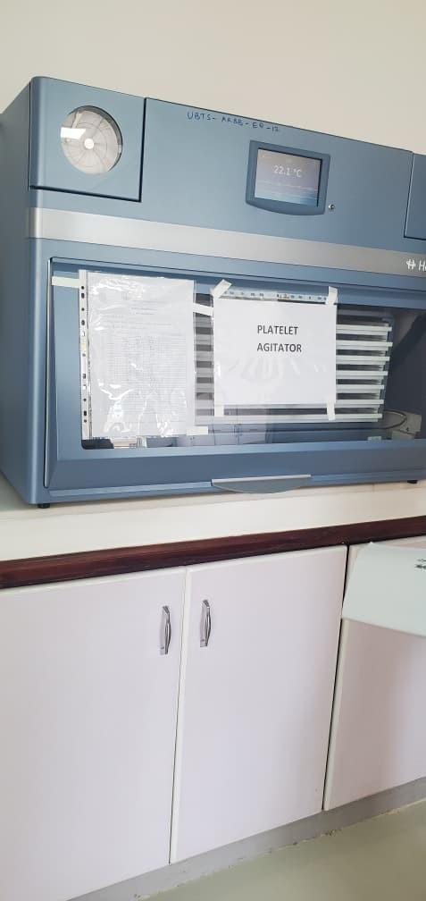
Blood bank refrigerator at Arua Regional Blood Bank, Arua City | Platelet agitator at Arua Regional Blood Bank, Arua City
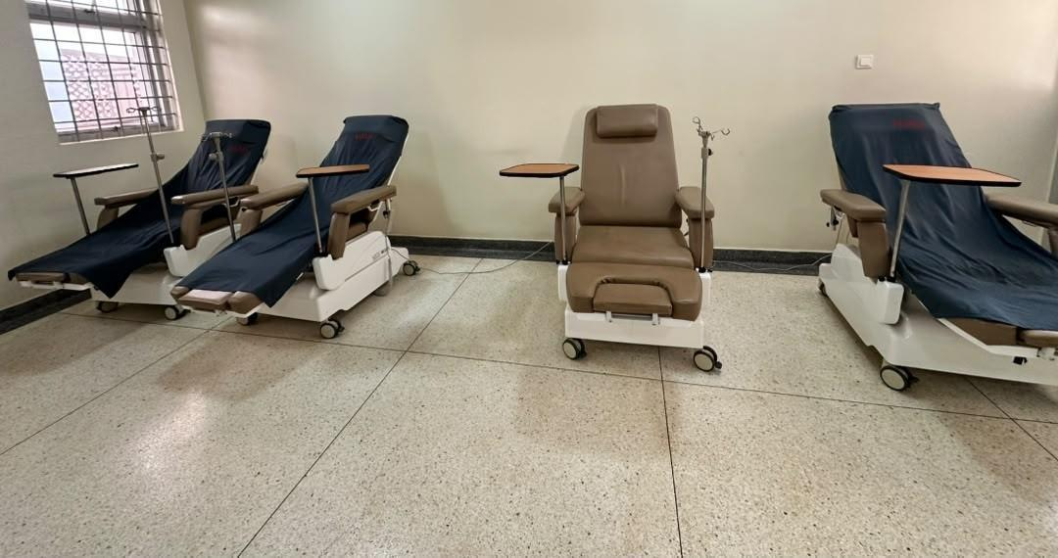 | 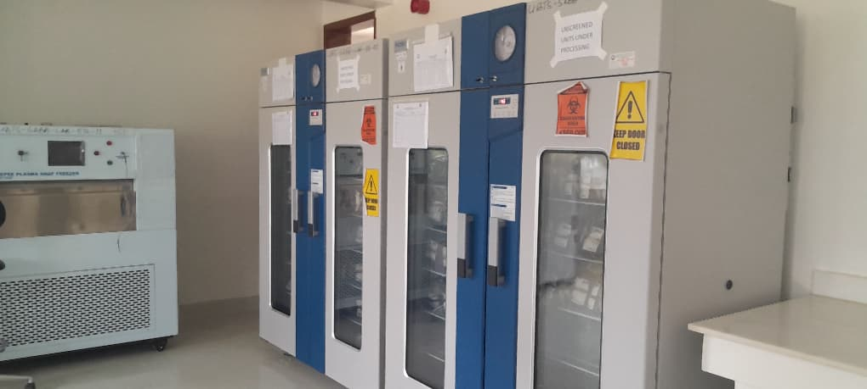
Donor couches in the donor room at Hoima Regional Blood Bank, Hoima City | Blood-bank refrigerators and plasma snap freezer at Soroti Regional Blood Bank.
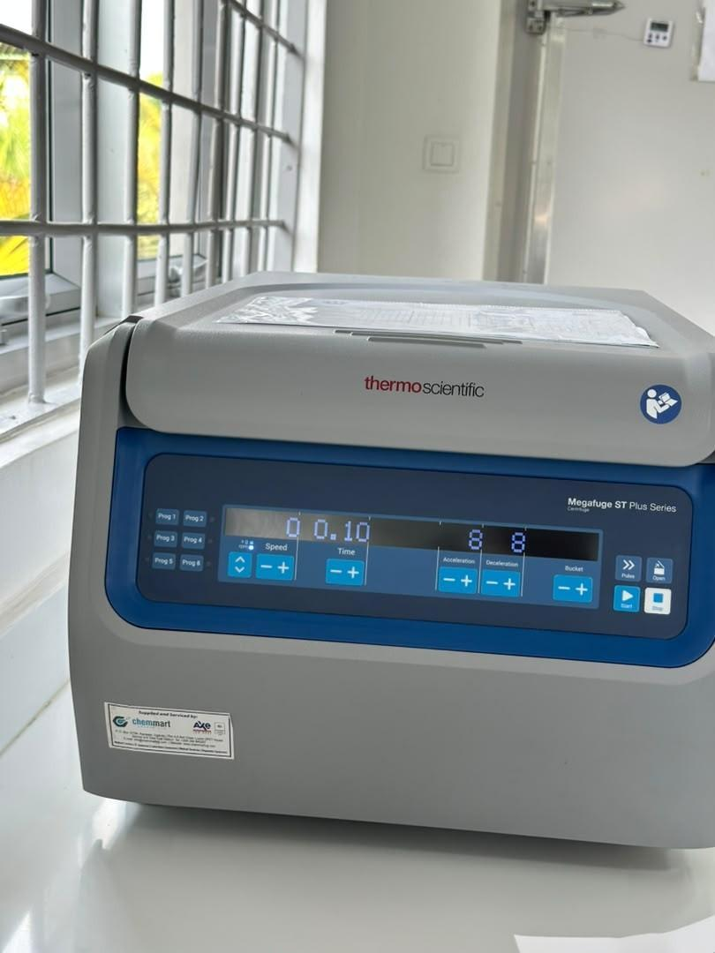 | 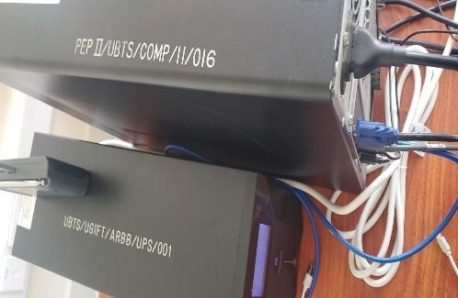
Benchtop centrifuge at Hoima Regional Blood Bank, Hoima City | Markings PEP II/UBTS/COMP/11/016 and UBTS/UGIFT/ARBB/UPS/001 on uninterruptible power supplies at Arua Regional Blood Bank, Arua City
Figure 16A: Asset photographs from regional blood banks

3.5 Local Government level results
The programme list at the LG level contained 629 UgIFT facilities, of which 371 were Health Centres and 258 were Seed Secondary Schools. Supporting returns accounted for 590 entries and 39 had discrepancies requiring reconciliation. A total of 208,688 assets were recorded at Health Centres and school locations, of which 63,432 were for Health Centres and 145,256 were for schools. Of the 208,688 assets, 195,224 (93.5%) were recorded as functional and in use while 13,464 (6.5%) were recorded as faulty and not in use. A further 3,067 assets were attributed to hospitals and four to other local-government locations. The details are presented in sections 3.6 (Health Centres) and 3.7 (Seed Secondary Schools).

3.6 Health Centres

Availability of the assets: The verification findings indicate that health facilities had 63,432 recorded assets across the different categories which include clinical and laboratory equipment, furniture, maternity ward equipment, ICT equipment, buildings, land and other items. The register includes 7,746 non-fixed assets. Table 24 presents assets by category and proportion.
Table 24: Availability of assets in Health Centres
Asset category | No. of Assets | Proportion
Medical, laboratory and research appliances | 36,721 | 57.9%
Furniture and fittings | 15,671 | 24.7%
Outside fixed-asset classification | 7,746 | 12.2%
Buildings and structures | 2,260 | 3.6%
Other classified assets | 537 | 0.8%
ICT equipment | 424 | 0.7%
Unclassified | 64 | 0.1%
Transport equipment | 5 | 0.0%
Land (pieces) | 4 | 0.0%
Total | 63,432 | 100.0%

Asset condition and functionality: The findings indicate that of the 63,432 health-centre assets, 57,759 (91.1%) were recorded as functional and in use and 5,673 (8.9%) were recorded as faulty and not in use. Table 25 presents the condition of the assets.
Table 25: Condition of assets at Health centres
Asset category | No. of Assets | Functional | Faulty
Medical, laboratory and research appliances | 36,721 | 32,473 | 4,248
Furniture and fittings | 15,671 | 14,988 | 683
Outside fixed-asset classification | 7,746 | 7,231 | 515
Buildings and structures | 2,260 | 2,144 | 116
Other classified assets | 537 | 479 | 58
ICT equipment | 424 | 374 | 50
Unclassified | 64 | 62 | 2
Transport equipment | 5 | 4 | 1
Land (pieces) | 4¹ | 4 | 0
Total | 63,432 | 57,759 | 5,673

The records indicated that some health-centre assets were not in use due to a number of reasons such as assets not delivered to the health centre (still in stores at LGs), idle assets, assets with missing parts, lack of power, assets not required at the facility, rooms or wards unavailable for installation, assets held at another facility, items awaiting installation, lost or missing items and equipment unused because staff were not trained or no specialist was available to operate it. Examples include a wall-mounted blood-pressure machine at Butawata Health Centre III (Mubende District) recorded as not functional; a wheelchair at Aarapoo Health Centre III (Serere District) that had not been delivered; a patient screen at Ayer Health Centre III (Kole District) that was on the delivery note but not seen; a paediatric bed at Okwerodot Health Centre III (Kole District) supplied without a mattress; and an autoclave at Anamwany Health Centre III (Amolatar District) unused for lack of electricity. The register's two condition categories do not provide a separate count for these reasons.
In terms of buildings, there were 2,260 assets comprising of 487 residential-building, 1,402 non-residential building, 364 other-structure entries and seven water supply systems. Table 26 presents the classifications.
Table 26: Health Centre buildings
Asset category | No. of Assets
Non-residential buildings | 1,402
Residential buildings | 487
Other Structures | 364
Water supply systems | 7

Asset marking and Identification: Of the 63,432 assets in Health Centres, 9,541 (15.0%) were engraved while 53,891 (85.0%) were not engraved. It was noted that 3,824 (6.0%) carried UgIFT markings and 5,717 (9.0%) carried other markings as shown in Table 27.
Table 27: Identification of assets at Health centres
Asset category | No. of Assets | UgIFT markings | Other markings | Not engraved
Medical, laboratory and research appliances | 36,721 | 1,786 | 2,826 | 32,109
Furniture and fittings | 15,671 | 1,484 | 1,888 | 12,299
Outside fixed-asset classification | 7,746 | 356 | 689 | 6,701
Buildings and structures | 2,260 | 45 | 179 | 2,036
Other classified assets | 537 | 20 | 43 | 474
ICT equipment | 424 | 133 | 32 | 259
Unclassified | 64 | 0 | 54 | 10
Transport equipment | 5 | 0 | 4 | 1
Land (pieces) | 4 | 0 | 2 | 2
Total | 63,432 | 3,824 | 5,717 | 53,891

Financial Value of assets: The findings indicate that the available recorded value of assets was UGX 260,692,452,291 and the available net book value was UGX 189,403,577,197, while available accumulated depreciation was UGX 39,211,094,700 as at 30th September 2026. Table 28 gives the recorded value and net book value.
Table 28: Recorded and net book values at Health centres
Asset category and coverage | Recorded cost (ugx million) | Accumulated depreciation (ugx million) | Net book value (ugx million) | % NBV
Medical, laboratory and research appliances | 39,592.633 | 14,080.055 | 18,715.685 | 57.1%
Furniture and fittings | 15,109.270 | 5,764.153 | 6,584.582 | 53.3%
Non-fixed assets | 479.803 | 0.000 | 0.000 | n/a
Buildings | 203,954.138 | 18,304.241 | 163,802.803 | 89.9%
Other assets | 347.206 | 172.492 | 133.099 | 43.6%
ICT equipment | 929.345 | 825.749 | 85.256 | 9.4%
Unclassified | 134.958 | 0.971 | 0.485 | 33.3%
Transport equipment | 75.100 | 63.433 | 11.667 | 15.5%
Land | 70.000 | 0.000 | 70.000 | 100.0%
Total | 260,692.452 | 39,211.095 | 189,403.577 | 82.8%

The verification established that some buildings were complete and in use while others were incomplete as presented in photographs below.
Photographs in Figures 20 to 23 show some of the facilities that are complete
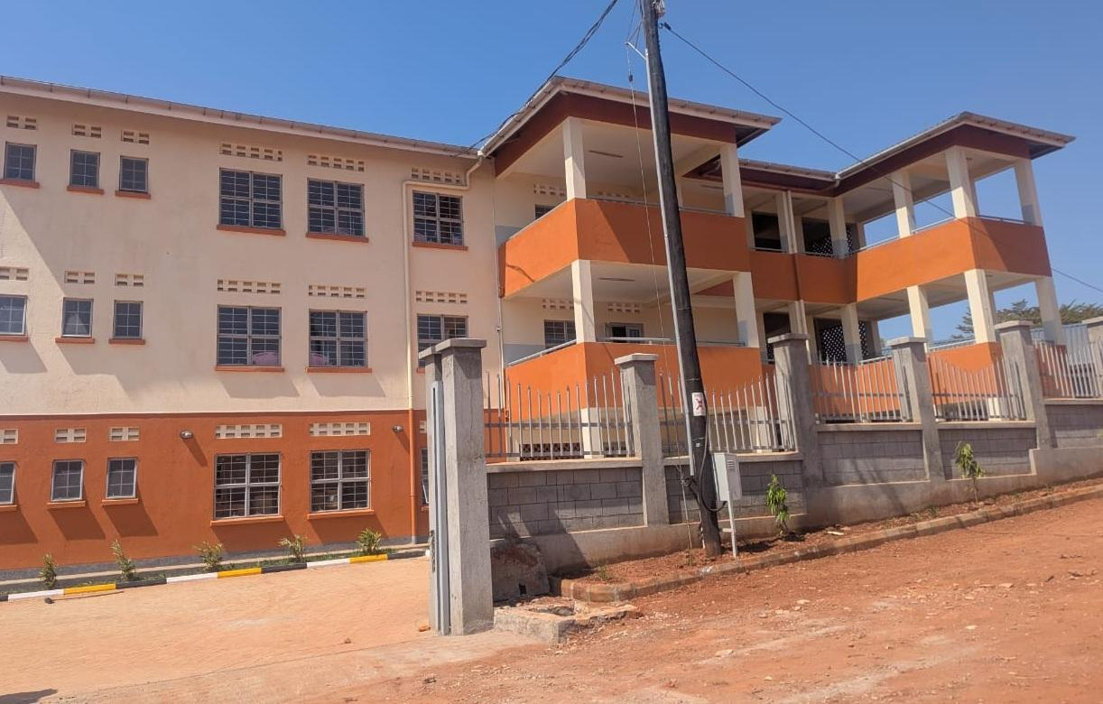  Figure 20: Health centre building at Kibiri HC III, Makindye-Ssabagabo Municipal Council (Buganda) |  |  | 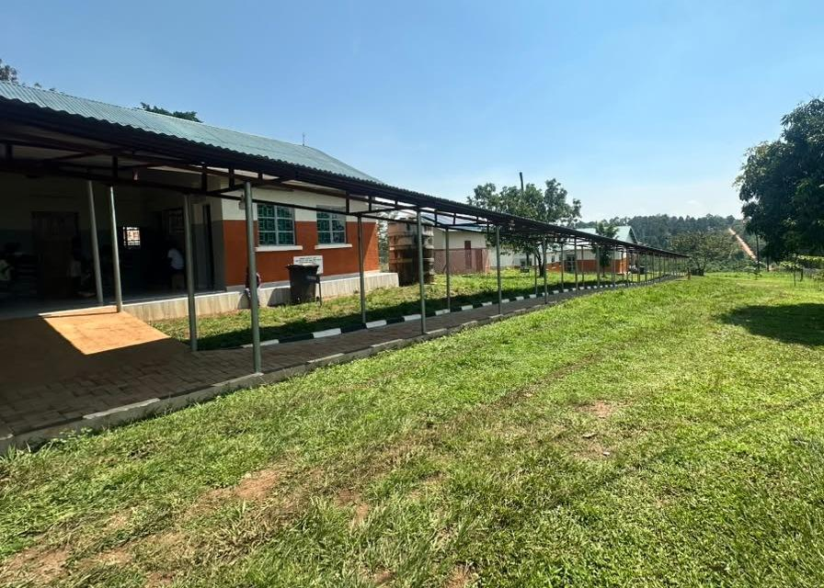  Figure 21: Health centre buildings and covered walkway at Kihuukya HC III, Hoima City (Bunyoro)
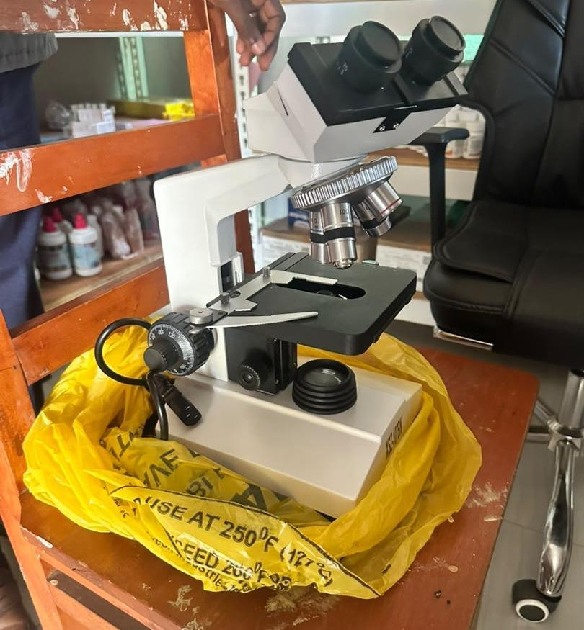  Figure 22: Binocular microscope at Kihuukya HC III, Hoima City (Bunyoro) |  | 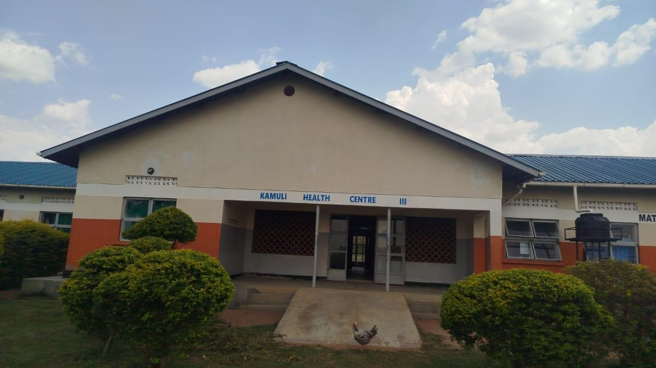  Figure 23: Maternity block entrance and access ramp at Kamuli HC III, Tororo District (Bukedi)

Photographs in Figure 24 and Figures 25 to 27 show some of the facilities that are Incomplete
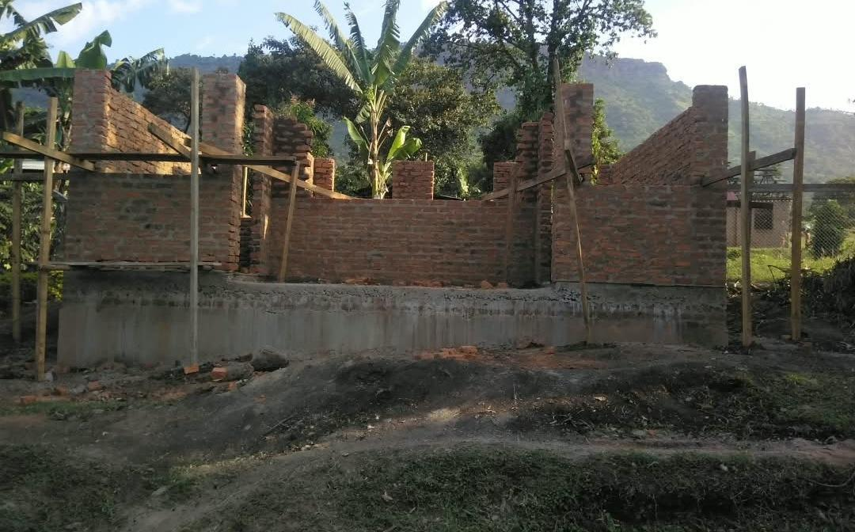
Figure 24: Unfinished laboratory building at a health centre, Sironko District (Bugisu)

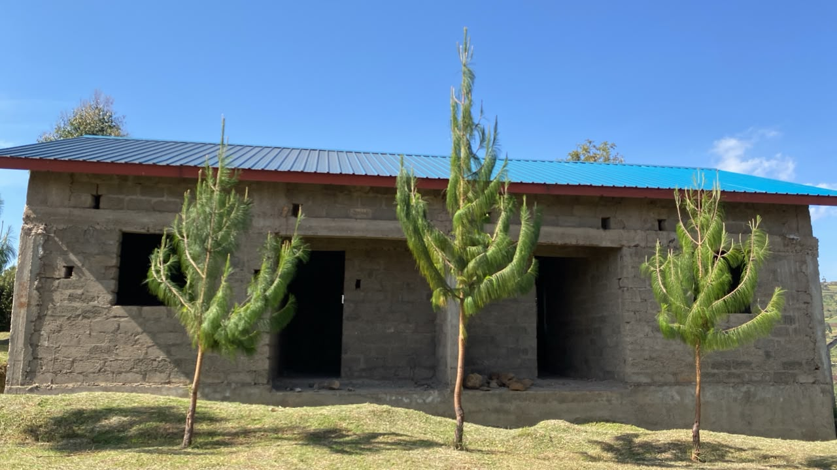 | 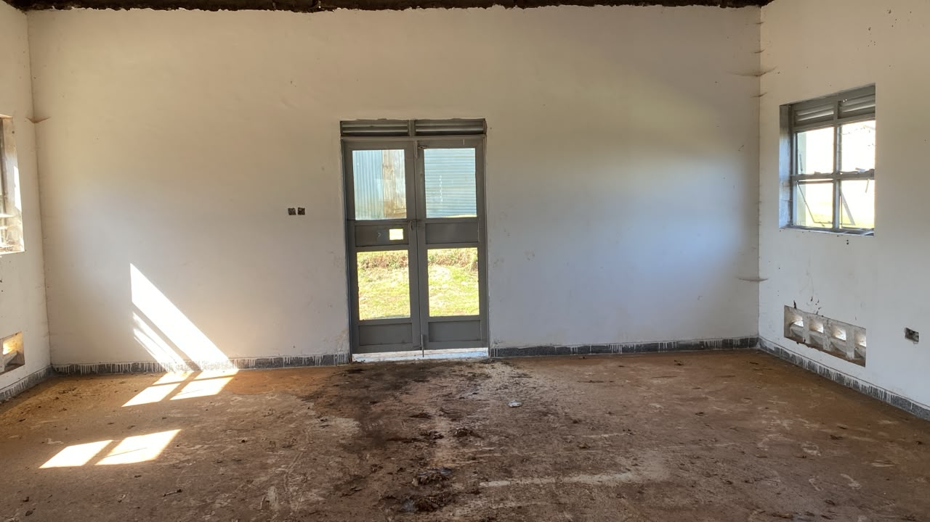
Figure 25: Incomplete staff quarters at Benet Health Centre III, Kween District. Field visit 27 August 2026. | Figure 26: Interior awaiting completion at Benet Health Centre III, Kween District. Field visit 27 August 2026.
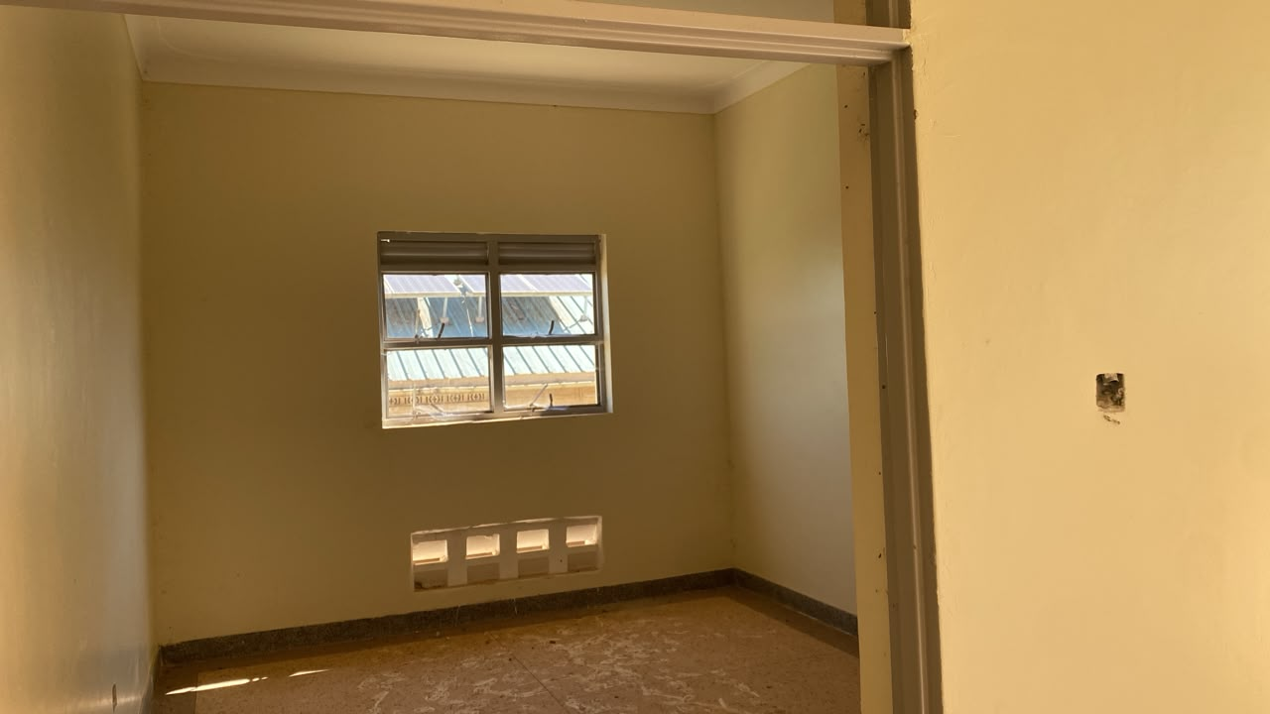
Figure 27: A further unfinished room at Benet Health Centre III, Kween District. Field visit 27 August 2026.

3.7 Seed Secondary Schools

Availability of the assets: The findings showed that schools had 145,256 recorded assets covering the following categories: school buildings, water facilities, furniture, computers and related equipment such as monitors, UPS units and keyboards; ICT equipment including printers, photocopiers, cameras and projectors; and other school assets such as laboratory items, electrical items, plant and machinery and sports equipment. Table 29 presents the details.
Table 29: Availability of assets in schools
Asset category | No. of Assets | Proportion
Furniture and fittings | 107,792 | 74.2%
ICT equipment | 12,036 | 8.3%
Outside fixed-asset classification | 9,081 | 6.3%
Buildings and structures | 7,505 | 5.2%
Medical, laboratory and research appliances | 5,604 | 3.9%
Other classified assets | 2,716 | 1.9%
Unclassified | 500 | 0.3%
Land (pieces) | 14 | 0.0%
Transport equipment | 8 | 0.0%
Total | 145,256 | 100.0%

Asset condition and functionality: Out of 145,256 assets, 137,465 (94.6%) were recorded as functional and in use. The verification further established that 7,791 (5.4%) were recorded as faulty and not in use. Table 30 indicates the asset condition.
Table 30: Condition of assets in schools
Asset category | No. of Assets | Functional | Faulty
Furniture and fittings | 107,792 | 102,521 | 5,271
ICT equipment | 12,036 | 10,404 | 1,632
Outside fixed-asset classification | 9,081 | 8,692 | 389
Buildings and structures | 7,505 | 7,220 | 285
Medical, laboratory and research appliances | 5,604 | 5,498 | 106
Other classified assets | 2,716 | 2,623 | 93
Unclassified | 500 | 485 | 15
Land (pieces) | 14 | 14 | 0
Transport equipment | 8 | 8 | 0
Total | 145,256 | 137,465 | 7,791

Table 30 further indicates that school furniture and fittings (desks, tables, chairs, shelves and stools) is the largest category with 107,792 assets. Of these, 102,521 were recorded as functional and in use while 5,271 were recorded as faulty. ICT equipment had 10,404 assets recorded as functional and in use.

Asset marking and Identification: Of the 145,256 school assets, 35,601 (24.5%) were engraved while 109,655 (75.5%) were not engraved. A total of 13,478 (9.3%) had UgIFT markings and 22,123 (15.2%) had other markings, as shown in Table 31.
Table 31: Identification of assets in schools
Asset category | No. of Assets | UgIFT Marking | Other Markings | Not engraved
Furniture and fittings | 107,792 | 12,985 | 18,503 | 76,304
ICT equipment | 12,036 | 315 | 2,426 | 9,295
Non fixed-assets | 9,081 | 0 | 452 | 8,629
Buildings and structures | 7,505 | 40 | 391 | 7,074
Medical, laboratory and research appliances | 5,604 | 121 | 242 | 5,241
Other classified assets | 2,716 | 17 | 96 | 2,603
Unclassified | 500 | 0 | 10 | 490
Land (pieces) | 14 | 0 | 2 | 12
Transport equipment | 8 | 0 | 1 | 7
Total | 145,256 | 13,478 | 22,123 | 109,655

Financial Value of school assets: The recorded asset value was UGX 700,242,561,371, accumulated depreciation was UGX 104,574,530,246 and the net book value was UGX 394,241,708,595 as at 30th September 2026, as shown in Table 32.
Table 32: Recorded value and net book value for schools
Asset category | Recorded cost (ugx million) | Accumulated depreciation (ugx million) | Net book value (ugx million) | % NBV
Furniture and fittings | 22,612.957 | 11,733.742 | 7,406.367 | 38.7%
ICT equipment | 29,669.809 | 15,836.227 | 9,584.916 | 37.7%
Non fixed-assets | 40,839.592 | 0.000 | 0.000 | n/a
Buildings and structures | 601,004.483 | 74,561.320 | 374,906.543 | 83.4%
Medical, laboratory and research appliances | 1,455.366 | 864.426 | 511.352 | 37.2%
Other classified assets | 2,488.189 | 1,037.888 | 1,224.696 | 54.1%
Unclassified | 610.010 | 33.415 | 141.245 | 80.9%
Land (pieces) | 110.029 | 0.000 | 110.029 | 100.0%
Transport equipment | 1,452.127 | 507.511 | 356.561 | 41.3%
Total | 700,242.561 | 104,574.530 | 394,241.709 | 79.0%

The verification established that some buildings were complete and in use while others were incomplete as presented in photographs below.
Photographs in Figures 28 to 30 show some of the facilities that are complete
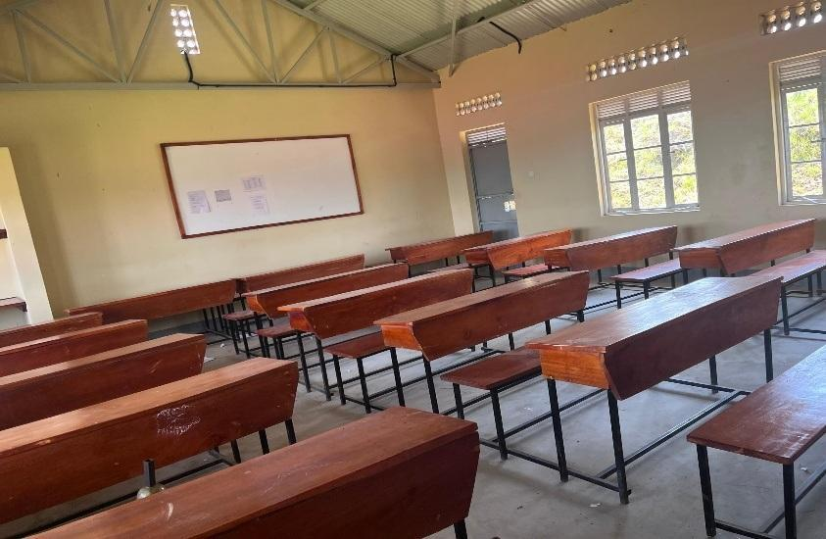  Figure 28: Classroom furnished with desks and a whiteboard at Gyagenda Memorial Seed Secondary School, Kalangala District (Buganda) | 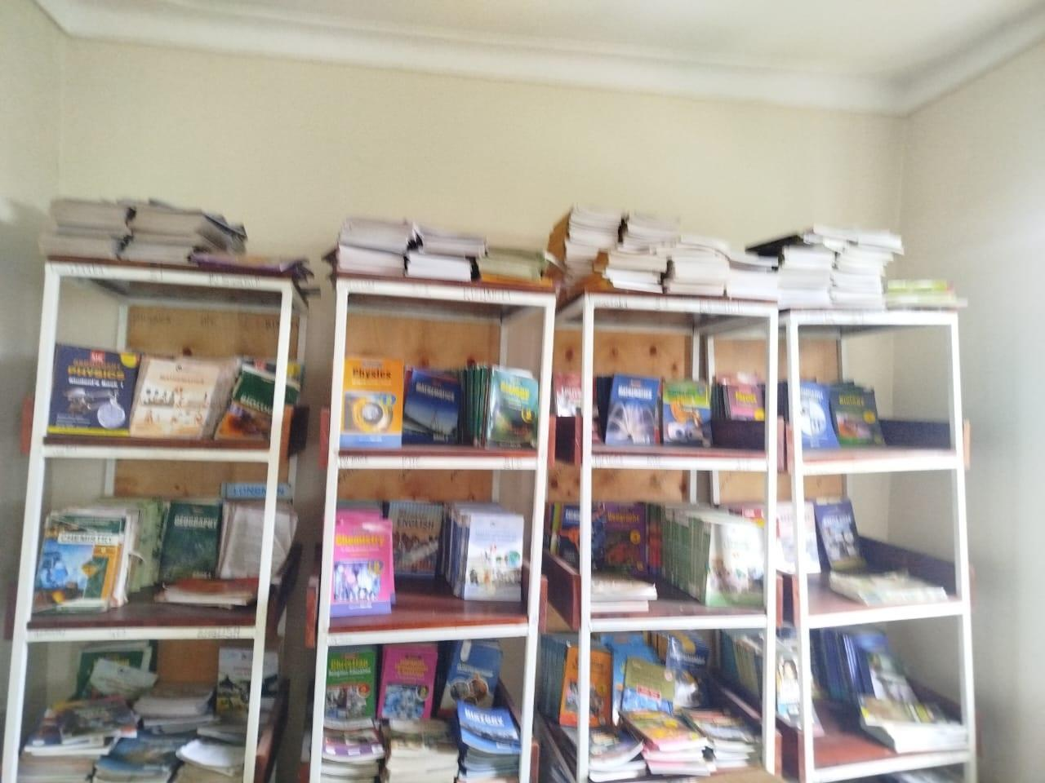  Figure 29: Books displayed in library shelves at Sibanga Seed School, Manafwa District (Bugisu) | 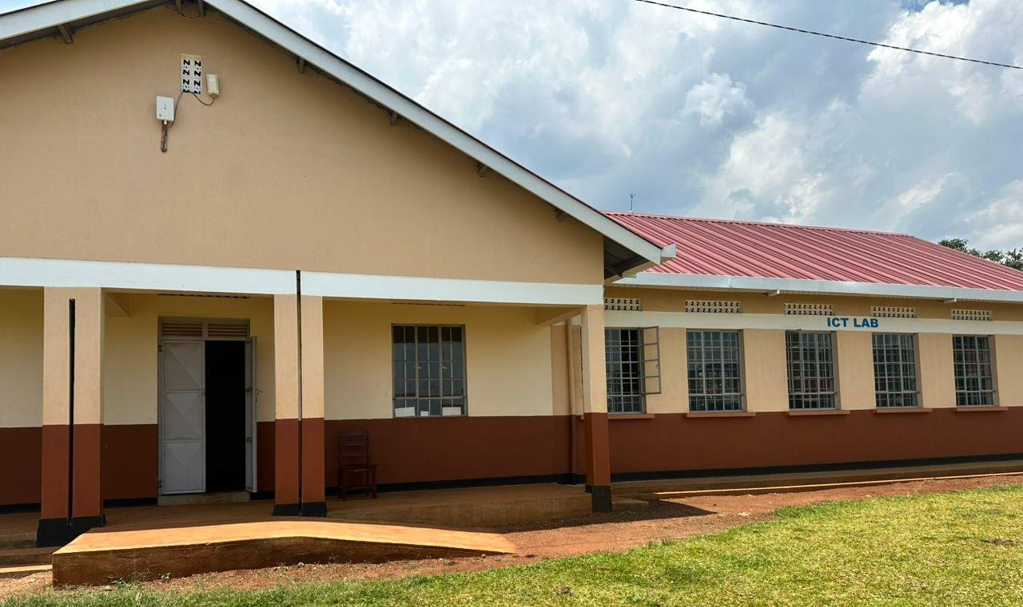  Figure 30: ICT laboratory block and entrance ramp at Sisiyi Seed Secondary School, Bulambuli District (Bugisu)

Photographs in Figures 31 to 43 show some of the facilities that are still under construction
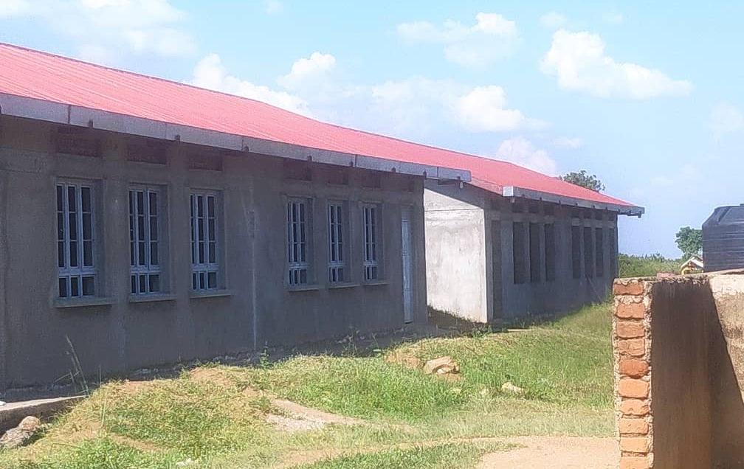  Figure 31: Unfinished school block at Got Apwoyo Seed Secondary  School, Nwoya District (Acholi) |  |  |  |  |  | 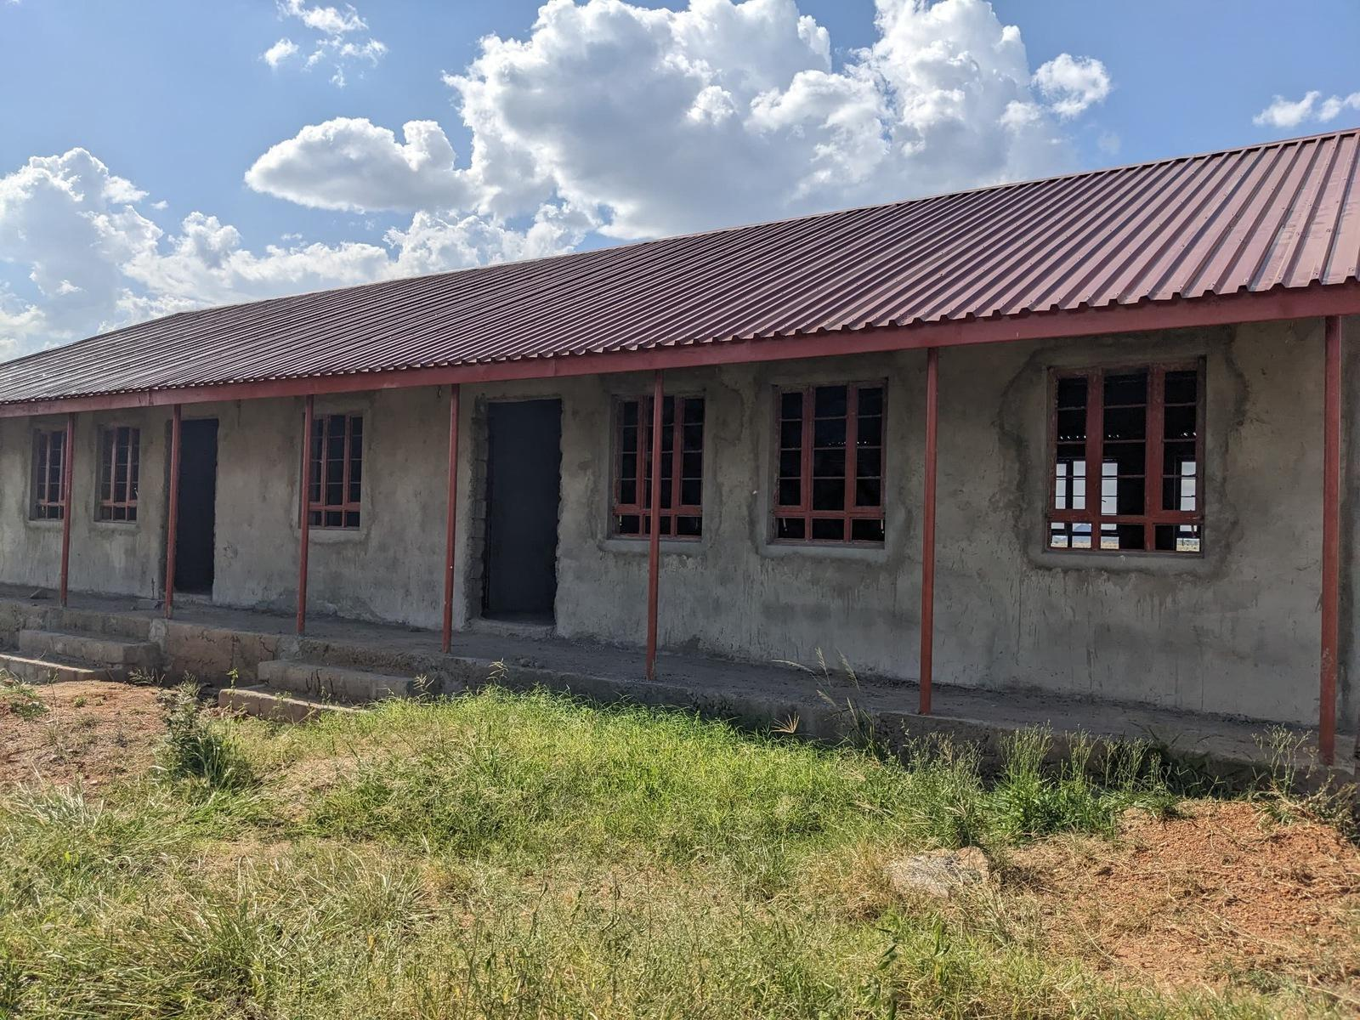  Figure 32: Unfinished classroom block at Sidok Seed Secondary School, Kaabong District (Karamoja)
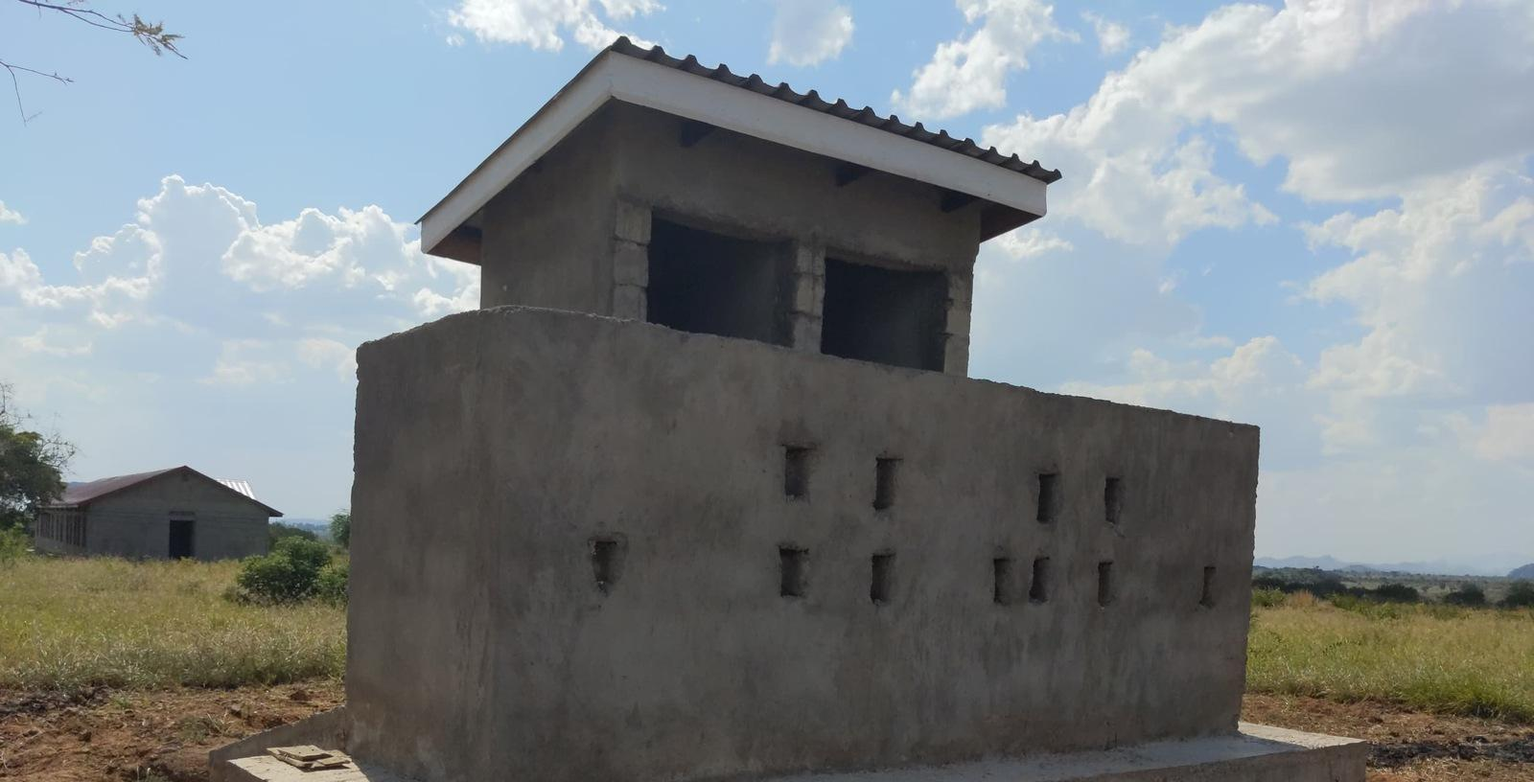  Figure 33: Latrine block under construction at Sidok Seed Secondary School, Kaabong District (Karamoja) |  |  |  |  | 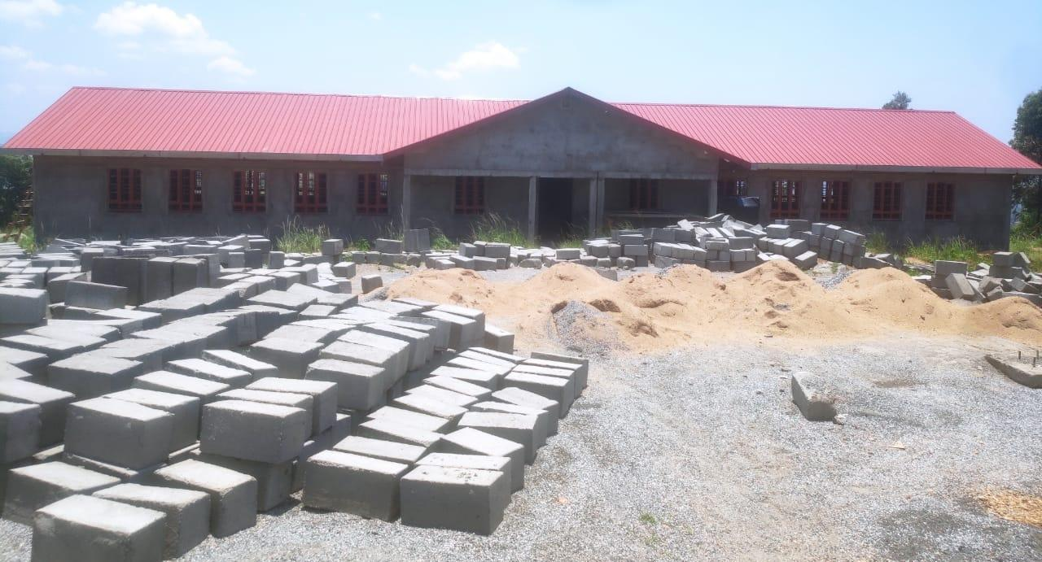  Figure 34: Building works and construction materials at Ndhew Seed Secondary School, Nebbi District (West Nile)
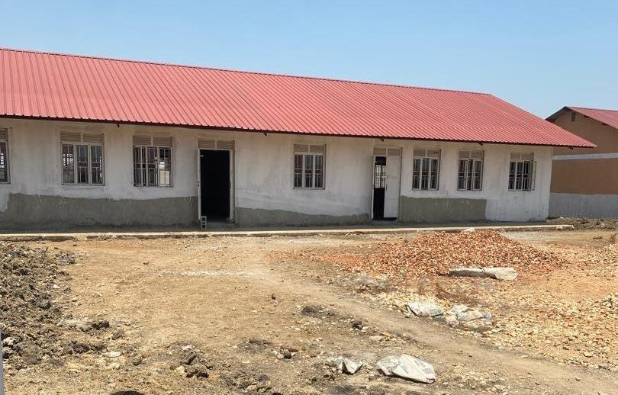  Figure 35: School block awaiting completion at Butungama Seed Secondary School, Ntoroko District (Tooro) | 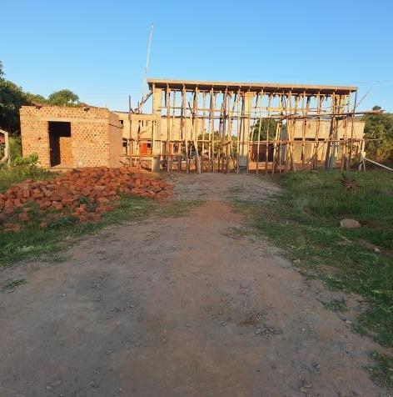  Figure 36: Building works at a seed secondary school, Kiboga District (Buganda) |  |  |  |  |  | 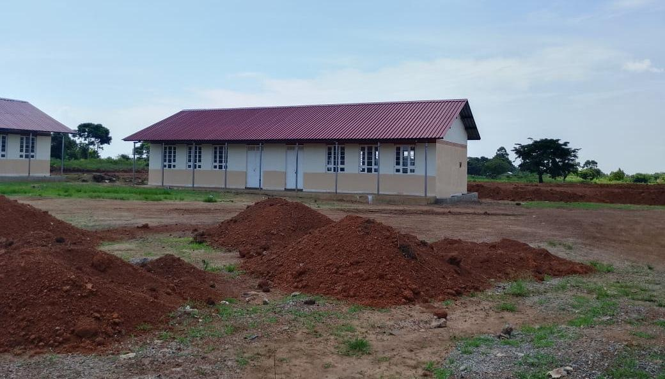  Figure 37: Classroom block with earthworks in the foreground at Kihungya Seed Secondary School, Buliisa District (Bunyoro)
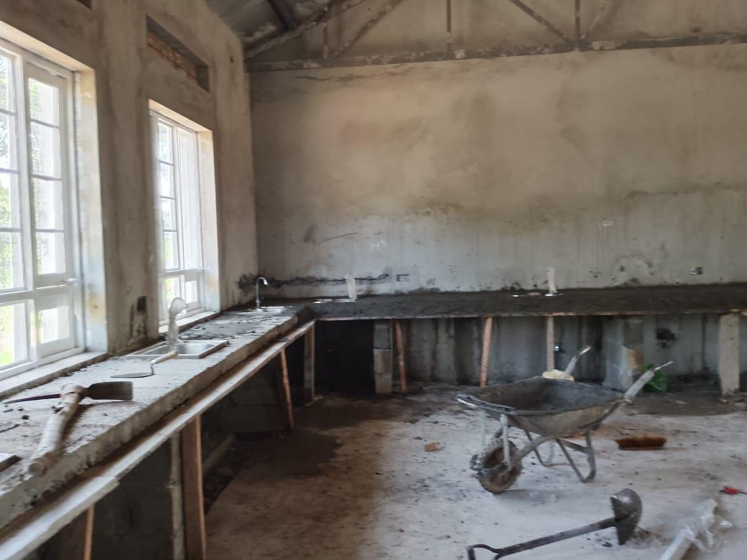  Figure 38: Biology laboratory under construction at a seed secondary school, Buliisa District (Bunyoro) |  | 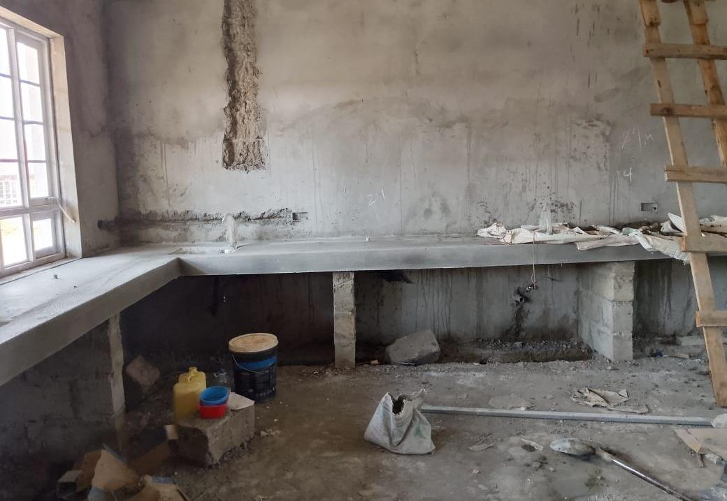  Figure 39: Unfinished laboratory interior at Kihungya Seed Secondary School, Buliisa District (Bunyoro)
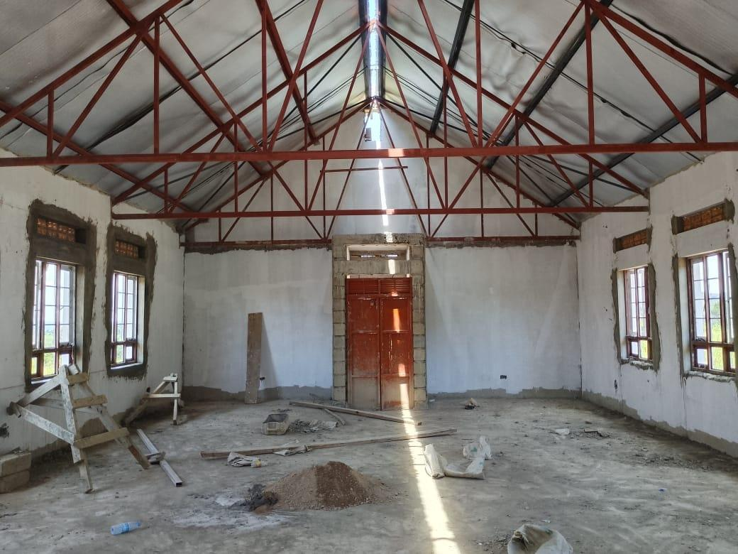  Figure 40: Library interior under construction at Kihungya Seed Secondary School, Buliisa District (Bunyoro) |  |  | 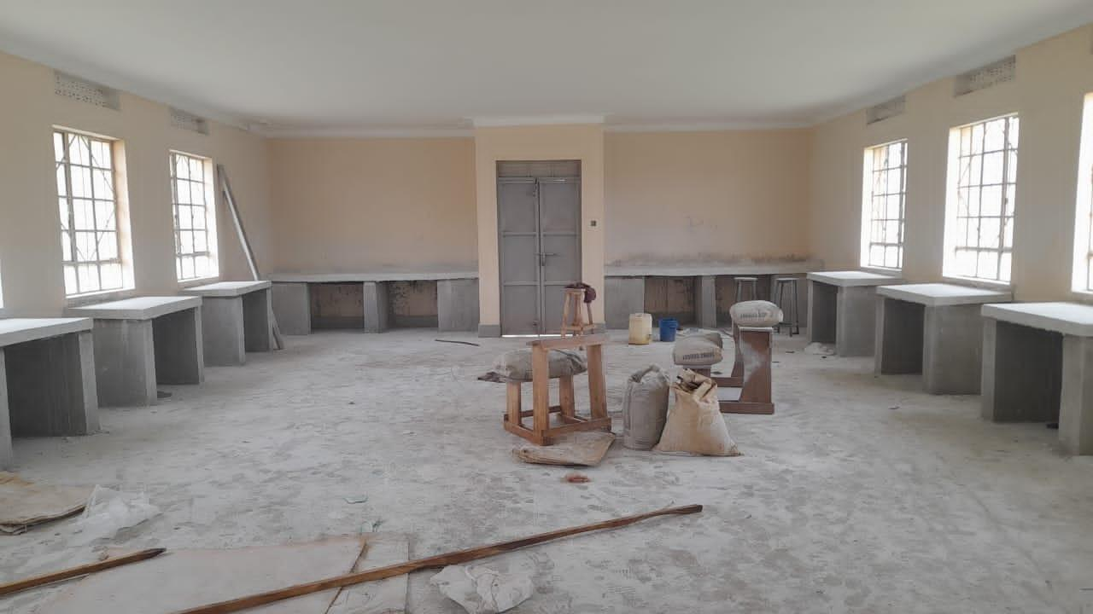  Figure 41: ICT laboratory interior under construction at Kitawoi Seed Secondary School, Kween District (Sebei)
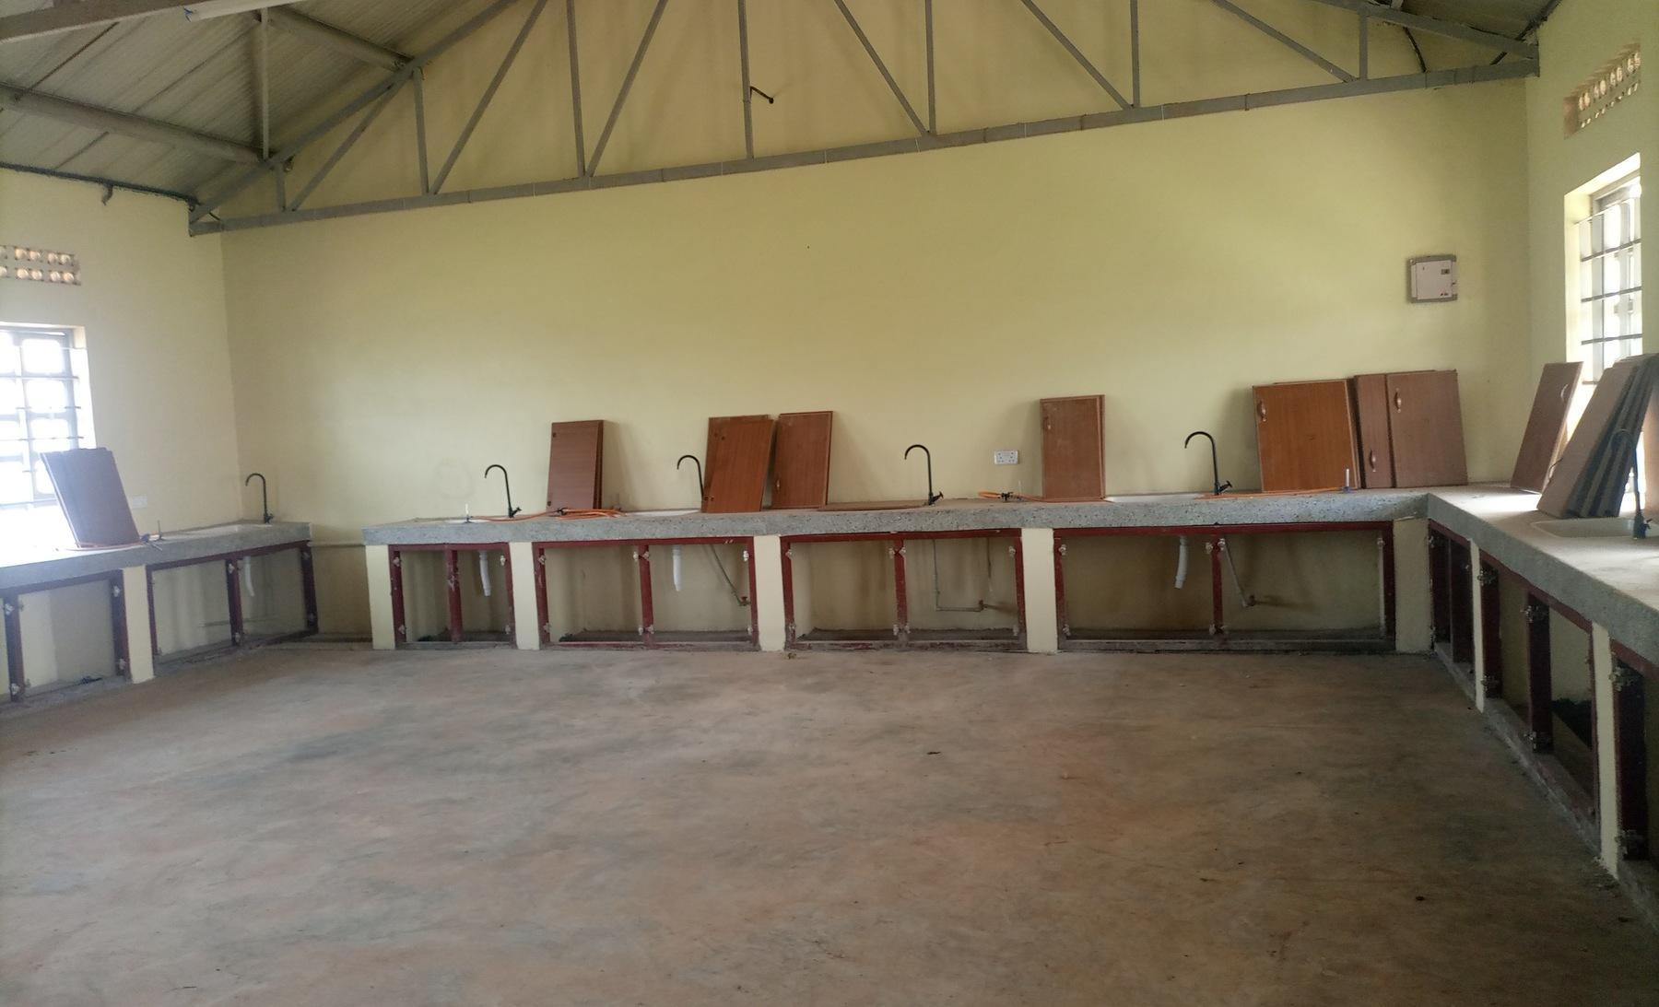  Figure 42: Laboratory benches with cupboard doors not yet fitted, in a science laboratory block recorded as under construction, at King Solomon Seed Secondary School, Kagadi District (Bunyoro) |  |  |  | 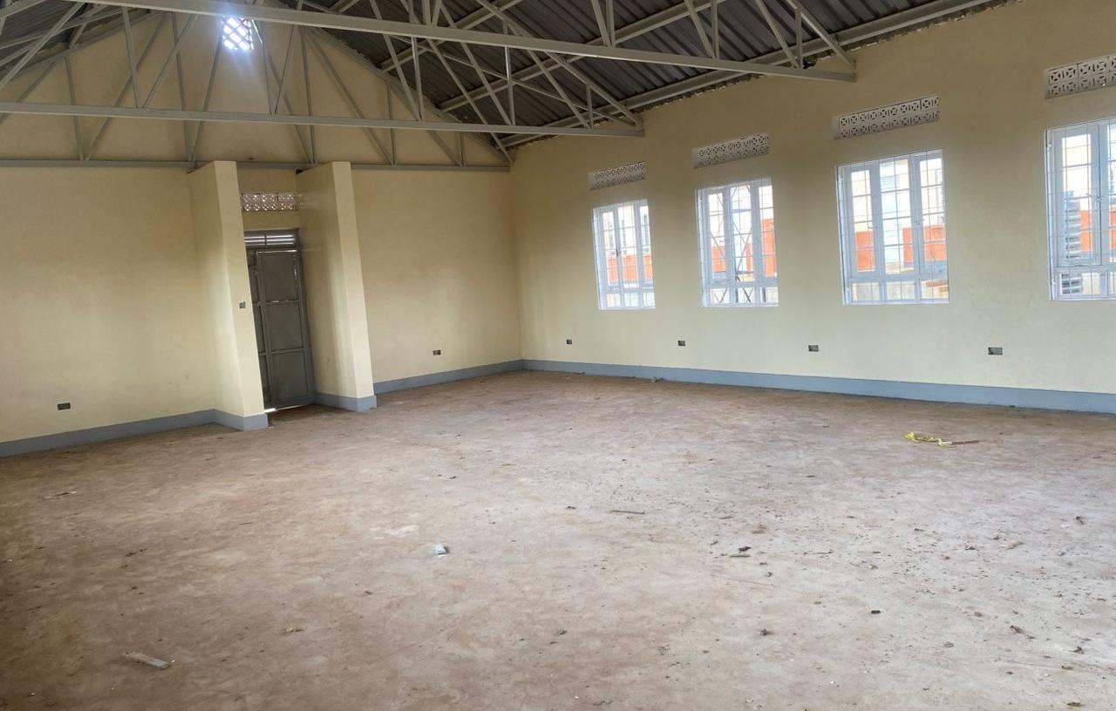  Figure 43: Empty computer laboratory at Kaptum Seed Secondary School, Kween District (Sebei), where the buildings had not been handed over and no ICT equipment had been received

3.10 Field Observations

Completion Status of Facilities
The verification established that there were a number of facilities that were either completed or not completed. Table 33 provides the status of the completed and non-completed buildings for both health centers and seed secondary schools.
Table 33: Completion Status for both Health centers and seed secondary schools
Status | Health centres | Schools | Total
Completed | 352 | 195 | 547
Ongoing | 19 | 63 | 82
Incomplete works | 13 | 57 | 70
Awaiting commissioning | 2 | 11 | 13
Total | 371 | 258 | 629

Table 33 indicates that 547 facilities were completed. Eighty-two facilities were ongoing comprising of 19 health centers and 63 seed secondary schools. The verification also showed that 70 facilities were incomplete, comprising 57 schools and 13 Health Centres. Another 13 facilities were awaiting handover or commissioning, comprising 11 schools and 02 Health Centres. Some facilities were providing services while works remained incomplete.

Location and Name changes
The verification exercise established that there were mismatches between information from the programme list and what was found on the ground. Out of 629 programme-list entries, 590 (93.8%) had supporting returns and 39 (6.2%) had discrepancies requiring reconciliation. These include entries on the programme list without matching returns or with conflicting location or facility-type information. Table 34 provides the details.
Table 34: Inconsistencies between the programme list and the facilities found
Status | Health centres | Schools | Total | Facilities
Facilities on the programme list but not on ground | 7 | 3 | 10 | Health centres: Olok HC II (Pader); Alik HC II (Lira); Acimi HC II (Oyam); Acokara HC II (Oyam); Ariba HC II (Oyam); Busia Eastern Division (Busia Municipal Council); Butoloogo HC II (Kassanda)  Seed schools: Eastern Division (Tororo Municipal Council); Central Division (Jinja City); Kishangara Seed School (Ibanda)
Not a UgIFT beneficiary | 2 | 1 | 3 | Health centres: Alira HC II (Oyam); Buyinda HC II (Kaliro)  Seed schools: Kiziranfumbi Seed School (Kikuube)
Exists with no UgIFT assets | 2 | 3 | 5 | Health centres: Pandwong HC II (Kitgum Municipal Council); Rwamujojo HC II (Sheema Municipal Council)  Seed schools: Bumbaire Seed School (Bushenyi); Kyamuhunga (Bushenyi); Kashenshero (Mitooma)
UgIFT assets relocated to another facility | 2 | 1 | 3 | Health centres: Alangi (Zombo) to Amwonyo HC III; Ther-uru HC II (Zombo) to Atyak HC III  Seed schools: Abanga (Zombo) to Kango SSS
Represented by another name | 2 | 0 | 2 | Health centers: Loinya HC II in Maracha (H213) was replaced by Liko HC III (H212),  Bussi HC II in Wakiso (H054) is treated as a village name for Zinga Health Centre III (H052).
Follow-up without a separate on-site asset return | 9 | 7 | 16 | Health Centers: Butalangu HC II and Semuto HC II in Nakaseke, Kiralamba HC II in Nakasongola, Kyondo HC II in Bundibugyo, Kabingo HC II in Kasese, Kyera HC II and Ntete HC II in Sembabule, Kyabakuza HC II in Masaka, and Lodonga TC in Yumbe.  Seed Schools: Kikamulo, Nakaseke Seed School and Ngoma in Nakaseke, Nakitoma in Nakasongola, Kichwamba in Kabarole, Karago TC in Fort Portal City, and Lwengo Seed School in Lwengo.
Total | 24 | 15 | 39

3.12 Impact of UgIFT Programme on service delivery
Of the 284 health centres, 238 (83.8%) reported at least one benefit from the UgIFT support. Improved maternity and delivery services were reported by 117 (41.2%), and 51 (18.0%) reported more or safer births at the facility. Improved antenatal, immunisation, laboratory or other specific services were reported by 89 (31.3%), improved access to care or shorter distances by 71 (25.0%) and more patients’ attendance reported by 61 (21.5%). More than half, 164 (57.7%), linked better services to the equipment and furniture supplied.
Of the 193 seed schools, 144 (74.6%) reported at least one benefit. A better learning environment, with classrooms, furniture and libraries, was reported by 74 (38.3%), and improved access to secondary education or shorter distances by 59 (30.6%). Practical science or ICT teaching improved at 39 schools (20.2%), and 37 (19.2%) reported higher enrolment. Forty schools (20.7%) also reported jobs and local economic benefits around the school.

3.12.1 Gaps and Challenges
The main gaps identified by the facilities include;
- Insufficient Power supply which was reported by 201 facilities (42.1%), including 44.4% of Health Centre respondents and 38.9% of school respondents;
- Inadequate Staffing which was reported by 32.1% of the facilities (153 of 477).
- Inadequate space or infrastructure reported by 31.7% of the facilities (151 of 477).
- Insecurity or absence of fencing reported by 27.0% of the facilities (129 of 477).
- Limited maintenance support was raised by 22.2% of the facilities (106 of 477).
- Inadequate staff houses reported by 22.0% of the facilities (105 of 477).
- Poor water supply reported by 20.1% of the facilities (96 of 477).
- inadequate training of staff to operate the equipment reported by 28.9% of the health centres (82 of 284), and 1.6% of schools (three of 193).
- Incomplete or delayed works, handover or commissioning reported by 28.0% of Seed Secondary School respondents (54 of 193) and 10.2% of Health Centre respondents (29 of 284).
- Equipment not installed, not assembled or delivered incomplete was raised by 17.6% of the facilities (84 of 477).

Figure 45: Service gaps and challenges

4 Asset management

4.1 Maintenance and repairs
Maintenance keeps UgIFT assets working for the services they were bought to support. Most of the verified assets are furniture, clinical equipment and computers in daily use at Health Centres and seed schools, where wear and breakage are to be expected. Routine checks, a record of faults and a dependable route for repair decide whether a broken item returns to use quickly or stays out of service. During the verification, each facility was asked how it maintains, repairs, services or replaces UgIFT assets and whether it keeps a regular record of their functionality or breakdown.
Repair arrangements. Of the 469 facilities that described their maintenance arrangements, 260 (55.4%) met repairs at facility level, from their own funds or with their own staff. Health Centres named Primary Health Care funds (94 of 278, 33.8%), while schools named the capitation or Universal Secondary Education grant, parents' contributions or the school budget (52 of 191, 27.2%). Busaale Health Centre III in Kayunga used Primary Health Care funds for repairs, and Kagumba Seed Secondary School in Kamuli had repaired broken furniture during the second term. A facility could describe more than one arrangement.
Support from outside the facility was cited by 152 facilities (32.4%): district offices, mainly the District Health Officer, 85 (18.1%); regional referral hospital workshops or national teams 52 (11.1%); hired technicians and artisans 27 (5.8%); and contractors or suppliers under defects liability, guarantee or warranty 12 (2.6%). Major medical equipment repairs depended on this support. Todora Health Centre III in Nwoya worked through the District Health Officer and the Gulu Regional Referral Hospital technical team, Avogera Health Centre III in Buliisa received support from Hoima Regional Referral Hospital, and Bundimulangya Health Centre III in Bundibugyo obtained a team through the District Health Officer.
In all, 97 facilities (20.7%), 59 of them schools, had not yet needed maintenance because the assets were new, not yet handed over or the buildings were still under construction, and 36 (7.7%) reported no repair arrangement, with broken items set aside or not repaired. Funds for maintenance and repair were reported as insufficient, particularly for major repairs, by 32 of the 505 facilities that described maintenance or challenges (6.3%). At Kyankaramata Health Centre III in Kyenjojo, Primary Health Care funds met minor repairs, but the cost of major repairs was a constraint.
Figure 46 compares these arrangements at Health Centres and seed schools. Health Centres relied more on outside technical support (41.4% of health centres against 19.4% of schools), while schools more often had not yet needed maintenance (30.9% against 13.7%).

Figure 46: Most facilities met repairs from their own funds or staff
Frequency. Few facilities worked to a fixed maintenance interval. Of the 494 programme-list facilities that described how they maintain UgIFT assets or check their condition, 50 (10.1%) did so at a fixed interval. Of these 50, 14 (28.0%) worked annually, 11 (22.0%) monthly, 10 (20.0%) quarterly, 9 (18.0%) every school term, 3 (6.0%) twice a year and 3 (6.0%) weekly or daily, as Figure 47 shows. A further 18 facilities (3.6%) described routine or scheduled servicing without a set interval, mostly scheduled visits by regional referral hospital maintenance teams, and 61 (12.3%) repaired items as the need arose. Ngwedo Seed Secondary School in Buliisa engaged a caretaker every month and used the Directorate of Industrial Training for furniture repairs, while Busaale reviewed asset condition every quarter.

Figure 47: Annual, monthly and quarterly checks were the most common stated intervals
Records. Of the 463 facilities that answered, 318 (68.7%) kept a regular record of asset functionality or breakdowns, 36 (7.8%) kept a partial or informal record, 80 (17.3%) kept none and 29 (6.3%) had not yet started because the assets were new or the facility was not yet operating. Of the 478 facilities that answered, 355 (74.3%) held a record of the UgIFT assets they received, 40 (8.4%) held a partial record, such as delivery notes only or a general register that does not identify UgIFT items, and 83 (17.4%) held none. Kagumba Health Centre III in Kamuli kept an asset condition book, a simple practice that other facilities can adopt.

4.2 Obsolete and Unserviceable Assets
Two wall-mounted aneroid blood-pressure machines at Nyanja Health Centre III, UGIFT-012842 and UGIFT-012843, were reported as spoilt, beyond repair and requiring replacement. Disposal approval or completion has not been confirmed.
A certified inventory of obsolete assets and an approved disposal schedule have not been established. Faulty equipment should be assessed individually for repair, replacement or disposal.

4.3 Missing and Unrecorded Assets
Assets reported stolen, items not received, equipment with missing accessories and items that could not be accessed during the visit require different follow-up. These circumstances cannot be combined into a single count of losses.
For example, the incubator at Buwembe Health Centre III (UGIFT-114904) and the ENT instrument set at Rubingo Health Centre III (UGIFT-188911) were reported not received. The wheelchair at Bukimanayi Health Centre III (UGIFT-115669) was not seen, and the officer in charge could not confirm whether it had been redistributed. Check delivery and transfer records before concluding that these assets were lost.
At Paloga Seed Secondary School, two monitors were reported stolen, while the others remained in use. At Bukiiro Seed Secondary School, accounts of 16 system units conflict: they were described as both present and functional and as stolen. Their status requires confirmation. At Ogur Seed Secondary School, furniture in locked rooms could not be verified because keys were unavailable; this is an access limitation, not evidence of loss.
The number of assets omitted from facility registers has not been established. A missing local asset register, an inaccessible item and a stolen asset should remain separate findings. Further examples and the required checks are set out in the asset reconciliation appendix.

5 Recommendations
Recommendation. Facility managers and school governing bodies should keep the local and regional repair arrangements that already work and adopt a fixed routine: a condition check at least every school term in schools and every quarter in health centres, and a full count of UgIFT assets each year. Each facility should keep a condition book or fault list naming each item requiring action, the responsible person and the agreed completion date; the 36 facilities with no repair arrangement and the 80 with no functionality or breakdown record should set these up first.
District health and education offices should review unresolved repairs each quarter and arrange technical assistance, and regional referral hospital workshops should include UgIFT equipment in their scheduled visits. Annual maintenance plans should separate minor repairs from major repairs such that the minor repairs be met from Primary Health Care funds or school grants, while major repairs can be handled through district or national funding.
Recommendation. Facility managers, district health and education officers, engineers and technical teams should prioritise unsafe furniture, electrical concerns and failed equipment needed for essential services. Withdraw unsafe items, obtain technical assessments and verify safe operation after repair. The broken down and not functional assets should be assessed in order of their effect on care and teaching, beginning with clinical equipment and the school furniture that makes up most of the broken down assets; items beyond economic repair should receive a formal disposal decision. At national level, the Office of the Prime Minister should decide on repair or replacement of its three laptops recorded as faulty, and Uganda Blood Transfusion Services (UBTS) should repair or replace the six blood-pressure machines recorded as faulty at Arua Regional Blood Bank. Keep damaged assets separate from usable assets awaiting installation so that each receives the appropriate action.
Recommendation. LG Accounting Officers, engineers, health and education officers and contractors should coordinate outstanding buildings, utilities, furniture and equipment through site-specific completion plans for each of the 83 documented facilities with works or handover outstanding, comprising seventy with incomplete works and thirteen awaiting handover or commissioning. These are documented minimums. Installation should follow confirmation that rooms, power, water and security are ready. Stored assets described as new or in good condition should be issued to the rooms where they are needed, and each asset waiting for power or installation should have a named date for connection and testing. Protect services already operating during construction. There should be complete testing and signing off before handover or closing each action.
Recommendation. District health officers, facility managers, suppliers and regional technical teams should provide practical training for staff who use specialist equipment, starting with the Health Centres that linked idle equipment to a lack of skills, including oxygen equipment users, for example, at Bubago and Sop Sop and staff requiring orientation at Avogera. Handover should include a demonstration, basic maintenance guidance and a named route for technical support. Future supply contracts should make on-site demonstration to the staff who will use the equipment, a condition of acceptance and staffing reviews should take account of the equipment each health centre now holds.
Recommendation. Institution asset managers and LG finance, health and education officers should engrave all the verified assets with UgIFT markings and confirm their locations and custodians. Assets carrying another marking only should receive the programme identifier at their next check. Resolve the continuing allocation of equipment e.g at Todora, Paraa and Masafu through signed transfer or receipt documentation, bring assets held at district stores to their facilities once rooms are ready, and complete delivery of the items still with suppliers.
The Ministry of Works and Transport should retain the completed tracing record and keep the confirmed custodians and locations current. Losses should be reported and investigated under the public finance rules, and every facility should hold a list of the UgIFT assets it received, showing each item, its engraving and its custodian. Maintain site, ownership and handover records for buildings and land.
Recommendation. The Ministry of Finance, Planning and Economic Development, with the Ministry of Health, the Ministry of Education and Sports and the local governments concerned, should approve a corrected programme list after rectifying the inconsistencies. The corrected list should then guide decisions wherever planned locations differed from what teams found.

5.1 Actions to address the reported service gaps
Table 35 sets out the actions, responsible officers and evidence of completion.
Table 35: Actions to address the reported service gaps
Gap | Responsible officers | Action | Evidence of completion
Power | LG engineers and facility managers | Assess electrical loads and complete safe grid or suitable alternative supply before testing and issuing idle equipment. | Connection and electrical test records
Staffing | District service authorities and sector ministries | Match staffing needs to operating rooms and equipment; deploy qualified staff through approved staffing and budget processes. | Approved deployment and duty rosters
Space | LG engineers and sector departments | Inspect room suitability, identify overcrowded services and sequence building completion or adaptations around service needs. | Room allocation and completion records
Security | Accounting Officers and facility governing bodies | Prioritise vulnerable stores and ICT rooms; provide secure storage, access controls and risk-based fencing. | Security inspection and custodian logs
Maintenance | Facility managers and district technical teams | Set funded maintenance schedules, record faults and escalate major repairs to the responsible workshop or supplier. | Fault register and closed repair orders
Staff housing | LG planners, engineers and sector departments | Identify housing constraints affecting attendance; complete contracted quarters and plan additional accommodation where justified. | Occupancy and outstanding-work schedules
Water | District water officers and facility managers | Restore reliable water and test storage, supply and sanitation connections before putting dependent equipment into use. | Water availability and system test records
Training | Sector technical teams and suppliers | Demonstrate operation, safety and basic care to named users; confirm competence and provide a support contact. | Training attendance and competency sign-off
Works | Accounting Officers, engineers and contractors | Agree site-specific defects and completion lists, milestones and handover requirements; verify each closure on site. | Inspection certificates and signed handover
Installation and delivery | Procurement units, suppliers and facility managers | Reconcile delivery notes, obtain missing parts, install equipment in ready rooms and complete acceptance tests. | Delivery reconciliation and acceptance tests

Appendices
  - Asset Register
  - Photographs

Appendix A Financial reconciliation and valuation limitations
The financial reporting date is 30 September 2026. Year-to-date depreciation covers 1 July to 30 September 2026. Amounts in Table 36 are in Uganda shillings, rounded to the nearest shilling after the totals are calculated. Only available amounts are added; blank cells and entries marked Pending calculation are not treated as zero. Each record has one unit, so no further quantity multiplier is applied.
Table 36: Available financial amounts and accounting coverage
Financial measure | Available records | Unavailable records | Available total UGX
Recorded cost | 227,938 | 1,086 | 996,812,628,890
Accumulated depreciation | 206,012 | 23,012 | 165,185,197,307
Year-to-date depreciation | 206,012 | 23,012 | 10,793,939,755
Net book value | 206,008 | 23,016 | 595,801,587,531
The cost, depreciation and net book value totals do not all cover the same records. A direct comparison is possible for 180,730 records classified CAPITALIZED or construction in progress (CIP), where all three amounts are available. Their recorded cost of UGX 760,986,784,838 less accumulated depreciation of UGX 165,185,197,307 gives net book value of UGX 595,801,587,531. For this group, net book value is 78.3% of cost. This is the share of recorded cost that has not been depreciated; it does not measure physical condition, service performance or market value. Table 37 reconciles the available recorded cost to net book value.
Table 37: Reconciliation of recorded cost and net book value
Reconciliation of available amounts | UGX
Available recorded cost, all accounting treatments | 996,812,628,890
Less known costs on records whose NBV remains unavailable | 190,742,908,682
Less positive recorded costs on expensed or non-recognized treatments | 45,082,935,370
Recorded cost of the assets with complete accounting information | 760,986,784,838
Less accumulated depreciation of those assets | 165,185,197,307
Net book value of those assets | 595,801,587,531
There are 21,978 records with a known cost but no calculated net book value. A further 5,336 records have positive costs but are treated as expenses or are not recognized as assets under the accounting treatment applied. Their costs must be excluded from the comparison above. This explains why subtracting all available depreciation from the full recorded cost does not give the reported net book value.

Extent of existing cost estimates
Table 38: Basis of recorded cost estimates
Basis of recorded cost | Records | Recorded cost UGX
Comparable assets within the same government | 26,922 | 122,474,661,776
Comparable assets in other governments | 139,671 | 699,262,256,528
Other available costs | 61,345 | 175,075,710,586
Total available costs | 227,938 | 996,812,628,890
Costs for 166,593 items were estimated by comparison with other assets, totalling UGX 821,736,918,304, or 82.44% of available recorded cost. These estimates require supporting valuation evidence. The other available costs also require acquisition or valuation records before they can be accepted as verified amounts. Costs remain missing for a further 1,086 items. Table 38 presents the basis of recorded costs.
Construction in progress requires particular care. Of 298 CIP records, 275 carry zero cost, 19 have positive cost totalling UGX 1,168,217,300 and four have missing cost. The reported CIP balance is therefore not a measure of the full value of unfinished works or the amount required to finish them. These are asset records, not 298 distinct incomplete facilities.
Depreciation includes the service month and is limited to cost less salvage value. Year-to-date depreciation is the increase in accumulated depreciation since the start of the financial year. All recorded salvage values are zero. The underlying dates and cost evidence require confirmation before the balances can be treated as verified amounts.
There are 23,154 fully depreciated items, including 22,161 still marked in use. These assets need a review of their condition and remaining useful life. A zero net book value alone is not a reason to regard an asset as failed, disposed of or due for replacement. The financial tables use the existing accounting classifications. Errors, such as diagnostic equipment classified as buildings, need supporting evidence and correction before category totals can be used as physical inventories.

Appendix B Service date exceptions and supporting evidence
Service-date entries across all assets
Table 39: Service-date entries across all assets
Service-date entry | Records | Share
Full date from 27 June 2017 to 30 September 2026 | 197,721 | 86.3%
Full date before 27 June 2017 | 3,345 | 1.5%
Month and year only | 2,987 | 1.3%
Year only | 7,701 | 3.4%
Year or financial-year period | 455 | 0.2%
Commissioning status or other text | 16,815 | 7.3%
Total asset records | 229,024 | 100.0%
Categories are mutually exclusive; rounded percentages may not total 100.0%. Table 39 presents mutually exclusive service-date categories; rounded percentages may not total 100.0%.
The cases in Table 40 illustrate service-date problems and the decisions required. They are examples rather than a complete list of all date exceptions. Asset references and facility names are provided to support follow-up.
Table 40: Service-date exception examples and supporting evidence
Asset reference | Location and service date | Finding and action
UGIFT-217326 | UNSPECIFIED  2009-08-20 | Source records purchase timing but leaves service date blank. Purchase does not establish commissioning.
UGIFT-010050 | Nkokonjeru Health Centre III  2012-03-01 | Service field absent or blank. No supported replacement date established.
UGIFT-010342 | Bukatube Health Centre III  2016-05-01 | Source records purchase timing but leaves service date blank. Purchase does not establish commissioning.
UGIFT-044388 | Maaji Seed Secondary School  2014-06-24 | Source records purchase timing but leaves service date blank. Purchase does not establish commissioning.
UGIFT-050677 | Labongo Amida Seed Secondary School  2014-01-01 | Service field absent or blank. No supported replacement date established.
UGIFT-114049 | Sikuda Seed Secondary School  2012-07-13 | Source states 13/7/2012 and Sikuda Primary School. Confirm legacy status, funding and school attribution.
UGIFT-118560 | Kyamwinula Health Centre III  2012-03-01 | Service field absent or blank. No supported replacement date established.
UGIFT-179828 | Makokoto Seed Secondary School  2014-01-01 | Service field absent or blank. No supported replacement date established.
UGIFT-196249 | Nyamarwa Seed Secondary School  2014-01-01 | Service field absent or blank. No supported replacement date established.
UGIFT-197564 | Namungo Seed Secondary School  2014-01-01 | Service field absent or blank. No supported replacement date established.
The shared 1 January 2014 value covers 260 wooden-chair records at Labongo Amida, 266 at Makokoto, 303 at Nyamarwa and 203 at Namungo. The original returns for these groups provide no service date. The sampled Kyamwinula source likewise lacks a service-date field and provides no full date to justify the stated date of 1 March 2012. The sampled Nkokonjeru return expressly states that receipt or service timing was not recorded. The dates therefore remain unresolved; the source material does not support replacement dates.

Rules for an approved register correction
Enter a full calendar date only when the evidence shows when the identified asset became available for use. Keep the source’s original wording and level of detail in the supporting record. A month, year, financial year or commissioning status must not be entered as though it were a full date.
Leave the date field blank in the corrected register where a full date cannot be supported. Record the reason, original value and source reference separately. Keep any work-in-progress or undelivered status visible even when the date is blank.
Where the source supports an early date, establish whether the asset predates UgIFT or has been assigned to the wrong beneficiary or programme. Do not simply move the year forward or remove the asset from the register. Record the approved decision about its ownership and programme assignment.
Before approving changes, compare purchase and service dates, check repeated entries and confirm which physical units they describe. A date may be applied to a whole batch only where the documents identify both the batch and the relevant event. Similar item names or dates at another facility are not sufficient evidence.
For each approved change, record the original and revised values, supporting evidence, decision, responsible officer and review date. Recalculate depreciation, net book value and any recoverable amount based on net book value. Retain independently supported recoverable amounts separately. Check the resulting balances and outstanding exceptions before migration to IFMIS.

Appendix C Definitions used in the analysis
The condition descriptions in section 2.5 distinguish physically faulty assets from usable items in store or awaiting installation. The quantitative tables use the current register codes: 215,504 assets marked Functional and in use, and 13,520 marked Faulty and not in use. All entries marked not in use carry the Faulty code in these totals, including usable stored or uninstalled items; the 13,520 therefore does not represent a count of physically broken assets.
The definitions in Table 41 explain how quantities, condition and financial values are presented. Unresolved receipt, ownership and classification matters are included in the relevant schedules for follow-up.
Table 41: Definitions used in the analysis
Term | Meaning in this report
Asset quantities | Each entry represents one recorded unit. Totals include capitalized, expensed and unresolved entries; receipt and ownership exceptions require confirmation.
Institution and location | Assets are grouped by the institution and beneficiary to which they are attributed. Transfers, substitutions and uncertain programme assignments require reconciliation.
Asset categories | The categories describe the existing accounting classification. Known errors require correction before the categories can be treated as confirmed physical inventories.
Recorded cost | The available cost in Uganda shillings. Some amounts are estimates. A missing amount remains unresolved and is distinguished from a recorded zero.
Service and purchase dates | The service date is when the asset became available for use. The purchase date is a separate event and does not establish the service date.
Useful life and salvage value | Useful life is the period used for depreciation. Salvage value is the amount expected to remain at the end of that period. Neither determines when an asset physically fails.
Depreciation | Accumulated depreciation is the cost allocated over the asset’s accounting life to date. Year-to-date depreciation covers 1 July to 30 September 2026. Pending calculations remain unavailable.
Net book value | Recorded cost less accumulated depreciation for assets recognized for accounting purposes. Comparisons use the same records with all required amounts available.
Recoverable amount | An independently supported recoverable amount must be distinguished from a value based on net book value. The latter does not constitute an independent impairment valuation.
Asset identification | Asset references, programme markings, serial numbers and vehicle registrations help establish identity. Shared identifiers and missing markings require physical and custody checks.
Condition and use | Functional and Faulty are the two reported condition classes. Reasons for non-use are examined separately to determine whether installation, repair, replacement or disposal is appropriate.
Complete accounting information | Assets classified CAPITALIZED or construction in progress, with cost, accumulated depreciation and net book value all available. These provide the basis for direct financial reconciliation.
The analysis distinguishes the thirteen asset-holding MDAs, the three regional blood banks, health centres, schools, hospitals and other local-government locations. Institution totals, programme-list facilities and interview respondents represent different populations and should not be used interchangeably.
Asset numbers are missing for 1,923 entries, while 34 state Not engraved. Three linked asset-number entries disagree: one at Birembo Health Centre III and two at Namungo Seed Secondary School. There are also 355 repeated asset-number values and 323 repeated serial-number values within individual institution books. Quantities and supporting records should be checked before any assets are counted as duplicates.

Principal references
Programme chronology: World Bank UgIFT Additional Financing programme paper, section I, paragraph 1, printed page 1.
Accounting policy context: Government of Uganda Asset Accounting Policies and Guidelines 2023, sections 3.3.5.2, 5.5, 5.7 and 5.9; pages 49, 67 and 68.
Field photographs and reports describe conditions at the time of the visits. Photographs alone cannot confirm functionality, completion, programme ownership or current condition.

Appendix D Programme list exception roster
The 39 entries in Table 42 explain gaps or differences between the programme list and the available asset returns. Reported absence is not an independent finding that a facility does not exist. A receiving facility already on the list is counted once.
Table 42: Programme-list exception roster
ID | Programme-list entry and LG | Outcome
H205 | Olok HC II  Pader | Reported absent or not constructed
H190 | Alik HCII  Lira | Reported absent or not constructed
H197 | Acimi HC II  Oyam | Reported absent or not constructed
H195 | Acokara HCII  Oyam | Reported absent or not constructed
H200 | Ariba HC II  Oyam | Reported absent or not constructed
H070 | Busia Eastern Division  Busia MC | Reported absent or not constructed
S010 | Eastern Division  Tororo MC | Reported absent or not constructed
S012 | Central Division  Jinja City | Reported absent or not constructed
S216 | Kishangara seed school  Ibanda | Reported absent or not constructed
H010 | Butoloogo HC II  Kasanda | Reported absent or not constructed
H193 | Alira HCII  Oyam | Outside UgIFT scope
H086 | Buyinda HC II  Kaliro | Outside UgIFT scope
S237 | Kiziranfumbi Seed School  Kikuube | Outside UgIFT scope
H149 | Pandwong HC II  Kitgum MC | No UgIFT assets reported
S214 | Bumbaire Seed School  Bushenyi | No UgIFT assets reported
S215 | Kyamuhunga  Bushenyi | No UgIFT assets reported
S221 | Kashenshero  Mitooma | No UgIFT assets reported
H282 | Rwamujojo HC II  Sheema MC | No UgIFT assets reported
H231 | Alangi  Zombo | Assets relocated
H233 | Ther-uru HC II  Zombo | Assets relocated
S208 | Abanga  Zombo | Assets relocated
H213 | Loinya HC II  Maracha | Already represented elsewhere
H054 | Bussi HC II  Wakiso | Already represented elsewhere
H044 | Butalangu HC II  Nakaseke | Follow-up without on-site return
H043 | Semuto HC II  Nakaseke | Follow-up without on-site return
S087 | Kikamulo  Nakaseke | Follow-up without on-site return
S088 | Nakaseke Seed School  Nakaseke | Follow-up without on-site return
H045 | Kiralamba HC II  Nakasongola | Follow-up without on-site return
S089 | Nakitoma  Nakasongola | Follow-up without on-site return
H370 | Kyondo HC II  Bundibugyo | Follow-up without on-site return
H373 | Kabingo HCII  Kasese | Follow-up without on-site return
H048 | Kyera HCII  Sembabule | Follow-up without on-site return
H047 | Ntete HCII  Sembabule | Follow-up without on-site return
H031 | Kyabakuza HCII  Masaka | Follow-up without on-site return
S059 | Kichwamba  Kabarole | Follow-up without on-site return
S058 | Karago TC  Fort-Portal City | Follow-up without on-site return
S004 | Ngoma  Nakaseke | Follow-up without on-site return
S080 | Lwengo Seed School  Lwengo | Follow-up without on-site return
H227 | Lodonga TC  Yumbe | Follow-up without on-site return

Appendix E Documented outstanding works and handover
Table 43 lists the 70 facilities with documented incomplete works and the 13 additional facilities awaiting handover or commissioning. It is a minimum list of documented cases, not a certification of the remaining facilities. A facility may operate while a block or ancillary structure remains unfinished.
Table 43: Documented outstanding works and handover
ID | Facility and LG | Outstanding matter
H145 | Omot Health Centre III  Agago | Incomplete works
H112 | Bukibologoto Health Centre III  Bulambuli | Incomplete works
H181 | Adagmon Health Centre III  Dokolo | Incomplete works
H008 | Mamba Health Centre III  Gomba | Incomplete ancillary works
H009 | Ngomamene Health Centre III  Gomba | Incomplete ancillary works
H312 | Maregamo Health Centre III  Kisoro | Incomplete works
H152 | Moyok Health Centre III  Kween | Handover or commissioning
H155 | Kaptum Health Centre III  Kween | Incomplete works
H156 | Benet Health Centre III  Kween | Incomplete works
H356 | Mutungo Health Centre III  Makindye-Ssabagabo MC | Incomplete ancillary works
H366 | Lama Health Centre III  Moyo | Incomplete works
H355 | Matugga Health Centre III  Nansana MC | Incomplete ancillary works
H367 | Tekulu Health Centre III  Omoro | Incomplete works
H368 | Abwoch Health Centre III  Omoro | Incomplete works
H228 | Amanyiri Health Centre III  Yumbe | Handover or commissioning
S141 | Alerek Seed Secondary School  Abim | Handover or commissioning
S021 | Kotomor Seed Secondary School  Agago | Incomplete works
S022 | Lamiyo Seed Secondary School  Agago | Incomplete works
S027 | Akwon Seed Secondary School  Amolatar | Incomplete works
S145 | Looro Seed Secondary School  Amudat | Incomplete works
S157 | Asamuk Seed Secondary School  Amuria | Incomplete works
S024 | Amuru Town Seed Secondary School  Amuru | Handover or commissioning
S030 | St Peters Aroi Seed Secondary School  Arua | Incomplete works
S005 | Kakule Seed Secondary School  Budaka | Handover or commissioning
S007 | Bushiribo Seed Secondary School  Bududa | Incomplete works
S011 | Mpiita Seed Secondary School  Bugweri | Incomplete works
S014 | Senendet Seed Secondary School  Bukwo | Incomplete works
S046 | Kihungya Seed Secondary School  Buliisa | Incomplete works
S054 | Burondo Seed Secondary School  Bundibugyo | Incomplete works
S055 | Kabango Seed Secondary School  Bundibugyo | Incomplete works
S250 | Kisuba Seed Secondary School  Bundibugyo | Incomplete works
S056 | Katugunda Seed Secondary School  Bunyangabu | Incomplete works
S057 | Nsuura Seed Secondary School  Bunyangabu | Incomplete works
S096 | Sikuda Seed Secondary School  Busia | Handover or commissioning
S009 | Muhula Seed Secondary School  Butaleja | Incomplete works
S025 | Patiko Seed Secondary School  Gulu | Incomplete works
S230 | Kidukuru Seed Secondary School  Hoima | Handover or commissioning
S019 | Sidok Seed Secondary School  Kaabong | Incomplete works
S159 | Aperikira Seed Secondary School  Kaberamaido | Incomplete ancillary works
S047 | Burora Seed Secondary School  Kagadi | Handover or commissioning
S048 | King Solomon Seed Secondary School  Kagadi | Incomplete works
S049 | Kitegwa Community Seed Secondary School  Kagadi | Incomplete works
S232 | St Catherine Kicucura Seed Secondary School  Kagadi | Incomplete works
S060 | Bwesumbu Seed Secondary School  Kasese | Incomplete works
S001 | Lwamata Town Council Seed Secondary School  Kiboga | Incomplete works
S050 | Kyangwali Seed Secondary School  Kikuube | Handover or commissioning
S040 | Lake Mburo Seed Secondary School  Kiruhura | Incomplete works
S051 | Kigumba Town Seed Secondary School  Kiryandongo | Incomplete works
S254 | Kanara Seed Secondary School  Kitagwenda | Handover or commissioning
S149 | Rengen Seed Secondary School  Kotido | Incomplete works
S164 | Kumi Seed Secondary School  Kumi | Incomplete ancillary works
S131 | Kaptum Seed Secondary School  Kween | Incomplete works
S132 | Kitawoi Seed Secondary School  Kween | Incomplete works
S133 | Moyok Seed Secondary School  Kween | Incomplete works
S075 | Ntwetwe Seed Secondary School  Kyankwanzi | Incomplete works
S256 | Rwentuha Seed Secondary School  Kyegegwa | Incomplete works
S061 | Kyarusozi Seed Secondary School  Kyenjojo | Incomplete works
S257 | Kigaraale Seed Secondary School  Kyenjojo | Incomplete works
S258 | Kyembogo Seed Secondary School  Kyenjojo | Incomplete works
S026 | Padibe Seed Secondary School  Lamwo | Incomplete works
S015 | Butta Seed Secondary School  Manafwa | Incomplete works
S016 | Sisuni Seed Secondary School  Manafwa | Incomplete works
S135 | Khabutoola Seed Secondary School  Manafwa | Incomplete works
S136 | Sibanga Seed Secondary School  Manafwa | Handover or commissioning
S151 | Rupa Seed Secondary School  Moroto | Incomplete ancillary works
S200 | Dufile Seed Secondary School  Moyo | Incomplete works
S085 | Kigando Seed Secondary School  Mubende | Incomplete works
S020 | Moruita Seed Secondary School  Nakapiripirit | Incomplete works
S153 | Nakapiripirit Seed Secondary School  Nakapiripirit | Incomplete works
S018 | Mukuto Seed Secondary School  Namisindwa | Incomplete works
S154 | Iriiri Seed Secondary School  Napak | Handover or commissioning
S033 | Mamba Seed Secondary School  Nebbi | Incomplete works
S034 | Ndhew Seed Secondary School  Nebbi | Incomplete works
S201 | Atego Seed Secondary School  Nebbi | Incomplete works
S062 | Butungama Seed Secondary School  Ntoroko | Incomplete works
S063 | Kibuuku Seed Secondary School  Ntoroko | Incomplete ancillary works
S035 | Got Apwoyo Seed Secondary School  Nwoya | Incomplete works
S028 | Okum Seed Secondary School  Otuke | Incomplete works
S102 | Olok Seed Secondary School  Pallisa | Incomplete ancillary works
S170 | Kamuda Seed Secondary School  Soroti | Incomplete works
S105 | Malaba Seed Secondary School  Tororo | Handover or commissioning
S209 | Atyak Seed Secondary School  Zombo | Incomplete works
S210 | Kango Seed Secondary School  Zombo | Incomplete ancillary works
Two additional locations outside this programme-list schedule, have outstanding works or commissioning: Bukuuku Community Seed Secondary School has staff quarters and a kitchen under construction; Kibuzigye Seed Secondary School has a kitchen recorded as completed and operational but not yet commissioned. Their programme-list attribution requires reconciliation.

Appendix F Facility interview scope and denominators
The interview analysis counts each programme-list facility once per topic. Multiple returns for a facility are reconciled before analysis. Answers about another institution, statements that do not answer the question and unclassifiable replies are excluded from the relevant denominator. The Mbirizi school response attributed to Kagganda Health Centre is excluded from health-centre analysis pending correction of the identity. Receiving-facility responses are linked to the appropriate programme entry. Table 44 gives the interview denominators.
Table 44: Facility interview scope and denominators
Measure | Health centres | Schools | Total
Service benefits and challenges | 284 | 193 | 477
Maintenance arrangements | 278 | 191 | 469
Maintenance or condition-check frequency | 294 | 200 | 494
Classified functionality or breakdown records | 282 | 181 | 463
Classified records of assets received | 281 | 197 | 478
A benefit or challenge percentage uses the respondents to that question, not all 629 programme-list entries. Topic categories overlap. The broader challenge measure includes both an explicitly described problem and a request for its remedy; it should not be confused with the narrower count of explicit complaints. The 50 fixed-interval responses combine maintenance and condition-check information. Forty-four facility responses share wording with another return, so the findings should be read as accounts reported by facilities, rather than independent measurements of impact.

Appendix G Asset reconciliation examples
The cases in Table 45 require delivery, custody or condition checks. They do not provide a national total of losses or disposals. Where a report concerns a batch of equipment, the affected items still need to be identified.
Table 45: Asset reconciliation examples
Facility and item | Asset reference | Finding and action
Kijuna Health Centre III  Oxygen Therapy Apparatus, Mininum 45L cylinder | UGIFT-003939 | Oxygen therapy apparatus lacks regulators/accessories. This concerns missing parts, not the whole asset.
Nyanja Health Centre III  B.P. Machine (Aneroid wall mounted) | UGIFT-012842 | Two machines, UGIFT-012842 and UGIFT-012843, were reported beyond repair. Disposal approval remains unconfirmed.
Paloga Seed Secondary School  Desktop Computer | UGIFT-052080 | Two monitors were reported stolen, while the others remained in use. Confirm which items were affected.
Ogur Seed Secondary School  Desks | UGIFT-057485 | Furniture in locked rooms could not be verified because keys were unavailable. Confirm its location and condition.
Buwembe Health Centre III  Incubator | UGIFT-114904 | Incubator reported not received. Check delivery records before concluding that it was lost.
Bukimanayi Health Centre III  Wheel Chair | UGIFT-115669 | Wheelchair not seen; possible redistribution unconfirmed. Establish its location.
Ikumbya Seed Secondary School  Desktop Computer | UGIFT-140448 | Reported quantities: 29 received, 12 verified, 10 stolen and two faulty. Reconcile receipt, transfer and loss records.
Kitojo Health Centre III  Microscope Binocular | UGIFT-150498 | Microscope reportedly not received although status says Functional. Resolve the contradiction.
Bukiiro Seed Secondary School  System Unit | UGIFT-159973 | Accounts of 16 system units conflict: described as both present and functional and as stolen. Confirm their status.
Rubingo Health Centre III  Instrument set, ENT Basic for HCIII | UGIFT-188911 | ENT instrument set reportedly not received. Reconcile supplier and facility receipt records.

Appendix H Photographic schedule
The photographs illustrate facilities, equipment and outstanding works at the time of the visits. They should be read alongside the findings on condition, use and completion. A photograph alone does not establish that equipment was functional or that a facility was ready for handover. Table 46 provides the photographic schedule.
Table 46: Photographic schedule
Facility | Photographic subject
Majanji Health Centre III | Delivery bed with a torn mattress cover at a health centre, Busia District (Bukedi).
Lungulu Seed Secondary School | Boxed computers and related equipment in a seed school store, Nwoya District (Acholi).
Malaba Seed School | UgIFT identification on a desk at a seed school, Tororo District (Bukedi).
Got Apwoyo Seed Secondary School | Unfinished school block at Got Apwoyo Seed Secondary School, Nwoya District (Acholi).
Lwamata Town Council Seed Secondary School | Building works at a seed secondary school, Kiboga District (Buganda).
Butungama Seed Secondary School | School block awaiting completion at Butungama Seed Secondary School, Ntoroko District (Tooro).
Bukibologoto Health Centre II | Cracked health centre block above collapsed ground, Bulambuli District (Bugisu).
Bundege Health Centre III | Stained and peeling ceiling at a health centre, Sironko District (Bugisu).
Napak Seed Secondary School | Stacked desks, chairs and stools at a seed secondary school, Napak District (Karamoja).
Butungama Seed Secondary School | Laboratory stools and other school furniture in storage, Ntoroko District (Tooro).
Kibiri Health Centre III | Boxed pulse oximeters at a health centre, Makindye-Ssabagabo Municipal Council (Buganda).
Ndhew Seed Secondary School | Building works and construction materials at Ndhew Seed Secondary School, Nebbi District (West Nile).
Simu Pondo Health Centre III | Unfinished laboratory building at a health centre, Sironko District (Bugisu).
Namboko Seed Secondary School | Broken desk frame at a seed secondary school, Namisindwa District (Bugisu).
Sibanga Seed School | Books displayed on library shelves at Sibanga Seed School, Manafwa District (Bugisu).
Kamuli HC III | Maternity block entrance and access ramp at Kamuli HC III, Tororo District (Bukedi).
Kyabasara Health Centre III | Hospital beds and screens stacked in storage at a health centre, Kagadi District (Bunyoro).
Kihungya Seed Secondary School | Biology laboratory under construction at a seed secondary school, Buliisa District (Bunyoro).
Older Butiaba Health Centre III facility | Flood-affected older health facility at Butiaba, Buliisa District (Bunyoro).
Kaptum Seed Secondary School | Empty computer laboratory at a seed secondary school, Kween District (Sebei).
Kalemungole HC III | Programme engraving on a weighing scale at Kalemungole HC III, Moroto District (Karamoja).
Kalemungole HC III | Wheelchair with programme marking at Kalemungole HC III, Moroto District (Karamoja).
Sidok Seed Secondary School | Unfinished classroom block at Sidok Seed Secondary School, Kaabong District (Karamoja).
Sidok Seed Secondary School | Latrine block under construction at Sidok Seed Secondary School, Kaabong District (Karamoja).
Kihungya Seed Secondary School | Unfinished laboratory interior at Kihungya Seed Secondary School, Buliisa District (Bunyoro).
Kihungya Seed Secondary School | Library interior under construction at Kihungya Seed Secondary School, Buliisa District (Bunyoro).
King Solomon Seed Secondary School | School engraving on wooden furniture at King Solomon Seed Secondary School, Kagadi District (Bunyoro).
King Solomon Seed Secondary School | Boxed projector and other equipment at King Solomon Seed Secondary School, Kagadi District (Bunyoro).
Budde Seed Secondary School | Programme and school engraving on a chair at Budde Seed Secondary School, Butambala District (Buganda).
Sisiyi Seed Secondary School | ICT laboratory block and entrance ramp at Sisiyi Seed Secondary School, Bulambuli District (Bugisu).
Majanji HC III | Pedal suction unit in packaging at Majanji HC III, Busia District (Bukedi).
Bumufuni Seed Secondary School | Computer sets stacked in a store at Bumufuni Seed Secondary School, Bulambuli District (Bugisu).
Kitawoi Seed Secondary School | ICT laboratory interior under construction at Kitawoi Seed Secondary School, Kween District (Sebei).
Moyok HC III | Institutional engraving on equipment at Moyok HC III, Kween District (Sebei).
Kibiri HC III | Health centre building at Kibiri HC III, Makindye-Ssabagabo Municipal Council (Buganda).
Gyagenda Memorial Seed Secondary School | Classroom furnished with desks and a whiteboard at Gyagenda Memorial Seed Secondary School, Kalangala District (Buganda).
Kihungya Seed Secondary School | Classroom block with earthworks in the foreground at Kihungya Seed Secondary School, Buliisa District (Bunyoro).
Kihuukya HC III | Health centre buildings and covered walkway at Kihuukya HC III, Hoima City (Bunyoro).
Kihuukya HC III | Binocular microscope at Kihuukya HC III, Hoima City (Bunyoro).
King Solomon Seed Secondary School | Laboratory benches with cupboard doors detached at King Solomon Seed Secondary School, Kagadi District (Bunyoro).
Iriiri Seed Secondary School | Computer and library block interior with furniture and stored items at Iriiri Seed Secondary School, Napak District (Karamoja).
Kamoru HC III | Microscope bearing local facility identification at Kamoru HC III, Kotido District (Karamoja).
Aperikira Seed Secondary School | Engraving reading APESSS MOES/UGIFT/KABE/SPLRS/2023-24/001 on a desk at Aperikira Seed Secondary School, Kaberamaido District (Teso)
Arua Regional Blood Bank | Completed blood bank building at Arua Regional Blood Bank, Arua City (West Nile)
Arua Regional Blood Bank | Markings PEP II/UBTS/COMP/11/016 and UBTS/UGIFT/ARBB/UPS/001 on uninterruptible power supplies at Arua Regional Blood Bank, Arua City (West Nile)
Hoima Regional Blood Bank | Donor couches in the donor room at Hoima Regional Blood Bank, Hoima City (Bunyoro)
Hoima Regional Blood Bank | Benchtop centrifuge at Hoima Regional Blood Bank, Hoima City (Bunyoro)
Arua Regional Blood Bank | Blood bank refrigerator at Arua Regional Blood Bank, Arua City (West Nile)
Arua Regional Blood Bank | Platelet agitator at Arua Regional Blood Bank, Arua City (West Nile)
Benet Health Centre III | Incomplete staff quarters at Benet Health Centre III, Kween District. Field visit 27 August 2026.
Benet Health Centre III | Interior awaiting completion at Benet Health Centre III, Kween District. Field visit 27 August 2026.
Benet Health Centre III | A further unfinished room at Benet Health Centre III, Kween District. Field visit 27 August 2026.
Hoima Regional Blood Bank | Freezer at Hoima Regional Blood Bank.
Soroti Regional Blood Bank | Refrigerators at Soroti Regional Blood Bank.

Appendix I Land records and ownership evidence
Eighteen entries are classified as land, including four at health centres. Ownership, area, tenure and valuation require supporting documents. Table 47 lists these entries for follow-up by the responsible institutions.
Table 47: Land records and ownership evidence
Asset reference | Location | Item | Cost UGX m | Available evidence
UGIFT-119332 | Kyamwinula Health Centre III | Land | 20.000 | Functional.
UGIFT-128460 | Sop Sop Health Centre III | 70X300M | 20.000 | Functional. Good and In Use.
UGIFT-177218 | Luwube Muslim Seed Secondary School | Land | Unavailable | Functional.
UGIFT-183077 | Kigorobya Seed Secondary School | Land | 0.912 | Functional. Only a partial service date is available; the exact date requires confirmation.
UGIFT-183078 | Kigorobya Seed Secondary School | Land | 0.912 | Functional. Only a partial service date is available; the exact date requires confirmation.
UGIFT-183079 | Kigorobya Seed Secondary School | Land | 0.912 | Functional. Only a partial service date is available; the exact date requires confirmation.
UGIFT-183080 | Kigorobya Seed Secondary School | Land | 0.912 | Functional. Only a partial service date is available; the exact date requires confirmation.
UGIFT-183081 | Kigorobya Seed Secondary School | Land | 0.912 | Functional. Only a partial service date is available; the exact date requires confirmation.
UGIFT-183082 | Kigorobya Seed Secondary School | Land | 0.912 | Functional. Only a partial service date is available; the exact date requires confirmation.
UGIFT-183083 | Kigorobya Seed Secondary School | Land | 0.912 | Functional. Only a partial service date is available; the exact date requires confirmation.
UGIFT-183084 | Kigorobya Seed Secondary School | Land | 0.912 | Functional. Only a partial service date is available; the exact date requires confirmation.
UGIFT-183085 | Kigorobya Seed Secondary School | Land | 0.912 | Functional. Only a partial service date is available; the exact date requires confirmation.
UGIFT-183086 | Kigorobya Seed Secondary School | Land | 0.912 | Functional. Only a partial service date is available; the exact date requires confirmation.
UGIFT-183087 | Kigorobya Seed Secondary School | Land | 0.912 | Functional. Only a partial service date is available; the exact date requires confirmation.
M161436 | Kabweri Seed Secondary School | School Land | 50.000 | Functional.
M161488 | Nalubembe Health Centre III | Hospital Land | 15.000 | Functional.
M183485 | Kasasira Seed Secondary School | School Land | 50.000 | Functional.
M183544 | Kabweri Health Centre III | Hospital Land | 15.000 | Functional.
Costs include nil amounts and estimates.

Appendix J Additional assets and classification checks
Hospitals on local-government books: 3,067 records. These are included in the report total and shown separately from Health Centres and schools. Table 48 presents the category financial values.
Table 48: Recorded financial values for hospitals on local-government books
Asset category and coverage | Recorded cost | Accumulated depreciation | Net book value | NBV / cost
Medical, laboratory and research appliances  2,843 records; NBV 2,632/2,843 | 1,436.617 | 738.099* | 546.884* | 42.6%
Outside fixed-asset classification  145 records; NBV 145/145 | 1.000 | 0.000 | 0.000 | n/a
Furniture and fittings  68 records; NBV 10/68 | 52.427 | 3.696* | 7.832* | 67.9%
Buildings and structures  6 records; NBV 4/6 | 396.408 | 35.986* | 356.923* | 90.8%
Other classified assets  3 records; NBV 3/3 | 1.010 | 0.662 | 0.348 | 34.5%
ICT equipment  2 records; NBV ½ | 0.552* | 0.506* | 0.046* | 8.3%
Amounts are in UGX million, rounded to three decimals. * Available amounts only; one or more amounts are missing or pending calculation. NBV coverage is given for each category. NBV/cost compares complete accounting records and does not measure physical condition. n/a means a comparable ratio is unavailable.
Other local-government or unassigned locations: 4 records. These are included in the report total and shown separately from Health Centres and schools. Table 49 presents the category financial values.
Table 49: Recorded financial values for other local-government locations
Asset category and coverage | Recorded cost | Accumulated depreciation | Net book value | NBV / cost
Transport equipment  4 records; NBV 4/4 | 431.136 | 279.424 | 151.712 | 35.2%
Amounts are in UGX million, rounded to three decimals. * Available amounts only; one or more amounts are missing or pending calculation. NBV coverage is given for each category. NBV/cost compares complete accounting records and does not measure physical condition. n/a means a comparable ratio is unavailable.
Review the classification of diagnostic sets listed under buildings and structures. Confirm item descriptions, account mapping, ownership and useful life before migration to IFMIS.

Appendix K Financial analysis by asset type
Tables 50 to 67 present financial values by asset type for each ministry, regional blood bank, Health Centres and schools. They separate laptops, printers, furniture, medical equipment and other items while retaining the full institution totals. Recorded costs, accumulated depreciation and net book values agree with the broader financial analysis in the report.
Items are grouped by their descriptions, with accounting categories used where the description is insufficient. Each record represents one unit. A desktop-computer description may refer to a system unit or an incomplete set; separately listed monitors, CPUs, keyboards and mice are therefore shown as components. Accessories and supplies are included even where they are not recognized as fixed assets. Unclear descriptions are reported separately. Some descriptions differ from their accounting categories: for example, Van de Graaff generators and strip cups classified as transport are grouped here as laboratory items. Their accounting classifications require correction.
Amounts are in UGX million at 30 September 2026, rounded to three decimals. An asterisk means the total includes available amounts only; Unavailable means none of the amounts for that measure can be calculated. NBV coverage shows how many records have a net book value. The NBV/cost ratio uses only CAPITALIZED or CIP records with cost, depreciation and net book value all available. It shows the share of cost not yet depreciated, not physical condition or market value. n/a means there is no positive cost on that comparable basis.

The four land entries were for Kyamwinula Health Centre III (UGIFT-119332), Sop Sop Health Centre III (UGIFT-128460), Nalubembe Health Centre III (M161488) and Kabweri Health Centre III (M183544). Dimensions are stated only for Sop Sop, at 70 × 300 metres.

