
CONSULTANCY SERVICES TO VERIFY AND RECORD ASSETS UNDER THE UGIFT Program

REF: MOFPED/UGIFT/CONS/25/26/00015

ASSET VERIFICATION DRAFT REPORT

SUBMITTED BY:


Plot 31, Bukoto Street
P.O Box 7657, Kampala, Uganda
+256 (0) 39 2000216/0772525235
email: cpa@cpa.ug
www.cpa.com

OCTOBER 2026

Contents
List of acronyms v
Executive summary vi
1 INTRODUCTION AND BACKGROUND 1
1.1. Introduction 1
1.2. Background to the verification 1
1.3. Justification 2
1.4. Objectives of the assignment 2
1.5. Scope of Work 3
1.6. Expected deliverables 3
2 APPROACH AND METHODOLOGY 4
2.1 Preparation 4
2.2 Pilot Test 4
2.3 Data collection 4
2.4 Quality assurance 5
2.5 Asset categories, condition, use and identification 5
2.6 Financial analysis and Valuation 5
2.6 7 Analysis and reporting 5
2.7 8 Challenges and Limitations to the assignment 5
3 VERIFICATION FINDINGS 7
3.1 Overall results 7
3.2 National level Ministries and Agencies 15
3.3 MDA specific results 19
3.3.1 Ministry of Finance, Planning and Economic Development 19
3.3.2 Ministry of Works and Transport 19
3.3.3 Ministry of Education and Sports 20
3.3.4 Ministry of Agriculture, Animal Industry and Fisheries 22
3.3.5 Ministry of Health 23
3.3.6 Office of the Prime Minister 24
3.3.7 Ministry of Water and Environment 24
3.3.8 Ministry of Gender, Labour and Social Development 25
3.3.9 National Environment Management Authority 25
3.3.10 Public Procurement and Disposal of Public Assets Authority 26
3.3.11 Office of the Auditor General (OAG) 26
3.3.12 Ministry of Local Government 27
3.3.13 Ministry of Lands, Housing and Urban Development 28
3.4 Regional Blood Banks 30
3.4.1 Arua Regional Blood Bank 30
3.4.2 Hoima Regional Blood Bank 31
3.4.3 Soroti Regional Blood Bank 31
3.5 Local Government Level results 34
3.5.1 Health Centres 34
3.5.2 Seed Secondary Schools 37
3.6 Field Observations 40
3.6.1 Completion Status of Facilities 40
3.6.2 Location and Name changes 41
3.7 Impact of UgIFT Program on service delivery 41
4 ASSET MANAGEMENT 42
4.1 Maintenance and repairs 42
5 GAPS AND CHALLENGES 44
6 LESSONS LEARNT AND BEST PRACTICES 45
6.1 Lessons learnt 45
6.2 Best practices 45
7 RECOMMENDATIONS 46
8 APPENDICES 48

List of Figures
Figure 1: Overall asset distribution by location 7
Figure 2: Overall asset distribution by location 8
Figure 2 3: Reasons for non-deployment of some of the assets even when they were found to be in good condition. 10
Figure 3 4: Asset marking and Identification 13
Figure 5: Asset marking and Identification 13
Figure 4 6:: Asset marking and Identification at MDAs 17
Figure 7: Asset marking and Identification at MDAs 18
Figure 5 8: Assets verified at MoH 23
Figure 6 9: Assets verified at OAG 27
Figure 7 10: Assets verified at MoLG 27
Figure 8 11: Assets verified at MoLHUD 29
Figure 12: Assets verified at MoLHUD 29
Figure 9 13: Asset condition tracking intervals 43
Figure 10 4: Service gaps and challenges 44

List of Photos/ Pictures
Pictorial 1: Some of the nondeployed UgIFT assets 10
Pictorial 2: Photos depicting the different markings and identification engravement of assets across the institutions 14
Pictorial 3: some of the assets verified at regional blood banks 33
Pictorial 4: Status of Health Centre Buildings in selected LGs 37
Pictorial 5: Status of Buildings in selected Seed Secondary Schools 39

List of tables
Table 1: Overall condition of UgIFT assets and functionality 9
Table 2: Overall Recorded asset value and net book value 15
Table 3: Number of verified UgIFT Assets by MDA 16
Table 4: Recorded costs and available accounting values at MoFPED 19
Table 5: Assets verified at MoWT 20
Table 6: MoWT asset values by category 20
Table 7: Condition and use of assets for MoES 20
Table 8: Identification of assets for MoES 21
Table 9: Recorded costs and available accounting values at MoES 22
Table 10: Condition and use of assets at MAAIF 22
Table 11: Recorded tag content of assets at MAAIF 22
Table 12: Recorded costs and available accounting values at MAAIF 23
Table 13: Recorded costs and available accounting values for MoH 24
Table 14: Recorded costs and available accounting values at OPM 24
Table 15: Recorded costs and available accounting values for MoWE 25
Table 16: Recorded costs and available accounting values for MoGLSD 25
Table 17: Recorded costs and available accounting values for NEMA 26
Table 18: Recorded costs and available accounting values for PPDA 26
Table 19: Recorded costs and available accounting values for OAG 27
Table 20: Recorded costs and available accounting values for MoLG 28
Table 21: Recorded costs and available accounting values for MoLHUD 29
Table 22: Recorded value and net book value: Blood banks 30
Table 23: Asset categories for Arua Regional Blood Bank 31
Table 24: Asset categories for Hoima Regional Blood Bank 31
Table 25: Asset categories at Soroti Regional Blood Bank 32
Table 26: Availability of assets in Health Centres 34
Table 27: Condition of assets at Health Centres 35
Table 28: Health Centre buildings 35
Table 29: Identification of assets at Health Centres 36
Table 30: Recorded and net book values at Health Centres 36
Table 31: Availability of assets in schools 37
Table 32: Condition of assets in schools 38
Table 33: Identification of assets in schools 38
Table 34: Recorded value and net book value for schools 39
Table 35: Completion Status for both Health centers and Seed Secondary Schools 41
Table 36: Inconsistencies between the Program list and the facilities found 41

List of acronyms

CPU: Central Processing Unit
DLI Disbursement Linked Indicator
GOU Government of Uganda
GPS: Global Positioning System
HC Health Centre
ICT Information and Communication Technology
IFMIS Integrated Financial Management Information System
IGFT: Inter-govermental Fiscal Transfers
IGFT RP: Inter-govermental Fiscal Transfers Reform Program
KCCA Kampala Capital City Authority
LG Local Government
LGFC Local Government Finance Commission
MAAIF Ministry of Agriculture, Animal Industry and Fisheries
MDA Ministries, Departments and Agencies
MDALGs: Ministries, Departments, Agencies and Local Governments
MoDVA Ministry of Defence and Veteran Affairs
MoES Ministry of Education and Sports
MOES Ministry of Education and Sports (as engraved)
MoFPED Ministry of Finance, Planning and Economic Development
MoGLSD Ministry of Gender, Labour and Social Development
MoH Ministry of Health
MOH Ministry of Health (as engraved)
MoLG Ministry of Local Government
MoLHUD Ministry of Lands, Housing and Urban Development
MoPS Ministry of Public Service
MoWE Ministry of Water and Environment
MoWT Ministry of Works and Transport
NBV Net Book Value
NDP National Development Plan
NEMA National Environment Management Authority
OAG Office of the Auditor General
OPM Office of the Prime Minister
PFM Public Financial Management
PforR Program-for-Results
PPDA Public Procurement and Disposal of Public Assets Authority
RA’s Research Assistants
RCU Reform Coordination Unit
RHD Refugee Hosting District
STL Straight Line Method
TELA Teacher Effectiveness and Learner Assessment
UBTS Uganda Blood Transfusion Services
UgIFT Uganda Intergovernmental Fiscal Transfer
UGX Uganda shillings
UPS Uninterruptible power supply

Executive summary

This report presents the findings of the UgIFT asset verification undertaken by the Ministry of Finance, Planning and Economic Development as part of Program closure activities. It sets out the status of the assets provided by the Program to the targeted Ministries, Departments and Agencies (MDAs) responsible for supporting Program implementation, Blood Banks and Local Governments (LGs). In LGs, Seed Secondary Schools and Health Centre IIIs upgraded from Health Centre IIs were specifically targeted.

Overall asset availability: A total of 228,796 228,638 assets were recorded across the targeted MDAs, beneficiary Blood Banks, Upgraded Health Centres and Seed Secondary Schools. These include motor vehicles, motorcycles, laptops, printers, desktop computers, projectors, cameras, furniture (desks, chairs, tables and stools), UPS systems, digital phones, paper shredders, computer tablets, medical, laboratory and research equipment, buildings, water tanks, fences and school playgrounds. Overall, the Seed Secondary Schools hold most assets 63.4% 63.5% (145,256 145,255), followed by Health Centres with 29.0% 27.7% (66,499 63,432). MDAs hold 7.3% 7.1% (16,663 16,282), and regional Blood Banks hold 0.3% (602). In addition, LGs reallocated some assets from Health Centres to hospitals such as Rukoki General Hospital in Kasese Municipality.

Overall Asset Condition and Functionality: Overall, 215,276 210,216 assets (94.1% 91.9%) were identified and classified as functional and in use, while , 5,487 (2.4%) were functional and in store, while 13,504 12,935 (5.9% 5.7%) were identified and classified as faulty and out of use. The verification exercise revealed that 13,476 12,895 assets, mainly in Seed Secondary Schools and Health Centres, were faulty and out of use. The verification established that some assets were awaiting installation some functional assets in store were awaiting installation, or the facility itself was not yet completed. Notable among the facilities were Lungulu Seed Secondary School in Nwoya District, where desktop computers, a printer and UPS units were still in boxes because the school was awaiting a power connection. At Nansanga Seed Secondary School in Budaka, 27 28 of 28 desktop computers remained packed for lack of reliable power.

Asset Marking and Identification: The verification exercise established that 50,329 50,158 (22.0% 21.9%) assets had UgIFT markings had usable identifiers, while 178,695 178,480 (78.0% 78.1%) lacked them. Of all assets, 22,253 22,096 (9.7%) had identifiers containing UgIFT markings. Identification varied across asset locations. Identifiers are recorded for 30.3% 30.0% of MDA records, 24.5% of school records and 15.0% of health-centre records. The Ministry of Education and Sports accounts for most assets that were not engraved, for example, TELA handsets and computer tablets.

Financial value of the assets: Overall, the 229,024 228,638 assets across the different institutions had a recorded value of UGX 996,812,628,890 994,483,547,185. Based on the straight-line depreciation method, accumulated depreciation was UGX 165,185,197,307 164,433,721,159 and net book value was UGX 595,801,587,531 596,318,135,810 as at 30th September 2026. Recorded values vary by institution, with MDAs at UGX 32,054,743,836 30,236,797,869, Blood Banks at UGX 1,503,720,926, Seed Secondary Schools at UGX 700,242,561,371 700,162,561,371, Health Centers at UGX 260,692,452,291, and hospitals and other local-government assets hospital assets accounting for the remaining UGX 2,319,150,466 1,888,014,728.

Completion Status of Facilities: 547 facilities were completed. Eighty-two facilities were ongoing, comprising 19 Health Centres and 63 Seed Secondary Schools. The verification also indicated that 70 facilities were incomplete, comprising of 57 Seed Secondary Schools and 13 Health Centres. Another 13 facilities were awaiting handover or commissioning, comprising of 11 Seed Secondary Schools and 02 Health Centres.

Location and Name changes: The verification exercise found mismatches between information on the Program list and what was observed on the ground. In addition, the program list had three (3) duplicate entries which are; Kapedo Seed Secondary School in Karenga district, Nyamarunda HCIII in Kibaale district and Kidubuli HC II in Kabarole. This accounts for the difference between the 632 facilities on the program list and 629 verified facilities in LGs. Out of 629 entries, 606 (96.3%) had supporting returns, and 23 (3.7%) had discrepancies requiring reconciliation as discussed further in the report.

Impact of UgIFT Program on service delivery: Of the 284 Health Centres which responded to the question on impact of UgIFT on service delivery, 238 (83.8%) reported at least one benefit from the UgIFT support. 117 (41.2%) reported improved maternity and delivery services, and 51 (18.0%) reported more or safer births at the facilities. Improved antenatal, immunisation, laboratory, or other specific services were reported by 89 (31.3%), improved access to care or shorter distances by 71 (25.0%), and increased patient attendance by 61 (21.5%). More than half, 164 (57.7%), linked better services to the equipment and furniture supplied.

Of the 193 Seed Secondary Schools which responded to the question on impact of UgIFT on service delivery, 144 (74.6%) reported at least one benefit. 74 (38.3%) reported a better learning environment, with classrooms, furniture, and libraries, and 59 (30.6%) reported improved access to secondary education or shorter distances. Practical science or ICT teaching improved at 39 schools (20.2%), and 37 (19.2%) reported higher enrolment. Forty schools (20.7%) also reported jobs and local economic benefits around the school.

Maintenance and repair of Assets: Most facilities reported some level of maintenance of the provided assets. However, maintenance arrangements varied by facility. All MDAs reported using departmental allocations for maintenance and repairs. At the LG level,55.4% of Health Centres met their maintenance/repair needs using Primary Health Care funds. In the case of Seed Secondary Schools, 27.2% used capitation or the Universal Secondary Education grant for maintenance and repair while 32.4% relied on the district education office support for maintenance.

Asset condition and Functionality: Of the 494 facilities that described how they maintain UgIFT assets or check their condition, 50 (10.1%) used a fixed interval. A further 18 facilities (3.6%) relied on routine or scheduled service without a set interval, mostly visits by regional referral hospital maintenance teams. Another 61 facilities (12.3%) repaired assets as the need arose.

Asset records management: Out of 629 facilities, 354 (56.3%) had asset records. Of these, 318 (89.8%) kept regular records of asset functionality or breakdowns, while 36 (10.2%) kept partial or informal records. In contrast, 275 (43.7%) had no records at all, as the assets were new or the facility was not yet operating.

Asset Disposal: The verification exercise noted a lack of clear asset planning and disposal process for UgIFT assets across the facilities. Obsolete assets and faulty equipment remained at the facilities, with no specific disposal schedules due to the absence of UgIFT asset disposal guidelines.

Gaps and Challenges: The main gaps identified by the facilities include the following:
- Insufficient Power supply, which was reported by 201 facilities (42.1%), including 44.4% by Health Centre respondents and 38.9% by school respondents;
- Inadequate staffing, which was reported by 32.1% of the facilities (153 of 477).
- Inadequate space or infrastructure was reported by 31.7% of the facilities (151 of 477).
- Insecurity or absence of fencing was reported by 27.0% of the facilities (129 of 477).
- Limited maintenance support was raised by 22.2% of the facilities (106 of 477).
- Inadequate staff housing was reported by 22.0% of the facilities (105 of 477).
- Poor water supply was reported by 20.1% of the facilities (96 of 477).
- Inadequate staff training to operate the equipment was reported by 28.9% of Health Centres (82 of 284) and 1.6% of schools (three of 193).
- Incomplete or delayed works, handover or commissioning were reported by 28.0% of Seed Secondary School respondents (54 of 193) and 10.2% of Health Centre respondents (29 of 284).
- Equipment not installed, not assembled or delivered incomplete was raised by 17.6% of the facilities (84 of 477).

Key Recommendations: The following key recommendations are made to improve on the management of the UGIFT assets.

- Maintenance of fixed asset registers at asset location level. It is recommended that;
- proper Fixed Asset Registers for UgIFT assets be maintained at the ultimate asset recipient/asset location level, in a format and content similar to those of the Uganda Government National-level Fixed Assets Register.
- Officers in charge of the assets at the ultimate recipient level should receive training in Fixed Asset Register maintenance.

- Assign unique program identifiers to UgIFT assets. The Program secretariat should engrave all the verified assets with UgIFT markings and confirm their locations and custodians. Assets carrying only another marking should receive the Program identifier and every facility should hold a list of the UgIFT assets it received, showing each item, its engraving and its custodian.

- Adopt a fixed routine asset condition check in addition to existing routine checks. It is recommended that;
- Conduct a condition check at least once per school term in schools and once per quarter in health centres and conduct a full count of UgIFT assets each year.
- Each facility should maintain a condition book or fault list listing each item requiring action, the responsible person and the agreed completion date.
- LG health and education offices should review unresolved repairs each quarter and arrange technical assistance.
- Regional referral hospital workshops should include checking on UgIFT equipment in their scheduled visits.
- All lost assets should be reported and investigated under the public finance rules, and Maintain site, ownership and handover records for buildings and land.

- Develop Asset Maintenance Plan; Facilities should prepare annual maintenance plans, separating minor from major repairs.

- Fast-track the construction of incomplete buildings, and supply of utilities, furniture and equipment: LG Accounting Officers, engineers, health and education officers and contractors should fast-track completion of outstanding buildings and supply of utilities, furniture and equipment through site-specific completion plans for each of the 83 documented facilities with outstanding works and or requiring handover or commissioning.

- Provision of user training: it is recommended that;
- LG technical officers, suppliers, and regional technical teams should provide user or practical training for staff who use specialised equipment. This is particularly important, as some Health Centres cited lack of skills as the reason for idle equipment, including oxygen equipment.
- Handover should include a demonstration, basic maintenance guidance, and a scheduled plan for technical support.
- Future supply contracts should make on-site demonstration for the staff who will use the equipment as a condition for acceptance.

- Leverage LG performance assessment: MoFPED and LGs should use the assessment process to track asset life cycles and plan for asset repair, disposal and replacement.

- Provide Operational Requirements; Responsible MDAs and LGs should ensure availability of power, staff, water, space and security necessary to ensure assets are deployed and are functional.

The Detailed UGIFT Fixed Assets Register is available for downloading at:

https://docs.google.com/spreadsheets/d/1oNVgJVJmakgqas_wiZWVp84xyTQpL3Xg/edit?usp=sharing&ouid=109845196979997160153&rtpof=true&sd=true

INTRODUCTION AND BACKGROUND

Introduction
This report presents the findings of the UgIFT asset verification undertaken by the Ministry of Finance, Planning and Economic Development as part of Program closure activities. It sets out the status of the assets provided by the Program to the targeted MDAs responsible for supporting Program implementation, Blood Banks and LGs. In LGs, Seed Secondary Schools and Health Centre IIIs upgraded from Health Centre IIs were specifically targeted.

Background to the verification
The Uganda Intergovernmental Fiscal Transfers (UgIFT) Program is a government Program implemented through a Program-for-Results (PforR) launched and aligned with the broader IGFT Reform Program (2015). UgIFT 1.0 started up with US$200 million in FY2017/18, supporting Education and Health. This was later expanded through additional financing of US$300 million, including US$240 million in credit and US$60 million in grants, with US$50 million from the IDA Refugee Support Window, to include water and Environment and Agriculture (micro-scale irrigation) making the overall funding total of US$500 million.

The Intergovernmental Fiscal Transfer Reform Program (IGFT RP) was revised in 2020 to align with the Third National Development Plan (NDP III 2020/21 - 2024/25), and to directly contribute to Four (04) Programs i.e. Human Capital Development; Public Sector Transformation; Natural Resources, Environment, Climate change, Land and Water Management; and Development Plan Implementation.
Overall, the development objective of the UgIFT Program was to: “Improve the adequacy, equity, and effectiveness of financing and the oversight, management, and delivery of Local Government services in Education, Health, Water and Environment, and Agriculture (micro-scale irrigation), including refugees and their host communities”.

Specifically, the Program sought to:
- Increase the adequacy and predictability of fiscal transfers to Local Governments for service delivery;
- Improve the equity and transparency of allocation mechanisms through the introduction of formula-based transfers;
- Strengthen performance incentives and accountability systems for Local Governments; and
- Expand access to quality education and health infrastructure, particularly in under-served areas.

The UgIFT Program had four components aimed at strengthening the intergovernmental fiscal transfer system while supporting investments in service delivery infrastructure. These included;

Component 1: Reform of the Intergovernmental Fiscal Transfer System
This supported the design and implementation of a reformed fiscal transfer framework based on objective and transparent allocation criteria. This resulted into introduction of formula-based grants - Revised allocation formulas reflecting population, infrastructure gaps, and service delivery needs.

Component 2: Education Infrastructure Development
This component financed the construction and upgrading of education facilities, particularly government secondary schools in under-served sub-counties. This involved construction and equipping of new secondary schools - classrooms, laboratories, administration blocks, sanitation facilities, teachers’ houses, furniture and ICT equipment in the Local Governments.

Component 3: Health Infrastructure Development
This supported investments in health facilities to improve access to primary health care services at the local level. The major outputs under the component were construction and upgrading of health centers - Staff accommodation, sanitation facilities and provision of medical equipment.

Component 4: Local Government Performance and Institutional Strengthening
This aimed at strengthening LG capacity in planning, budgeting, procurement, and infrastructure management. Under this component, annual Local Government Performance Assessments have been undertaken across the 176 LGs, capacity building and technical support strengthened monitoring and reporting systems.

The Program was implemented through a clearly defined results framework that connected actions and incentives across three levels of government to strengthen service delivery outcomes. The Program ended on 31 December 2025. The following areas of support describe the following outputs under the different components; current asset and facility findings are presented later in this report.

Budget Support
- Education: 196 of 259 Seed Secondary Schools are complete of which 189 are operational.
- Health: 354 of 373 health facilities, upgrades/new constructions (HC II to HC III) are complete.
- Water and Environment: 758 - piped water systems, 5,398- point water sources, 7,082 water supply systems rehabilitated, 325 designs completed, and 256 sanitation facilities in the targeted service units.
- Agriculture (Micro-scale Irrigation): Over 6,235 irrigation systems were installed (4,843 hectares under irrigation), 632 irrigation demonstration sites in 135 LGs set up.
- Refugee intervention: 51 primary schools and 35 health facilities in refugee hosting districts (RHD) were transitioned and integrated into the LG service.
- Blood Banks: Regional Blood Banks in Arua and Hoima were completed and commissioned while Soroti Regional Blood Bank was rehabilitated.

Grant management
Assets for institutional strengthening and retooling, including ICT equipment and vehicles, were provided. The Ministry of Finance, Planning and Economic Development (MoFPED), through the PFM Coordination Unit (RCU), manages the Government of Uganda counterpart funding for the Program to support the grant management component of the UgIFT Program. The grant management supports the financing of Central Government actions intended to achieve Program objectives and Disbursement Linked Indicators (DLIs). To this end, MoFPED, through RCU, supported MDAs in acquiring assets to support Program implementation.

Justification
The UgIFT Program came to an end on 31st December 2025. As part of the Program’s closure activities, MoFPED, through RCU, commissioned an end-of-Program asset verification exercise to take stock of the assets procured under the Program, establish where they were, and determine how they were being used, as part of the processes to hand them over to government for sustainability purposes.

Objectives of the assignment
The objective of the assignment was to verify and record all assets acquired under the UgIFT Program. Specifically, the assignment intended to:
- Identify and verify the existence of the assets;
- Verify the assets condition and status: specifically, the condition on functionality, usage/performance and location among others;
- Assess financial management aspects: residual value of the investments/hardware/tools for purposes of financial reporting for project closure;
- List the assets that are obsolete, unserviceable and require disposal;
- Develop a computerized database of the investment/hardware/tools to facilitate recording of new deployed assets/investments; and
- Undertake PFM Assessment on Asset Management practices (including sustainability, Operations and Maintenance) of the UgIFT implementing LGs.

Scope of Work
The assignment covered institutions at national and local government level that directly implemented the UgIFT Program through coordination, support and implementation. At local government level, the study focused on upgraded health facilities and Seed Secondary Schools that received assets under the Program. Health Centers and other local-government assets are also reported separately.

Specifically, the assignment involved the following tasks:
- Verification of the Asset’s Records of targeted ministries departments and agencies and local governments;
- Physical and Functional Verification of assets;
- Data Consolidation for generation of a single data base of assets provided by the Program;
- Generation of an IFMIS ready Asset Register for Integration, and Migration into IFMIS; and
- Review of the UgIFT Asset Management Practices.

Expected deliverables
Key expected outputs of the consultant include:
- Report with the list and current status of assets acquired under the Program;
- An automated up-to-date assets data base of UgIFT Investments across MDALGs;
- Report on the estimated value of assets under the Program as well as operations and maintenance arrangements;
- IFMIS-Ready Asset Register and Data Migration Report;
- Report on functionality of assets relating to systems investments; and
- Report on Assessment of Asset Management Practices, Risks and recommendations.

APPROACH AND METHODOLOGY

The verification exercise was conducted using a participatory and consultative process and implemented in three interlinked phases: Preparatory and inception phase, data collection phase and the report writing phase.

Preparation
After signing the contract, the assignment commenced with an entry meeting on 28th May 2026. During this meeting, the Client specified the target MDAs to be visited, the LG stakeholders to be engaged, and the documents to be reviewed. The Inception phase was completed, and the inception report was submitted on 18th June 2026. The inception report that was approved provided an agreed scope, approach, and work plan for the exercise.

Pilot Test
The team undertook a pilot test in the Wakiso District Local Government, with verification carried out at Buloba Health Centre III and Sumbwe Seed Secondary School. During the pilot test, it was established that, among other things, there were cases of mismatches in facility names, and that UgIFT assets were integrated into the general LG asset register. This informed improvement to the design of the data collection process, including the design of data collection tools, the determination of the data collection timelines, and cost estimation.

Data collection
This exercise was undertaken in two phases, first at the national level and later at the local government level.

National level: Physical visits to verify assets provided by the Program at the national level were completed on the 19th of August 2026. This covered 15 MDAs, including the Ministry of Works and Transport (MoWT); the Ministry of Education and Sports (MoES); the Ministry of Agriculture, Animal Industries and Fisheries (MAAIF); the Ministry of Health (MoH); the Office of the Prime Minister (OPM); the Ministry of Water and Environment (MoWE); the Ministry of Gender, Labour and Social Development (MoGLSD); the Local Government Finance Commission; the National Environment Management Authority (NEMA); the Public Procurement and Disposal of Assets Authority (PPDA); the Office of the Auditor General (OAG); the Ministry of Public Service (MoPs); the Ministry of Lands, Housing and Urban Development (MoLHUD); the Ministry of Local Government (MoLG); and the Ministry of Finance, Planning and Economic Development (MoFPED). Additionally, three Blood Banks in Hoima, Arua and Soroti were reached.

Local Government level: The local government verification targeted UgIFT-upgraded or -constructed Health Centres and Seed Secondary Schools. The Program reconciliation list contains 629 distinct entries: 371 Health Centres and 258 schools across 176 Local Government.

Training of field teams: The process began with training for field teams prior to the field verification. A total of 85 Research Assistants (RAs) and 7 Regional Supervisors were trained. The training took place from 21st to 23rd August 2026, with physical verification starting on the 24th of August 2026. During the asset verification, the RAs visited Seed Secondary Schools, Health Centres and Blood Banks.

Physical verification: This exercise commenced on 24 August 2026 and was completed on 17 September 2026. The Local Government physical verification involved entry meetings with the LG leadership at the LG headquarters for authorisation and review of reports on UgIFT assets, and key informant interviews with the technical teams, especially the Chief Administrative Officers, Finance Officers, District Health Officers, and District Education Officers. Thereafter, the RAs proceeded to the facilities for physical verification of the assets.
At the local government level, the Program list included 629 facilities: 371 Health Centres and 258 Seed Secondary Schools. Of these, 547 (87.0%) were recorded as completed and 82 (13.0%) as ongoing. Ongoing work was more common among Seed Secondary Schools (63, or 24.4%) than among Health Centres (19, or 5.1%).

Quality assurance
Regional supervisors monitored daily field activity and reviewed completed tools. The central technical team conducted spot checks and helped resolve operational queries. Teams compared institutional asset information with the items and explanations provided during visits, while supervisors referred matters requiring clarification to the team leader and the field coordinator.

Asset categories, condition, use and identification
Asset categories: Each entry in the Asset Register represents one recorded unit. The analysis covers buildings, ICT equipment, transport equipment, furniture and fittings, medical, laboratory and research equipment, other classified assets, items outside fixed-asset classification and unclassified entries. Assets are grouped by the institution or beneficiary to which they are attributed.

Condition and use: Condition and use of the asset were noted and reported for each asset during the verification. A working asset is one recorded as functional and in use. Assets recorded as faulty were reported as not working and not in use. This included assets that were broken down or damaged. An asset that was new and in store was recorded as functional but not in use. Additionally, an asset that was held elsewhere, not yet delivered or awaiting power installation, completion of buildings or trained users, was also recorded as functional but not in use.

Identification: An asset is properly identified when it carries a UgIFT Program marking. However, there were other assets that had no UgIFT marking, but the officers on the ground identified them as UgIFT assets.

Financial analysis and Valuation
The Government of Uganda Asset Accounting Policies and Guidelines 2023 were used as the policy basis for determining recorded values, depreciation and net book values. Financial values are reported as at 30th September 2026. Straight-line depreciation method was applied where the required information was available.

Analysis and reporting
Analysis and reporting were done through triangulation of the literature from different policy, Planning and Financial documents, including: Government of Uganda Asset Accounting Policies and Guidelines 2023; asset registers; asset records at national and local government levels; physical inspections; discussions with facility managers; photographs; and asset counts for each institution.

Challenges and Limitations to the assignment

- Difficult terrain and poor physical accessibility of facilities: Physical accessibility posed a significant operational challenge, especially for facilities in areas characterised by difficult terrain and limited transport access, such as Bwesumbu HC III, Bwesumbu Seed School, Buhuhira and Kabingo in Kasese District. In addition, accessing facilities on the Island was difficult, time-consuming and expensive. This led the teams to exceed the anticipated time and cost for data collection.

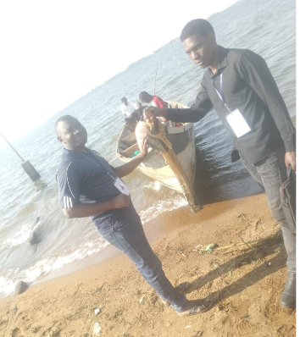
- High transportation costs: Given the nationwide coverage, rising fuel prices led to high field costs. Fuel prices rose from the budgeted Ushs 4,500 per litre to over Ushs 7,500 per litre in some areas. The field teams spent more than anticipated. Costs were exceptionally high for island facilities such as Kalangala, Buvuma, and Mayuge, among others. For instance, Kalangala had 3 facilities on water routes that were far away, requiring the hiring of a private boat because these were not common routes for transporters and fell outside the ferry schedules. A similar situation was encountered in Buvuma and Namayingo districts. In Kyotera, the team did not visit Nangoma Health Centre. This was because the health centre is closer to Tanzania, and the easiest route is via Mutukula, which would require the team to have passports. In Buvuma, the facilities in Lwajje and Lubya were also closer to Tanzania and required special boat hire amounting to two million Uganda shillings.

- Poor record keeping: In many LGs and facilities, there were no clear records of the assets delivered under UgIFT. The LGs and the facilities had incomplete or missing UgIFT asset registers, which delayed data collection. As a result, teams took longer to identify assets in these facilities, as most were not engraved with UgIFT identifiers, and some were not engraved at all. Additionally, the field teams encountered situations where some assets could not be physically accessed, especially in schools, since it was holiday time.

- Loss of institutional memory and suspicious officers. It was observed that institutional memory was lost after staff who were present during the delivery of these assets were transferred to other stations. In addition, capacity gaps were noted, especially in health centres, where on-site officers could not identify the stated assets as indicated in the tool and delivery books. This affected the timely progress of the verification. In addition, the exercise took place while the Ministers in charge of Local Governments were visiting schools and health centres as part of a service delivery verification campaign. In some stations, officers were suspicious and conflated the objective of our assignment with that of the visiting ministers. To mitigate the risk, we fully explained the assignment's purpose and objectives.

VERIFICATION FINDINGS

This section presents results of the verification exercise based on the specific objectives. The results are presented in different result levels, indicating asset availability, asset condition and functionality, asset marking and identification, and the financial analysis in each subsection.

Overall results
This section provides an overall view of the UgIFT asset status combining both national-level agencies, schools and health centres.

Overall asset availability
A total of 228,796 228,638 assets are recorded across the targeted MDAs, beneficiary Blood Banks, Upgraded Health Centres and Seed Secondary School. These include vehicles, laptops, printers, desktop computers, projectors, cameras, furniture (desks, chairs, tables and stools), UPS systems, digital phones, paper shredders, tablets and clinical equipment, among others.

Overall, the Seed Secondary Schools hold most assets 63.4% 63.5% (145,256 145,255), followed by Health Centres with 29% 27.7% (66,499 63,432). MDAs hold 7.3% 7.1% (16,663 16,282), and regional Blood Banks hold 0.3% (602). In addition, LGs reallocated some assets from Health Centres to hospitals such as Rukoki General Hospital in Kasese Municipality.

Figure 1: Overall asset distribution by location
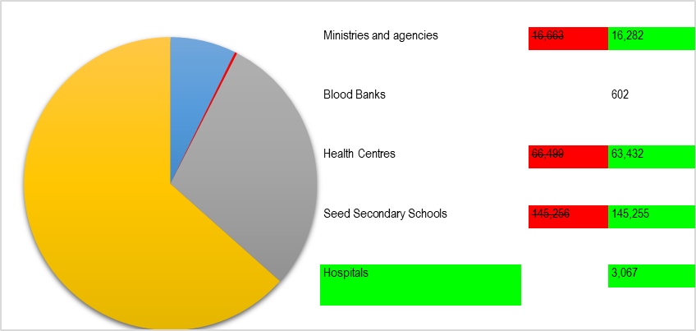
Figure 2: Overall asset distribution by location
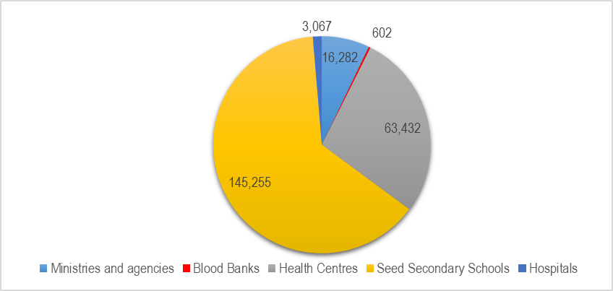
Source: Primary data analysis

Overall Asset Condition and Functionality
Overall, 215,276 210,216 assets (94.1% 91.9%) were identified and classified as functional and in use, while , 5,487 (2.4%) were functional and in store, while 13,504 12,935 (5.9% 5.7%) were identified and classified as faulty and out of use. Table 1 presents a detailed analysis of asset condition.

Table 1: Overall condition of UgIFT assets and functionality
Institution | No. of Assets | Functional |  | Faulty and not in use | % functional
Institution | No. of Assets | In use | In store | Faulty and not in use | % functional
MoFPED | 458 | 458 | 0 | 0 | 100.0%
MoWT | 87 | 71 | 16 | 0 | 100.0%
MoES | 10,783 | 10,783 | 0 | 0 | 100.0%
MAAIF | 2,045 | 2,045 | 0 | 0 | 100.0%
MoH | 51 | 50 | 0 | 1 | 98.0%
OPM | 10 | 7 | 0 | 3 | 70.0%
MoWE | 2,939 2,782 | 2,939 2,756 | 0 26 | 0 | 100.0%
MoGLSD | 10 | 10 | 0 | 0 | 100.0%
NEMA | 6 | 6 | 0 | 0 | 100.0%
PPDA | 5 | 5 | 0 | 0 | 100.0%
OAG | 20 | 20 | 0 | 0 | 100.0%
MoLG | 13 | 13 | 0 | 0 | 100.0%
MoLHUD | 12 | 12 | 0 | 0 | 100.0%
Health centres | 66,499 63,432 | 60,814 55,690 | 0 2,283 | 5,685 5,459 | 91.4%
Seed Secondary Schools | 145,256 145,255 | 137,465 134,657 | 0 3,162 | 7,791 7,436 | 94.6% 94.9%
Blood Banks | 602 | 578 | 0 | 24 | 96.0%
Hospitals | 3,067 | 3,055 | 0 | 12 | 99.6%
Total | 228,796 228,638 | 215,276 210,216 | 16 5,487 | 13,504 12,935 | 94.1% 94.3%
Source: Primary data analysis

As indicated in table 1 above, most of the deployed assets were already in service while some were in store and still in good condition but not in use. This was attributed mainly to some localized challenges such as power, incomplete structures, untrained staff, among others. Some assets were broken, mainly furniture in Seed Secondary Schools, and require repair.

The verification exercise revealed that 13,476 12,895 assets, mainly in Seed Secondary Schools and Health Centres, were faulty and out of use. Some were awaiting installation A further 5,445 assets were functional and in store; some were awaiting installation, or the facility itself was not yet ready, as indicated in Figure 2 3. Notable among the facilities were Lungulu Seed Secondary School in Nwoya District, where desktop computers, a printer and UPS units were still boxed because the school was waiting for a power connection. At Nansanga Seed Secondary School in Budaka, 27 28 of 28 desktop computers remained packed for lack of reliable power.

Figure 2 3: Reasons for non-deployment of some of the assets even when they were found to be in good condition.
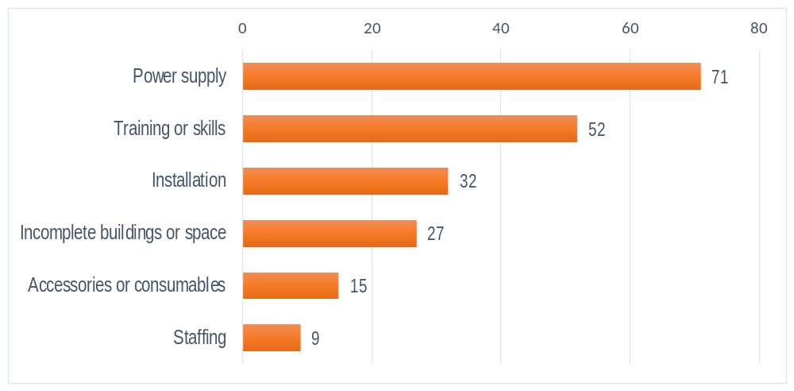
Source: Primary data analysis

In addition, classrooms and stores at Seed Schools in Namisindwa and Napak had broken desks and stools. At Arua Regional Blood Bank, six blood pressure machines were recorded as damaged or not functional. The photos below show some of the issues described above.

Pictorial 1: Some of the nondeployed UgIFT assets
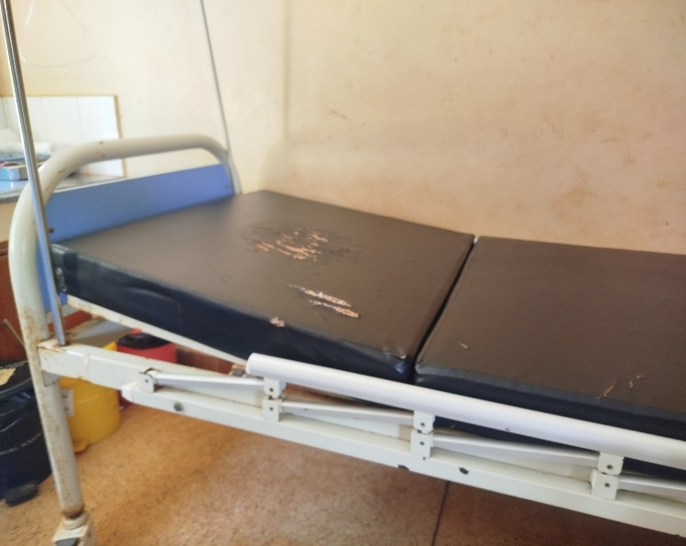 | 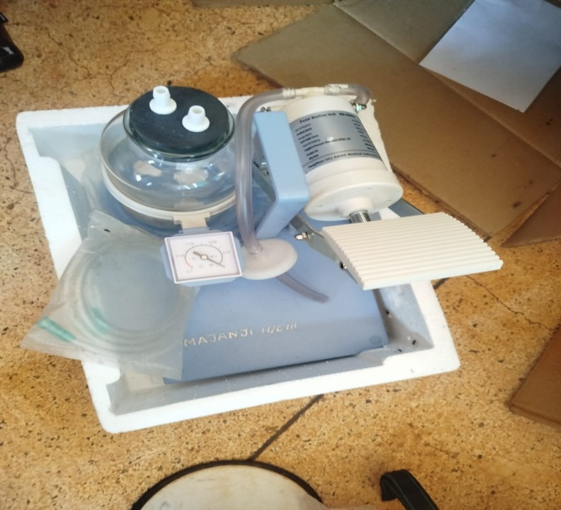
Delivery bed with a torn mattress cover at Majanji Health Centre III, Busia District | Pedal suction unit marked MAJANJI H/C III still in its packing, recorded as not in use for lack of technical knowledge, Majanji Health Centre III, Busia District
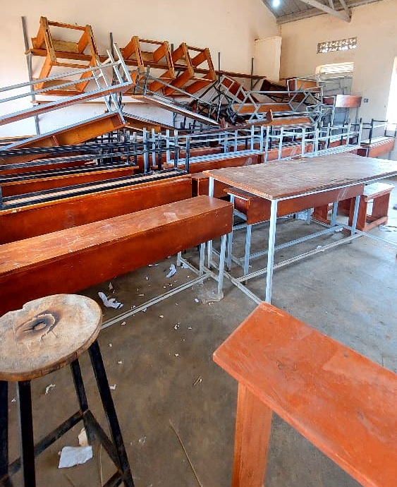 | 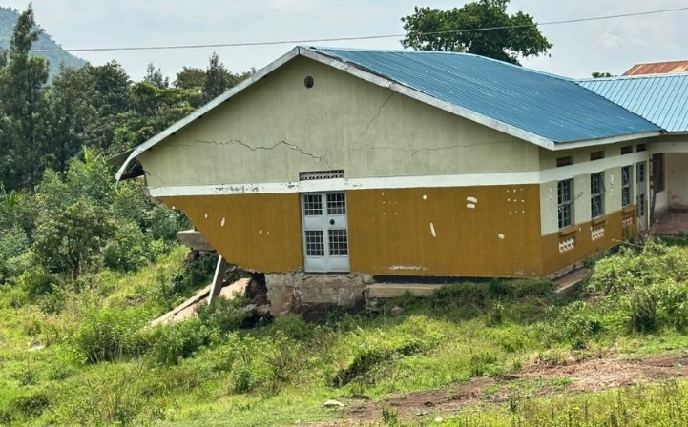
Stacked desks, chairs and stools, some recorded as broken , at Napak Seed Secondary School, Napak District | Cracked health centre block above collapsed ground at Bukibologoto Health Centre II, Bulambuli District
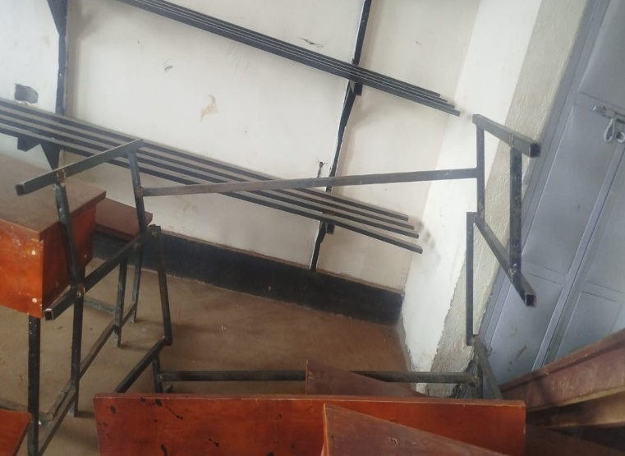 | 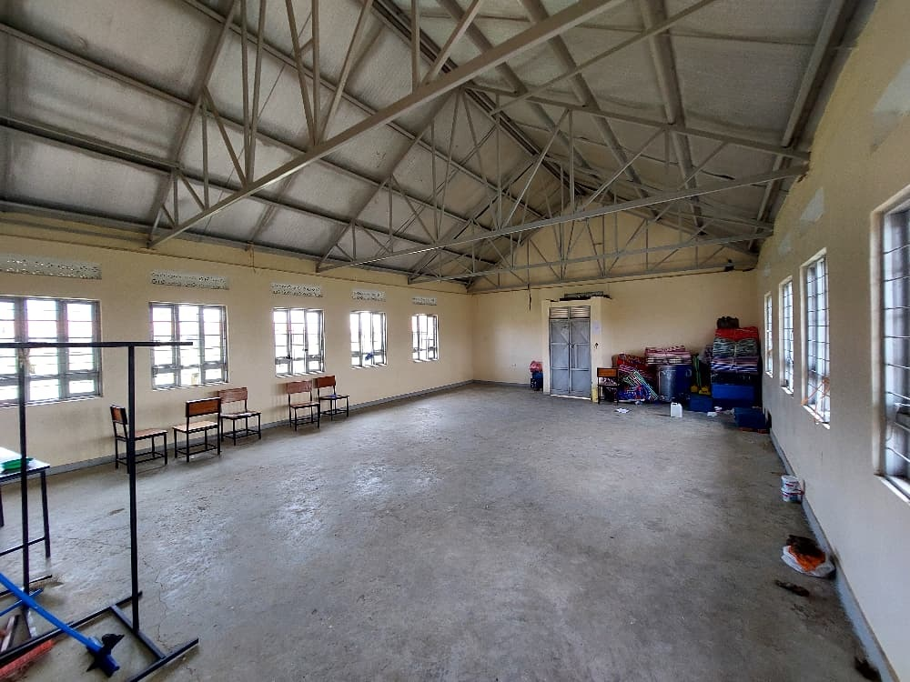
Broken desk frame at Namboko Seed Secondary School, Namisindwa District | Empty ICT and library block with a few chairs and items kept in one corner at Iriiri Seed Secondary School, Napak District,
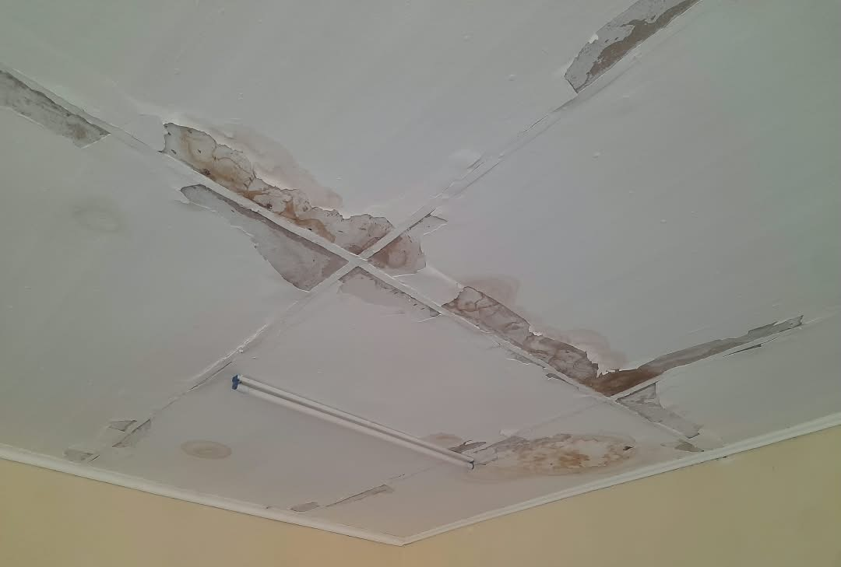 | 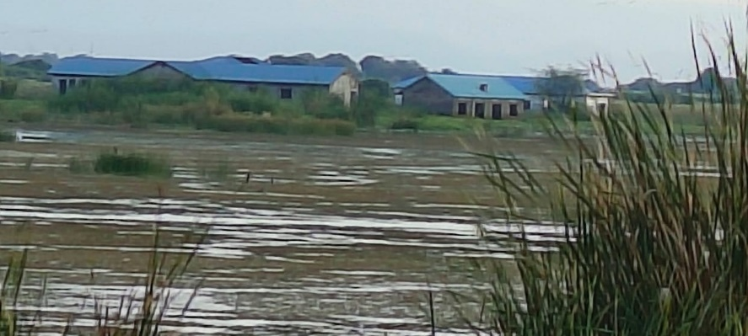
Stained and peeling ceiling at Bundege Health Centre III, Sironko District | Flood-affected older Butiaba Health Centre III building, Buliisa District
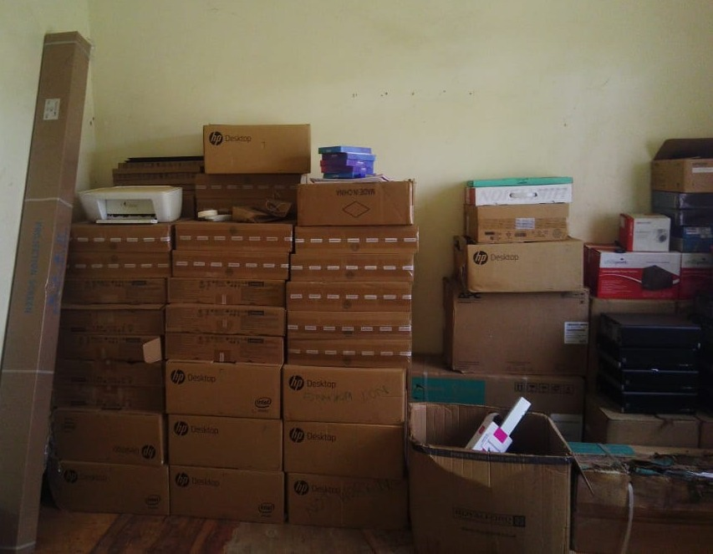 | 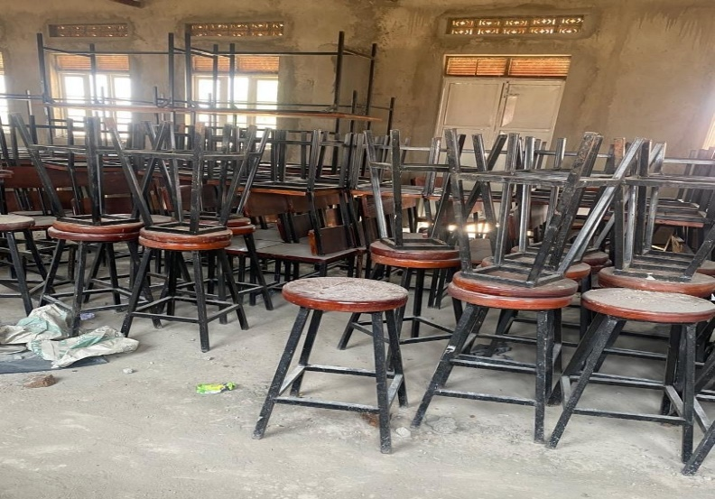
Desktop computers, a printer and UPS units still boxed in the store at Lungulu Seed Secondary School, Nwoya District awaiting a power connection for installation | Laboratory stools and desks stored and not yet in use at Butungama Seed Secondary School, Ntoroko District where the school buildings were still under construction
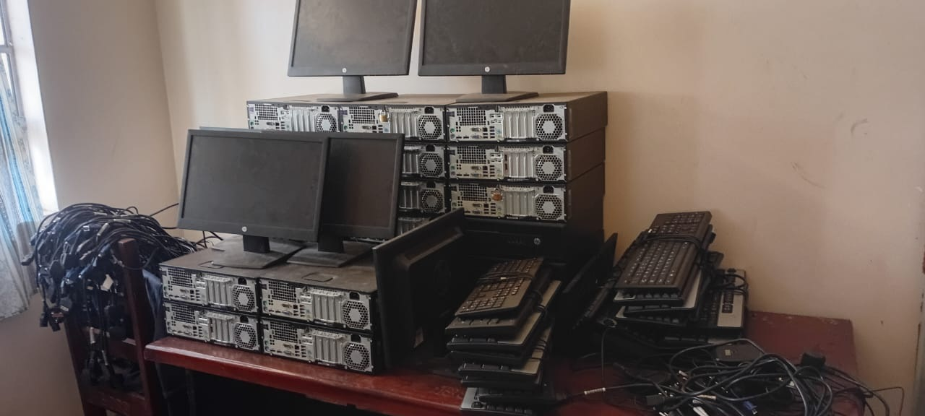 | 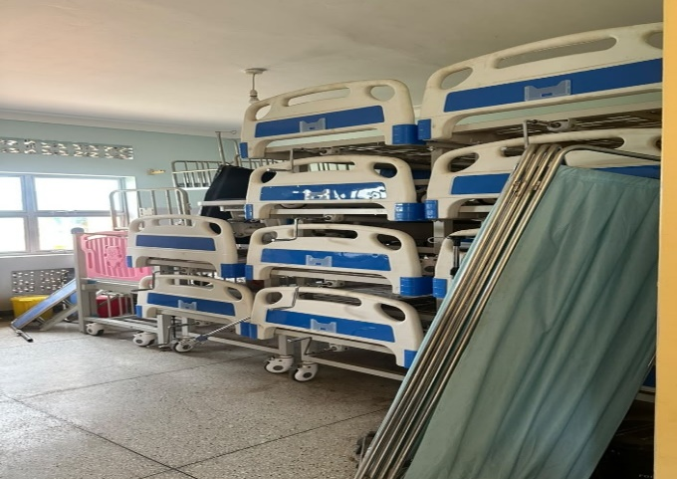
HP computer sets stacked in store with cables still bundled and not installed at Bumufuni Seed Secondary School, Bulambuli District | Beds and screens stacked in storage at Kyabasara Health Centre III, Kagadi District
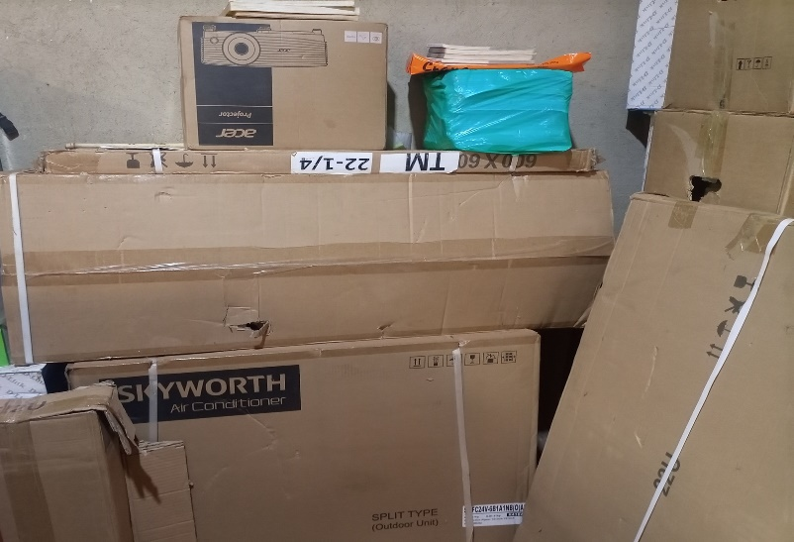 | 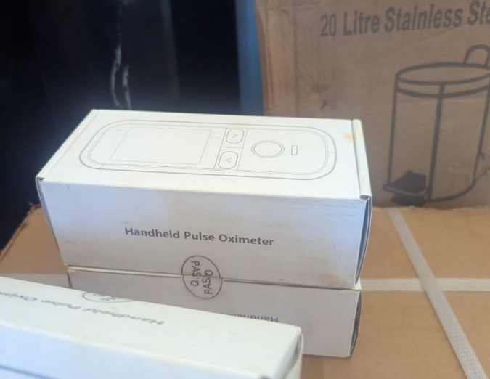
Boxed projector, air conditioner and other equipment in store at King Solomon Seed Secondary School, Kagadi District kept boxed because the school was still under construction | Boxed handheld pulse oximeters at Kibiri Health Centre III, Makindye-Ssabagabo Municipal Council.

Asset Marking and Identification
The verification exercise established that 50,329 50,158 (22.0% 21.9%) assets had UgIFT markings had usable identifiers, while 178,695 178,480 (78.0% 78.1%) were not engraved had no usable identifier recorded. Of all assets, 22,253 22,096 (9.7%) had identifiers containing UgIFT markings. Identification varied across asset locations. Identifiers are recorded for 30.3% 30.0% of MDA records, 24.5% of school records and 15.0% of health-centre records. Among the MDAs, the Ministry of Education and Sports accounts for most ministry assets without usable identifiers, mainly for the TELA handsets and tablets. The details of asset identification are provided in figure 3 5.

Figure 3 4: Asset marking and Identification
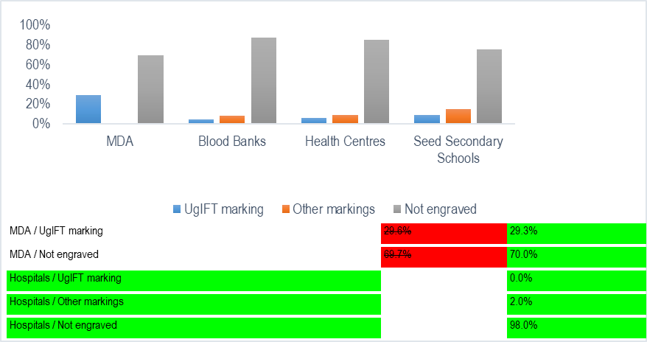
Figure 5: Asset marking and Identification
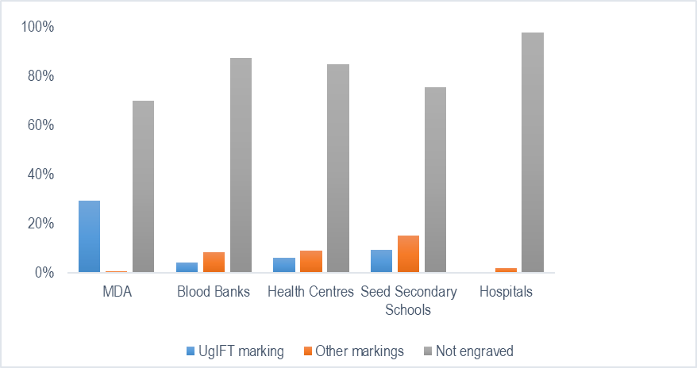
Source: Primary data analysis

Below are some of the photos depicting the different markings and identification engravement of assets across the institutions

Pictorial 2: Photos depicting the different markings and identification engravement of assets across the institutions
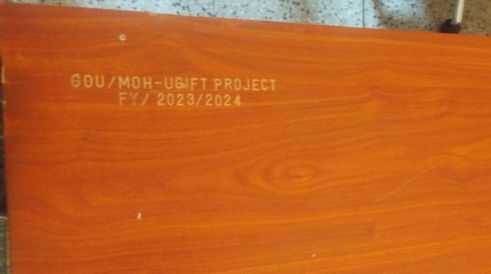 | 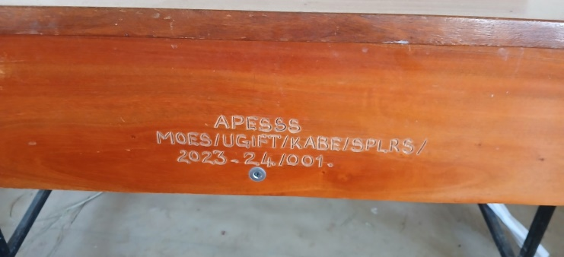
Engraving reading GOU/MOH-UGIFT PROJECT FY/2023/2024 on a desk at Namwaya Health Centre III, Tororo District | Engraving reading APESSS MOES/UGIFT/KABE/SPLRS/2023-24/001 on a desk at Aperikira Seed Secondary School, Kaberamaido District
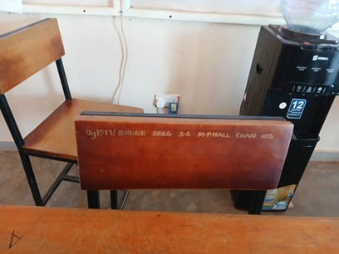 | 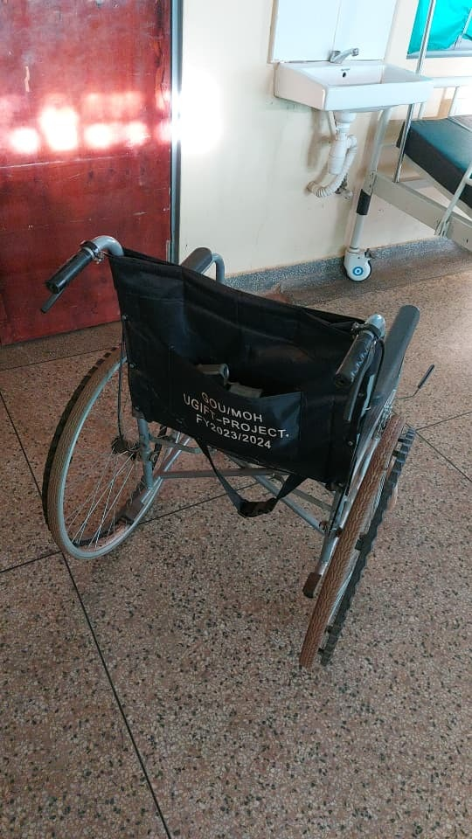
Chair engraved UgIFT/ BUDDE SEED S.S M-PHALL CHAIR with a serial number at Budde Seed Secondary School, Butambala District | Wheelchair backrest marked GOU/MOH UGIFT-PROJECT. FY2023/2024 at Kalemungole Health Centre III, Moroto District
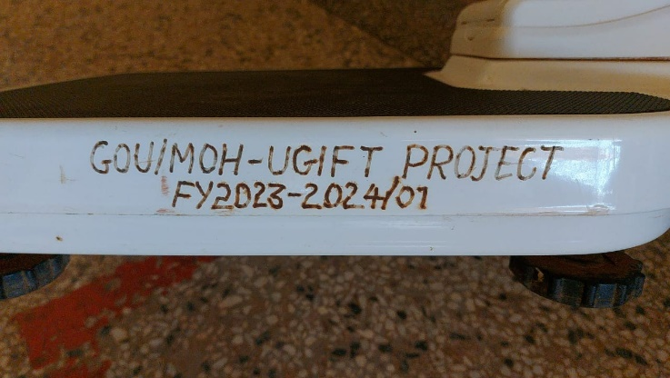 | 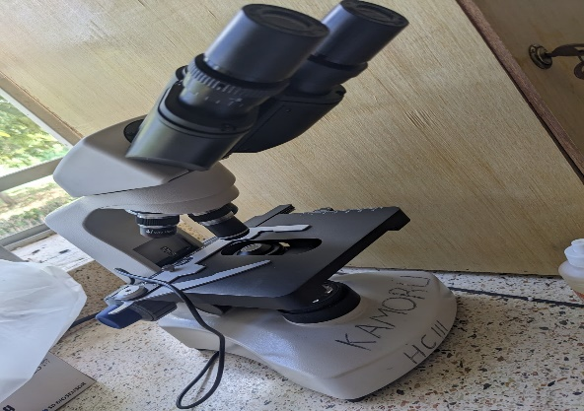
Engraving reading GOU/MOH-UGIFT PROJECT FY2023-2024/01 on a weighing scale at Kalemungole Health Centre III, Moroto District | Microscope marked KAMORU HC III by hand at Kamoru Health Centre III, Kotido District
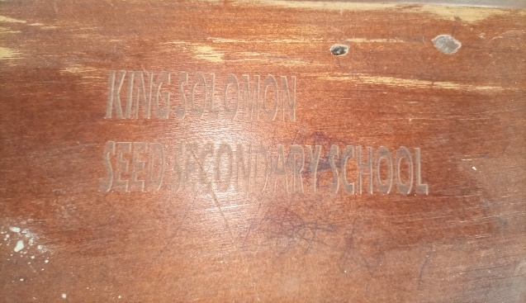 | 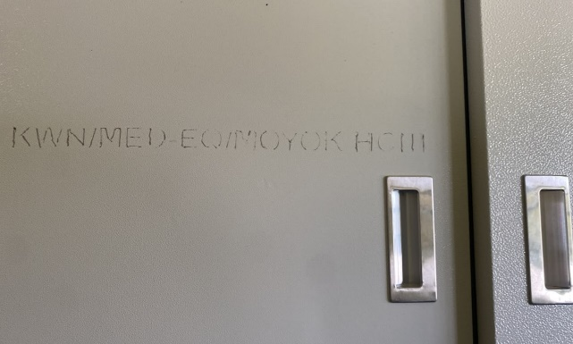
Engraving reading KING SOLOMON SEED SECONDARY SCHOOL, without a UgIFT marking, on furniture at King Solomon Seed Secondary School, Kagadi District | Engraving reading KWN/MED-EQ/MOYOK HCIII on a steel cupboard at Moyok Health Centre III, Kween District

Financial analysis
Overall, the 229,024 228,638 assets across the different institutions had a recorded value of UGX 996,812,628,890 994,483,547,185. Based on the straight-line depreciation method, accumulated depreciation was UGX 165,185,197,307 164,433,721,159 and net book value was UGX 595,801,587,531 596,318,135,810 as at 30th September 2026. Recorded values vary by institution, with MDAs at UGX 32,054,743,836 30,236,797,869, Blood Banks at UGX 1,503,720,926, Seed Secondary Schools at UGX 700,242,561,371 700,162,561,371, Health Centers at UGX 260,692,452,291, and hospitals and other local-government assets hospital assets accounting for the remaining UGX 2,319,150,466 1,888,014,728, as indicated in table 2.

Table 2: Overall Recorded asset value and net book value
Asset category | Recorded cost (ugx million) | Accumulated depreciation (ugx million) | Net book value (ugx million) | % NBV
Schools | 700,242.56 700,162.56 | 104,574.53 104,600.96 | 394,241.71 394,577.11 | 79.00% 56.36%
Health Centres | 263,011.60 260,692.45 | 40,269.47 38,688.52 | 190,467.32 189,938.59 | 72.42% 72.86%
Ministries and Agencies | 32,054.74 30,236.80 | 19,787.51 19,811.61 | 10,265.93 10,063.77 | 34.20% 33.28%
Regional Blood Banks | 1,503.72 | 553.689 | 826.632 | 59.90% 54.97%
Hospitals | 1,888.01 | 778.95 | 912.03 | 48.31%
Total | 996,812.63 994,483.55 | 165,185.20 164,433.72 | 595,801.59 596,318.14 | 78.30% 59.96%

Table 2 further indicates that the netbook value represents 78.3% 60.0% of the recorded costs of the assets that were determined by the STL method.

National level Ministries and Agencies
Asset availability at Ministries and Agencies: The exercise recorded 16,663 16,282 assets across all thirteen asset-holding Ministries and Agencies, spanning multiple categories. In terms of categorization, the exercise recorded 15,192 ICT equipment items, including desktop computers, laptops, tablets and Uninterruptible Power Supply (UPS) units; 77 55 transport items; 99 furniture and fittings; 48 46 other classified assets; 1,235 878 items outside fixed-asset classification; and 12 unclassified entries.

By location, most MDA assets (94.6% 95.9%) were at MoES, MoWE and MAAIF while PPDA was found with only five assets including three Lenovo think pad Laptops, one HP Laser Jet Color Printer and one Samsung Galaxy tablet as indicated in Table 3.

Table 3: Number of verified UgIFT Assets by MDA
Ministries and Agencies | No. of Assets
Ministry of Finance, Planning and Economic Development (MoFPED) | 458
Ministry of Works and Transport (MoWT) | 87
Ministry of Education and Sports (MoES) | 10,783
Ministry of Agriculture, Animal Industry and Fisheries (MAAIF) | 2,045
Ministry of Health (MoH) | 260 51
Office of the Prime Minister (OPM) | 10
Ministry of Water and Environment (MoWE) | 2,939 2,782
Ministry of Gender, Labour and Social Development (MoGLSD) | 10
National Environment Management Authority (NEMA) | 6
Public Procurement and Disposal of Public Assets Authority (PPDA) | 5
Office of the Auditor General (OAG) | 20
Ministry of Local Government (MoLG) | 13
Ministry of Lands, Housing and Urban Development (MoLHUD) | 27 12
Total | 16,663 16,282

Asset Condition and functionality: At MDA level, apart from Ministry of Health that had one double cabin boarded off and three broken laptops at the Office of the Prime minister, the rest of the assets 16,643 (99.9%) 16,236 assets (99.7%) were in good condition and were in use. were in use, while 42 (0.3%) were functional and in store. The Ministry of Education and Sports held 10,783 of these assets, mainly TELA handsets and tablets and these were all in good condition at the time of handover over to the different schools across the country. LGFC and MoPS indicated that they never received UgIFT assets.

Asset marking and Identification: At MDA level, there were 16,663 16,282 asset records, of which 5,045 4,879 (30.3% 30.0%) had UgIFT markings had usable identifiers, with 4,925 4,768 assets (29.6% 29.3%) bearing UgIFT markings and 120 111 (0.7%) had other markings. Most assets, 11,618 11,403 (69.7% 70.0%), were not engraved. Figure 4 7 shows the identification status of the assets at the different MDAs.

Figure 4 6:: Asset marking and Identification at MDAs
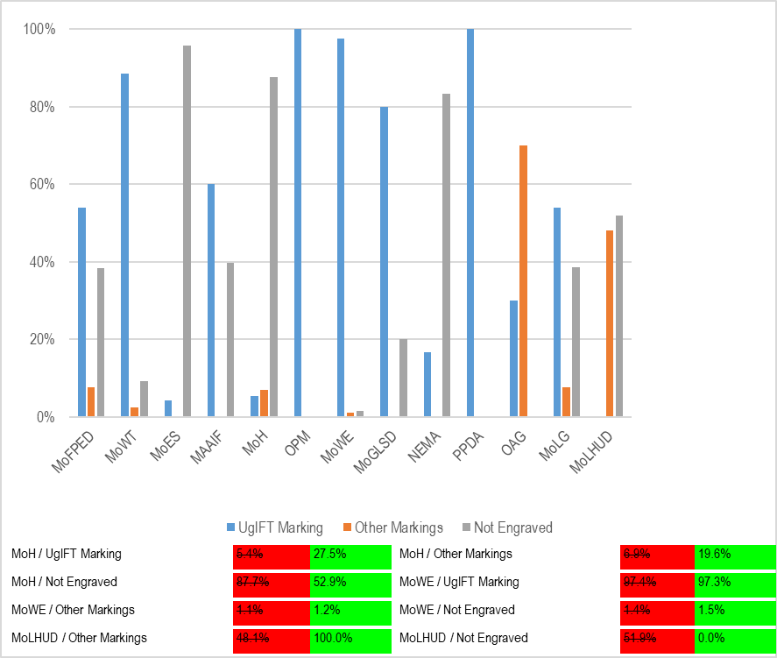Source: Primary data analysis
Figure 7: Asset marking and Identification at MDAs
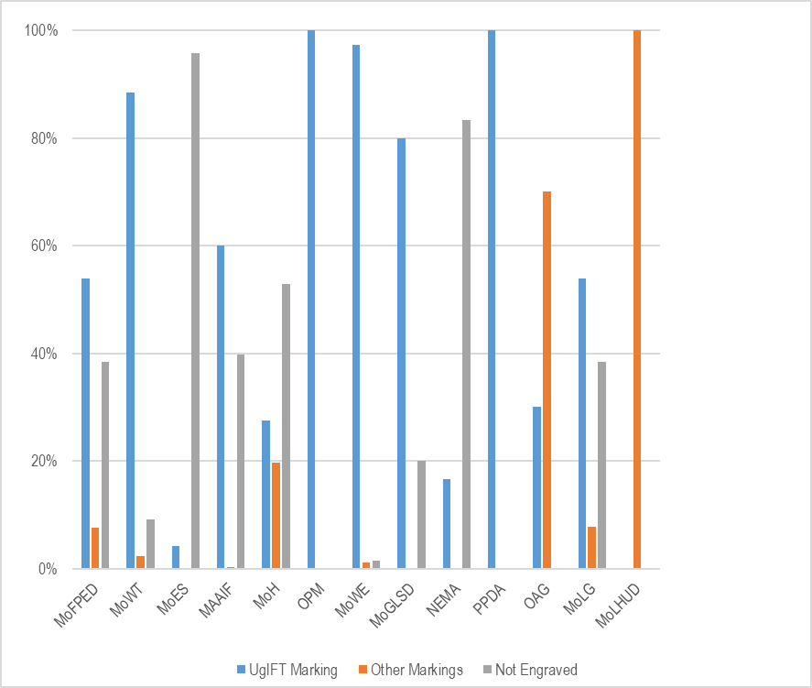Source: Primary data analysis

Financial value of assets: recorded costs total UGX 32,054,743,836 30,236,797,869 across 16,651 16,270 of 16,663 16,282 records. Accumulated depreciation totals UGX 19,787,511,232 19,811,607,459 and net book value totals UGX 10,265,924,979 10,063,768,621 as at 30th September 2026.

MDA specific results

Ministry of Finance, Planning and Economic Development
Asset availability: The ministry keeps a UgIFT asset register and the consolidated register for all MDAs that received UgIFT assets. A total of 458 assets were recorded at the ministry including 230 ICT items, 99 furniture and fittings, 21 transport items, 37 other classified assets, 65 items outside fixed-asset classification and six unclassified entries. The main items were office chairs and desks, desktop computers, tablets and 20 Toyota Hilux double-cabin pickups.

Condition and functionality: All 458 assets (100.0%) were recorded as functional and in use, and none was classified as faulty.
Reports described spoilt keyboards and UPS units, computers that freeze and laptop losses. The affected quantities and individual assets were not specified, so the number of broken or lost items could not be established. The asset manager should identify the affected items and reconcile the damage and loss reports.

Marking and identification: A total of 282 assets (61.6%) had usable identifiers and 176 (38.4%) had no usable tag recorded. Of all 458 assets, 247 (53.9%) had UgIFT or UGFT in the tag field and 35 (7.6%) carried another identifier. The 20 double-cabin pickups were identified by their registration numbers rather than UgIFT tag text. These tag-field counts do not confirm physical engraving.

Financial Value of assets: The recorded value of the ministry's UgIFT assets is UGX 6,204,318,000. Accumulated depreciation is UGX 4,312,193,629 and net book value is UGX 1,785,677,771 at 30 September 2026. Table 4 presents the category breakdown.

Table 4: Recorded costs and available accounting values at MoFPED
Asset category | Recorded cost (ugx million) | Accumulated depreciation (ugx million) | Net book value (ugx million) | % NBV
ICT equipment | 1,350.105 | 1,011.732 | 238.731 | 19.1% 17.7%
Furniture and fittings | 137.037 | 96.069 | 40.968 | 29.9%
Non-fixed-asset | 6.564 | 0.000 | 0.000 | n/a 0.0%
Other assets | 159.987 | 158.377 | 1.610 | 1.0%
Transport equipment | 4,550.385 | 3,046.016 | 1,504.369 | 33.1%
Unclassified | 0.240 | 0.000 | 0.000 | 0.0%
Total | 6,204.318 | 4,312.194 | 1,785.678 | 29.3% 28.8%

Ministry of Works and Transport
Asset availability: The Ministry did not provide a UgIFT Asset Register. The MoWT register contained 87 assets, of which 70 69 ICT items were mainly desktop computers, monitors, uninterruptible power supply (UPS) units, video-conferencing equipment, printers and photocopiers; one Toyota Hilux pickup; sixteen items outside fixed-asset classification; and one unclassified entry. The sixteen items outside fixed-asset classification were keyboards as presented in Table 5.
Table 5: Assets verified at MoWT
Asset category | Assets
ICT equipment | 70 69
Non-fixed-asset | 16
Transport equipment | 1
Unclassified | 1
Total | 87

Asset condition and functionality: All the assets were functional and in use. 71 assets (81.6%) were functional and in use, while 16 (18.4%) were functional and in store.

Asset Marking and Identification: Of the 87 assets, 79 (90.8%) had usable identifiers, with 77 (88.5%) having UgIFT or UGFT in the tag field and two (2.3%) carrying another identifier other than UgIFT engravement; eight (9.2%) had no usable tag recorded.

Financial Value of assets: The recorded value was established as UGX 455,932,376. Accumulated depreciation is UGX 326,484,882 and net book value is UGX 115,311,494 as at 30th September 2026 as presented in Table 6

Table 6: MoWT asset values by category
Asset category | Recorded cost (ugx million) | Accumulated depreciation  (ugx million) | Net book value (ugx million) | % NBV
ICT equipment | 259.914 | 137.001 | 108.778 | 44.3% 41.9%
Transport equipment | 196.018 | 189.484 | 6.534 | 3.3%
Unclassified | Unavailable | 0.000 | 0.000 | n/a
Outside fixed-asset classification | 0.000 | 0.000 | 0.000 | n/a
Total | 455.932 | 326.485 | 115.311 | 26.1% 25.3%

Ministry of Education and Sports
Asset availability: The verification at the Ministry of Education and Sports (MoES) established that the ministry had 10,783 assets. All the assets are ICT equipment, and these include 9,324 TELA handsets, 1,001 tablets (976 of them inspection tablets), 456 laptops, a photocopier and a printer. Teacher, Effectiveness and Learner Achievement (TELA) is the system, financed by UgIFT, that the ministry uses to monitor attendance and performance in schools; the handsets and inspection tablets are deployed in local governments and remain MoES assets.

All 10,783 assets (100.0%) are recorded as functional and in use. All 456 laptops are recorded as functional and in use. Table 7 presents condition and use.

Table 7: Condition and use of assets for MoES
Condition | No. of Assets | Proportion
Functional | 10,783 | 100.0%
Faulty | 0 | 0.0%
Total | 10,783 | 100.0%

Marking and Identification: Of the 10,783 assets, 458 (4.2%) had UgIFT or UGFT in the tag field, while 10,325 (95.8%) had no UgIFT tag recorded. None of the handsets or tablets carries an engravement mark.
Table 8: Identification of assets for MoES
Identification | No. of Assets | Proportion
Engraved UgIFT | 458 | 4.2%
Not engraved | 10,325 | 95.8%

Financial Value of assets: The recorded value is UGX 14,925,128,359, the highest among the MDAs. Accumulated depreciation is UGX 10,607,476,704 and net book value is UGX 4,317,651,655 as at 30th September 2026. Table 9 presents the category breakdown.

Table 9: Recorded costs and available accounting values at MoES
Asset category | Recorded cost (ugx million) | Accumulated depreciation (ugx million) | Net book value (ugx million) | % NBV
ICT equipment | 14,925.128 | 10,607.477 | 4,317.652 | 28.9%
Total | 14,925.128 | 10,607.477 | 4,317.652 | 28.9%

Ministry of Agriculture, Animal Industry and Fisheries
Asset availability: The team recorded UgIFT assets at the Ministry of Agriculture, Animal Industry and Fisheries (MAAIF) and established that it held 2,045 assets. These included 1,236 ICT equipment items, two transport items and 807 others, comprising 797 outside fixed-asset classification, five other classified assets and five unclassified entries. The ICT items were mainly 819 tablets, 211 computers (162 desktop CPU entries and 49 laptops), 149 monitors and 21 printers.

Asset condition and functionality: All 2,045 assets (100.0%) are recorded as functional and in use. All 211 computers and 819 tablets are recorded as functional and in use. Table 10 presents condition and use of asset.

Table 10: Condition and use of assets at MAAIF
Condition | No. of Assets | Proportion
Functional | 2,045 | 100.0%
Faulty | 0 | 0.0%
Total | 2,045 | 100.0%

Asset Marking and Identification: Of the 2,045 verified assets, 1,232 (60.2%) are engraved, 1,228 (60.0%) with the UgIFT marking while 4 (0.2%) had other engravement marks as in picture 2 above, and 813 (39.8%) were not engraved as indicated in table 11.

Table 11: Recorded tag content of assets at MAAIF
Identification | No. of Assets | Proportion
Engraved UgIFT | 1,228 | 60.0%
Another identifier | 4 | 0.2%
Not engraved | 813 | 39.8%

Financial Value of assets: The recorded value was UGX 2,856,556,593. Accumulated depreciation is UGX 1,380,059,505 and net book value is UGX 1,403,429,899 as at 30th September 2026. Table 12 presents the category breakdown.

Table 12: Recorded costs and available accounting values at MAAIF
Asset category | Recorded cost (ugx million) | Accumulated depreciation (ugx million) | Net book value  (ugx million) | % NBV
ICT equipment | 2,278.449 | 952.109 | 1,326.341 | 58.2%
Outside fixed-asset classification | 72.467 | 0.000 | 0.000 | n/a 0.0%
Other assets | 8.000 | 5.467 | 2.533 | 31.7%
Transport equipment | 497.040 | 422.484 | 74.556 | 15.0%
Unclassified | 0.600 | 0.000 | 0.000 | 0.0%
Total | 2,856.557 | 1,380.060 | 1,403.430 | 50.4% 49.1%

Ministry of Health
The verification at the MoH did not find a UgIFT Asset Register but relied on the list provided by the Ministry of Finance, Planning and Economic Development.

Asset availability: A total of 51 assets were recorded. Of the 51 assets, 31 were classified as ICT equipment, 16 as transport equipment (motor vehicles and motorcycles), 4 were classified as other assets. The Ministry’s other items include 2 heavy-duty binding machines and 2 CC20240 paper shredders. as indicated in Figure 9 8

Figure 5 8: Assets verified at MoH
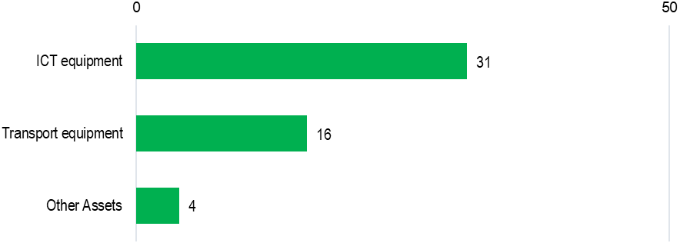

Asset condition and functionality: The assets recorded as functional and in use were 50 (98.0%). Only one asset, a double-cabin pickup, was recorded as faulty and not in use.

Asset Marking and Identification: Out of the 51 assets, 24 (47.1%) were engraved while 27 (52.9%) were not engraved. There were 14 (27.5%) assets with UgIFT markings and 10 (19.6%) with other identifiers.

Financial Value of assets: The MoH assets had a recorded value of UGX 879,893,642. Accumulated depreciation value was UGX 406,599,572 527,218,687 and net book value was UGX 287,726,201 352,674,955 as at 30th September 2026. Table 11 3 presents the category breakdown.

Table 13: Recorded costs and available accounting values for MoH
Asset category | Recorded cost (ugx million) | Accumulated depreciation (ugx million) | Net book value (ugx million) | % NBV
ICT equipment | 211.927 | 109.806 | 102.122 | 48.2%
Transport equipment | 663.136 | 294.379 414.998 | 183.189 248.138 | 38.4% 37.4%
Other assets | 4.831 | 2.415 | 2.415 | 50.0%
Total | 879.894 | 406.600 527.219 | 287.726 352.675 | 41.4% 40.1%

Office of the Prime Minister
The Assets Register for the Office of the Prime Minister was not obtained and no list of assets was provided. The verification relied on the listing obtained from the Ministry of Finance, Planning and Economic Development.

Asset availability: Office of the Prime Minister received 10 assets which were all HP laptop computers
Condition and functionality: Seven assets (70.0%) were recorded as functional and in use. Three (30.0%) were recorded as faulty and out of use.

Marking and identification: All ten laptops (100.0%) had UgIFT or UGFT in the tag field.
Financial Value of assets: The recorded value of these computers in OPM was UGX 53,535,300. Accumulated depreciation is UGX 48,181,770 and net book value is UGX 5,353,530 as at 30 September 2026. Table 14 presents the category breakdown.

Table 14: Recorded costs and available accounting values at OPM
Asset category | Recorded cost (ugx million) | Accumulated depreciation (ugx million) | Net book value (ugx million) | % NBV
ICT equipment | 53.535 | 48.182 | 5.354 | 10.0%
Total | 53.535 | 48.182 | 5.354 | 10.0%

Ministry of Water and Environment
Asset availability: The Asset Verification at the Ministry of Water and Environment established that the ministry keeps a general register which does not conform to IFMIS Standards. The register recorded 2,782 ICT equipment. The assets received by the Ministry included 2,368 tablets, of which 2,344 were Euron tablets; computers and related monitors, keyboards and UPS units; and 31 laptops. The Ministry also received sixteen real-time kinematic GPS machines. Other assets received included; seven survey units described as ground-penetrating radar equipment, 3 Samsung Galaxy Tab S9 tablets, 2 Lenovo Think Book notebooks, 1 Kyocera heavy-duty copier, 1 Huawei 65-inch infrared screen and 1 UPS unit.

Asset condition and functionality: The findings indicated that 2,756 assets (99.1%) were recorded as functional and in use, 26 (0.9%) were functional and in store, and none was classified as faulty.

Asset Marking and Identification: The ministry received a total of 2,782 assets, of which 2,740 (98.5%) were engraved, 2,707 (97.3%) with UgIFT markings and 33 (1.2%) with other markings; 42 (1.5%) were not engraved.

Financial Value of the assets: The recorded value was UGX 3,773,982,079 3,773,981,561. Accumulated depreciation is UGX 2,092,642,121 and net book value is UGX 1,535,627,440 as at 30th September 2026. Table 15 presents the category breakdown.

Table 15: Recorded costs and available accounting values for MoWE
Asset category | Recorded cost (ugx million) | Accumulated depreciation (ugx million) | Net book value (ugx million) | % NBV
ICT equipment | 3,773.982 | 2,092.642 | 1,535.627 | 42.3% 40.7%
Total | 3,773.982 | 2,092.642 | 1,535.627 | 42.3% 40.7%

Ministry of Gender, Labour and Social Development
Asset availability: Asset Verification at the Ministry of Gender, Labour and Social Development found out that the ministry keeps a UgIFT asset register which has 10 UgIFT assets. These comprised eight Lenovo computers, including four ThinkBook laptops, and two Samsung tablets.

Asset condition and functionality: The findings further indicate that all ten UgIFT assets (100.0%) were recorded as functional and in use.

Asset Marking and Identification: A total of Eight Lenovo ThinkPad Laptops (80.0%) were engraved with the UgIFT markings, and the Two Samsung Tablets (20.0%) were not engraved.

Financial Value of the assets: The findings pointed out that the recorded value to be UGX 46,180,000. Accumulated depreciation is UGX 13,260,000 and net book value is UGX 14,860,000 as at 30th September 2026. Table 16 presents the category breakdown.

Table 16: Recorded costs and available accounting values for MoGLSD
Asset category | Recorded cost (ugx million) | Accumulated depreciation (ugx million) | Net book value (ugx million) | % NBV
ICT equipment | 46.180 | 13.260 | 14.860 | 52.8% 32.2%
Total | 46.180 | 13.260 | 14.860 | 52.8% 32.2%

National Environment Management Authority
Asset availability: National Environment Management Authority (NEMA) had six (06) ICT items: four computers, a printer and a heavy-duty photocopier.

Condition and functionality: All six assets (100.0%) were recorded as functional and in use.

Asset marking and identification: One asset (16.7%), the heavy-duty photocopier, had UgIFT or UGFT in the tag field while the other five (83.3%) had no usable tag recorded.

Financial value of Assets: The recorded value is UGX 46,824,409. Accumulated depreciation is UGX 32,841,273 and net book value is UGX 13,983,136 as at 30th September 2026. Table 17 presents the category breakdown.

Table 17: Recorded costs and available accounting values for NEMA
Asset category | Recorded cost (ugx million) | Accumulated depreciation (ugx million) | Net book value (ugx million) | % NBV
ICT equipment | 46.824 | 32.841 | 13.983 | 29.9%
Total | 46.824 | 32.841 | 13.983 | 29.9%

Public Procurement and Disposal of Public Assets Authority
Public Procurement and Disposal of Public Assets Authority (PPDA) did not provide a UgIFT Asset Register. Verification relied on information obtained from the Ministry of Finance, Planning and Economic Development.

Asset availability: A total of five (05) assets were verified in PPDA; these were 3 Lenovo ThinkPad laptops, a Samsung Galaxy tablet and an HP printer.

Asset condition and functionality: All the five assets (100.0%) were recorded as functional and in use.

Asset marking and identification: All five assets (laptops, a tablet and a printer) had UgIFT engravement.

Financial Value of assets: The recorded cost was UGX 30,153,500. Accumulated depreciation is UGX 13,066,516 and net book value was UGX 17,086,984 as at 30th September 2026. Table 18 presents the category breakdown.

Table 18: Recorded costs and available accounting values for PPDA
Asset category | Recorded cost (ugx million) | Accumulated depreciation (ugx million) | Net book value (ugx million) | %NBV
ICT equipment | 30.154 | 13.067 | 17.087 | 56.7%
Total | 30.154 | 13.067 | 17.087 | 56.7%

Office of the Auditor General (OAG)
Asset availability: Evidence gathered during the verification confirmed that OAG had no UgIFT asset register but rather had a list of assets which indicated 20 assets; 18 of which were ICT items (16 laptops and 2 printers) and 2 pickup vehicles.

Asset condition and functionality: All 20 (100.0%) were in good condition and in use.

Asset marking and Identification: Six (30.0%) were engraved with the UgIFT markings and 14 (70.0%) were not engraved with UgIFT markings. The engravement was carrying the office's own asset code or vehicle registration number for the two pickups as in figure 6.

Figure 6 9: Assets verified at OAG
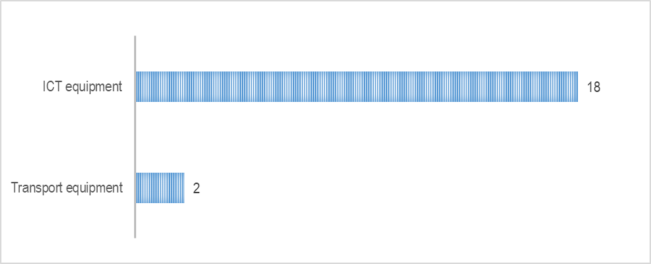

Financial value of Assets: The assets were worth UGX 388,773,680. Accumulated depreciation was UGX 111,591,545, and the net book value is UGX 277,182,135 as at 30th September 2026. Table 19 presents the category breakdown.

Table 19: Recorded costs and available accounting values for OAG
Asset category | Recorded cost (ugx million) | Accumulated depreciation (ugx million) | Net book value (ugx million) | % NBV
ICT equipment | 228.774 | 71.592 | 157.182 | 68.7%
Transport equipment | 160.000 | 40.000 | 120.000 | 75.0%
Total | 388.774 | 111.592 | 277.182 | 71.3%

Ministry of Local Government
Asset availability: The asset verification at the Ministry of Local Government (MoLG) established that the ministry kept a UgIFT asset register and had 13 UgIFT assets; one double-cabin pickup and 12 ICT items. The ICT assets comprised of 6 computers, 4 computer peripherals and 2 heavy duty photocopiers. Figure 7 10 presents the UgIFT assets verified for MoLG.

Figure 7 10: Assets verified at MoLG
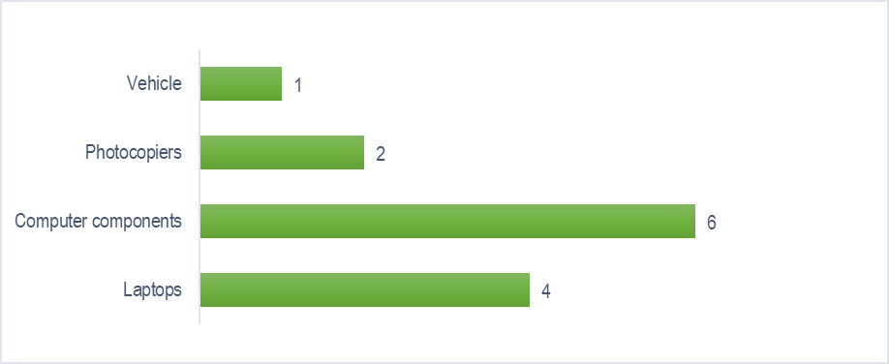

Asset condition and functionality: The findings further indicated that all thirteen assets (100.0%) were recorded as functional and in use.

Asset marking and identification: Out of the 13 assets, eight (61.5%) were engraved while five (38.5%) were not. Of the eight assets that were engraved, 7 (53.8%) were engraved with UgIFT markings while one was not. In terms of ICT equipment which formed the bulk of assets, 3 7 (50.0% 58.3%) were engraved and 3 5 (50.0% 41.7%) were not engraved while 1 0 (7.7% 0.0%) carried another identifier.

Financial Value of assets: The findings noted a recorded value of UGX 343,320,450. Accumulated depreciation was UGX 284,670,827 and net book value was UGX 54,649,623 as at 30th September 2026. Table 18 20 presents the category breakdown.

Table 20: Recorded costs and available accounting values for MoLG
Asset category | Recorded cost (ugx million) | Accumulated depreciation (ugx million) | Net book value (ugx million) | %NBV
ICT equipment | 94.800 | 36.151 | 54.650 | 60.2% 57.6%
Transport equipment | 248.520 | 248.520 | 0.000 | 0.0%
Total | 343.320 | 284.671 | 54.650 | 16.1% 15.9%

Ministry of Lands, Housing and Urban Development
Asset availability: The verification exercise established that MoLHUD had 27 12 UgIFT assets. These include 25 12 Honda motorcycles and two (02) other entries described as Accessories (2 Helmets). Additionally, the ministry received survey equipment and other motorcycles that it gave out to local governments.

Figure 8 11: Assets verified at MoLHUD
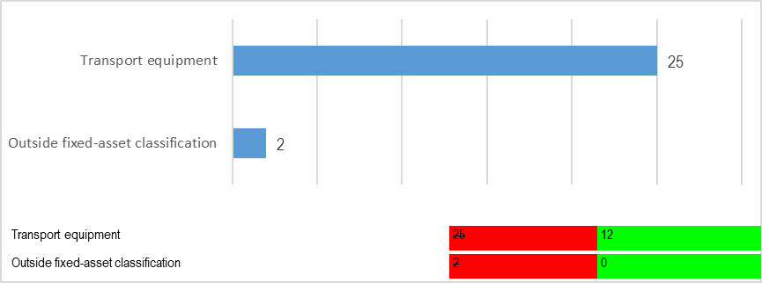
Figure 12: Assets verified at MoLHUD
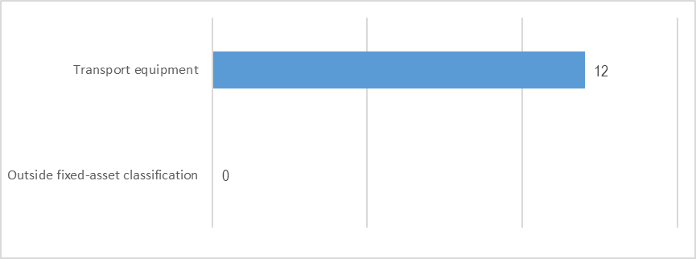

Asset condition and functionality: All the 27 12 assets (100.0%) were recorded as functional and in use, and none was classified as faulty.

Asset marking and Identification: All the 27 12 (100.0%) were not engraved with UgIFT markings. Thirteen 12 (48.1% 100.0%) had other identifiers and fourteen 0 (51.9% 0.0%) were not engraved. It was also noted that the motorcycles did not have the UgIFT labelling but were identified by their registration numbers only.

Financial Value of assets: The findings further indicated the recorded value to be UGX 487,349,999 232,199,999. Accumulated depreciation was UGX 123,840,000 61,920,000 and net book value was UGX 340,559,999 170,279,999 as at 30th September 2026. Table 21 presents the category breakdown.

Table 21: Recorded costs and available accounting values for MoLHUD
Asset category | Recorded cost (ugx million) | Accumulated depreciation (ugx million) | Net book value (ugx million) | %NBV
Transport equipment | 483.750 232.200 | 123.840 61.920 | 340.560 170.280 | 73.3%
Non-fixed assets | 3.600 0.000 | 0.000 | 0.000 | n/a
Total | 487.350 232.200 | 123.840 61.920 | 340.560 170.280 | 73.3%

Regional Blood Banks
UgIFT financed the rehabilitation of Soroti Regional Blood Bank and the construction of the Arua and Hoima regional blood banks, which were completed and commissioned. The three Blood Banks operate under Uganda Blood Transfusion Services (UBTS).

Asset availability: The blood banks held a total UgIFT asset base of 602 fixed assets inclusive of the assets at the Uganda Blood Transfusion Services. The exercise verified all assets at the three regional blood banks as follows. Arua Regional Blood Bank held 324 assets, Hoima Regional Blood Bank had 163 and Soroti Regional Blood Bank had 115 assets.

Asset Condition and functionality: Assets at the regional blood banks were generally recorded as functional and in use: 578 (96.0%) had that status. Only Arua Regional Blood Bank had faulty assets, accounting for all 24 (4.0%) faulty assets in the three-bank total.

Asset Marking and Identification: Of the 602-regional blood-bank assets, 76 (12.6%) had UgIFT engravement and 526 (87.4%) were not engraved. Of the engraved, 26 (4.3%) carried UgIFT markings and 50 (8.3%) carried a none UgIFT engravement.

Financial aspects: The recorded asset value was UGX 1,503,720,926 and the net book value as at 30th September 2026 was UGX 826,632,084. Accumulated depreciation was UGX 553,688,842. Table 22 presents the blood-bank financial values.

Table 22: Recorded value and net book value: Blood banks
Asset category | Recorded cost (ugx million) | Accumulated depreciation (ugx million) | Net book value (ugx million) | % NBV
Arua Regional Blood Bank | 1,153.115 | 472.399 | 557.316 | 54.1% 48.3%
Hoima Regional Blood Bank | 312.991 | 48.561 | 264.430 | 84.5%
Soroti Regional Blood Bank | 37.615 | 32.729 | 4.886 | 13.0%
Total | 1,503.721 | 553.689 | 826.632 | 59.9% 55.0%

Arua Regional Blood Bank
Asset availability: Arua Regional Blood Bank held a total of 324 assets.

Asset Marking and identification: Twenty-six assets (8.0%) have identifiers containing UgIFT or UGFT, 48 (14.8%) have another identifier and 250 (77.2%) have no identifier.

Asset condition and functionality: Out of 324 assets at Arua regional blood bank, 300 (92.6%) were classified as functional and in use, while 24 (7.4%) were classified as faulty and not in use.

Financial value of assets: The recorded asset value was UGX 1,153,114,971. Accumulated depreciation value was UGX 472,399,460 and net book value UGX 557,315,511 as at 30th September 2026. Table 23 gives the category breakdown of values.

Table 23: Asset categories for Arua Regional Blood Bank
Asset category | Recorded cost (ugx million) | Accumulated depreciation (ugx million) | Net book value (ugx million) | % NBV
Medical, laboratory and research appliances | 57.612 | 41.213 | 16.400 | 28.5%
Furniture and fittings | 192.104 | 99.390 | 92.715 | 48.3%
ICT equipment | 91.478 | 41.308 | 50.170 | 54.8%
Other classified assets | 261.024 | 142.271 | 118.753 | 45.5%
Outside fixed-asset classification | 123.400 | 0.000 | 0.000 | n/a 0.0%
Transport equipment | 240.000 | 124.000 | 116.000 | 48.3%
Buildings and structures | 187.496 | 24.218 | 163.278 | 87.1%
Total | 1,153.115 | 472.399 | 557.316 | 54.1% 48.3%

Hoima Regional Blood Bank
Asset availability: The verification team established that, Hoima Regional Blood Bank had a total of 163 assets.

Asset Marking and identification: No asset was engraved with UgIFT marking. Two assets (1.2%) had other identification marks and 161 (98.8%) were not engraved at all.

Asset condition and functionality: All 163 assets at Hoima Regional blood bank were functional and in use.

Financial value of assets: The recorded asset value was UGX 312,990,807. Accumulated depreciation value was UGX 48,560,694 and net book value was UGX 264,430,113 as at 30th September 2026. Table 24 gives the category breakdown.

Table 24: Asset categories for Hoima Regional Blood Bank
Asset category | Recorded cost (ugx million) | Accumulated depreciation (ugx million) | Net book value (ugx million) | % NBV
Medical, laboratory and research appliances | 54.192 | 37.973 | 16.219 | 29.9%
Other classified assets | 6.840 | 3.544 | 3.296 | 48.2%
Furniture and fittings | 0.520 | 0.338 | 0.182 | 34.9%
Buildings and structures | 251.439 | 6.705 | 244.734 | 97.3%
Total | 312.991 | 48.561 | 264.430 | 84.5%

Soroti Regional Blood Bank
Asset availability: Soroti Regional Blood Bank held 115 assets.

Asset Marking and identification: None of the 115 assets were engraved.

Asset condition and functionality: All the assets were functional and in use.

Financial value of assets: The recorded asset value was UGX 37,615,148. Accumulated depreciation value was UGX 32,728,688 and net book value was UGX 4,886,460 as at 30th September 2026. Table 25 gives the category breakdown.

Table 25: Asset categories at Soroti Regional Blood Bank
Asset category | Recorded cost (ugx million) | Accumulated depreciation (ugx million) | Net book value (ugx million) | % NBV
Medical, laboratory and research appliances | 32.599 | 28.131 | 4.468 | 13.7%
ICT equipment | 4.416 | 4.048 | 0.368 | 8.3%
Furniture and fittings | 0.600 | 0.550 | 0.050 | 8.3%
Total | 37.615 | 32.729 | 4.886 | 13.0%

Asset photographs below show some of the assets verified at regional blood banks

Pictorial 3: some of the assets verified at regional blood banks
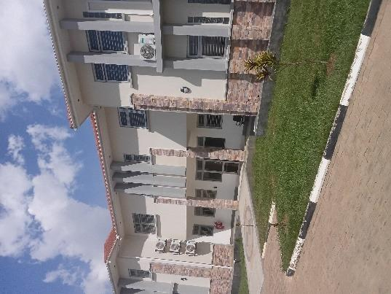 | 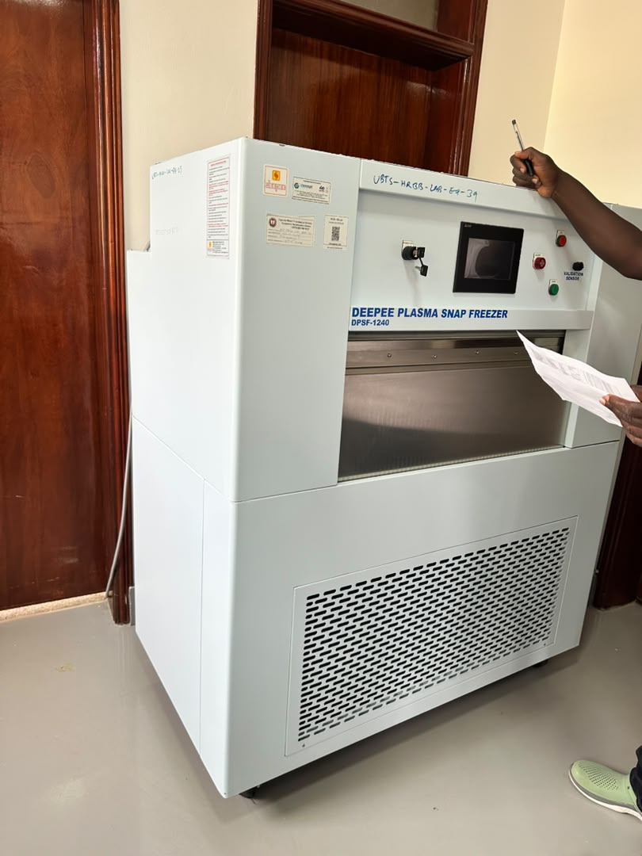
Blood-bank building at Arua Regional Blood Bank, Arua City | Plasma snap freezer at Hoima Regional Blood Bank, Hoima City
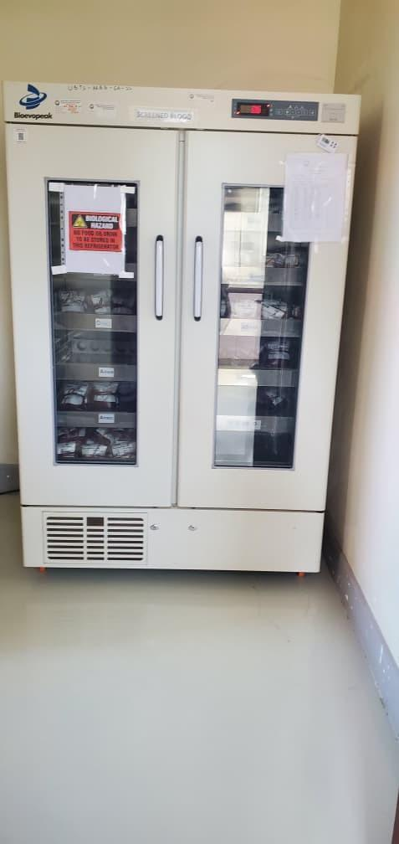 | 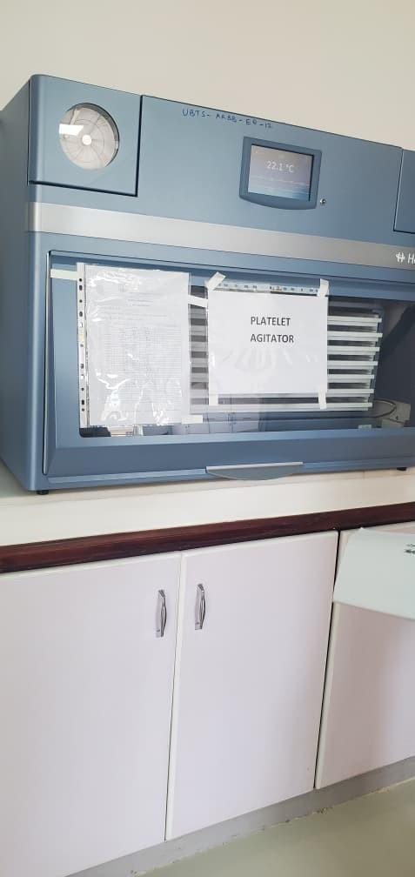
Blood bank refrigerator at Arua Regional Blood Bank, Arua City | Platelet agitator at Arua Regional Blood Bank, Arua City
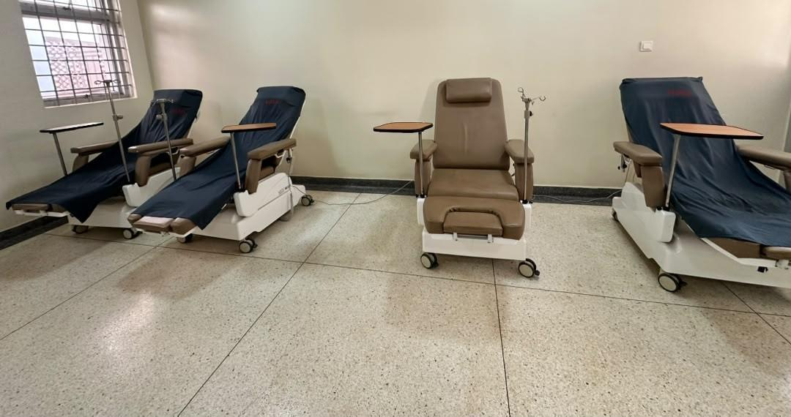 | 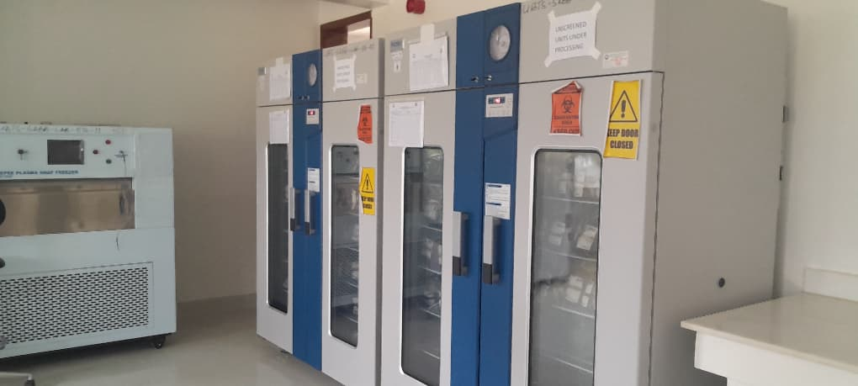
Donor couches in the donor room at Hoima Regional Blood Bank, Hoima City | Blood-bank refrigerators and plasma snap freezer at Soroti Regional Blood Bank.
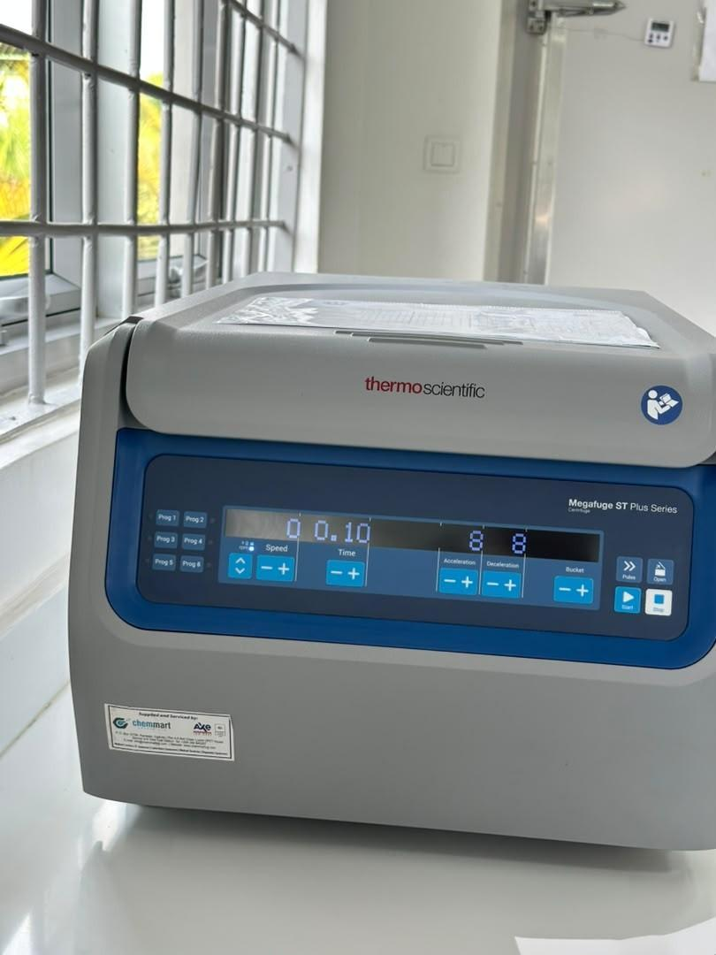 | 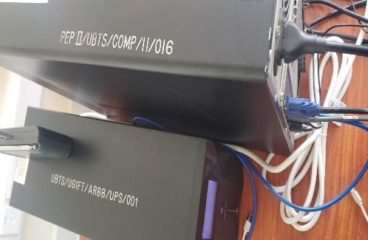
Benchtop centrifuge at Hoima Regional Blood Bank, Hoima City | Markings PEP II/UBTS/COMP/11/016 and UBTS/UGIFT/ARBB/UPS/001 on uninterruptible power supplies at Arua Regional Blood Bank, Arua City

Local Government Level results
The verified list at the LG level contained 629 UgIFT facilities, of which 371 were Health Centres and 258 were Seed Secondary Schools. Supporting returns accounted for 590 entries and 39 had discrepancies requiring reconciliation. A total of 208,688 208,687 were recorded at Health Centres and school locations, of which 63,432 were for Health Centres and 145,256 145,255 were for schools. Of the 208,688 208,687 assets, 195,224 190,347 (93.5% 91.2%) were recorded as functional and in use while in use, 5,445 (2.6%) were functional and in store, while 13,464 12,895 (6.5% 6.2%) were recorded as faulty and not in use. A further 3,067 assets were attributed to hospitals. Section 3.5.1 (Health Centres) and Section 3.5.2 (Seed Secondary Schools) present the details.

Health Centres
Availability of the assets: The verification findings indicate that health facilities had 63,432 recorded assets across the different categories which include clinical and laboratory equipment, furniture, maternity ward equipment, ICT equipment, buildings, land and other items. The register includes 7,746 non-fixed assets. Table 26 presents assets by category and proportion.

Table 26: Availability of assets in Health Centres
Asset category | No. of Assets | Proportion
Medical, laboratory and research appliances | 36,721 | 57.9%
Furniture and fittings | 15,671 | 24.7%
Outside fixed-asset classification | 7,746 | 12.2%
Buildings and structures | 2,260 | 3.6%
Other classified assets | 537 | 0.8%
ICT equipment | 424 | 0.7%
Unclassified | 64 | 0.1%
Transport equipment | 5 | 0.0%
Land (pieces) | 4 | 0.0%
Total | 63,432 | 100.0%

Asset condition and functionality: The findings indicate that of the 63,432 health-centre assets, 57,759 55,690 (91.1% 87.8%) were recorded as functional and in use and in use, 2,283 (3.6%) were functional and in store, and 5,673 5,459 (8.9% 8.6%) were recorded as faulty and not in use. Table 27 presents the condition of the assets.

Table 27: Condition of assets at Health Centres
Asset category | No. of Assets | Functional | Faulty
Medical, laboratory and research appliances | 36,721 | 32,473 32,653 | 4,248 4,068
Furniture and fittings | 15,671 | 14,988 15,001 | 683 670
Outside fixed-asset classification | 7,746 | 7,231 | 515
Buildings and structures | 2,260 | 2,144 2,158 | 116 102
Other classified assets | 537 | 479 484 | 58 53
ICT equipment | 424 | 374 376 | 50 48
Unclassified | 64 | 62 | 2
Transport equipment | 5 | 4 | 1
Land (pieces) | 4¹ ⁴ | 4 | 0
Total | 63,432 | 57,759 57,973 | 5,673 5,459

The records indicated that some health-centre assets were not in use due to a number of reasons such as assets not delivered to the health centre (still in stores at LGs), idle assets, assets with missing parts, lack of power, assets not required at the facility, rooms or wards unavailable for installation, assets held at another facility, items awaiting installation, lost or missing items and equipment unused because staff were not trained or no specialist was available to operate it. Examples include a wall-mounted blood-pressure machine at Butawata Health Centre III (Mubende District) recorded as not functional; a wheelchair at Aarapoo Health Centre III (Serere District) that had not been delivered; a patient screen at Ayer Health Centre III (Kole District) that was on the delivery note but not seen; a paediatric bed at Okwerodot Health Centre III (Kole District) supplied without a mattress; and an autoclave at Anamwany Health Centre III (Amolatar District) unused for lack of electricity. The register's two condition categories do not provide a separate count for these reasons.

In terms of buildings, there were 2,260 assets comprising of 487 residential-building, 1,402 non-residential building, 364 other-structure entries and seven water supply systems. Table 28 presents the classifications.
Table 28: Health Centre buildings
Asset category | No. of Assets
Non-residential buildings | 1,402
Residential buildings | 487
Other Structures | 364
Water supply systems | 7

Asset marking and Identification: Of the 63,432 assets in Health Centres, 9,541 (15.0%) were engraved while 53,891 (85.0%) were not engraved. It was noted that 3,824 (6.0%) carried UgIFT markings and 5,717 (9.0%) carried other markings as shown in Table 29.

Table 29: Identification of assets at Health Centres
Asset category | No. of Assets | UgIFT markings | Other markings | Not engraved
Medical, laboratory and research appliances | 36,721 | 1,786 | 2,826 | 32,109
Furniture and fittings | 15,671 | 1,484 | 1,888 | 12,299
Outside fixed-asset classification | 7,746 | 356 | 689 | 6,701
Buildings and structures | 2,260 | 45 | 179 | 2,036
Other classified assets | 537 | 20 | 43 | 474
ICT equipment | 424 | 133 | 32 | 259
Unclassified | 64 | 0 | 54 | 10
Transport equipment | 5 | 0 | 4 | 1
Land (pieces) | 4 | 0 | 2 | 2
Total | 63,432 | 3,824 | 5,717 | 53,891

Financial Value of assets: The findings indicate that the available recorded value of assets was UGX 260,692,452,291, the available net book value was UGX 189,403,577,197 189,938,593,910, and the available accumulated depreciation was UGX 39,211,094,700 38,688,515,987 as at 30th September 2026. Table 30 gives the recorded value and net book value.

Table 30: Recorded and net book values at Health Centres
Asset category and coverage | Recorded cost (ugx million) | Accumulated depreciation (ugx million) | Net book value (ugx million) | % NBV
Medical, laboratory and research appliances | 39,592.633 | 14,080.055 14,085.950 | 18,715.685 18,719.599 | 57.1% 47.3%
Furniture and fittings | 15,109.270 | 5,764.153 5,765.308 | 6,584.582 6,585.877 | 53.3% 43.6%
Non-fixed assets | 479.803 | 0.000 | 0.000 | n/a 0.0%
Buildings | 203,954.138 | 18,304.241 17,774.449 | 163,802.803 164,332.595 | 89.9% 80.6%
Other assets | 347.206 | 172.492 | 133.099 | 43.6% 38.3%
ICT equipment | 929.345 | 825.749 | 85.256 | 9.4% 9.2%
Unclassified | 134.958 | 0.971 1.135 | 0.485 0.501 | 33.3% 0.4%
Transport equipment | 75.100 | 63.433 | 11.667 | 15.5%
Land | 70.000 | 0.000 | 70.000 | 100.0%
Total | 260,692.452 | 39,211.095 38,688.516 | 189,403.577 189,938.594 | 82.8% 72.9%

The verification established that some buildings were complete and in use while others were incomplete as presented in the photographs below.

Pictorial 4: Status of Health Centre Buildings in selected LGs
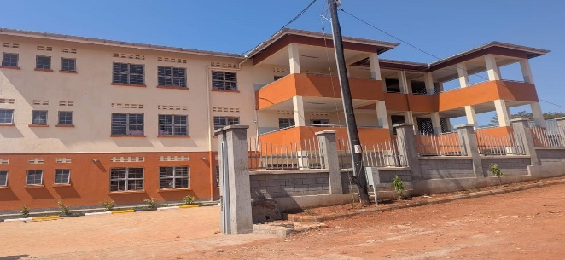 |  | 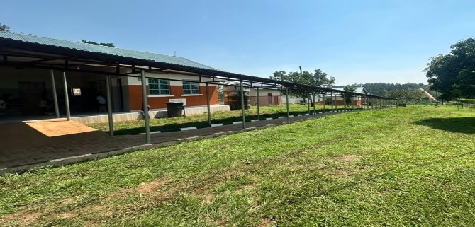
Health centre building at Kibiri Health Centre III, Makindye-Ssabagabo Municipal Council |  | Health centre buildings and covered walkway at Kihuukya Health Centre III, Hoima City
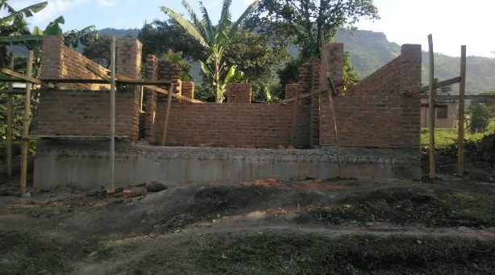 | 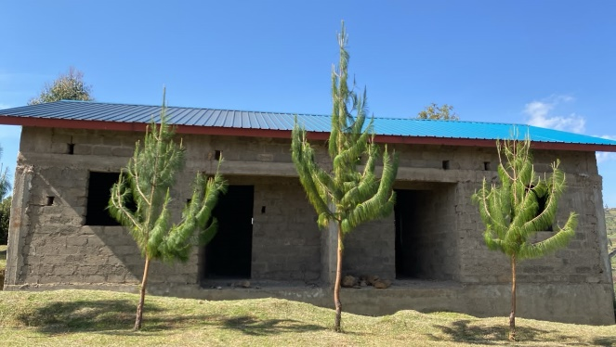
Unfinished laboratory building at Simu Pondo Health Centre III, Sironko District | Incomplete staff quarters at Benet Health Centre III, Kween District.
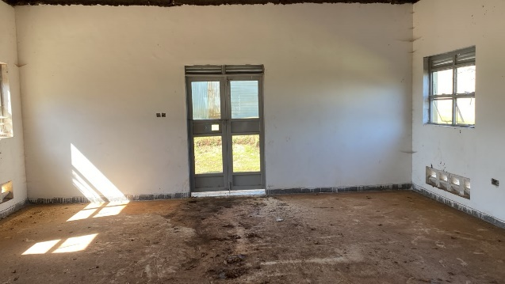 | 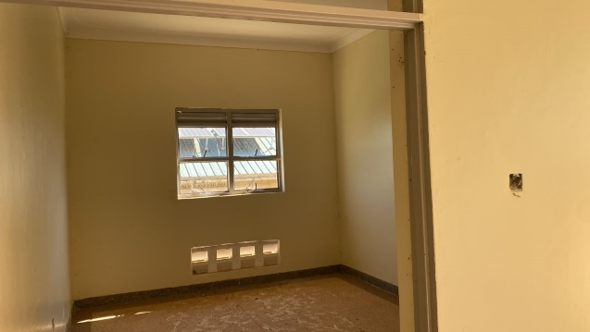
Interior awaiting completion at Benet Health Centre III, Kween District. | An unfinished room at Benet Health Centre III, Kween District

Seed Secondary Schools
Availability of the assets: The findings showed that schools had 145,256 145,255 recorded assets covering the following categories: school buildings, water facilities, furniture, computers and related equipment such as monitors, UPS units and keyboards; ICT equipment including printers, photocopiers, cameras and projectors; and other school assets such as laboratory items, electrical items, plant and machinery and sports equipment. Table 31 presents the details.
Table 31: Availability of assets in schools
Asset category | No. of Assets | Proportion
Furniture and fittings | 107,792 | 74.2%
ICT equipment | 12,036 12,035 | 8.3%
Outside fixed-asset classification | 9,081 | 6.3%
Buildings and structures | 7,505 | 5.2%
Medical, laboratory and research appliances | 5,604 | 3.9%
Other classified assets | 2,716 | 1.9%
Unclassified | 500 | 0.3%
Land (pieces) | 14 | 0.0%
Transport equipment | 8 | 0.0%
Total | 145,256 145,255 | 100.0%

Asset condition and functionality: Out of 145,256 145,255 assets, 137,465 134,657 (94.6% 92.7%) were recorded as functional and in use. functional and in use, while 3,162 (2.2%) were functional and in store. The verification further established that 7,791 7,436 (5.4% 5.1%) were recorded as faulty and not in use. Table 32 indicates the asset condition.

Table 32: Condition of assets in schools
Asset category | No. of Assets | Functional | Faulty
Furniture and fittings | 107,792 | 102,521 102,581 | 5,271 5,211
ICT equipment | 12,036 12,035 | 10,404 10,665 | 1,632 1,370
Outside fixed-asset classification | 9,081 | 8,692 | 389
Buildings and structures | 7,505 | 7,220 7,241 | 285 264
Medical, laboratory and research appliances | 5,604 | 5,498 | 106
Other classified assets | 2,716 | 2,623 2,635 | 93 81
Unclassified | 500 | 485 | 15
Land (pieces) | 14 | 14 | 0
Transport equipment | 8 | 8 | 0
Total | 145,256 145,255 | 137,465 137,819 | 7,791 7,436

Table 32 further indicates that school furniture and fittings (desks, tables, chairs, shelves and stools) is the largest category with 107,792 assets. Of these, 102,521 100,864 were recorded as functional and in use while in use, 1,717 were functional and in store, while 5,271 5,211 were recorded as faulty. ICT equipment had 10,404 9,449 assets recorded as functional and in use.

Asset marking and Identification: Of the 145,256 145,255 school assets, 35,601 35,600 (24.5%) were engraved while 109,655 (75.5%) were not engraved. A total of 13,478 (9.3%) had UgIFT markings and 22,123 22,122 (15.2%) had other markings, as shown in Table 33

Table 33: Identification of assets in schools
Asset category | No. of Assets | UgIFT Marking | Other Markings | Not engraved
Furniture and fittings | 107,792 | 12,985 | 18,503 | 76,304
ICT equipment | 12,036 12,035 | 315 | 2,426 2,425 | 9,295
Non-fixed-assets | 9,081 | 0 | 452 | 8,629
Buildings and structures | 7,505 | 40 | 391 | 7,074
Medical, laboratory and research appliances | 5,604 | 121 | 242 | 5,241
Other classified assets | 2,716 | 17 | 96 | 2,603
Unclassified | 500 | 0 | 10 | 490
Land (pieces) | 14 | 0 | 2 | 12
Transport equipment | 8 | 0 | 1 | 7
Total | 145,256 145,255 | 13,478 | 22,123 22,122 | 109,655

Financial Value of school assets: The recorded asset value was UGX 700,242,561,371 700,162,561,371, accumulated depreciation was UGX 104,574,530,246 104,600,960,410 and the net book value was UGX 394,241,708,595 394,577,108,431 as at 30th September 2026, as shown in Table 34.

Table 34: Recorded value and net book value for schools
Asset category | Recorded cost (ugx million) | Accumulated depreciation (ugx million) | Net book value (ugx million) | % NBV
Furniture and fittings | 22,612.957 | 11,733.742 | 7,406.367 | 38.7% 32.8%
ICT equipment | 29,669.809 29,589.809 | 15,836.227 15,772.471 | 9,584.916 9,570.003 | 37.7% 32.3%
Non-fixed-assets | 40,839.592 | 0.000 | 0.000 | n/a 0.0%
Buildings and structures | 601,004.483 | 74,561.320 74,216.507 | 374,906.543 375,256.856 | 83.4% 62.4%
Medical, laboratory and research appliances | 1,455.366 | 864.426 | 511.352 | 37.2% 35.1%
Other classified assets | 2,488.189 | 1,037.888 | 1,224.696 | 54.1% 49.2%
Unclassified | 610.010 | 33.415 468.415 | 141.245 | 80.9% 23.2%
Land (pieces) | 110.029 | 0.000 | 110.029 | 100.0%
Transport equipment | 1,452.127 | 507.511 | 356.561 | 41.3% 24.6%
Total | 700,242.561 700,162.561 | 104,574.530 104,600.960 | 394,241.709 394,577.108 | 79.0% 56.4%

The verification established that some buildings were complete and in use while others were incomplete as presented in photographs below.

Pictorial 5: Status of Buildings in selected Seed Secondary Schools
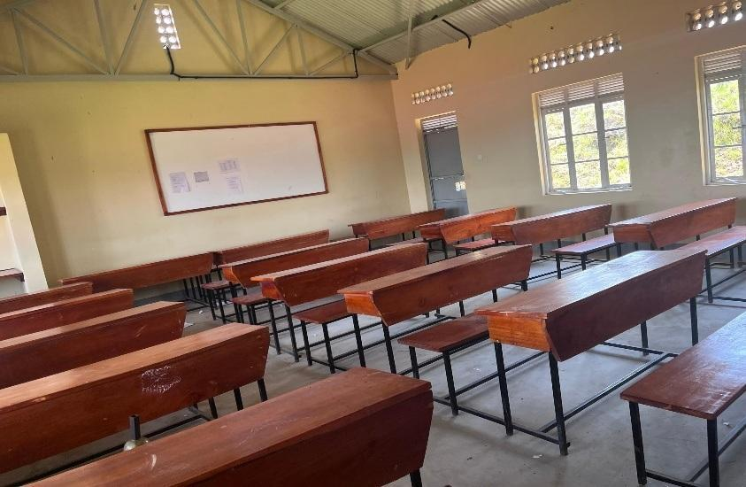 | 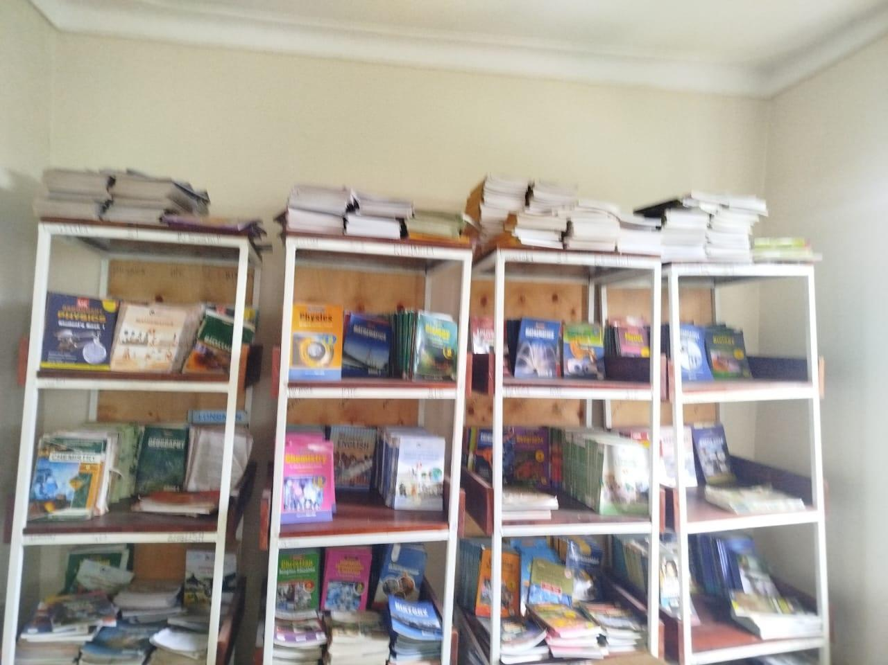
Classroom furnished with desks and a whiteboard at Gyagenda Memorial Seed Secondary School, Kalangala District | Books displayed in library shelves at Sibanga Seed School, Manafwa District
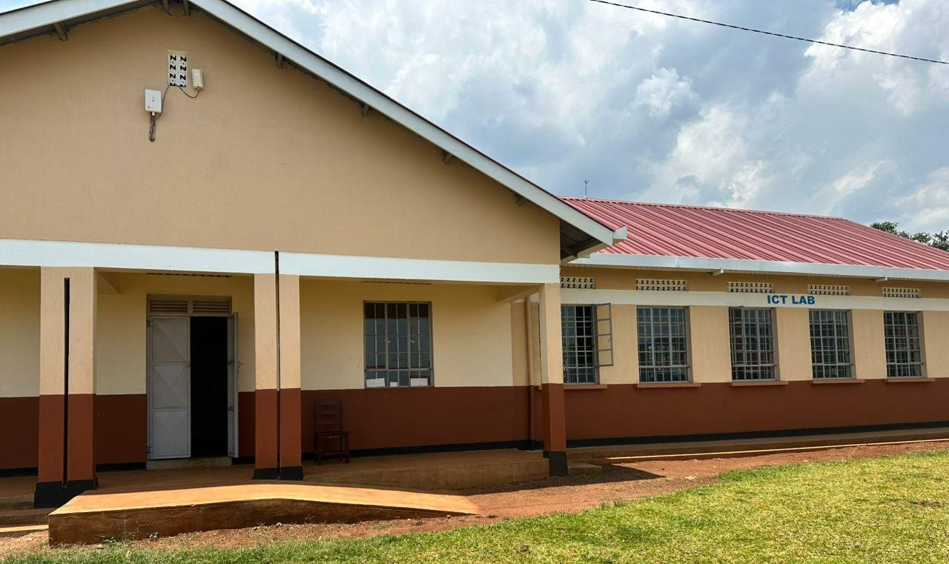 | 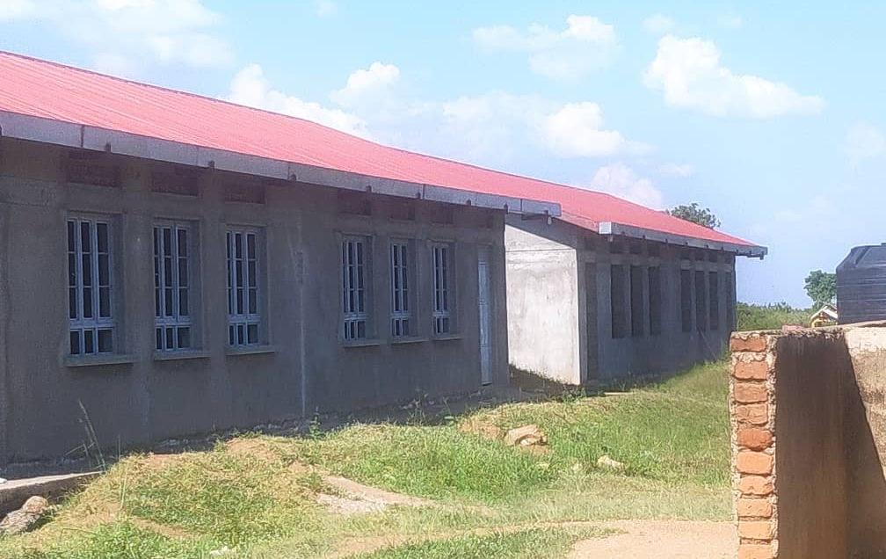
ICT laboratory block and entrance ramp at Sisiyi Seed Secondary School, Bulambuli District | Unfinished school block at Got Apwoyo Seed Secondary  School, Nwoya District
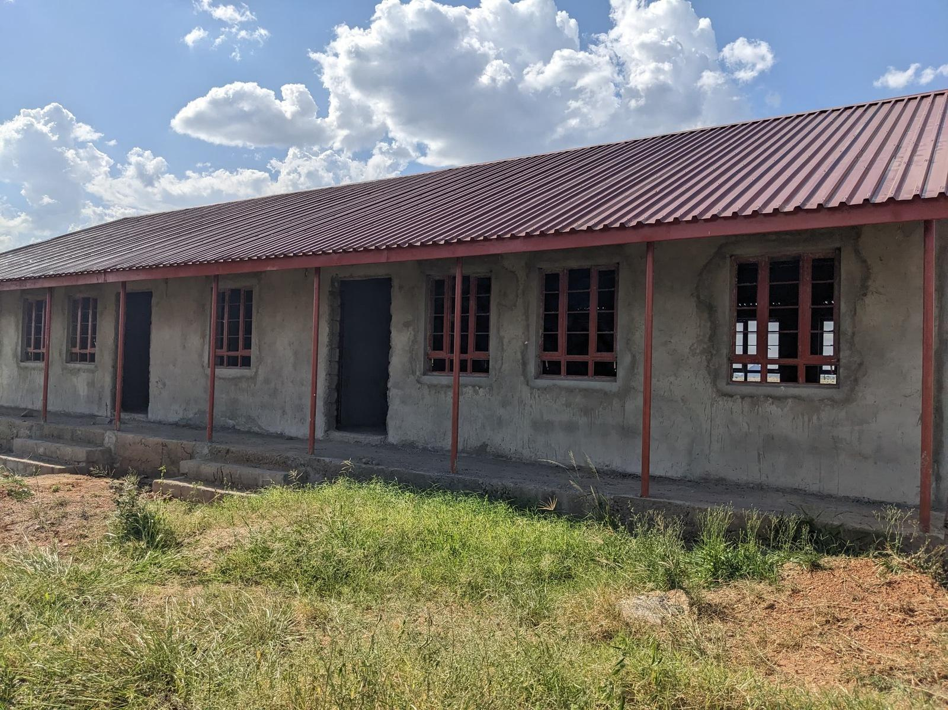 | 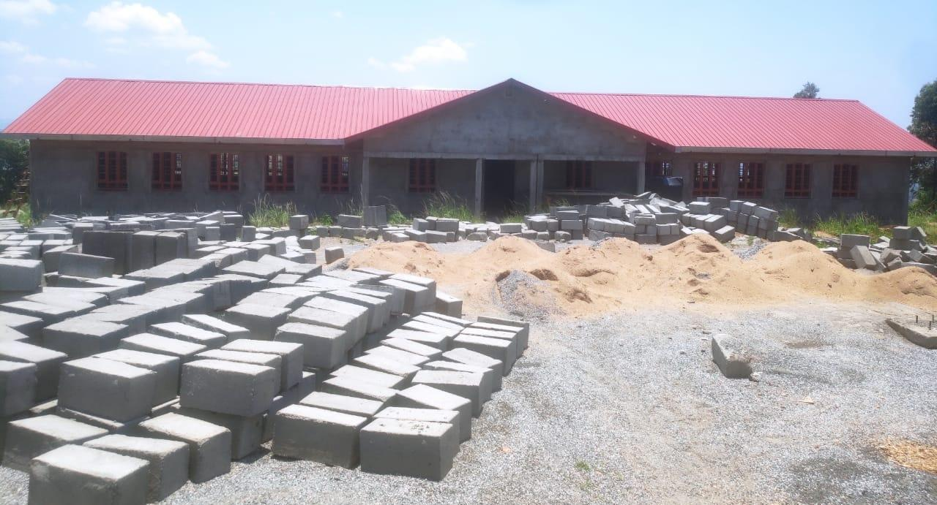
Unfinished classroom block at Sidok Seed Secondary School, Kaabong District | Building works and construction materials at Ndhew Seed Secondary School, Nebbi District
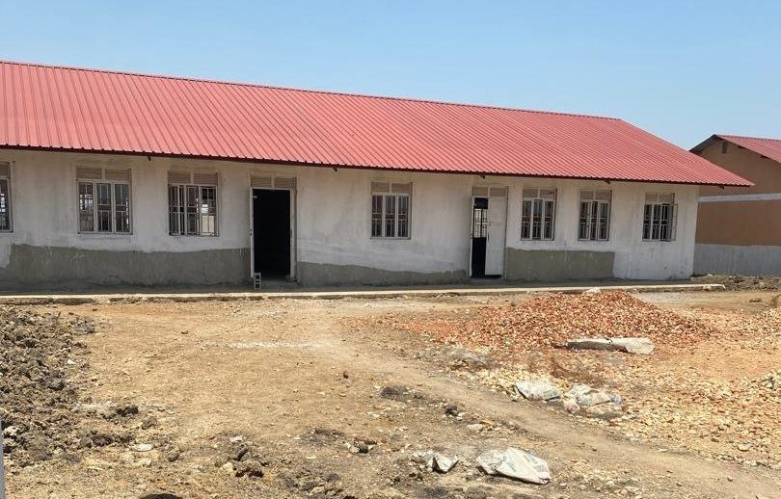 | 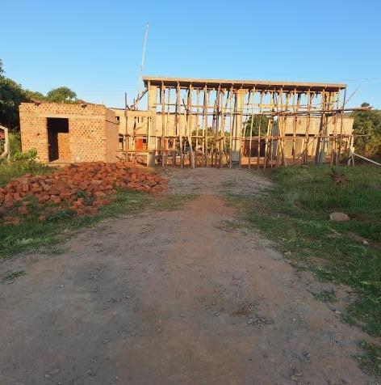
School block awaiting completion at Butungama Seed Secondary School, Ntoroko District | Building works at a seed secondary school, Kiboga District
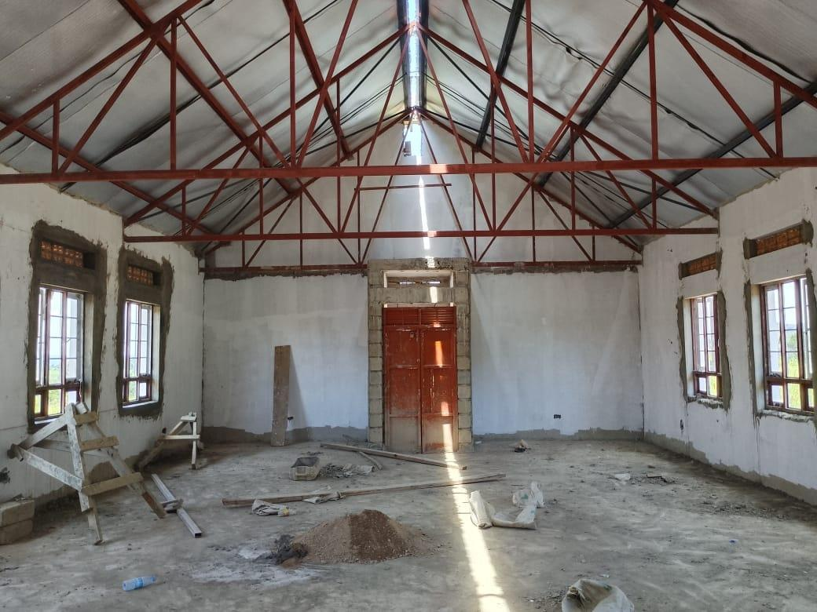 | 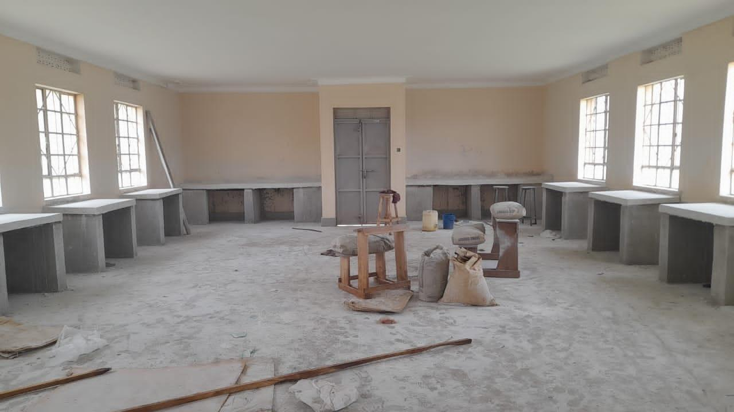
Library interior under construction at Kihungya Seed Secondary School, Buliisa District | ICT laboratory interior under construction at Kitawoi Seed Secondary School, Kween District

Field Observations

Completion Status of Facilities
The verification established that some facilities were completed, while others were not. Table 35 provides the status of the completed and non-completed buildings for both health centres and Seed Secondary Schools. In total, facilities verified were 629 contrary to 632 which was on the program list. This was due to the three (3) duplicate entries which are; Kapedo Seed Secondary School in Karenga district, Nyamarunda HCIII in Kibaale district and Kidubuli HC II in Kabarole.

Table 35: Completion Status for both Health centers and Seed Secondary Schools
Status | Health centres | Schools | Total
Completed | 352 | 195 | 547
Ongoing | 19 | 63 | 82
Incomplete works | 13 | 57 | 70
Awaiting commissioning | 2 | 11 | 13
Total | 371 | 258 | 629

Table 35 indicates that 547 facilities were completed. Eighty-two facilities were ongoing comprising of 19 health centers and 63 Seed Secondary Schools. The verification also showed that 70 facilities were incomplete, comprising 57 schools and 13 Health Centres. Another 13 facilities were awaiting handover or commissioning, comprising 11 schools and 02 Health Centres. Some facilities were providing services while works remained incomplete.

Location and Name changes
The verification exercise found mismatches between information in the Program list and what was observed on the ground. Out of 629 Program-list entries, 606 (96.3%) had supporting returns, and 23 (3.7%) had discrepancies requiring reconciliation. These include entries on the Program list without matching returns or with conflicting location or facility-type information. Table 36 provides the details.

Table 36: Inconsistencies between the Program list and the facilities found
Status | Health Centres | Schools | Total | Facilities
Facilities on the Program list but not on the ground | 7 | 3 | 10 | Health centres: Olok HC II (Pader); Alik HC II (Lira); Acimi HC II (Oyam); Acokara HC II (Oyam); Ariba HC II (Oyam); Busia Eastern Division (Busia Municipal Council); Butoloogo HC II (Kassanda)  Seed schools: Eastern Division (Tororo Municipal Council); Central Division (Jinja City); Kishangara Seed School (Ibanda)
Not a UgIFT beneficiary | 2 | 1 | 3 | Health centres: Alira HC II (Oyam); Buyinda HC II (Kaliro)  Seed schools: Kiziranfumbi Seed School (Kikuube)
Exists with no UgIFT assets | 2 | 3 | 5 | Health centres: Pandwong HC II (Kitgum Municipal Council); Rwamujojo HC II (Sheema Municipal Council)  Seed schools: Bumbaire Seed School (Bushenyi); Kyamuhunga (Bushenyi); Kashenshero (Mitooma)
UgIFT assets relocated to another facility | 2 | 1 | 3 | Health centres: Alangi (Zombo) to Amwonyo HC III; Ther-uru HC II (Zombo) to Atyak HC III  Seed schools: Abanga (Zombo) to Kango SSS
Represented by another name | 2 | 0 | 2 | Health centers: Loinya HC II in Maracha (H213) was replaced by Liko HC III (H212),  Bussi HC II in Wakiso (H054) is treated as a village name for Zinga Health Centre III (H052).
Total | 15 | 08 | 23

Impact of UgIFT Program on service delivery
Of the 284 health centres, 238 (83.8%) reported at least one benefit from the UgIFT support. 117 (41.2%) reported improved maternity and delivery services, and 51 (18.0%) reported more or safer births at the facilities. Improved antenatal, immunisation, laboratory or other specific services were reported by 89 (31.3%), improved access to care or shorter distances by 71 (25.0%) and more patients’ attendance reported by 61 (21.5%). More than half, 164 (57.7%), linked better services to the equipment and furniture supplied.
Of the 193 seed schools, 144 (74.6%) reported at least one benefit. 74 (38.3%) reported a better learning environment, with classrooms, furniture, and libraries, and 59 (30.6%) reported improved access to secondary education or shorter distances. Practical science or ICT teaching improved at 39 schools (20.2%), and 37 (19.2%) reported higher enrolment. Forty schools (20.7%) also reported jobs and local economic benefits around the school.

ASSET MANAGEMENT

4.1 Maintenance and repairs
Most of the verified assets were furniture, clinical equipment and computers in daily use at Health Centres, Seed Secondary Schools and MDAs. During verification, each facility reported how it maintains, repairs, services or replaces UgIFT assets, and whether it keeps a regular record of their functionality or breakdowns.

Repair arrangements: Most facilities reported some level of maintenance of the provided assets. However, maintenance arrangements varied by facility. All MDAs reported using own funds for maintenance and repairs. At LG level, 260 (55.4%) met repair needs at facility level, using own funds (Primary Health Care funds 33.8%) for health centres, while schools used capitation or the Universal Secondary Education grant (52 of 191, 27.2%). 152 facilities (32.4%) relied on external support for maintenance, citing support from district or higher-level facilities; hiring technicians and artisans (27, 5.8%); or engaging contractors or suppliers under defects liability, guarantee, or warranty (12, 2.6%).

A significant proportion of facilities, 97 (20.7%), of which 59 were schools, had not yet required maintenance because the assets were new, some had not yet been handed over, or the buildings were still under construction. 36 (7.7%) reported no repair arrangements, with broken items set aside or left unrepaired. However, 6.3% of facilities reported insufficient funds for asset maintenance, particularly for major repairs. At Kyankaramata Health Centre III in Kyenjojo, Primary Health Care funds covered minor repairs, but the cost of major repairs was a constraint.

Asset condition/Life cycle tracking: The verification noted that a small proportion of facilities 13.7% (68) kept track of the asset condition/lifecycle. Of these 10.1% (50) had fixed maintenance interval with facilities 28.0% (14) checking asset condition annually, 22.0% (11) monthly, 20.0% (10) quarterly, 18.0% (9) every school term, 6.0% (3) twice a year and 6.0% (3) weekly. Eighteen (18) facilities (3.6%) depended on routine/scheduled servicing by regional referral hospital maintenance teams as shown in Figure 10 3. Furthermore, 12.3% (61 facilities) repaired their assets as the need arose.

Figure 9 13: Asset condition tracking intervals
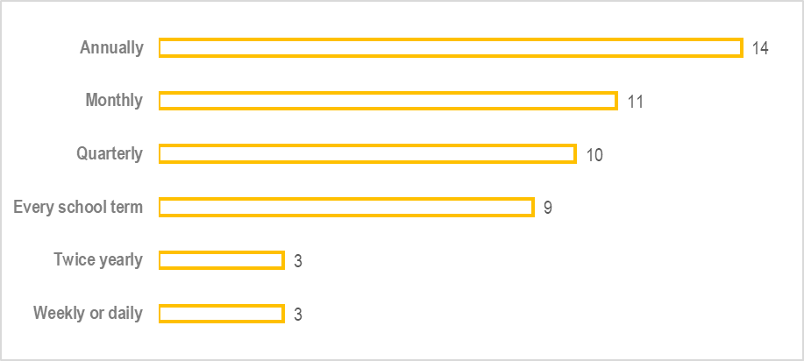

Asset Records management: Of the 629 facilities, 354 (56.3%) facilities had asset records. Of these, 318 (89.8%) kept a regular record of asset functionality or breakdowns, 36 (10.2%) kept partial or informal records. In contrast, 275 (43.7%) had no records at all because the assets were new or the facility was not yet operating. Records indicated that some assets were obsolete and unserviceable for example; two wall-mounted aneroid blood-pressure machines at Nyanja Health Centre III, UGIFT-012842 and UGIFT-012843, were reported as spoilt, beyond repair and requiring replacement.

In addition, records indicate that some assets were reported stolen, others not received, while other equipment had missing accessories. Examples include the incubator at Buwembe Health Centre III (UGIFT-114904) and the ENT instrument set at Rubingo Health Centre III (UGIFT-188911), which were reported as not received. At Paloga Seed Secondary School, two monitors were reported stolen.

Asset Disposal: The verification exercise noted a lack of a clear asset planning and disposal process for UgIFT assets across the facilities. Obsolete assets and faulty equipment remained at the facilities, with no specific disposal schedules due to the absence of UgIFT asset disposal guidelines.

GAPS AND CHALLENGES

The main gaps identified by the facilities include the following, as indicated in figure 9 14
- Insufficient Power supply which was reported by 201 facilities (42.1%), including 44.4% of Health Centre respondents and 38.9% of school respondents;
- Inadequate staffing, which was reported by 32.1% of the facilities (153 of 477).
- Inadequate space or infrastructure reported by 31.7% of the facilities (151 of 477).
- Insecurity or absence of fencing reported by 27.0% of the facilities (129 of 477).
- Limited maintenance support was raised by 22.2% of the facilities (106 of 477).
- Inadequate staff housing was reported by 22.0% of the facilities (105 of 477).
- Poor water supply reported by 20.1% of the facilities (96 of 477).
- Inadequate staff training to operate the equipment was reported by 28.9% of health centres (82 of 284) and 1.6% of schools (three of 193).
- Incomplete or delayed works, handover or commissioning reported by 28.0% of Seed Secondary School respondents (54 of 193) and 10.2% of Health Centre respondents (29 of 284).
- Equipment not installed, not assembled or delivered incomplete was raised by 17.6% of the facilities (84 of 477).

Figure 10 14: Service gaps and challenges
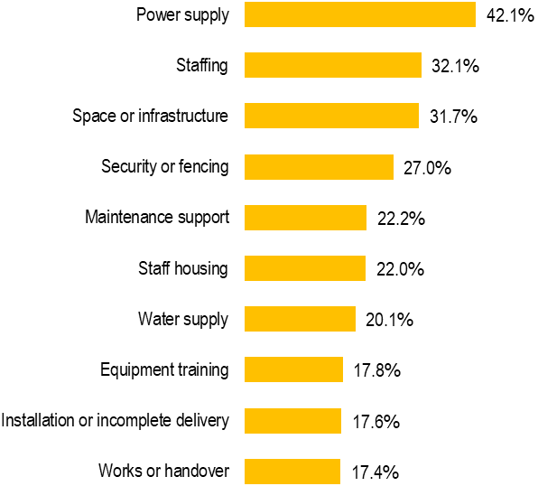

LESSONS LEARNT AND BEST PRACTICES

The lessons and good practices below draw on the verification findings.

Lessons learnt
Incomplete facilities and attendant amenities constrained equipment utilization. At some facilities equipment remained nonfunctional due to lack of space, power, water and other amenities. For example, at Lungulu Seed Secondary School in Nwoya, computers and related equipment remained in storage pending a power connection while at Pamaka Health Centre III in Nebbi, a nonfunctional solar system and power constraints prevented use of oxygen equipment.
Limited technical capacity affects functionality and utilization of equipment supplied: Some facilities had equipment in good condition but could not utilize them owing to capacity gaps. For example, Bubago health centre III reported limited capacity to operate and maintain an oxygen concentrator.
Poor planning for operation and Maintenance leads to ineffective management of assets: Verification established that some facilities could only meet minor repairs from Primary Health Care funds but had difficulties financing major repairs.
Missing or incomplete registers made it harder to identify UgIFT assets. The verification noted that some MDs and LGs did not have proper asset registers. This makes asset identification and attribution difficult. Loss of assets and insufficient asset information is partly due to lack of official handover by transferred/ retired staff. In some MDAs and LGs asset information could not be traced due to loss of institutional memory as some staff were new and had no official records from previous staff.

Best practices
Keeping accessible registers allows ease of storage and retrieval of important information. This provides a basis for maintaining program attribution within the institution's main asset records. The use of simple asset condition books and scheduled checks provide models for easy and simple controls.

Using available technical support improves asset maintenance. Some facilities collaborated with other external institutions to maintain and repair their assets. For example, Ngwedo Seed Secondary School reported engaging a caretaker for repairs from the Directorate of Industrial Training while Todora Health Centre III reported relying on the Gulu Regional Referral Hospital technical team for major equipment maintenance.

Documenting asset movement from one facility to another requires transfer of relevant records. This is a useful documentary practice for tracing changes in location, asset identification details, reason for movement and asset condition on transfer. For example, Busia district report recorded requisition vouchers for equipment transferred from Bumunji, Buwembe and Majanji health centres to Masafu Hospital.

Integrating supplied assets into the planned facility activities enhances easy utilization of the asset. This provides a basis for facilities to utilize the acquired equipment in line with existing plans and program which strengthens delivery of services. For example, Musiitwa Seed Secondary School in Busia District reported using its irrigation system for practical teaching and food production, linking a supplied asset to an educational activity.

Piloting of tools before field work enhances the quality of data collection tool. The piloting of the tool at Buloba Health Centre III and Sumbwe Seed Secondary School in Wakiso District helped to refine tools, timelines and costs.

RECOMMENDATIONS

The following key recommendations are made to improve the management of the UGIFT assets.
- Maintenance of fixed asset registers at asset location level. It is recommended that;
- proper Fixed Asset Registers for UgIFT assets be maintained at the ultimate asset recipient/asset location level, in a format and content like those of the Uganda Government National-level Fixed Assets Register.
- Officers in charge of the assets at the ultimate recipient level should receive training in Fixed Asset Register maintenance.

- Assign unique program identifiers to UgIFT assets. The Program secretariat should engrave all the verified assets with UgIFT markings and confirm their locations and custodians. Assets carrying only another marking should receive the Program identifier and every facility should hold a list of the UgIFT assets it received, showing each item, its engraving and its custodian.

- Adopt a fixed routine asset condition check in addition to existing routine checks. It is recommended that;
- LGs should conduct a condition check at least once per school term in schools and once per quarter in health centres and conduct a full count of UgIFT assets each year.
- Each facility should maintain a condition book or fault list listing each item requiring action, the responsible person and the agreed completion date.
- LG health and education offices should review unresolved repairs each quarter and arrange technical assistance.
- Regional referral hospital workshops should include checking on UgIFT equipment in their scheduled visits.
- All lost assets should be reported and investigated under the public finance rules, and Maintain site, ownership and handover records for buildings and land.

- Develop Asset Maintenance Plan; Facilities should prepare annual maintenance plans, separating minor from major repairs.

- Fast-track the construction of incomplete buildings, and supply of utilities, furniture and equipment: LG Accounting Officers, engineers, health and education officers and contractors should fast-track completion of outstanding buildings and supply of utilities, furniture and equipment through site-specific completion plans for each of the 83 documented facilities with outstanding works and or requiring handover or commissioning.

- Provision of user training: it is recommended that;
- LG technical officers, suppliers, and regional technical teams should provide user or practical training for staff who use specialised equipment. This is particularly important, as some Health Centres cited lack of skills as the reason for idle equipment, including oxygen equipment for example Bubago HCIII in Kamuli District and Sop Sop HCIII in Tororo District and staff requiring orientation at Abogera HCIII in Buliisa District.
- Handover should include a demonstration, basic maintenance guidance, and a scheduled plan for technical support.
- Future supply contracts should make on-site demonstration for the staff who will use the equipment as a condition for acceptance.

- Leverage LG performance assessment: MoFPED and LGs should use the assessment process to track asset life cycles and plan for asset repair, disposal and replacement.

- Provide Operational Requirements; Responsible MDAs and LGs should ensure availability of power, staff, water, space and security necessary to ensure assets are deployed and are functional.

APPENDICES

Fixed Assets Register: The detailed Fixed Assets Register is available at:

https://docs.google.com/spreadsheets/d/1oNVgJVJmakgqas_wiZWVp84xyTQpL3Xg/edit?usp=sharing&ouid=109845196979997160153&rtpof=true&sd=true

Rukoki’s recorded assets include a digital BP machine/multiparameter monitor (1), autoclaves (2), kick bowls (8), bowls (10), bowl stands (3), lockable steel cupboards (6), instrument cupboards (6), drip stands (10), examination couches (4), glucometers (2 verified; 2 in store), instrument trolleys (8), patient screens (10 seen; 5 in store), patient trolleys (2), refrigerators (2), stethoscopes (10 verified; 3 in store), a stretcher (1), adult weighing scales with height meters (4), infant weighing scales (4), wheelchairs (2 verified; 2 in store), MCH diagnostic sets (2 sets), OPD diagnostic sets (2 sets), ward diagnostic sets (2 sets), laboratory glassware (2 sets), dressing instruments (3 sets), suture instruments (3 sets), handheld pulse oximeters (10; 4 in use), adult beds with mattresses (50 received; 20 others recorded as kept), paediatric beds with mattresses (20), bedside lockers (10 verified; 10 kept), hydraulic delivery beds (2), other delivery beds (2), oxygen therapy apparatus/cylinders (2), infant manual resuscitators (5), adult manual resuscitators (3), electric suction apparatus (1), an ultrasonic nebulizer (1), a dual-flow oxygen concentrator (1), baby cots (8), delivery instruments (1 set), laboratory stools (2), penguin suckers (8), a Doppler fetoscope (1), bubble CPAP equipment (1), an electric centrifuge (1), a kangaroo mother care chair (1), a radiant infant warmer (1) and incubators (3; 1 in use). Ward hollow ware (quantity unspecified), stitch-removal instruments (quantity unspecified), an examination light (quantity unspecified), basic ENT instruments and a neonatal Ambu bag.
The four land entries were for Kyamwinula Health Centre III (UGIFT-119332), Sop Sop Health Centre III (UGIFT-128460), Nalubembe Health Centre III (M161488) and Kabweri Health Centre III (M183544). Dimensions are stated only for Sop Sop, at 70 × 300 metres.

