

ASSET VERIFICATION AND RECORDING TOOL KIT


Plot 31, Bukoto Street
P.O Box 7657, Kampala, Uganda
+256 (0) 39 2000216/0772525235
email: cpa@cpa.ug

www.cpa.com

August to September 2026

VERIFICATION DETAILS

NAME OF THE REGION: | CENTRAL
SUB-REGION: | BUGANDA
Name of Local Government | MUBENDE
VERIFIER PARTICULARS
Full name | JALIYAH BALUUBU
Contact/ email and Telephone | Jaliahb45@gmail.com  0794775877
Supervisor/ Sub team leader
Name | Prof: MBONIGABA DEPAUL
Contact | 0788483159
Date of submission | 06/09/2026

HEALTH CENTRES
INFORMANT INTERVIEW/DISCUSSION GUIDE (INCHARGE OR RESPONSIBLE PERSON)

Name of Health Centre:

1a | Does the Facility have a record of all assets provided under UgIFT.  (Obtain a record and verify if it has the costs and numbers supplied
1b | If Not ask how many were supplied and when.

2 | How does this facility Maintain (repair/service/replace) the assets provided under Ugift

3 | Does the facility take regular record about functionality/ or breakdown of the assets provided?

4 | How has the UgIFT support helped in service delivery in the area, any issues, challenges and any recommendations for better program implementation.

PROCEED TO VERIFICATION AFTER THIS DISCUSSION

Health centre checklist

NAME OF LG
NAME OF HEALTH FACILITY

Equipment/ Item | Department | Asset Number | Item  Description | Life in Months | Tag Number ( engrave no.) | Date Of Purchase | Date Placed In Service | Recoverable cost | Cost | Acc Dep Cost | Net Book Value | Ytd Deprn | Equipment status | Remarks

SCHOOL VERIFICATION CHECKLIST

SCHOOL INTERVIEW/DISCUSSION GUIDE

Name of school: RWENTUHA SEED SECONDARY SECONDARY SCHOOL

1a | Does the Facility have a record of all assets provided under UgIFT.  (Obtain a record and verify if it has the costs and numbers supplied | yes
1b | If Not ask how many were supplied and when.

2 | How does this facility Maintain (repair/service/replace) the assets provided under Ugift

The school has a portion off the school budget to handle damages and repairs in addition to the capitation grants
It recieves from the government

3 | Does the facility take regular record about functionality/ or breakdown of the assets provided?  Nonfunctional/ working, and reasons for non-functionality. | Not applicable

Yes, The school had a proper asset register that indicated the number of each asset it received abd the number of items that were damaged and repaired

4 | How has the UgIFT support helped in service delivery in the area, any issues, challenges and any recommendations for better program implementation.

UGIFT program has improved, promoted and eased the teaching of both the science and computer subjects.

The incharge said that most the playground was left incomplete till now which has affected the sports activities at school

The incharge recommended that the contractor should work on completion of the sports play ground

PROCEED TO VERIFICATION AFTER THIS DISCUSSION

SCHOOL FURNITURE
(School Desks, Office chairs, Laboratory stools, Book shelves)

Name of SCHOOL RWENTUHA SEED SECONDARY SCHOOL

Equipment/ Item | Department | Asset Number | Item  Description | Life in Months | Tag Number ( engrave no.) | Date Of Pur | Date Placed In Service | Recoverable cost | Cost | Acc Dep Cost | Net Book Value | Ytd Deprn | Equipment status | Remarks
School desks | Education |  | Wooden varnished desks |  | RWE SSS  RWE SSS  RWE SSS | l | 01.01.22 |  |  |  | 27, 900,000 |  | Functional | 93 desks well engraved and functional 10 of them are damaged pending repair
Single seaters | Education |  | Wooden varnished |  | RWE SSS  RWE SSS  RWE SSS |  | 15.02.22 |  |  |  | 4,000,000 |  | Functional | 50 engraved chairs
Laboratory Tables | Education |  | Varnished wooden tables |  | Not engraved |  |  |  |  |  |  |  | Functional | 13 functional tables
Laboratory stools | Education |  | Well varnished wooden stools |  | Not engraved |  |  |  |  |  |  |  | Functional | 35 functional stools

ICT ITEMS TO VERIFY
(Desktop Computer, Server Processor, Network Switch 24 Port, Multipurpose Printer, UPS, Projector, Air Conditioners, Server, CCTV Camera)

Name of LG KYEGEGWA

Name of SCHOOL RWENTUHA SEED SECONDARY SCHOOL

Equipment/ Item | Department | Asset Number | Item  Description | Life in Months | Tag Number ( engrave no.) | Date Of Pur | Date Placed In Service | Recoverable cost | Cost | Acc Dep Cost | Net Book Value | Ytd Deprn | Equipment status | Remarks
Desktop computers | Education |  | Computers |  | RWE SSS  RWE SSS  RWE SSS |  | 01.01.22 |  |  |  |  |  | Functional | 28 functional and in good shape
Projector | education |  | projector |  | RWE SSS |  | 01.01.22 |  |  |  |  |  | Functional | Functional and in use
Printer | Education |  | Printer |  | RWE SSS |  | 01.01.22 |  |  |  |  |  | Functional | Functional

BUILDINGS TO VERIFY
(Non- Residential and Residential, Kitchen, Toilets/Pit latrine Water tanks, Fences etc.)

Name of LG KYEGEGWA
Name of SCHOOL RWENTUHA SEED SECONDARY SCHOOL

Equipment/ Item | Department | Asset Number | Item  Description | Life in Months | Tag Number ( engrave no.) | Date Of Pur | Date Placed In Service | Recoverable cost | Cost | Acc Dep Cost | Net Book Value | Ytd Deprn | Equipment status | Remarks
Water tanks | education |  | Water tanks of 5000, 10000, and 3000ltrs |  | Not engraved |  |  |  |  |  |  |  | functional | Functional
Staff toilets | Education |  | Well built 1 block of 2 stances and a bathroom |  |  |  |  |  |  |  | 15,656,500 |  | functional | Fully functioning and in good shape
Staff quarters | Education |  | 3 blocks of two units of two rooms |  |  |  |  |  |  |  | 352,355,439 |  | Functioning | Construction still in progress
Student toilets | Education |  | 2 blocks of respective gender boys and girls of 5 stances with a dressing room on the girls’ block |  |  |  |  |  |  |  | 30,238,000 boys  29,248,000 girls |  | Fully functioning | Good shape and already in use
Kitchen | Education |  | 2 blocks of 2 rooms |  |  |  |  |  |  |  |  |  | Functional | In use
scienceLaboratory | Education |  | I block of 2 rooms |  |  |  |  |  |  |  | 173,298,400 |  | Functional l | In use
Computer lab/library | education |  | I block of 2 rooms with a library |  |  |  |  |  |  |  | 227,635,358 |  | Functional | In use
Multi purpose hall | Education |  | I block of 2 entrances |  |  |  |  |  |  |  | 261,898.500 |  | Functional | In use
Staff quarters toilets | Education |  | 3 blocks of two stances and a bathroom |  |  |  |  |  |  |  | 51,379,500 |  | Functional | In use
Staff quarters kitchen | Education |  | 3 blocks of 2 units |  |  |  |  |  |  |  |  |  | Functional | In use
classrooms | Education |  | 3 blocks of two classes |  |  |  |  |  |  |  | 427,317,300 |  | Functional | In use
Water tanks | education |  | 5000, 3000, and 10000 ltrs |  |  |  |  |  |  |  |  |  | Functional | In use
Sports field | Education |  |  |  |  |  |  |  |  |  |  |  | Functional | Still incomplete
Administration block | Education |  | I block 2rooms |  |  |  |  |  |  |  | 17,286,088 |  | Functional | Functional
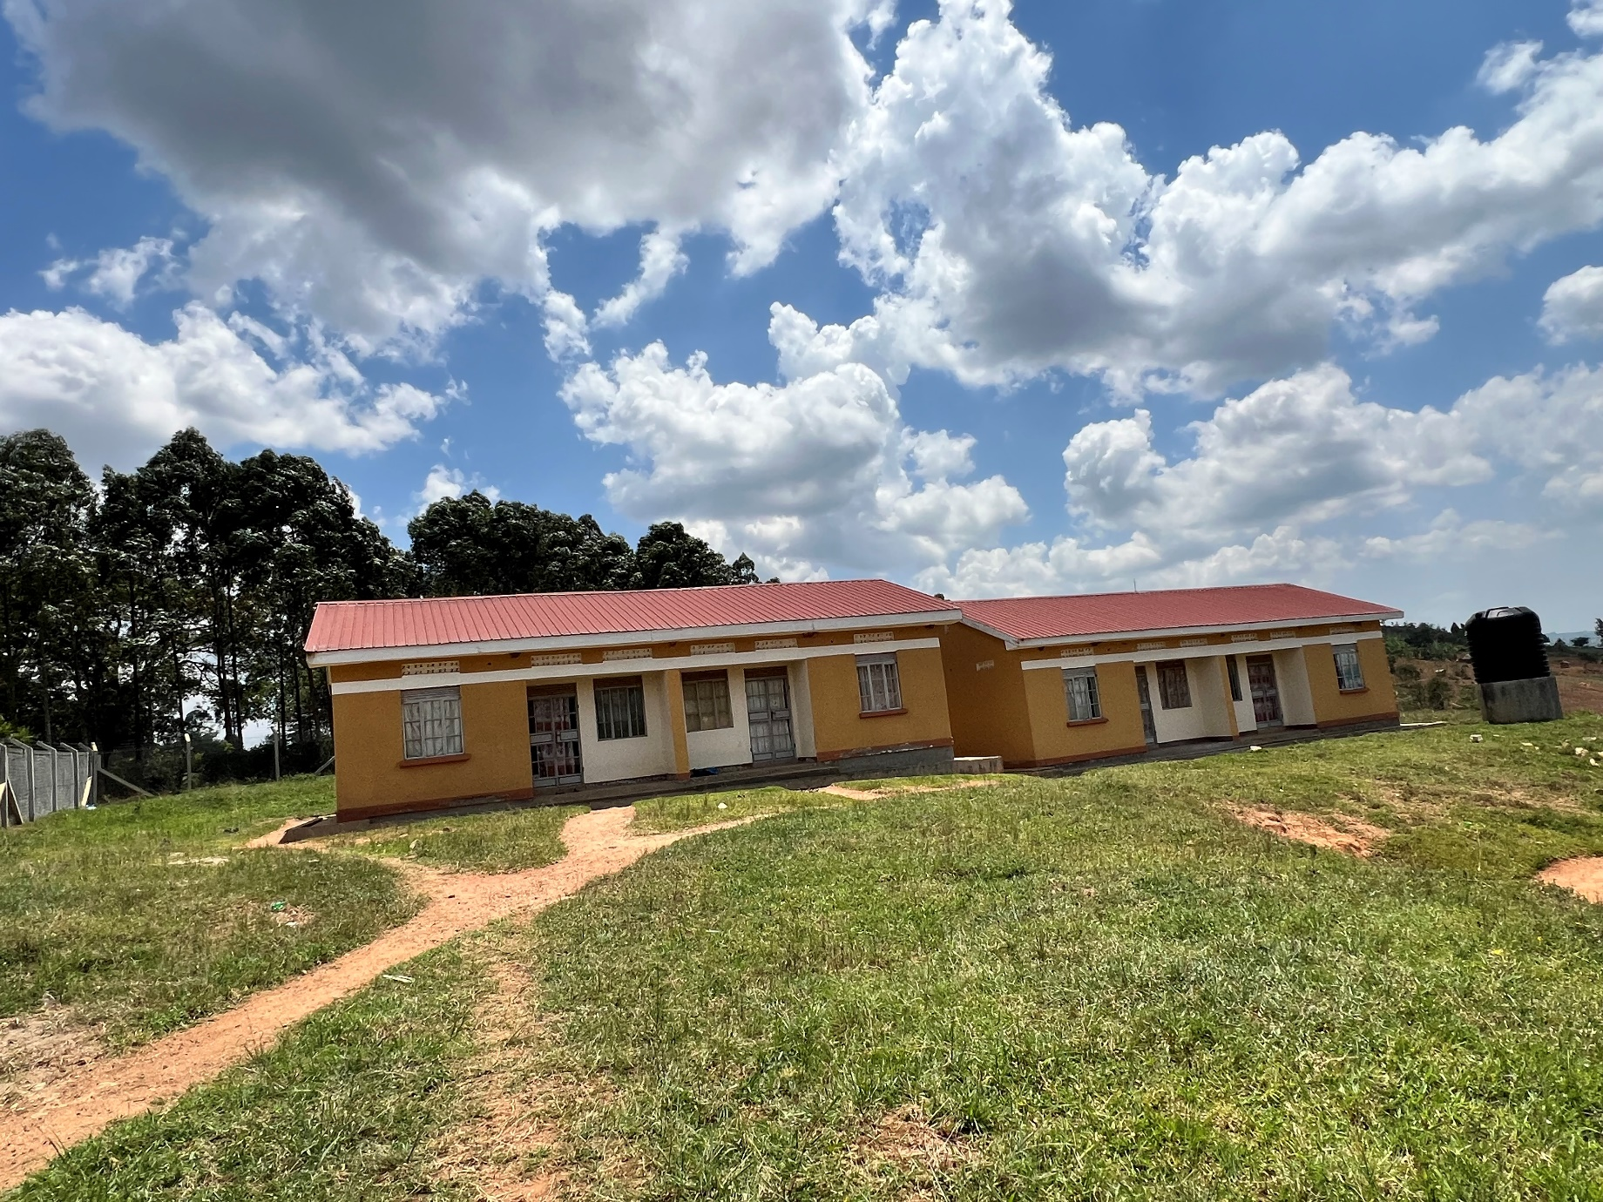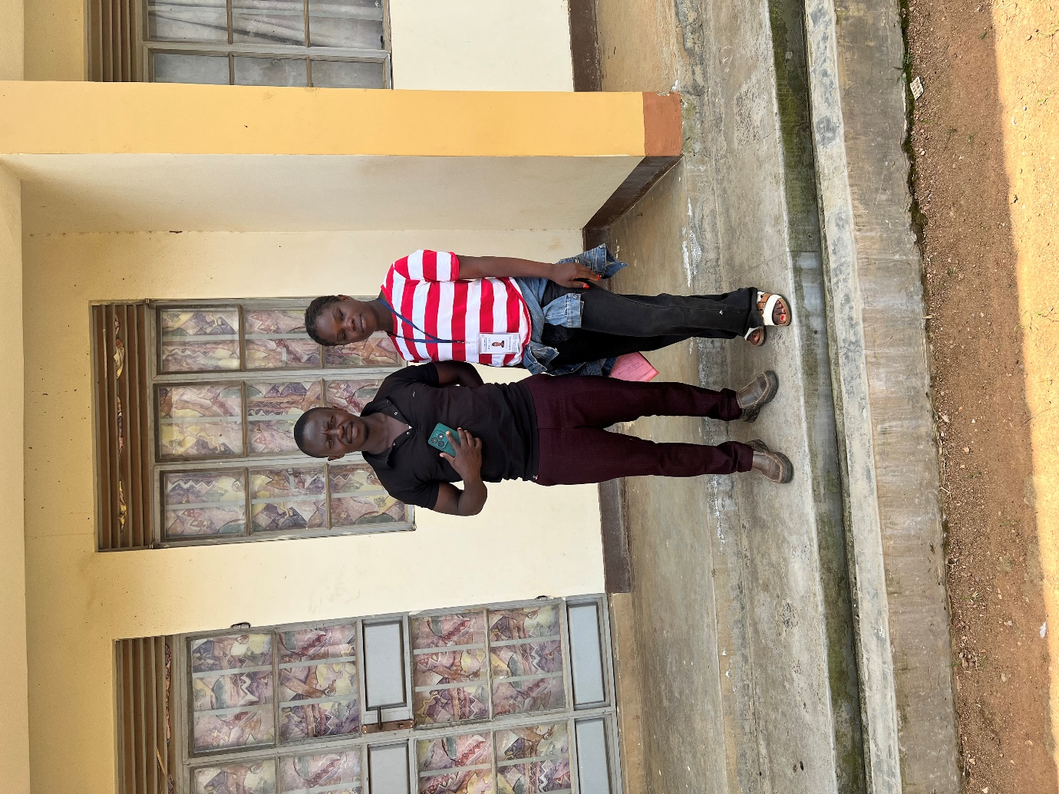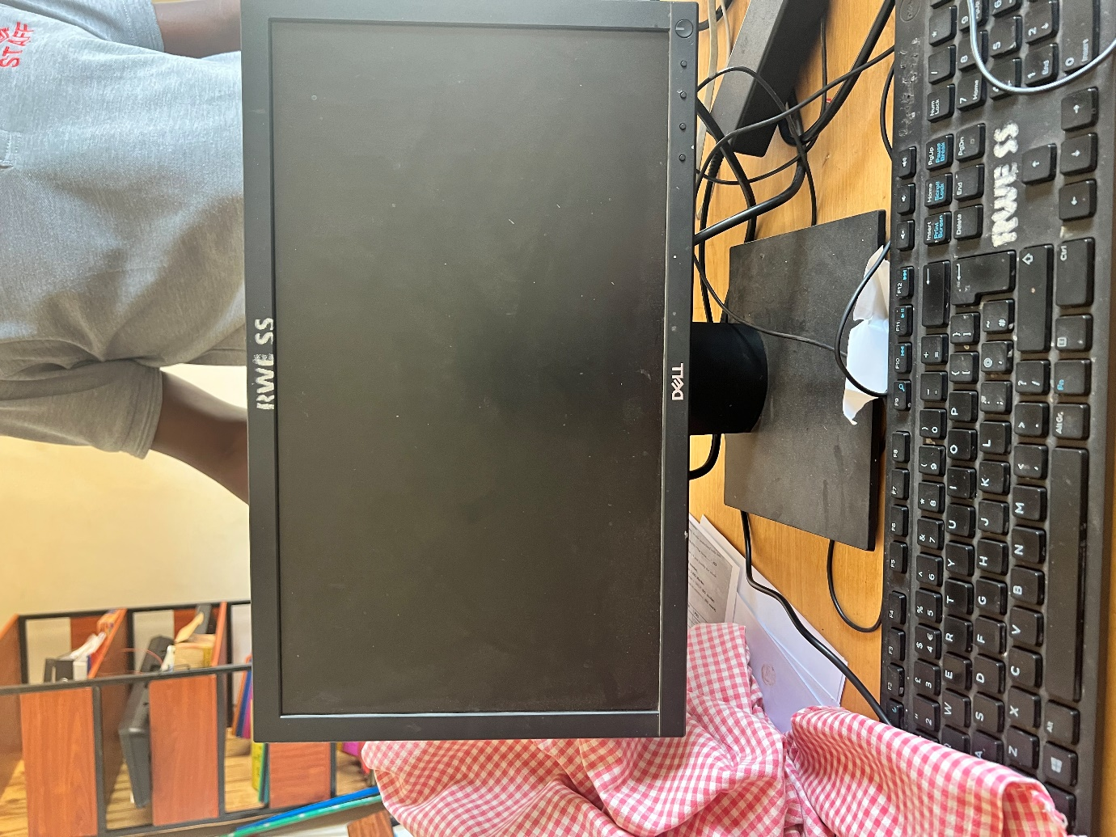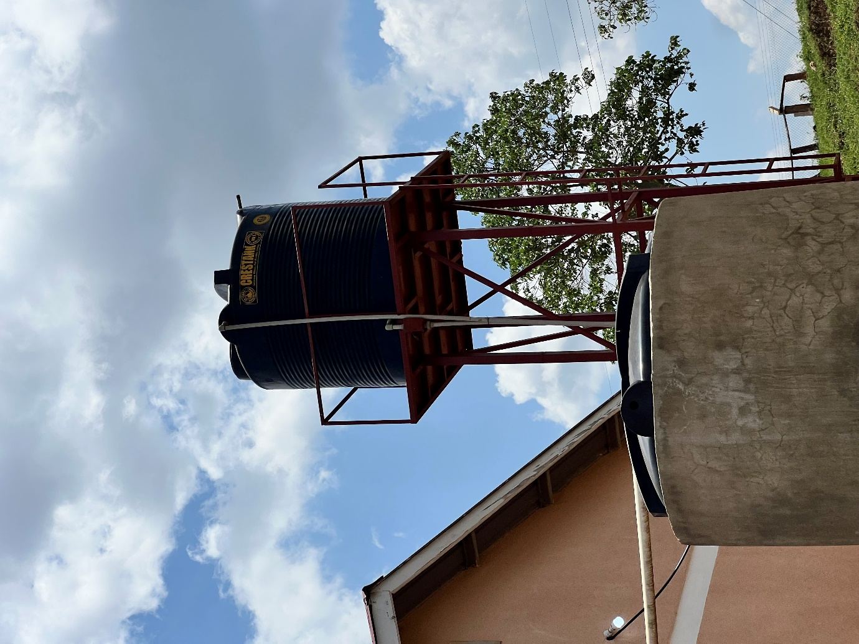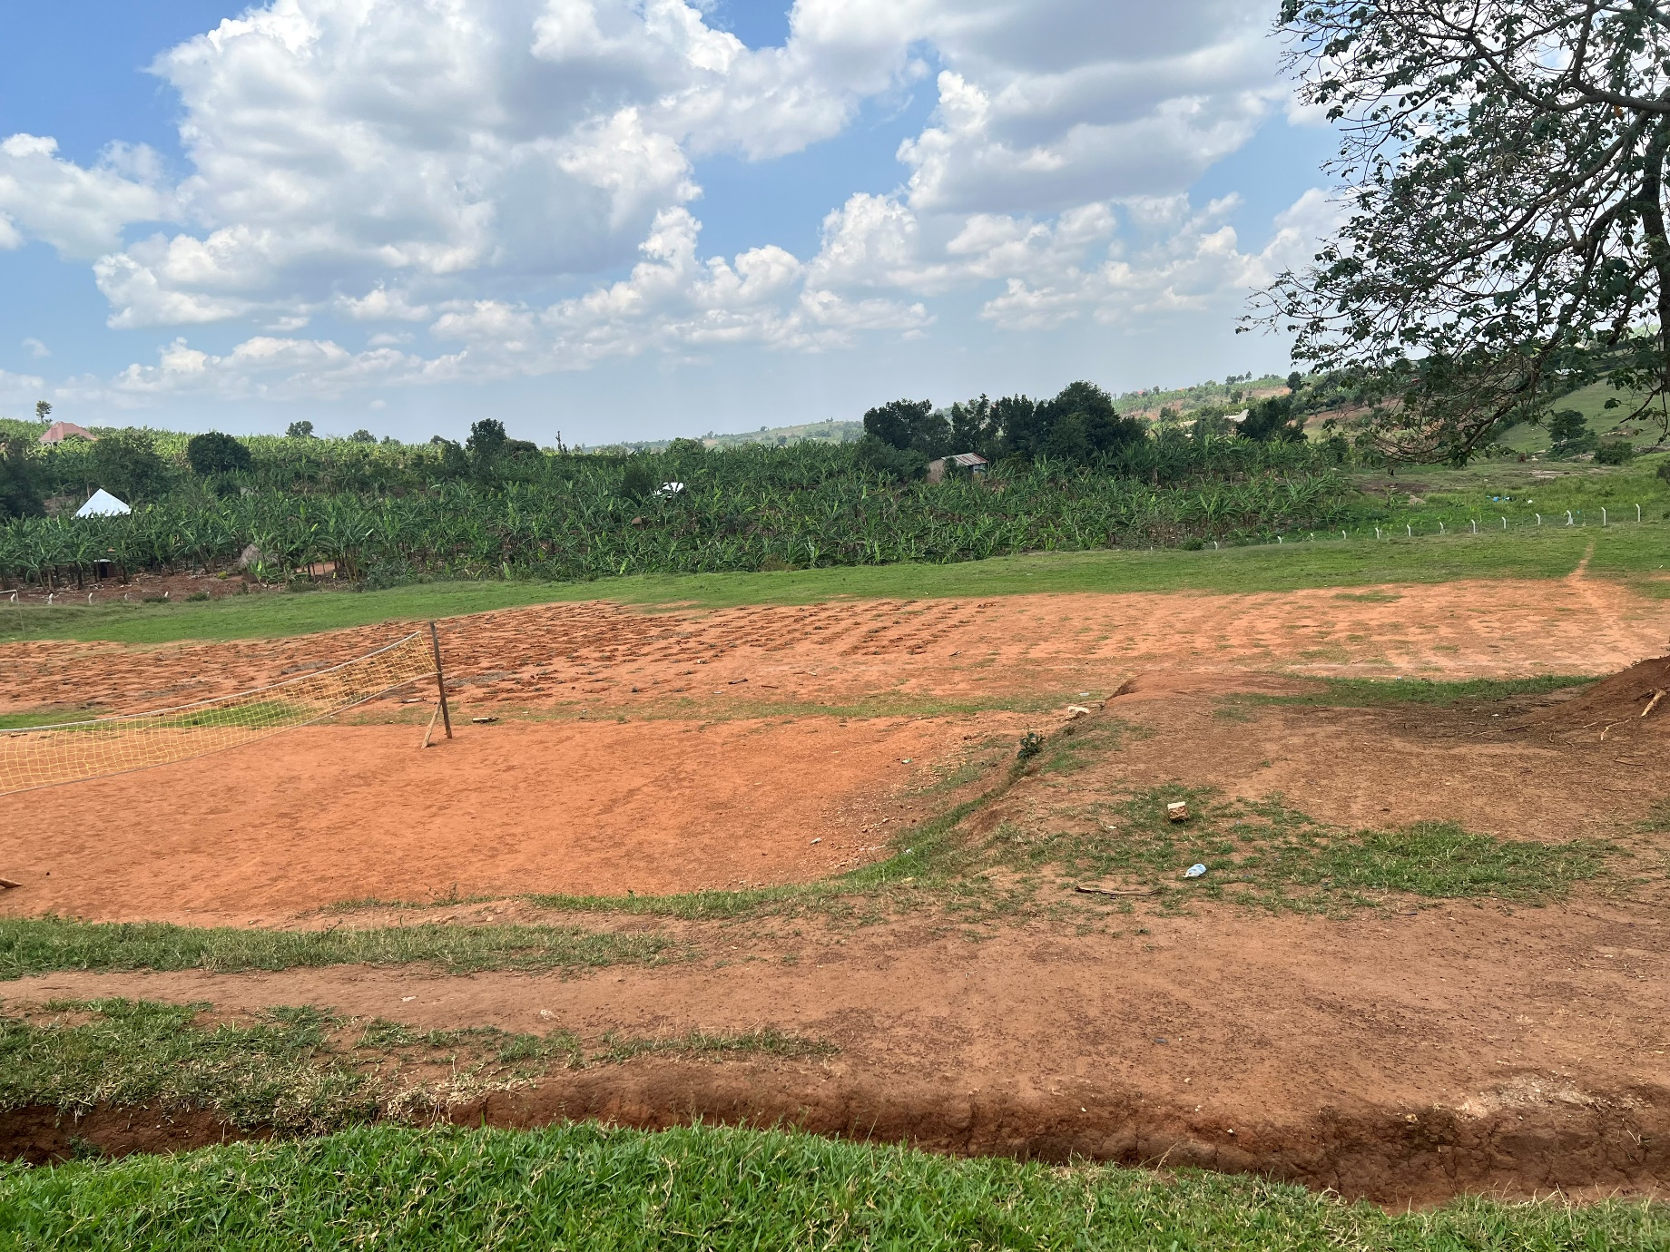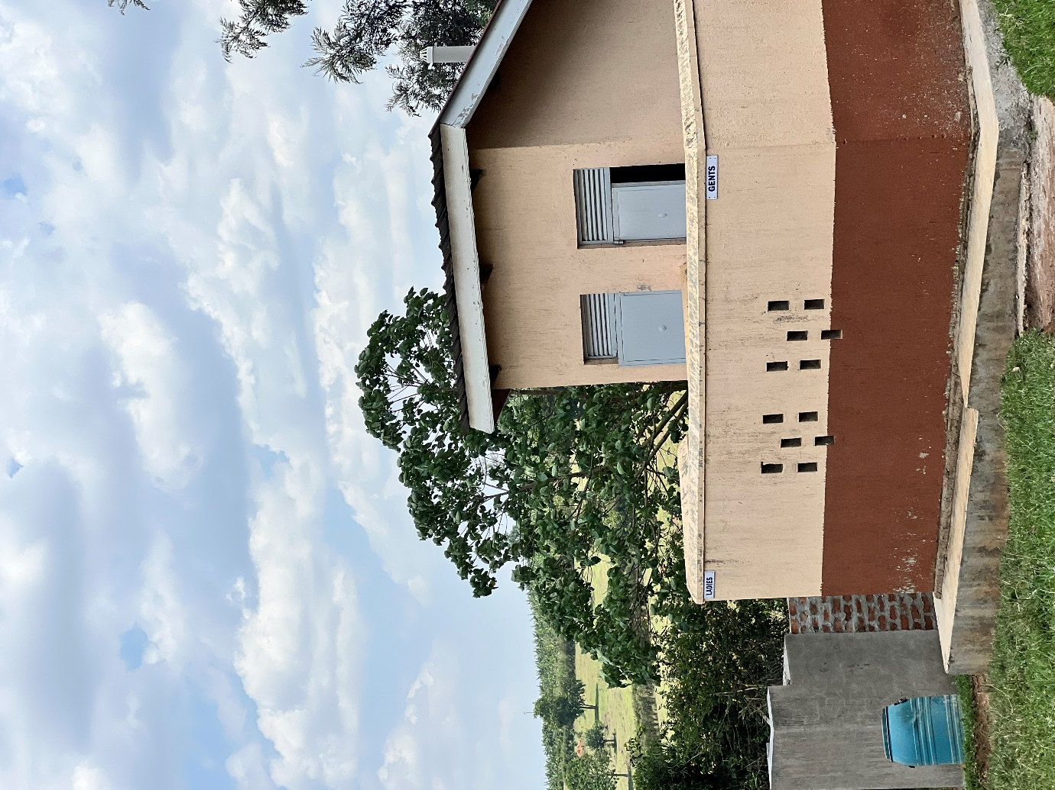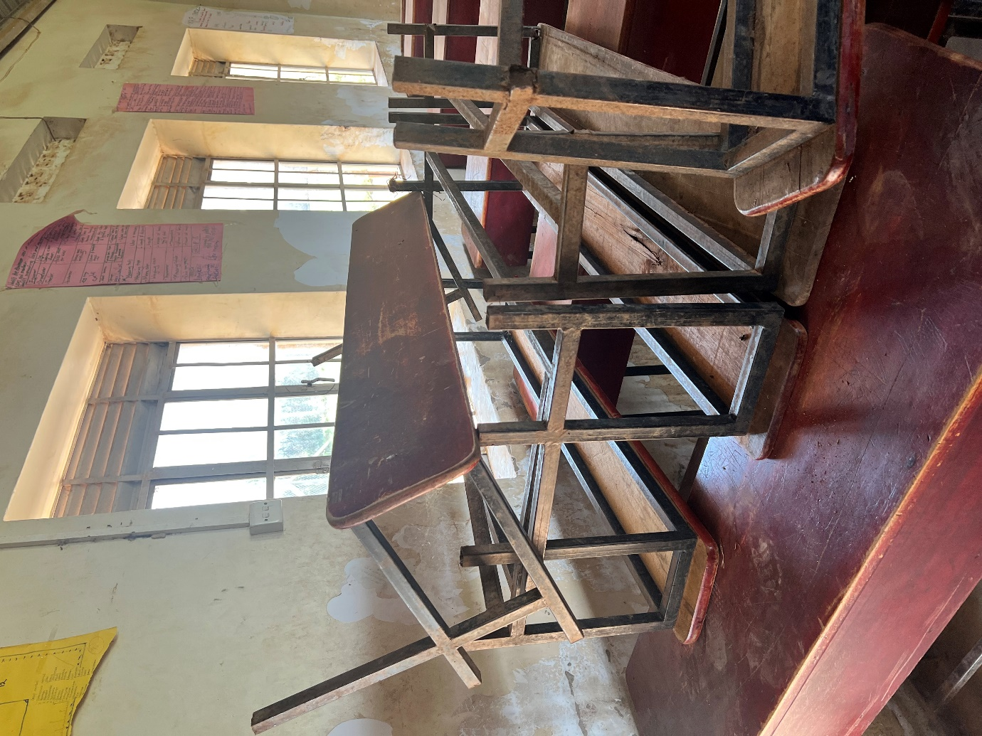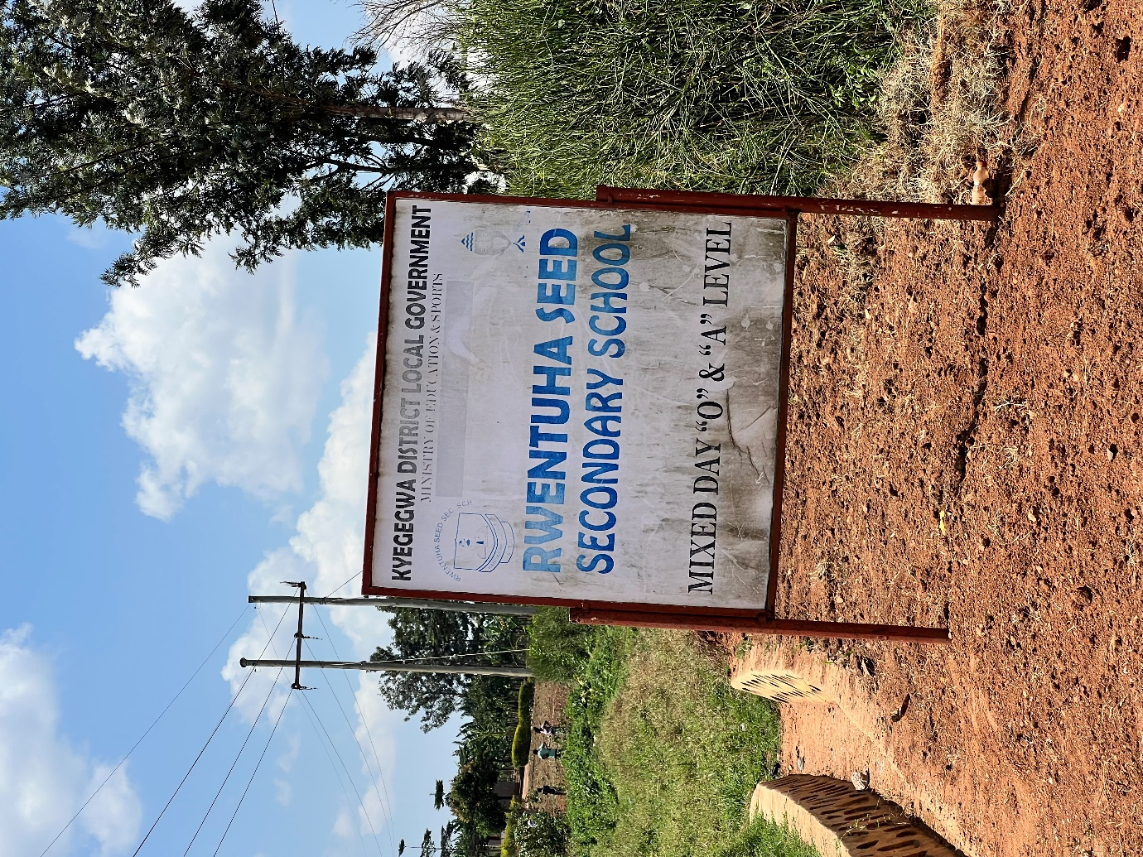
Staff quarters
Staff quarters
Computer with its accesories
Water tank
Unfinished play ground
Staff latrines

Damaged desks pending repair

