CONTACT INFORMATION
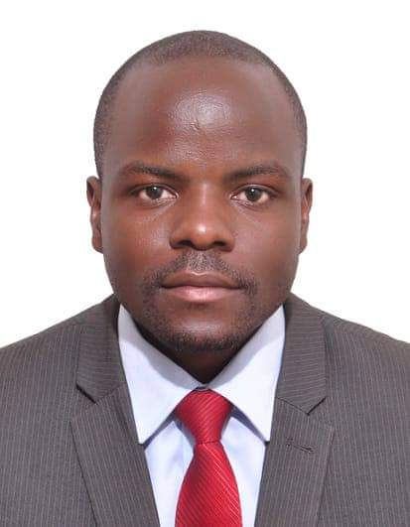
NAME: WASSWA WILSON
PHONE: +256 753 113 200 / +256 783 230 321
EMAIL ADDRESS: wilgrace2624@gmail.com
PERSONAL STATEMENT
I am a Biomedical Engineer and a Software developer with over 7 years of active programming in the following areas: Android app development using Java and Android Studio, Backend design with PHP CodeIgniter 3 & 4, Laravel, frontend design using Next Js, React Native and TypeScript, Database design and optimization, MATLAB programming, electronics and embedded programming and Amazon Web Services.

CORE COMPETENCIES
Java Programming, Web Services, Net Programming, User Interface Design, Front End/Back End, Project Lead, Project Management, Database Development and Implementation, Object Oriented Programming, Concurrency and Multi-Threading, Data Structures and Collections, Algorithms, Dependency Injection, JVM and Memory Management, AWS.
TECHNICAL SKILLS
Languages: Java, JavaScript, HTML, CSS, PHP, MATLAB, Arduino C, Python.
Web Services: Restful.
Web and Application Servers: Apache HTTP server.
Frameworks: React (Next Js, React Native), CodeIgniter, Laravel, TypeScript, Spring, Spring Boot.
Databases: MySQL.
Tools: Visual Studio Code, NetBeans, Eclipse IDE, STS, Maven, Android Studio, Git.
Platforms: Windows.

EDUCATION
Duration | Institution | Award | Score
Sept-2022 | University of Washington | Certificate in Leadership and  Management in health | A+
2012–2017 | Makerere University | BSc. Biomedical Engineering  Key Courses: Information and Communication Technology, Computer OOP Principles, Software Engineering, Database Systems. | Second Upper Honors degree
Dec/2018-  Apr/2019 | Uganda Virus  Research Institute | Biomedical Intern  Key Courses: Mathematical Modeling and Pipeline design Using Python | Research
2016 - 2016 | Green Bridge School of Open Technology | Advanced Java Programming | A+

PROJECTS
- Endoscopy reporting software (2017 - 2019)
A medical image capturing and reporting system for the endoscopy system.
Institution: St. Catherine Hospital, St. Francis Hospital
Role: LEAD SOFTWARE DEVELOPER
Tasks Performed:
- Project planning and development of algorithms.
- Developed the views of the application using JavaFX and FXML
- Design and implementation of the relational model of application using PhpMyAdmin.
- Imported existing user data from Excel files into the database.
- Trained users on how to use the system and wrote a user manual.
- Compiled system requirements and proposed a process flow to guide application development.
- Troubleshooting, debugging and upgrading of existing software.
- Successful installation, integration, and configuration of the software on several endoscopy systems.
Technologies Used:
Tools: JavaFx, CSS, Visual Studio, MySQL, JavaScript, Entity Framework, ASP.NET, MVC, Help & Manual, Git, PHP, Windows, Tomcat,

- Shulekeeper (2021 - 2024)
An online web-based system for managing school information.
Role: ASSISTANT SOFTWARE DEVELOPER
Made key contributions to back-end and Front-end software development and implementation
Tasks Performed:
- Interfaced with co-developers to conduct a business needs analysis and defined the software requirements with clear process flows and user cases.
- Developed the application views using JavaScript, bootstrap, HTML5, and CSS3.
- Designed and implemented the relational model of application.
- Trained users on how to use the system and wrote a user manual using Help & Manual and SnagIt to capture screenshots of the system.
- Compiled system requirements and proposed a process flow to guide application development.
- Conducted troubleshooting, debugging, and upgrading of existing software.
- Successfully integrated software components and third-party programs into the existing software.
Technologies Used:
Tools: React Js, Next Js, Styled Components, Styled System, Pure react carousel, Chart.js, Formik, Typescript, Visual Studio code, , JavaScript, JQuery, Bootstrap, Git, Laravel, Tomcat, Postman, Visual Studio Code, AWS

- Wekebere (2017 - 2024)
A mobile application and embedded system built with Arduino C and Java for monitoring fetal heart rate during the 3rd trimester of pregnancy.
Role: ELECTRONICS DEVELOPER AND PROGRAMMER
Tasks Performed:
- Designing and testing the Android App
- Designing and implementing system flow and interconnection between the hardware and Android app.
- Assisted in implementing and linking the Electronics and the mobile App using Java Serial Communication programming.
Technologies Used:
Tools: Arduino, Arduino C, Java, Android Studio, Microsoft Azure.

NEXT OF KIN
Musanje Moses (Brother)
+256784486269, +256703113444
REFERENCES
- Eng. Richard Ssejong (Biomedical Engineer, St. Francis Hospital Nsambya & Case
Hospital)
+256753818754, +256777132489
- Dr. Annet Khingi Kugonza (Chief Radiographer, International Hospital Kampala)
+256772592771, +256701592771

