# INTRODUCTION

## 1.1 Project Overview

The Expense Tracker is a comprehensive, full-stack web application developed using the MERN stack — comprising MongoDB, Express.js, React.js, and Node.js. It aims to assist individuals in managing their finances by allowing them to track income and expenses, visualize spending trends, and maintain better control over their budgeting practices.   
  
Built with a modern frontend using React and Vite, the application integrates Tailwind CSS for responsive styling and Recharts for rich data visualization. The design is tailored to provide an intuitive and mobile-friendly user interface, ensuring accessibility across various devices. The dashboard includes pie, bar, and line charts that summarize user income and expenses in real time.  
  
The backend, constructed with Express.js and MongoDB, provides RESTful API endpoints for secure CRUD operations on users, income, and expenses. Authentication and authorization are implemented using JSON Web Tokens (JWT), with passwords hashed via bcryptjs for enhanced security. Middleware components such as 'authMiddleware' protect sensitive routes, while 'uploadMiddleware' allows users to upload profile images and import/export financial data in Excel format.  
  
User data is structured in MongoDB using three primary models: User, Income, and Expense. Each model includes timestamps and user reference IDs, enabling multi-user support and robust data association. The platform also includes a modular file system for better code organization, such as dedicated routes, controllers, middleware, and utilities.  
  
  
  
  
  
  
  
  
  
  
  
  
  
The project adheres to a user-centric design approach, incorporating ideation tools such as the Empathy Map Canvas, Problem Statement Framework, and Brainstorming Templates. These tools helped define user personas and critical needs, ensuring that the application’s features are directly aligned with user expectations and real-world scenarios. Features like personalized dashboards, toast-based notifications, secure login/logout, and visual summaries of financial health are all a result of this structured ideation process.  
  
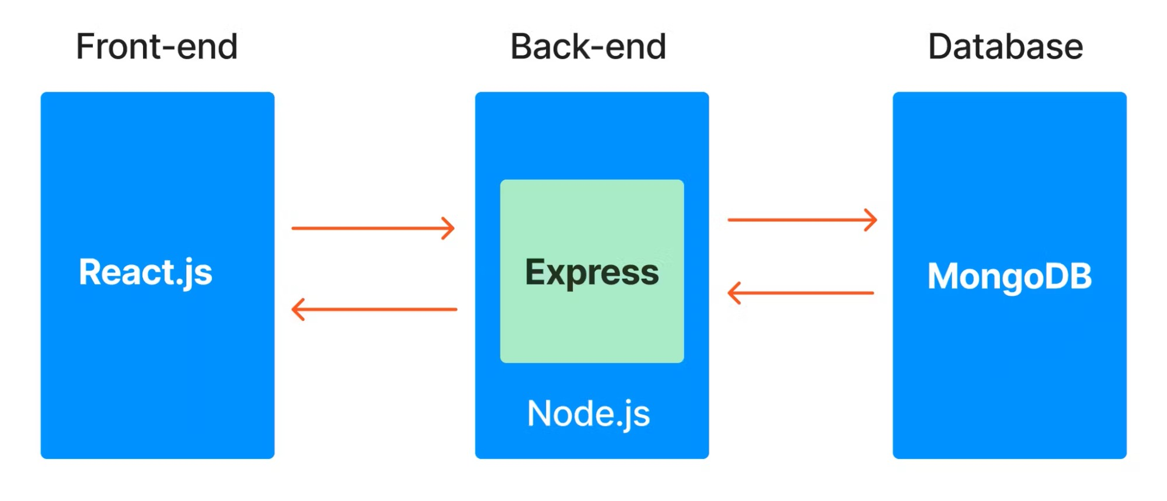

## 1.2 Purpose

The primary purpose of the Expense Tracker project is to empower individuals to effectively monitor, control, and understand their financial behavior. In today’s fast-paced digital world, many people—especially students, freelancers, and young professionals—find it difficult to track their earnings and expenditures due to a lack of simple, intuitive financial tools. This project provides an all-in-one digital finance assistant that resolves these issues through a streamlined interface and intelligent features.  
  
  
  
  
  
  
  
  
  
  
  
  
Key purposes include:  
  
- To centralize financial data: Users can log income and expenses in one place and categorize them for better clarity.  
- To offer visual analytics: Charts help users identify trends, overspending areas, and savings potential through dynamic, interactive visuals.  
- To enhance accessibility: A mobile-responsive design ensures that users can access their financial data from anywhere at any time.  
- To provide a secure experience: The use of JWT authentication and encrypted data storage guarantees user privacy and data integrity.  
- To allow data portability: Importing and exporting income/expense records in Excel format enhances convenience, especially for professional recordkeeping or financial reviews.  
- To promote future scalability: The architecture supports easy extension for advanced features such as budget alerts, goal setting, and bank API integrations.  
  
Ultimately, this application addresses the problem of fragmented financial tracking tools by delivering a centralized, feature-rich platform. It not only improves the day-to-day financial management experience but also fosters long-term financial awareness and responsibility. Whether it's used by a student budgeting for school expenses or a freelancer tracking multiple income streams, the Expense Tracker aims to be a reliable, secure, and easy-to-use financial companion.  
  
  
  
