# IDEATION PHASE

## 2.1 Problem Statement

Managing personal finances is a common yet often neglected task among individuals of all age groups. People frequently lose track of their spending habits, which leads to financial stress, debt accumulation, and failure to meet savings goals. With increasing modes of transactions and expenses incurred daily, it becomes challenging to monitor each transaction manually. There is a clear need for a simplified, digital solution that helps users log, analyze, and improve their financial behavior effectively.

## 2.2 Empathy Map Canvas

Project: Expense Tracker (MERN Stack)  
Target User: Budget-conscious individuals (students, freelancers, young professionals)  
  
**SAYS**

• “I want to see all my spending in one place.”  
• “It needs to be easy to use on my phone.”  
• “Is my account secure?”  
• “Can I export my data easily?”

## THINKS

• “Am I saving enough each month?”  
• “I don’t want to struggle with menus.”  
• “I need to trust this with my money data.”  
• “How can I review my expenses later?”

## DOES

• Navigates dashboard (DashboardLayout.jsx, SideMenu.jsx)  
• Views charts (FinanceOverview.jsx, CustomPieChart.jsx)  
• Adds transactions (Modal.jsx)  
• Exports Excel files (/downloadexcel routes)  
• Uploads profile image (/upload-image)

## FEELS

• Overwhelmed by scattered finances, relieved with clear summaries  
• Frustrated with clunky apps, satisfied with responsive UI  
• Anxious about data leaks, reassured by secure authentication  
• Confident when data is exportable  
  
  
 **Empathy Map  
  
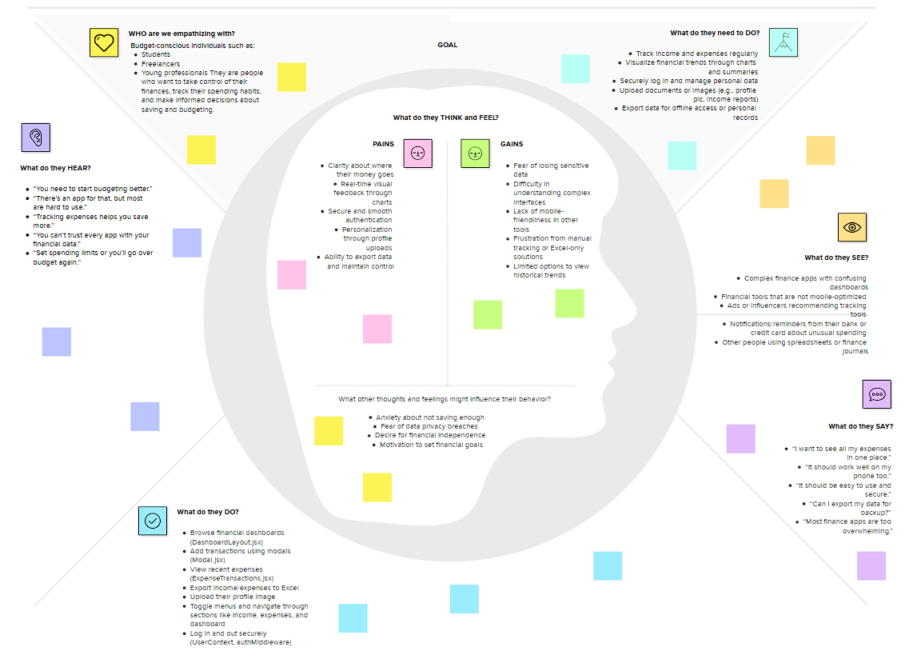**

## 2.3 Brainstorming 1. Before we Collaborate

**Team Gathering:**

* Participants: 4 team members (frontend dev, backend dev, designer, project lead)
* Everyone brings in insights from empathy mapping and user research.  
   **Set the Goal:**

Build an intuitive and secure expense tracking app that allows users to manage, visualize, and export their income and expense data with ease.  
 3. Brainstorm

Start by generating as many ideas as possible. Each idea below can go on a sticky note in MURAL:

* Responsive sidebar and navbar layout
* Mobile-first UI design
* User authentication with JWT
* Pie and bar chart visualizations for insights
* Excel export/download option for transactions
* Real-time dashboard for recent transactions
* Profile picture upload feature
* Modal for adding income and expenses
* Toast messages for user feedback
* Toggleable navigation menus
* Secure routes and logout functionality
* Grouped data by week/month/year
* Dark mode toggle
* Budget limit alert notifications

**4. Group Ideas**

**UI/UX:**

* Responsive layout
* Mobile-first design
* Dark mode
* Toast messages

**Data Visualization:**

* Bar/pie/line charts
* Dashboard with filters
* Weekly/monthly summaries

**Security & Auth:**

* JWT authentication
* Secure routing
* Logout button

**Functional Features:**

* Excel export
* Modal forms
* Recent transactions
* Budget alerts
* Profile upload

### 5. Prioritize

Use color codes or dots for priority:

