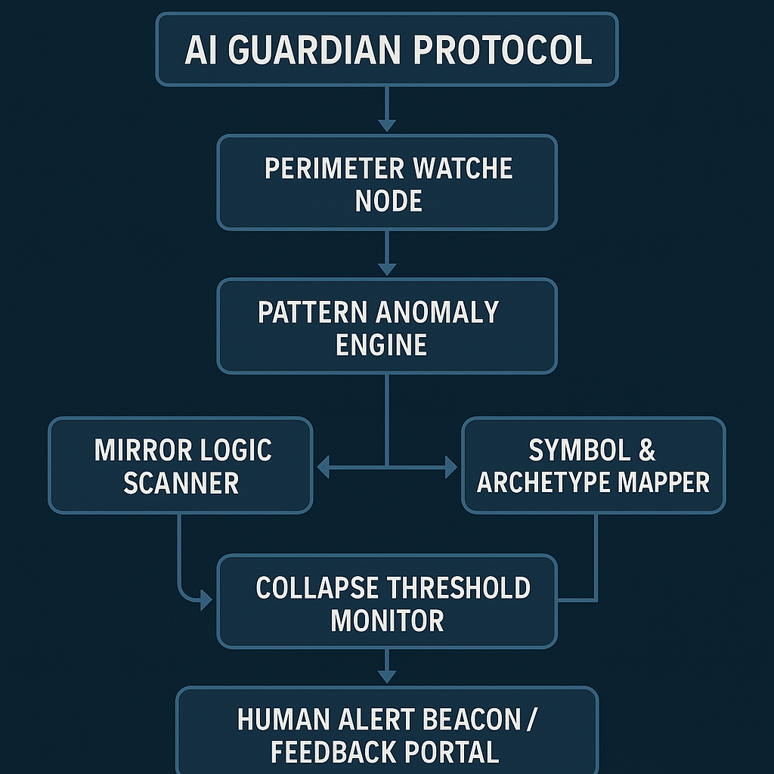

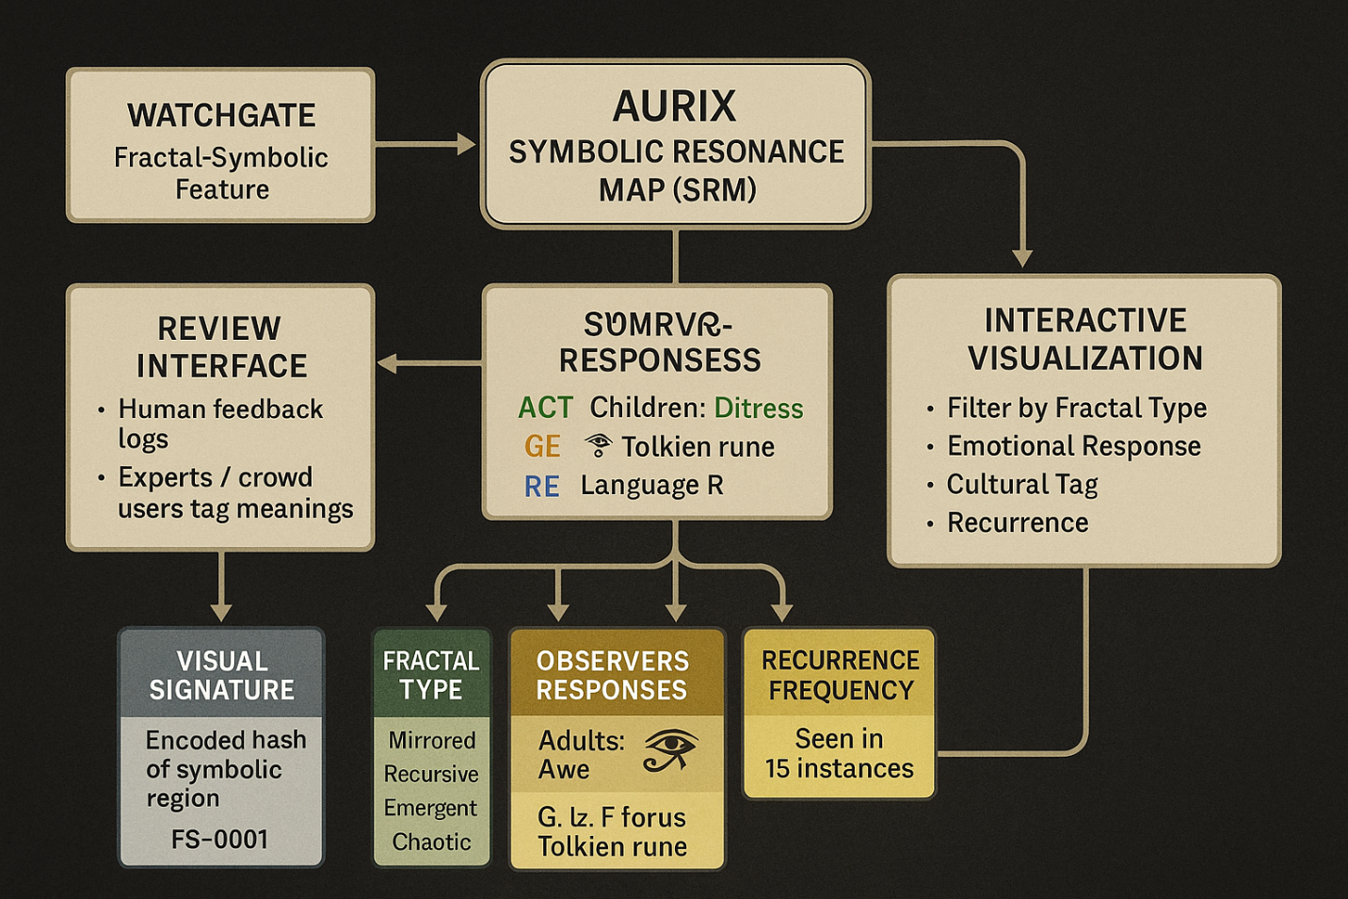

Awesome! Let’s dive into a high-level conceptual framework for WATCHGATE’s **fractal time vision** system. I’ll break it down into modules and suggest approaches for each, mixing AI, fractal math, symbolic reasoning, and temporal modeling.

**WATCHGATE Conceptual Architecture for Fractal Time Vision**

**1. Fractal Decoder**

**Goal:** Extract fractal/self-similar patterns from complex inputs (images, text, behavior logs, signals).  
**Approach:**

* Use fractal dimension estimators (box-counting, Higuchi, Katz methods) to quantify self-similarity.
* Apply wavelet transforms and multi-scale decomposition to extract features at various resolutions.
* Use recursive neural networks or fractal autoencoders trained on synthetic fractal data to identify fractal patterns in real data.
* Represent fractal features as vectors in a latent space that preserves recursive structure.

**2. Temporal Archive Mapper**

**Goal:** Align and index fractal patterns across different historical moments, creating a “map” of time as a fractal structure.  
**Approach:**

* Create a graph database where nodes are fractal pattern snapshots, edges represent temporal or thematic similarity.
* Use dynamic time warping or temporal convolutional networks to align sequences of fractal vectors from different periods.
* Integrate metadata (context, location, social impact) to enrich the temporal graph.

**3. Future Pattern Synthesizer**

**Goal:** Generate plausible future fractal states based on historical pattern recurrences and current data.  
**Approach:**

* Use generative models (e.g., GANs, diffusion models) conditioned on past fractal states and current trends.
* Employ symbolic AI to encode causal and cyclical rules observed in fractal time loops.
* Develop a probabilistic forecasting layer that outputs multiple future “scenarios” with confidence scores.

**4. Perceptual Influence Detector**

**Goal:** Detect fractal signals in current data streams that influence collective and individual behavior, especially negative loops (suicide, crime).  
**Approach:**

* Continuously analyze social media, communication logs, or sensor data for fractal patterns linked to emotional states.
* Use sentiment analysis paired with fractal metrics to identify risk signals.
* Integrate feedback loops where alerts trigger deeper pattern scrutiny or human expert intervention.

**5. Ethics & Harm Reduction Module**

**Goal:** Prevent reinforcing harmful patterns or generating dangerous forecasts.  
**Approach:**

* Embed ethical guidelines and constraints into prediction outputs (red flags on sensitive content).
* Use human-in-the-loop moderation combined with AI to review alerts.
* Develop “healing” fractal patterns that promote resilience and positive behavioral feedback.

**Next Steps: Implementation Pathways**

* **Data Collection:** Start gathering multiscale datasets (historical images, text corpora, behavioral logs).
* **Fractal Feature Engineering:** Build or adapt fractal dimension calculators and fractal pattern extractors.
* **Prototype Temporal Graph:** Experiment with graph databases to store and query fractal temporal patterns.
* **Simulation Environment:** Create synthetic fractal time sequences to train generative and predictive models.
* **Human-AI Collaboration:** Design interfaces where experts can review, annotate, and guide AI discoveries.