**User Manual**

1. Open The App.
2. Enter Patient’s Name and Patient’s Age.
3. Press “Bluetooth Connect” button.
4. Now Start Test 1, Test 2, and Test 3 and press the “Stop Timer” button if necessary.
5. After conducting all tests, press “Submit Detail” button.
6. View the Report of Patient.

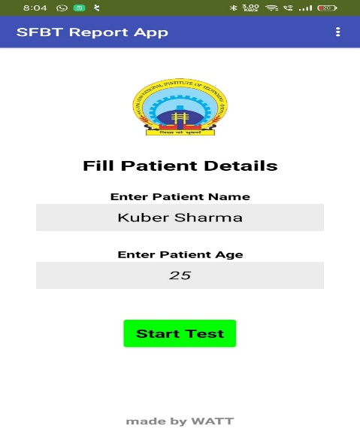 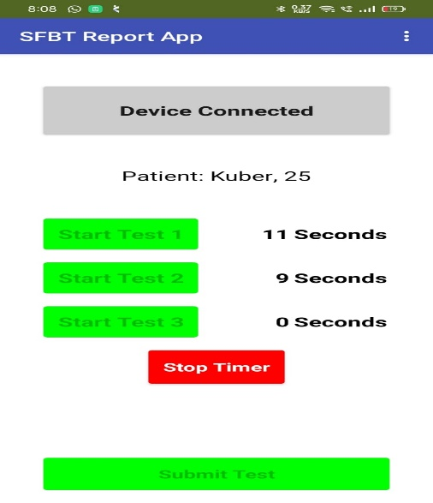

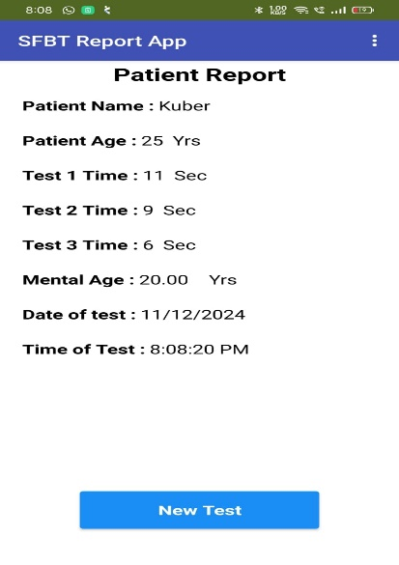

**Project Flowchart**

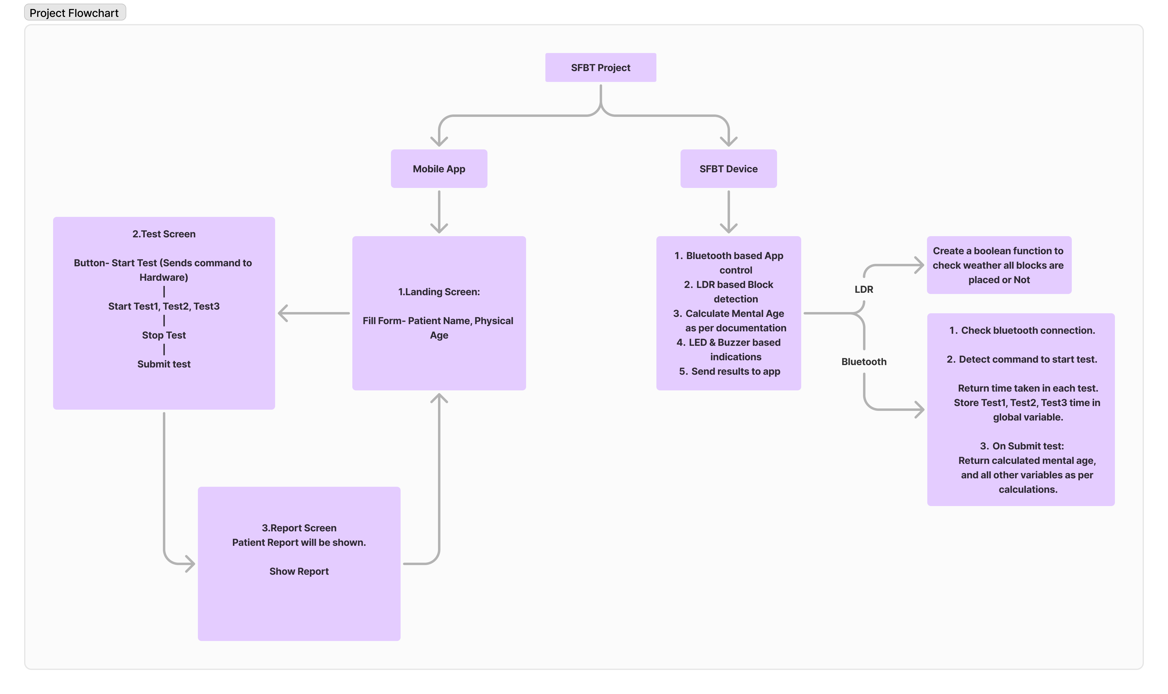

**Use-Case Diagram**

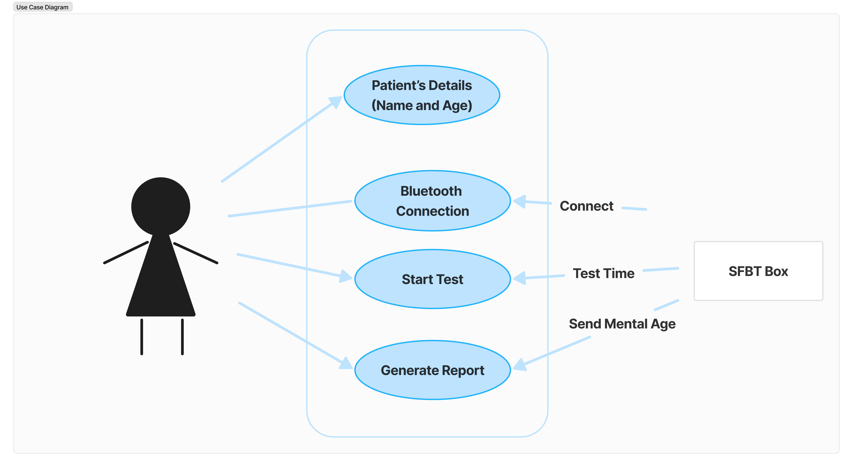

**System Architecture**

The system consists:

* Wireless communication via Bluetooth for remote app control.
* Indicators using LED and buzzer.
* LDR sensor-based block detection connected to Arduino digital pins D4–D13.

• **LDR10**(Shape: Diamond)

• **LDR9** (Shape: Square)

• **LDR8** (Shape: Obround)

• **LDR7** (Shape: Circle)

• **LDR6** (Shape: Rectangle)

• **LDR5**  (Shape: Hexagon)

• **LDR4** (Shape: Plus)

• **LDR3** (Shape: Triangle)

• **LDR2** (Shape: Star)

• **LDR1**  (Shape: Semicircle)

**Circuit Diagram**

