**CLASS DIAGRAM PENDIDIKAN DAN IMPLEMENTASI KEDALAM OOP PYTHON**



**Nama : Wahyu Andre Wibowo**

**Npm : 5220411238**

**UNIVERSITAS TEKNOLOGI TOGYAKARTA**

**TAHUN 2023/2024**

1. 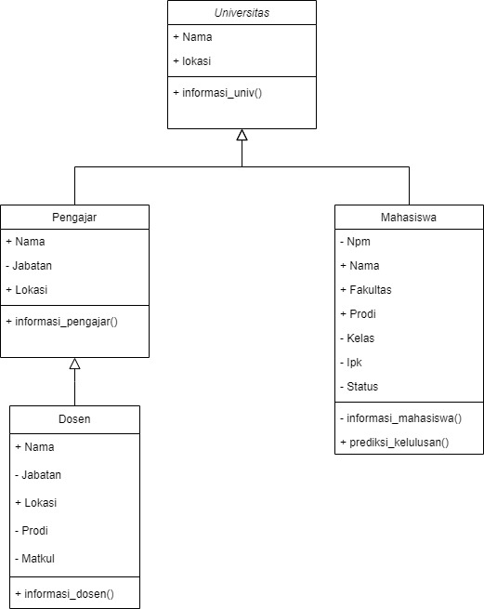**CLASS DIAGRAM**
2. **CODE PROGRAM**

*class* Universitas:

*def* __init__(*self*,*nama*,*lokasi*):

*self*.nama = *nama*

*self*.lokasi = *lokasi*

*def* informasi_univ(*self*):

        print(*self*.nama)

        print(*self*.lokasi)

*class* Pengajar(Universitas):

*def* __init__(*self*,*nama*,*jabatan*,*lokasi*):

        super().__init__(*nama*,*lokasi*)

*self*.__jabatan = *jabatan*

*def* informasi_pengajar(*self*):

        print()

*self*.informasi_univ()

        print(*self*.__jabatan)

        print()

*class* Dosen(Pengajar):

*def* __init__(*self*,*nama*,*jabatan*,*lokasi*,*prodi*,*matkul*):

        super(Dosen,*self*).__init__(*nama*,*jabatan*,*lokasi*)

*self*.__prodi = *prodi*

*self*.__matkul = *matkul*

*def* informasi_dosen(*self*):

*self*.informasi_pengajar()

        print(*self*.__prodi)

        print(*self*.__matkul)

*class* Mahasiswa(Universitas):

*def* __init__(*self*,*npm*,*nama*,*fakultas*,*prodi*,*kelas*,*lokasi*,*ipk*):

        super().__init__(*nama*,*lokasi*)

*self*.__npm = *npm*

*self*.fakultas = *fakultas*

*self*.prodi = *prodi*

*self*.__kelas = *kelas*

*self*.__ipk = *ipk*

*self*.__status = None

*def* hitung_ipk(*self*, *total* = None):

        if *total* is not None:

            total_sks = 0

            total_nilai = 0

            for i in *total*:

                sks = i['sks']

                nilai = i['nilai']

                if nilai is not None:

                    total_sks += sks

                    total_nilai += sks * nilai

            if total_sks > 0:

                ipk = total_nilai / total_sks

                return ipk

        else:

            if *self*.__ipk >= 3.0:

*self*.__status = "Lulus"

            else:

*self*.__status = "Tidak lulus"

*def* __informasi_mahasiswa(*self*):

        print(*self*.__npm)

*self*.informasi_univ()

        print(*self*.fakultas)

        print(*self*.prodi)

        print(*self*.__kelas)

        print(*self*.__ipk)

        print(*self*.__status)

universitas = Universitas("Universitas Teknologi Yogyakarta","Yogyakarta")

pengajar = Pengajar('Tubagus Linux,S.KOM.,M.KOM.,Ph.D.',"Rektor","Yogyakarta")

dosen = Dosen('Arif Parameter,S.KOM.,M.KOM.','dosen','nganjuk','Informatika','pengembangan web')

mahasiswa = Mahasiswa(5220411123,"Ahmad Nginx","sains & teknologi","informatika","F","jepara",3.10)

universitas.informasi_univ()

pengajar.informasi_pengajar()

dosen.informasi_dosen()

print()

mahasiswa.hitung_ipk()

mahasiswa._Mahasiswa__informasi_mahasiswa()

print()

nilai = [{'sks': 3,'nilai':3.10},

         {'sks': 2,'nilai':3.20},

         {'sks': 1,'nilai':4.0},

         {'sks': 2,'nilai':3.50}]

print(mahasiswa.hitung_ipk(nilai))

1. 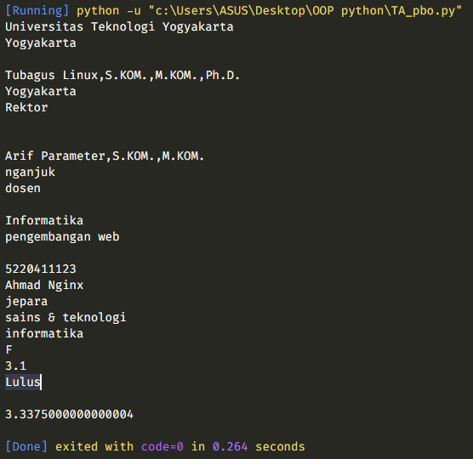**Hasil Running Program**