Customer Requirements   
Specification

**(Lastenheft)**

(TINF18C, SWE I Praxisprojekt 2019/2020)

Project: DD2AML Converter

Customer: Rentschler & Ewertz

Rotebühlplatz 41

70178 Stuttgart

Supplier: by Lara Mack and Nora Baitinger - Team 3  
 (Nora Baitinger, Antonia Wermerskirch, ~~Carl Beese~~, Lara Mack, Bastiane Storz)

*Rotebühlplatz 41*

*70178 Stuttgart*

|  |  |  |  |
| --- | --- | --- | --- |
| **Version** | **Date** | **Author** | **Comment** |
| 0.1 | 07.09.2019 |  | Created |
| 0.2 | 04.10.2019 | Bastiane Storz | Copy the goal from the task |
| 0.3 | 21.10.2019 | Lara Mack | Added BC/UC and Features, also added other product characteristics |
| 0.4 | 22.10.2019 | Bastiane Storz | BP translated into English and completed with diagrams, UC created and completed with diagrams |
| 0.5 | 23.10.2019 | Carl Beese | Goal and Product Environment translated; Product Data added |
| 0.6 | 26.10.2019 | Bastiane Storz | Fully translated, Product Environment diagram, generally verified |
| 0.7 | 30.10.2019 | Bastiane Storz | Improved on feedback |
| 0.8 | 01.11.2019 | Lara Mack | Improved on feedback, added two points on other product characteristics |
| 0.9 | 06.03.2020 | Bastiane Storz | Deleted ESI / team change |
| 1.0 | 24.03.2020 | Nora Baitinger | Complete overhaul |

CONTENTS

1. Goal 3

2. Product Environment 4

3. Product Usage 5

3.1. Business Processes 5

3.1.1. <BP.001>: File conversion 5

3.1.2. <BP.002>: Library 6

3.2. Use Cases 6

3.2.1. <UC.001> File conversion CLI 7

3.2.2. <UC.002> File conversion GUI 8

3.2.3. <UC.003> Library usage 9

3.3. Features 10

3.3.1. /F01/Import 10

3.3.2. /F02/File format analysis 10

3.3.3. /F03/File validation 10

3.3.4. /F04/Conversion 10

3.3.5. /F05/ CAEX Version 10

3.3.6. /F06/AML Package 10

3.3.7. /F07/Error handling 10

3.3.8. /F08/Output selection 10

4. Product Data 11

4.1. /LD10/ AML-DD 11

4.2. /LD20/ File conversion 11

4.3. /LD30/ AMLX package 11

4.4. /LD40/Command line interface 11

4.5. /LD50/Library 11

5. Other Product Characteristics 12

5.1. /NF10/Graphical User Interface 12

5.2. /NF20/System Environment 12

5.3. /NF30/Installation wizard 12

5.4. /NF40/Portable Program 12

6. Figures 13

7. References 14

# Goal

For the conversion of device description files for Profinet devices (called PN-GSD) to AML/CAEX V2.15, a tool called GSD2AML exists. GSDML is short for “General Station Description Markup Language” and AML is short for “Automation Markup Language”. Both formats are based on XML.

The goal of this project is to develop a software which can convert other field-bus-specific formats to AML/CAEX V2.15 and AML/CAEX V23.0. Those formats will be IODD and CSP+ and the software should be able to recognize the given format on its own.

The generated AML-DD (“AML-Device-Description") must contain an AML root file with all the necessary information. The AML-DD with its companion files shall be contained in an AMLX package which can be loaded into the AML editor.

The software shall be implemented as a library and supplied with a command line interface-based reference implementation and should also be usable trough a graphical user interface.

The documentation of the software as well as the documentation of the development and project is also part of the goal.

# Product Environment

AutomationML (AML) is short for Automation MarkUp Language and is used to describe parts of automation plants as objects. These objects can consist of multiple other objects and be part of a larger assembly of objects. That way AML can be used to describe a single screw or an entire robot with the necessary level of detail.

AML makes use of various standards to describe plant components:

1. CAEX (Computer Aided Engineering Exchange) to describe attributes of objects and their relations in a hierarchical structure. This is called a system topology. In this respect, CAEX forms the overarching integration framework of AutomationML. [1]
2. COLLADA to describe the geometry and 3D models of a objects
3. COLLADA also integrates motion planning. It describes the connections and relations of moveable objects, which is called Kinematics.
4. PLCopen XML describes the logic. Internal behaviour and states if objects, action-sequences and I/O connections are implemented via this format.

An IODD (IO Device Description) file describes the sensors and actuator of a plant or component. It also contains information on identity, parameters, process data, communication and more. It is written in XML-format, same as AML, which ensures a conversion. [2]

CSP+ is used to describe components of the CC-Link Family or those which are compatible with them.

The converter will be implemented as a library. It will give the option of a standalone tool, a command line interface and a graphical user interface. The library will work with other software and thus supporting the export of an AML as a string.

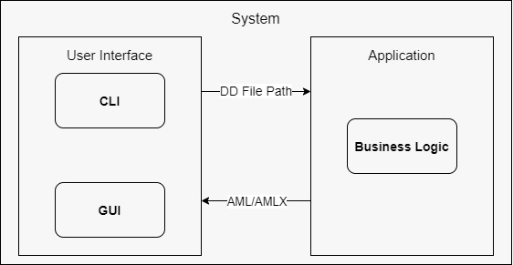

Figure 1 Product Environment

# Product Usage

The main purpose of the software will be to convert the original format into an AMLX file. Thus, from the user's point of view, the main case of application is the conversion into an AMLX file. This can be done using the options mentioned in the business process. To make things easier, the converted file should be stored in the same folder.

The following features must essentially be executable by the software:

1. The DD2AML converter automatically recognizes the input format.
2. Design and implementation of the DD2AML converter as command line tool and library. The tool should be implemented as a portable application without registry entries.
3. Transformation rules for IODD (IO-Link) and CSP + (CC-Link) shall be developed analogous to the previous transformation rules for PN-GSDs (in gsd2aml.xml).

## Business Processes

This section will make a difference between the conversion of the file and the implementation of the library in a different project.

### <BP.001>: File conversion

|  |  |
| --- | --- |
| Triggering Event: | User has a DD file and wants to convert it to an AMLX. |
| Result: | The system converts the DD file and stores the output AMLX file in the same directory. |
| Involved Roles: | User and DD2AML converter |

Ein Bild, das Text, Karte enthält.

Figure 2 <BP.001> File conversion service

### <BP.002>: Library

Figure 3 <BP.002> Library usage

Ein Bild, das Screenshot, Vogel enthält.

|  |  |
| --- | --- |
| Triggering Event: | Developer wants to implement the functionality of the DD2AML converter to his project. |
| Result: | The developer implements the library to his  project. |
| Involved Roles: | Developer and DD2AML converter |

## Use Cases

This project will implement the library with a command line interface and optionally with a graphical user interface. Those will be two different, independent programs.

Secondly other developers might want to implement this library to their software. Since a developer might not want to save the file to the file system immediately, he can choose to get a string back from the library which contains the AML.

Figure 4 Use Case Overview Diagram

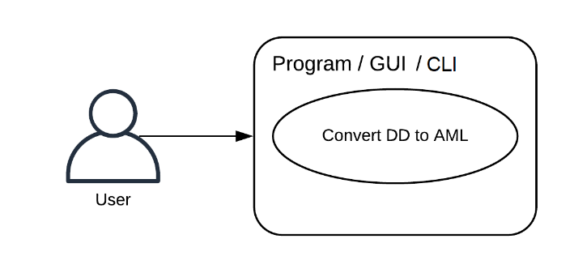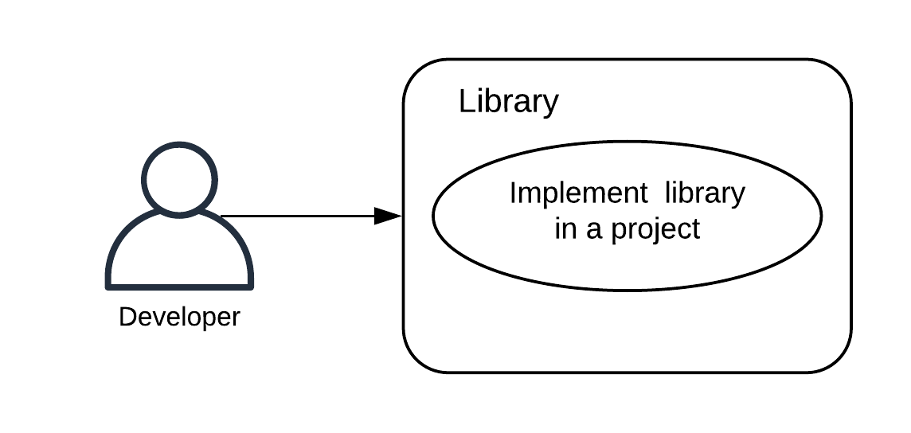

### <UC.001> File conversion CLI

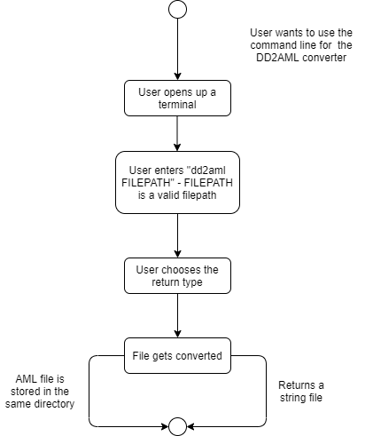

Figure 5 <UC.001> File conversion CLI

|  |  |
| --- | --- |
| **Related Business Process:** | <BP.001>: File conversion |
| **Use Cases Objective:** | User wants to convert his DD file to an AMLX file  using the command line. |
| **System Boundary:** | Program itself is the system boundary. |
| **Precondition:** | * The program must be installed on the device. * “dd2aml” needs to be registered as a   environment variable   * The DD file must be without errors. |
| **Postcondition on success:** | The command line should not be closed before the conversion is finished. |
| **Involved roles:** | User and Converter |
| **Triggering Event:** | Typing dd2aml file with a valid FILEPATH in the command line |

### <UC.002> File conversion GUI

|  |  |
| --- | --- |
| **Related Business Process:** | <BP.001>: File conversion |
| **Use Cases Objective:** | User wants to convert his file to an AMLX file  using the GUI. |
| **System Boundary:** | Program itself is the system boundary. |
| **Precondition:** | * The program must be installed on the device. * The DD file must be without errors. |
| **Postcondition on success:** | The program should not be closed before the  conversion is finished. |
| **Involved roles:** | User and Converter |
| **Triggering Event:** | Program is started |

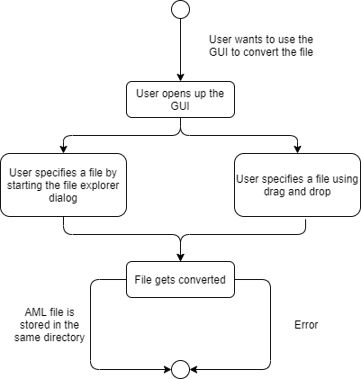

Figure 6 <UC.002> File conversion GUI

### <UC.003> Library usage

|  |  |
| --- | --- |
| **Related Business Process:** | <BP.002>: Library implementation |
| **Use Cases Objective:** | Possibility for a developer to implement this project in their own software. |
| **System Boundary:** | Program itself is the system boundary. |
| **Precondition:** | The library needs to have a clearly documented inter-face and must be downloadable from GitHub.  It needs to be published under the AGPL-license. |
| **Postcondition on success:** | The DD file was successfully converted into an AMLX package. |
| **Involved roles:** | Developer and library |
| **Triggering Event:** | Developer wants to implement a conversion function to his project. |

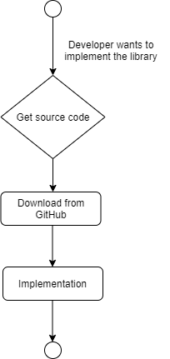

Figure 7 <UC.003> Library usage

## Features

### /F01/Import

The application should be able to import a file by the absolute path to the file.

### /F02/File format analysis

The program shall be able to recognize the file format as one of the listed formats: GSD, IODD or CSP+.

### /F03/File validation

The system shall be able to detect wrongly formatted GSD files and throw an error to the user.

### /F04/Conversion

The system should be able to convert a valid DD file into an AML file.

### /F05/ CAEX Version

The application shall give the option to decide if the CAEX Version 2.12 or the CAEX Version 3.0 should be used for the generated AML.

### /F06/AML Package

The system shall collect all resources and create an AMLX package from the AML file and the resource files.

### /F07/Error handling

The system shall be able to handle errors (unexpected shut down, wrongly formatted files, …) and throw an error to the user.

### /F08/Output selection

The system shall provide the user with the ability to choose between storing the result as a file or returning the AML as a string.

# Product Data

## /LD10/ AML-DD

The system shall create a valid AML-DD with all the necessary information the original file contained. Including an AML root file complete with versioning header, a “SystemUnitClass” with logical description, identification and configuration parameters as well as a reference to the original file and pictures if there are any.

## /LD20/ File conversion

The system shall be able to convert a syntactically correct file of the formats GSD, IODD or CSP+.

## /LD30/ AMLX package

The system shall create an AMLX file containing the AML-DD the original file and the device picture(s), which can be loaded into the AML editor.

## /LD40/Command line interface

The software shall support a command line interface.

## /LD50/Library

The software shall be implemented as a library so that other developers can use it in their projects.

# Other Product Characteristics

This section describes the already known requirements for the product.

## /NF10/Graphical User Interface

The software should support a graphical user interface.

## /NF20/System Environment

The software shall run under Windows 10 or lower version, because the only limitation is the .NET Framework.

## /NF30/Installation wizard

The software shall be installable via an installer.   
The installer shall allow to update to a newer version of the program.

## /NF40/Portable Program

Also, the software shall exist as a portable program. This means that no installation is required.

# Figures

[Figure 1 Product Environment 4](https://d.docs.live.net/e4d1a8a509920803/00_Schule/3.Semester/Software_Projekt/CRS%20-%20Lastenheft/TINF18C_CRS_DD2AMLConverter_Team_3_v1.0.docx#_Toc39429727)

[Figure 2 <BP.001> File conversion service 5](https://d.docs.live.net/e4d1a8a509920803/00_Schule/3.Semester/Software_Projekt/CRS%20-%20Lastenheft/TINF18C_CRS_DD2AMLConverter_Team_3_v1.0.docx#_Toc39429728)

[Figure 3 <BP.002> Library usage 6](https://d.docs.live.net/e4d1a8a509920803/00_Schule/3.Semester/Software_Projekt/CRS%20-%20Lastenheft/TINF18C_CRS_DD2AMLConverter_Team_3_v1.0.docx#_Toc39429729)

[Figure 4 Use Case Overview Diagram 6](https://d.docs.live.net/e4d1a8a509920803/00_Schule/3.Semester/Software_Projekt/CRS%20-%20Lastenheft/TINF18C_CRS_DD2AMLConverter_Team_3_v1.0.docx#_Toc39429730)

[Figure 5 <UC.001> File conversion CLI 7](https://d.docs.live.net/e4d1a8a509920803/00_Schule/3.Semester/Software_Projekt/CRS%20-%20Lastenheft/TINF18C_CRS_DD2AMLConverter_Team_3_v1.0.docx#_Toc39429731)

[Figure 6 <UC.002> File conversion GUI 8](https://d.docs.live.net/e4d1a8a509920803/00_Schule/3.Semester/Software_Projekt/CRS%20-%20Lastenheft/TINF18C_CRS_DD2AMLConverter_Team_3_v1.0.docx#_Toc39429732)

[Figure 7 <UC.003> Library usage 9](https://d.docs.live.net/e4d1a8a509920803/00_Schule/3.Semester/Software_Projekt/CRS%20-%20Lastenheft/TINF18C_CRS_DD2AMLConverter_Team_3_v1.0.docx#_Toc39429733)

# References

[1] <https://www.elektroniknet.de/automation/automationml-die-grundarchitektur-829-Seite-5.html>

[2] <https://www.kunbus.de/io-device-description.html>