
pCLIAR Dashboard
GOVERNANCE
User Manual
Version December 1, 2023


CLIAR NOTES
CLIAR Dashboard
User Manual

This version: CLIAR Dashboard 2.0. October 2, 2024

Table of Contents
Acronyms and Abbreviations 3
Acknowledgements 3
1. Introduction to the CLIAR Dashboard 4
2. Dashboard analyses 5
A. Country Benchmarking 5
Basic Instructions 5
Resulting Figures 9
Customizing the Country Benchmarking Figure 12
Downloading Custom Reports and Data 15
B. Cross-Country Comparison 16
Basic Instructions 16
Resulting Figure 18
C. Bivariate Correlation 18
Basic Instructions 18
Resulting Figure 20
Customizing the Bivariate Correlation Figure 21
D. World Map 22
Basic Instructions 22
Resulting Figures 24
Customizing the World Map Figure 24
E. Time Trends 25
Basic Instructions 25
Resulting Figure 27
F. Data 28
Data Available 28
Example of Downloaded Data 29

Acronyms and Abbreviations

CLIAR | Country Level Institutional Assessment and Review
CTF | Closeness to Frontier

Disclaimer
The term country, used interchangeably with economy, does not imply political independence but refers to any territory for which authorities report separate social or economic statistics.

Acknowledgements

To be added after review

Introduction to the CLIAR Dashboard

The Country-Level Institutional Assessment and Review (CLIAR) Dashboard is a tool that assesses the strengths and weaknesses of a country’s selected institutional dimensions against a set of comparator countries. The dashboard’s objective is to contribute to the identification of entry-points and priorities for institutional reform.

The tool is based on publicly available data and contains 138 indicators, each of which are mapped to one of 13 institutional clusters. The CLIAR Dashboard employs the closeness to frontier (CTF) methodology to standardize and compare these institutional indicators. For each indicator, a country's performance (y) is rescaled on a 0–1 scale using a linear transformation $\frac{(Worst-y)}{(Worst-Frontier)}$ , where the final CTF score ranges between 0 (representing the worst performer) and 1 (representing the best performer). These indicator-level CTF scores are then averaged across the 13 institutional clusters to produce a cluster-level CTF score. For more details, please consult the CLIAR Methodological Note.

The CLIAR Dashboard has several tabs that correspond to different analyses that users can use: country benchmarking, cross-country comparisons, bivariate correlation, world map, time trends, and data. Beyond these analysis tabs, there are additional tabs related to the methodology, terms of use, Frequently Asked Questions, and more. These sections are listed in the panel on the lefthand side of the dashboard. In this section, we focus and briefly describe the analyses that users can perform with each type of tab.

- The Country Benchmarking tab shows how one country compares to another group of countries in terms of the closeness to the frontier for each relevant indicator and institutional cluster. Users can conduct this benchmarking exercise for a single country or for multiple countries, which may be more suitable for regional reports. It is most useful if the user wants to understand how a base country (or base countries) performs relative to medium or large number of peer comparators.

- The Cross-country Comparison tab shows how one country compares to another group of countries for each relevant indicator. Though it is like the country benchmarking tab, it works even with a small number of comparator countries. This tab is most useful if a user wants to understand how a base country performs relative to only one or two peers.

- The Bivariate Correlation tab shows correlations between the CTF scores for pairs of indicators. Users may compare cluster averages or individual indicators. The correlation tab produces a scatter plot where each point represents a country and the base country is highlighted.

- The World Map tab shows the CTF of a given indicator for all countries with available data. Users choose an indicator and then the dashboard generates a map of the world colored according to country’s values for that indicator.

- The Time Trends tab shows the evolution year by year of multiple indicators. Users select an indicator, a base country, and comparator country (or countries). The dashboard then generates a time series plot which shows how values of the base and comparator countries evolve over time.

- The Data tab provides an interactive table containing the CTF data for all countries. It also allows users to download the data in different formats for additional analyses not available on the dashboard.

Dashboard analyses

Country Benchmarking

Basic Instructions

The Country Benchmarking tab has four main sections…
- Base country: This is where the user selects the country that is the object of the analysis.
- Comparator countries: This is where the user selects the countries against which the base country will be compared.
- Benchmarking options: This is where the user selects options customize the plot.
- Outputs: This is where the user selects the institutional cluster to plot as well as the type of output that the user would like to receive.
The first, second, and fourth sections above are necessary to produce a plot. The third section includes options that are helpful if the user wants to customize their plot. Each of these sections will be explained and explored in the instructions below.

1. Select a base country – From the dropdown menu, choose the base country (or countries) that you would like to analyze. You can choose more than one, but the resulting figures will be clearest if you choose one or a small number. In the example screenshot below, we have chosen Ghana as the base country.

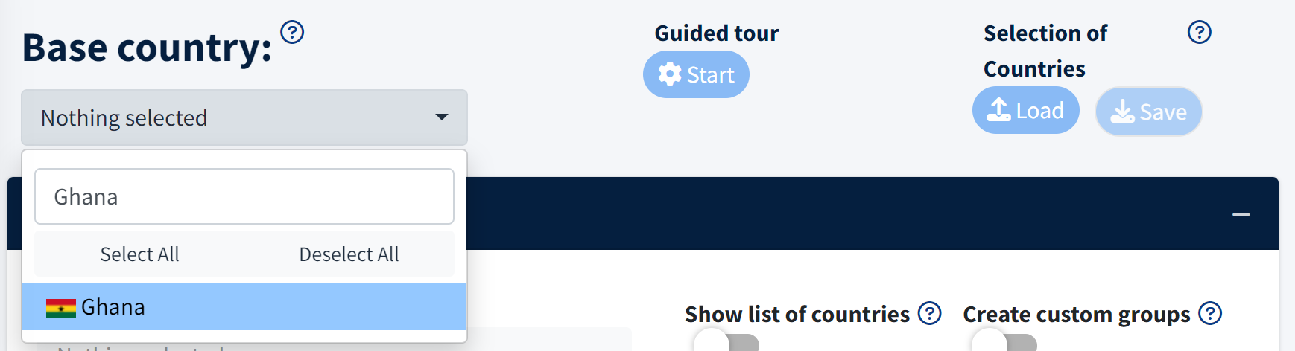

2. Select comparator countries – The base country will be compared to a set of other countries. There are multiple ways to select the comparators and they are each described in turn below.

First, the most direct way to select a group of comparator countries is to choose a pre-defined grouping: such as economic groups (like the European Union), regional groups (like South Asia or the Arab World), or income groups (like low income or middle income). From the dropdown menu, choose the group to which you would like the base country to be compared. In the example below, we have selected Sub-Saharan Africa as the regional comparison for the base country of Ghana.

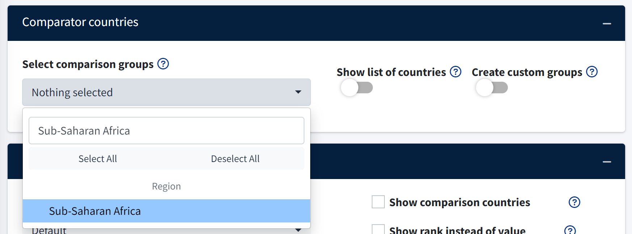

Second, if you have selected one of the pre-defined groups such as the European Union or Low-income countries, you may manually edit the countries that are included in this grouping. Click the toggle below “Show list of countries” to reveal all potential comparison countries. If you have already selected a pre-defined comparison group above, these countries will appear with a red checkmark next to their name. If you would like to add any additional comparison countries, click on them to add additional red checkmarks.

Note that in the example below countries from Sub-Saharan Africa are selected with red checkmarks because we selected Sub-Saharan Africa as the comparison group. If you would like to add or remove countries, click on their name to add or remove the checkmark.

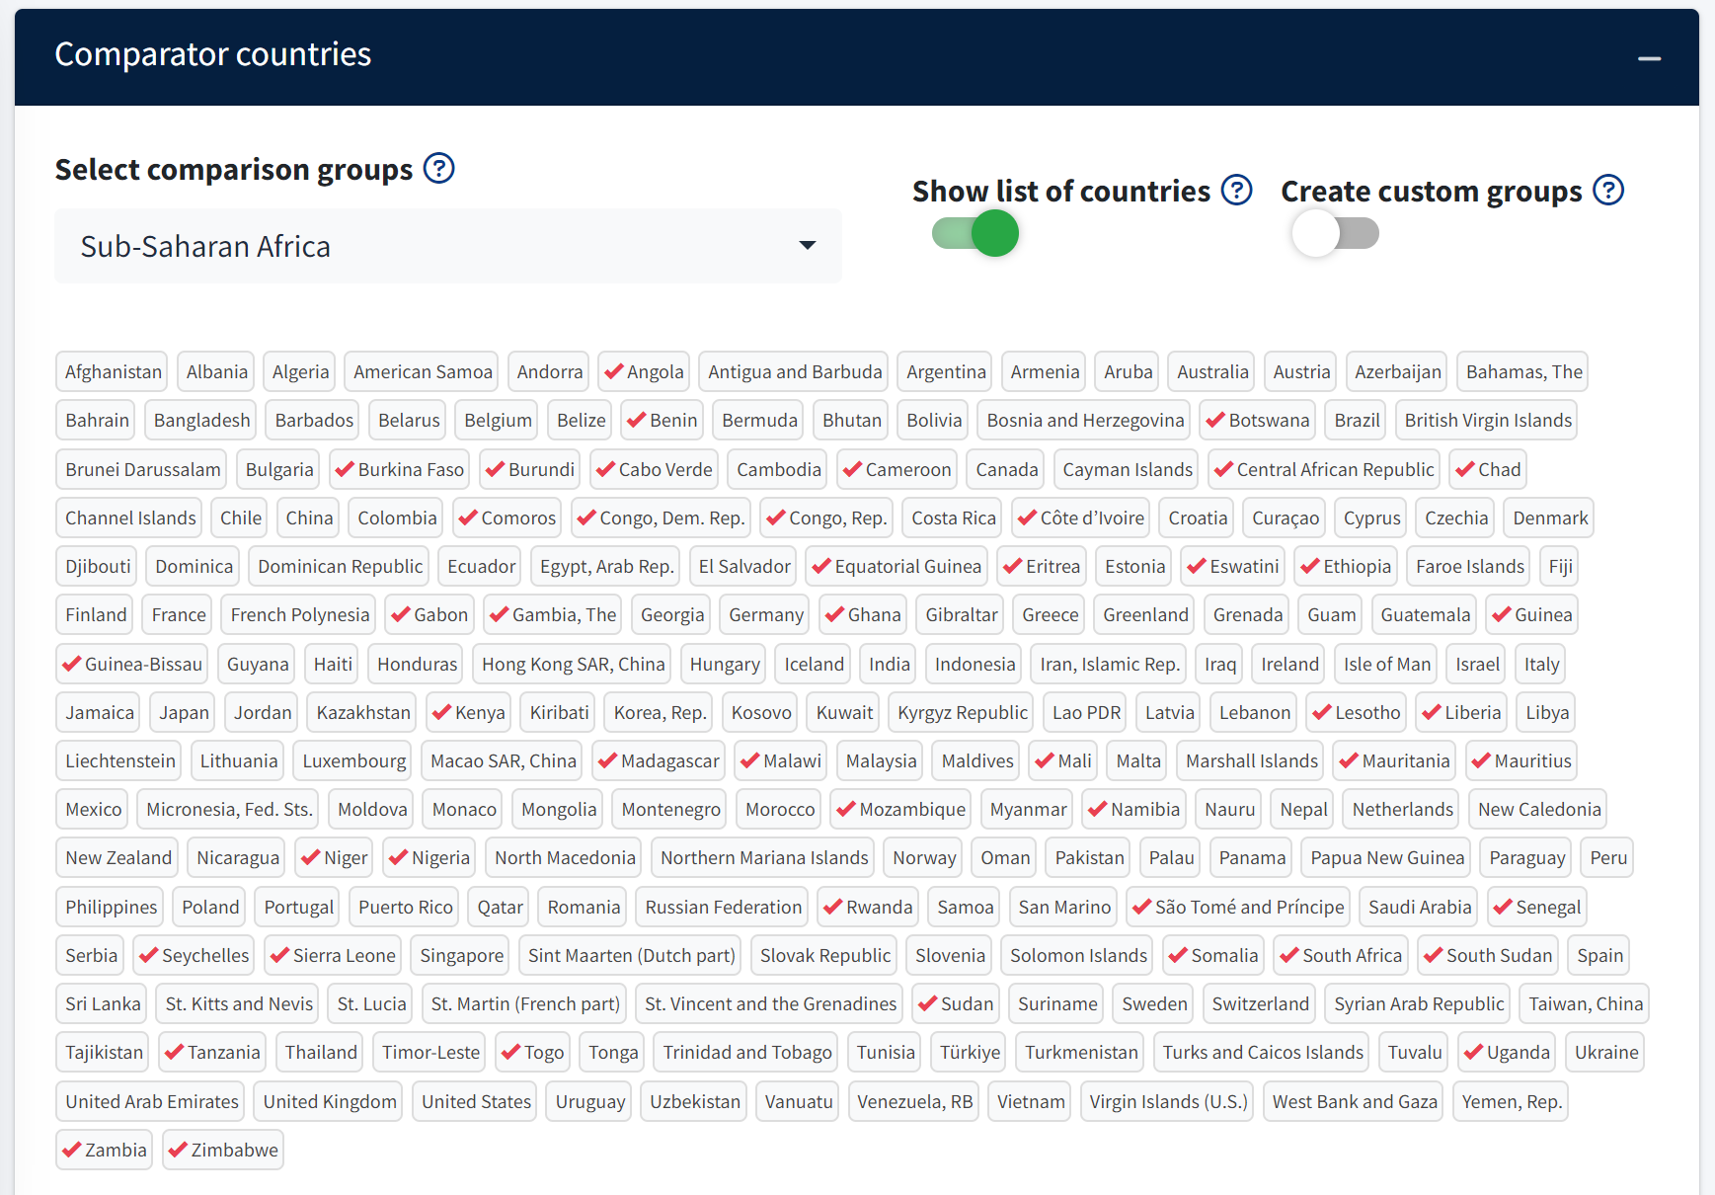

Third, you may create entirely custom groupings. Creating custom groups is particularly helpful if users want to compare a base country to a set of structural or aspirational peers. Click the toggle below “Create custom groups” box to reveal options to manually create these custom groups. Enter the number of groups you would like to create and then, for each group, name the group and select the desired countries from the dropdown menu. The resulting figure will also plot the median CTF value for the countries in each group.

In the example below, we have created a single custom group named Aspirational peers. We have selected Colombia, Ecuador, Morocco, South Africa, and Tunisia as part of this group.

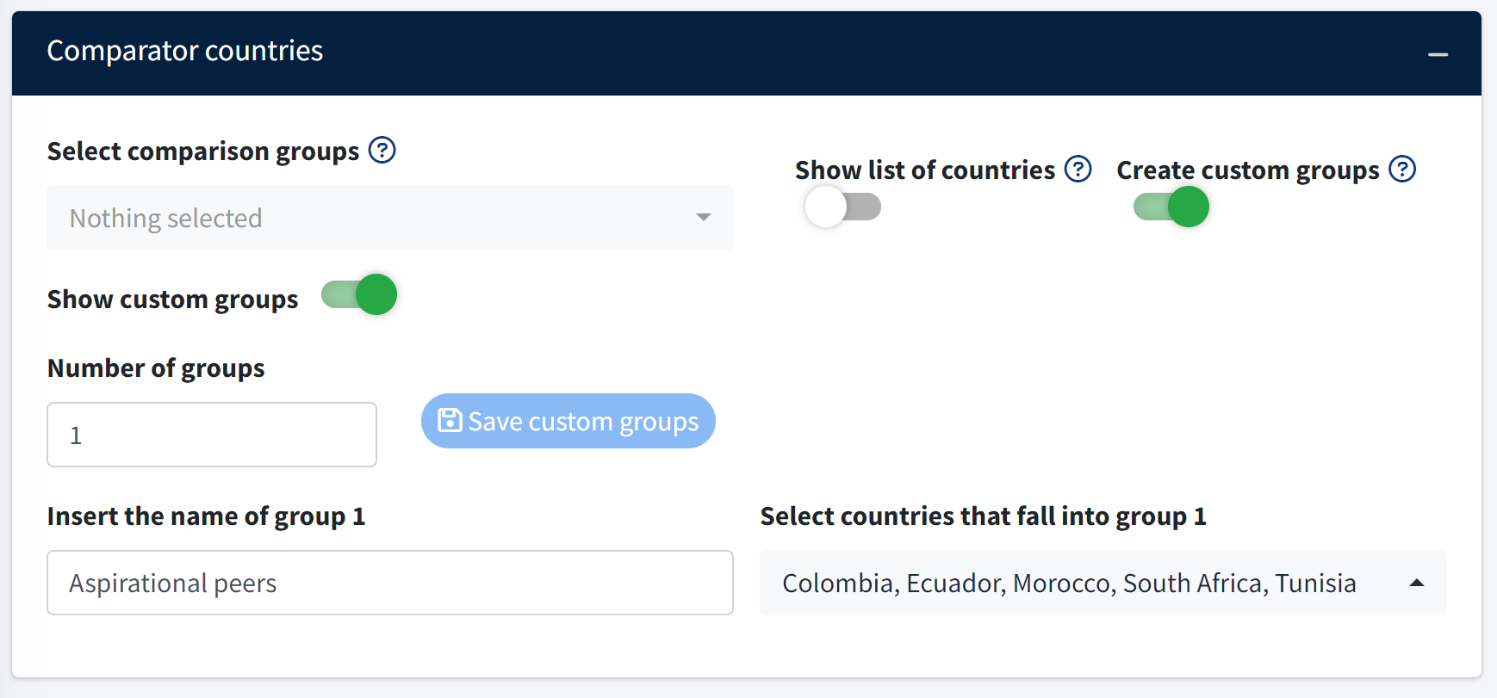

3. Select outputs – From the “Select institutional cluster” dropdown menu, select the data you would like to analyze. You may either select “Overview” or a specific institutional cluster, such as “Political Institutions,” “Labor and Social Protection Institutions,” etc.

Selecting “Overview” will present average CTF scores for each of the thirteen institutional clusters. Selecting one specific institutional cluster will plot the average score for that cluster, plus the CTF scores for each of the underlying indicators within that institutional cluster. In the below example, we select the Public Human Resources Management Institutions cluster.

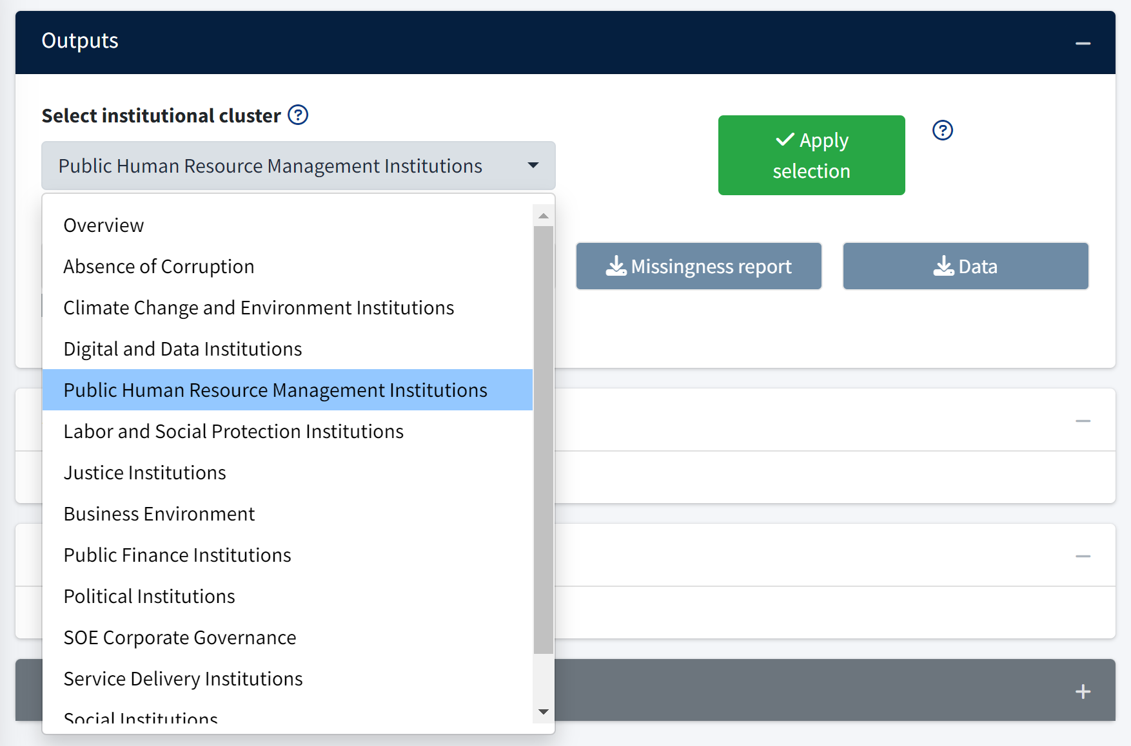

4. Select “Apply Selection” to load the resulting figures.

Box: Saving and loading selected inputs
If you wish to save your selected inputs to return to at a future time, note that you can click the red “Save” button below “Selection of countries” in the top-right corner of the page. This will download a .rds file to your computer. When you return to the dashboard, you can click the red “Load” button and then “Browse” to select this same .rds file. Loading this .rds file will re-populate all of the selections that you previously made.

Resulting Figures

Static benchmarks – The static benchmark plot compares the base country (shown as a black circle) to the comparison group. The vertical axis displays the names of the indicators or institutional-level averages. The horizontal axis shows the CTF statistic.

The black circle represents the base county. By default, the colored bars represent the 0 to 25th percentile (red), 25th to 50th percentile (yellow), and greater than the 50th percentile (green). Selecting terciles switches these boundaries to the following: 0 to 33rd percentile (red), 33rd to 66th percentile (yellow), and above the 66th percentile (green). Note where these sections are indicated in the image below.

The image below shows the country-level overview for Ghana with Sub-Saharan Africa as the comparison group. We can see that Ghana’s values (i.e. the black circle) for all of the institutional cluster averages are in the green bar, so Ghana is in the top 50% of countries from Sub-Saharan Africa.
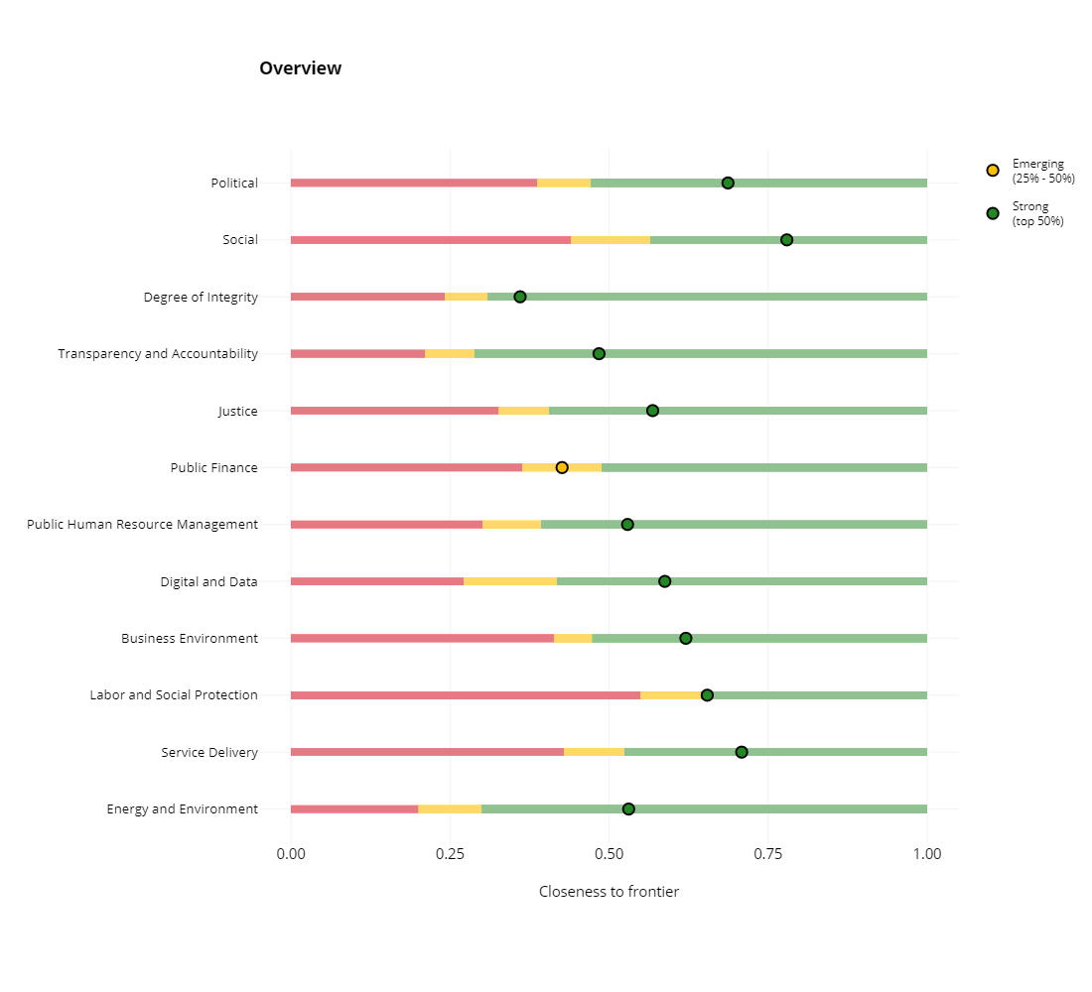
Ghana
(the base country)
0 to 25th percentile in red
Greater than the 50th percentile in green
26th to 50th percentile in yellow
The next image shows the Public Human Resource Management Institutions cluster plotted for Ghana with Sub-Saharan Africa as the comparison group. We can see that Ghana’s values (i.e. the black circle) for all of the variables except for “Rigorous and impartial public administration” are in the green bar, so Ghana is in the top 50% of countries from Sub-Saharan Africa for these variables. Ghana’s value for the “Rigorous and impartial public administration” variable is in the yellow bar, so the 25-50% percentile of Sub-Saharan Africa.
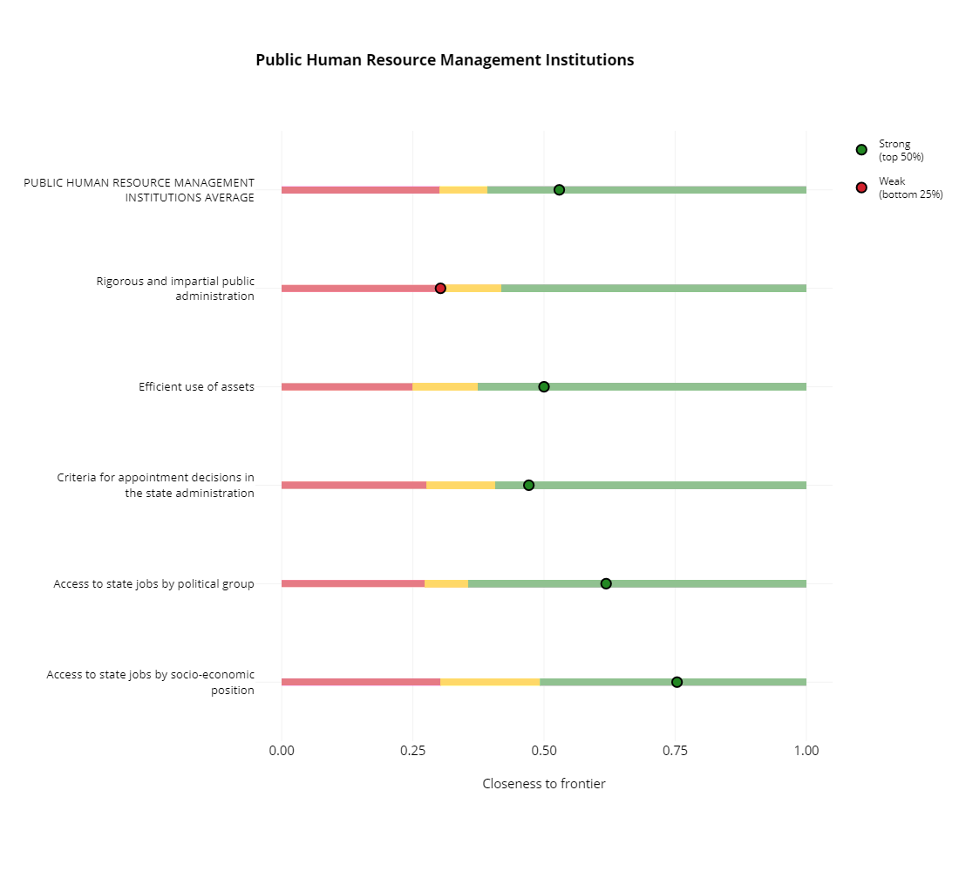

Note that a given base country can be compared to different groups of countries. When this happens, the base country’s black circle remains the same, but the colored areas of each bars change. This is because the distribution against which the base country is compared changes. To make clear which countries are included in the comparator group, the user may toggle the “Show notes” toggle below the plot. As the image below shows, clicking on the toggle will reveal a caption that specifies both the base country and the comparator group.

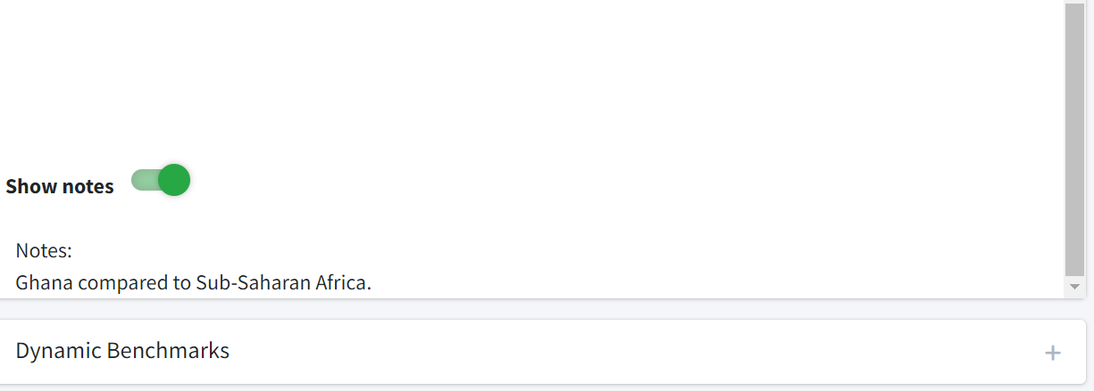

Dynamic benchmarks – The user can also analyze the evolution of the base country’s CTF score over time. These dynamic figures are automatically generated below the static figure. Note though that they take slightly more time to generate due to the volume of data. The dynamic plot uses data for the country/years since 2013 for which the variables have observations. For each indicator, the dynamic plots show the CTF statistic on the vertical axis and years on the horizontal axis. The vertical-colored bars represent the same percentiles as shown in the static plot. Similarly, as in the static plot, the black circle (now connected across years) represents changes in the value for the base country.

The image below shows the Access to state jobs by political group and Access to state jobs by socio-economic position plotted for Ghana with Sub-Saharan Africa as the comparison group. For both variables, Ghana (i.e. the black circles and black line) is in the green bars across all years, which means it is consistently in the top 50% of countries from Sub-Saharan Africa.

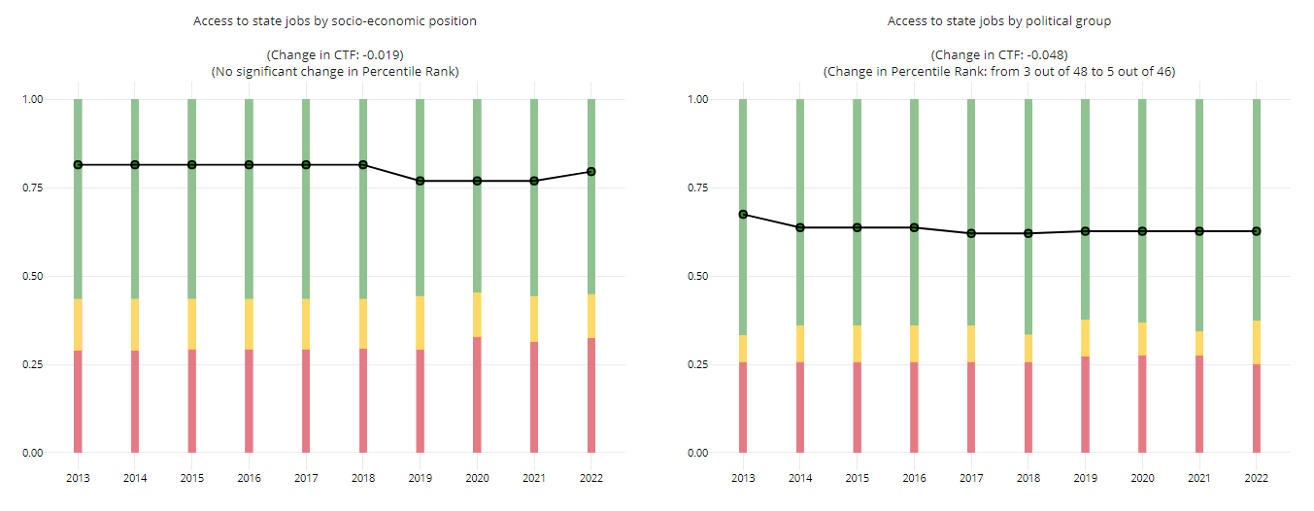

Indicator definitions – Note that the definitions and sources for each indicator is always found below the dynamic benchmarking plots.

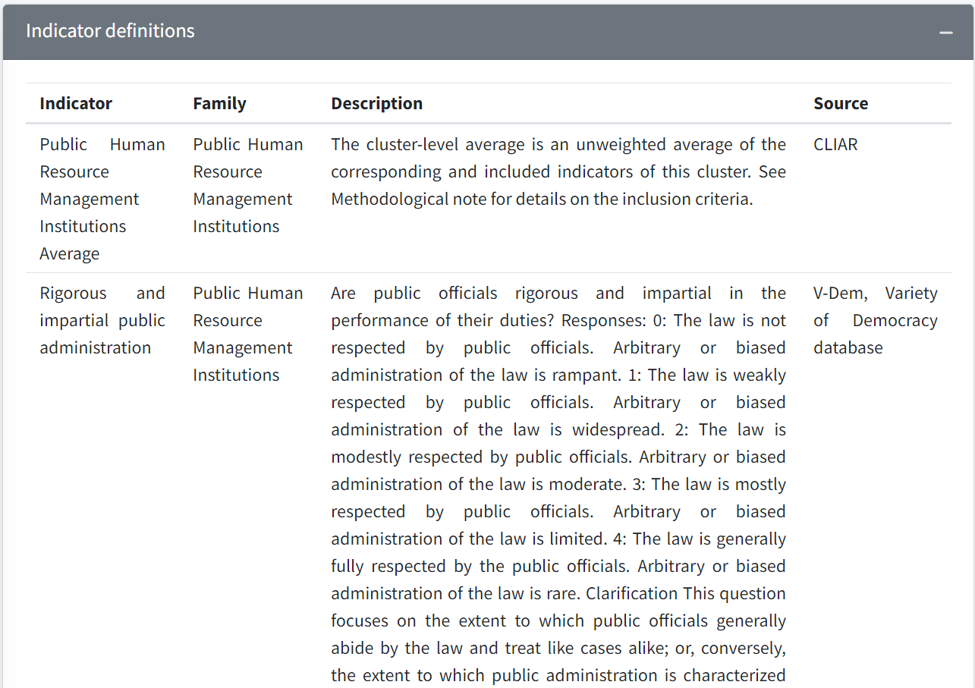

Customizing the Country Benchmarking Figure

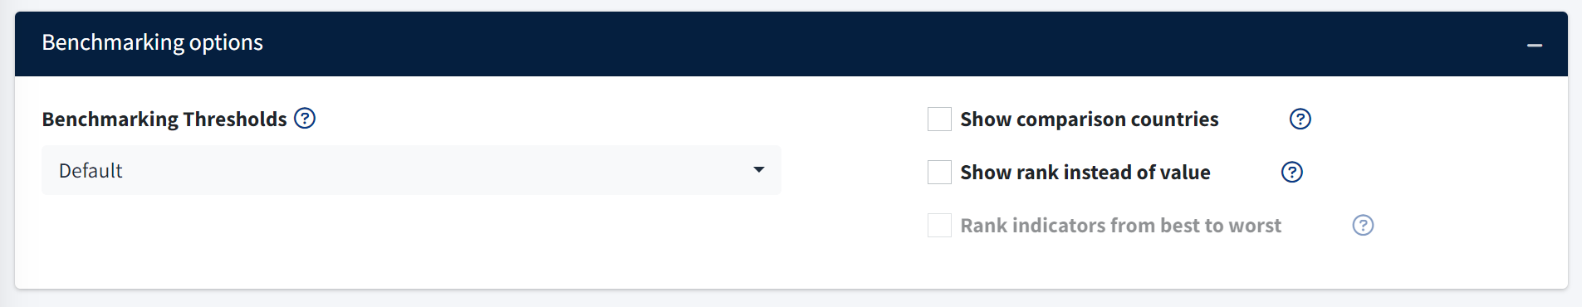

The section displayed above includes several different ways to customize the benchmarking plots. Each customization is described in more detail below.

Show comparison countries – Select the box to show the comparison countries as white circles on the plot. You may hover over each circle to see the country name. Note that individual countries are represented by circles in the first example below. This shows the distribution of values for the comparison group. The cursor in the image below is hovering over Benin in the Public Human Resource Management institutional cluster average.

To examine the distribution of countries more closely, you may select a range of the x-axis as shown in the second example below. This will zoom in on that segment of each variable, producing the third example below.

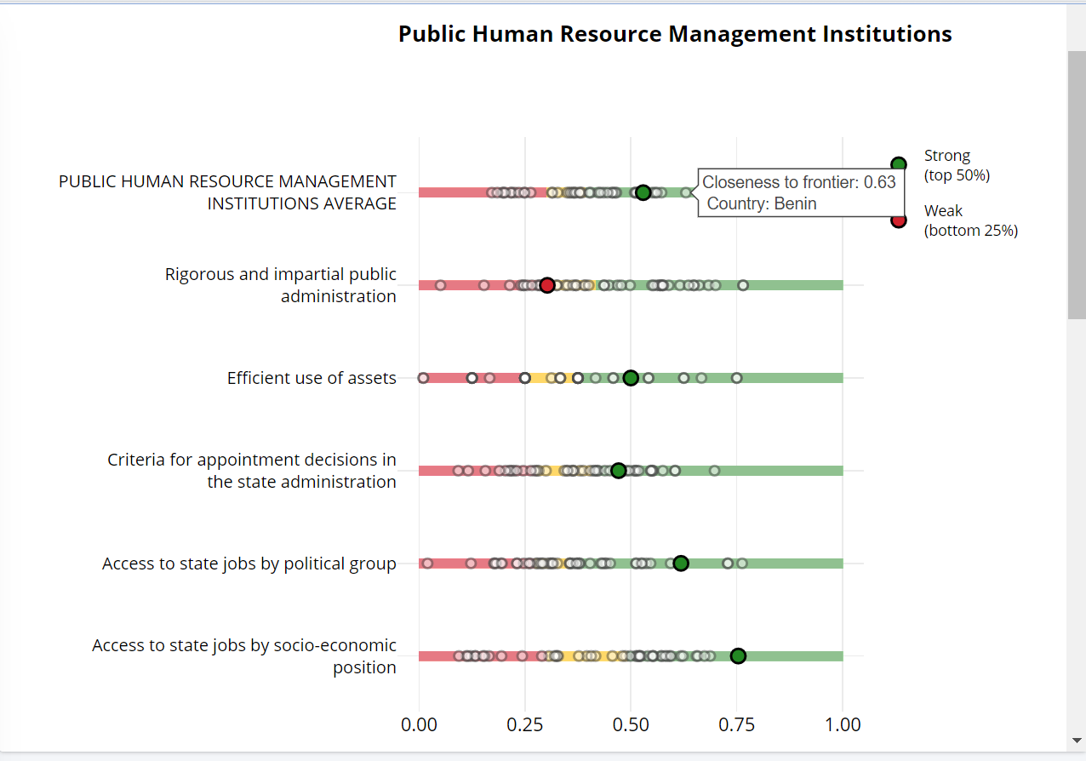

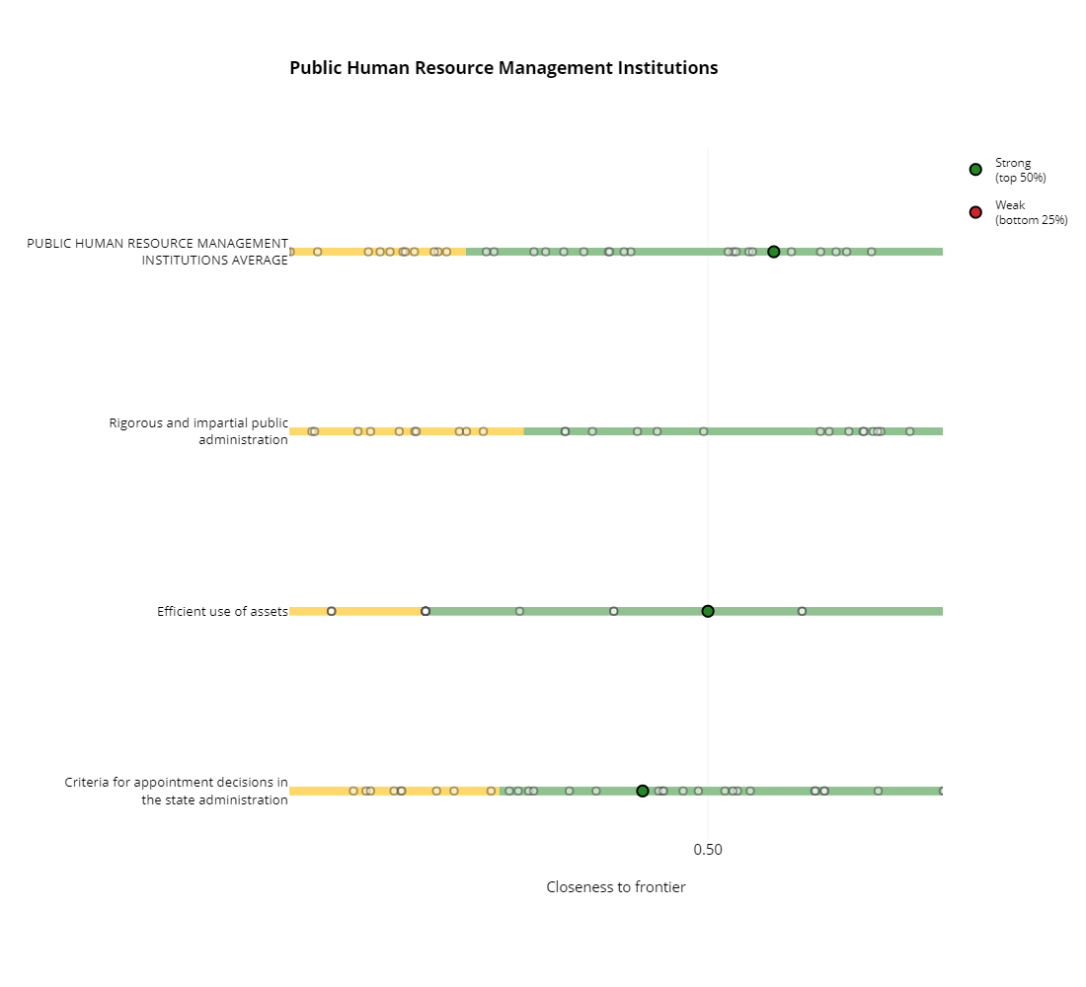

Show rank instead of value – Select the box to change the x-axis of the static benchmarking plot to display rankings instead of the CTF value. Note the difference in the x-axis in the plot below.

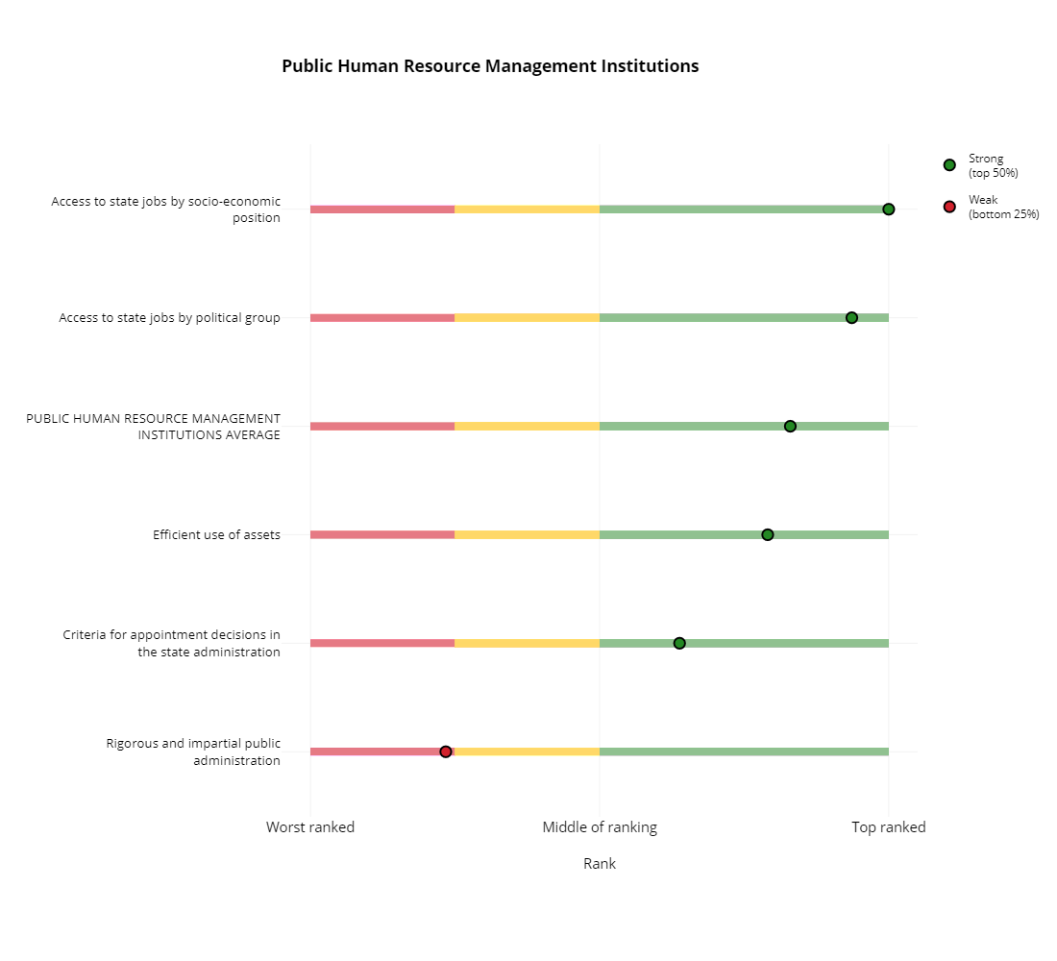

Rank indicators from best to worst – Select the box to change the ordering of the variables on the vertical axis of the figure. Ranking from best to worst will place the indicator for which the base country has the highest value first and the indicator with the lowest value last.

Note the different vertical ordering of the variables in the figure below. The variable with the largest value on the x-axis is now the first row and the variable with the smallest value is now the bottom row.
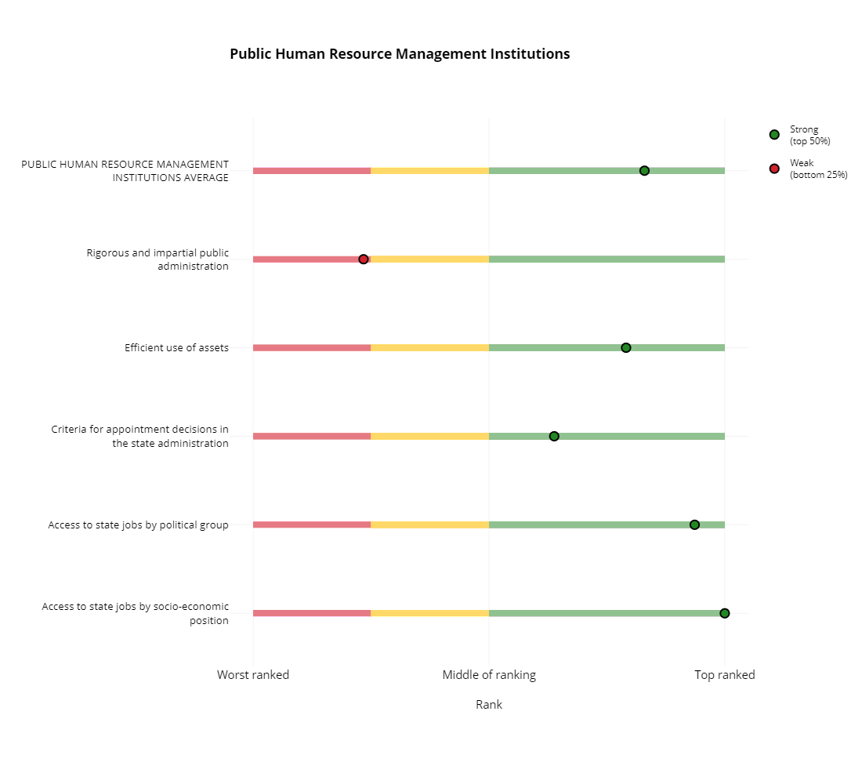

Benchmarking thresholds – Select “Terciles” from the dropdown menu to change the red, yellow, and green bars in the static benchmarking plot. When selected, the different colors represent terciles of the distribution. Red represents the bottom 33% of the distribution, yellow represents from 33% to 66%, and green represents from the top 33%.

Note the difference in the legend in the plot below. The colored sections of each horizontal bar have also changed, even though the location of the black circle and gray squares on the x-axis have not changed.

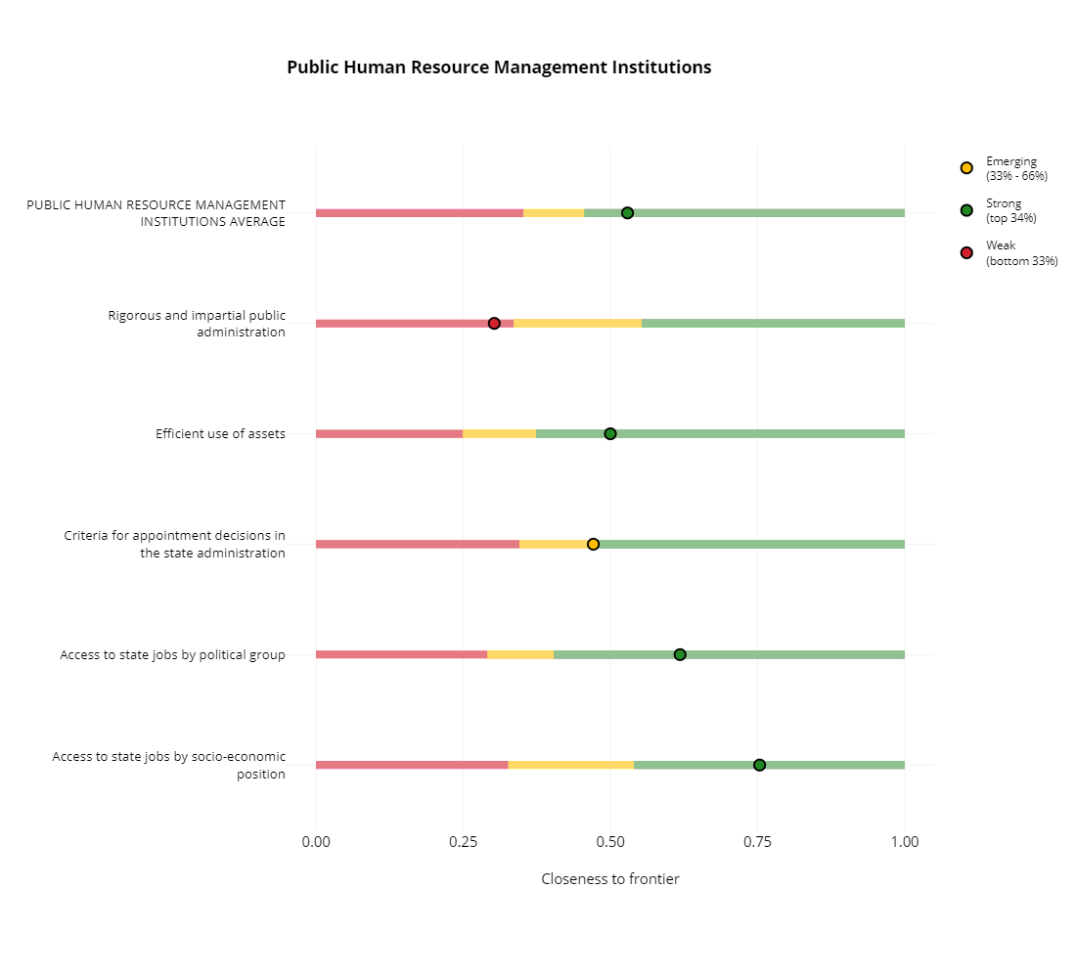

Downloading Custom Reports and Data

Pre-populated Reports – Click the “Download editable report” or “Download PPT report” buttons to download either a Word or PowerPoint document that contains the static and dynamic plots for the base country, comparison group, and group medians that you have selected. The reports contain the following sections…
- Explanation of CLIAR and its key objectives.
- Explanation of CLIAR’s methodology and how indicators were selected.
- Overview static benchmarking plot with each of the institutional clusters.
- Overview dynamic benchmarking plot with each of the institutional clusters.
- Static benchmarking plot (for each institutional cluster) with every cluster’s variables.

Note that the user may select the “Download Advanced Report (~10 min)” box to receive more detailed information. Selecting this box and then clicking the “Download editable report” button produces a longer report than clicking the button without selecting the box. The primary difference between the advanced report and the default report is that the advanced report includes all available dynamic graphs for the base country. These plots take a lot of time to produce, so please wait about 10 minutes for the advanced report to download.

Download data – Click the “Download Data” button to download a CSV file that contains the data needed to recreate the static benchmarking plot. The data contain the following key information…
- country_name – Name of the base country.
- variable / var_name – Name and abbreviation of the variables from the selected institutional cluster.
- dtf – Base country’s CTF value for the respective variables.
- family_var / family_name – Institutional cluster name and abbreviation.
- dtt – Percentile of the base country’s CTF value based on the distribution of comparator countries.
- q25 / q50 – Values for the 25th and 50th percentiles (i.e. where the red bar changes to the yellow bar and the yellow bar changes to the green bar in the static benchmarking plot).
- status – “Weak” if the base country falls in the yellow bar (0 to 25th percentile), “Emerging” if it falls in the yellow bar (25th to 50th percentile), and “Green” if it falls in the green bar (above the 50th percentile).
- nrank – Rank of the base country against the comparison group.

Cross-Country Comparison

Basic Instructions

Below is a diagram of the cross-country comparison tab with the most important buttons and options highlighted with arrows and textboxes. Each of these options will be explained and explored in the instructions below.

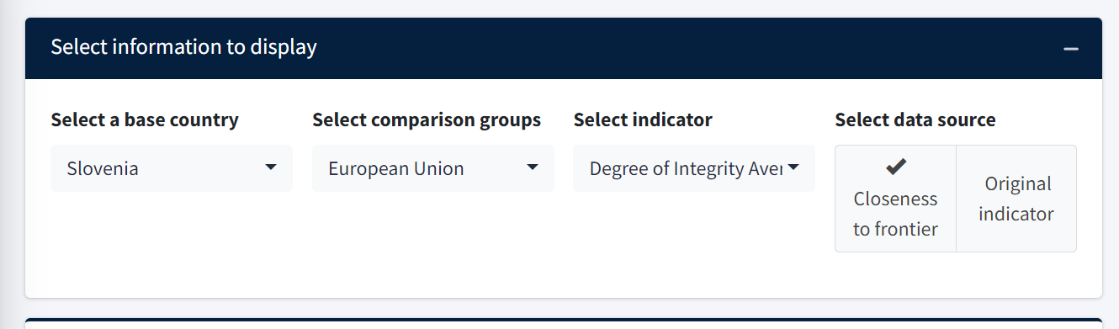
Choose the comparison group (if any)
Choose the base country to analyze

1. Select the base country – The base country is the country that will serve as the center of the analysis. It is the country that you would like to comparator to other country groups or other individual countries. In the screenshot below, we have chosen Slovenia as the base country.

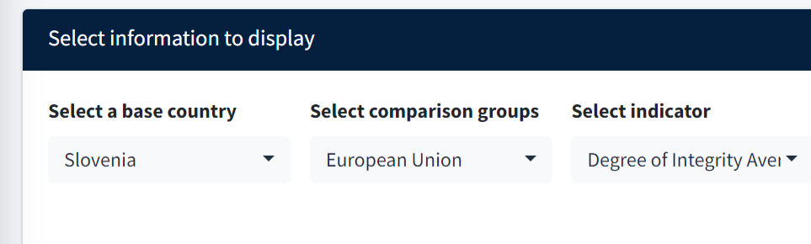

2. Select the comparison groups. – The comparison group is an average of countries against which you would like to compare the selected indicator for the base country. You may select economic groups (like the European Union), regional groups (like South Asia or the Arab World), or income groups (like low income or middle income). In the example below, we have selected the European Union as a comparison group.



3. Select an indicator – From the dropdown menu, choose the indicator (or institutional family) that you would like to analyze. In the screenshot below, we have chosen the Political Institutions Average as the indicator to analyze.

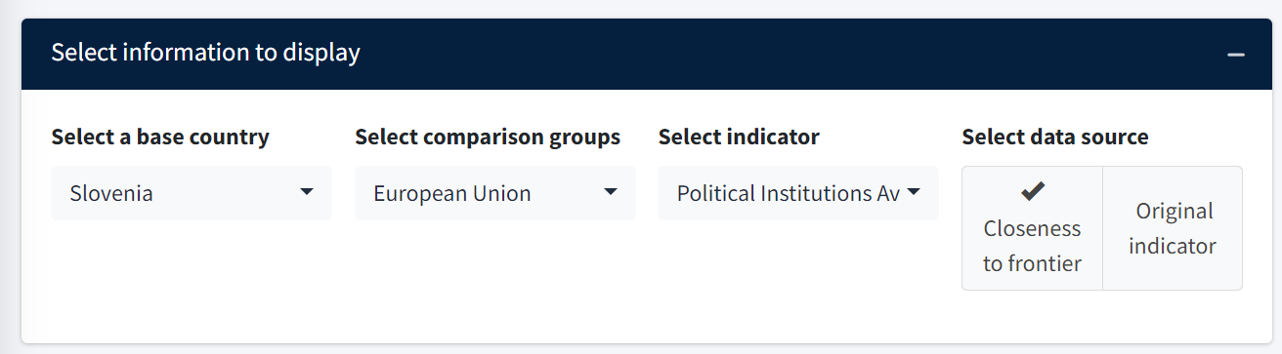

4. Select individual comparison countries. – In addition to selecting a comparison group, you may also select individual comparison countries to plot against the base country’s value for the selected indicator. Click the “+” sign on the “Select individual comparison countries” tab to reveal all potential comparison countries. In the example below, we have additionally selected Bosnia and Herzegovnia, Croatia, Moldova, North Macedonia, Serbia, and Slovenia as individual comparison countries.

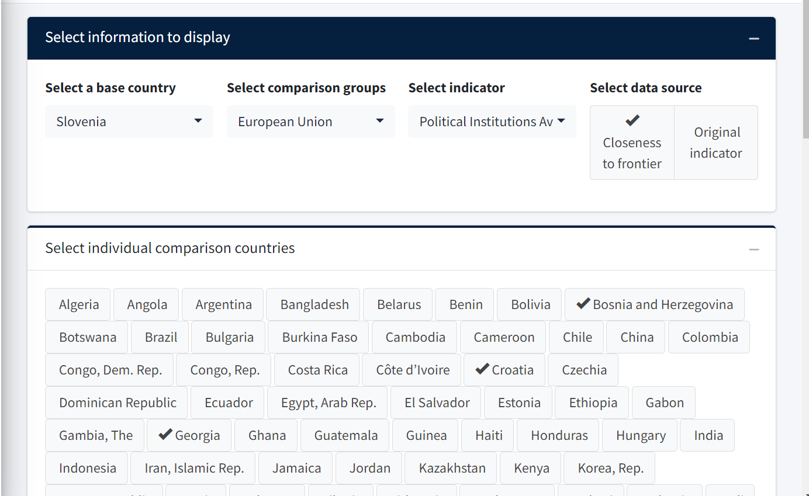

Resulting Figure

The cross-country comparison plot compares the value of a variable for a single country to several different of comparison groups and countries. It presents the same information as the country-benchmarking plot, though it a different manner to ease interpretation and comparison. The relative advantage of the country-benchmarking plot is that users can easily understand how a base country compares to relevant percentiles of the selected comparison group. In contrast, the relative advantage of the cross-country comparison plot is that users can more easily understand how that base country compares to other individual countries.

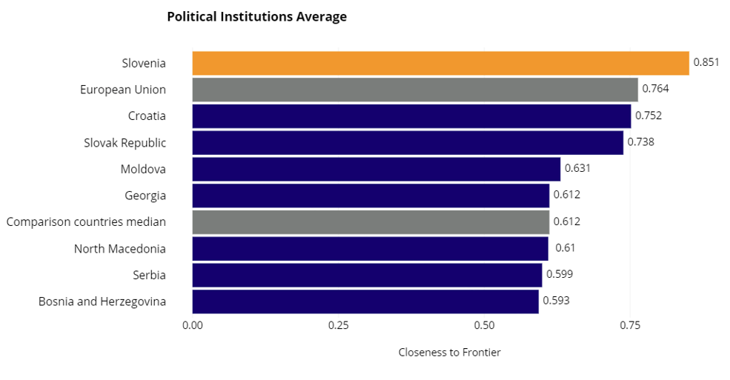

The plot above specifically shows the results of the running example that compares the Political Institutions Average for Slovenia to the European Union and other individual comparison countries. Albania – which is highlighted in orange – has a CTF score of 0.615 for the Political Institutions Average, which is comparable to many other countries in Southeastern Europe such as Moldova, North Macedonia, and Serbia. The European Union – which is highlighted in gray – has a CTF score of 0.763 for the selected variable, which is higher than Albania’s and closer to the scores of Slovenia and Croatia.

Bivariate Correlation

Basic Instructions

Below is a diagram of the bivariate correlation tab with the most important buttons and options highlighted with arrows and textboxes. Each of these options will be explained and explored in the instructions below.

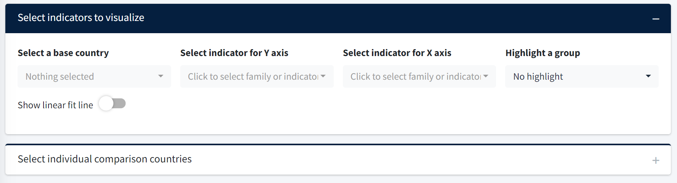
Choose the base country to analyze
Select individual countries to highlight in the scatter plot
Choose a group of countries to highlight in the scatter plot
Choose the variables to plot on the y and x-axises

1. Select a base country. – From the dropdown menu, choose the base country that you would like to analyze. This country will be highlighted in yellow in the resulting scatter plot. In the running example below, we choose Guatemala as the base country.

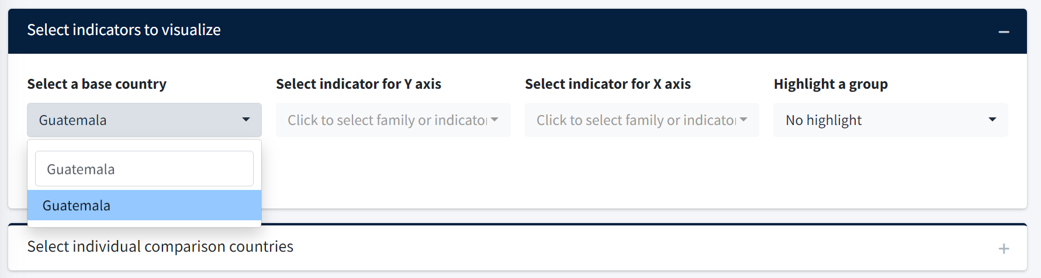

2. Select an indicator for the Y-axis. – From the dropdown menu, choose the indicator that you would like to plot on the y-axis (i.e. the vertical axis). In the example below, the Public Human Resource Management Institutional Average is selected as the y-axis indicator.

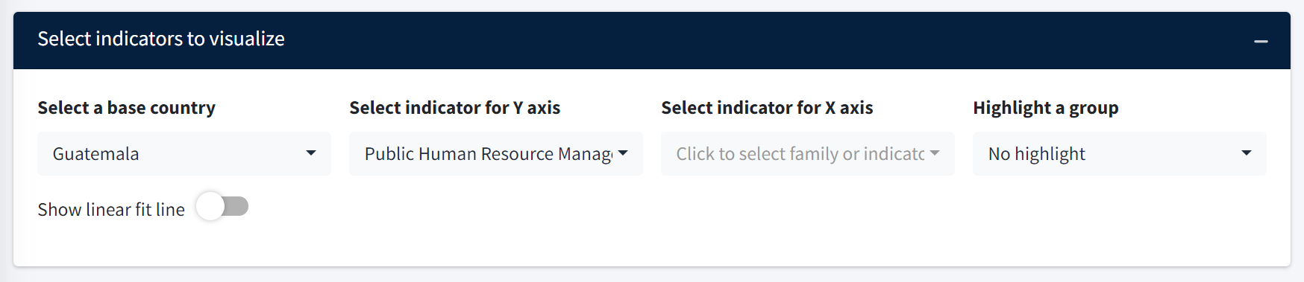

3. Select an indicator for the X-axis. – From the dropdown menu, choose the indicator that you would like to plot on the x-axis (i.e. the horizontal axis). In the example below, the Log GDP per capita, PPP is selected as the x-axis indicator.

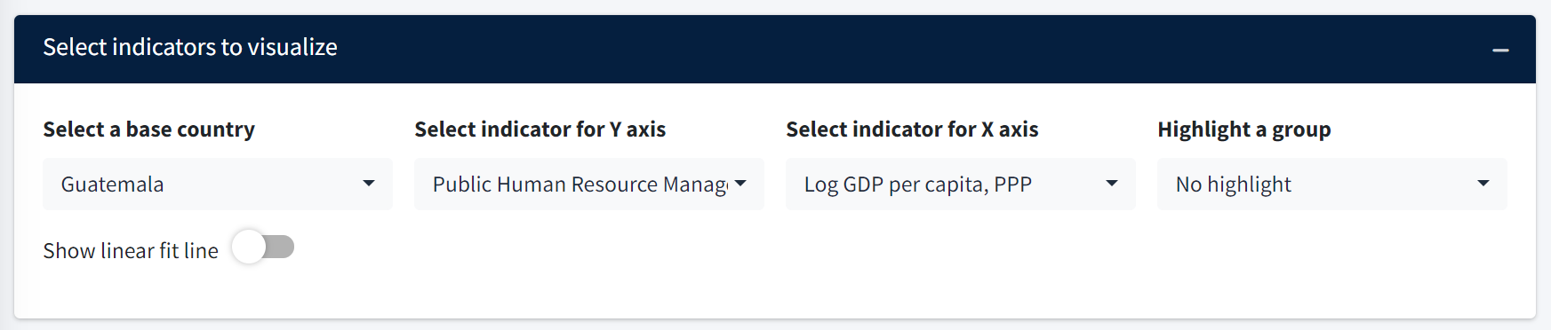

4. Highlight a group. – From the dropdown menu, you may select a group of countries that you would like to highlight in the ensuing scatter plot. As in previous tabs, you may select economic groups (like the European Union), regional groups (like South Asia or the Arab World), or income groups (like low income or middle income). The countries in the selected group will be highlighted with a blue ring around their respective point in their scatter plot. Note that this step is optional and you may still plot the two indicators even without highlighting a group. In the example below, the regional grouping Latin America and the Caribbean is selected.

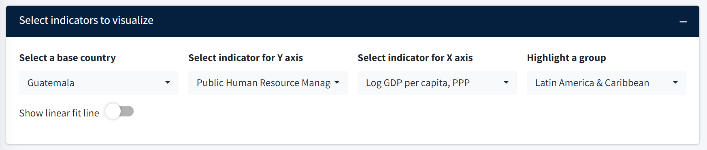

5. Select individual comparison countries. – – In addition to highlighting a comparison group, you may also select individual comparison countries to highlight in the scatter plot. Click the “+” sign on the “Select individual comparison countries” tab to reveal all potential comparison countries. Like the previous step, this step is optional and you may still plot the two indicators even without selecting individual comparison countries. In the example below, El Salvador, Honduras, and Nicaragua are selected as individual comparison countries.

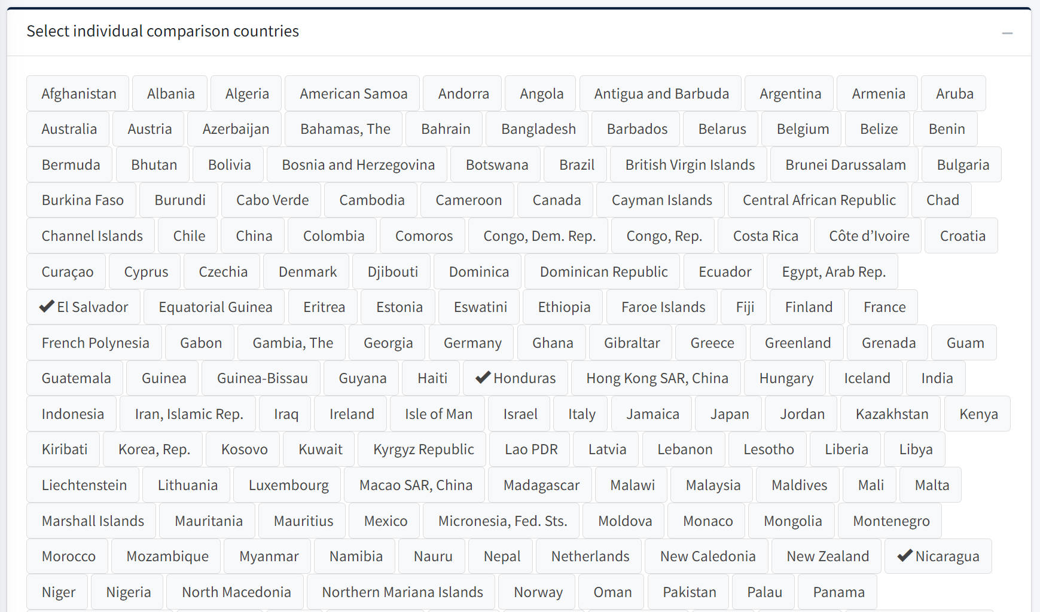

Resulting Figure

The bivariate correlation plot compares the values of two indicators for every country, but specifically highlights the points for the base country and any individual countries or groups selected for comparison. Unlike the country-benchmarking or the cross-country comparison plots, the bivariate correlation plot helps the user study relationships between two variables in the CLIAR database.

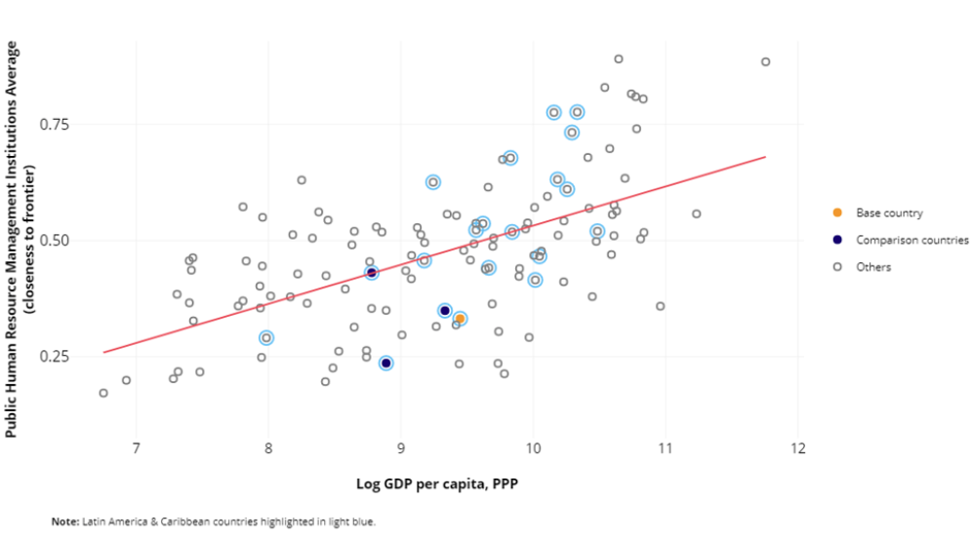

In the example above, the Public Human Resources Management Institutions Average is plotted against Log GDP per capita, PPP. Note that, for any specific point, the user can hover over that point to learn the country that the point represents and the country’s scores for the variables on either axis. The base country with an orange insert is Guatemala and the three points with black inserts are the individual comparison countries of El Salvador, Guatemala, and Nicaragua. The points circled in light blue belong to the Latin America and the Caribbean regional grouping.

Customizing the Bivariate Correlation Figure

Show linear fit – Switch this toggle to add a linear “line of best fit” to the scatter plot. The slope of the red line plotted in the example below represents the resulting coefficient estimate on the x-axis variable if the y-axis variable was regressed on the x-axis variable. It measures of the correlation or strength of the relationship between the two variables.

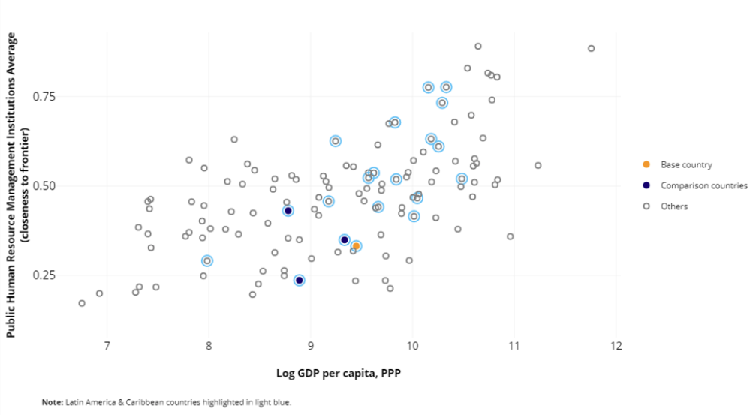

World Map

Basic Instructions

Below is a diagram of the World Map tab with the most important buttons and options highlighted with arrows and textboxes. Each of these options will be explained and explored in the instructions below.
Choose version of the indicator to plot

Choose which countries to plot on the map
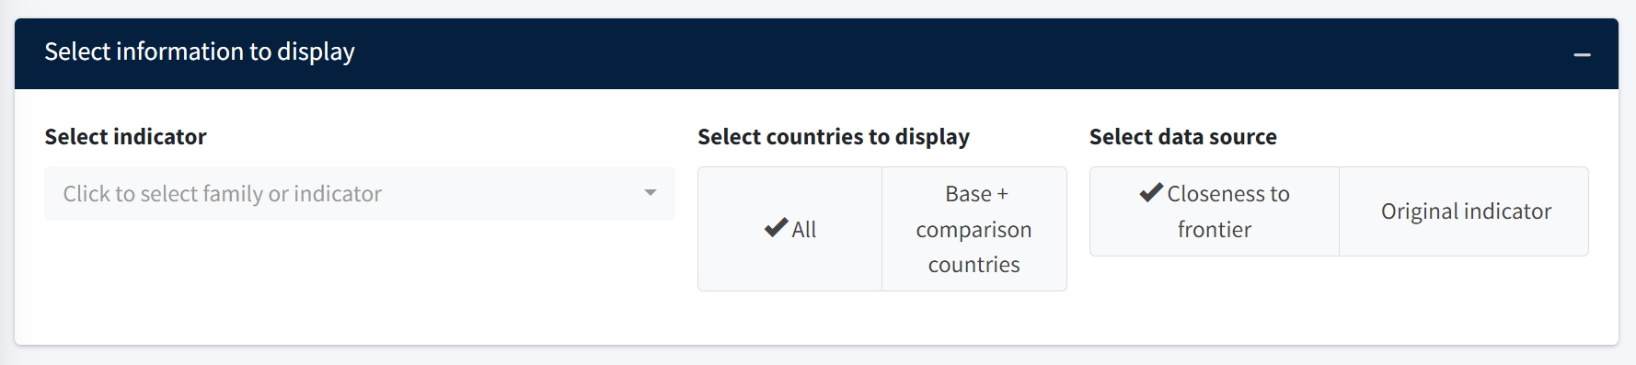
Choose the variable to display

Note that – in order to create a world map plot – one needs to first select a base country and comparison group in the country benchmarking tab. The base country and comparison group that are first selected in the country benchmarking tab are then the base country and comparison group that will be used in the World Map tab.

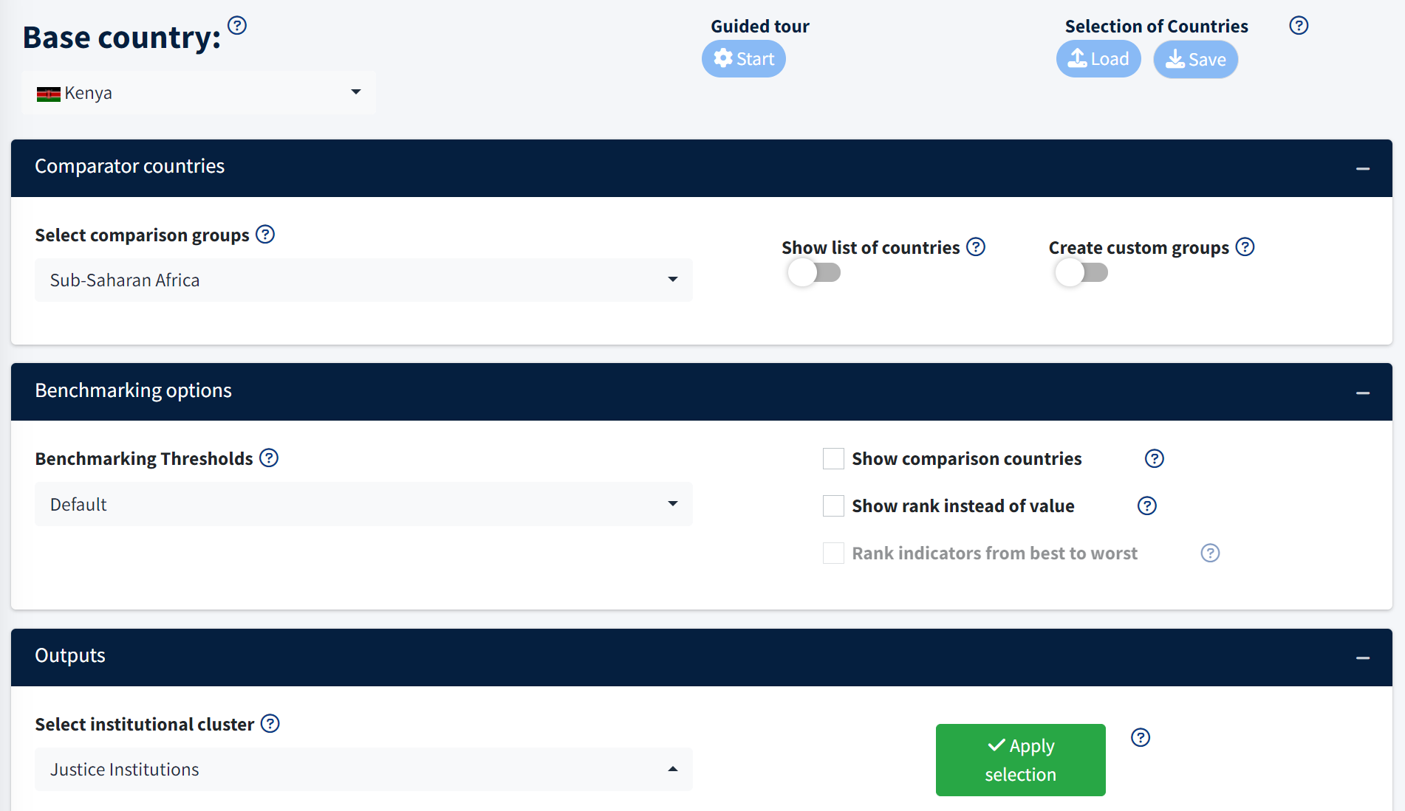

In the running example that follows, we first selected the following settings for the Country Benchmarking tab that is shown above: Kenya as the base country, Sub-Saharan Africa as the comparison group, and the Justice Institutions Average as the indicator.

1. Select indicator. – Select the indicator that you would like to plot in the world map. Note that it doesn’t have to necessarily be the same indicator as selected in the Country Benchmarking tab. In the example below, we have selected the Justice Institutions Average

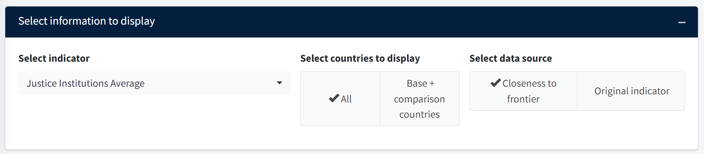

2. Select countries to display. – Select whether you would like the world map to include all countries or only the base country and comparison countries as defined in the Country Benchmarking tab. In the example below, we have selected All countries.

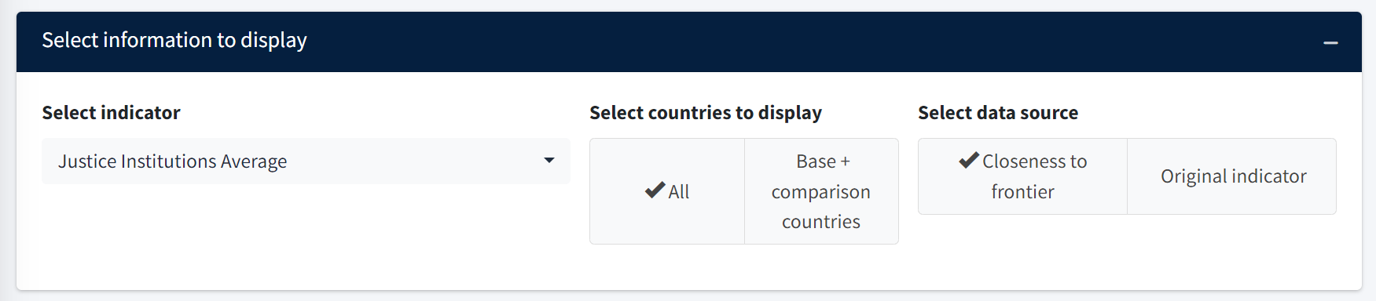

3. Select data source. – Select whether you would like the world map to use the CTF scores or the original raw indicators. In the example below, we have selected the CTF scores.

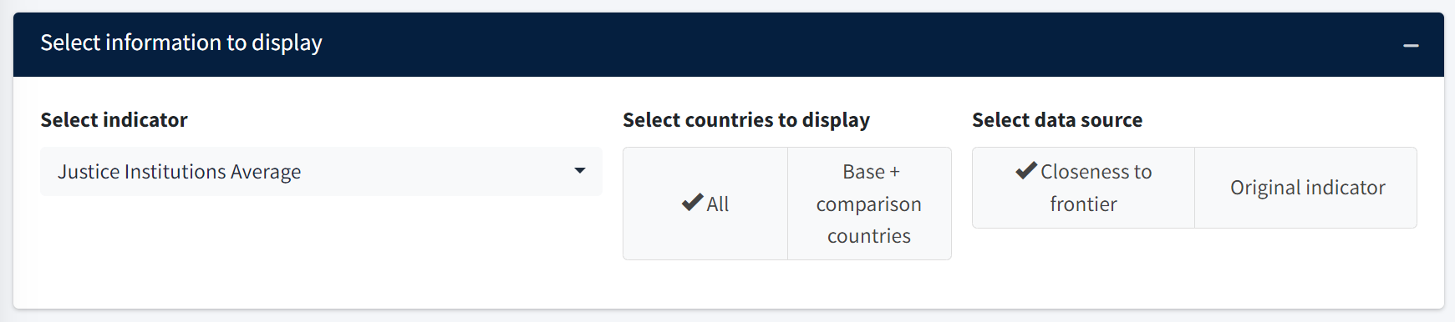

Resulting Figures

The resulting figure is shown below. The coloring of each country refers to the country’s CTF score for the Justice Institutions Average. The legend on the right groups the values of the CTF scores into five different categories: 0.0-0.2 (red), 0.2-0.4 (orange), 0.4-0.6 (yellow), 0.6-0.8 (green), and 0.8-1.0 (blue). Countries for which there is no data are plotted in gray. Note that the user can place their mouse over any individual country to see the country’s precise CTF score and original indicator value.

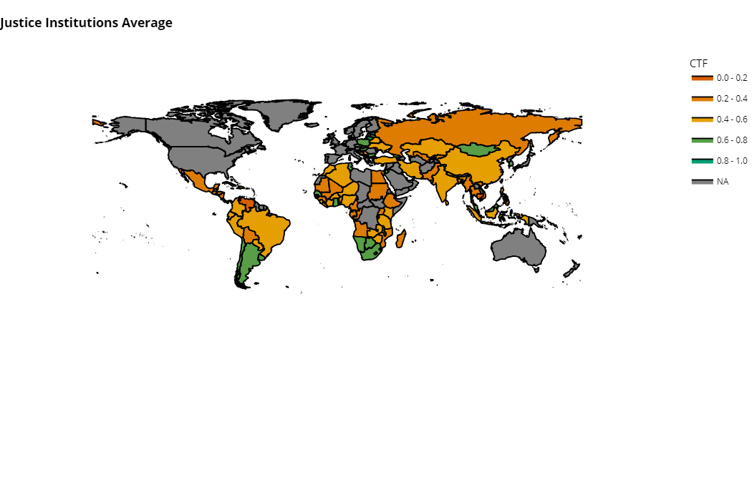

Customizing the World Map Figure

Switching between the countries that are displayed – The “Select countries to display” toggle changes which countries are plotted. In the above example, all countries are plotted. However, the user may also switch the plot so that only the base country and the comparison countries are displayed. Remember that the base country and the comparison countries are defined by the what was first selected in the Country Benchmarking tab. Note that in the example below only Kenya and countries from the comparison group of Sub-Saharan Africa are selected. All other countries are white.

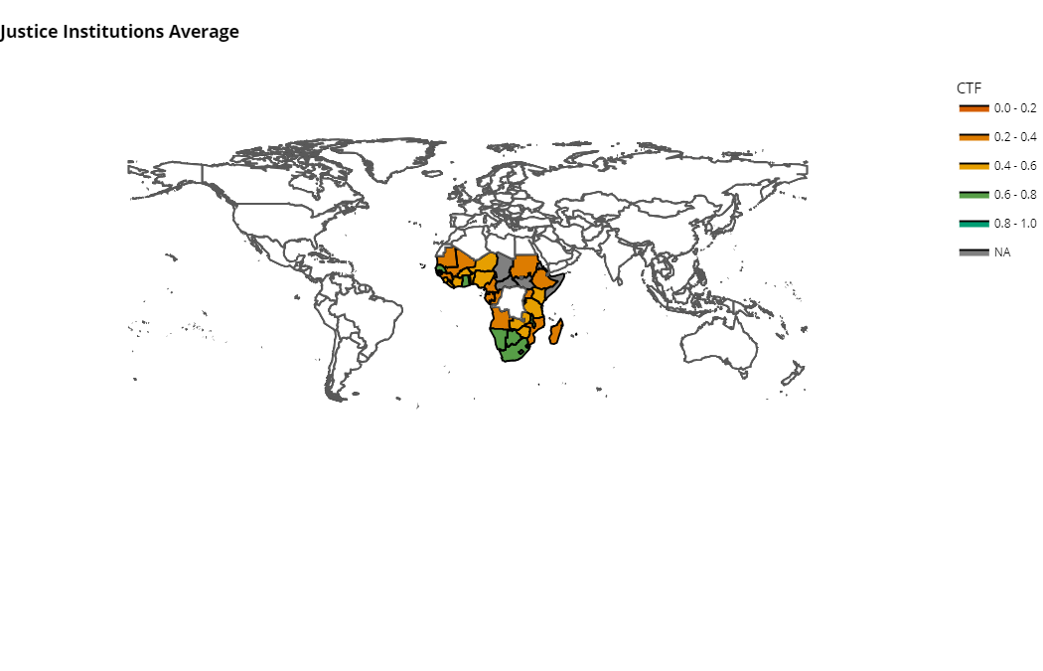

Switching the data source. – The “Select data source” toggle changes the type of variable that is plotted. The user may either plot the original indicator (i.e. the raw variable before it is normalized relative to the institutional frontier) or the CTF score. In the above example, the CTF score was selected. However, the user may also select the original indicator. Note that this option is not available for cluster-level averages.

Time Trends

Basic Instructions

Below is a diagram of the Time Trends tab with the most important buttons and options highlighted with arrows and textboxes. Each of these options will be explained and explored in the instructions below.

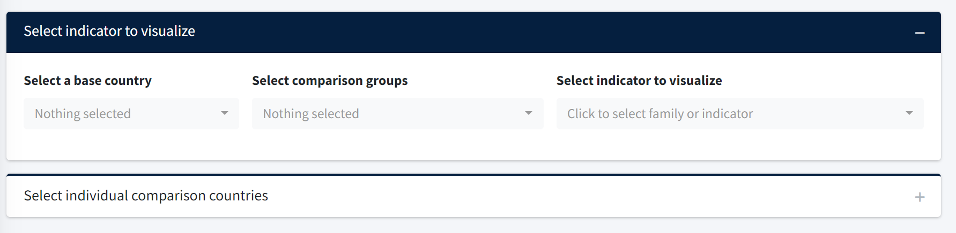
Select individual comparison countries
Choose the indicator to visualize here
Choose a base country and the relevant comparison group

1. Select a base country – The dropdown menu allows the user to select a base country that they wish to study over time. In the example below, we select Vietnam as the base country.

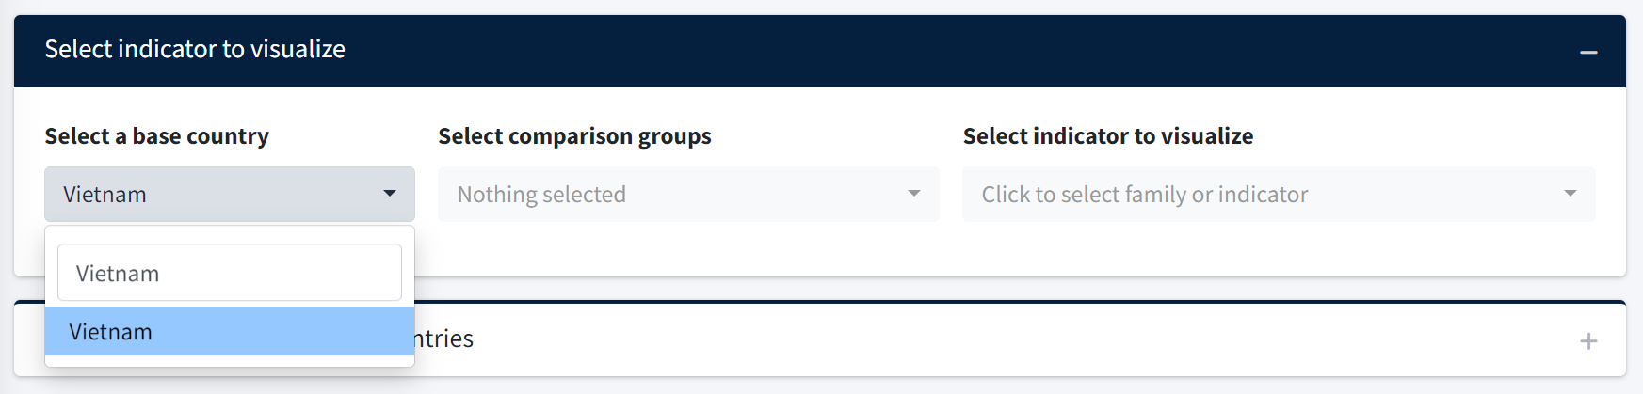

2. Select comparison groups – The dropdown menu allows the user to select the comparison group against which they wish to compare the base country. As before, the user may select economic groups (like the European Union), regional groups (like South Asia or the Arab World), or income groups (like low income or middle income). Note that the user may select more than one comparison group. If so, the time trend for both groups will be plotted. In the example below, we select East Asia & Pacific as the comparison group.

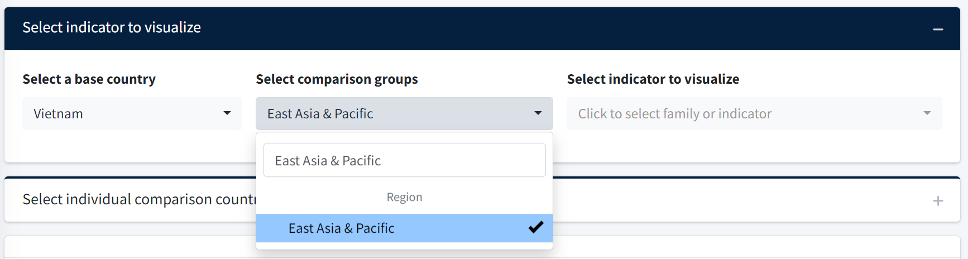

3. Select indicator to visualize – The dropdown menu allows the user to select the indicator they would like to plot over time. In the running example below, we plot the Property rights indicator which is part of the Business Environment Institutional family.

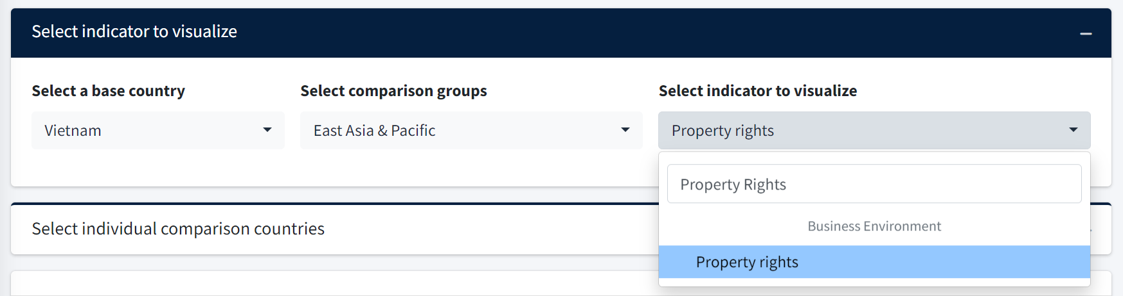

3. Select individual comparison countries – Click the “+” sign on the “Select individual comparison countries” tab to reveal all potential comparison countries. You may then select individual comparison countries to add to the time trend plot. In the example below, we select Thailand.

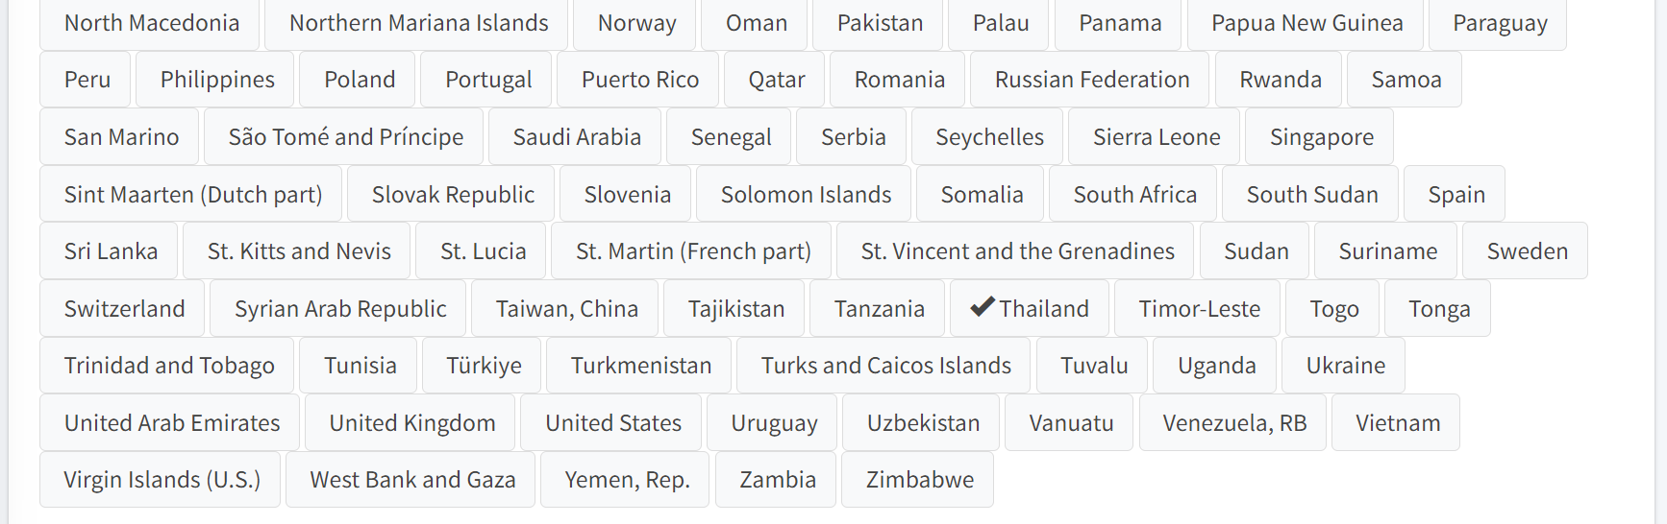

Resulting Figure

The resulting figure from the running example is shown below. Note that the base country Vietnam is shown in orange. Vietnam’s score on the Property rights variable increases from about 0.3 to more than 0.7 over the time period from 1990 to 2022. In contrast, the scores for Thailand and the East Asia & Pacific region are much more stable.

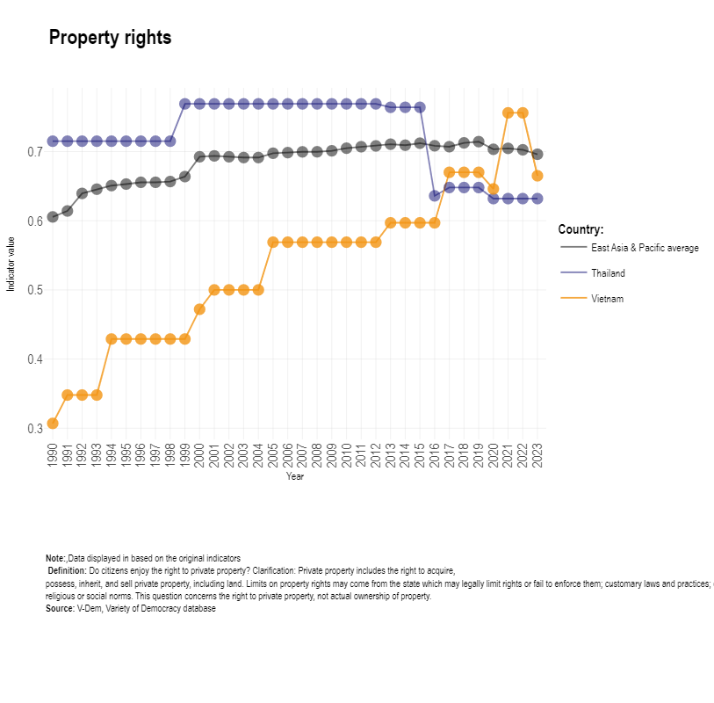

Data

Overview
The Data tab offers two ways to access and download CLIAR data. The first header is the “Data download” which shows different quick and easy options for downloaded different types of complete datasets. The second header is the “Interactive Data Access & Custom Download” where users can visualize and download customized subsets of the different types of data available.

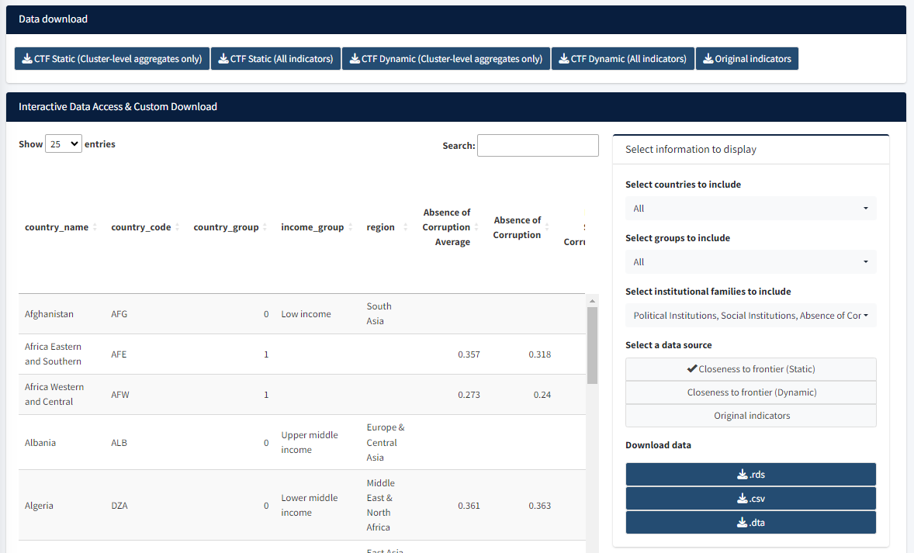
Options for quick download
Change the rows in the data
Change the columns in the data
Choose the type of data to download
Choose the file format to download

Data Download
The user may quickly download the core datasets using the buttons at the top of the tab. These buttons include the following options…
- “CTF Static (Cluster-level aggregates only)” – Download data with all countries, but only the cluster-level aggregate CTF scores.
- “CTF Static (All indicators)” – Download data with all countries and all indicators, including individual variables and the cluster-level aggregate CTF scores.
- “CTF Dynamic (Cluster-level aggregates only)” – Download dynamic data (i.e. across years) with all countries, but only the cluster-level aggregate CTF scores.
- “CTF Dynamic (All indicators)” – Download dynamic data (i.e. across years) with all countries and all indicators, including variables and the cluster-level aggregate CTF scores.
- “Original indicators” – Download the original data for all countries and years prior to transforming the variables with the CTF methodology.

Interactive Data Access & Custom Download
Three basic types of data are available for download from the CLIAR Dashboard. Within the Data tab, they are listed below the “Select a data source” header. Selecting one of these options changes the precise data to be downloaded. There three options are…
- “CTF (Static)” – This option uses the most recent CTF value for every country in the last five years (2018-2022). The unit of observation is the country. In other words, every row in the resulting data is a unique country (or group of countries such as the “Arab World.”).
- “CTF (Dynamic)” – This option includes a different CTF value for every country since 2013. Note that selecting this option adds the “year’ column to the table. The unit of observation is the country/year combination. In other words, every row in the resulting data is a unique country and year.
- Original indicators – This option includes the original indicators form which the CTF values are calculated. Like the dynamic CTF option, note that selecting this option adds the “year” column to the table. The unit of observation is the country/year combination. In other words, every row in the resulting data is a unique country and year.

The data may be downloaded in one of three file types: .rds for use in the statistical software R, .csv for use in Microsoft Excel, and .dta for use in the statistical software STATA. These options are listed below the “Download data” header.

While the default is to download data for all countries and variables, the user may also select some subset of variables (i.e., columns in the table) or rows (i.e. countries or groups of countries) that may be downloaded.

The dropdown list below the “Select the countries to include” header changes the rows (i.e. the countries or groups of countries) included in both the online visualization in the Data tab and the data available to download. It includes the following three options…
- “All” which includes all countries in the data download.
- “Base country only” which includes only the base country last selected in the country benchmarking tab.
- “Base + comparison countries” which includes the base country and the comparison countries last selected in the country benchmarking tab.

The dropdown list below the “Select groups to include” header further changes the rows (i.e. the countries or groups of countries) included in both the online visualization in the Data tab and the data available to download. It includes the following options…
- “All” which includes all countries in the data download.
- “Comparison groups only” which includes only those countries last selected as comparison groups in the country benchmarking tab.
- “None” which includes no comparison countries.

The dropdown list “Select institutional clusters to include” changes the columns (i.e. the institutional cluster averages or the individual indicators) included in the data download. You may select any of the institutional clusters or an “(other indicators)” option.
- By default, the table displays all institutional averages and variables.
- Selecting one or more of the clusters will limit the number of columns in the data download to those indicators.
- The “(other indicators)” option refers to relevant indicators that are not part of a single institutional cluster.

Example of Downloaded Data

Below are two examples of data tables that could be downloaded from the Data tab. Each example provides an instance of a descriptive analysis that could be conducted with the downloaded data, but otherwise is not possible on the dashboard itself.

First, suppose that a user wants to understand how the Political Institutions cluster in Nepal relates to Low-income countries. The user would first need to generate a plot with Nepal as the base country and low-income countries as the comparison group in the country benchmarking tab.

Next, the user would select options from the dropdown lists in the data tab. The image below demonstrates the options that should be selected and what the top of the resulting table would look like. Even though the top of the table does not include Nepal, we know the country is selected because the option “Base + comparison countries” is chosen.

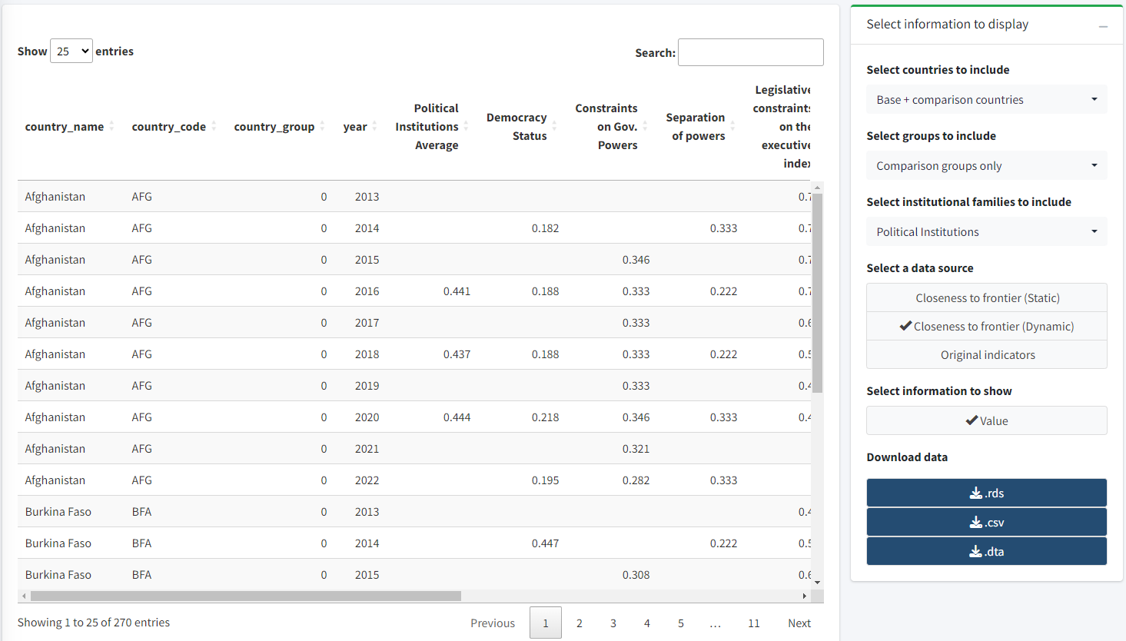

Below is an example of a plot that could be made with the downloaded data. It shows the political institutions average CTF every two years from 2016 to 2022. The black lines and points represent low-income countries (i.e. the comparison group selected above), while the red lines and points represent Nepal’s values.
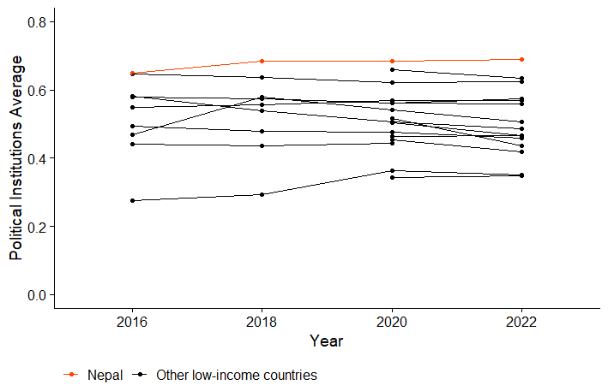

Second, suppose a user wants to compare the regional averages of the Justice Institutions cluster. Since this analysis does not involve a specific base country, the user does not need to first generate a plot in the country benchmarking tab. The user could simply select options from the dropdown lists in the data tab. The image below demonstrates the options that should be selected and what the top of the resulting table would look like.

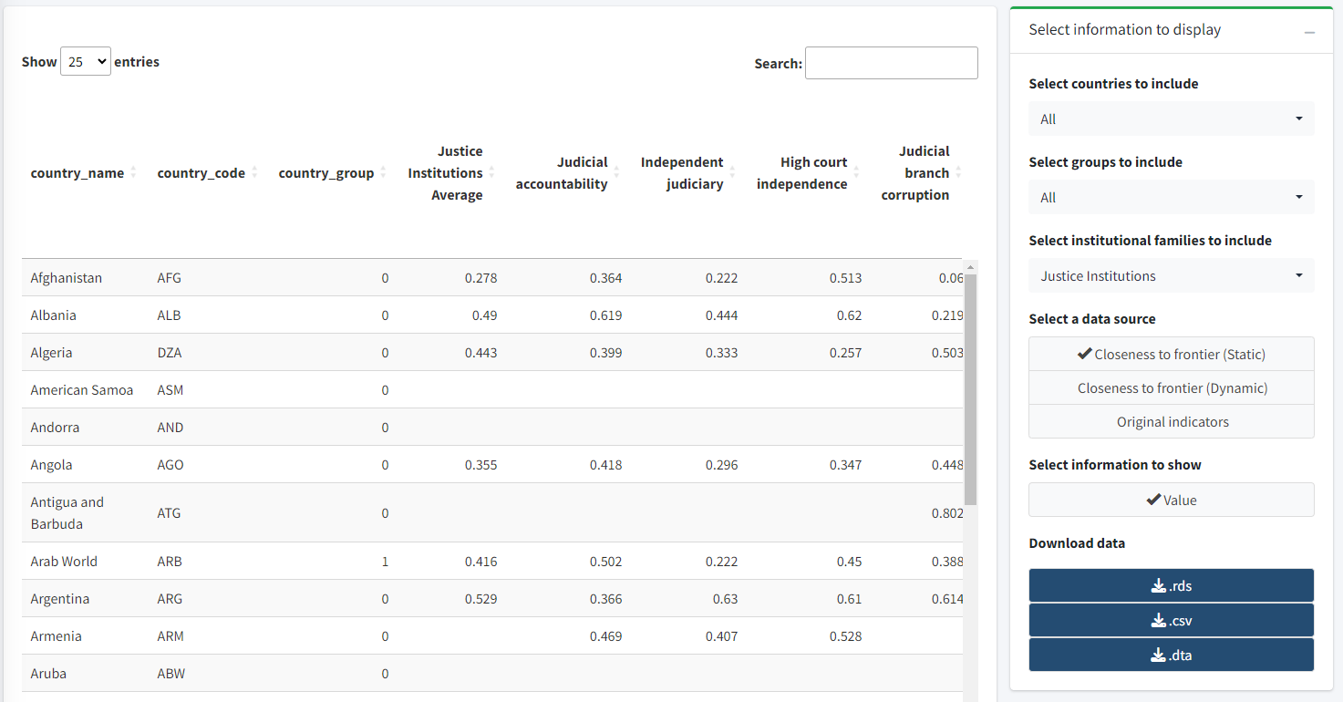

In particular, note the Country_group variable. This variable indicates whether a row in the dataset corresponds to an individual country or a regional grouping such as East Asia & Pacific or Latin America & Caribbean. Based on this variable and the Justice Institutions Average column, the user could create the following plot that compares regional averages.

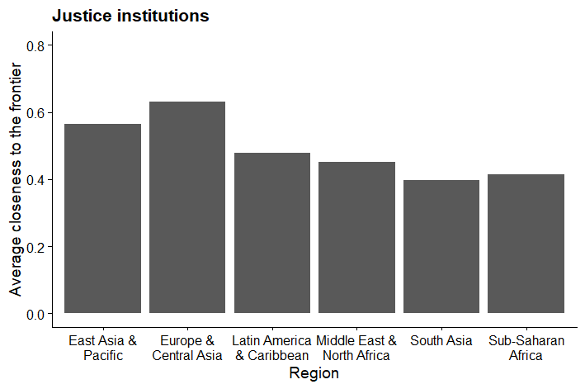

Questions, suggestions, and reporting of errors

We will continue to update and extend the CLIAR Dashboard. Future versions will include additional functionalities and faster user experience.

For questions, suggestions, or if you find any errors, please contact us at CLIAR@worldbank.org

Annex A: Dashboard’s FAQ

- Does the CLIAR Benchmarking collect new data on governance and institutions?
No. The CLIAR Benchmarking collects indicators that are publicly available and have been validated by our internal review process as proxies to measure country-level governance and institutions, with their corresponding caveats and limitations. In some exceptional cases, CLIAR does combine existing indicators to create new ones (e.g., aggregation of binary indicators); these are detailed in the CLIAR Methodological Note.

- Can I add my own indicators to the dashboard and run the analysis including these indicators?
You cannot add indicators to the dashboard. However, you can download the full database and augment it with additional indicators to customize your analysis. You can also get in touch with the CLIAR team (CLIAR@worldbank.org) indicating which data you would like to be added in the database, and for which cluster. Each request will be reviewed by a team of technical experts and if the indicator meets the selection criteria indicated in the methodological note (quality and coverage) it will be added during the next update round.

- What does the traffic coloring mean? Is there a methodological foundation?
The results from the institutional benchmarking are relative for a given country of interest vis a vis a chosen set of comparator countries. Using the distribution of the CTF scores in the set of comparator countries, we identify the score range for the bottom 25% of comparators, the score range for the 25%-50% group and the score range for the top 50% of comparators (or alternatively, using 33% and 66% as thresholds). Given the CTF score of the country of interest, we identify whether the country of interest for the analysis belong to the bottom, middle or top group. These percentile groups are used because they are simple and intuitive.

- Why the length of the bar is different? Why a red bar is longer than another red bar, if they are both red?
Using the distribution of the CTF scores in the set of comparator countries, we identify the score range for the bottom 25% of comparators, the score range for the 25%-50% group and the score range for the top 50% of comparators. The red bar represents the score range for the bottom 25% of comparators. (The same explanation applies if 33% and 66% thresholds are used.) While the CTF scores always range between 0 and 1, the length of the red bar varies across indicators depending on the distribution of the CTF scores in the comparator group. As an illustration, for a given set of comparator countries, for a given indicator the CTF scores in the bottom 25% of comparators may range between 0 and 0.2, while for another indicator it may range between 0 and 0.5.

- What is the difference between the static and dynamic benchmarking?
The static benchmarking presents a cross-country snapshot based on averaging available indicators over the period 2018-2022; CTF calculations and distributional analysis are implemented over that cross-section. The dynamic benchmarking, computes CTF scores at the individual level on an annual basis, from 2013 to 2022, and distributional analysis is implemented on an annual basis, when data is available. Given data limitations, the dynamic benchmarking is more limited in the number of indicators and families analyzed --and some families are not included precisely because they do not offer data that could be aggregated and compared over time."

- Why are certain indicators or institutional clusters not included in my benchmarking results?
Indicators that are missing for the base country or exhibit low variance are dropped from the analysis. In some cases, such as for the SOE Governance family, this can result in dropping an entire institutional cluster.

- Can I change in the dashboard the time period over which the benchmarking is applied?
The Dashboard does not offer that functionality, but such customized analyzed could be performed by downloading the data from the dashboard.

- Why are certain indicators and clusters not included in the dynamic benchmarking?
Compared to static benchmarking, dynamic benchmarking is more selective (or “demanding”) with respect to indicators, considering their panel characteristics. Hence, indicators that do not offer multiple measurements for the same country are excluded from the analysis – e.g., OECD PMR and PEFA, which consequently excludes the SOE Governance Institutions and Public Finance Institutions indicator clusters from dynamic benchmarking

- How do you deal with missing data for certain indicators and for certain countries?
We deal with missing data in various ways. First, the (static) benchmarking analysis uses the average of indicators over recent years. Conceptually, governance and institutional indicators are expected to show limited yearly variations. This helps in reducing data gaps. Second, we only include in the institutional benchmarking the indicators that are non-missing for the country of interest. Third, we only include in the institutional benchmarking the indicators that are non-missing for at least 70% of the countries in the comparator group. The average CTF scores at institutional cluster level are calculated as averages of the CTF scores of the indicators in that clusters, but only for the indicators that meet these criteria above. This ensures that, for each pair of country of interest and group of comparator countries, the average CTF scores are calculated from the same indicators.

- Why do I have to choose at least 10 comparator countries for the benchmarking analysis?
The percentile analysis identifies whether the performance of the country of interest in a given indicator or institutional cluster belongs to the bottom 25%, the 25%-50% group or the top 50% of the comparator countries (or, alternatively, the groups based on 33% and 66% thresholds). This percentile analysis can be meaningfully performed only if there is sufficient number of comparator countries.

- How do you choose the comparator countries/groups?
It depends on the purpose of the analysis and the country context. For example, many reports have used regional, aspirational, and structural peers as identified by World Bank Country Teams.

- Can I download the raw data for my own research/analytical purposes?
Yes, the full compiled database is available in the "Data" tab for download. Both the "Closeness to Frontier" scores and the full database with yearly indicators are available for download.

- Why are certain cluster-level averages missing when I download the data even if there is non-missing data on the indicators of that cluster?
A balanced sample of individual CTF scores is aggregated by cluster to create cluster-level CTF scores. For each institutional cluster, a “balanced” subset of countries with full coverage (i.e., non-missing data) across all indicators within each cluster is created. This ensures that each cluster-level aggregate score relies on the same set of indicators for every country, allowing for robust and methodically sound inferences. The CTF cluster-level score is computed via simple averaging of the indicators within each cluster. This cluster-level score captures the overall performance for a given institutional category relative to the “global frontier.” The drawback of this robust methodological aggregation decision is that the data requirement is higher. Several families in both the static and dynamic versions do not meet the data requirements for meaningful aggregation (i.e., the balanced sample is too small or empty), and thus CTF cluster scores are not computed.

- How often is the CLIAR data updated? How do I know that the CLIAR data uses the latest available data?
It is currently planned that the CLIAR Database will be updated once per year. The CLIAR Benchmarking Dashboard is programmed so that the data extraction from the data sources (primarily ProsperityData360) is automated through APIs, therefore with minimal maintenance costs for the indicators already included in the dashboard and with stable APIs. The full compiled database, once updated, is available in the "Data" tab for download. Both the CLIAR Benchmarking "Closeness to Frontier" scores and the full CLIAR master database with yearly indicators are available for download and therefore users can easily verify the latest year available for each indicator.

- How were the indicators included in the CLIAR Benchmarking selected?"
The indicators included in the CLIAR Benchmarking were selected following a criteria of (geographical and time) coverage and quality. This list was defined based on initial internal reviews, and will be further refined based on inputs recently received by sector experts and from the experiences of country teams in applying this tool. The list of indicators used will be periodically reviewed in order to include new indicators that may be become available in the future. As such, the CLIAR database is a "live tool".

- How does CLIAR manage changes in the methodology of the construction of individual indicators used in the CLIAR database?
CLIAR aims to keep consistent indicators. Hence, if specific indicators go through changes in their methodology, CLIAR will keep only those that are consistent, prioritizing the most recent ones. Some examples include PEFA and PMR indicators. If such change means a given indicator no longer meets the benchmarking criteria, then it is dropped from the benchmarking analysis.

The option for multiple base countries will be described in advanced/customized applications further below.
This name must be different than an existing pre-defined groups. For instance, trying to name a custom group “European Union” will return an error, but alternatives such as “European Union (custom)” or “EU” would work.

