standard_hrmis_assessment
## `summarise()` has grouped output by 'paygrade'. You can override using the
## `.groups` argument.
## Scale for colour is already present. Adding another scale for colour, which
## will replace the existing scale.
## Warning: Removed 4 rows containing missing values or values outside the scale range
## (`geom_line()`).
## Warning: Removed 4 rows containing missing values or values outside the scale range
## (`geom_point()`).
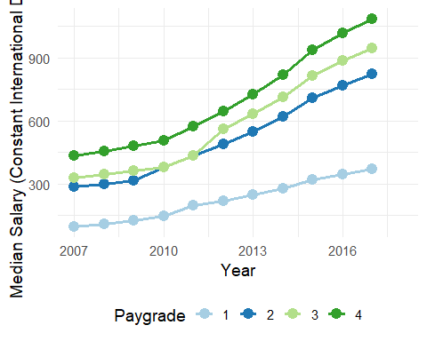
## Warning: Removed 2 rows containing missing values or values outside the scale range
## (`geom_line()`).
## Warning: Removed 8 rows containing missing values or values outside the scale range
## (`geom_point()`).
## Warning: Removed 8 rows containing missing values or values outside the scale range
## (`geom_text_repel()`).
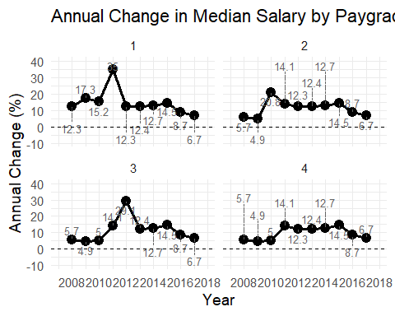
## Warning: Removed 1 row containing missing values or values outside the scale range
## (`geom_line()`).
## Warning: Removed 1 row containing missing values or values outside the scale range
## (`geom_point()`).
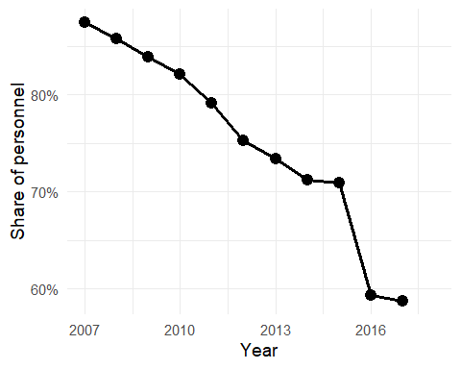
## Scale for colour is already present.
## Adding another scale for colour, which will replace the existing scale.
## Warning: Removed 4 rows containing missing values or values outside the scale range
## (`geom_line()`).
## Warning: Removed 4 rows containing missing values or values outside the scale range
## (`geom_point()`).
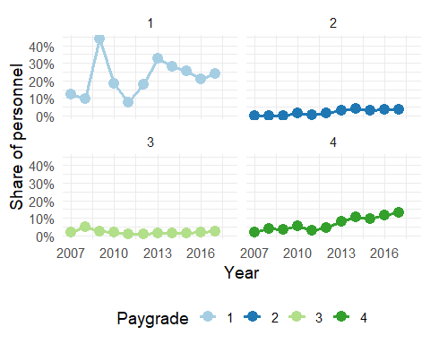
## Warning: Removed 4 rows containing missing values or values outside the scale range
## (`geom_point()`).
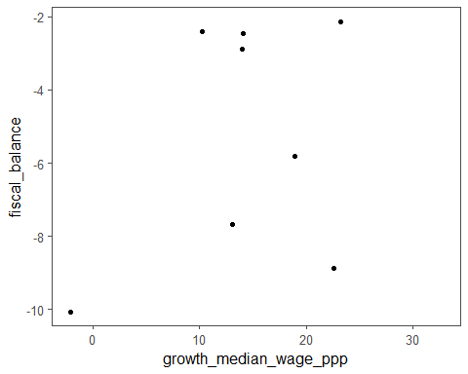
## Warning: Removed 2 rows containing missing values or values outside the scale range
## (`geom_point()`).
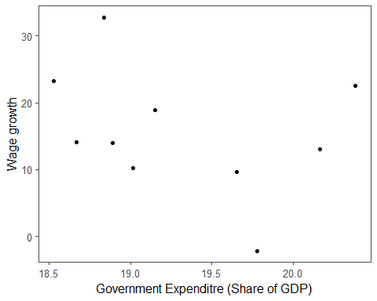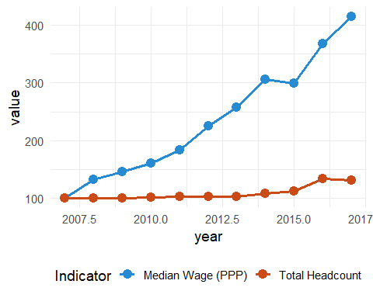
## # A tibble: 1 × 21
## country_code year median_wage_ppp total_headcount growth_median_wage_ppp
## <chr> <dbl> <dbl> <int> <dbl>
## 1 BRA 2018 NA 74418 NA
## # ℹ 16 more variables: gdp_lcu <dbl>, pexpenditure_lcu <dbl>,
## # prevenue_lcu <dbl>, taxrevenue_lcu <dbl>, emp_pop_rate <dbl>,
## # labor_force_total <dbl>, labor_force_advanced_edu <dbl>, tot_pop <dbl>,
## # salaried_rate <dbl>, government_expenditure_gdp <dbl>, cpi <dbl>,
## # ppp <dbl>, fiscal_balance <dbl>, emp_pop <dbl>, salaried_pop <dbl>,
## # confidence_in_gov <dbl>
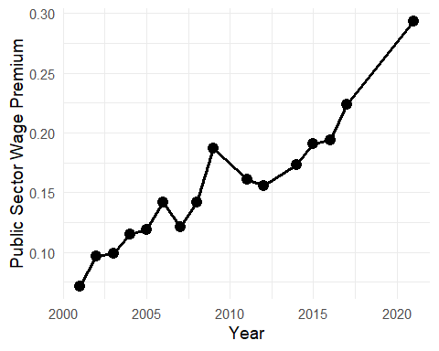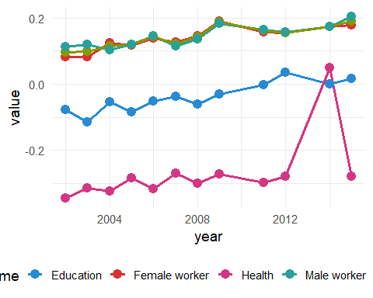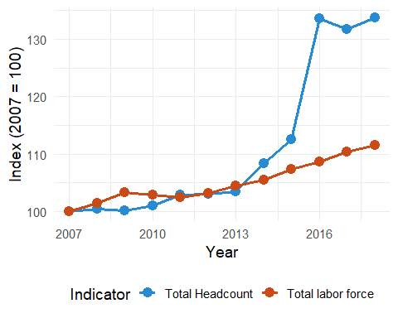
## Warning: Removed 1 row containing missing values or values outside the scale range
## (`geom_point()`).
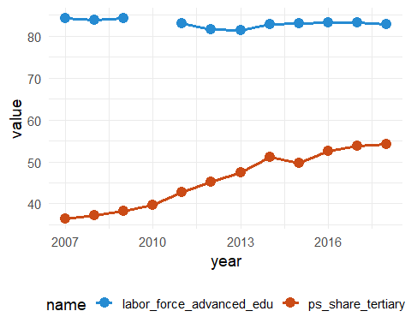
## Warning: Removed 4 rows containing missing values or values outside the scale range
## (`geom_point()`).
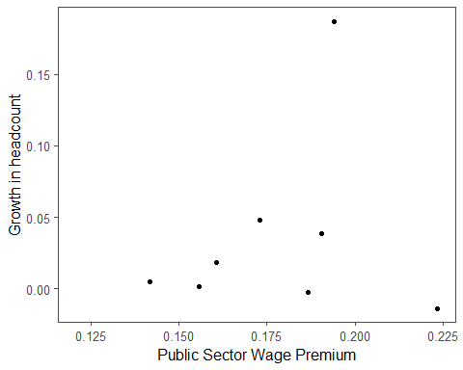
## # A tibble: 1 × 3
## country_code year workforce_constraint
## <chr> <chr> <chr>
## 1 BRA 2009 74.8868

