Governance Portfolio Review
May 01, 2026
Table of Contents

Overview
The dataset covers active World Bank operations led by the Governance Global Practice (GOV) in IDA-eligible and Blend countries, approved between FY2019 and FY2026. Data were extracted from the World Bank Data Explorer between April 21–29, 2026. The dataset includes both lending operations and analytic and advisory activities (ASAs), with a thematic focus on governance-related issues.
The analysis below provides an overview of lending and ASA trends over time, as well as a thematic breakdown of projects in the portfolio. It also provides regional comparisons in the lending and ASA portoflios.

Lending trends
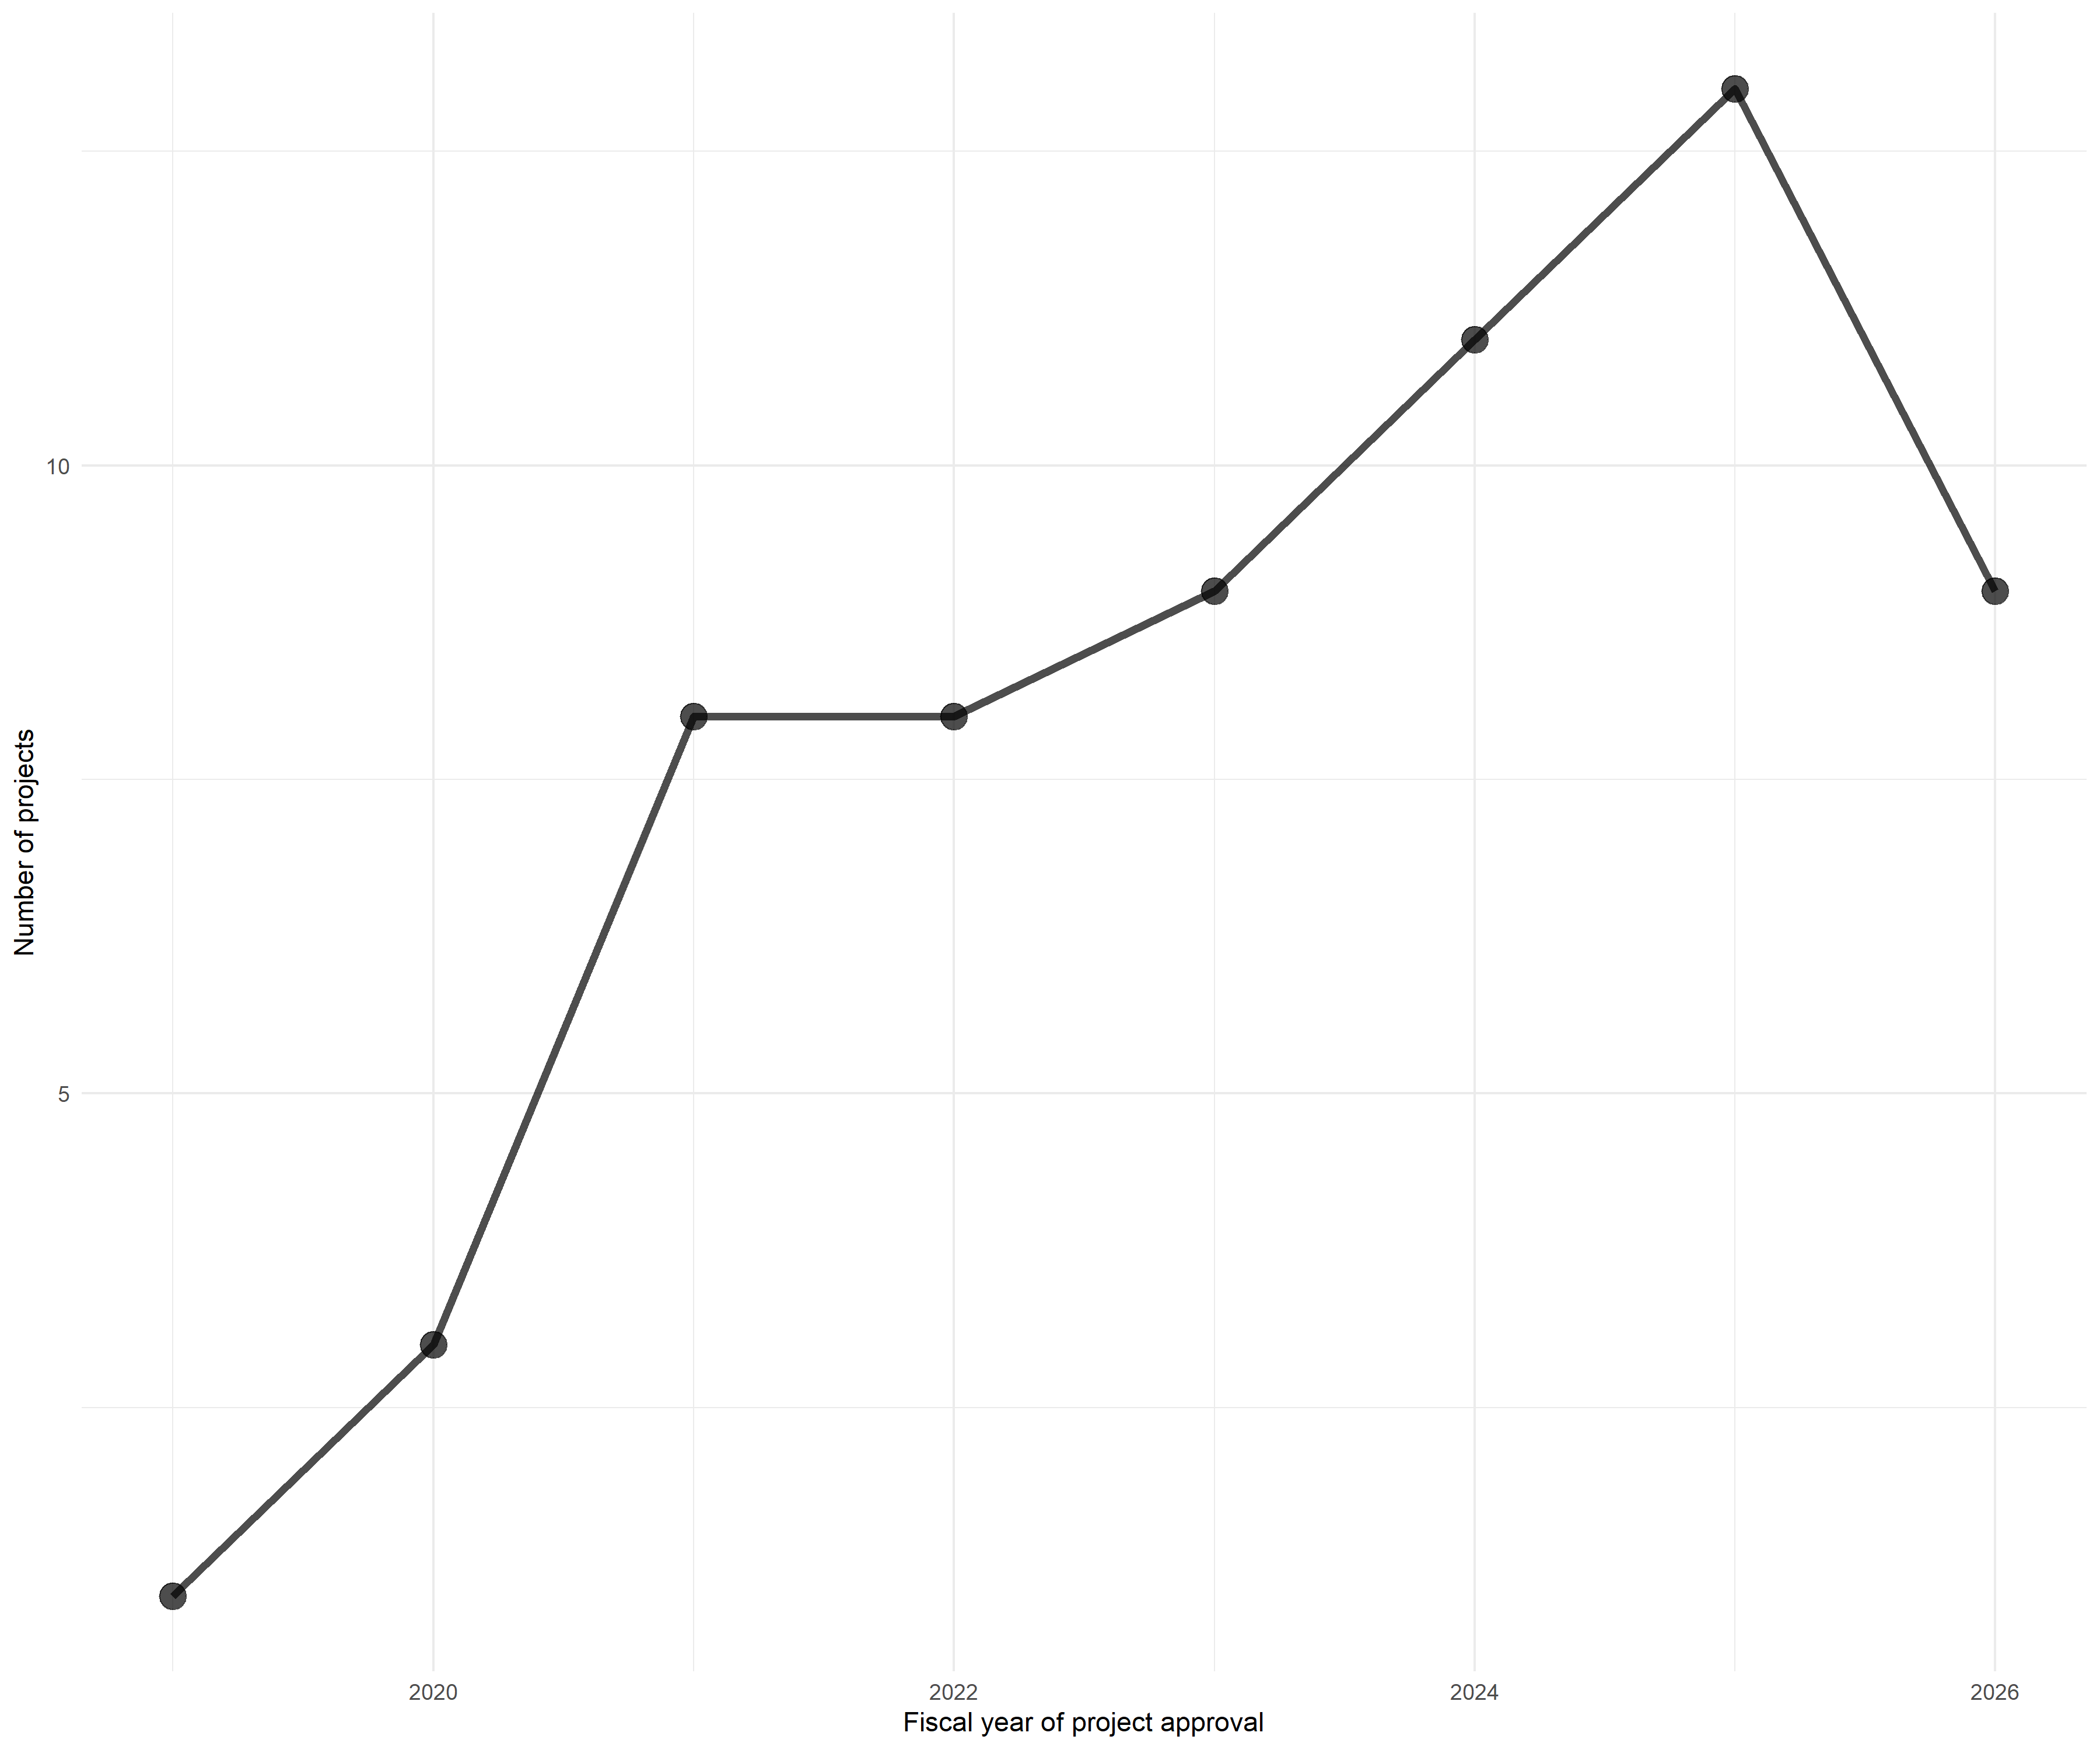

Lending trends by region
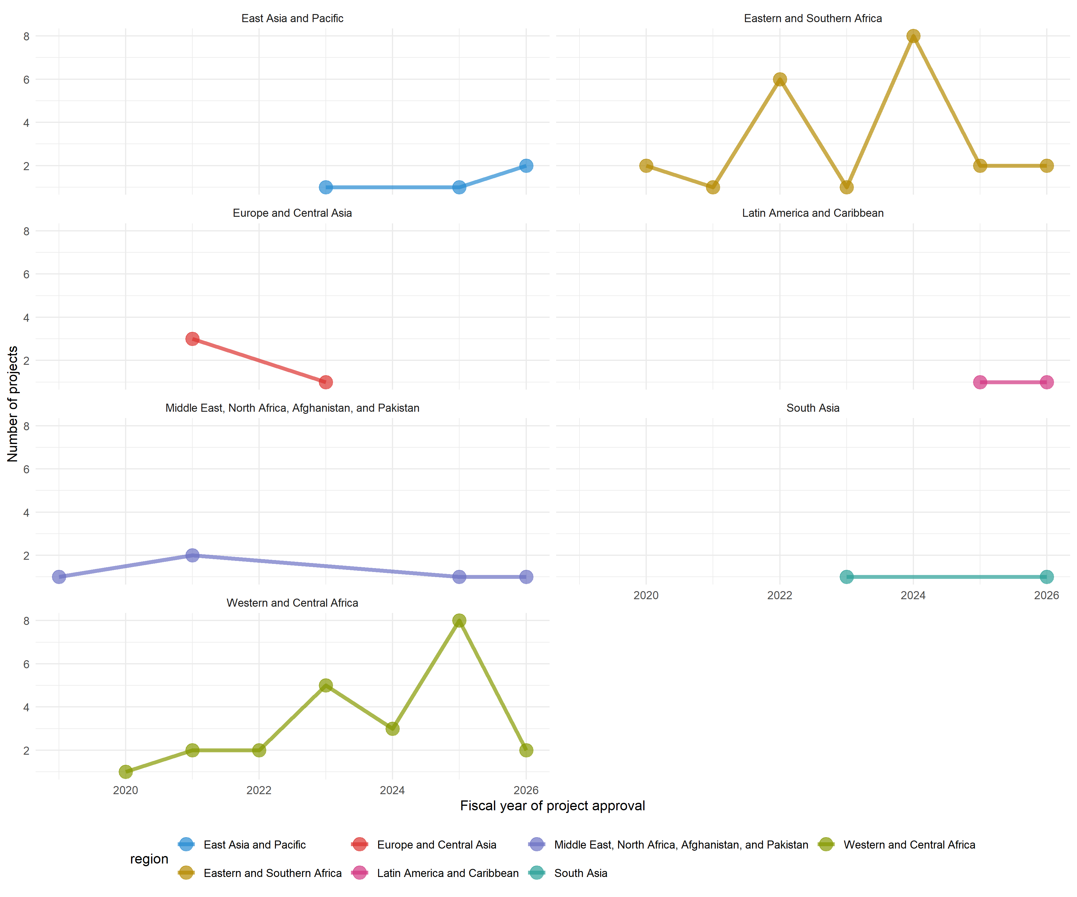

ASA trends
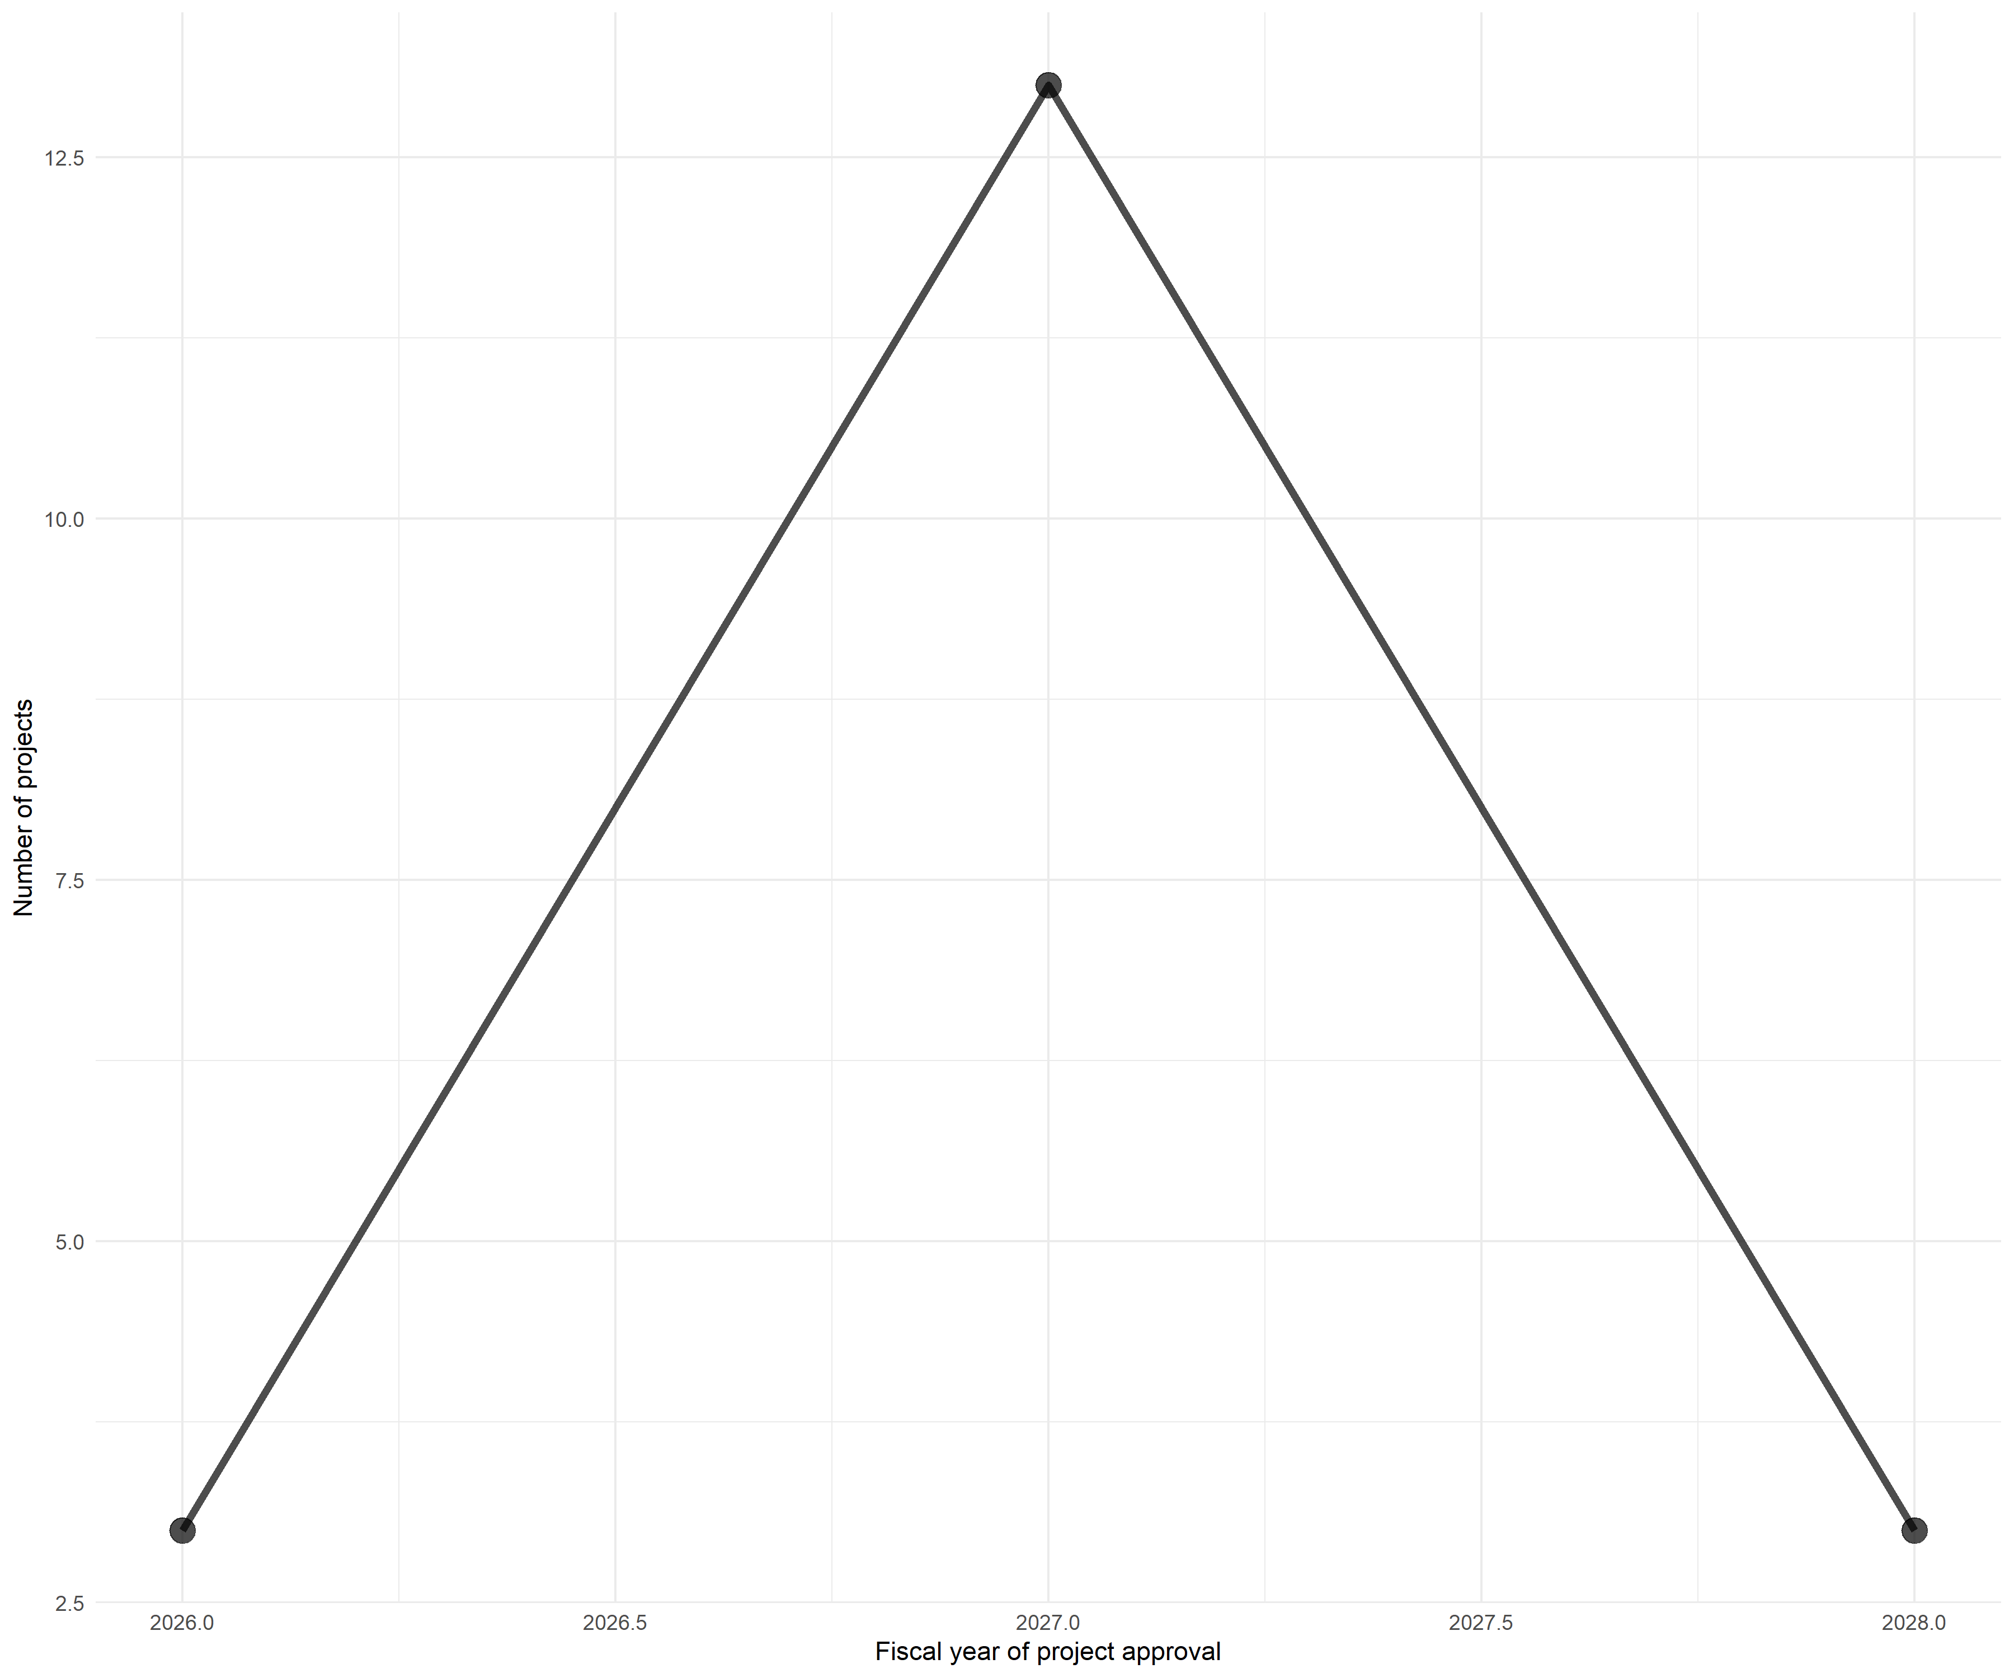

ASA trends by region
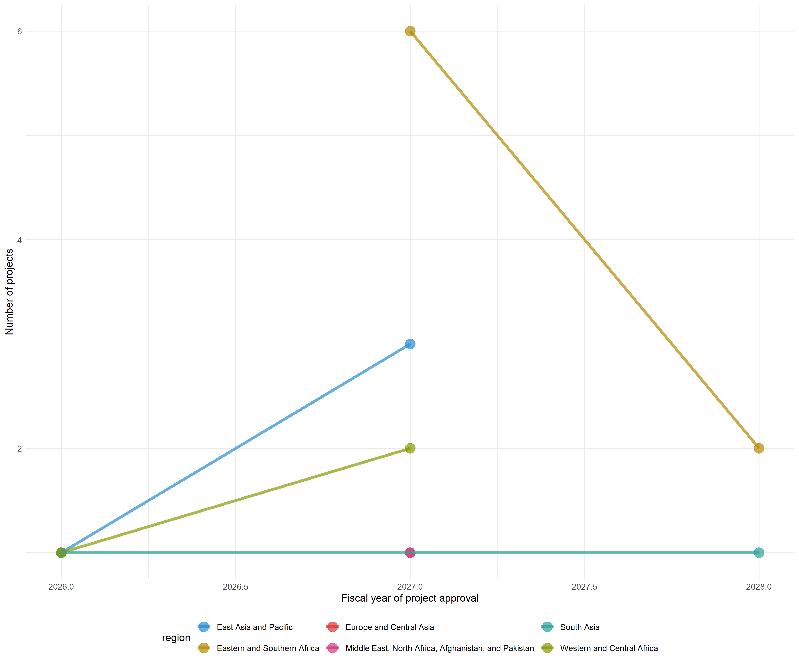

Thematic breakdown over time
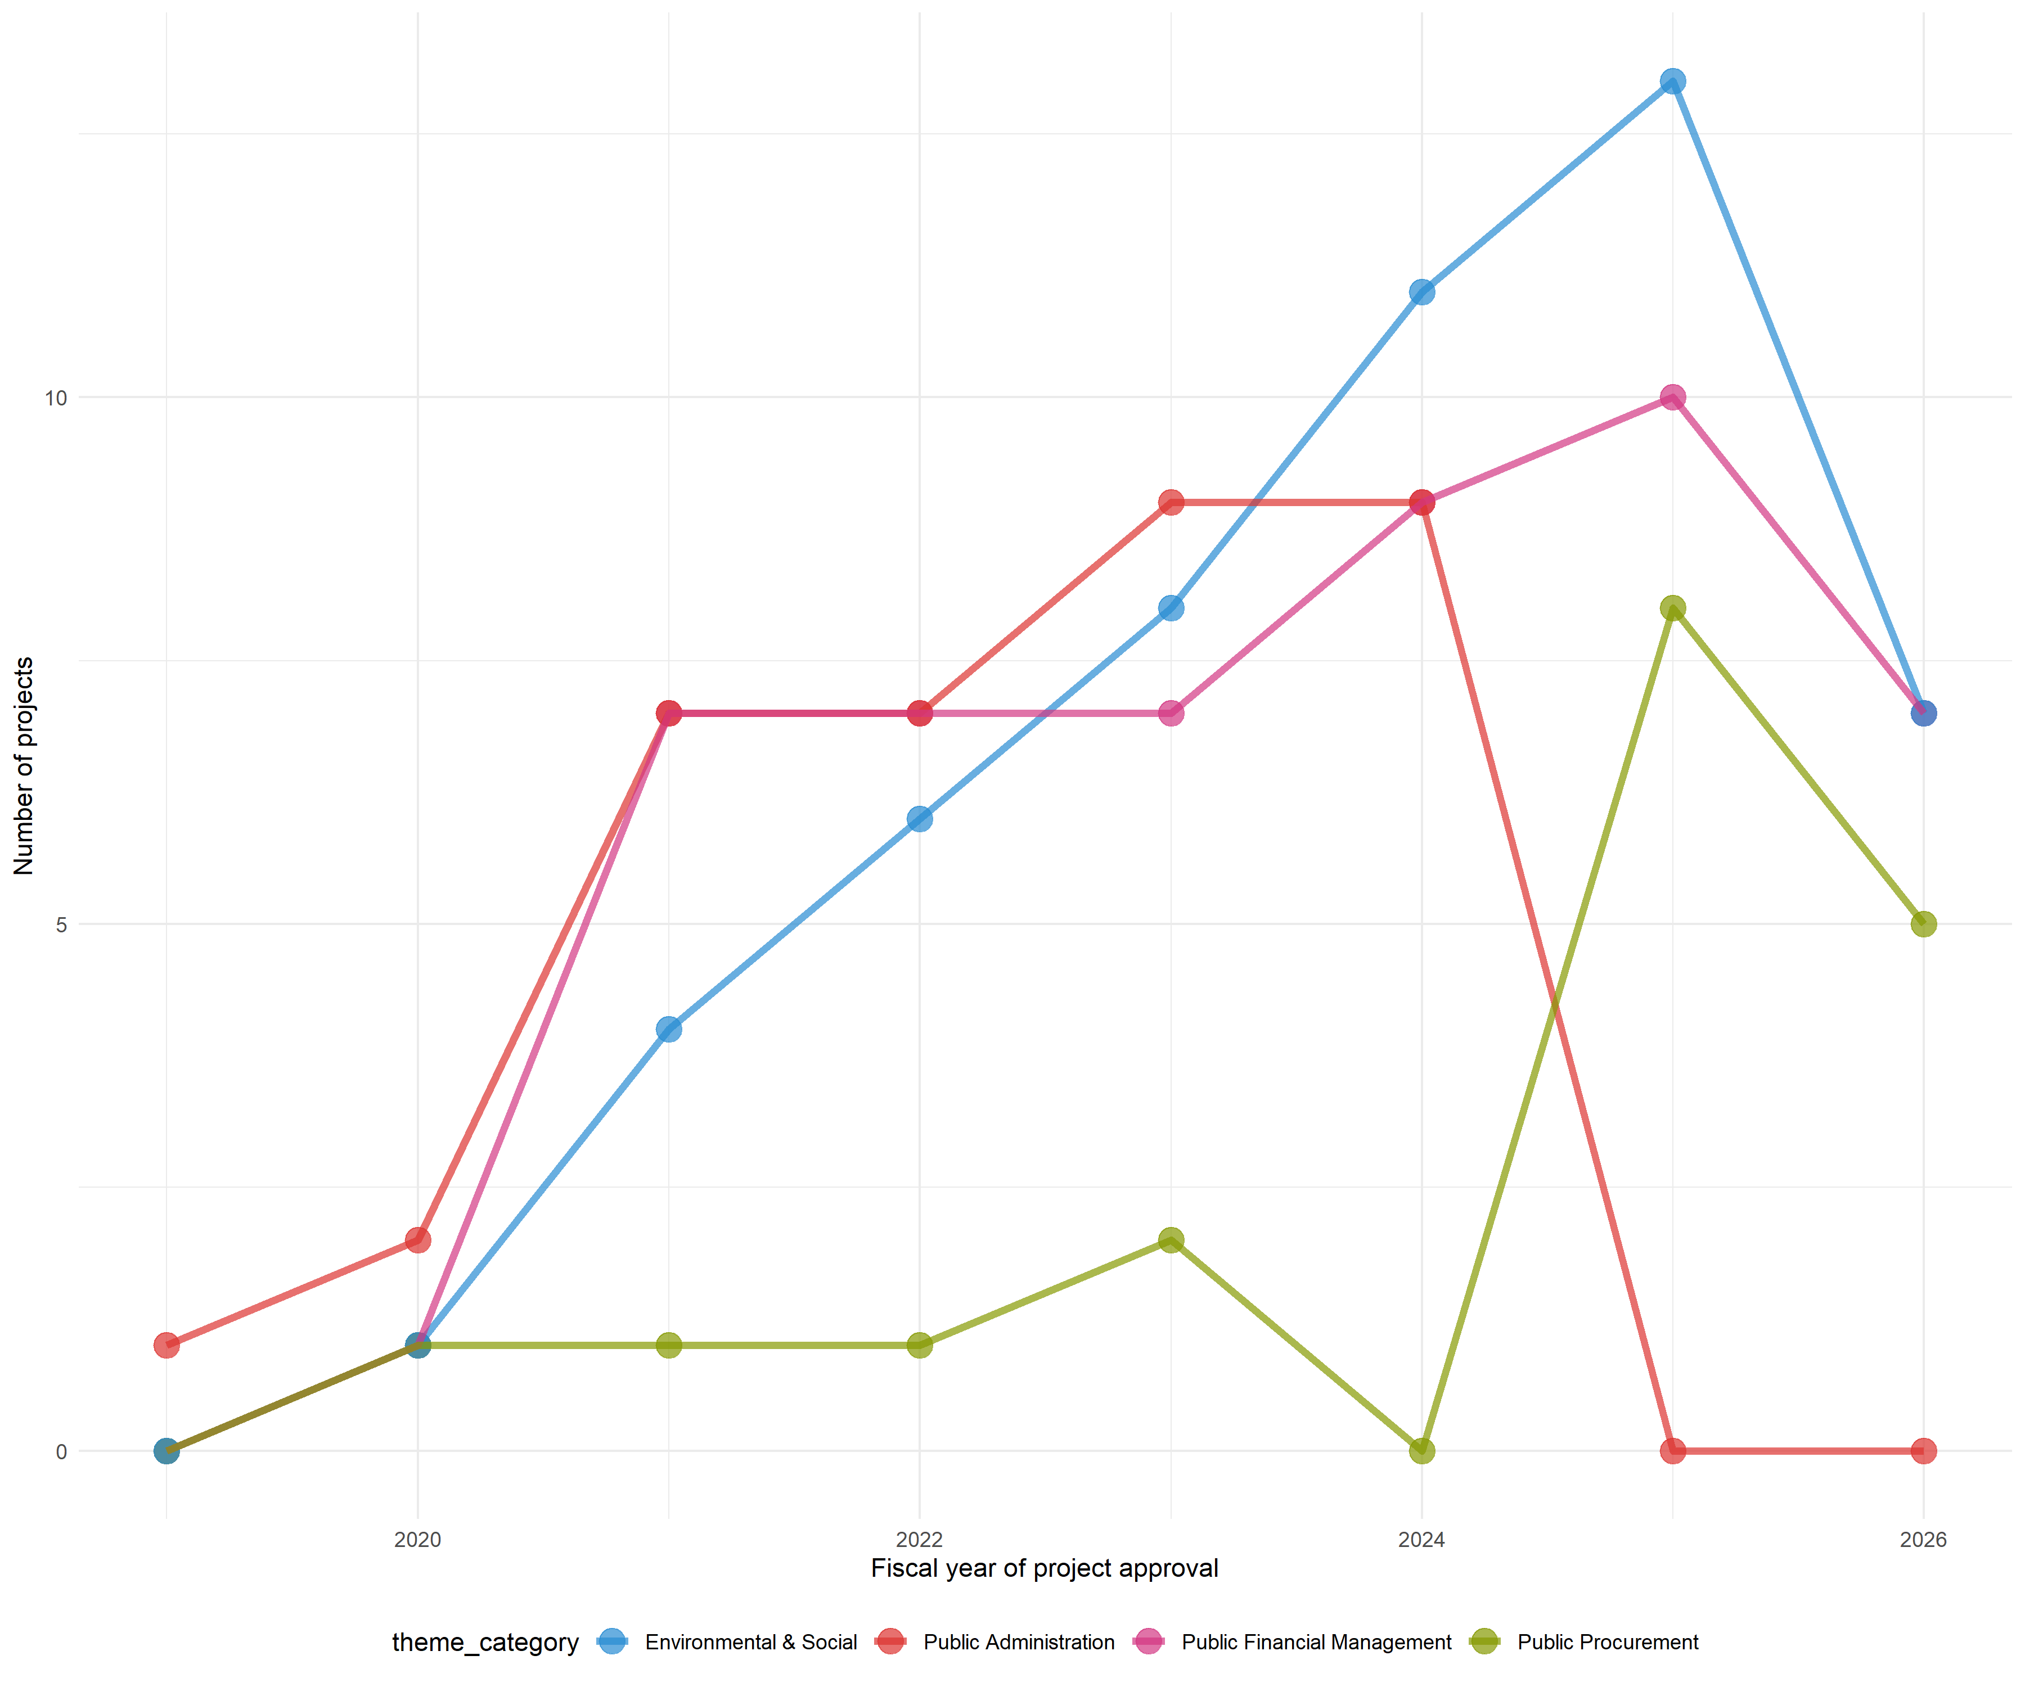

Thematic breakdown over time by region
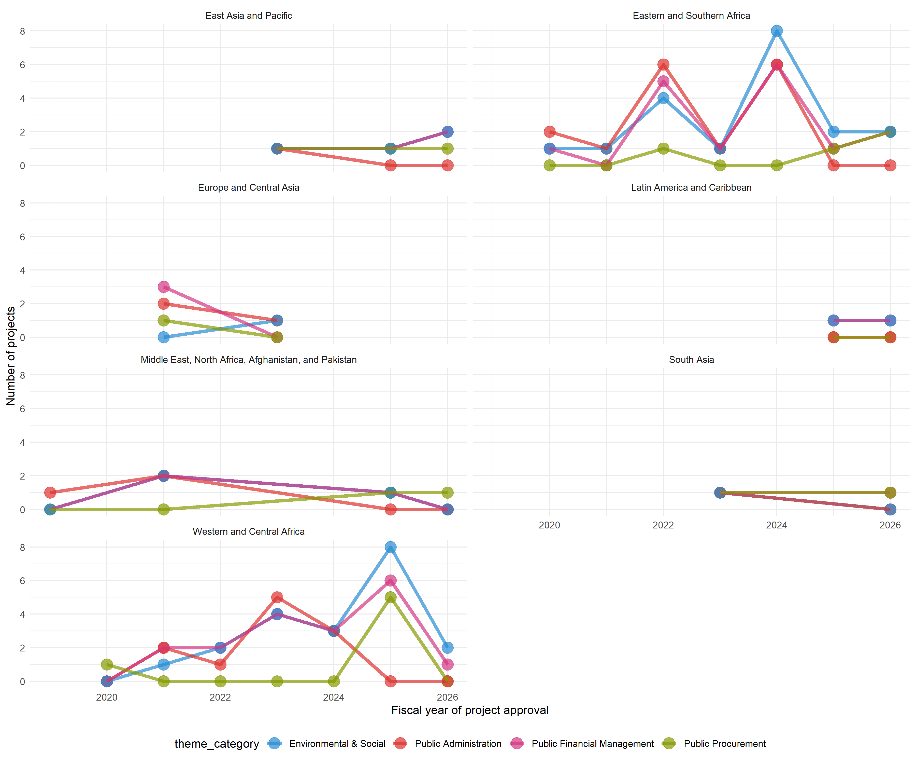

Thematic breakdown in FY2026
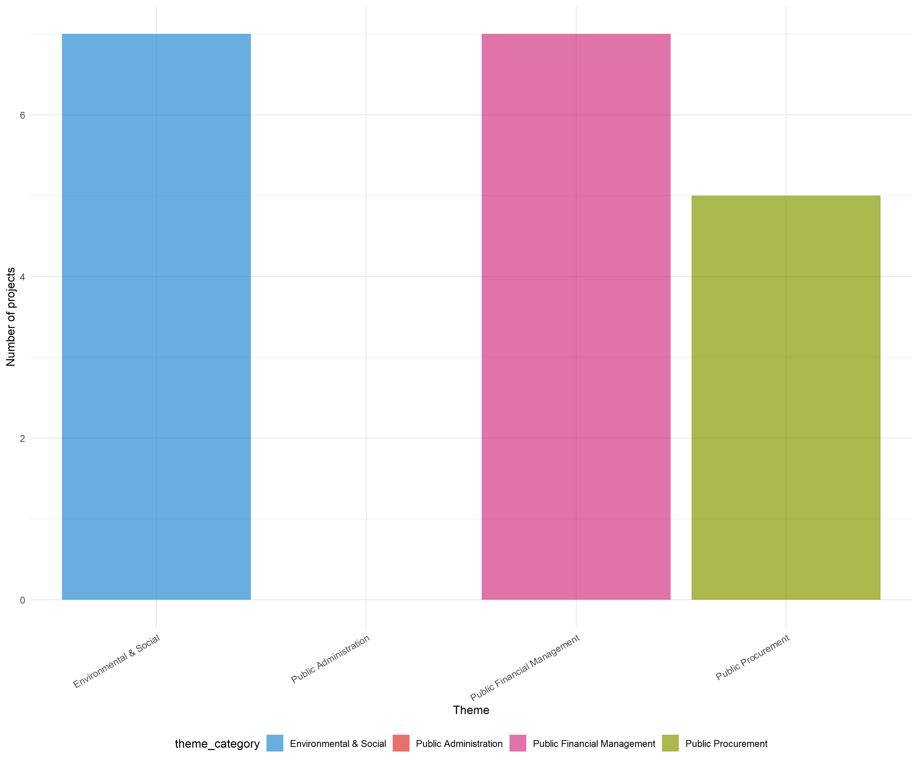

Thematic breakdown in FY2026 by region
