IDA21 Policy Commitment: Institutional Strengthening
May 12, 2026

Overview
This portfolio review monitors the World Bank Governance Global Practice (GOV) portfolio in IDA-eligible and Blend countries, in support of the IDA21 Policy Commitment on Institutional Strengthening. The portfolio covers active lending operations and Advisory Services and Analytics (ASA) led by the Governance GP. Projects are classified across four thematic areas: Public Financial Management, Public Procurement, Public Administration, and Environmental & Social Governance.
The current portfolio comprises 69 projects across 35 countries, of which 40 are lending operations and 29 are ASAs.

Lending portfolio trends
Number of GOV-led lending operations approved per fiscal year that are currently active in IDA/Blend countries.
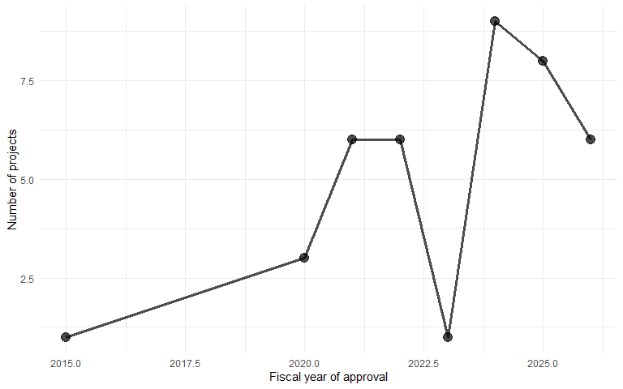

Lending portfolio by region
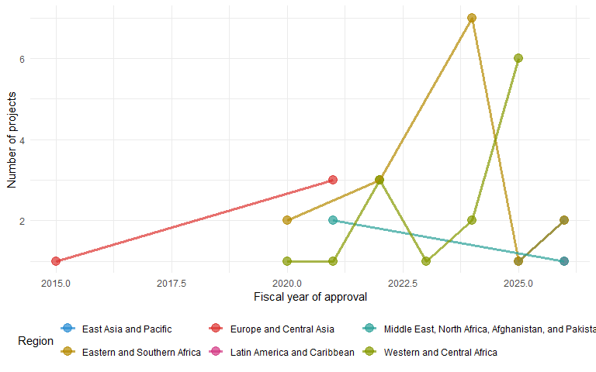

Thematic breakdown over time
Number of lending operations per thematic area by fiscal year.
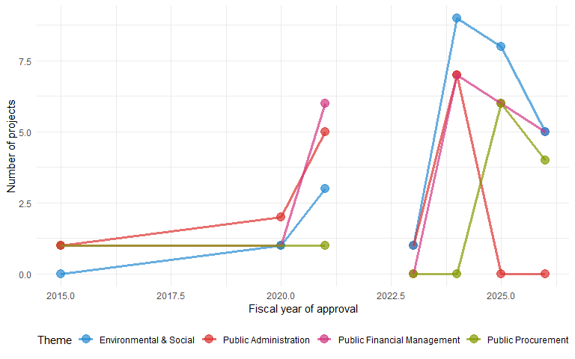

Country reach by IDA cycle
Number of countries with at least one active project (lending or ASA), comparing the current IDA21 cycle (FY2026 onwards) to the preceding period.
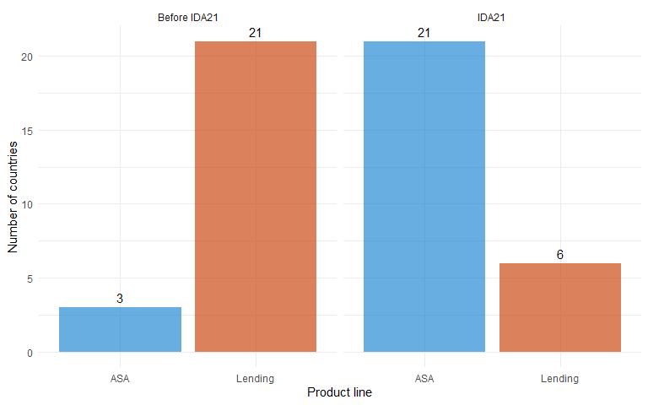

Country reach by thematic area and IDA cycle
