Team 11

SOEN 6441

18-Oct-18

**Architecture of Risk Project**

According the instruction of the Project and the Grading list, our team implements the first phase of development, and generate the Build 1.

1. **Module structure in our implementation**

As the following graph showed, these are our basic module and their function in our implementation.

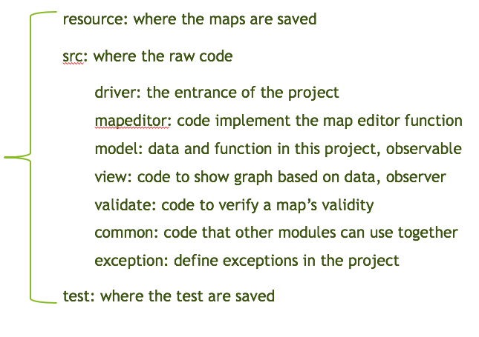

1. **Observer pattern in our implementation**

In our implementation, we use three layer of observer pattern to update the interface in the real time:

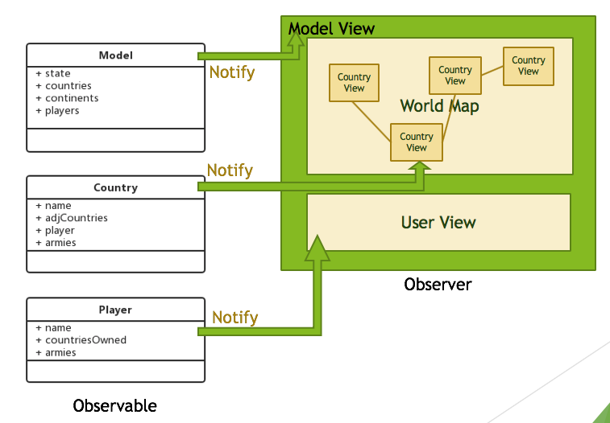

1. Model ---- Model View: Model View change its pattern (interface, listen pattern) according observer the state of STATE in Model.
2. Country ---- Country View: display correct country info according the Country notification.
3. Player ---- Player View: display correct user info according the users notification.
4. **Project process and information exchange in our implementation**

Based on our implementation, following is our flow chart. The main part of this project and how it runs is listed in the following figure.

