Team 11

SOEN 6441

09-Nov-18

**Architecture of Risk Project**

According the instruction of the Project and the Grading list, our team implements the first phase of development, and generate the Build 1.

1. **Module structure in our implementation**

As the following graph showed, these are our basic module and their function in our implementation.

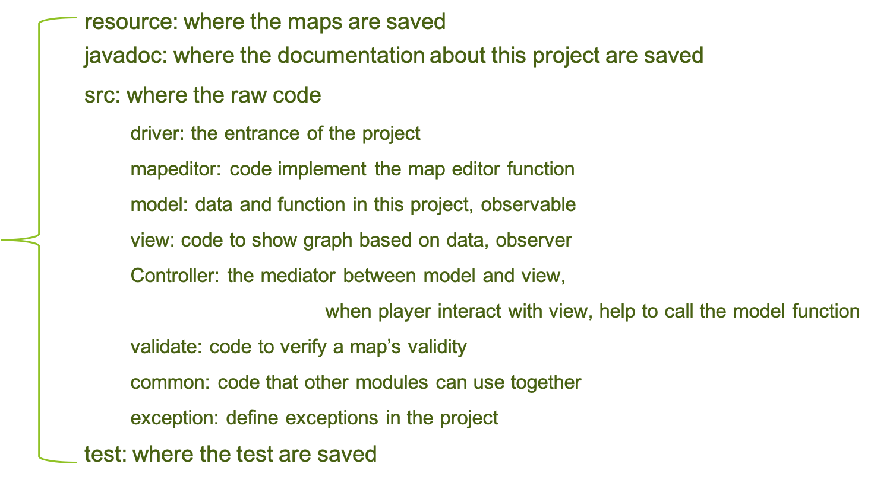

1. **Observer pattern in our implementation**

In our implementation, we use three layer of observer pattern to update the interface in the real time:

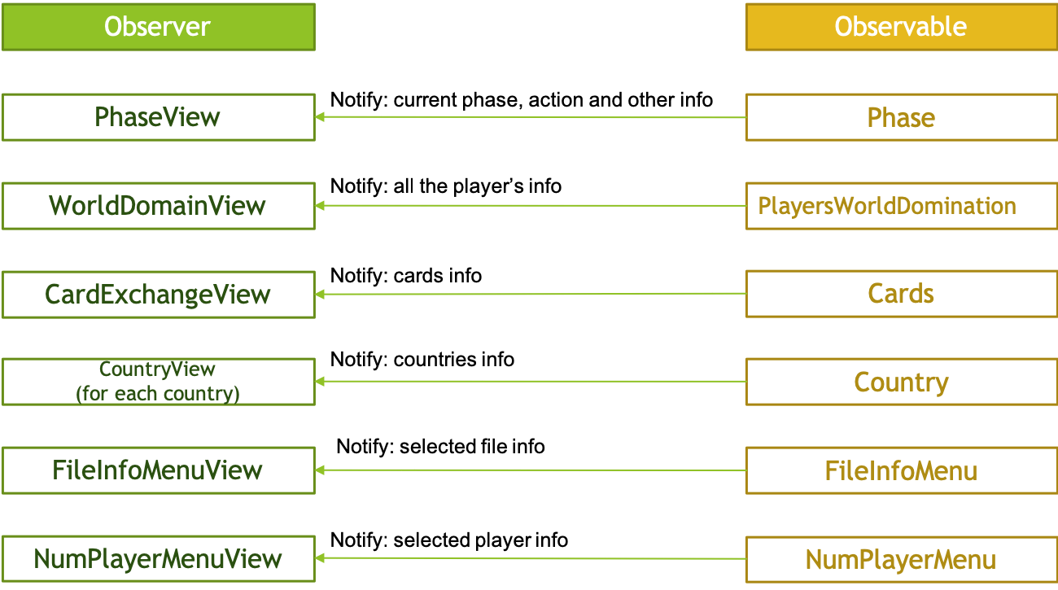

Detail:

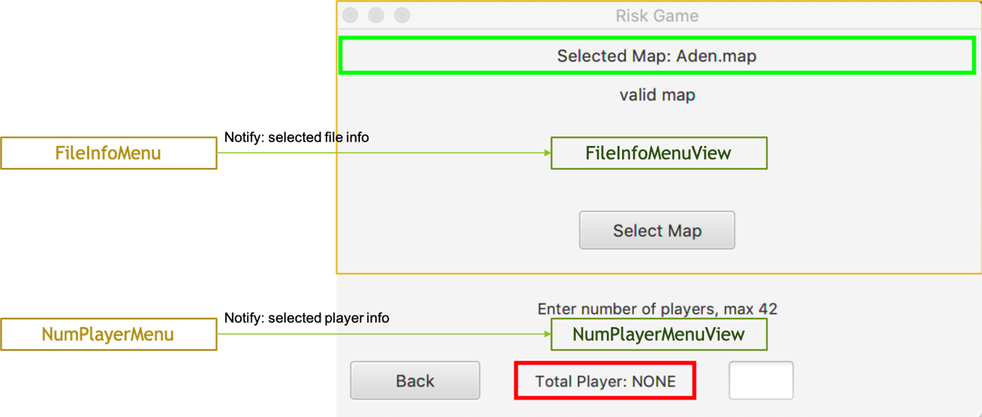

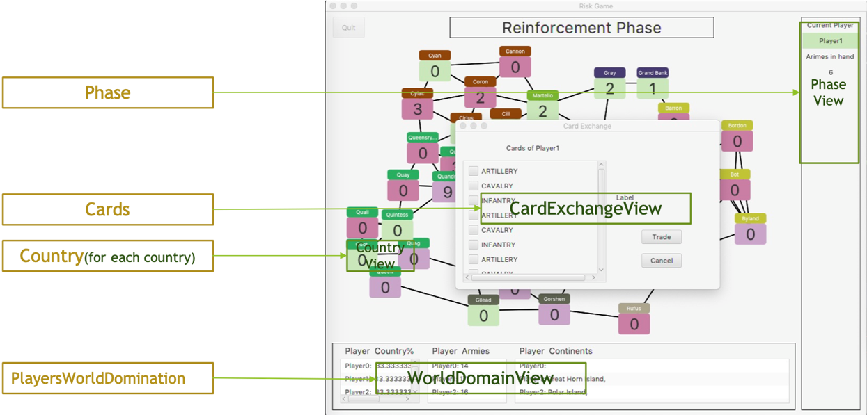

1. **Project process and information exchange in our implementation**

Based on our implementation, following is our flow chart. The main part of this project and how it runs is listed in the following figure.

