Group:

Marta Kwolik  
Robert Bodziony

Wiktor Bednarek  
Łukasz Kula

Restaurant Ordering System

Android APP & WebService

2016

1. User requirements according the VOLERE

**Project Drivers**

**1. The Purpose of the Project**

Creating a restaurant management software. Our goal is to speed up service, minimize a number of workers and time of waiting of customer to be served, leading to more income. Our purposes are planned to be done thanks to an innovative software for restaurant management. We want to make an Android application for restaurant’s customers and a desktop web-service for restaurant’s owners.

**2. The Client, the Customer, and Other Stakeholders**

*Clients and customers:* owners of middle-sized (15 tables) to big restaurants (more than 15 tables)

*Other Stakeholders:*

|  |  |
| --- | --- |
| **Position** | **Responsibilities** |
| Sponsor- an IT Company | Provide all resources needed to create a project (office space, servers, workers payment) |
| Front-end developers | Creating front-end of our webservice and Android application |
| Back-end developers | Connecting database to our services. Designing all back-end mechanism in Android application and web-service to establish stable data transfer. |
| Testers | Testing all the software in order to find bugs and check compatibility with certain operating systems/browsers  listed in further part of this documentation |
| Legal Experts | Preventing patent or copyright violation |
| Marketing experts | Consultations with technology experts on functionalities; commerce; selling a product |

**3. Users of the Product**

Users of the product: restaurant’s customers and restaurant’s owners

* all ages
* all genders
* all education levels
* low to high technology knowledge

Every person needs to be able to use our product easily therefore our priority is to make it as much user-friendly as possible.

Project Constraints

**4. Mandated Constraints**

Budget: 50000zł

Time: 4 months

Android application needs to be compatible with versions 4.4-6.0.

Web-service needs to run on most popular browsers (Internet Explorer, Firefox, Opera, Google Chrome, Safari) in newest versions and 10 previous ones and they will be tested accordingly.

Database will run on MySql, web-service will be done in HTML + PHP + CSS using Eclipse development environment and an Android application will be developed in Java language using Android Software Development Kit using Android Studio IDE.

**5. Naming Conventions and Definitions**

***Meal id*** - all meals available in the menu will be given an unique id (5 digits)

***Android app/application*** - a software installed on a tablet with Android operating system. Tablets will be placed on every table and connected to wifi so every restaurant’s customer will be able to order a meal

***Web-service*** - a web-page available for restaurants’ owners containing a list of made orders and statistics. Entry will be protected by username and password.

***Staff*** - Restaurant’s owner and it’s workers. They are authorised to access a webservice by unique usernames and passwords

***Customers*** - People coming to a restaurant to order meal

***Rating*** - a 1 to 5 scale in which customers can rate a service in a restaurant

***Menu*** - a list of all meals and drinks available in a restaurant saved in MySQL database (every meal has it’s name, price and id)

**6. Relevant Facts and Assumptions**

In order to reach more clients we can adjust certain functionalities according to their needs.

Functional Requirements

**7. The Scope of the Work**

Nowadays ordering meals requires a waiters and this means cost for an employer because restaurant need to hire them. When orders will be handled by an Android application number of waiters can decrease. That directly leads to more income.

**Event List**

|  |  |  |
| --- | --- | --- |
| **Event Name** | **Input & output** | **Description** |
| Ordering meal | Meal id, price | Main functionality of our software; restaurant’s customer will be able to order meal via Android app |
| Rate service | Rating, opinion | Rating is showed in a 1 to 5 scale. Thanks to it customer can rate a service. They can also add a verbal opinion. |
| Log in as owner | Login, password | A restaurant staff can log in to webservice in order to proceed with events listed above |
| Viewing orders | Check-box, Meal id | Main functionality of webservice; restaurant’s owner will be able to view made orders and delete prepared ones from the list (check-box). |
| Viewing rating | Rating, opinion | Rating is showed in a 1 to 5 scale. All ratings and verbal opinions can be viewed by staff. |
| Browsing statistics | Income, most popular meal, less popular meal in certain period of time | All statistics will be showed in a chosen period of time (day/week/month/year) |
| Add item to menu | Name, price | Restaurant’s owner will be able to add meals to the menu, by adding it to database it will automatically change the menu in android app. |
| Remove items from menu | Meal id | Restaurant’s owner will be able to remove meals from the menu, by removing it to database it will automatically change the menu in android app. |

**8. The Scope of the Product**

**Data model**

|  |  |
| --- | --- |
| **Name** | **Description** |
| Meal | A position in menu with an unique id (5 digits; int), name (string), description (string) and price (float) |
| Menu | All meals listed in MySQL database |
| Oder | List of ordered meals; a table containing: restaurant’s table number, meals, price, time of order, information if it has been prepared already |
| Rating | A rating of restaurant given by customer |

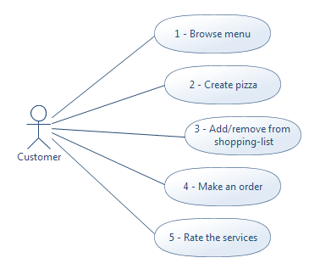

Picture 1. Usecases for customer.

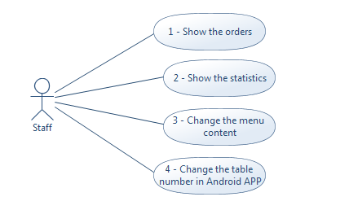

Picture 2. Usecases for staff.

**9. Functional and Data Requirements**

|  |  |  |  |
| --- | --- | --- | --- |
| * ***Customer interface requirements (Android APP):*** | | | |
| Requirement #: **1** | Requirement Type: **9** | Event/use case #: **Customer - 1,4** | |
| Description: | **System should allow customer to browse and order the meals.** | | |
| Rationale: | **To reduce numbers of waiters and time of waiting for the menu in physical form.** | | |
| Originator: | **Xxxx Xxxxx - Android programmer.** | | |
| Fit Criterion: | **Client should be able to order a meal via APP. Each table has an android device which has defined the table number. Each customer has a shopping list, which define his order. It should be intuitive.** | | |
| Customer Satisfaction: | **4** | Customer Dissatisfaction: | **5** |
| Priority: | **9** | Conflicts: | **-** |
| Supporting Materials: **-** | | | |
| History: **Created April 12, 2016** | | | |
| Requirement #: **2** | Requirement Type: **9** | Event/use case #: **Customer - 2** | |
| Description: | **System should allow customer to create his own meal (pizza) and show customer the price of created meal.** | | |
| Rationale: | **To satisfy the most demanding clients.** | | |
| Originator: | **Xxxx Xxxxx - Team coordinator.** | | |
| Fit Criterion: | **Ingredients should be present on device screen in form of checkboxes or graphical form. Each ingredient has defined price (different prices for meat, vegetables etc.) and it decrees or increes when ingredient is added or removed.** | | |
| Customer Satisfaction: | **3** | Customer Dissatisfaction: | **3** |
| Priority: | **7** | Conflicts: | **-** |
| Supporting Materials: **-** | | | |
| History: **Created April 12, 2016** | | | |

|  |  |  |  |
| --- | --- | --- | --- |
| Requirement #: **3** | Requirement Type: **9** | Event/use case #: **Cusomer - 3** | |
| Description: | **System should allow customer to add/remove meals to/from the shopping list.** | | |
| Rationale: | **If client make a mistake he should be able to repair it.** | | |
| Originator: | **Xxxx Xxxxx - Android programmer.** | | |
| Fit Criterion: | **APP should have icon “add to basket”** | | |
| Customer Satisfaction: | **5** | Customer Dissatisfaction: | **5** |
| Priority: | **9** | Conflicts: | **-** |
| Supporting Materials: **-** | | | |
| History: **Created April 12, 2016** | | | |

|  |  |  |  |
| --- | --- | --- | --- |
| Requirement #: **5** | Requirement Type: **9** | Event/use case #: **Customer - 5** | |
| Description: | **System should allow customer to rate the services.** | | |
| Rationale: | **To allow customer to show the opinion about the services provided by restaurant.** | | |
| Originator: | **Xxxx Xxxxx - Android programmer.** | | |
| Fit Criterion: | **It should be done using dialog-box, which appears after customer order is handled by the service. Dialog-box should contain the field for comments and spinner with values from 1 to 5.** | | |
| Customer Satisfaction: | **4** | Customer Dissatisfaction: | **3** |
| Priority: | **8** | Conflicts: | **-** |
| Supporting Materials: **-** | | | |
| History: **Created April 12, 2016** | | | |
| * ***Owner interface requirements (Website and Android-App):*** | | | |
| Requirement #: **6** | Requirement Type: **9** | Event/use case #: **Staff - 1** | |
| Description: | **System should allow owner and employees to see the orders.** | | |
| Rationale: | **Staff need to know what meal should prepare.** | | |
| Originator: | **Xxxx Xxxxx - Web developer.** | | |
| Fit Criterion: | **It should be auto-refresh list. There should be information about how much time past since order and for which table order was made.** | | |
| Customer Satisfaction: | **5** | Customer Dissatisfaction: | **5** |
| Priority: | **9** | Conflicts: | **-** |
| Supporting Materials: **-** | | | |
| History: **Created April 12, 2016** | | | |

|  |  |  |  |
| --- | --- | --- | --- |
| Requirement #: **7** | Requirement Type: **9** | Event/use case #: **Staff - 2** | |
| Description: | **System should allow owner and employees to see the statistics about meals which are served in restaurant and daily income.** | | |
| Rationale: | **To get information about taste/quality of food.** | | |
| Originator: | **Xxxx Xxxxx - Web developer.** | | |
| Fit Criterion: | **It should be an web-site for staff where all information are shown. Statistics should be stored in data-base and the web-site should get it from there.** | | |
| Customer Satisfaction: | **5** | Customer Dissatisfaction: | **5** |
| Priority: | **9** | Conflicts: | **-** |
| Supporting Materials: **-** | | | |
| History: **Created April 12, 2016** | | | |
| Requirement #: **8** | Requirement Type: **9** | | Event/use case #: **Staff - 3** |
| Description: | **System should allow owner and employees to add/remove an items to/from the menu on Android App from the side of web-service.** | | |
| Rationale: | **To update the offer of restaurant.** | | |
| Originator: | **Xxxx Xxxxx - Android programmer.** | | |
| Fit Criterion: | **There should be an special table in database which consist all items from menu.** | | |
| Customer Satisfaction: | **4** | Customer Dissatisfaction: | **5** |
| Priority: | **9** | Conflicts: | **-** |
| Supporting Materials: **-** | | | |
| History: **Created April 15, 2016** | | | |

|  |  |  |  |
| --- | --- | --- | --- |
| Requirement #: **9** | Requirement Type: **9** | | Event/use case #: **Staff - 4** |
| Description: | **System should allow the owner and employees to change the table number from the Android app interface.** | | |
| Rationale: | **To get information about which table has ordered the meal and where it should be brought.** | | |
| Originator: | **Xxxx Xxxxx - Team coordinator.** | | |
| Fit Criterion: | **It should be hidden for the customer and secure by password. One of the way how to hide it is to click 5 or more times on the logo of restaurant, after that dialog-box for password should appear.** | | |
| Customer Satisfaction: | **5** | Customer Dissatisfaction: | **4** |
| Priority: | **8** | Conflicts: | **-** |
| Supporting Materials: **-** | | | |
| History: **Created April 22, 2016** | | | |

Nonfunctional Requirements

**10. Look and Feel Requirements**

|  |  |  |  |
| --- | --- | --- | --- |
| Requirement #: **10** | Requirement Type: **10** | | Event/use case #: **-** |
| Description: | **Both, service and APP, should looks modern. The interface should be intuitive. Colors should be combined white with some warm colors, to make view nicer for customer.** | | |
| Rationale: | **To make the user interface more user-friendly.** | | |
| Originator: | **Xxxx Xxxxx - Team coordinator.** | | |
| Fit Criterion: | **It should be made using design templates / style-sheets or components made by the front end developers.** | | |
| Customer Satisfaction: | **4** | Customer Dissatisfaction: | **2** |
| Priority: | **6** | Conflicts: | **-** |
| Supporting Materials: **-** | | | |
| History: **Created April 14, 2016** | | | |

**11. Requirements referring to ergonomics and comfort.**

|  |  |  |  |
| --- | --- | --- | --- |
| Requirement #: **11** | Requirement Type: **11** | | Event/use case #: **-** |
| Description: | **Android Application should have menu button which should allow user to go wherever he want. "Add to basket" button should be in visible place and it should be quite big.** | | |
| Rationale: | **To allow user to intuitive navigate between all functionalities.** | | |
| Originator: | **Xxxx Xxxxx - Team coordinator.** | | |
| Fit Criterion: | **It should be made on the MAIN-SCREEN which appears right after Android application is turned on.** | | |
| Customer Satisfaction: | **4** | Customer Dissatisfaction: | **4** |
| Priority: | **6** | Conflicts: | **-** |
| Supporting Materials: **-** | | | |
| History: **Created April 14, 2016** | | | |

**12. Performance Requirements**

|  |  |  |  |
| --- | --- | --- | --- |
| * ***Customer interface requirements (Android APP):*** | | | |
| Requirement #: **12** | Requirement Type: **12** | | Event/use case #: **-** |
| Description: | **System should be able to send the order to the website immediately (at most 10 sec after the user’s request).** | | |
| Rationale: | **To provide immediate support order.** | | |
| Originator: | **Xxxx Xxxxx - Team coordinator.** | | |
| Fit Criterion: | **Internet connection should be provided for both - owner and customer interface.** | | |
| Customer Satisfaction: | **5** | Customer Dissatisfaction: | **4** |
| Priority: | **9** | Conflicts: | **-** |
| Supporting Materials: **-** | | | |
| History: **Created April 15, 2016** | | | |

|  |  |  |  |
| --- | --- | --- | --- |
| Requirement #: **13** | Requirement Type: **12** | | Event/use case #: **-** |
| Description: | **System should provide services at least for the time when the restaurant is open.** | | |
| Rationale: | **To allow customers to use the services provided by the restaurant.** | | |
| Originator: | **Xxxx Xxxxx - Team coordinator.** | | |
| Fit Criterion: | **Device with Android application should have an electrical supply provided on the table when battery is low.** | | |
| Customer Satisfaction: | **4** | Customer Dissatisfaction: | **5** |
| Priority: | **9** | Conflicts: | **-** |
| Supporting Materials: **-** | | | |
| History: **Created April 15, 2016** | | | |

|  |  |  |  |
| --- | --- | --- | --- |
| Requirement #: **14** | Requirement Type: **12** | | Event/use case #: **-** |
| Description: | **System should be scalable with the new features.** | | |
| Rationale: | **To allow owner to add more functions when needed in the future.** | | |
| Originator: | **Xxxx Xxxxx - Team coordinator.** | | |
| Fit Criterion: | **Interface should have enough space to add new components into.** | | |
| Customer Satisfaction: | **4** | Customer Dissatisfaction: | **2** |
| Priority: | **6** | Conflicts: | **-** |
| Supporting Materials: **-** | | | |
| History: **Created April 14, 2016** | | | |

|  |  |  |  |
| --- | --- | --- | --- |
| * ***Owner interface requirements (Website):*** | | | |
| Requirement #: **15** | Requirement Type: **12** | | Event/use case #: **-** |
| Description: | **System should be able to receive the user order from the app.** | | |
| Rationale: | **To allow user to order the meal and staff to see the customer orders on the website.** | | |
| Originator: | **Xxxx Xxxxx - Team coordinator.** | | |
| Fit Criterion: | **It should be made using database connection with android application and web-site.** | | |
| Customer Satisfaction: | **4** | Customer Dissatisfaction: | **2** |
| Priority: | **6** | Conflicts: | **-** |
| Supporting Materials: **-** | | | |
| History: **Created April 14, 2016** | | | |

|  |  |  |  |
| --- | --- | --- | --- |
| Requirement #: **16** | Requirement Type: **12** | | Event/use case #: **-** |
| Description: | **System should provide services at least for the time when the restaurant is open.** | | |
| Rationale: | **To allow restaurant to provide the services for the customers.** | | |
| Originator: | **Xxxx Xxxxx - Team coordinator.** | | |
| Fit Criterion: | **There should be continuous supply for the screen which display the orders.** | | |
| Customer Satisfaction: | **5** | Customer Dissatisfaction: | **5** |
| Priority: | **9** | Conflicts: | **-** |
| Supporting Materials: **-** | | | |
| History: **Created April 14, 2016** | | | |

**13. Maintainability and Support Requirements**

|  |  |  |  |
| --- | --- | --- | --- |
| Requirement #: **17** | Requirement Type: **13** | | Event/use case #: **-** |
| Description: | **Products need to be supported and updated for 3 years after launching.** | | |
| Rationale: | **To allow the system owner to make changes into it and get the support of experts when needed.** | | |
| Originator: | **Xxxx Xxxxx - Team coordinator.** | | |
| Fit Criterion: | **Contract with the system providers and system owners should established.** | | |
| Customer Satisfaction: | **3** | Customer Dissatisfaction: | **3** |
| Priority: | **7** | Conflicts: | **-** |
| Supporting Materials: **-** | | | |
| History: **Created April 14, 2016** | | | |

**14. Security Requirements**

|  |  |  |  |
| --- | --- | --- | --- |
| Requirement #: **18** | Requirement Type: **14** | | Event/use case #: **-** |
| Description: | **All user data needs to be safe and properly protected.** | | |
| Rationale: | **To secure users of the system from stealing the personal data by third persons.** | | |
| Originator: | **Xxxx Xxxxx - Team coordinator.** | | |
| Fit Criterion: | **There should be password authorization.** | | |
| Customer Satisfaction: | **5** | Customer Dissatisfaction: | **4** |
| Priority: | **8** | Conflicts: | **-** |
| Supporting Materials: **-** | | | |
| History: **Created April 14, 2016** | | | |

**15. Cultural and Political Requirements**

|  |  |  |  |
| --- | --- | --- | --- |
| Requirement #: **19** | Requirement Type: **15** | | Event/use case #: **-** |
| Description: | **Products mustn’t be offensive to any religion/race/ethnic group. There has to be no reference to politics.** | | |
| Rationale: | **To avoid unintended offend of the customers.** | | |
| Originator: | **Xxxx Xxxxx - Team coordinator.** | | |
| Fit Criterion: | **The content of the system has to be checked before putting into use.** | | |
| Customer Satisfaction: | **4** | Customer Dissatisfaction: | **2** |
| Priority: | **5** | Conflicts: | **-** |
| Supporting Materials: **-** | | | |
| History: **Created April 14, 2016** | | | |

**16. Legal Requirements**

|  |  |  |  |
| --- | --- | --- | --- |
| Requirement #: **20** | Requirement Type: **16** | | Event/use case #: **-** |
| Description: | **System should be patent or copyright violation free.** | | |
| Rationale: | **To prevent issues with the law.** | | |
| Originator: | **Xxxx Xxxxx - Team coordinator.** | | |
| Fit Criterion: | **Consultation with lawyers is required.** | | |
| Customer Satisfaction: | **4** | Customer Dissatisfaction: | **2** |
| Priority: | **6** | Conflicts: | **-** |
| Supporting Materials: **-** | | | |
| History: **Created April 14, 2016** | | | |

1. Project estimation using Function Points
2. **Type of PF Count:** Development Project FP Count.
3. **Main Components**

|  |  |  |  |
| --- | --- | --- | --- |
| **External Inputs** | **FTR** | **DET** | **Complexity** |
| Ordering meals | 2 | 7 | Low |
| Rating service | 2 | 3 | Low |
| Creating own meal | 2 | 4 | Low |
| Adding item to menu | 2 | 5 | Low |

|  |  |  |  |
| --- | --- | --- | --- |
| **External Outputs** | **FTR** | **DET** | **Complexity** |
| Viewing details of a meal | 2 | 5 | Low |
| Viewing order details | 2 | 6 | Low |

|  |  |  |  |
| --- | --- | --- | --- |
| **External Inquiries** | **FTR** | **DET** | **Complexity** |
| Viewing menu in Android App | 2 | 5 | Low |
| Viewing orders list and in webservice | 2 | 6 | Average |
| Viewing statictics in webservice | 1 | 2 | Low |

|  |  |  |  |
| --- | --- | --- | --- |
| **Internal Logical Files** | **RET** | **DET** | **Complexity** |
| Menu (with all available meals) | 1 | 5 | Low |
| Ratings given by clients | 1 | 2 | Low |
| Income statistics | 1 | 2 | Low |

Things listed above are based on ER diagram placed on next page.

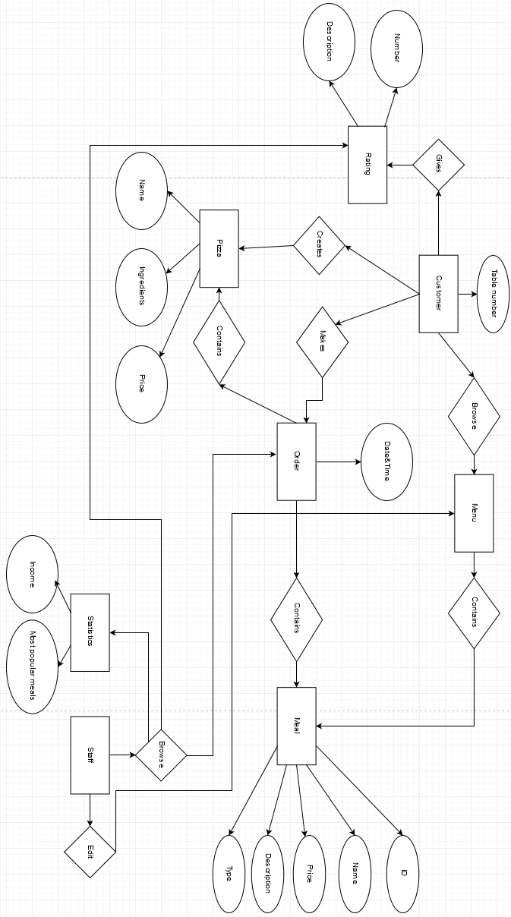

1. **Domain Characteristic Table**

|  |  |  |  |  |  |  |  |
| --- | --- | --- | --- | --- | --- | --- | --- |
|  | Low | | Average | | High | | Total |
| External Inputs | 4 | x3 | - | x4 | - | x6 | 12 |
| External Outputs | 2 | x4 | - | x5 | - | x7 | 8 |
| External Inquiries | 2 | x3 | 1 | x4 | - | x6 | 10 |
| Internal Logical Files | 3 | x7 | - | x10 | - | x15 | 21 |
| Sum (UT)=51 | | | | | | | |

1. **Complexity Adjustment Table**

|  |  |  |  |
| --- | --- | --- | --- |
|  | Complexity Adjustment | Scale | Description |
| 1. | Data Communication | 2 | We need to establish connection between android app and webservice via wifi. Communication is required, however it’s not very complex. |
| 2. | Distributed data processing | 1 | Only simple statistics are required. |
| 3. | Performance | 4 | Our application needs to work fast to fulfill customers’ expectations. |
| 4. | Heavily used configuration | 1 | Software works on Android tablet and PC dedicated only to them. |
| 5. | Transaction rate | 3 | Transaction are executed frequently (aprox. 50/day) but the process itself (and it’s data) is not complicated. |
| 6. | Online data entry | 5 | All information is stored online. |
| 7. | End user efficiency | 1 | Our software should have simple menu supporting scrolling, autorotating (for Android app). |
| 8. | Online update | 2 | On-line update is included. Volume of updating is low and recovery is easy. |
| 9. | Complex processing | 1 | Only simple mathematical processing is required. |
| 10. | Reusability | 1 | Only small changes might be required in order to adjust software for various restaurants’ needs. |
| 11. | Installation ease | 1 | Installation of Android app is standard, webservice is accessible by an Internet browser. |
| 12. | Operational ease | 0 | No special operational considerations other than the normal back-up procedures were stated by the client. |
| 13. | Multiple sites | 2 | Application is designed to operate under similar hardware and/or software environments. |
| 14. | Facilitate change | 3 | Query handling is simple but webservice needs to be updated immedietly after an oder happens. |
| Sum | | 27 |  |

$$VAF=0.65+0.01\sum_{i=1}^{14}{C_{i}}$$

$$VAF=0.65+0.27=0.92$$

$$FP=VAF×UT$$

$$FP=51.92$$

Lines of code can be estimated by:

$$LOC=FP×M$$

According to literature M for Java is 53, so

$$LOC=2752$$

1. **Risk management**

To analyze risk level we will use this table:

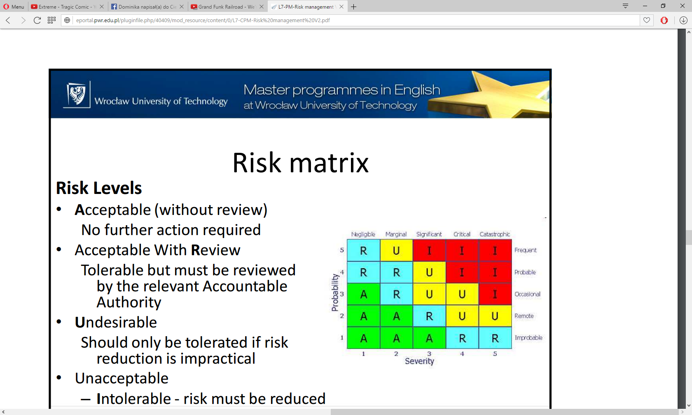

Here we have description for each risk level:

* **A**cceptable (without review) - No further action required
* Acceptable With **R**eview - Tolerable but must be reviewed by the relevant Accountable Authority
* **U**ndesirable - Should only be tolerated if risk reduction is impractical
* Unacceptable - **I**ntolerable - risk must be reduced

# 1. Problem

**·**        **Purpose**

To prevent delay with ending project.

**·**        **Definition**

We should remember that we need to end project before deadline. Factor which may prevent it may be that we are new with technology which will be using.

**·**        **Roles and Responsibilities**

        To prevent this situation, we appoint Risk Manager. This will be Tom. He will be responsible for overseeing the work and when he notices that we have a small delay, he will react.

**·**        **Risk Documentation**

Table 1 Risk Register

|  |  |
| --- | --- |
| ID | 1 |
| Risk Name | Ignorance of the technology |
| Description | We are new with the technology which is used, so it is hard to predict how much time we need to build this application. There is a necessity to monitor work and check if we don’t have delays. The best way to do this it be use Miniature Milestones method. With this approach we will see problem as soon as it possible. |
| Risk factors to monitor | Delays on miniature milestones. |
| Likelihood | Occasional |
| Impact level | Critical |
| Risk Level | Undesirable |
| Responsible Person | Tom Smith |
| Update date | 21.05.2016 |

**·**        **Schedule for Risk Management Activities**

If delays occur, the best way to work with them will be appoint a person who was working with this technology before. Also we can buy for our team training session with developers who use this stuff.

# 2. Problem

**·**        **Purpose**

To prevent delay with ending project.

**·**        **Definition**

Our workers also have another projects which they take part. This mean that they may have not enough time to work with this project.

**·**        **Roles and Responsibilities**

As in previous case responsible for preventing this will be Tom. He will need to have a good view on tasks which will be given to our developers.

Table 2 Risk Register

|  |  |
| --- | --- |
| ID | 2 |
| Risk Name | Not enough time to work with project |
| Description | To get known with technology, developers will need quite much time. We cannot allow a situation when they have few project, especially when this projects are in different technologies. |
| Risk factors to monitor | Numbers of project which employee is working (more than one) |
| Likelihood | Remote |
| Impact level | Significant |
| Risk Level | Acceptable with Review |
| Responsible Person | Tom Smith |
| Update date | 21.05.2016 |

**·**        **Schedule for Risk Management Activities**

If worker have more than one project, his work should be monitor with more care. Also he can’t take part in another project. If Tom will see that two projects are too much for this person, he will be forced to focus on this project and leave that.

# 3. Problem

**·**        **Purpose**

To ensure that we use our time in 100%.

**·**        **Definition**

In project like that, very important is communication. When we rise up quality of it, may occurs that our people work better because of flow of information is better or how they feel in work.

**·**        **Roles and Responsibilities**

Tom will care about this problem. He will need to oversee how people cooperate.

**·**        **Risk Documentation**

Table 3 Risk Register

|  |  |
| --- | --- |
| ID | 3 |
| Risk Name | Communication problem |
| Description | Communication problem can make our time wasted. It is important to know what have been done for now and what we have to do now. Also if people have good communication and they are friendly for themselves it may mean that they will work much better. |
| Risk factors to monitor | Level of cooperation. |
| Likelihood | Remote |
| Impact level | Critical |
| Risk Level | Undesirable |
| Responsible Person | Tom Smith |
| Update date | 21.05.2016 |

**·**        **Schedule for Risk Management Activities**

To fight with this problem, we can organize integration party. People will meet themselves and maybe this will help with friendly attitude. Also we can use Trello to manage our work. If we do this everybody will be able to check what have been done for this moment.

# 4. Problem

**·**        **Purpose**

An alternative scenario needs to be prepared in case of any problems with project’s team members.

**·**        **Definition**

We can’t allow a situation where project can’t be finished on time because of lack in staff. We can’t prevent an absence of a team member that is why need to focus on actions that will be taken after it occurs.

**·**        **Roles and Responsibilities**

        The best way to prevent delay in finishing a project when a team member is absent is to replace them with another person or to transfer their work to another team member. Since we want it to be done smoothly, without disrupting the workflow, all team members need to remember

to write documentation and comment code lines. Developer’s team leader is responsible for enforcing such practice.

**·**        **Risk Documentation**

Table 4 Risk Register

|  |  |
| --- | --- |
| ID | 4 |
| Risk Name | Problems with team members |
| Description | People may be ill, resign, have personal issues etc. resulting in their inability to work |
| Risk factors to monitor | Workers health |
| Likelihood | Rare |
| Impact level | Significant |
| Risk Level | Acceptable with review |
| Responsible Person | Adam Blue |
| Update date | 21.05.2016 |

**·**        **Schedule for Risk Management Activities**

Fortuitous events can’t be predicted therefore we should concentrate on planning appropriate actions after they happen. In case of a team member unable to do their task, they will be replaced with another one, so the project can be finished on time. This is why the documentation needs to be clear and comprehensive. A person taking over someone else’s tasks has to be able to do it fast and smoothly.

# 5. Problem

**·**        **Purpose**

Preventing too little motivation.

**·**        **Definition**

If we want to our employer work hard, we need to encourage them. They need to be motivated. In oder way they may try cheating.

**·**        **Roles and Responsibilities**

        Care of this is in manager responsibilities. He is committed to invent motivation system for workers. It have to reward people how end their work before deadline.

**·**        **Risk Documentation**

Table 5 Risk Register

|  |  |
| --- | --- |
| ID | 5 |
| Risk Name | Motivation |
| Description | Motivation is obvious way to make our project better and faster finish it. It has good impact on how the people feel. When they that they have good salary for job, they will work gladly. |
| Risk factors to monitor | Workers moods |
| Likelihood | Rare |
| Impact level | Critical |
| Risk Level | Undesirable |
| Responsible Person | Jan Kowalski |
| Update date | 21.05.2016 |

**·**        **Schedule for Risk Management Activities**

If our motivation system will not work in proper way, we will give people some extra bonuses.

1. **Ideas for Solutions**

When all requirements are gathered, team is focused on finding out what the real requirements are and try to avoid coming up with solutions

**Work organization**

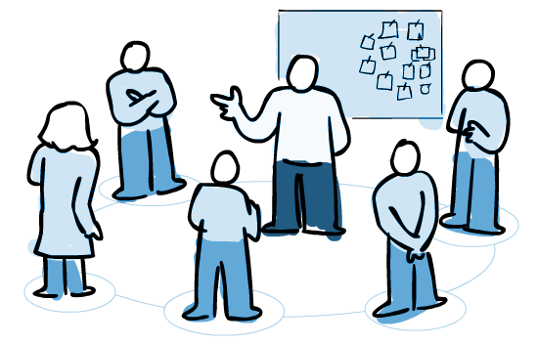

**Team works in Scrum for managing product development**

* Scrum helping to maintain clarity and efficiency during project progress
* Team was focused on objectives, not tasks
* Each role in project were self-organized and self-motivated
* Responsibility for delivering potentially shippable increments of product at the end of each sprint

**There was Team Leader (Scrum Master) with his responsibilities:**

* Removing things that block effective team work (Impediment)
* Facilitating team events to ensure regular progress
* Responsible for the organization and conduction of Scrum meetings
* Coaching the team, within the scrum principles
* Improves communication

**Product owner took on the following strategic and tactical responsibilities:**

* Represented the customer, interfaces and engages the customer
* Inspected the product progress (time and budget)
* Created and MAINTAINS the Product Backlog
* He was reminding sprint’s/release aims
* He can interrupt ongoing sprint (!)
* Described the user experience and product features

**Communication with customer**



* This was product owner responsibility
* Customer provided User Stories:

o    User Stories were provided in following way: "As a *<role>,* I want *<goal/desire>* so that *<benefit>*"

o    Describes system functionality from user’s point of view

o    Defines who, what and why executing in system

o    For each US is assigned number defining level of task difficulty - so- called Story Points

·         Product owner has to be in continuous contact with customer

·         Customer had capability to check progress

·         Customer can change some requirements during work progress, but he

must not change whole application concept (!)

**Summary**

* + Project is focused on reliability and easy, friendly interface from customer’s point of view
  + Each development team role in project was clearly defined according to Scrum framework rules
  + Application for Android can replace waiter and his responsibilities, system should be able to receive the user order from the app
  + System should be able to send the order to the website immediately (at most 10 sec after the user’s request)
  + Providing feature that allows customer to browse the meals
  + Allowing customer to create his own meal (pizza)
  + System should allow customer to add/remove meals to/from the shopping list
  + Changeability: Owner and employees to add/remove an items to/from the menu on Android App from the side of web-service
  + Safety issues: All user data needs to be safe, properly protected and changeable
  + System should provide services at least for the time when the restaurant is open
  + Products mustn’t be offensive to any religion/race/ethnic group. There has to be no reference to politics
  + System should be scalable with the new features
  + System should provide services at least for the time when the restaurant is open
  + Products need to be supported and updated for 3 years after launching
  + System should be patent or copyright violation free