**Name:** Carl Wico

**ID:** 20191312

**Course:** JavaScript (Lab-7)

**Lab 7-1** (Random user and Pokemon API)

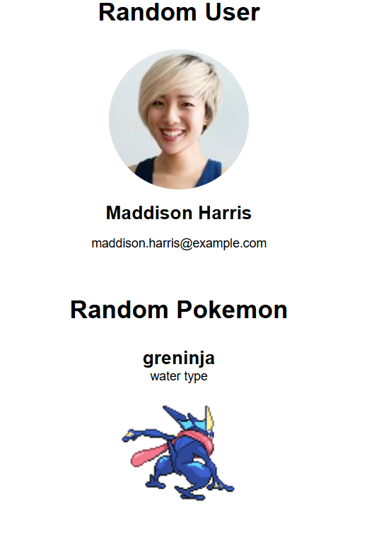

**Lab 7-2 (**Holiday API fetch**)**

