**Standard Operating Procedure – How to configure a DHCP pool on WCAT.DC01:**

**Purpose:**

To demonstrate adding a new pool to the DHCP server for future growth

**Scope:**

Applies to the IT staff and system administrators

**Requirements:**

* Access via Remote Desktop Protocol to the Domain Controller 1 server

**Process Overview:**

Part 1 – Configuring the DHCP role on DC01

Part 2 – Making a new pool using DHCP

**Process Steps:**

**Part 1 – Configuring the DHCP role on DC01:**

**Step 1:** On DC01, click **Manage** and **Add roles and features:**

**Step 2:** On the Add roles and features page, review the welcome page then **click Next:**

**Step 3:** On Installation type, ensure **Role-based or feature-based installation** is selected, click **Next:**

**Step 5:** On the installation roles page, select **DHCP role. Click Next:**



**Step 6:** Leave the features page as default, **click Next:**

**Step 7:** Review the summary and click **Install:**

Wait for the server to install the role

**Step 8:** Back on Server manager, complete the post-depolment configuration:

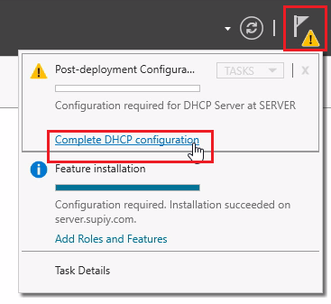

**Part 2 – Making a new pool using DHCP**

**Step 1:** Back on server manager, click **Tools** and **DHCP:**

**Step 2:** In the DHCP manager, click the arrow on your domain and click **IPv4**

**Step 3:** Right click **IPv4** and click **new scope:**

**Step 4:** The welcome page greets you, **click Next:**

**Step 5:** Name the pool and give it a description:

**Step 6:** Configure the ip addresses used in the pool and **click Next:**

**Step 7:** Add any exculsions to the pool. Click **Next:**

**Step 8:** Leave the defaults and click **Next:**

**Step 9:** On the DHCP configuration page, leave the button clicked on **Yes, I want to configure these options now. Click Next:**

**Step 10:** Add the default gateway of your pool:

**Step 11:** Add the DNS server ip address. **It has to be a DNS server that is valid because it validates it:**

When done, **click Next:**

**Step 12:** On the WIN servers page, leave the defaults and **click Next:**

**Step 13:** Active the scope and click **Next:**

**Now the pool is ready for DHCP use!**