# **Post-Lab Write Up**

Name: JeongGyu Tak

Lab: Lab2

1. Describe the process you went through to solve this problem (complete this lab)? 3 to 4 sentences should suffice.

I have organized what information we need for each condition and draw a diagram to visualize what we are making. After we finished the discussion, we started to write the code.

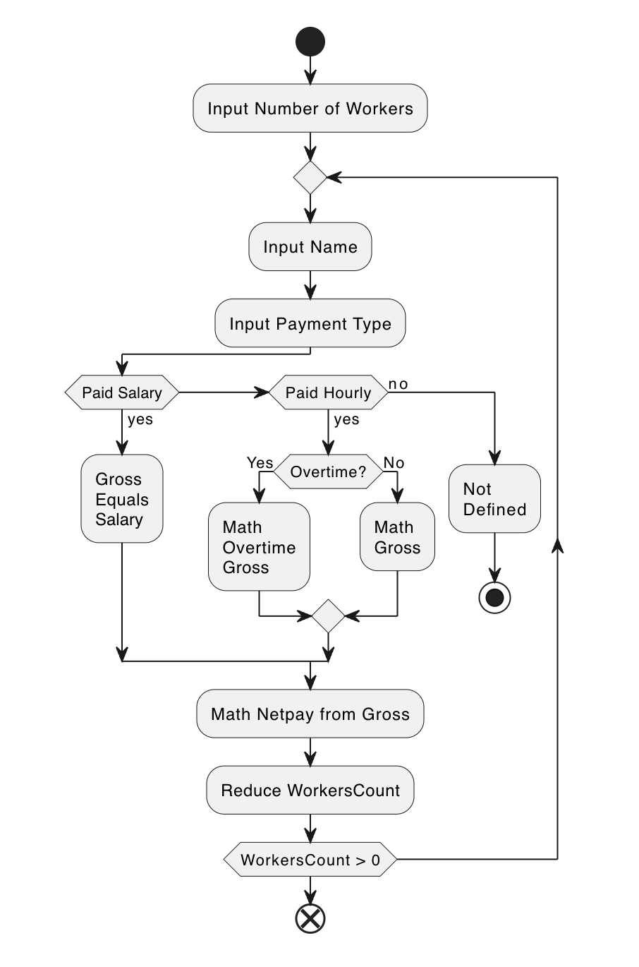

1. What went well in this process?

Things went well while debating the logic for this program, because we were visualizing the logic while we were in discussion. It was a paper drawing, not the diagram above, but it helped us a lot to make sure we are on the same track.

1. What was challenging/difficult in this process?

Before we started to diagram we had some hard time communicating and we fell into a loop of arguments and misunderstandings.

1. Think about a particular challenge that you faced in this lab. What was this challenge? How did you work past that challenge and overcome it?

I was using the function nextLine() but it was detecting a newline from the previous input stream, which is nextInt() before. To workaround, I asked to input the person's name twice by asking first name and the last name separately.

1. What will you do differently in the future to avoid/overcome these challenges?

I would like to make a new class inheriting the scanner class and override the function nextLine() with my own exception. For example, if there is no value before a newline, raise insufficient value error. So I have to handle the exception every time I call nextLine().

1. What is something that you learned while working on this lab?

I've learned to improve readability of java code to help my labmates understand the code easier.

1. How can what you learned in this lab be applied to the real world?

A skill to communicate.

1. Are there any bugs in the code that you turned in? If so, what are they? Why did you not fix them? (e.g. lack of time, lack of knowledge, etc)

No, there was no bug from what I have tested, I did not have a bug. However right now, while I am writing the postLab, I realize that there should not be a negative number for payments. It's not a bug, but I think I need to add restrictions on that.