Rocket Sim Documentation:
(This is a REAL TIME simulation. That means if you maneuver to go to the moon like the Apollo program it WILL TAKE ~3 DAYS.)

Startup:

Dbl clicking on JigRocket.jar will start the program running. You will be initially positioned on the earth at Lat 0, Long 0 pointing straight up. The moon, visible on the Cockpit view screen, is the little white oval in the middle.

Cockpit Screen legend:

VS = vertical speed in miles/hr
TS = tangential (ground speed) in mph
Thrust = force of thrust
Speed = overall speed in mph
Grav = the force of gravity
Fuel = fuel remaining
Drag = force of drag
Alt = altitude in miles

The ADI is the attitude direction indicator (artificial horizon)
The G meter indicates Gs felt on the rocket.

The controls have tool tips and are Roll, Pitch, and Yaw.

The track check box indicates whether position track recording is on in the exterior view.

The HUD check box turns on the Heads Up Display. The cross hairs point directly forward and the velocity vector position circle tells you what direction you are headed.

The drop down box allows you to select the sun, moon or earth as reference bodies for the instruments and readings.

The vertical slider bar on the far left is the thrust control. The numbers are % thrust.

And the vertical slider bar next to the attitude control buttons is the rate trim control. If you want to roll, pitch or yaw at a slower rate per button click use this slider to adjust that rate.

The view menu toggles between Exterior View and Cockpit view. From the Exterior view you can slew to a position and view angle of choice. When opening the Exterior view the little gray strip at the bottom must be clicked on so that the component “gets focus” and allows the use of the key pad keys for slewing.

Key pad 1 & 3 are yaw
4 & 6 are roll
2 & 8 are pitch

Key board ‘=/+’ key moves you forward
Key board ‘-‘ key moves you backward

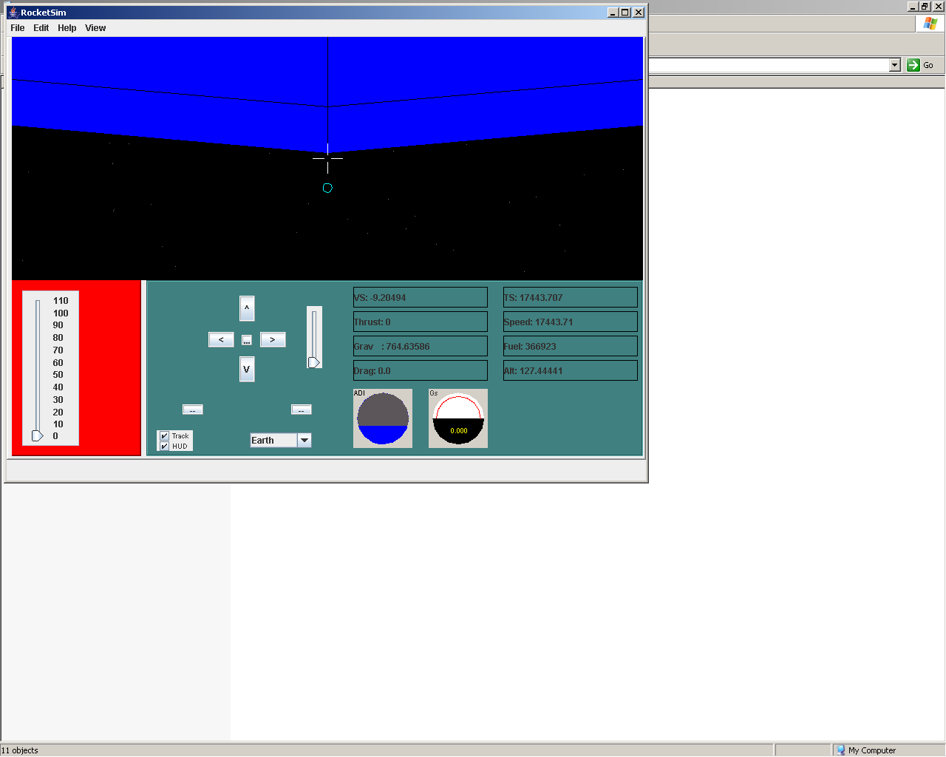

Exterior view is seen below with the rocket’s local coordinate axes depicted with the red dots indicating it’s position history: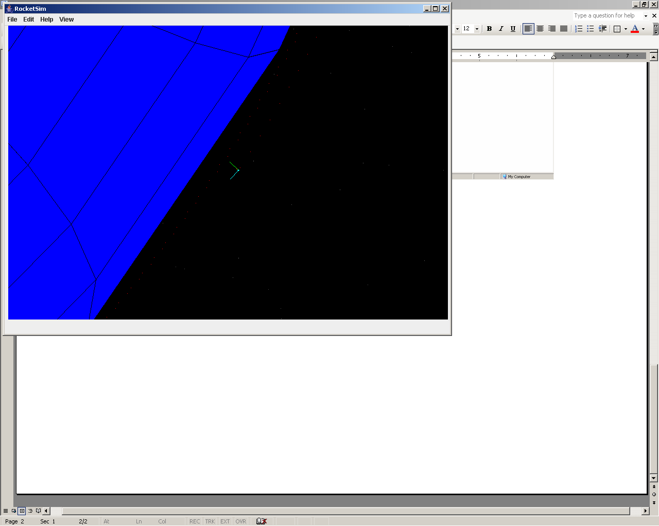

A typical launch to get into orbit consists of applying full thrust and slowly pitching back/up so that you arrive at an altitude of say 150 miles with a tangential speed of ~17500 mph.

It’s not easy.

