USB Gain/Phase Analyzer

Watson Capstone Projects (WCP*52*)

Christopher M. Pavilina, EE

Kenneth M. Zachary, CoE

Harrison B Owens, CoE

Kaidi Xu, EE

Faculty Advisor: Kyle J. Temkin

November 17, 2014

Revision: A

Submitted in partial fulfillment of the requirements of ME 493/EECE 487

in the Fall Semester of 2014.

**Executive Summary**

We are creating a USB driven device that analyzes the frequency response of filters, amplifiers, and control systems and creates a corresponding Bode Plot of the analysis.

**Table of Contents**

****

1. Problem Definition

1.1. Problem Scope

1.2. Technical Review

1.3. Design Requirements

2. Design Description

2.1. Overview

2.2. Detailed Description

2.2.1. Subsection 1

2.2.2. Subsection 2

2.2.3. Subsection 3

2.2.4. Subsection 4

2.2.5. Subsection 5

2.3. Use

3. Evaluation

3.1. Overview

3.2. Prototype

3.3. Testing and Results

3.4. Assessment

4. Next Steps

5. References

Appendix A     Computer Code

Appendix B    Schematics

# Problem Definition

Students are in need of an educational tool that will help them understand circuit analysis. Vector analyzers are often very heavy and expensive to utilize when analyzing the gain of a frequency output.

## Problem Scope

This project need to be a portable analyzer that assists students with understanding the overall behavior of output amplifiers and other circuits through a Bode plot.

## Technical Review

## Design Requirements

### Context Level Constraints

This project is to produce one gain/phase analyzer system. As shown in Figure 1:

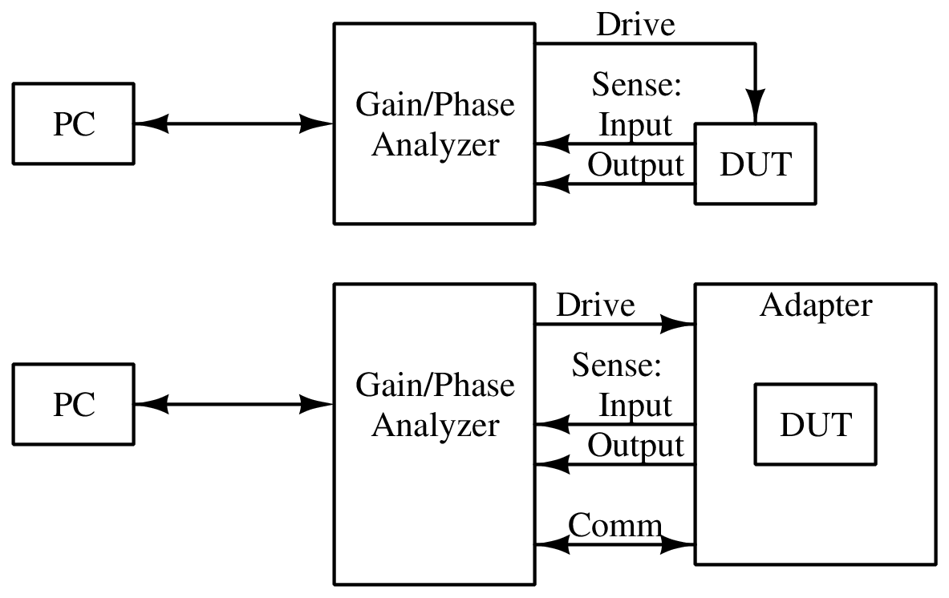

Figure 1: Gain/Phase Analyzer Context Diagram

### System Level Constraints

As shown in Figure 2: Gain/Phase Analyzer System Diagram, the analyzer will use a *Synthesizer* to generate the stimulus signal, and an *Output Amplifier* to provide the stimulus signal to the DUT, at up to 1.25 V RMS and up to 150 MHz, *Input Filters*, an *Input Switching Network* and the *Input Detector* will provide a signal corresponding to the amplitude of the signals at the *Sense* ports. The Input Switching Network can also select a *Phase Reference* to be summed with the signals for phase measurement. These will be digitized by an *Analog-Digital Converter* to be processed by the *Microprocessor*. The Microprocessor will then interface with the *Software* via the *PC Interface*.

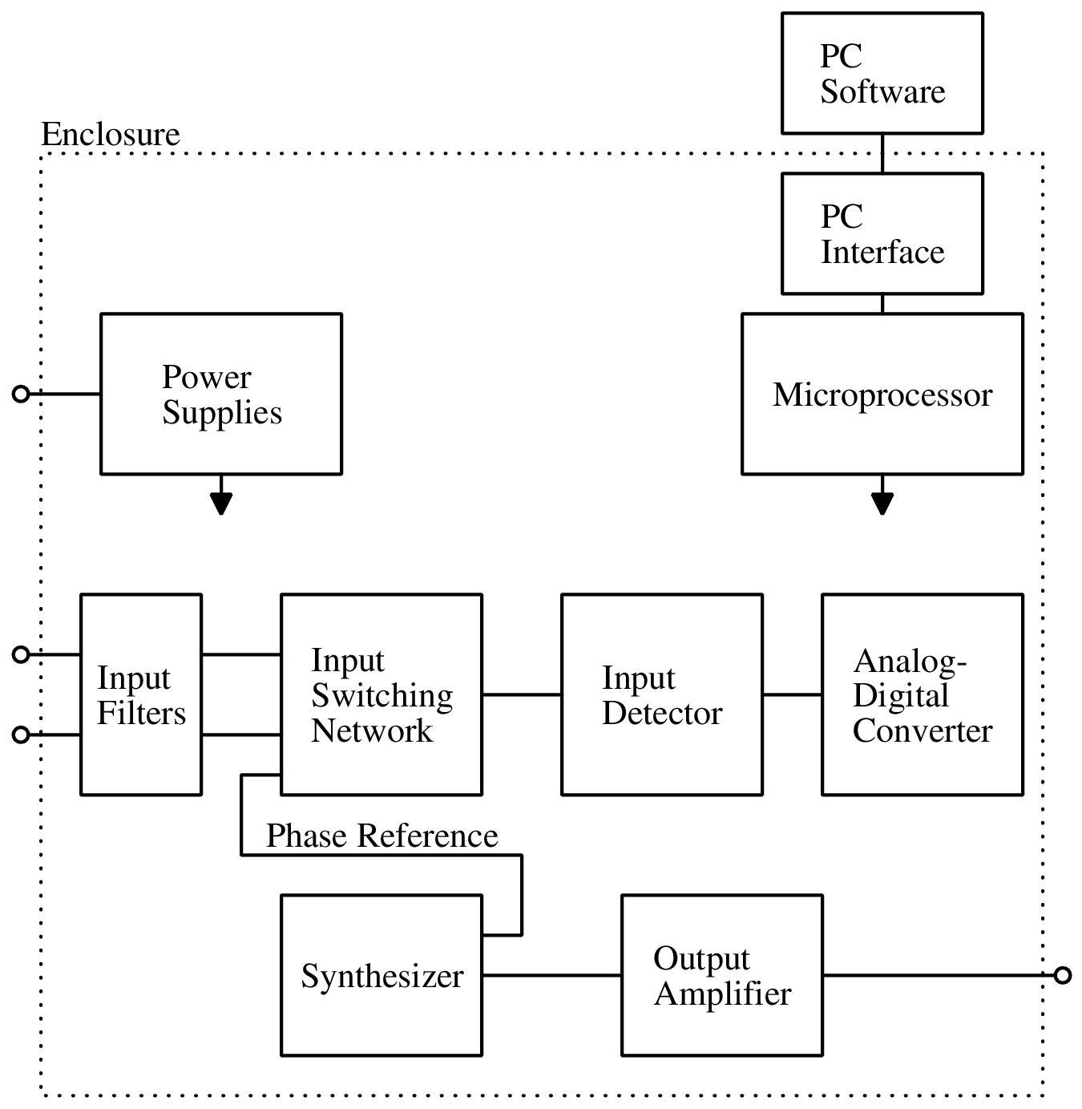

Figure 2: Gain/Phase Analyzer System Diagram

Gain/Phase Analyzer Context Diagram, the device is to connect to a PC for user control and viewing of data. It is to have one Drive output, with which it applies a stimulus to a Device Under Test (DUT), and two Sense inputs, with which it detects the amplitude and phase of signals before and after the DUT. The device will also have an Adapter port, with which it can connect to external adapters for measuring various types of DUTs.The gain/phase analyzer system, in addition to the hardware, will comprise PC Softwarewith which the end user may start analyses and view results.

# Design Description

## Overview

A Gain/Phase Analyzer is an instrument used to plot the frequency response of a network or

amplifier. The project, sponsored by Professor Kyle Temkin, specifies a small, computer -

controlled gain/phase analyzer for use by students and individuals. It can stimulate and

then measure filters, amplifiers and control systems, allowing their behavior to be plotted

and analyzed. The device is to be developed as an open-source project, so that students may

study its inner workings.

insert smiley face here

Figure 1. Bimetallic strip used to measure temperature

## Detailed Description

Our project is one without many various and viable implementation possibilities. As such, many major decisions will involve study of other instrumentation which performs similar tasks, including a few open-source network analyzers. Trade study will be used as required for selecting high-cost components or designs of subsystems, and this will be addressed as necessary during the development cycle.

Modeling and analysis will be performed using SPICE simulation and mathematical software like MATLAB, Octave or Mathematica.

### Subsection 1

Insert frowning face here

### Subsection 2

|  |  |  |
| --- | --- | --- |
| **A** | **B** | **C** |
| 1 | 2 | 3 |
| 4 | 5 | 6 |
| 7 | 8 | 9 |

Table 1. A table of ur mother

### Subsection 3

### Subsection 4

### Subsection 5

## Use

# Evaluation

## Overview

Final acceptance testing will be done with the detailed test procedures and associated qualification methods performed by the development team under the supervision of Customer representatives and/or quality assurance personnel.

## Prototype

## Testing and Results

### Requirement WCP52.1 – Weight

### Requirement WCP52.2 – Speed

### Requirement WCP52.3 – Vibration

### Requirement WCP52.4 – Temperature

### Requirement WCP52.5 – Power output

## Assessment

# Next Steps

# References

# Appendix A Computer Code

Appendix B Schematics