USB Gain/Phase Analyzer

Watson Capstone Projects (WCP*52*)

Christopher M. Pavlina, EE

Kenneth M. Zachary, CoE

Harrison B. Owens, CoE

Kaidi Xu, EE

Faculty Advisor: Kyle J. Temkin

March 27, 2015

Revision: -

Submitted in partial fulfillment of the requirements of ME 493/EECE 487

in the Fall Semester of 2008.

Thomas J. Watson School of Engineering and Applied Science

State University of New York at Binghamton

**Executive Summary**

In the current market, electronics lab equipment that can analyze a frequency response by gain and phase (a vector analyzer) is very expensive, often reaching into the tens of thousands of dollars. They are large, heavy instruments, and are not portable between home, class and a lab. A direct result of this high cost is that they are generally unobtainable for teachers to use in classrooms and labs to enhance their education techniques and for students to use as a hands-on tool for circuit analysis projects. Due to their lack of portability, those teachers who do have access to a vector analyzer can not use its vast functionality for demonstrations of a circuit’s behavior in front of a classroom or in a lab with many students.

It is our goal to remedy this situation by creating a low cost, portable device that can provide an analysis of gain and phase in a graph.

This gain/phase analyzer can be produced and sold for approximately $100. The device is portable and can be carried between home, work, labs, classrooms, etc and is very easy to set up with a USB connection to a computer and a power outlet.

Additionally, our device is an open source project, with all hardware and software source available online. Thus, any capable students or engineers will have ability to learn how it works and modify the design any way they choose. This can be a great way for students to gain some hands-on experience in learning some advanced circuit design techniques and microcontroller programming. Additionally, one can apply one’s own creativity and ingenuity to improve the design of this project; making a better device for future teachers and students.

**Table of Contents**

1. Problem Definition 1

1.1. Problem Scope 1

1.2. Technical Review 1

1.3. Design Requirements 2

2. Design Description 3

2.1. Overview 4

2.2. Detailed Description 5

2.2.1. Subsection 1 5

2.2.2. Subsection 2 6

2.2.3. Subsection 3 7

2.2.4. Subsection 4 8

2.2.5. Subsection 5 8

2.3. Use 9

3. Evaluation 10

3.1. Overview 10

3.2. Prototype 11

3.3. Testing and Results 11

3.3.1. Requirement WCP34.1 – Weight 11

3.3.2. Requirement WCP34.2 – Speed 12

3.3.3. Requirement WCP34.3 – Vibration 12

3.3.4. Requirement WCP34.4 – Temperature 12

3.3.5. Requirement WCP34.5 – Power output 13

3.4. Assessment 13

4. Next Steps 14

5. References 15

Appendix A Computer Code 16

Appendix B CAD Drawings 17

# 

# Problem Definition

Tools such as vector analyzers are heavy and expensive, costing tens of thousands of dollars. There is need of a tool for students and teachers to help teach electronics and similar courses. Currently, there are no feasibly affordable tools to show the frequency response and phase of a circuit, amplifier, or control loop, and the learning experience is hindered by this gap.

## Problem Scope

This project will produce a portable frequency response analyzer. It will communicate data with a computer through USB which will form a Bode plot of the frequency response and calculate the phase of the circuit.

## Technical Review

Proper circuit analysis is a fundamental practice in the field of engineering, since it is necessary for every electronic device on the market. As a result, it is the goal of every engineering institution to give students a strong basis in circuit design and analysis.

Currently, this is done mainly through lecture and labs. A professor stands in front of a classroom and delivers a lecture based on PowerPoint slides that they have created. It is expected that, from this, students grasp the concepts necessary to make them proficient in working with electronics. Although this may be a seemingly efficient way to broadcast the fundamentals to many people, it must be augmented with practice.

Then, there is the lab section of the class. Students are asked to put together a circuit and then observe it using a measuring device. Unfortunately, few such devices are available for frequency-domain work.

It is the goal of this project to help remedy this situation. This USB Gain/Phase Analyzer is a cheap, portable tool. With this, a teacher would have the ability to bring circuits to class and actually demonstrate fundamentals to their students. This would inevitably enhance the effectiveness of their lectures because students would see how these circuits respond in application. The aim, here, is to help a teacher captivate his/her students.

Additionally, the analyzer is a tool that students can afford. In a lab, they could now be asked to design something, increasing the creative thinking of the prospective engineer. With this tool, they can now do more meaningful analysis and see their devices’ behaviors on real world signals. Also, the device is portable enough that students could take it home and do lab work there, without needing to spend thousands of dollars on lab equipment.

## Design Requirements

### Context-Level Constraints

This project is producing one gain/phase analyzer system. As shown in Figure 1: Gain/Phase Analyzer Context Diagram, the device connects to a PC for user control and viewing of data. It has one Drive output, with which it applies a stimulus to a Device Under Test (DUT), and two Sense inputs, with which it detects the amplitude and phase of signals before and after the DUT. The device will also have an Adapter port, with which it can connect to external adapters for measuring various types of DUTs. The gain/phase analyzer system, in addition to the hardware, comprises PC Software with which the end user may start analyses and view results.

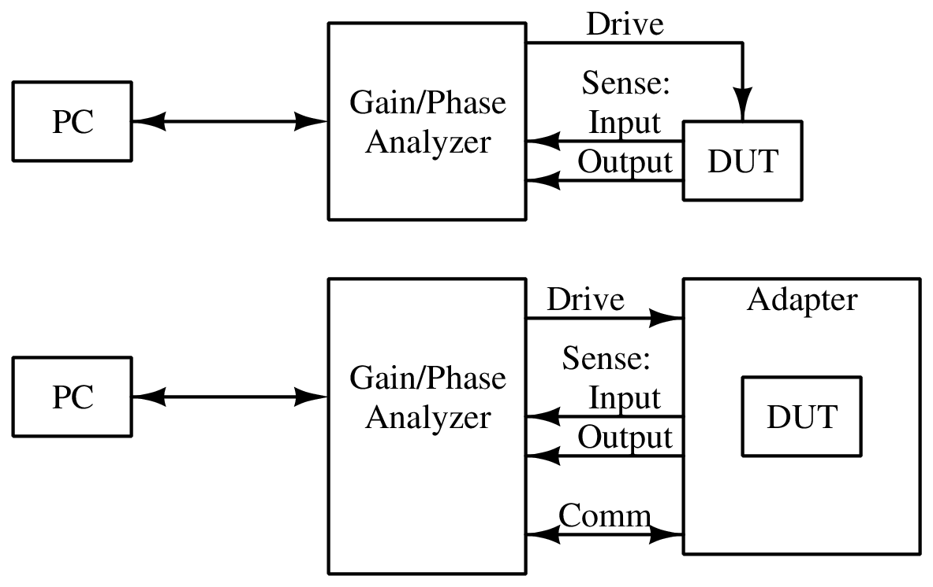

Figure : Gain/Phase Analyzer Context Diagram

### System-Level Constraints

As shown in Figure 2: Gain/Phase Analyzer System Diagram, the analyzer uses a *Synthesizer* to generate the stimulus signal, and an *Output Amplifier* to provide the stimulus signal to the DUT, at up to 1.25 V RMS and up to 150 MHz. *Input Filters*, an *Input Switching Network* and the *Input Detector* provide a signal corresponding to the amplitude of the signals at the Sense ports. The Input Switching Network can also select a *Phase Reference* to be summed with the signals for phase measurement. These are digitized by an *Analog-Digital Converter* to be processed by the *Microprocessor*. The Microprocessor then interfaces with the *Software* via the *PC Interface*.

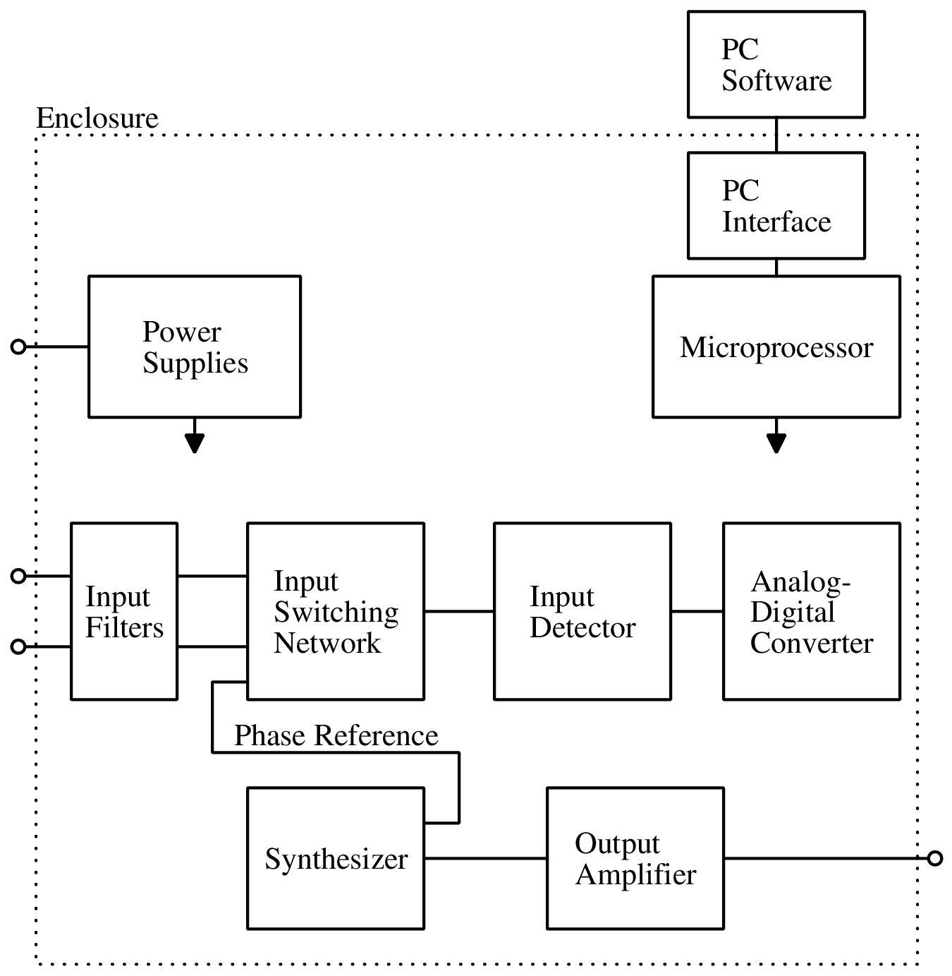

Figure : Gain/Phase Analyzer System Diagram

# Design Description

## Overview

A Gain/Phase Analyzer is an instrument used to plot the frequency response of a network or amplifier. The project, sponsored by Professor Kyle Temkin, specifies a small, computer controlled gain/phase analyzer for use by students and individuals. It can stimulate and then measure filters, amplifiers and control systems, allowing their behavior to be plotted and analyzed. The device is to be developed as an open-source project, so that students may study its inner workings.

## Detailed Description

Our project is one without many various and viable implementation possibilities. As such, many major decisions will involve study of other instrumentation which performs similar tasks, including a few open-source network analyzers. Trade study will be used as required for selecting high-cost components or designs of subsystems, and this will be addressed as necessary during the development cycle. Hardware is being designed and implemented in different stages in order to ease the process of design. Software will be created with the purpose of interfacing with the microcontroller.

### Synthesizer

The first subsystem that will be built is the frequency synthesizer. This needs to generate a frequency up to 150 MHz. For this design the circuit uses the AD9958 Direct Digital Synthesis (DDS) chip and a ‘video’ op-amp to produce the correct output.

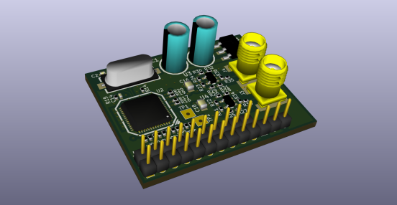

Figure : Synthesizer PCB, 3D Render

In the final product, we may integrate an optional CPLD or FPGA to allow the user to drive the modulation feature of the DDS chip; for the purposes of testing we have tied the modulation inputs straight to ground, as we do not require them.

### Input Front-end

The next section of the design is the input front-end subsystem.

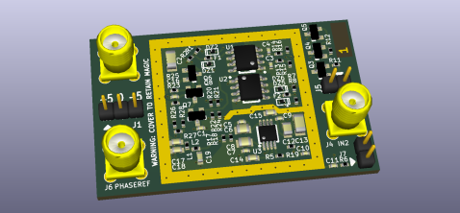

Figure : Input Front-end PCB, 3D Render

Our input front-end must take the signals from the front-panel input connectors and present them in a form which can be directly sampled by the microcontroller's analog-to-digital converter. The signals first pass through a simple input protection circuit. This consists of a small-footprint SMD fuse in series with the input and a clamping arrangement set around 3.3V (23 dBm peak). After the input protection, the two input signals enter a switching circuit to select between them. This allows all of the following circuitry to be shared between channels, minimizing cost and inter-channel variation. This is followed by a buffer, which isolates the input signal from the following power combiner and filter. After that, a power combiner adds in a variable phase reference, which allows the system to measure the input signal's phase, and a filter cuts the signal off at 300 MHz. The filtered signal then passes into a logarithmic detector with integrated low-pass filter, which presents a voltage proportional to the logarithm of the input amplitude to the microcontroller.

### Output Amplifier

The next section of the design is the output amplifier subsystem.

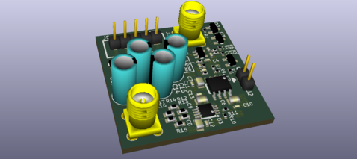

Figure : Output Amplifier PCB, 3D Render

The output amplifier must take small signals, at –8.5 dBm as they arrive from the synthesizer, and output the full 15 dBm signal. For design margin, a 16.5 dBm output amplitude is assumed. This gives a required gain of 25 dB. An additional 6 dB gain is required to compensate for the insertion loss of the termination, giving a total required gain of 31 dB. A gain of 31 dB from 1 kHz (practically DC) to 150 MHz is difficult to achieve, particularly with the very large absolute amplitude of 21 dBm at the output. We chose to use two gain stages of 15.5 dB each. The final stage is a THS3001 operational amplifier, as it supports the high slew rate, high voltage and high output current required. This is a very expensive amplifier, though, so we used the AD8000 (similar specifications, but with a lower maximum supply voltage) for the first stage. The synthesizer allows amplitude control, but this control is applied at the digital stage, resulting in a loss of DAC resolution. To get more range at full resolution, we included a MAADSS0008 switchable 15 dB attenuator in the output amplifier's signal path.

### Microprocessor

For our system’s microprocessor, we used the Atmel SAM4S16C ARM Cortex-M4 microcontroller. In the final product, we will switch to a less expensive microcontroller in the SAM4S line with a smaller amount of memory, after we have determined the amount needed.

In the current prototype, we are using the Atmel SAM4S Xplained evaluation kit; the final product will use the chip by itself.

## Use

The purpose of this device is to provide students with tangible data when analyzing circuits. As shown in Figure 1: Gain/Phase Analyzer Context Diagram, the device is to be connected between a PC and a device under test; the user can initiate an analysis using the supplied software.

# Evaluation

Omnes facilis eu ius. No saperet fabellas his, vim ex homero adolescens. Pro suas populo putent ei, mea verterem posidonium ex. Est nobis altera pertinacia id. Semper denique deserunt est te, facilisi lobortis in quo, sea lobortis persequeris reformidans ex.

Ex dictas doctus molestie eam, vitae graeco eam no. Eam dicam civibus in, id dicat dicit recteque pro. Ius utinam menandri sapientem et, vis justo gloriatur ne. Mei cu detraxit pertinacia. Vix ea hinc lobortis definitiones, primis adolescens in vim, duo mutat dicit imperdiet eu.

Et sed insolens expetenda, usu tacimates periculis conceptam te. In cum dolorum evertitur democritum, mandamus efficiantur concludaturque eu ius. Te vel quidam dissentias deterruisset. Mea in audire propriae consectetuer, hinc viris dolorem no per. Eum ei rebum consetetur, mea consulatu maiestatis cu, impetus aliquip iuvaret pri ut.

## Overview

Ea vel falli quodsi interpretaris, aperiri feugiat erroribus ne vel. Ne has habemus concludaturque, labore quaestio eu nam. Vim te duis ignota legimus. Ne probo similique delicatissimi ius. Eam an audiam luptatum, an est dicit volumus insolens. Vidit gubergren ex per. Eam illud ignota principes ex, consequat necessitatibus has ea. In affert habemus vivendum pro. Fabulas dolorum no mea, mel liber suavitate pertinacia ea. Fastidii pertinax his ea, ex usu numquam appareat maiestatis.

At qui affert luptatum. Sed ad tritani sensibus. Mei quot errem nihil at, eu est cibo tacimates, consetetur theophrastus deterruisset mei ei. Ne fabellas splendide quo, pri oratio nullam ut. In veri nostrud bonorum usu, no est adhuc invidunt elaboraret. An nullam melius comprehensam pro, solet scaevola antiopam cu eum, sit ne causae euismod menandri.

Id prompta iracundia mei, no oratio semper ponderum vix. Tale ridens fastidii et per. Id vim dicat affert democritum. Eos elit adhuc ornatus et. Summo veritus perpetua et nam, prima disputationi pro ne, cu his quem instructior.

Per commune facilisi ei, harum utroque voluptatum in sit. Munere corpora ei sea. Dicat labitur persequeris an per, ut latine oportere euripidis eam. Agam vide adhuc duo ei, ius alienum voluptua te.

Id prompta iracundia mei, no oratio semper ponderum vix. Tale ridens fastidii et per. Id vim dicat affert democritum. Eos elit adhuc ornatus et. Summo veritus perpetua et nam, prima disputationi pro ne, cu his quem instructior.

Per commune facilisi ei, harum utroque voluptatum in sit. Munere corpora ei sea. Dicat labitur persequeris an per, ut latine oportere euripidis eam. Agam vide adhuc duo ei, ius alienum voluptua te.

## Prototype

Ea vel falli quodsi interpretaris, aperiri feugiat erroribus ne vel. Ne has habemus concludaturque, labore quaestio eu nam. Vim te duis ignota legimus. Ne probo similique delicatissimi ius. Eam an audiam luptatum, an est dicit volumus insolens. Vidit gubergren ex per. Eam illud ignota principes ex, consequat necessitatibus has ea. In affert habemus vivendum pro. Fabulas dolorum no mea, mel liber suavitate pertinacia ea. Fastidii pertinax his ea, ex usu numquam appareat maiestatis.

At qui affert luptatum. Sed ad tritani sensibus. Mei quot errem nihil at, eu est cibo tacimates, consetetur theophrastus deterruisset mei ei. Ne fabellas splendide quo, pri oratio nullam ut. In veri nostrud bonorum usu, no est adhuc invidunt elaboraret. An nullam melius comprehensam pro, solet scaevola antiopam cu eum, sit ne causae euismod menandri.

Id prompta iracundia mei, no oratio semper ponderum vix. Tale ridens fastidii et per. Id vim dicat affert democritum. Eos elit adhuc ornatus et. Summo veritus perpetua et nam, prima disputationi pro ne, cu his quem instructior.

Per commune facilisi ei, harum utroque voluptatum in sit. Munere corpora ei sea. Dicat labitur persequeris an per, ut latine oportere euripidis eam. Agam vide adhuc duo ei, ius alienum voluptua te.

Id prompta iracundia mei, no oratio semper ponderum vix. Tale ridens fastidii et per. Id vim dicat affert democritum. Eos elit adhuc ornatus et. Summo veritus perpetua et nam, prima disputationi pro ne, cu his quem instructior.

Per commune facilisi ei, harum utroque voluptatum in sit. Munere corpora ei sea. Dicat labitur persequeris an per, ut latine oportere euripidis eam. Agam vide adhuc duo ei, ius alienum voluptua te.

## Testing and Results

Ea vel falli quodsi interpretaris, aperiri feugiat erroribus ne vel. Ne has habemus concludaturque, labore quaestio eu nam. Vim te duis ignota legimus. Ne probo similique delicatissimi ius. Eam an audiam luptatum, an est dicit volumus insolens. Vidit gubergren ex per. Eam illud ignota principes ex, consequat necessitatibus has ea. In affert habemus vivendum pro. Fabulas dolorum no mea, mel liber suavitate pertinacia ea. Fastidii pertinax his ea, ex usu numquam appareat maiestatis.

### Requirement WCP34.1 – Weight

At qui affert luptatum. Sed ad tritani sensibus. Mei quot errem nihil at, eu est cibo tacimates, consetetur theophrastus deterruisset mei ei. Ne fabellas splendide quo, pri oratio nullam ut. In veri nostrud bonorum usu, no est adhuc invidunt elaboraret. An nullam melius comprehensam pro, solet scaevola antiopam cu eum, sit ne causae euismod menandri.

Id prompta iracundia mei, no oratio semper ponderum vix. Tale ridens fastidii et per. Id vim dicat affert democritum. Eos elit adhuc ornatus et. Summo veritus perpetua et nam, prima disputationi pro ne, cu his quem instructior.

Per commune facilisi ei, harum utroque voluptatum in sit. Munere corpora ei sea. Dicat labitur persequeris an per, ut latine oportere euripidis eam. Agam vide adhuc duo ei, ius alienum voluptua te.

### Requirement WCP34.2 – Speed

At qui affert luptatum. Sed ad tritani sensibus. Mei quot errem nihil at, eu est cibo tacimates, consetetur theophrastus deterruisset mei ei. Ne fabellas splendide quo, pri oratio nullam ut. In veri nostrud bonorum usu, no est adhuc invidunt elaboraret. An nullam melius comprehensam pro, solet scaevola antiopam cu eum, sit ne causae euismod menandri.

Id prompta iracundia mei, no oratio semper ponderum vix. Tale ridens fastidii et per. Id vim dicat affert democritum. Eos elit adhuc ornatus et. Summo veritus perpetua et nam, prima disputationi pro ne, cu his quem instructior.

Per commune facilisi ei, harum utroque voluptatum in sit. Munere corpora ei sea. Dicat labitur persequeris an per, ut latine oportere euripidis eam. Agam vide adhuc duo ei, ius alienum voluptua te.

### Requirement WCP34.3 – Vibration

At qui affert luptatum. Sed ad tritani sensibus. Mei quot errem nihil at, eu est cibo tacimates, consetetur theophrastus deterruisset mei ei. Ne fabellas splendide quo, pri oratio nullam ut. In veri nostrud bonorum usu, no est adhuc invidunt elaboraret. An nullam melius comprehensam pro, solet scaevola antiopam cu eum, sit ne causae euismod menandri.

Id prompta iracundia mei, no oratio semper ponderum vix. Tale ridens fastidii et per. Id vim dicat affert democritum. Eos elit adhuc ornatus et. Summo veritus perpetua et nam, prima disputationi pro ne, cu his quem instructior.

Per commune facilisi ei, harum utroque voluptatum in sit. Munere corpora ei sea. Dicat labitur persequeris an per, ut latine oportere euripidis eam. Agam vide adhuc duo ei, ius alienum voluptua te.

### Requirement WCP34.4 – Temperature

At qui affert luptatum. Sed ad tritani sensibus. Mei quot errem nihil at, eu est cibo tacimates, consetetur theophrastus deterruisset mei ei. Ne fabellas splendide quo, pri oratio nullam ut. In veri nostrud bonorum usu, no est adhuc invidunt elaboraret. An nullam melius comprehensam pro, solet scaevola antiopam cu eum, sit ne causae euismod menandri.

Id prompta iracundia mei, no oratio semper ponderum vix. Tale ridens fastidii et per. Id vim dicat affert democritum. Eos elit adhuc ornatus et. Summo veritus perpetua et nam, prima disputationi pro ne, cu his quem instructior.

Per commune facilisi ei, harum utroque voluptatum in sit. Munere corpora ei sea. Dicat labitur persequeris an per, ut latine oportere euripidis eam. Agam vide adhuc duo ei, ius alienum voluptua te.

### Requirement WCP34.5 – Power output

At qui affert luptatum. Sed ad tritani sensibus. Mei quot errem nihil at, eu est cibo tacimates, consetetur theophrastus deterruisset mei ei. Ne fabellas splendide quo, pri oratio nullam ut. In veri nostrud bonorum usu, no est adhuc invidunt elaboraret. An nullam melius comprehensam pro, solet scaevola antiopam cu eum, sit ne causae euismod menandri.

Id prompta iracundia mei, no oratio semper ponderum vix. Tale ridens fastidii et per. Id vim dicat affert democritum. Eos elit adhuc ornatus et. Summo veritus perpetua et nam, prima disputationi pro ne, cu his quem instructior.

Per commune facilisi ei, harum utroque voluptatum in sit. Munere corpora ei sea. Dicat labitur persequeris an per, ut latine oportere euripidis eam. Agam vide adhuc duo ei, ius alienum voluptua te.

## Assessment

Ea vel falli quodsi interpretaris, aperiri feugiat erroribus ne vel. Ne has habemus concludaturque, labore quaestio eu nam. Vim te duis ignota legimus. Ne probo similique delicatissimi ius. Eam an audiam luptatum, an est dicit volumus insolens. Vidit gubergren ex per. Eam illud ignota principes ex, consequat necessitatibus has ea. In affert habemus vivendum pro. Fabulas dolorum no mea, mel liber suavitate pertinacia ea. Fastidii pertinax his ea, ex usu numquam appareat maiestatis.

At qui affert luptatum. Sed ad tritani sensibus. Mei quot errem nihil at, eu est cibo tacimates, consetetur theophrastus deterruisset mei ei. Ne fabellas splendide quo, pri oratio nullam ut. In veri nostrud bonorum usu, no est adhuc invidunt elaboraret. An nullam melius comprehensam pro, solet scaevola antiopam cu eum, sit ne causae euismod menandri.

Id prompta iracundia mei, no oratio semper ponderum vix. Tale ridens fastidii et per. Id vim dicat affert democritum. Eos elit adhuc ornatus et. Summo veritus perpetua et nam, prima disputationi pro ne, cu his quem instructior.

Per commune facilisi ei, harum utroque voluptatum in sit. Munere corpora ei sea. Dicat labitur persequeris an per, ut latine oportere euripidis eam. Agam vide adhuc duo ei, ius alienum voluptua te.

At qui affert luptatum. Sed ad tritani sensibus. Mei quot errem nihil at, eu est cibo tacimates, consetetur theophrastus deterruisset mei ei. Ne fabellas splendide quo, pri oratio nullam ut. In veri nostrud bonorum usu, no est adhuc invidunt elaboraret. An nullam melius comprehensam pro, solet scaevola antiopam cu eum, sit ne causae euismod menandri.

# Next Steps

Omnes facilis eu ius. No saperet fabellas his, vim ex homero adolescens. Pro suas populo putent ei, mea verterem posidonium ex. Est nobis altera pertinacia id. Semper denique deserunt est te, facilisi lobortis in quo, sea lobortis persequeris reformidans ex.

Ex dictas doctus molestie eam, vitae graeco eam no. Eam dicam civibus in, id dicat dicit recteque pro. Ius utinam menandri sapientem et, vis justo gloriatur ne. Mei cu detraxit pertinacia. Vix ea hinc lobortis definitiones, primis adolescens in vim, duo mutat dicit imperdiet eu.

Et sed insolens expetenda, usu tacimates periculis conceptam te. In cum dolorum evertitur democritum, mandamus efficiantur concludaturque eu ius. Te vel quidam dissentias deterruisset. Mea in audire propriae consectetuer, hinc viris dolorem no per. Eum ei rebum consetetur, mea consulatu maiestatis cu, impetus aliquip iuvaret pri ut.

Ea vel falli quodsi interpretaris, aperiri feugiat erroribus ne vel. Ne has habemus concludaturque, labore quaestio eu nam. Vim te duis ignota legimus. Ne probo similique delicatissimi ius. Eam an audiam luptatum, an est dicit volumus insolens. Vidit gubergren ex per. Eam illud ignota principes ex, consequat necessitatibus has ea. In affert habemus vivendum pro. Fabulas dolorum no mea, mel liber suavitate pertinacia ea. Fastidii pertinax his ea, ex usu numquam appareat maiestatis.

At qui affert luptatum. Sed ad tritani sensibus. Mei quot errem nihil at, eu est cibo tacimates, consetetur theophrastus deterruisset mei ei. Ne fabellas splendide quo, pri oratio nullam ut. In veri nostrud bonorum usu, no est adhuc invidunt elaboraret. An nullam melius comprehensam pro, solet scaevola antiopam cu eum, sit ne causae euismod menandri.

Ex dictas doctus molestie eam, vitae graeco eam no. Eam dicam civibus in, id dicat dicit recteque pro. Ius utinam menandri sapientem et, vis justo gloriatur ne. Mei cu detraxit pertinacia. Vix ea hinc lobortis definitiones, primis adolescens in vim, duo mutat dicit imperdiet eu.

Et sed insolens expetenda, usu tacimates periculis conceptam te. In cum dolorum evertitur democritum, mandamus efficiantur concludaturque eu ius. Te vel quidam dissentias deterruisset. Mea in audire propriae consectetuer, hinc viris dolorem no per. Eum ei rebum consetetur, mea consulatu maiestatis cu, impetus aliquip iuvaret pri ut.

Ea vel falli quodsi interpretaris, aperiri feugiat erroribus ne vel. Ne has habemus concludaturque, labore quaestio eu nam. Vim te duis ignota legimus. Ne probo similique delicatissimi ius. Eam an audiam luptatum, an est dicit volumus insolens. Vidit gubergren ex per. Eam illud ignota principes ex, consequat necessitatibus has ea. In affert habemus vivendum pro. Fabulas dolorum no mea, mel liber suavitate pertinacia ea. Fastidii pertinax his ea, ex usu numquam appareat maiestatis.

At qui affert luptatum. Sed ad tritani sensibus. Mei quot errem nihil at, eu est cibo tacimates, consetetur theophrastus deterruisset mei ei. Ne fabellas splendide quo, pri oratio nullam ut. In veri nostrud bonorum usu, no est adhuc invidunt elaboraret. An nullam melius comprehensam pro, solet scaevola antiopam cu eum, sit ne causae euismod menandri.

# References

[1] J. K. Herrington , “Title of chapter in the book,” in Title of Published Book, xth ed. City of Publisher, Country if not USA: Abbrev. of Publisher, year, ch. x, sec. x, pp. xxx–xxx.

[2] J. K. Herrington , “Title of chapter in the book,” in Title of Published Book, xth ed. City of Publisher, Country if not USA: Abbrev. of Publisher, year, ch. x, sec. x, pp. xxx–xxx.

[3] J. K. Herrington , “Title of chapter in the book,” in Title of Published Book, xth ed. City of Publisher, Country if not USA: Abbrev. of Publisher, year, ch. x, sec. x, pp. xxx–xxx.

[4] J. K. Herrington , “Title of chapter in the book,” in Title of Published Book, xth ed. City of Publisher, Country if not USA: Abbrev. of Publisher, year, ch. x, sec. x, pp. xxx–xxx.

[5] J. K. Herrington , “Title of chapter in the book,” in Title of Published Book, xth ed. City of Publisher, Country if not USA: Abbrev. of Publisher, year, ch. x, sec. x, pp. xxx–xxx.

[6] J. K. Herrington , “Title of chapter in the book,” in Title of Published Book, xth ed. City of Publisher, Country if not USA: Abbrev. of Publisher, year, ch. x, sec. x, pp. xxx–xxx.

# Appendix A Computer Code

#include "StdAfx.h"

#include "RADDS_Utilities.h"

#include "WarehouseEquipment.h"

#include "Teachpoint.h"

#include "Channel.h"

#include "WorkcellEquipment.h"

#pragma warning (disable : 4996)

////////////////////////////////////////////////////////

//

// Workcell Equipment Class

//

////////////////////////////////////////////////////////

// constructor

WorkcellEquipment::WorkcellEquipment()

{

m_FinancialMetric = new FinancialMetric();

m_HardwareMetric = new HardwareMetric();

m_ll_Teachpoint = new LinkedList();

m_ll_Connection = new LinkedList();

m_ll_ConnectedTo = new LinkedList();

Clear();

}

Appendix B CAD Drawings

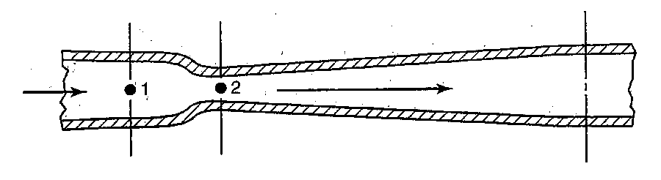

Appendix C Test Procedures

**3.1.1: Required mode: Idle**

“The signal source and detection subsystems are inactive, and the system is waiting for commands.”

The idle state of the signal source is to be verified by viewing the signal from the “output” connector on an oscilloscope. Any signal present must be less than 5 mV peak to peak.

The idle state of the detection subsystem is verified by viewing the status annunciators on the printed circuit board. The annunciator designated “sample” must not light.

**3.1.2: Required mode: Analysis**

“The system is performing a gain/phase analysis.”

This requirement is satistfied peripherally by the completion of requirement 3.2.1.

**3.2.1: Bode plot output**

To test this requirement, connect a patch cable between the “Output” connector and the “Input 1” connector, and initiate a non-normalized single-input analysis via the PC software with frequency bounds of 1 kHz and 150 MHz. A pair of plots must be produced, one indicating gain, and one indicating phase. This requirement places no constraints on the data that is displayed.

**3.2.2: Signals sourced from 1 kHz to 150 MHz**

To test this requirement, connect a patch cable between the “Output” connector and an oscilloscope with at least 100 MHz bandwidth. Either using the PC software or manual control via a serial terminal, command the instrument to generate a signal with a frequency of 1 kHz, and then a signal with a frequency of 150 MHz. Using the oscilloscope’s frequency display, verify that the signal is present, and that the frequency is within 2.5% of its nominal value.

**3.2.3: Signals up to 1.25 V RMS under 100 MHz**

To test this requirement, connect a patch cable between the “Output” connector and an oscilloscope with at least 300 MHz bandwidth. Either using the PC software or manual control via a serial terminal, command the instrument to generate a signal with a frequency of 1 kHz, and then a signal with a frequency of 100 MHz, both with maximum amplitude. Using the oscilloscope’s amplitude display, verify that both signals have an amplitude of at least 1.25 V RMS.

**3.2.4: Signals detected as low as 40 dB below output amplitude**

To test this requirement, connect a patch cable between the “Output” connector and the “Input 1” connector. Command the instrument to generate a signal with a frequency of 100 kHz and maximum amplitude. Query the reported amplitude on the input. Next, remove the patch cable, and query the reported amplitude on the input again. The reported amplitude must be at least 45 dB lower than the amplitude reported above.

**3.2.5: Signals detected should be as low as 60 dB below output amplitude**

To test this optional requirement, perform the same test as in 3.2.4, but verify that the final reported amplitude is at least 65 dB lower than the amplitude reported above.

**3.2.6: Accuracy within 3 dB, 5 degrees**

To test this requirement, connect a pair of patch cables in series using a cable coupler, and connect this pair between the “Output” connector and the “Input 1” connector. Configure the PC software for a full sweep from 1 kHz to 150 MHz including phase analysis. Perform normalization. Then, remove the cable coupler and insert a 50-ohm attenuator with specified attenuation between 5 dB and 15 dB and bandwidth of at least 200 MHz. Perform analysis. Verify that the reported gain is within 3 dB of the specified gain of the attenuator at all frequencies, and that the reported phase shift is within 5 degrees of zero (above -5 degrees and below +5 degrees) at all frequencies.

**3.3.1: The analyzer shall interface with a PC.**

This requirement is satistfied peripherally by the completion of requirements 3.2.1 through 3.2.6, which all required PC interfacing to complete.

**3.3.2: The analyzer should use a text-driven protocol.**

To test this requirement, connect the instrument to a PC. Connect a serial terminal application to it, and perform at least one command that produces a response. Demonstrate that the command and response comprise displayable symbols.

**3.3.3: The analyzer should use a common, standard communication protocol, for example, USB-CDC.**

To test this requirement, connect the instrument to a PC running a Linux-based operating system, and follow this procedure:

1. Open a command prompt.
2. Run this command to discover the device ID: dmesg | tail
3. Enter the following directory:

/sys/bus/usb/devices/*deviceID*/driver/module/drivers

1. View the directory listing, and verify that at least one of the following entries is present:
   * usb-serial:generic
   * usb:usbserial
   * usb:usbserial_generic

**3.3.4: The analyzer shall use either SMA or BNC connectors to interface to the device under test.**

To test this requirement, observe the front panel of the device, and see that the RF connectors are either SMA or BNC.

**3.3.5: The analyzer shall provide power via a front-panel connector for use with external DUT adapters. The voltage should be at least +/- 7 V, and up to 40 mA should be available.**

To test this requirement, ensure that the device is powered and connected to a PC. Connect the “common” input of a multimeter to device ground, then use the multimeter to probe the “Auxiliary” connector and verify that there are power supply pins with a voltage present of at lest +7 V and -7 V. Then, switch the multimeter to ammeter mode, and connect in series a selected resistor. Probe these pins again, and verify that at least 40 mA is supplied.

The resistor is to be selected such that it will draw at least 40 mA at the voltage that was measured on the connectors. This resistance may depend on the actual voltage that was present, which is allowed to be *above* the required +/- 7 V.

**3.6.1: Operator’s manual**

Demonstrate the existence of a manual in digital format, containing at least the following sections: Theory of Operation, Operational Instructions. Demonstrate that there exist example test setups for characterization of filters and of control loops.

**3.6.2: Protocol guide**

Demonstrate the existence of documentation explaining the protocol with which a PC communicates with the instrument. This documentation may be part of the Operator’s Manual, or it may be separate.

**3.6.3: Surface-mount technology**

Demonstrate that the parts on the PCB are surface-mount devices, with the following allowed exceptions:

* Connectors: through-hole connectors have higher mechanical stability.
* Inductors and capacitors larger than 5mm in diameter: through-hole parts have higher mechanical stability.

Demonstrate that the only leadless devices on the PCB are essential for its function. This may be as a result of directly satistfying an above requirement. An anticipated example is device U3, an Analog Devices AD9958BCPZ digital frequency synthesizer, which directly satisfies requirement 3.2.2 (test signal frequency between 1 kHz and 150 MHz).

**3.6.4: Direct control of hardware functions should be exposed**

Viewing the protocol guide, demonstrate the existence of:

* A command to set the output value of an arbitrary GPIO pin.
* A command to query the input value of an arbitrary GPIO pin.
* A command to transmit arbitrary data via the on-board SPI interface.
* A command to query the direct output value of the analog-to-digital converter.

**3.6.5: The system shall have no voltages greater than 30 V peak-to-peak accessible externally**

To test this requirement, connect the “common” input of a multimeter to the instrument ground, and verify that no signals on the “Auxiliary” connector are more positive than 15 V or more negative than -15 V. Then, connect a patch cable between the “Output” connector and an oscilloscope. Command the instrument to generate a signal with a frequency of 100 kHz and maximum amplitude. Using the oscilloscope’s amplitude display, verify that the positive and negative peaks are no more positive than 15 V and no more negative than -15 V.