# **Project 1: The role of NK cells in inflammation**

# **Background**

First described 40 years ago, natural killer (NK) cells represent the founding members of the innate lymphoid cell (ILC) family. They were initially defined by their ability to kill cancer cells of hematopoietic origin. More recently, NK cells are recognized not only for their ability to kill infected or malignant cells, but also for mediating cytotoxicity against a range of normal immune cells. They thereby play an important physiological role in controlling immune responses and maintaining homeostasis. Besides cytotoxic activity, NK cells activation is accompanied by secretion of pro-inflammatory cytokines. Hence, NK cells have the potential to act both in driving inflammation and in restricting adaptive immune responses that may otherwise lead to excessive inflammation or even autoimmunity.

# **Suggested aims:**

* Reconstruct an executable model for studying the role of NK cells in inflammation
* You can consult the Atlas of Inflammation Resolution here <https://air.bio.informatik.uni-rostock.de/>
* You can use the submap of NK cells found in the AIR map:
* <https://air.elixir-luxembourg.org/minerva/>
* From the submaps choose the NKcell map. Right click on the map and download it as CellDesigner SBML.
* Open it in CellDesigner and study the pathways that are involved – decide if you want to expand, reduce or use the graph as is to produce your model.
* Rerun the CaSQ practical -🡪 create your Boolean model.
* Calculate the stable states 🡪 what do you observe?
* How can we proceed and analyse the steady states?

# **Additional Resources:**

The role of NK cells in inflammation:

<https://pubmed.ncbi.nlm.nih.gov/30122459/>

You can also take inspiration from the following papers for analysing a large set of attractors:

<https://academic.oup.com/bioinformatics/article/36/16/4473/5836892> (3.3.2.2 Logical steady-state analysis for the mast cell activation models.)

<https://www.mdpi.com/2072-6694/12/12/3664>

<https://www.frontiersin.org/articles/10.3389/fphys.2020.558606/full>

# **Project 2: Modelling anti-TNF treatment in RA patients**

# **Background**

The typical therapy for RA includes the use of disease-modifying anti-rheumatic drugs (DMARDs). Conventional DMARDs include drugs that target the entire immune system, whereas biologic DMARDs are monoclonal antibodies (mAbs) and soluble receptors that target protein messenger molecules or cells. Patients who do not respond to conventional DMARDs usually initiate therapy with TNF inhibitors. However, approximately 30–40% of RA patients fail to respond to anti-TNF therapy and are usually obliged to undergo several rounds of drug combinations. Due to the complex nature of RA, systems biology and integrative approaches are needed to gain insight into the disease pathogenesis and progression. In addition, focusing only on one aspect of the disease provides a limited understanding of the multifactorial nature of RA.

# **Suggested aims:**

* Reconstruct an executable model for studying the role of TNF in RA and how blocking its actions affects the inflammatory outcome.
* You can use as a basis the model proposed in Miagoux et al, 2021 – to obtain the file go to the following repository: [https://gitlab.com/genhotel/inference-of-a-global-integrative-network-for-rheumatoid-arthritis/ /tree/main/data/modeling_and_simulation/subnetwork_casqed](https://gitlab.com/genhotel/inference-of-a-global-integrative-network-for-rheumatoid-arthritis/%20/tree/main/data/modeling_and_simulation/subnetwork_casqed)
* Download the subnetwork_without_coregnet file and open it in CellDesigner – what do you observe?
* Think about improving, enriching or modifying the model to make it more intuitive. For example you can add phenotype nodes.
* Rerun the CaSQ hands on, create your executable sbml.
* Import the model to Cell Collective and consult the following paper to reproduce some of the experiments: <https://www.mdpi.com/2075-4426/11/8/785>
* You can use the CaSQ CoLoMoTo notebook to calculate attractors.
* You can also use the following commands to enumerate and to visualize the attractors on the graph:

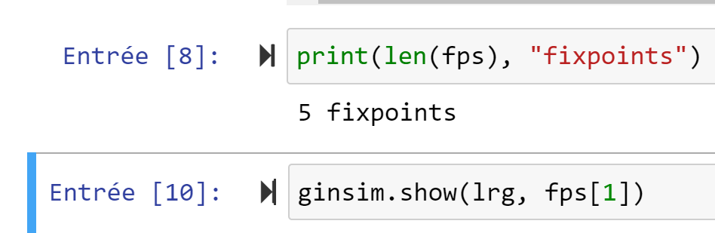

# **Additional Resources:**

You can visit the RA map to get information about pathways you might wish to add to your model

<https://academic.oup.com/database/article/doi/10.1093/database/baaa017/5821574?login=true>

<https://ramap.uni.lu/minerva/>