PROJECT 3 (INFINITE FLYER)
CHAUGHN ROBIN

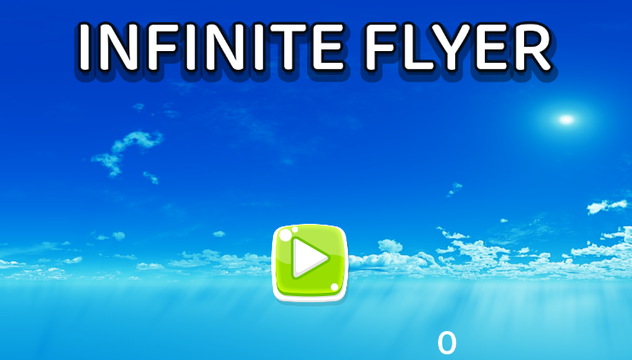

How To Play
Menu –
On launch, the game begins on the main menu screen. The options are ‘Play’, ‘Settings’, and ‘Exit’.
- Press Play to begin the game.
- Press Settings to open the settings menu.
- Press Exit to exit the game.

Controls –
- ‘WASD keys or ↑←↓→ keys’ are used for the movement controls.
- W / ↑ is used to pitch downwards.
- S / ↓ is used to pitch upwards.
- D / → turns the player to the right.
- A / ← turns the player to the left.

- SPACE makes the player brake, allowing for quick grabs of flies, entering of close rings, or the chance to avoid a building.

- ESC opens or closes the menu overlay. If the game is in progress, opening the menu will also pause the game.

- The controls can also be found by navigating to Main Menu→Settings→Controls or by using the menu overlay’s Controls tab.

Obstacles –
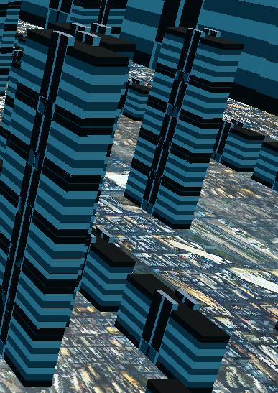
Buildings/Skyscrapers are the main obstacle players will encounter. Flying into them will hurt the bird and cause a game over– watch out! Skyscrapers can spawn horizontally or vertically! Buildings come in varying sizes, small all the way up to skyscrapers touching the clouds!

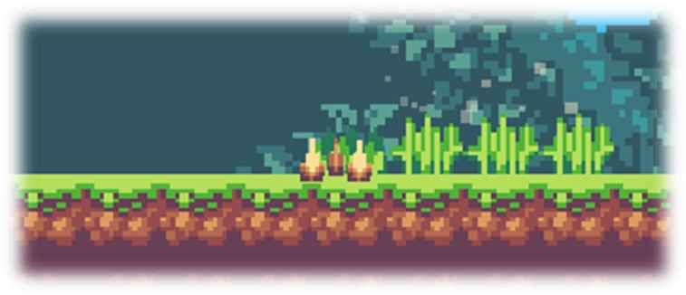

Items–
Rings are collectible items that give the player 200 points each. 

Flies are bonus items that give the player 100 points each.
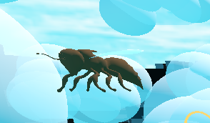

Planes are not an obstacle but a random event players will see flying in the background! I wonder where they’re going!
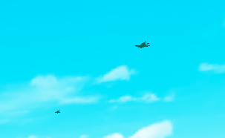

Clouds are not a harmful obstacle either, unless you’re afraid to get wet!
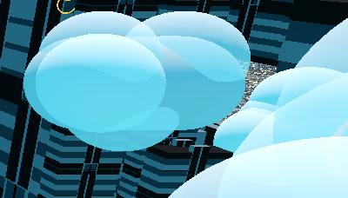

Results of the Playtesting
Rev2:
UI:
- Added score counter and menu to UI.
Player Scene:
- Changed plane to bird model.
- Bird flying and braking animation.
- Added several controls for birds.

Menu Scene:
- Added menu scene from my previous game. Same documentation.

Rev1:
- Navigation between starting screen to game start, and game end back to starting screen is functioning correctly.
- Base functionality from game.
- Screens and UI basic functionality.
- Ranking.

Documentation
Four changes from the Project instructions:
- Change the theme of your game by changing the look and sounds of your game.

- Add an additional dynamic element of the game that rewards the player somehow. (Powerups with unique looks, sound, and animations. Black holes, )

- Add an additional dynamic element of the game that harms the player somehow.

- Creating a second game experience for a single level after a set number of levels or other triggering event.

