PROJECT 2 (JUNGLE JUMP)
CHAUGHN ROBIN

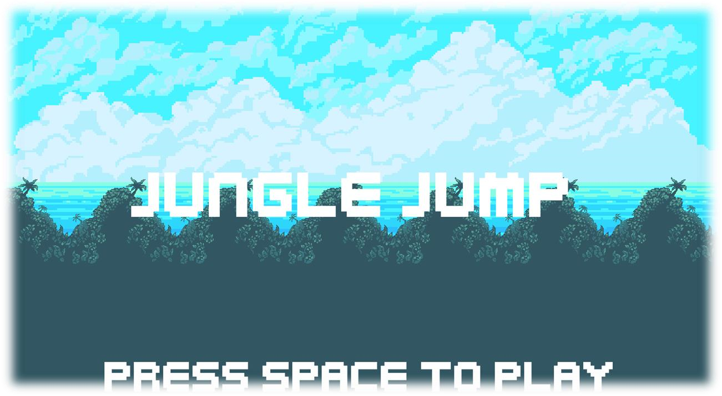

How To Play
Menu –
On launch, the game begins on the main menu screen. The options are ‘Play’, ‘Settings’, and ‘Exit’.
- Press Play to begin the game.
- Press Settings to open the settings menu.
- Press Exit to exit the game.

Controls –
- ‘WASD keys or ↑←↓→ keys’ are used for the movement controls.
- W / ↑ is used to climb upwards.
- S / ↓ is used to climb downwards.
- D / → moves the player to the right.
- A / ← moves the player to the left.

- SPACE makes the player jump. (2x in succession will double jump)

- ESC opens or closes the menu overlay. If the game is in progress, opening the menu will also pause the game.

- The controls can also be found by navigating to Main Menu→Settings→Controls or by using the menu overlay’s Controls tab.

Obstacles –
Spikes are one obstacle players will encounter. Landing on or running into them will damage the player – watch out!

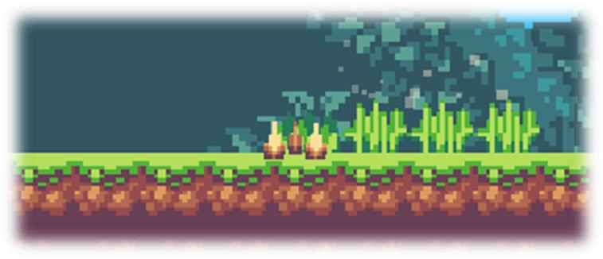
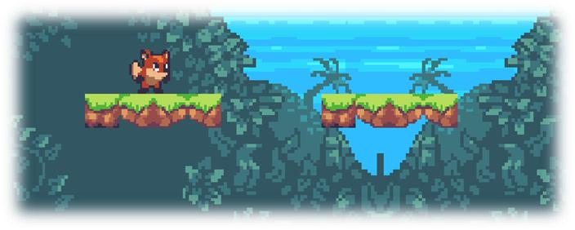

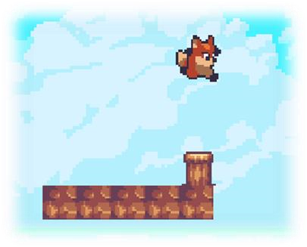
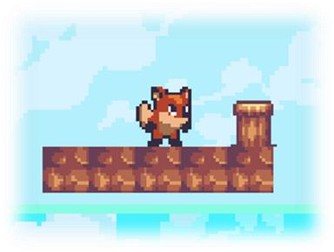
Launch pads are another obstacle the player will encounter – but these obstacles can be used to your benefit! Jump on top and propel yourself higher!

Moving platforms can pose a challenge for the player. There are platforms that move vertically, horizontally, and at different speeds. Be careful!

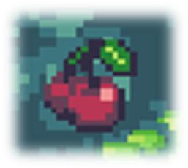
Items–
Cherries are collectible items that give the player 50 points each.
Gems are special collectible items that will be tallied up at the end of the game for a special score. They also offer the player certain hidden benefits.
Many gems are hidden throughout levels, triggered by different events / locations.
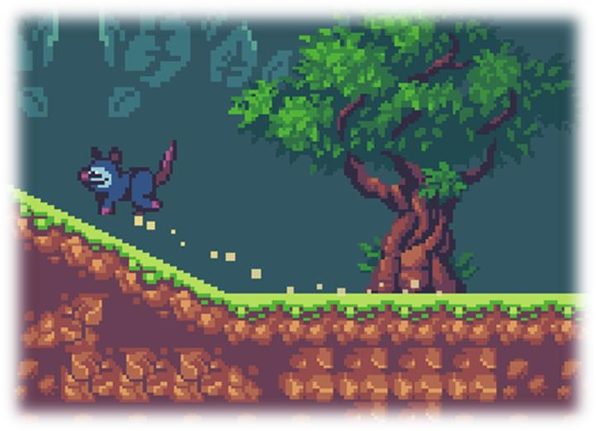
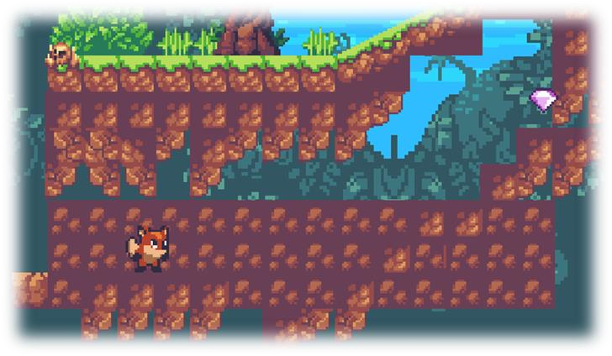
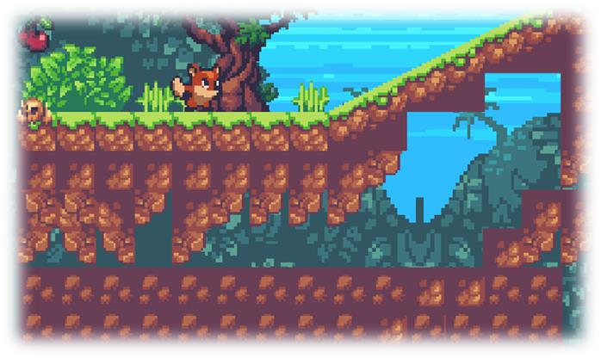

Enemies –
Possums are a simple enemy you will encounter in Jungle Jump. They will hurt the player on contact! Unless the player jumps on top of them – the possum’s one weakness.

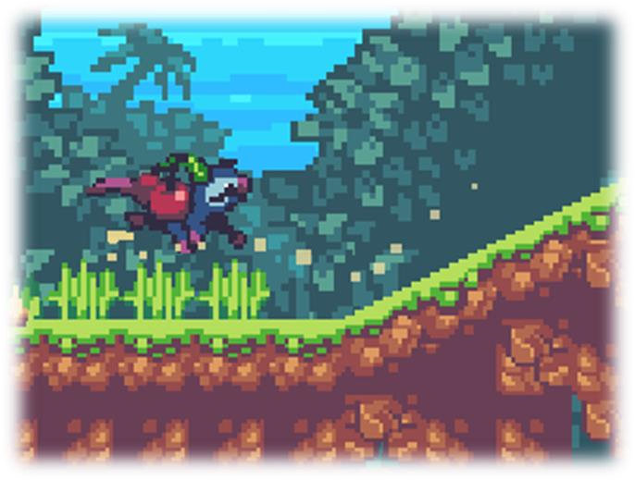
If a possum collides with an item the player can pick up, the possum will snatch it and carry it until it is defeated!

Results of the Playtesting
Rev2:
Level Scene:
- Spawns gems based on grouping.

Enemy Scene:
- Added various dust CPUParticlesEffects based on movement.
- Enemies will now “snatch” items that the player can pick up. Adds an interesting addition. But, has a possible bug based on how I did the code.

GameState Scene:
- Added checkpoint style feature, on each level you get 3 tries before GameOver state.
UI:
- Added Gem counter.
Player Scene:
- Changed / added certain sounds. E.g. Jump, Hurt, Death.
- I implemented my own version of double jumping.
- Added animation for player to jump up when hurt, and on death, player jumps up higher than falls down off the screen – like Super Mario.
Menu Scene:
- Added menu scene from my previous game. Same documentation.
Bounds Scene:
- Used to check if player out of bounds for death.

Rev1:
- Navigation between starting screen to game start, and game end back to starting screen is functioning correctly.
- Base functionality from game.
- Screens and UI basic functionality.
Player Scene:
- Added various dust CPUParticlesEffects based on movement.
Sounds:
- Added several sounds (points, pick up sounds, etc)
- Obstacles:
- Added Launch Pad.
Enemy Scene:
- Added various dust CPUParticlesEffects based on movement.

Documentation
Four changes from the Project instructions:
- Change the theme of your game by changing the look and sounds of your game.

- Add an additional dynamic element of the game that rewards the player somehow. (Powerups with unique looks, sound, and animations. Black holes, )

- Add an additional dynamic element of the game that harms the player somehow.

- Creating a second game experience for a single level after a set number of levels or other triggering event.

- Create a story between levels with animation, sound, and text.

- Create a secondary player that is inert while not being used, but that can be activated by the player for use rendering the primary player inert.

❖ - Yellow highlight indicates this has not yet been implemented.

