**US Computer and Mathematical Employment Analysis**

* At nation level in 2017, office and administrative support, sales, and food preparation and serving are the 3 largest major occupations. Computer and mathematical occupations rank No. 14 among 22 major occupation categories.

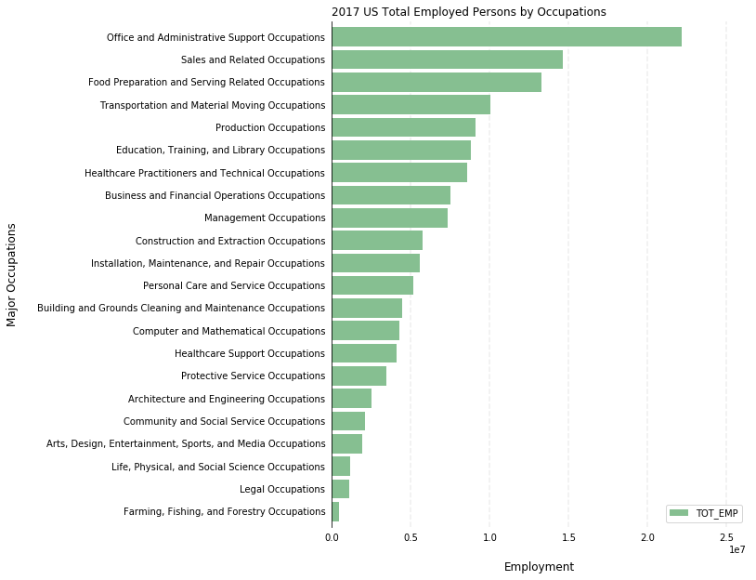

Inside computer and mathematical occupations, software developers, computer user support specialists and computer system analysts occupations had the highest number of employees.

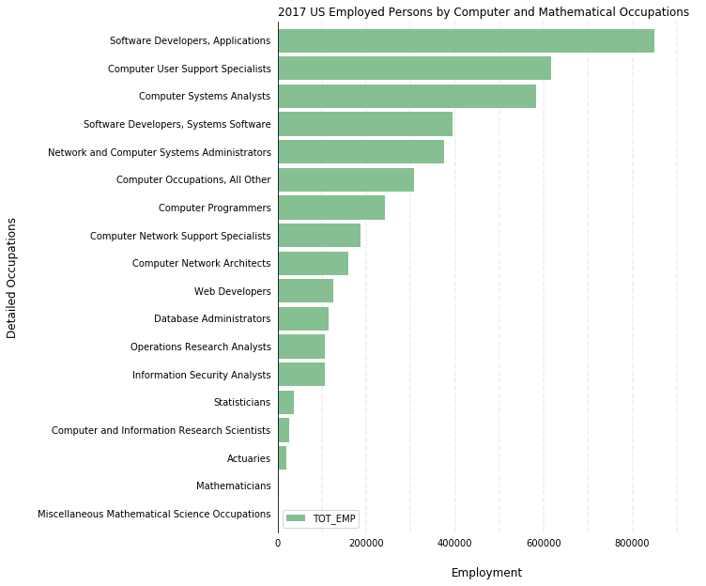

* At state level in 2017, California, Texas, and New York are the top 3 states had the most people working in computer and mathematical related occupations.

