**多线程**

**工作机制：**

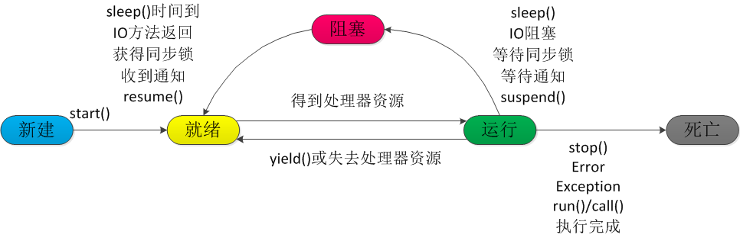

**参考：**

https://blog.csdn.net/xingjiarong/article/details/47984659