**Title of my project.**

Design and Implementation of iOS-Oriented Financial Data Analysis Software.

**Descriptive Abstract of my Project.**

In order to let banks understand all kinds of financial related information of enterprises better and safely, it is necessary to construct corresponding financial data analysis software, which can integrate various types of financial information published by different sources and store them in a database, then analysis them according to relevant data and indicators.

**Introduction.**

As one of many financial institutions, banks have a lot of capital flow every day, such as personal flow, wage flow, large amount of personal flow, personal flow in different places, enterprise flow, etc., and a large part of which comes from lending to various enterprises.

Before a bank grants a loan to an enterprise, the bank needs to determine whether there is commercial risk in granting a loan to the enterprise according to the basic information of the enterprise, the basic information of the enterprise's shareholders, the financial statements, the enterprise's equity financing and other basic information in advance.

In order to meet the needs of banks and other financial institutions for enterprise information collection, to let them obtain all kinds of enterprise information related to finance faster and more safely. It is necessary to design financial data analysis software to reduce the risk of bank loans in combination with the characteristics of efficient and fast Internet and the characteristics of financial data informatization.

The software can sort out all kinds of financial information from different publishing sources and store them in the database. According to the relevant data, indicators and algorithms, it can automatically analyze them. It is convenient for bank staff to extract data and evaluate the corresponding enterprises.

**Work Completed.**

We have already completed the Company Search part, and the Financing Report part.

In Company Search part, this app can show a list of companies related to search keywords, this part also support fuzzy search.

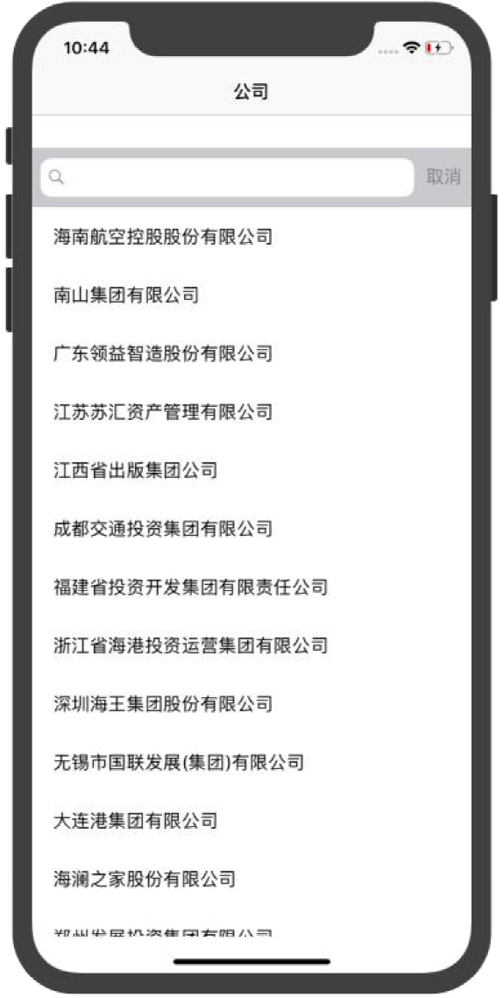 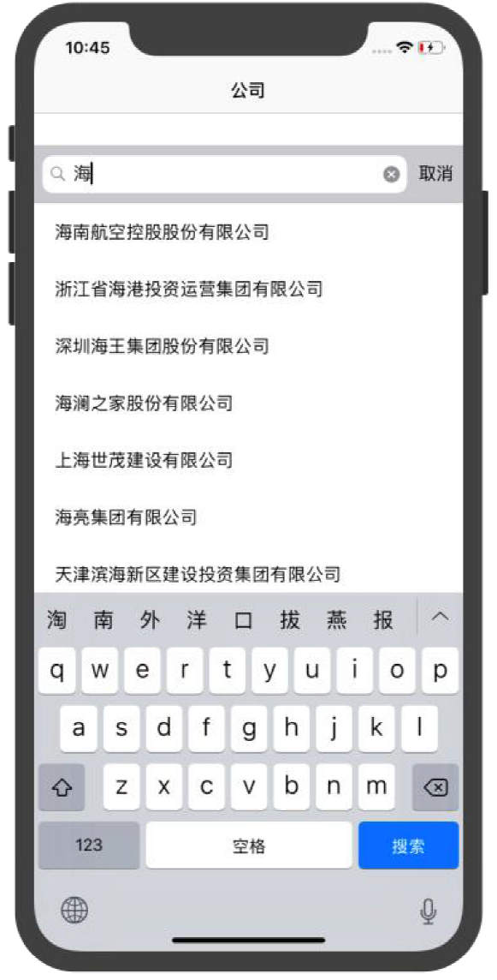

In Financing Report part, when I click a company in search result list, the app can show the financing report of the company, the report include basic information, stockholder background, history, manager, production management, financing report and capital raising. each tag can be tapped in and show the detail information.

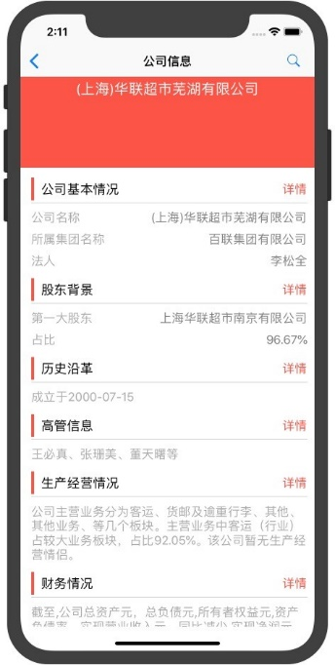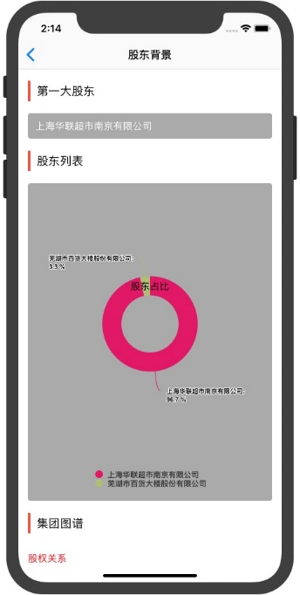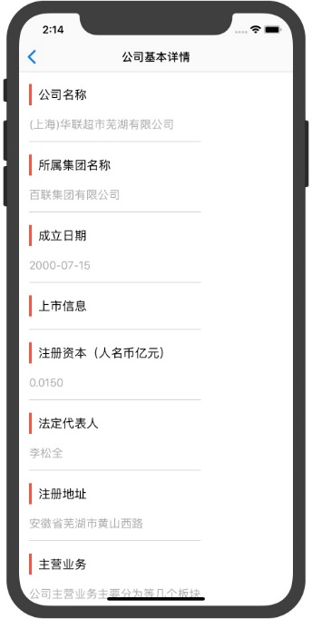

**Work to Be Completed.**

Business opportunity part and user management part need to be done. We have already design the interface prototype of each part. At the same time, some related database tables will be designed.

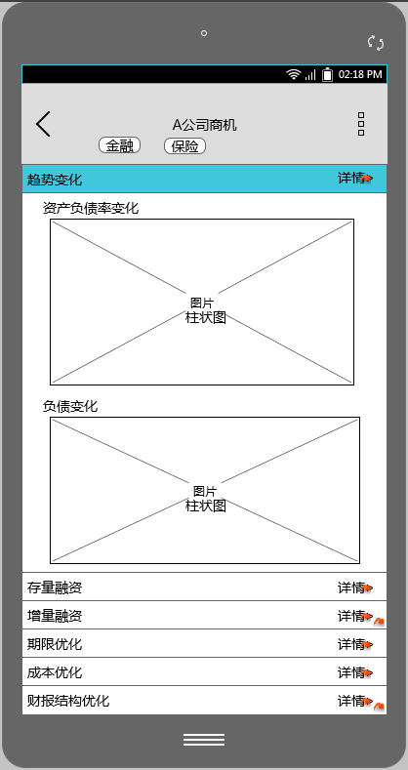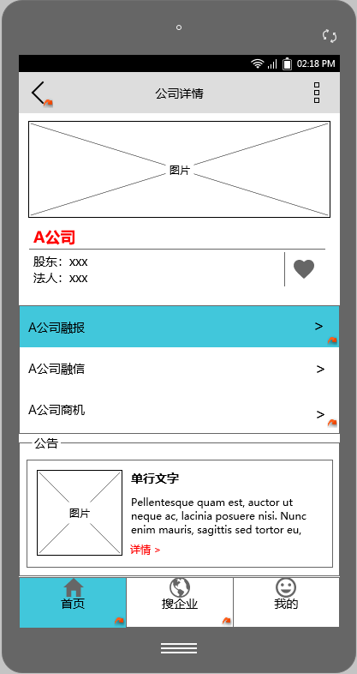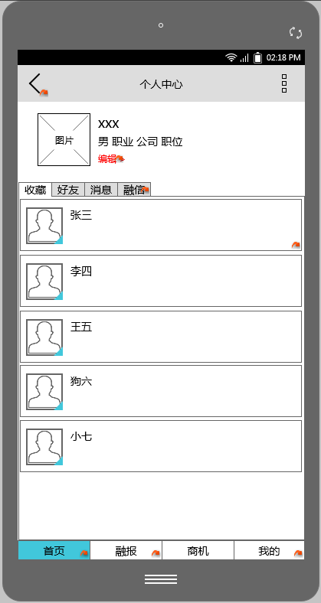

**Research/Resources.**

Financial data analysis software is to mine the corresponding financial data from the specific financial website, then carry out a series of specific processing on these data, and store these formed structured data in the database, to let relevant staff extracting, querying and using data more convenient.

At present, financial data analysis methods at home and abroad include financial statement analysis method and risk environment analysis method.

(1) Analysis of financial statements. The financial statement analysis method can process, analyze, compare and evaluate the data on the financial statements of an enterprise, which can fully reflect whether the financial situation of the enterprise is good or not, whether the operation and management are sound or not, and whether the business prospects are bright or not. In addition, we can find out the problems in enterprise management through analysis, and put forward corresponding solutions to these problems.

(2) Risk environment analysis method. Risk environment analysis method can be used to identify specific enterprise risks. According to the internal and external environment of the enterprise, systematic analysis can be carried out to infer the risks and potential losses of the enterprise in the enterprise environment.

**Revised Time Line.**

**Conclusion.**

We have completed the development and testing of the completed modules, and the progress is basically the same as the expected plan. Finally, I will complete the development of the whole app with the help of teachers and project managers.