**Chain**

1. **Gaussian model**

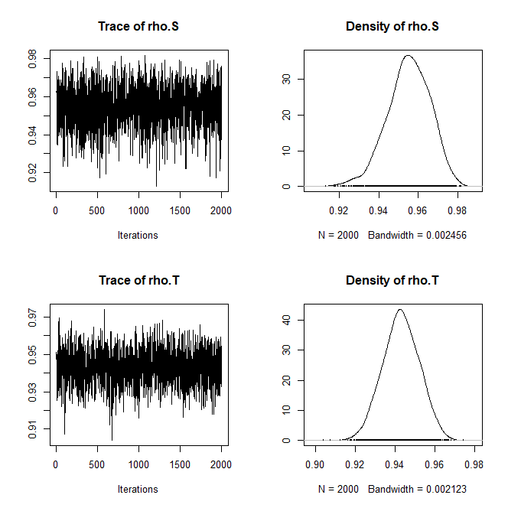

1. **Poisson model (just takeing the integer part)**

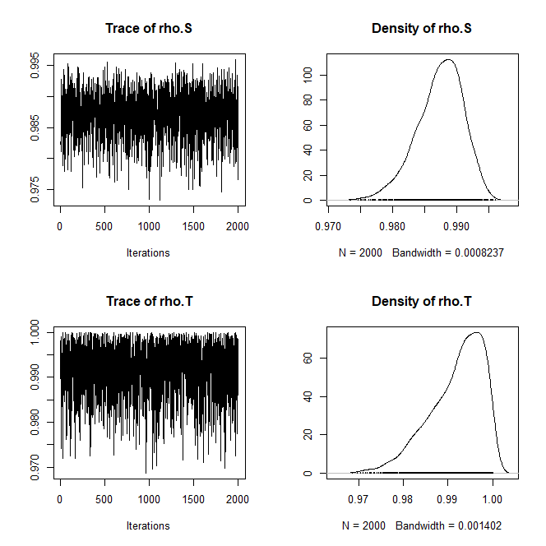

1. **Poisson model (mulitiple by 10)**



**Texas NA**

1. **Gaussian model**

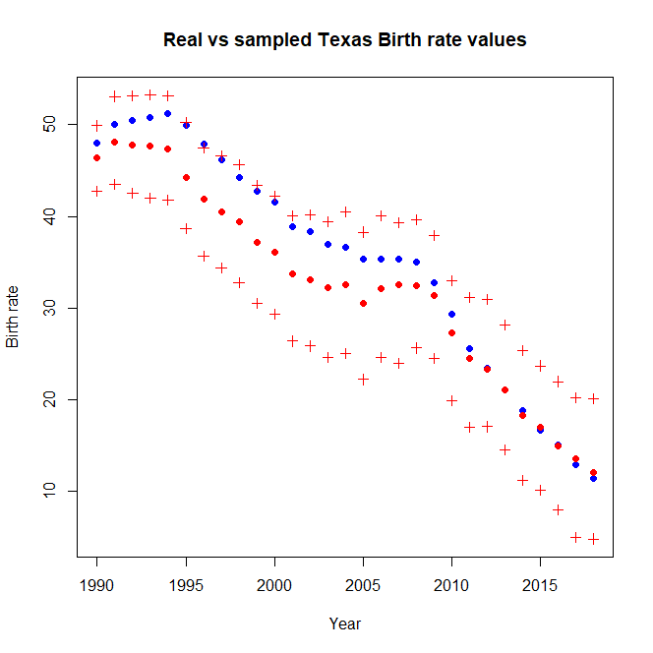

**MSE：12.88089**

1. **Poisson model (just takeing the integer part)**

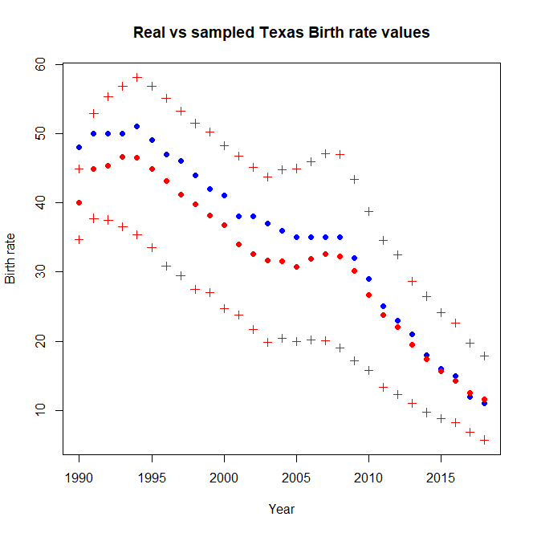

**MSE: 13.77823**

1. **Poisson model (mulitiple by 10)**

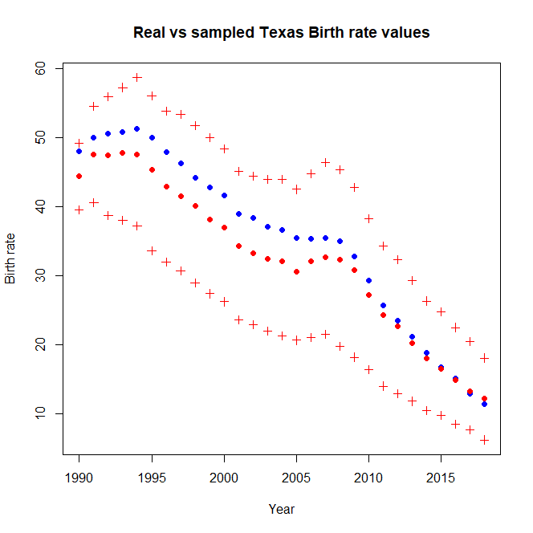

**MSE：11.56185**

**MISSOURI NA**

**1. Gaussian model**

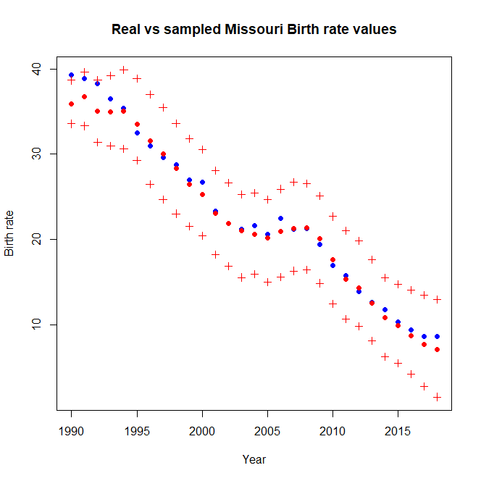

**MSE: 1.456504**

**2. Poisson model (just takeing the integer part)**

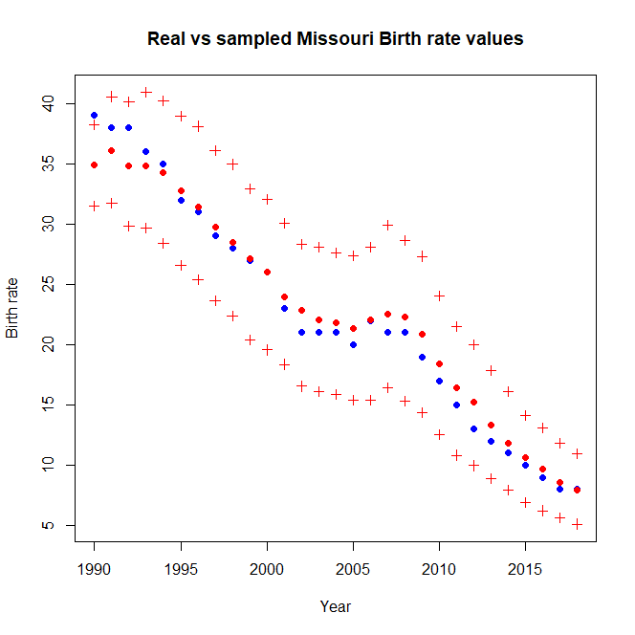

**MSE: 2.118324**

**3. Poisson model (mulitiple by 10)**

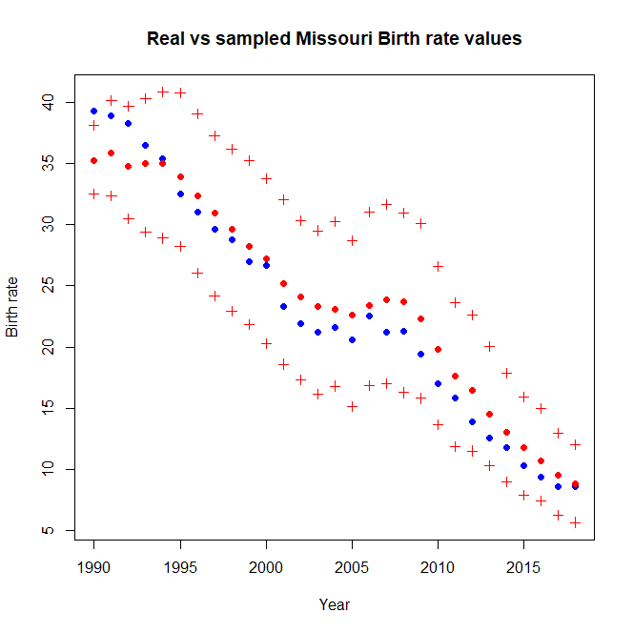

**MSE：4.052272**

**Washington NA**

**1. Gaussian model**

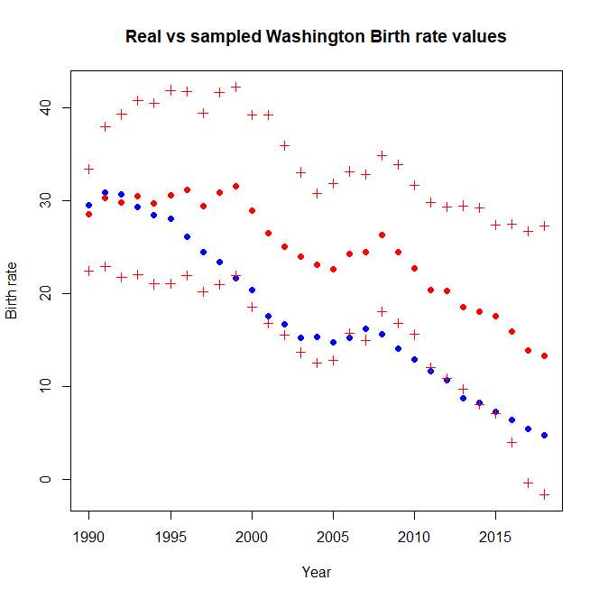

**MSE: 62.21455**

**2. Poisson model (just takeing the integer part)**

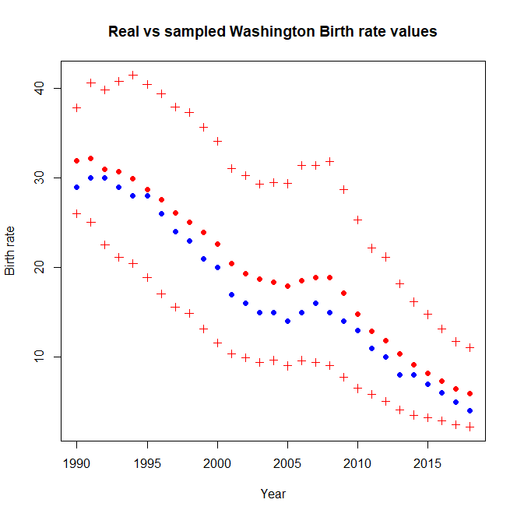

**MSE: 6.331506**

**3. Poisson model (mulitiple by 10)**

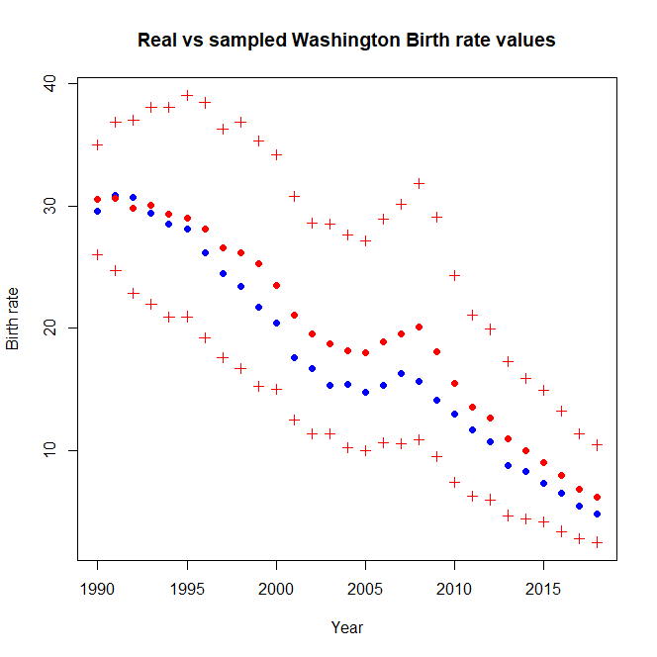

**MSE: 6.25294**

**Missouri 3NA: prediction**

**1. Gaussian model**

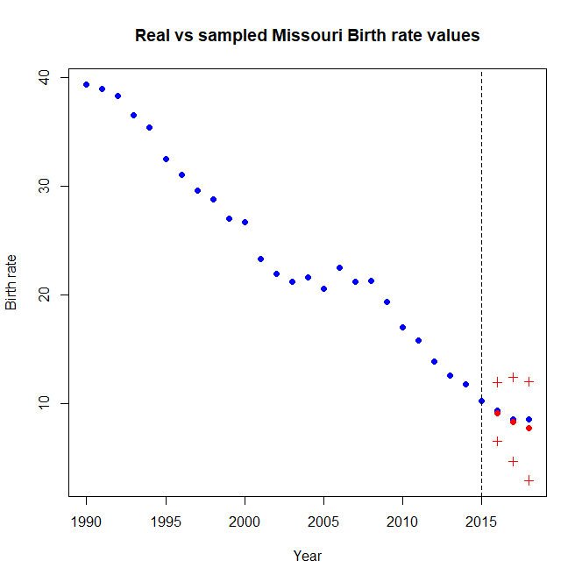

**MSE: 0.2577047**

**2. Poisson model (just takeing the integer part)**

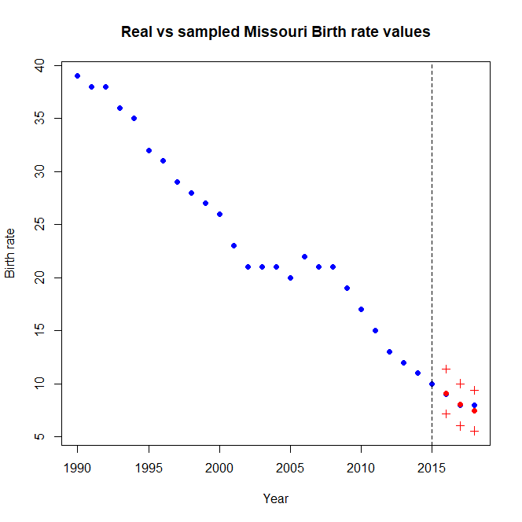

**MSE: 0.10557**

**3. Poisson model (mulitiple by 10)**

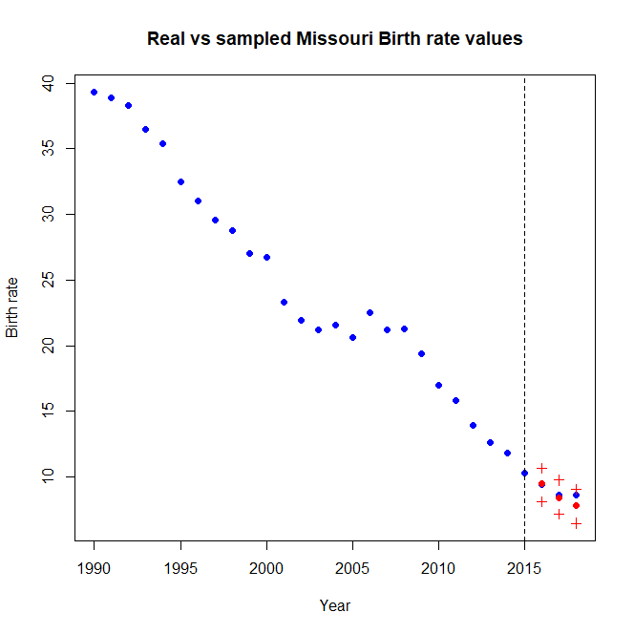

**MSE: 0.231346**