SYSC 4907

Come and Chat (C&C):

Fourth Year Engineering Progress Report

Carleton University

Group Members:

Yunzhou Liu 101027110

Shizhong Shang 101115304

Zirui Qiao 101100225

Supervisor:

Lynn Marshall

30 November 2022

**Abstract**

Instant messaging (IM) technology is a type of online chat allowing real-time text transmission over the Internet or another computer network. There are many famous IM software, such as Discord, WhatsApp and Facebook Messenger. To develop the web based instant messaging software --- Come and Chat (C&C), a series of research, analysis, design, implementation and test will be done.

This report tracks the processes of developing the C&C system from the research phase to the very beginning of the implementation phase because later stages still need to be started. After a survey of three of the most famous instant messaging software, Discord, WhatsApp and Facebook Messenger, many unexpected techniques were learned. Followed by intense discussions and rigorous analysis, we extracted many common and valuable requirements from the three famous IM software and added some new features of our own conception. A detailed requirements document was then created. Use Case Diagram and Description are generated based on the requirement documents, then the Flow Diagram, Overall Structure, ER Diagram, Back-end UML, Front pages prototype, Front-end UML and finally, the API specification document.

Then, a series techniques that will be used in implementation are identified through discussion and justification about choosing them is provided in the report. Some estimation of challenges and risks that may encounter in the future are listed, as well as the timetable.

Table of Content

1. Introduction 3

1.1 Purpose 3

1.2 Scope 3

1.3 Plan 3

1.4 Accomplishments 4

1.5 Overview of Report 4

2. Engineering Project 5

2.1 Health and Safety 5

2.2 Engineering Professionalism 5

2.3 Management Methodology 5

2.4 Relation to Degree Program 6

2.4.1 Yunzhou Liu 6

2.4.2 Shizhong Shang 6

2.4.3 Zirui Qiao 7

2.5 Individual Contribution 8

2.5.1 Progress Report Contributions 8

2.5.2 Project Design Contribution 9

3. Background 9

3.1 Discord 9

3.2 Database 10

3.3 WhatsApp 10

3.4 Facebook Messenger 11

4. Objectives 12

4.1 Functional Requirements 12

4.1.1 Identity Functions 12

4.1.2 Friend Functions 12

4.1.3 Group Functions 12

4.1.4 Chat Functions 13

4.1.5 Status Functions 13

4.1.6 Administrator Functions 13

4.1.7 System Scheduling 13

4.1.8 Optional Functions: Camp Grouping 13

4.2 Page Requirements 14

4.3 Design Constraints 14

4.4 Software Quality Attributes 14

4.5 Other Requirements 14

4.6 Measurability 14

5. Design 14

5.1 Use Case Diagram 15

5.2 Use Case Descriptions 16

5.3 Flow Diagrams 17

5.4 Overall Project Structure 20

5.5 Back-end 21

5.5.1 Module UML 21

5.5.2 ER Diagram 22

5.5.3 Back-end UML 23

Single responsibility principle 24

Opening and closing principle 25

Liskov Substitution Principle 25

Interface Segregation Principle 25

Dependency Inversion Principle 25

5.6 Front-end 25

5.6.1 Prototype 25

5.6.2 Page Structure Document 27

5.6.3 UML 39

5.7 API Documents 41

6. Tools Selected and Justification 44

6.1 Java 44

6.2 Spring 44

6.3 MYSQL 45

6.4 Redis 45

6.5 Vue3 46

6.6 Element-Plus & Tailwind 46

6.7 HTTP and WebSocket 47

6.8 Restful API 48

7. Plan and Timetable 49

8. Risks and Mitigation 49

9. Progress, Updates, and Upcoming Challenges 50

9.1 Changes to Objectives 50

9.2 Progress 51

9.3 Upcoming Challenges 51

10. Conclusions and Reflections 51

References 52

Appendix 1. Definition, Acronyms, and Abbreviations 55

Appendix 2. Source Documents 56

Appendix 3. Proposal 57

# **1. Introduction**

## 1.1 Purpose

Instant messaging is an efficient way to deliver information, and today, instant messaging software has become an integral part of our lives. For some of the most famous instant messaging software, such as Discord, WhatsApp and Facebook Messenger, we enjoy the convenience they offer while occasionally complaining about their shortcomings. This has led us to take a keen interest in such software.

Based on the instant messaging software that we have studied, in this project, we will build an imitated, web-based instant messaging software called Come and Chat (C&C). This proposal will outline the proposed plan and objectives to complete a working prototype of the project in early January 2023.

## 1.2 Scope

The C&C will provide mechanisms for signing up/in users, searching users, adding/deleting friends, sending/receiving messages to/from friends, building group chats, recording chat history, and allowing users to post messages as their status, allowing users' friend to see users' status.

More functions could be added after the functions above are implemented. Customized parts are always considered after the procedures above.

## 1.3 Plan

Firstly, research about similar software is needed for our team to design the most reasonable C&C system (section 3). Considering the research and our thinking, we will produce a detailed requirements document (section 4).

Then, we will focus on the design of C&C. A Use Case Diagram will be generated from the requirements documents, followed by a Use Case Description document which describes all details in the Use Case Diagram. Based on the previous documents and diagrams, Flow Diagrams about C&C will be generated. After designing the Overall Structure of C&C, our team will be working on both the front-end and back-end design at the same time. The back end will be responsible for the database and the UML design of the back-end system. The front end will be responsible for the front page prototype and the UML design of the front-end system. Once the front-end and back-end tasks are completed, we will integrate the front-end and back-end and generate specific API documents, including a uniform request and response format, as well as information on the number, name, purpose and type of all API parameters. The design part of C&C ends here.

Before we implement the project, it is essential to identify the techniques used in the project and learn how to use them. After most techniques are identified and understood, the implementation of C&C starts. Like the design part, the front-end and back-end will be implemented simultaneously, and unit tests will be written as the implementation continues. This is the implementation part.

Once both front-end and back-end codes are complete and the unit tests reach a 100% coverage of codes, API tests start. If all tests are passed, the C&C system is ready to be deployed on the server. In this project, we will use our cloud server as the server. Finally, a performance test will be run to test the non-functional requirements. The C&C test section ends here.

## 1.4 Accomplishments

To design a reasonable C&C system, researches about Discord, WhatsApp and Facebook Messenger are done. A lot of unexpected techniques are learned from them.

A detailed requirements document is generated according to our researches and thinking. And the design part is finished in high quality by following the design part in subsection 1.3.

Through discussion and further investigation, main techniques that will be used in implementation is determined. Learning about these techs is ongoing.

Finally, some possible challenges in implementation were identified. Draft solutions to these challenges are also proposed.

## 1.5 Overview of Report

In this Progress Report, the research about Discord, WhatsApp and Facebook Messenger will be shown, followed by the requirements documents. The complete design section of the C&C will then be explained in depth. The justifications for choosing specific techniques for C&C implementation will also be shown. Timetable and possible risks are shown, and corresponding solutions are provided. Finally, a comparison between the requirements document of this report and the previous proposal is made, and the conclusion is stated.

# **2. Engineering Project**

## 2.1 Health and Safety

According to the Health and Safety Manual, Yunzhou Liu, Zirui Qiao, Shizhong Shang are laboratory workers and Lynn Marshall is a supervisor. In this project, there is no need to use the school's laboratory and anything other than computers. Laboratory staff will report all events in the project to the supervisor, such as the specific implementation process of the project and the required resources. The work place for completing the project is located at the home of the laboratory staff and the school library. In the library, the laboratory staff only need to use their own laptops to work. It will not involve the use of any chemicals when working.

## 2.2 Engineering Professionalism

Team 6 consists of 3 people. The team is not managed by a single person but negotiation among the three people. Before authority and cyber security problems are solved, the software will not be published to the public, thus neither of Professional Misconduct nor Code of Ethics will be violated. All of three people attended the weekly meeting on time. All of the team members are polite to each other in any communication and share opinions actively.

## 2.3 Management Methodology

Water Fall model is selected for our project management. We spent tons of time on designing, it is unlikely for us to miss many important requirements. Therefore, the requirements for our project is tend to be explicit and constant. In our project, only one iteration is estimated to be proceed.

Rapid Prototyping model is an excellent model for software projects, it allows flexible design and development. Developers can make any changes in no either designing phase or developing phase, and the end user can “see” the system requirements as they are being gathered by the project team. For our project, there is no end user in our designing nor developing phase. The whole team designed the project together and discussed various aspects of the project, changes will occur, but not much. Another reason for not using the rapid prototyping model is that this model requires rapid iterations, so our team must put tons of time into the project. All three of us planned to graduate in 2023, and this model is not friendly for 4th-year students like us.

Spiral Model is very attractive for our team. It handles change through iteration and minimizes risk. Still, rapid iteration is not a good choice for our team. Doing risk analysis takes time and require a large team, 3 people team is never considered as a large team.

Rapid Application Development model is also a good model, it divides the whole project into several small projects and use waterfall model on each. The start of the second small project does not require a complete of the first small project, such developing model could work very fast. However, performing such a development process requires a very familiar team with the corresponding area, which has to be large enough to split into smaller groups for different small projects. Our team of three did not meet any of the above points, so we could not choose this model either.

The main idea of using the incremental model is to keep the whole team working; however, for a small group of only three team members dealing with such a complex C&C project, most of the work is already planned, and there is not much free time. Therefore, there is no need to choose incremental model despite its excellence.

In conclusion, the Water Fall model best suits our situation.

## 2.4 Relation to Degree Program

The title of the courses are described in Appendix 1.

### 2.4.1 Yunzhou Liu

My major is computer system engineering. I learned the basic programming languages Java, python and c. The back-end part I am responsible for in the project is written in the java language. I also learned about database structure, which can be applied to the creation of project databases.

I learned SYSC 3020, which introduces the structure of software engineering, and helps me build the overall structure of the project. The various drawing techniques I used in the project, such as UML diagrams, and the hierarchical knowledge required for a complete project come from this course. In the two courses SYSC 3303 and SYSC 3310, I learned about real-time systems, which can help me solve the concurrent problem of multiple people sending messages at the same time in the project. SYSC 4801 taught about security issues in information transmission. I will use this knowledge to ensure the safety of information transmission in the project.

ECOR 2050 and ECOR 4995 have taught me the processes and specifications to pay attention to when making projects.

### 2.4.2 Shizhong Shang

I am majoring in Software Engineering, which mainly studies program designing, programming and communication skills. In the final project, we will use HTML [15],

CSS [16] and JS [17] to build the front-end of this web app, and the back-end is java based, the database is built with MYSQL and Redis.

I have learned Java code from SYSC 2004, SYSC 3110 and SYSC 4806, these three courses teach java code. In SYSC 3110, we are divided into groups to do a game project, which will help with scheduling and team working. In SYSC 4806, I chose to make an online server as the project, it will help us with the use of database, HTML, CSS and JS.

SYSC 3120 and SYSC 4106 will help us with the beginning of the designing of this web app, such as the structure, use cases and diagrams. And by digging into the project, we will get a better understanding of how to organize this project and risk management. CCDP 2100 has trained us on how to communicate with each other, especially when the team members are from different backgrounds.

### 2.4.3 Zirui Qiao

My major degree is Software Engineering which taught me about programming skills, data structure and, most important - project management. In this project, we will build the front-end part with Vue3 [18], the back-end part with Java [19] and the database part with MYSQL [20] and Redis [21].

I learned about Java and used it as a tool to build projects in SYSC2004, SYSC3110 and SYSC3303. These courses helped me build a firm base for Java which would be very helpful in this project. SYSC2100 taught me about data structure and algorithms, and COMP3005 taught me about the operation of Databases; these two courses will reduce the hindrance in database development. The design and management of a project are always essential, SYSC3120 and SYSC4106 are great courses, and I will practice the knowledge in this project. This semester, SYSC4101 is a course on software validation, and I believe I will use what I have learned in this class in this project.

Communication skills can be easily overlooked, but with the help of CCDP2100 and ECOR4995, I am aware of the importance of communication skills and will apply them in this project.

## 2.5 Individual Contribution

### 2.5.1 Progress Report Contributions

|  |  |
| --- | --- |
| Name | Progress Report Contribution |
| Yunzhou Liu | 2.1 Engineering Project - Health and Safety  2.4.1 Engineering Project - Relation to Degree Program - Yunzhou Liu  3.1 Background - Discord  3.2 Background - Database  5.1 Design - Use Case Diagram  5.2 Design - Use Case Descriptions  5.3 Design - Flow Diagrams  5.5 Design - Back-end  6.1 Tools Selected and Justification - Java8  6.2 Tools Selected and Justification - Spring  6.3 Tools Selected and Justification - MYSQL  9.2 Progress, Updates, and Upcoming Challenges - Progress |
| Shizhong Shang | 2.4.2 Engineering Project - Relation to Degree Program - Shizhong Shang  3.1 Background - Discord  4.6 Design - Front-end  4.7 Design - API Specifications  4.8 Design - Overall Sequence Diagrams  5.5 Justification - Vue3  5.6 Justification - Element-Plus & Tailwind  8 Upcoming Challenges |
| Zirui Qiao | Abstract  1. Introduction  2.2 Engineering Project - Engineering Professionalism  2.3 Engineering Project - Management Methodology  2.4.1 Engineering Project - Relation to Degree Program - Zirui Qiao  3.3 Background - WhatsApp  4. Objectives  5.4 Design - Overall Project Structure  6.4 Tools Selected and Justification - Redis  6.7 Tools Selected and Justification - HTTP and WebSocket  6.8 Tools Selected and Justification - Restful API  7. Plan and Timetable  9.1 Progress, Updates, and Upcoming Challenges - Changes to Objectives  Appendix 2. Source Documents |
| Together | 2.5 Engineering Project - Individual Contribution  Reference  Appendix 1. Definition, Acronyms, and Abbreviations  Appendix 3. Proposal |

Table 1.0 Individual Contribution in Progress Report

### 2.5.2 Project Design Contribution

|  |  |
| --- | --- |
| Name | Project Design Contribution |
| Yunzhou Liu | ERDiagram V1.0-V1.2  Admin Back-end UML  Module UML V1.1 |
| Shizhong Shang | User Page Structure  Admin FlowDiagram  Admin Front-end Page  Admin Front-end UML |
| Zirui Qiao | UseCase Diagram V1.0-V1.3  User FlowDiagram V1.0-V1.2  User Back-end UML V1.0  API specification V1.0-V1.4  Overall Project Structure |
| Yunzhou&Zirui | Module UML V1.0 |
| Shizhong&Zirui | User Page Design  User Front-end UML |
| All Members Together | UseCase Description 1st, 2nd draft |

Table 1.1 Individual Contribution in Project Design

# **3. Background**

## 3.1 Discord

To study the functions and implementation methods that we will use in our project, we first looked at Discord [1].

Discord is a chat software. Discord started from game voice and IM tool services, then turned to live broadcast platforms, and then opened a community platform for game stores, becoming the preferred tool for players to communicate and collaborate in games.

According to the Discord development log, Discord's internal resources include Application, Audit Logs, Auto Modification, Channels, Emoji, Guild, Guild Scheduled, Guild Template, Invite, Stage Instance, Sticker, Users, Voice, and Webhook. Each instance corresponds to the user's operation. For example, a channel. You can create a new channel. Channel settings, such as name and type, are determined by channel attributes. The user enters the information on the front-end page. After the information is transferred to the back-end, the back-end creates a channel instance to contain the input information; and then operates the database through the instance.

Our project also uses chat technology. Some internal resources of Discord are helpful to our project. The user object in Discord contains a variety of attributes, including id, username, avatar, locale, email and other attributes that we can apply to our projects. The services for corresponding users include acquiring users, acquiring current users, modifying user information, and acquiring current users' Guilds. Guild object has id, name, owner_ ID, roles, etc. The corresponding service methods include creating Guilds, obtaining Guilds, modifying Guild’s information, deleting Guilds, etc. Object is associated with a database structure [1].

This information describes the functions and specific implementation methods of Discord, and helps us define the basic function we need to have when designing projects.

## 3.2 Database

A database is a warehouse that organizes, stores and manages data according to the data structure. Each database has different APIs for creating, accessing, managing, searching, and copying saved data.

The database is implemented by MySQL technology. MySQL is developed by MySQL AB of Sweden and belongs to Oracle. MySQL is a relational database management system. Relational databases store data in different tables instead of putting all data in a large warehouse, which increases speed and flexibility [2].

## 3.3 WhatsApp

We have investigated WhatsApp in detail.

WhatsApp is a famous IM software focusing on simple, secure, reliable messaging. Its features include text messaging, voice and video calls, photo and video sharing, document sharing, voice sharing, group chat, end-to-end encryption, feasible on the web, desktop and mobile [3] and many more. These features of WhatsApp have inspired our team, and we will use some of them as a C&C requirement.

Another document about WhatsApp has also been investigated: WhatsApp Business Platform. From WhatsApp Business Platform’s official website: “*The WhatsApp Business Platform gives medium to large businesses the ability to connect with customers at scale. You can start conversations with customers in minutes, send customer care notifications or purchase updates, offer your customers a level of personalized service and provide support in the channel that your customers prefer to be reached on.*” [4]. It is certainly possible to implement C&C with the help of WhatsApp Business API, but that would be too boring, and we would learn very little from it.

Instead of using the API directly, our team decided to learn from the APIs and design our APIs. One exciting thing found during the investigation is called Authentication; the WhatsApp service will authenticate the sender's identity each time a request is received. The request is responded to only when the identity has the power. Only a few operations need no authentication, such as login and register. The authentication operation is done by verifying the token in the HTTP request header, and the token should follow a specific format. The token will be generated after login and expire in 7 days, or after logout [5].

WhatsApp sends all requests in RESTful API form and only in 5 common methods: post, get, delete, patch and put. “*A REST API (also known as RESTful API) is an application programming interface (API or web API) that conforms to the constraints of REST architectural style and allows for interaction with RESTful web services. REST stands for representational state transfer and was created by computer scientist Roy Fielding.*” [6]. This technology is very helpful for the C&C project in HTTP request implementation.

WhatsApp Business document published their API response format which is made up of 4 components:

1. HTTP Status Code: Status codes are issued by the server in response to a request made to the server. Represent the status of the response (e.g., error, success …)
2. Payload: Actual data, only returns when the request is successful.
3. Meta: Some version data (e.g., API client version)
4. Errors: Errors’ detail, only returns when errors occurred.

This is very helpful for our team to design the response data form. Except for Meta, C&C will need all the other three components in responses [7].

Capacity Rate Limits are also provided for each request, the sender cannot send requests higher than a specific rate. Our team believes this is a means of combating DDoS attacks and will not be used in this project as C&C will not be very large.

In general, WhatsApp is excellent as an IM software. Not only is it efficient and secure, but it is also prepared to deal with many unpredictable events. Our team's investigation also closely examined its client architecture [8], security [9], API reference [10] and current research [11]. Still, they are all less relevant to this project for various reasons, so no more details will be provided here.

## 3.4 Facebook Messenger

Messenger is an instant messaging service owned by Facebook. But at the same time Messenger can be used without a Facebook account and it can be used on Android and iOS devices (mobile application), works as a Web-app, and it also has a desktop version for Windows and iOS. So Messenger is a successful app that not only keeps users from Facebook, but also gathers more users whose not using Facebook and makes them know the Facebook app from using Messenger, it is a perfect example of expanding the user amount of a single app [12].

As a messaging app, it can do the basic function which allows users to send messages, short audio, short video, and pictures and it also can be used to make phone calls and video calls. After those basic functions, this app can also connect with other apps, such as sending locations from Map, sending pictures or videos from the local album, texting friends from both Facebook and Instagram, and adding bank cards and PayPal to transfer money between friends [13].

Messenger also has more functions, making this app more usable and fancier. Users can create chat groups and send messages, make group phone calls and video calls as well, then the group members can play games and do the poll in the group chat, when the user thinks the chat or the group is too annoying, they can mute them for the time length they chose. On the chat page, users can change the theme of the app, to make the app unique and more personal, when the user gets a message, they can simply replay it with emojis. Messages also support the users to share their life and make them closer to their friends, there is a function called watch together, it allows chat friends to watch shows, games, films and TVs together over video chat, so people can talk about the same video anywhere anytime. To make this app more secure, whenever the user gets back to Messenger for other apps on their phone, their device will ask for the Face ID or the fingerprint to let the user get into the app [14]. These features increase the playability of Messenger.

Messenger is one of the most typical instant message-sending apps for the public, almost all features in the app are free. This app makes life became more convenient. It allows users to connect anywhere anytime as long as there is data from the service company or WiFi. At some point, it helps people save money by not calling others through the phone and gives the users a better life. Messenger provides our team with many new ideas for developing a new usable web app, to make our app better, some deeper research and more rigorous analysis will be needed.

# **4. Objectives**

All requirements listed in each subsection of section 2 are in priority order, which means the requirement with the highest priority order in 2.1.1 is shown as the first requirement in section 2.1.1. The subsections in section 3 are also in priority order; the subsections int front are the prerequisites of the following subsections. For example, a user cannot search for friends (2.1.2 - 1) before register in (2.1.1 - 1) the C&C system.

## 4.1 Functional Requirements

### 4.1.1 Identity Functions

1. Users provide email, nickname and password to sign up for the system.

2. Users provide their nickname and password to sign in.

3. Users can modify their profiles, including changing nickname, password, email, address, avatar, phone number, and birthday.

4. Users can log out of C&C.

### 4.1.2 Friend Functions

1. Users search for other users by nickname.

2. A user can apply to be a friend of another user.

3. A user can approve/reject a friend request from another user.

4. A user can view all his/her friends in a friend list.

5. A user can delete a friend.

6. A user can mute a friend so that he/her will not receive any message from the friend until unmuted or enters the chat room of the friend.

7. A user can hide a friend so that he/her will not be able to find the friend from friends list.

8. A user can unset a friend so that the friend is unmuted and unhidden.

9. A user can show all friends so that all friends, including hidden friends, are shown in friends list.

10. A user can search his/her friends by friend’s nickname.

11. A user can view a friend’s information including: avatar, nickname, email and statuses.

### 4.1.3 Group Functions

1. A user can create a group by providing a proper group name; group notice, avatar and group initial members are optional.

2. A user in a group can increase the member of a group by inviting friends.

3. A user can view all groups he/her joined in a group list.

4. A user can leave a group.

5. A user can view all the members of the group he/her has joined.

6. Users can view and change the information of the groups they have joined.

7. A user can mute a group so that he/her will not receive any message from the group until unmuted or enters the chat room of the group.

8. A user can hide a group so that he/her will not be able to find the group from group list.

9. A user can unset a group so that the group is unmuted and unhidden.

### 4.1.4 Chat Functions

1. Chat messages can only be sent to/received from a user’s friends and groups.

2. Users can send texts and images in chat room as a chat message.

3. Only the user themselves and the friend/group members can view messages in a chat room.

4. All users in a group chat can view messages from all users in the group chat.

5. A user can view the chatting histories of chats and group chats.

6. A friend receiving a chat message and a user sending a chat message should happen almost simultaneously.

7. A user will be able to know whether or not unread messages have been sent by a group or friend without entering a chat room.

### 4.1.5 Status Functions

1. A user can post text and image messages as his/her status.

2. A user can only view his/her own and friends' statuses.

3. A user can ‘like’/’unlike’ a status and view the amount of ‘like’s of a status.

4. A user can write text as comments to a status.

5. A user can view all comments of a status.

6. A user can delete his/her own statuses.

### 4.1.6 Administrator Functions

1. An administrator of C&C can log into C&C by providing the correct username and password.

2. An administrator of C&C can view statistics including:

a) total number of users,

b) number of online users,

c) total number of statuses,

d) total number of comments, and

e) total number of chat messages.

3. An administrator can search a user by nickname or user id.

4. An administrator can block/unblock a user, and the blocked user cannot log in to the C&C system until unblocked.

### 4.1.7 System Scheduling

1. The system shall use the MVC model.

### 4.1.8 Optional Functions: Camp Grouping

1. There exist n camps in C&C set by the administrator

2. Every client must join 1 and only 1 camp during registration.

3. Clients within the same camp, if they are friends, can chat with each other without

limits.

4. Chat messages sent from different camps will be encoded, which means one

cannot chat with clients in other camps.

5. There are periodic events that allow 2 random camps to understand each other’s

messages over time. These events are triggered by time.

6. Clients cannot switch camp.

## 4.2 Page Requirements

1. The list shows all friends' chats, and group chats should exist the whole time after signing in.

2. Signing in/up page should be a separate page from the chatting pages.

3. All messages sent by a user should appear with their avatar simultaneously.

## 4.3 Design Constraints

1. Performance should be reasonably fast.

2. The system shall be usable at least on Chrome.

3. The system shall support PC and mobile.

4. The system must comply with the relevant privacy legislation.

## 4.4 Software Quality Attributes

1. Users can only see messages in chats between themselves and friends, and the group chat they joined.

2. Users can only view the history of messages that they can see.

3. The system can be remotely accessible to all users.

4. The system shall protect all users' information.

## 4.5 Other Requirements

1. The time plan can be divided into 2 parts, version 1 and version 2. Version 1 will be completed before Jan 22, 2023, and version 2 will be completed before Mar 14, 2023.

2. The hard deadline for the system is the end of April of next year for project completion.

3. One or many servers are required for this project. Specific requirements are still in process of investigation.

## 4.6 Measurability

When all 4.1 (Functional requirements), 4.2 (Page requirements) and 4.5 (Other requirements) are met, the project is primed for completion, which could be seen as a "B" project. When 4.3 (Design Constraints) and 4.4 (Software Quality Attributes) have been completed, the project has been fully completed, which could be seen as an "A" project. If extra functions are added the project is considered to be over-completed, and the project can then be rated as an “A+” project.

# **5. Design**

The design methodology learned from SYSC 3120 (Software Requirements Engineering) was very useful in the design of this project. As a result, the design process followed the requirements analysis, modelling and specification learned in SYSC 3120.

## 5.1 Use Case Diagram

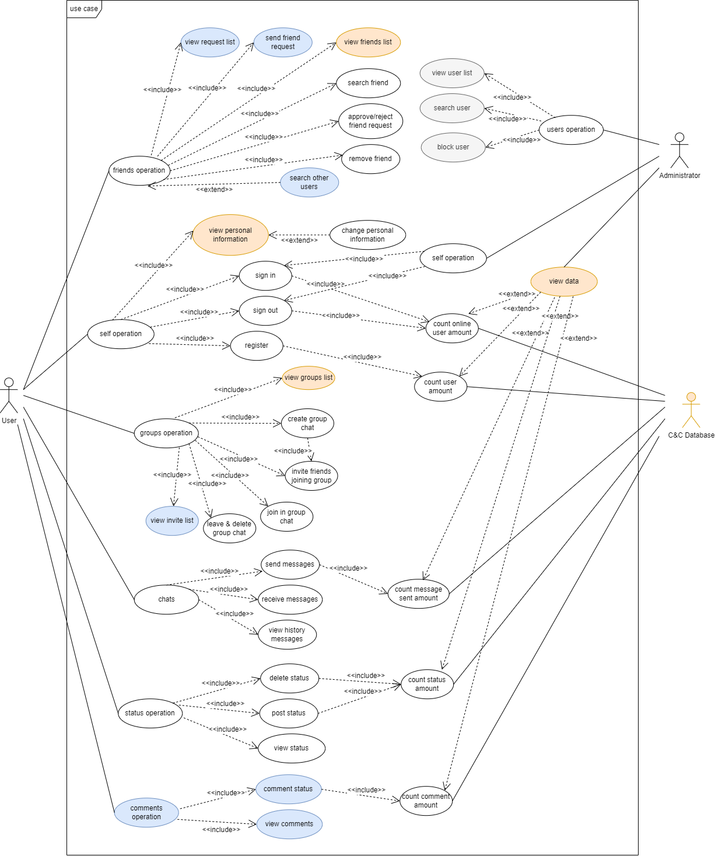

Figure 5.1.1: Use Case Diagram

[Use Case Diagram Version 4](https://github.com/WEB-NART/NART/blob/main/doc/design/useCase_V1.3.png)

In the use case diagram, we made three modifications. Use cases with white as the background colour are designed when they are created. Use cases with an orange background are added or modified during the first modification. Use cases with blue background are added or modified during the second modification. Use cases with grey background are added or modified in the third modification.

There are three objects in the use case diagram: user, administrator and database.

Users mainly have six operations. The first case is that the user operates the friend system. Users can add, delete and find users at will. The second situation is that users operate the self information system. Users can freely change their personal data, register their accounts, log in or log out of their accounts. The third situation is that users operate the group system. Users can create groups at will, invite friends to join their own groups, leave groups, and accept group invitations from friends. The fourth situation is that users can manage their own chat system. Users can send, receive and delete chat messages with their friends or groups. The fifth situation is that users can manage their own status system. Users can create, delete, and view previous statuses. The sixth case is that users can add their comments after their friends or their status.

The administrator mainly performs three operations in this software. First, the administrator can log in or out of the account freely. Secondly, the administrator has the right to view the list of all users and lock other users. Finally, the administrator can view the database information, such as the number of registrations and online accounts.

## 5.2 Use Case Descriptions

Link on Appendix 2. Source Documents

[Use Case Description Version 2](https://github.com/WEB-NART/NART/blob/main/doc/design/user%20case%20description%202st%20draft.pdf)

The use case description file records the information of each operation in the use case diagram in detail.

The use case description file records the information of each operation in the use case diagram in detail. Each operation is described by the following attributes.

Use case name

Brief description. A simple sentence that explains the meaning of the use case name.

Primary actor. The main roles involved in the use case

Secondary actor. Secondary actor participating in the use case

Precondition. You want to implement the precondition of the use case

Dependency. Derivative operation of use case

Basic flow. Basic process of realizing use cases

Specific alternative flow1. The response of the system when exceptional operations occur

Specific alternative flow2. The system's response when exceptional operations occur

Global alternative flows

Bounded alternative flows

Special requirements

## 5.3 Flow Diagrams

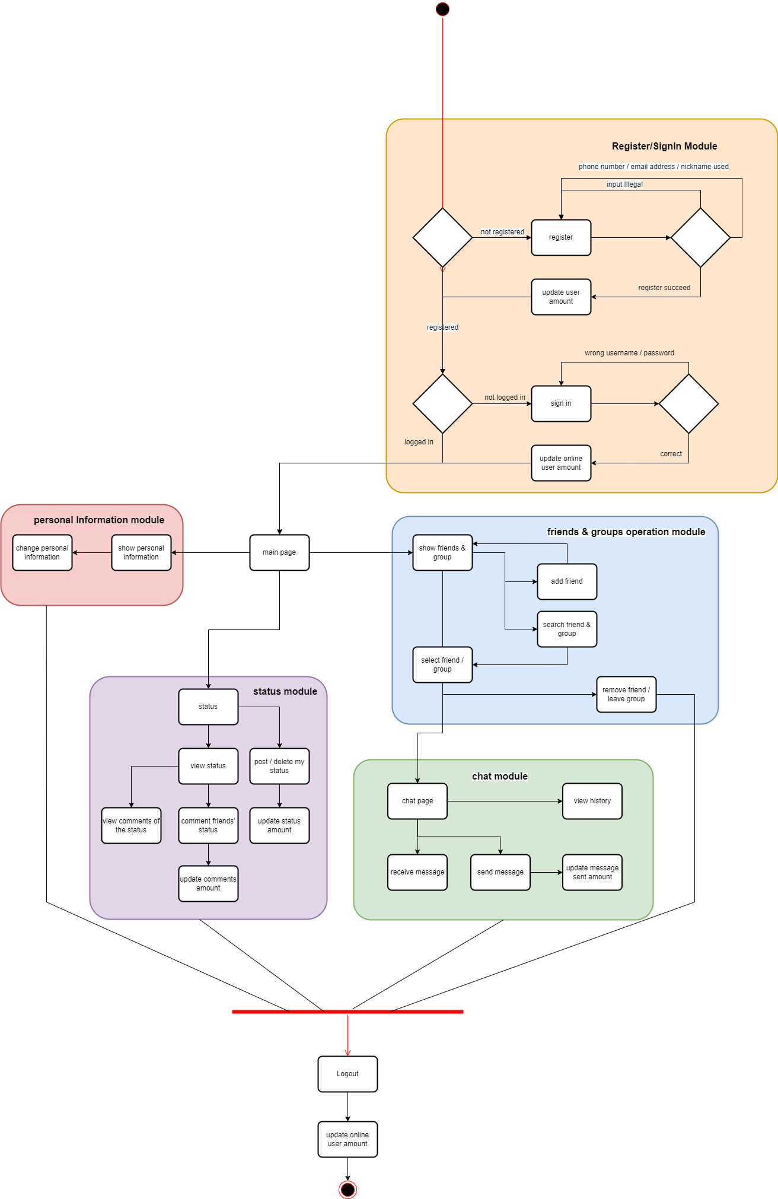

Figure 5.3.1: User Flow Diagram

Link on Appendix 2. Source Documents

[User FlowDiagram Version 3](https://github.com/WEB-NART/NART/blob/main/doc/design/user_flowDiagram_v1.2.png)

Flow Diagram shows the operation of a user from logging in to logging out of the account under normal process. First, the user enters the website page to log in. If there is an account, the user will enter the main page. If there is no account, the user will enter the registration page. The user enters the login page after successfully registering an account. Entering the correct user name and password will cause the user to enter the main page or enter the login page repeatedly after entering the wrong user name or password. After entering the homepage, users can choose to enter the personal information page, friends and groups page, chat page and status page. Users can enter the logout page to perform logout operation no matter which page they are on.

When the user enters the personal information page, the user can view and modify the user information.

When users enter the friends and groups page, they can add, delete, and view friends and groups.

When users enter the status page, they can add, delete, modify, and view the status.

When users enter the chat page, they can view past chat messages and send chat messages.

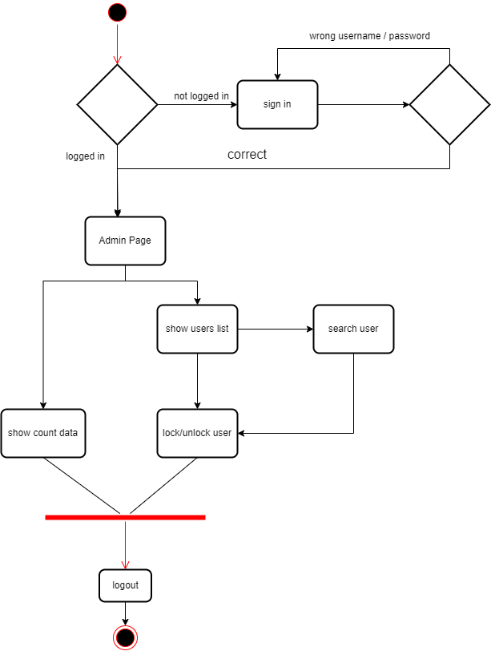

Figure 5.3.2: Administrator Flow Diagram

[Admin FlowDiagram Version 1](https://github.com/WEB-NART/NART/blob/main/doc/design/admin_flowDiagram.png)

The above figure shows the administrator flow chart. The process of the administrator when logging in the page is the same as that of ordinary users. The difference is that the administrator will enter the administrator page after passing the login page. On the administrator page, the administrator can view the user's data, such as the number of online users, the total number of public registrations, and then enter the login page. The administrator can also select to display all users and block users, and then enter the login page.

## 5.4 Overall Project Structure

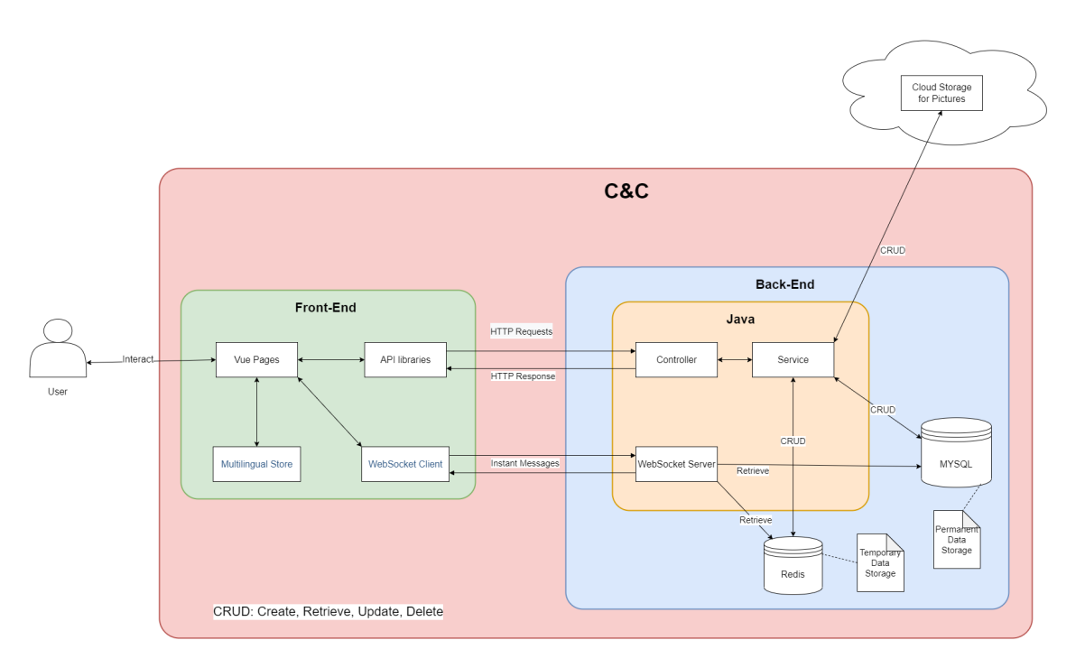

Figure 5.4.1: Overall Structure of C&C Project

An overall project structure is designed to describe the project in a more clear way.

Users can only interact with Vue pages in Front-End part. Vue pages handles page jumping by itself and provide multi-languages through the help of Multilingual Store. Most requests are sent to Back-End part through API libraries as HTTP requests. Once Back-End generate replies corresponding to requests, API libraries obtain and return the replies to Vue pages and display it to the user. Chat messages cannot be treated exactly as HTTP requests, therefore, WebSocket Client module will send and receive instant messages (WebSocket messages) to and from WebSocket Server in Back-End.

Java is the main software application in Back-End. The Controller module recognize all HTTP requests and invoke the corresponding service in Service module to handle the requests. Once service generate a result, Controller judge the result and reply the judging result to Front-End. MYSQL is a relational database which stores permanent data for C&C and Redis is a NoSql database which stores temporary data for C&C. The Cloud Storage on the top of the graph is a cloud database which can only store pictures, all pictures in C&C will be stored in the Cloud Storage module. Only Service module can perform all CRUD operations on the three databases, CRUD stands for Create, Retrieve, Update and Delete. The WebSocket Server module is only used to accept and reply to instant messages (WebSocket messages). To obtain necessary user data, the WebSocket Server can retrieve data from both Redis and MYSQL.

C&C comprise all elements in the graph except for User and Cloud Storage. The C&C portion is labelled in red.

## 5.5 Back-end

### 5.5.1 Module UML

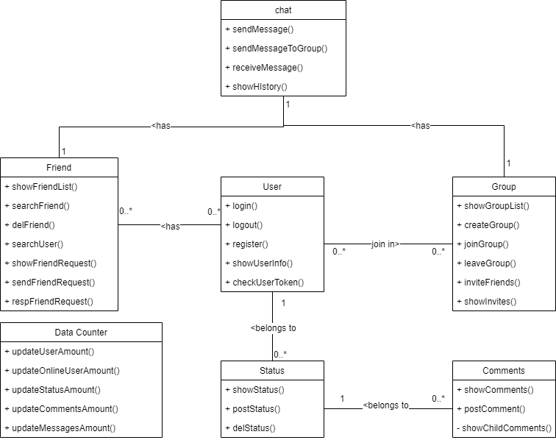

Figure 5.5.1: Back end simple module diagram

[Module UML](https://github.com/WEB-NART/NART/blob/main/doc/design/user_moduleUML_v1.0.png)

Link on Appendix 2. Source Documents

The figure above simply describes the composition of the back-end program. Each module corresponds to the function in the design. For example, in the user module, users can log in, log out, register, view personal information and other functions through the user module.

The user module represents the individual user, who can log in, log out, register, etc. The friend module represents the association between users. A user can have multiple friends. Users can modify, add and delete friends through the friend module. The group module represents another relationship between users. A group is similar to a container, which can contain multiple users. Users can create a new group, or join, leave or invite other users who are not in the group to join the group. The status module represents the comments published by users, and users can modify, publish and delete the status. The comment module is used to talk about the status. Users can publish comments after their or others' status. Chat module represents all information exchanges between users. The data counter module can count the data of other modules, such as the number of users and the number of status.

### 5.5.2 ER Diagram

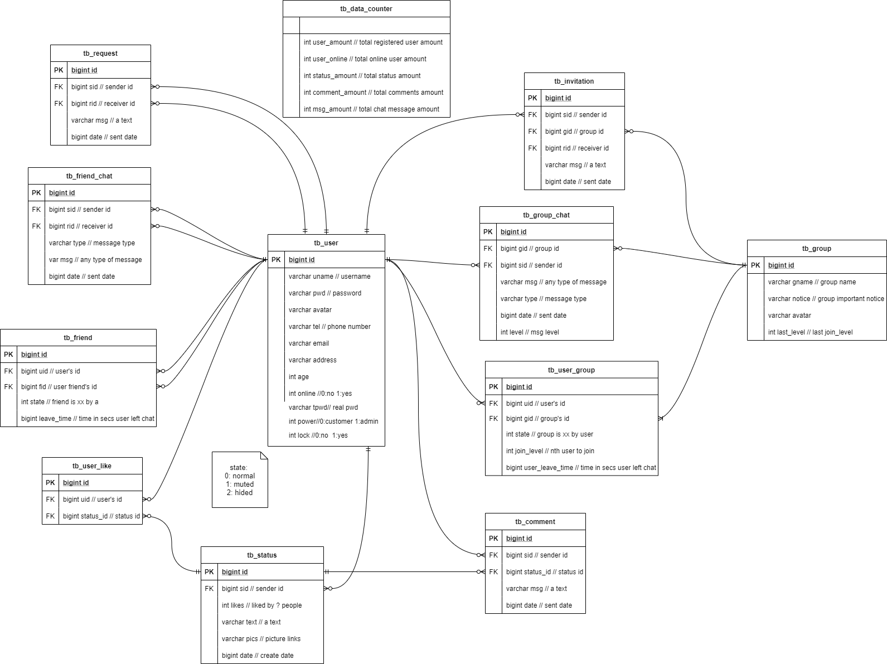

Figure 5.5.2: Database structure diagram

[ERDiagram Version 4](https://github.com/WEB-NART/NART/blob/main/doc/design/ERDiagram_v1.3-erDiagram.drawio.png)

Link on Appendix 2. Source Documents

The above figure describes the names and corresponding attributes of all tables in the database. The description of each attribute is labeled by annotations.

There are 12 tables in the database.The tb_user stores various user information. The online attribute indicates whether the user is online. The pwd attribute represents the user's encrypted password. Tpwd represents the original password of the user. Lock indicates the status of the user's account and whether it is available. The tb_friend table stores friend relationships. The state attribute indicates whether the user is blocked by his friends in a friend relationship. The leave_time attribute indicates the time when the user last sent the message. tb_ friend_ Chat table stores chat information between users and friends. The type attribute indicates whether the user is sending a picture or text. The tb_ request table stores the invitation to add friends sent by users. The tb_ data_ counter table stores various information about the system. The tb_ invitation table stores the group joining invitations sent by users. The tb_group table stores all group information. The last_level attribute indicates the last member to join the group. The tb_ group_chat table stores the chat information of members in the group. The tb_ user_ group table stores group member information. The tb_ user_ like table stores users' likes of status. The tb_ status table stores all status information. The likes attribute indicates how many user tags like this status. tb_ Comment stores all comment information.

### 5.5.3 Back-end UML

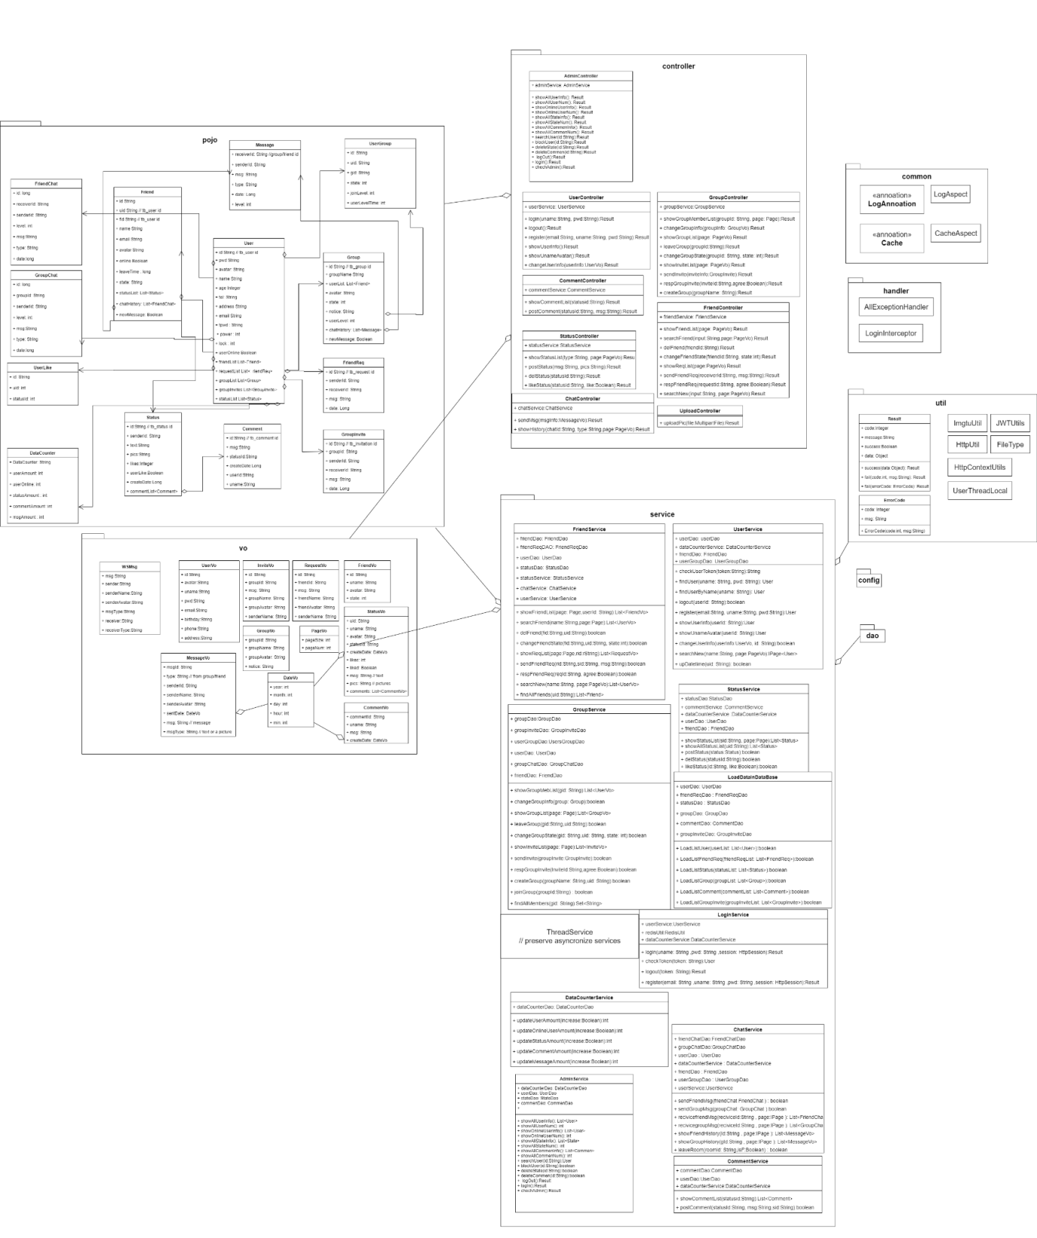

Figure 5.5.3: Detailed design drawing of back end

[User Back-End UML Version 2](https://github.com/WEB-NART/NART/blob/main/doc/design/user_backend_uml_v1.1.png)

Link on Appendix 2. Source Documents

The figure above describes the specific design requirements of the control layer, service department, instance, tool layer and setting layer in the back-end.

There are 9 packages in the back-end system. Each package contains some classes. Pojo packages represent entity classes. These entity classes correspond to the tables in the database. The user class contains user information, such as username and password. When the user performs login and other operations on the front end, the user class will be called to obtain information. The friend class contains the friend relationship between users. The friendchat class represents the entity class that carries information when users send information to friends. The friendreq class represents the class that hosts the request for adding friends when the user sends the request to an unknown user. In the group class, you can find the information of the group created now. The usergroup class contains information about the members of each group. The groupchat class contains chat messages between members of each group. The groupinvite class is an invitation sent by a group member to other users who are not members of the group. The status class is the status information published by the user. The comment is the user's evaluation published after the status. The message class is a summary of different chat messages. The datacounter class is the statistics of all existing information.

Dao packages are developed through annotations. The function of dao is to contact the database and modify the records in the database through the classes in pojo.

Vo packet is the format of transmitting information to the front end. The classes in the pojo package carry information. These classes can be converted into classes in the vo package and then sent to the front end. The service package is the service layer. The classes in the package are concrete operations. The friendservice class calls multiple dao layer classes to operate the database. Finally, modify the friend table in the database. The userservice class calls userdao, frienddao, usergroupdao, and datacounterdao to perform login, logout, and other operations. The groupservice calls the dao layer to modify the group information. Statusservice calls dao to modify the status information. Loginservice mainly supports user login and logout operations. Commentservice modifies the information in the comment table. Chatservice is used to manage chat information of all users. Adminservice operates on behalf of the administrator.

The controller package is mainly oriented to the front end. The classes in the package implement different operations by calling the service layer. The admincontroller calls adminservice to perform various operations on the user, status, and comment. The usercontroller calls the userservice to implement the operation. Friendcontroller calls friendservice to implement the operation on friend. Chatcontroller operates the user's chat by calling chatservice. The commentcontroller calls commentservice to operate on the comment.

The config package is used to include various configuration classes. The structure rules of these configuration settings information. The util package contains different tool classes for other classes to use. The classes in the handler package set system errors.

In back-end development, we follow the software SOLID. SOLID is composed of five design principles: single responsibility principle, open/close principle, internal replacement principle, interface isolation principle and dependency inversion principle.

**Single responsibility principle**

A class is only responsible for completing one responsibility or function. In other words, instead of designing large and comprehensive classes, we should design classes with small granularity and single function. To put it another way, a class contains two or more unrelated functions, so we say that its responsibilities are not simple enough, and it should be divided into multiple classes with more single functions and finer granularity.

**Opening and closing principle**

Software entities (modules, classes, methods, etc.) should be "open to extension and closed to modification".

Adding a new function should be to extend code (add modules, classes, methods, etc.) on the basis of existing code, rather than modify existing code (modify modules, classes, methods, etc.).

**Liskov Substitution Principle**

The object of subtype/derived class can replace the object of base/parent class in the program, and ensure that the logical behaviour of the original program remains unchanged and the correctness is not damaged.

**Interface Segregation Principle**

The client should not be forced to rely on interfaces it does not need. The "client" can be understood as the caller or user of the interface.

**Dependency Inversion Principle**

The dependency inversion principle is also called the dependency inversion principle. This principle is similar to the inversion of control, and is mainly used to guide the design at the framework level. High level modules do not rely on low level modules, they all rely on the same abstract. Abstraction does not depend on specific implementation details, and specific implementation details depend on abstraction. [24]

## 5.6 Front-end

### 5.6.1 Prototype

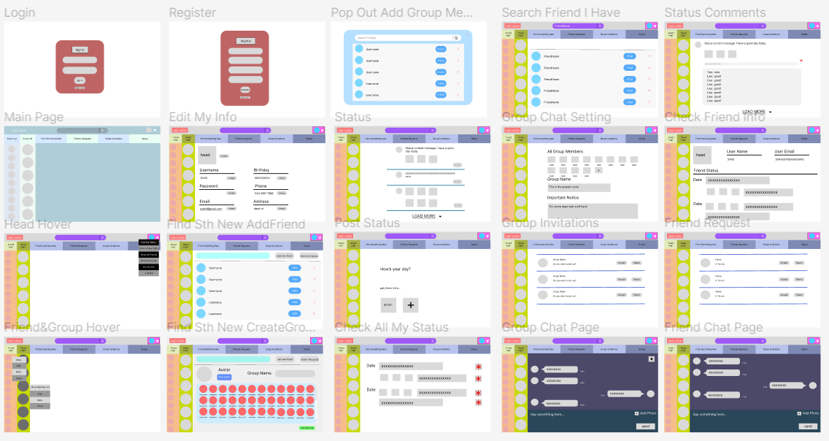

Figure 5.6.1.1: Overall Client Side Prototype C&C Project

The figure 5.6.1.1 above is the user side overall prototype for the C&C project, and it can be check by the link [User Front Page Structure](https://github.com/WEB-NART/NART/blob/main/doc/design/user_pageStructure.md) in Appendix 2. Source Documents, this figure shows all twenty pages that will be shown to the user while using the C&C system. There is a main page that has a big difference of color with the other pages is because the team is still considering about the color set of this system when it is shown to the users.

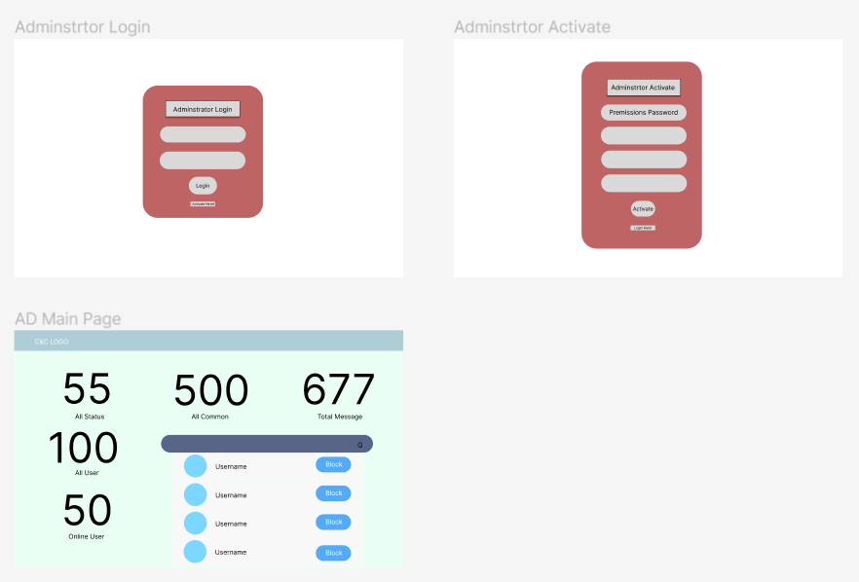

Figure 5.6.1.2: Overall Administrator Side Prototype C&C Project

The figure 5.6.1.2 above is the administrator side overall prototype for the C&C project, this figure shows all three pages that will be shown to the administrator while using the C&C system. The team is deciding about if new administrator is allowed to register or just fix it.

For more information on all the page structures, refer to 5.6.2 Page Structure Document

### 5.6.2 Page Structure Document

All the page designs are made in the website Figma [42], this design website is convenient to use and easy to make changes, so the team decide to use it as design support.

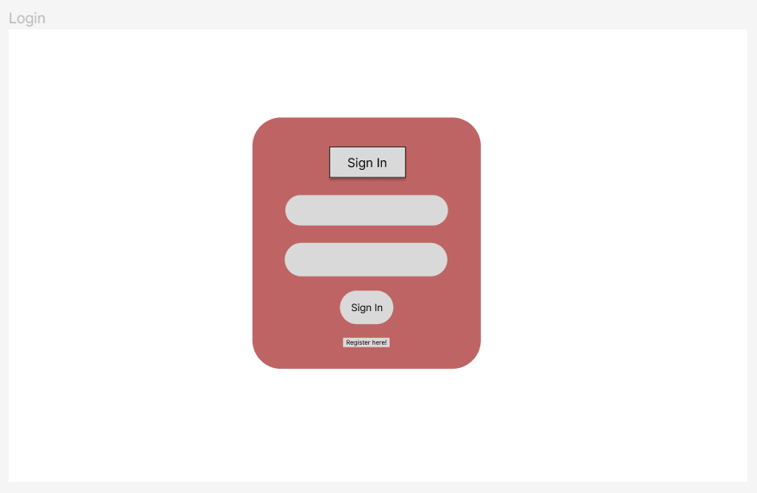

Figure 5.6.2.1 - “Login” page

“Login” page (Figure 5.6.2.1) is used to let users login to the system, user’s name and password are needed. On this page, the user can either choose to login by clicking the “Sign In “ button or if the user is new to the system, this page can jump to the “Register” page by clicking the “Register here!” button.

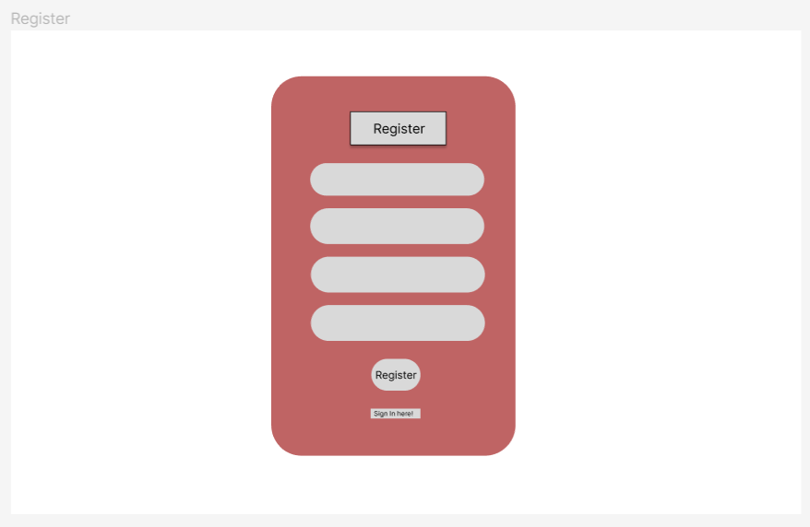

Figure 5.6.2.2 - “Register” page

“Register” page (Figure 5.6.2.2) is used for the registration of users. On this page, users need to create a username, provide their email address, and confirm their password to make sure the two passwords are the same. Users can click the “Register” button to register, or if the user already has an account, they can click “Sign In Here!” to jump to the “login” page.

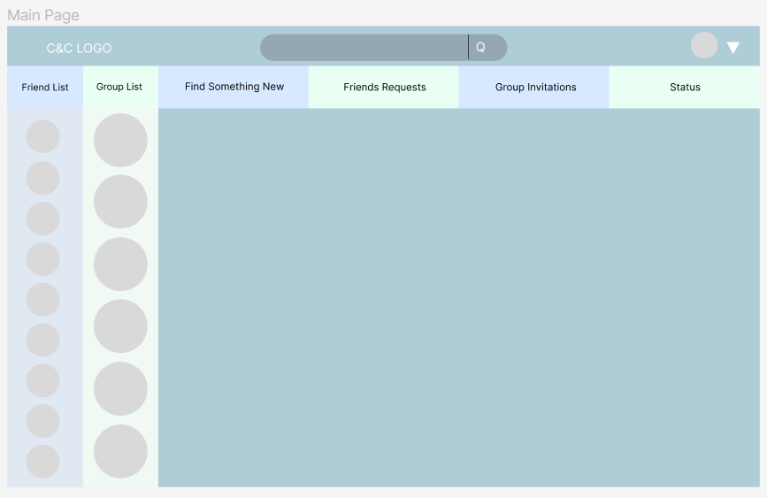

Figure 5.6.2.3 - “Main” page

“Main” page (Figure 5.6.2.3) is the page that will be shown to users after they login to the system, it will show the C&C logo, the searching bar and the user avatar at the top, then it followed by six main parts of this website: friend list, group list, find something new, friends requests, group invitations and the status.

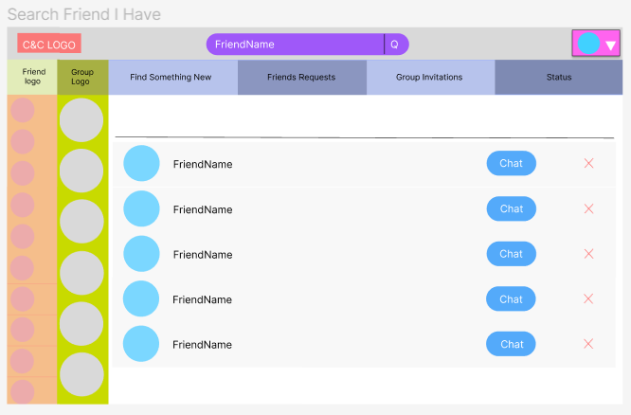

Figure 5.6.2.4 - “Search Friend I Have” page

“Search Friend I Have” page (Figure 5.6.2.4) is shown when the user searches a friend’s name in the searching bar, the page will show the scroll component of all the similar friends’ names, then the user can choose to chat with them.

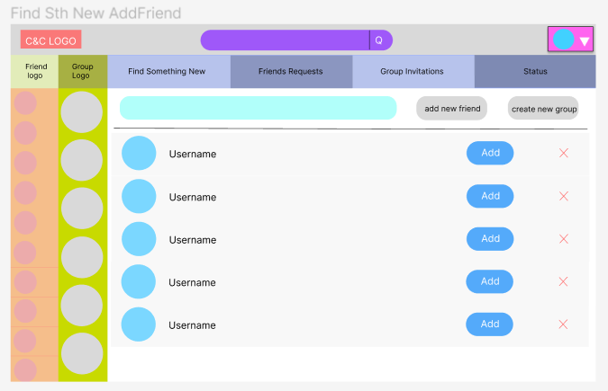

Figure 5.6.2.5 - “Find Something New Add Friend” page

“Find Something New Add Friend” page (Figure 5.6.2.5) is shown when the user wants to find a new friend, then can input the name in the search bar, then the C&C system will find all the similar names to help the user find this person.

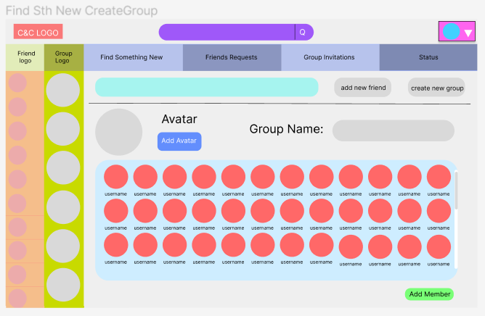

Figure 5.6.2.6 - “Find Something New Create Group” page

“Find Something New Create Group” page (Figure 5.6.2.6) is used when the user wants to create a new group, then the user can choose an avatar for the group and give a name to the group. By clicking the “Add Member” button, the selected friends will be shown in the scroll component, then the selected friends will get a group invitation.

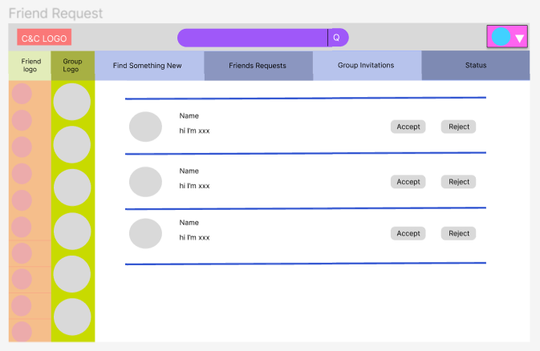

Figure 5.6.2.7 - “Friend Request” page

“Friend Request” page (Figure 5.6.2.7) is used for showing all the pending friends, the user can choose to accept or reject the friend request.

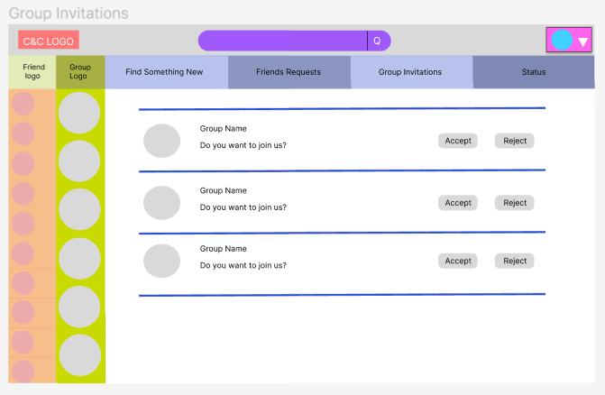

Figure 5.6.2.8 - “Group Invitations” page

“Group Invitations” page (Figure 5.6.2.8) is used for showing all the pending group invitations, the user can choose to accept or reject the group invitations.

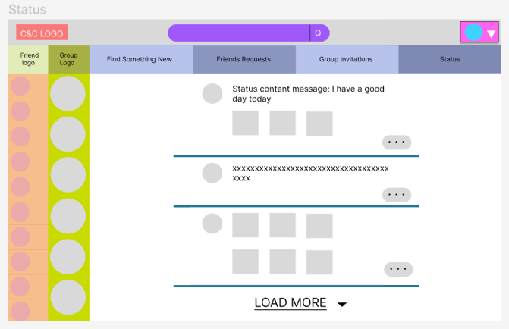

Figure 5.6.2.9 - “Status” page

“Status” page (Figure 5.6.2.9) is used to show all the statuses that the user can see, user can do a “like” action or comment on the status.

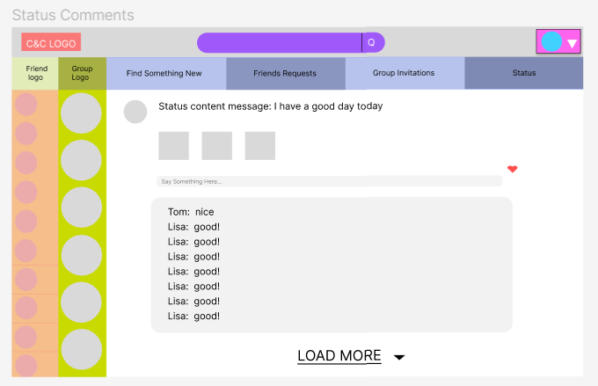

Figure 5.6.2.10 - “Status Comments” page

“Status Comments” page (Figure 5.6.2.10) can show all the comments in detail, the user can see comments from common friends.

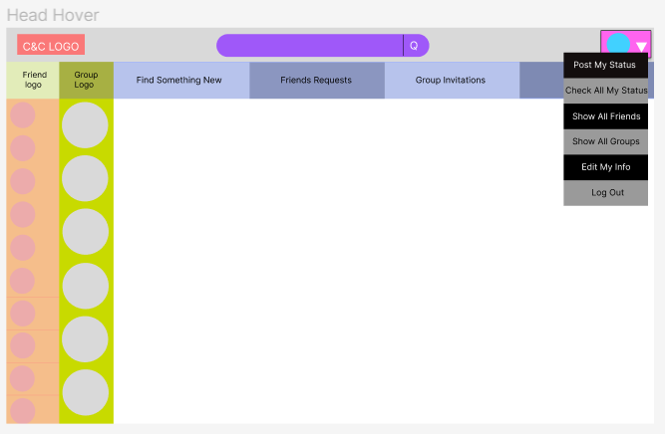

Figure 5.6.2.11 - “Head Hover” page

Head hover is shown in Figure 5.6.2.11, the head hover can post status, check users’ own status, edit users’ own info and log out. Besides that, the “show all friends” and “show all groups” can refresh users’ friend list and group list.

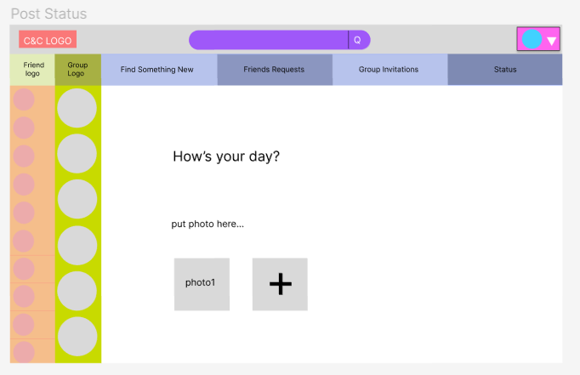

Figure 5.6.2.12 - “Post Status” page

Users can post their status through the “Post Status” page (Figure 5.6.2.12).

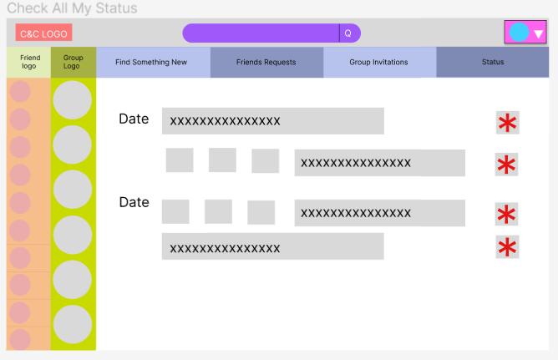

Figure 5.6.2.13 - “Check All My Status” page

Users can check all their past statuses or delete their statuses on “Check All My Status” page (Frigure 5.6.2.13), the status on this page will be shown with the post date.

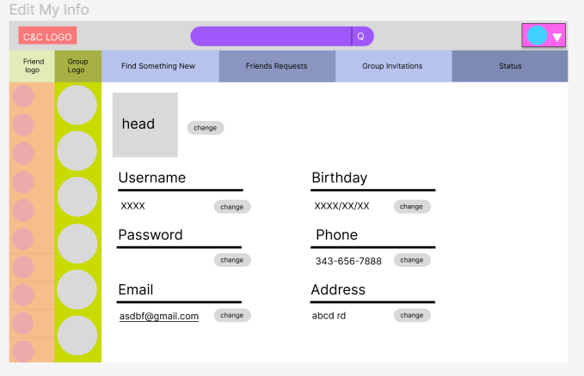

Figure 5.6.2.14 - “Edit My Info” page

Users can edit their personal information on “Edit My Info” page (Figure 5.6.2.14).

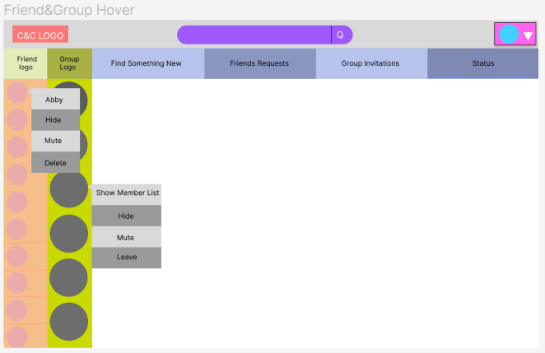

Figure 5.6.2.15 - “Friend and Group Hover” page

Friend and group hover are shown in Figure 5.6.2.15. The friend hover shows the friends’ names on top, users can choose to hide, mute or delete this friend. Users can use the group hover to show the group member list, hide the group, mute the group or leave the group. After the user chooses to mute the friend or the group, the mute button will become unset. After the user chose to hide the friend or the group, they can use “show all friends” and “show all groups” in the head hover to show those friends or the group again.

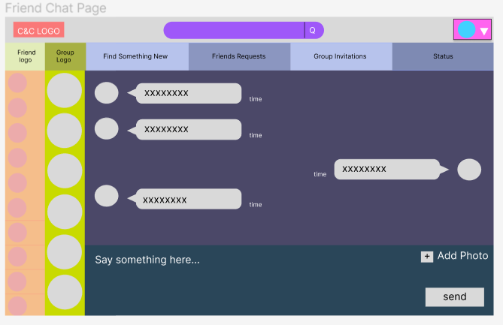

Figure 5.6.2.16 - “Friend Chat” page

“Friend Chat” page (Figure 5.6.2.16) support the users to chat with other people, and upload photoes while chatting. This page will also show the time that the message has been sent and the sender’s avatar. By clicking the friend’s avatar, user can get into this friend’s info page.

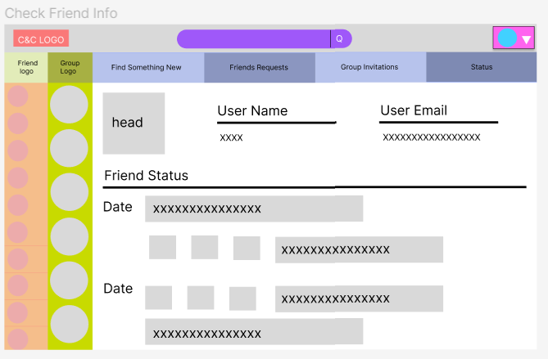

Figure 5.6.2.17 - “Check Friend Info” page

“Check Friend Info” page (Figure 5.6.2.17) show some of the friends’ information and their statuses with post dates.

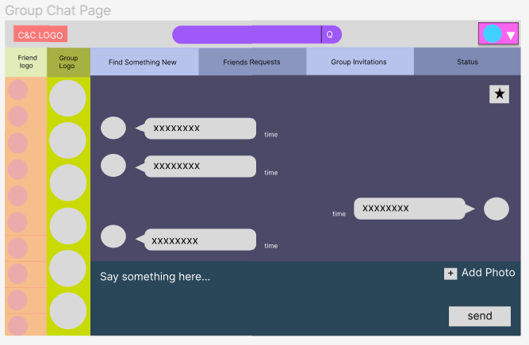

Figure 5.6.2.18 - “Group Chat” page

“Group Chat” page (Figure 5.6.2.18) is similar to the “Friend Chat” page, the difference is, this time the user cannot see personal info by clicking the avatar but they can click the star on the right corner to access to the group setting page.

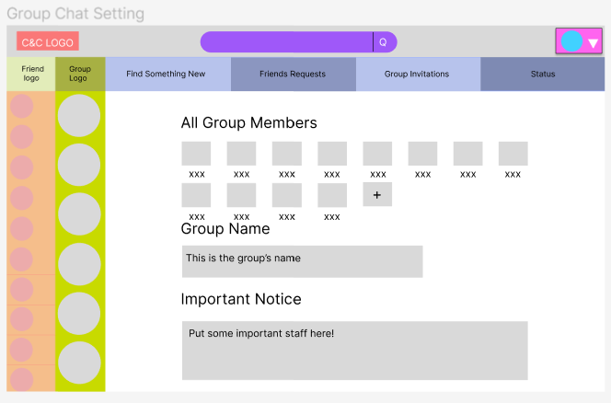

Figure 5.6.2.19 - “Group Chat Setting” page

“Group Chat Setting” page (Figure 5.6.2.19) shows all the group members, group name and important notice for this group, on this page, users can invite their friends to the group, the little add icon will pop an invitation window.

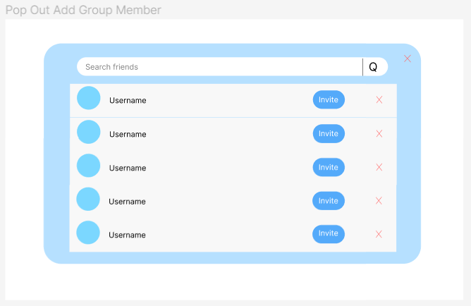

Figure 5.6.2.20 - “Pop Out Add Group Member” page

“Pop Out Add Group Member” page (Figure 5.6.2.20) has a scrolling page to show users’ friends that can be invited, and the users can search for their friends’ name to send the invitation.

### 5.6.3 UML

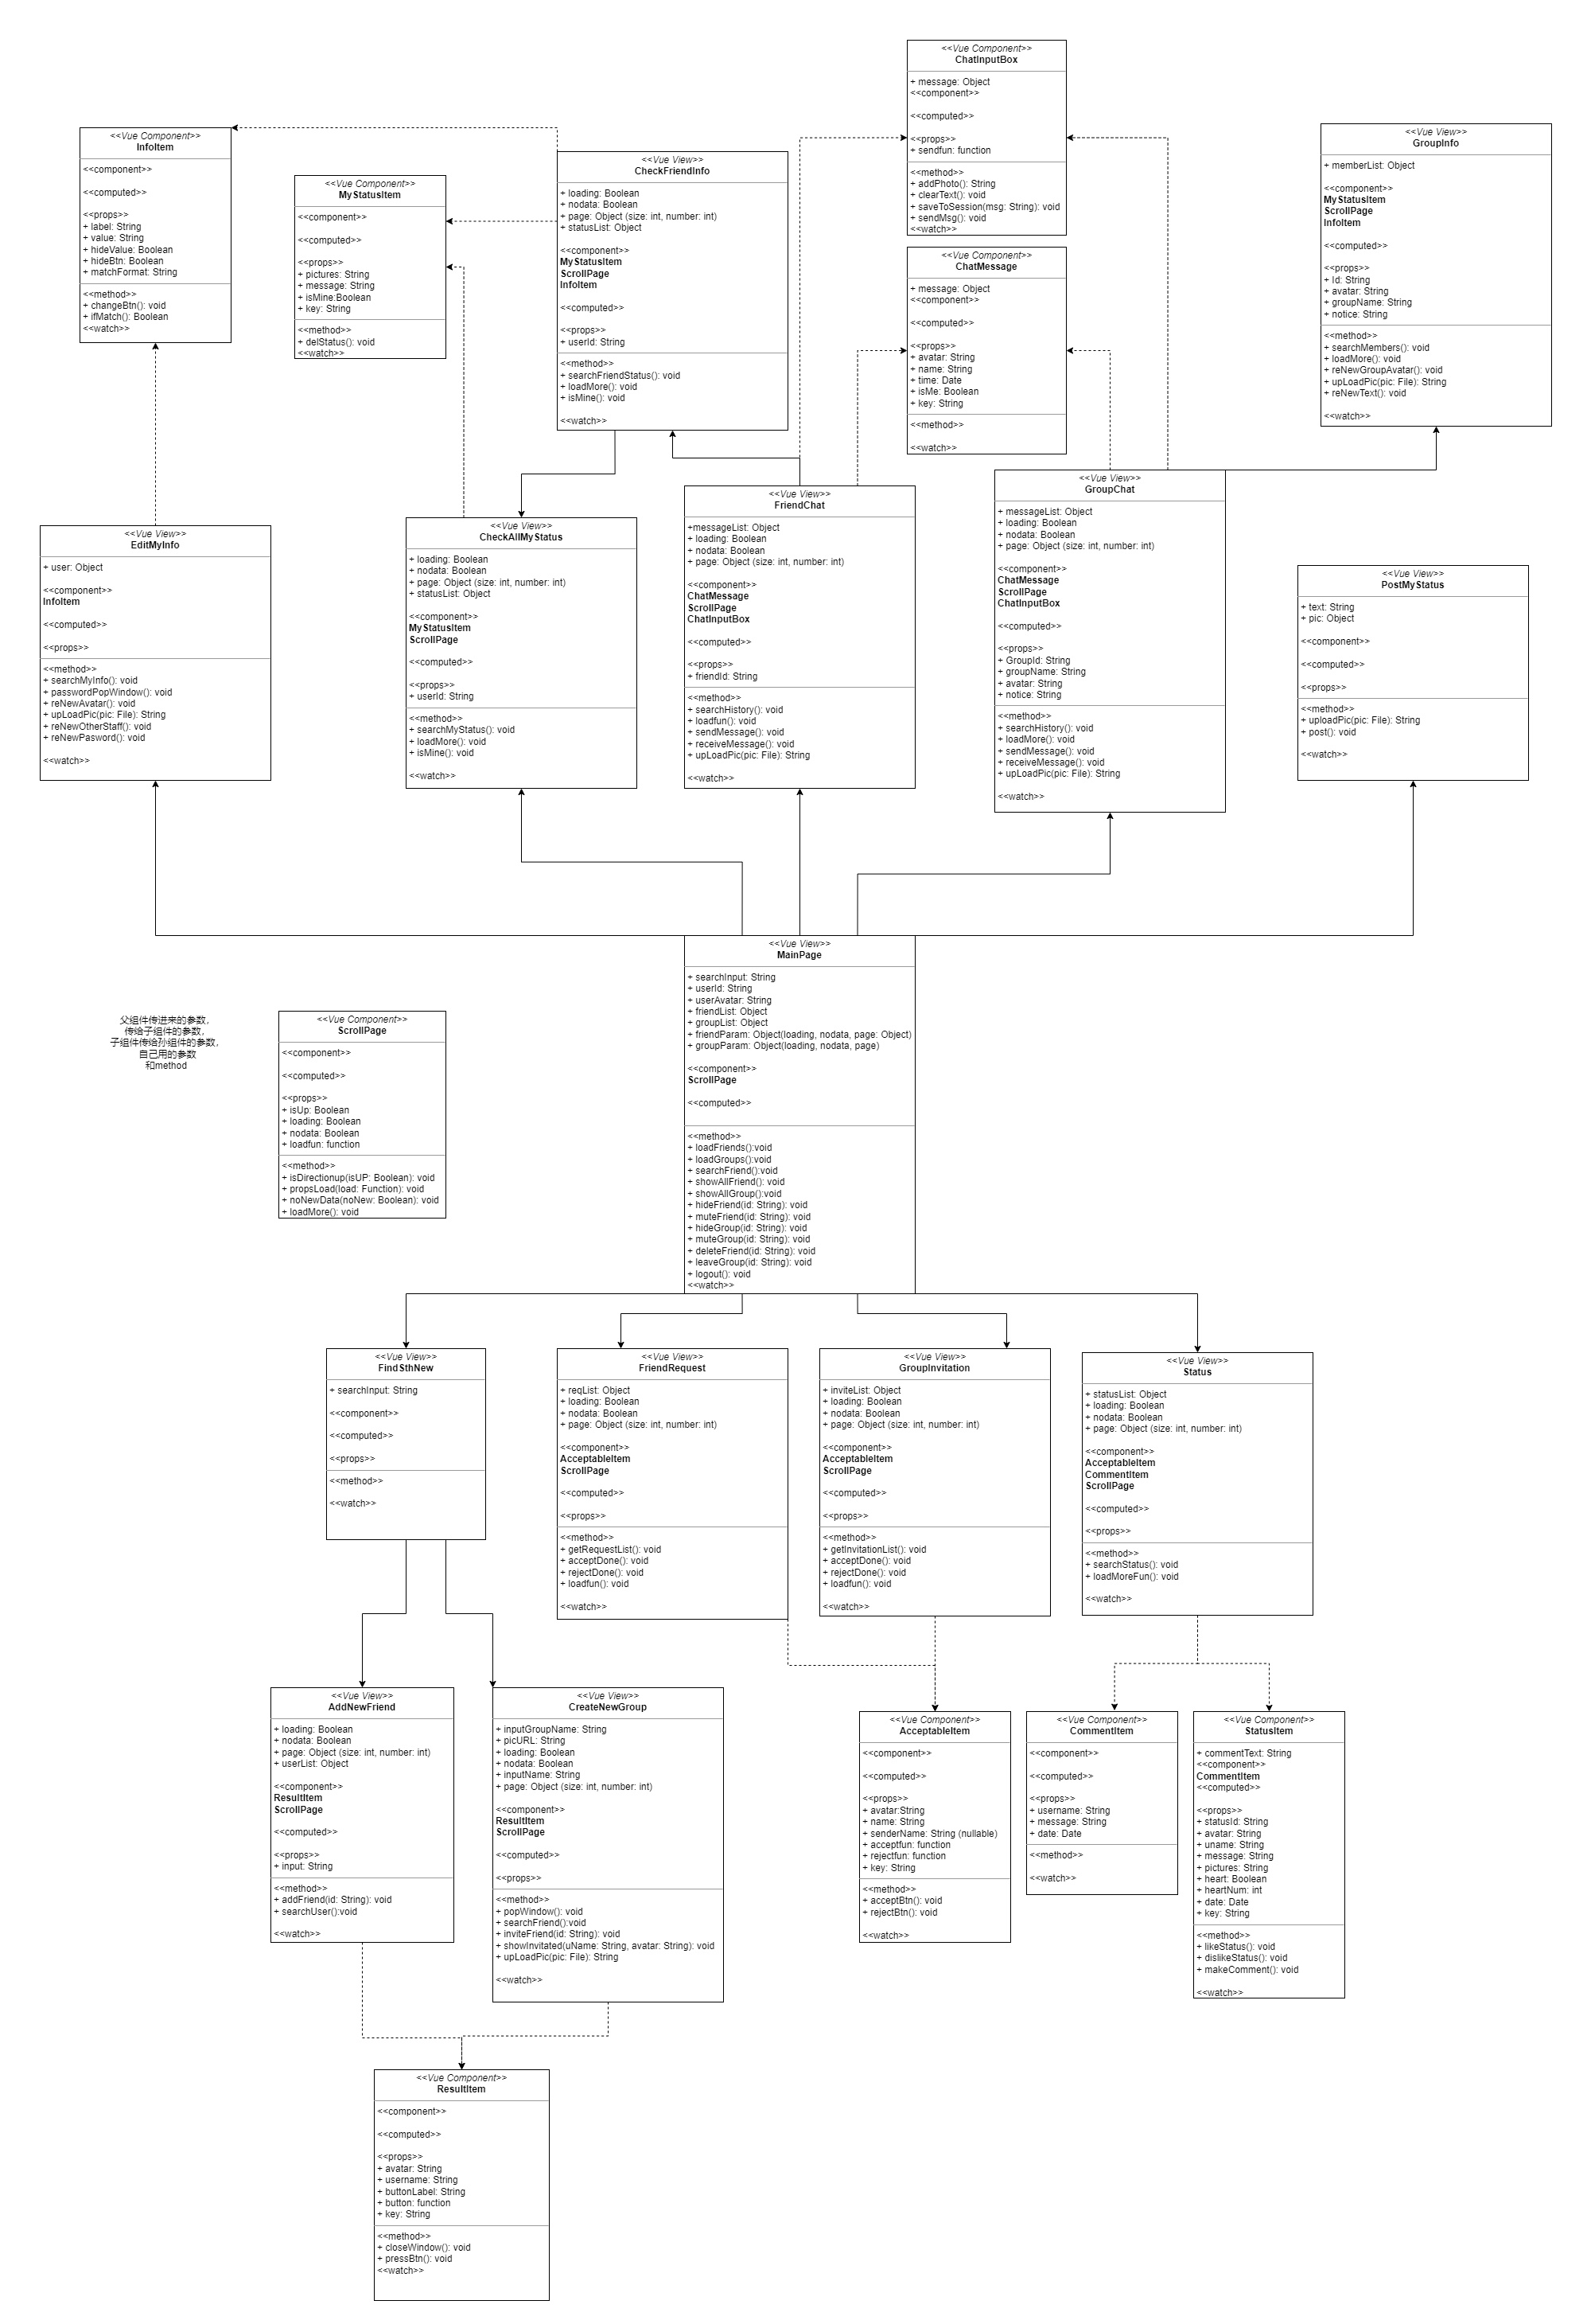

Figure 5.6.3.1 - Front-end UML

Depending on the page jumping rules described in page structure document (5.6.2), a simple front-end UML is designed, which can be found in [User Front-End UML](https://github.com/WEB-NART/NART/blob/main/doc/design/user_frontend_uml_v1.0.png) in Appendix 2. Source Documents . Arrows pointing directions explains the jumping sequences, for example, jumping from MainPage to EditMyInfo is possible.

Each box represents a class, and the very top few lines are the local variables of the class. The component part shows all reused classes in the current class. The props part shows all parameters given by the class’s parent. The computed part lists all parameters that change instantly, and the method part shows all local functions. The watch part list all parameters that are monitored by the class.

Although, most front pages structures are designed well in the front-end UML, small changes will occur during implementation.

## 5.7 API Documents

The team has already designed the APIs that we can think about to build this C&C system, all the APIs are saved in the API document(api_v1.4.md). The explanation of a sample API is shown in (figure 5.7.1).

This API will be used in the user login page, and it is corresponding to the userController in the login() method. The request type of this sign in API is PUT, it will ask for the username and the password in a string from the backend, and the data that is returned will tell if the request succeeds, sending the error code and the succeed message back and returning the token of the data (figure 5.6.4).

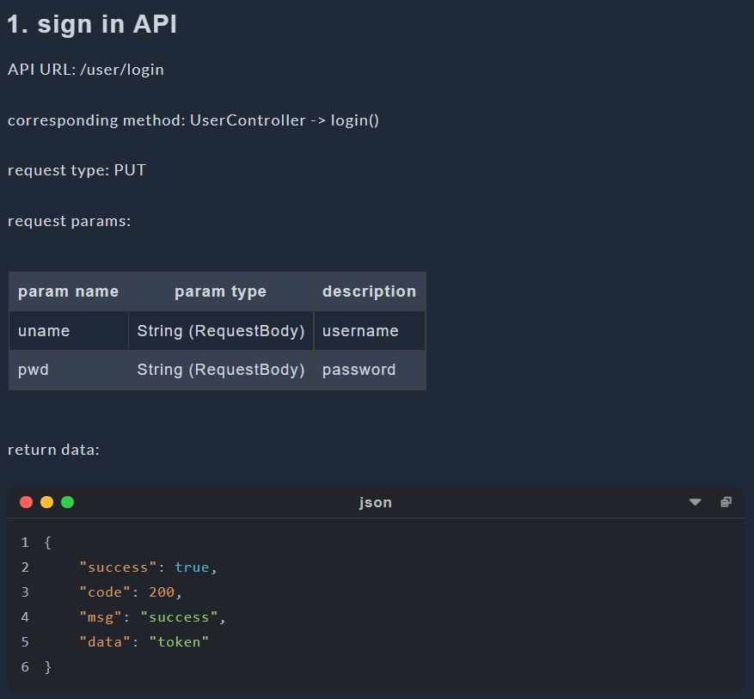

Figure 5.7.1 - “Sign In” API

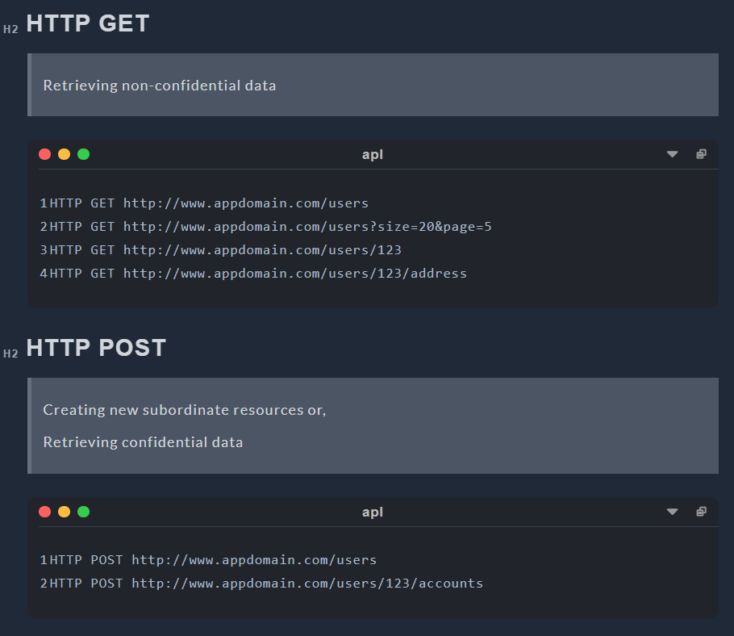

Figure 5.7.2 - HTTP Request Structure 1

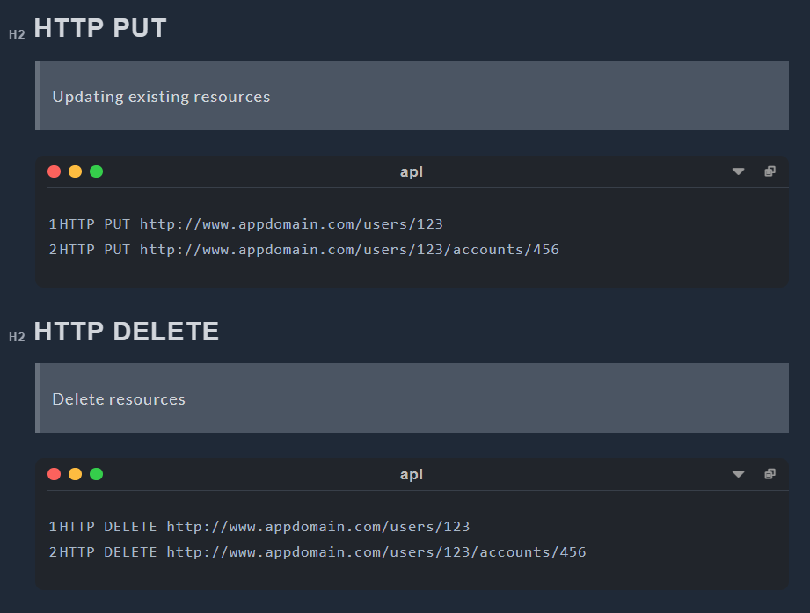

Figure 5.7.3 - HTTP Request Structure 2

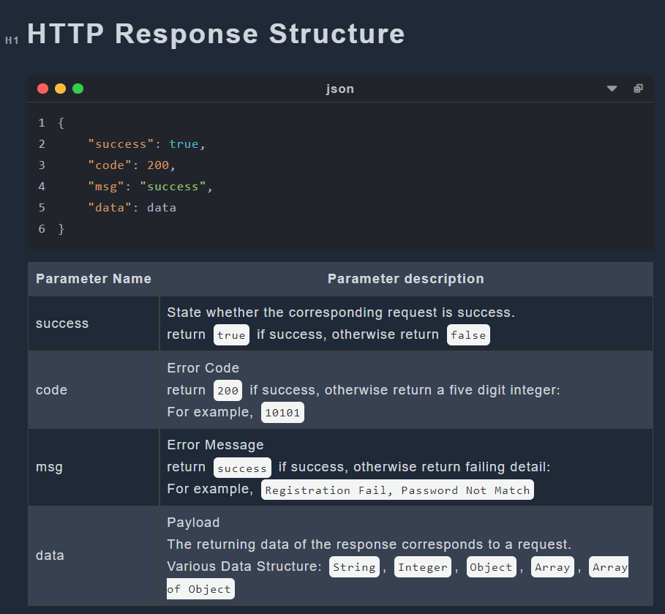

Figure 5.7.4 - Explanation of the returning data

# **6. Tools Selected and Justification**

Implementation of C&C has not start yet. We focus on choosing the reasonable techniques which will be used in the implementation.

## 6.1 Java

Specifically, the Java language has the following advantages:

1. Java is a pure object-oriented language. It can directly reflect the objects in real life, such as animals. Therefore, it is easier for developers to understand and write programs.

2. Java language can be used on multiple platforms. Java programs can be compiled on Windows platform, Linux, MacOs and other platforms. The compiled programs can run on other platforms.

3. Java provides a lot of built-in class libraries, which can simplify the programming work of developers and shorten the development time of projects.

4. It provides support for Web application development. For example, Servlets and JSPs can be used to develop Web applications.

5. The C++ language has removed features that are difficult to understand or easily confused, such as header files, pointers, structures, units, operator overloads, virtual basic classes, multiple inheritance, etc., making the program more rigorous and clean. [25]

Using java technology can help us reduce unnecessary repetitive work when making this project, and the database provided by java can help us reduce the working time.

## 6.2 Spring

Spring is an open source framework. One of the main advantages of the framework is its hierarchical architecture, which allows users to choose which component to use. Spring uses basic JavaBeans to do things that previously could only be done by EJBs. However, Spring's use is not limited to server-side development. From the perspective of simplicity, testability and loose coupling, any Java application can benefit from Spring.

1. Declaration of support

In Spring, we can get rid of the transaction management code and flexibly manage transactions in a declarative manner to improve development efficiency and quality.

2. Convenient program testing

In Spring, testing is no longer a complex operation, but a very simple thing. For example, Spring supports Junit4 and can easily test Spring programs through annotations.

3. Convenient integration of various excellent frameworks

Spring does not exclude various excellent open source frameworks. On the contrary, Spring can reduce the difficulty of using various frameworks. Spring provides direct support for various excellent frameworks.

4. Reduce the difficulty of using Java EE APIs

Spring provides an encapsulation layer for many Java EE APIs that are difficult to use. Through the simple encapsulation of Spring, the difficulty of using these Java EE APIs is greatly reduced. [26]

In this project, we use spring because spring is used by many people. Other users have written many spring based libraries and new technologies. These technologies can make it easier for us to deal with projects.

## 6.3 MYSQL

The main advantages of MySQL are as follows:

1. Speed: fast operation.

2. Price: MySQL is free for most individuals.

3. Easy to use: Compared with the setting and management of other large databases, it is less complex and easy to learn.

4. Portability: It can work on many different system platforms, such as Windows, Linux, UNIX, Mac OS, etc.

5. Rich interfaces: APIs for C, C++, Eiffel, Java, Perl, PHP, Python, Ruby, Tcl and other languages are provided.

6. Security and connectivity: Host based authentication is allowed. When connecting to the server, all password transmissions are encrypted to ensure password security. Because MySQL is networked, it can be accessed anywhere on the Internet to improve the efficiency of data sharing. [27]

In this project, we use MySQL because it is a very popular and free technology. We can use MySQL to reduce our spending on projects and find rich learning resources.

## 6.4 Redis

A user is unlikely to send only one request after logging into C&C. Therefore, a lot of time is wasted frequently retrieving data from MYSQL. To speed up the generation of responses to requests, it is helpful for the C&C system to keep useful data for an extended period of time instead of retrieving it from MYSQL every time it needs it.

NoSQL Database solves this problem perfectly; they store temporary data in a RAM or cache and provide data when software needs them. Retrieving data from RAM (NoSQL Database) is a million times faster than the same operation from SSD/HDD (Relational Database). Therefore, to speed up the response, C&C stores frequently used data in the NoSQL database, for example, user tokens. There are two famous NoSQL databases: Redis and MongoDB. Redis is faster and uses fewer resources, but most of its APIs are atomic, which means it could take time to write customized APIs for C&C to use it. Redis stores data in the RAM only in the Key-Value pair and does not support other query languages. MongoDB is slower and uses more resources; while it owns APIs with various functions, it is undoubtedly more straightforward to use than Redis. MongoDB store data in Key-Value pair but allow multiple keys and support many query languages, even JSON [28].

Redis states that the MongoDB database needs Redis when the following requirements are required [29]:

* Query optimization (caching)
* Session management
* Real-time analytics
* High-speed data ingestion
* Message brokering and queues

The comparison between Redis and MongoDB is very similar to that between C and Python; both Redis and C have higher performance, while MongoDB and Python are easier for developers. C&C will not store complex data in RAM; the speed is the most relevant. Therefore, Redis is chosen. However, if C&C is a huge, sophisticated software and stores various types of data in RAM or cache, MongoDB is the better choice.

## 6.5 Vue3

Vue is a JavaScript framework for building user interfaces. It builds on top of standard HTML, CSS, and JavaScript and provides a declarative and component-based programming model that helps you efficiently develop user interfaces, be they simple or complex [30].

Vue is designed to be flexible and incrementally adoptable, depending on the use case, Vue can be used in different ways:

* Enhancing static HTML without a build step
* Embedding as Web Components on any page
* Single-Page Application (SPA)
* Fullstack / Server-Side Rendering (SSR)
* Jamstack / Static Site Generation (SSG)
* Targeting desktop, mobile, WebGL, and even the terminal

We choose it to build the C&C web-pages, because compared with the traditional HTML, Vue contains HTML, CSS and JavaScript together, so it decrease the possibility of using the wrong path while building the user interface. Also, Vue has a better structure than HTML, instead of having three files for a single page, Vue page contain all of HTML, CSS and JS codes in the same file, the size of the C&C system can be reduced significantly.

## 6.6 Element-Plus & Tailwind

Element-Plus and Tailwind will be used for designing the webpages, these two components will take the place of the traditional CSS while developing the webpage.

Element-Plus is a Vue 3.0 based component library for developers, it contains many built-in beautiful visual components that can be used to decorate the webpage. Since Vue 3.0 is being used to build the system, Element-Plus is suitable for design. It also provides many fancy webpage building functions that can be used directly [31].

Tailwind is an API for the design system, different from CSS that we need to use big blocks for each class, Tailwind can reduce those classes into one line of code. Each part of the webpage can have its own style, instead of collecting all the style parts and putting them together, the high flexibility of it also allows customized web-pages [32].

Although both Element-Plus and Tailwind simplify the process of decorating front pages dramatically, neither of them can replace CSS for the reason that some customized requirements cannot be proceeded by them. CSS is still an indispensable decorating tool for C&C project.

## 6.7 HTTP and WebSocket

HTTP represents for Hypertext Transfer Protocol which is an application-layer protocol for transmitting hypermedia documents, such as HTML [33] and JSON. Through it, data can be transferred between Front-End and Back-End easily. In C&C, most of the transferred data are in format of JSON [34]. However, only the client can send HTTP requests, not the server, and there must be an HTTP request before an HTTP response.

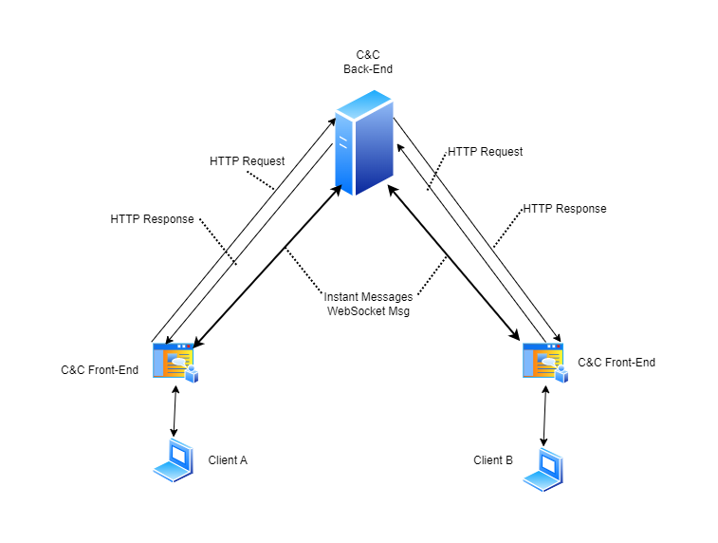

Figure 6.7.1: Data Flow Diagram of C&C

There is no direct connection between Client A and Client B users in the C&C system in Figure 6.7.1. The only way for A to see messages sent by B is for the server to send messages to A without being requested. However, servers cannot send unsolicited HTTP messages to clients, while client A needs to know messages sent by client B immediately. To be dumb, we could solve this problem by generating a set of HTTP requests to the server once every second. But this would seriously increase the pressure on the server, and a one-second delay is a long time for instant messaging, so such a solution doesn't work.

To solve the problem, there are two possible solutions according to our investigation: WebSocket and WebRTC.

WebSocket is an advanced technology that makes it possible to open a two-way interactive communication session between the user’s browser and a server [35]. WebRTC represents for Web Real-Time Communication which is a technology that enables Web applications and sites to capture and optionally stream audio and/or video media, as well as to exchange arbitrary data between browsers without requiring an intermediary [36]. Both technology allows clients connect with each others.

Briefly, WebSocket need a intermediary to create TCP connection among clients while WebRTC create p2p UDP connection (peer to peer) directly between two clients. UDP connection [37] could lose some data during transmittion while 100% transmission integrity guaranteed for TCP connection [38]. The guarantee of transmission integrity can take a lot of time, so that UDP transmission will be faster than TCP.

In terms of performance, WebRTC is much faster than WebSocket, as it connects directly to its peer using UDP, while WebSocket first connects to the server and then connects to another client from the server using TCP. Conversely, WebSocket has a clear advantage in terms of data integrity.

In C&C, a chat messages encoding requirement is described in sub-section 2.1.8-Optional Functions; C&C may need to control whether or not chat messages are encoded among users. A chat history viewing function is described in term 5 of sub-section 2.1.4-Chat Functions; C&C need to store all sent chat messages for each user. To do message encoding, decoding and recording, we cannot put the three steps in front-end for security reasons, back-end it the only choice, therefore, WebSocket is the better choice of C&C.

In the future, C&C may add video and voice calling capabilities, and WebRTC would be a good choice for implementing these features.

## 6.8 Restful API

To handle HTTP requests, it is essential to have a consistent architecture for APIs. Fortunately, many API architectures have been developed by predecessors. According to out investigation, there are 3 main API architectures: REST, SOAP and RPC.

A REST API (also known as RESTful API) is an application programming interface (API or web API) that conforms to the constraints of REST architectural style and allows for interaction with RESTful web services. REST stands for representational state transfer, is a set of guidelines for scalable, lightweight, and easy-to-use APIs [39]. The guidelines of REST are:

* Client-Server Separation: Separate client from server.
* Uniform Interface: Use specific HTTP format.
* Stateless: Each client-server interaction is independent of every other interaction.
* Layered system: Requests and responses must always be formatted the same way.
* Cacheable: Server responses should indicate whether a provided resource can be cached by the client and for how long.

The design of C&C which separates client and server is a guideline for REST. As the most famous API architecture, it perfect for our web-based instant messaging software — C&C.

SOAP stands for Simple Object Access Protocol which relies heavily on XML, and together with schemas, defines a very strongly typed messaging framework. SOAP strictly defines how messages should be sent and what must be included. This makes SOAP APIs more secure than REST APIs, although the rigid guidelines make them more code-heavy and harder to implement [40]. In C&C, various types of data structures are used in API transfer; therefore, despite its safety features, it is not a good choice for the C&C project.

The RPC (Remote Procedural Call) protocol is the most straightforward of the three architectures. Unlike REST and SOAP, which facilitate data transfer, RPC APIs invoke processes. In other words, they execute scripts on a server. RPC APIs are limited in security and capabilities, so it is unlikely to see them as often as REST or SOAP APIs on the web. However, it can be used for internal systems for making basic process requests, especially many at once [41]. As an internal system-specific API architecture, it is not a suitable choice for the API architecture of C&C.

In conclusion, REST API or Restful API is the best choice among the three API architectures.

# 7. Plan and Timetable

The project plan is made according to the group members’ ability and school schedule, the schedule is divided into two blocks, the first semester and the second semester. The first semester is mainly focused on designing and some parts of the coding, and the second semester will be used for coding, improving the web app design and writing the report. Besides that, there are some gap times in the timetable, which are based on team members’ midterm and the final exam, which means to left more space for the team members to study.

For this project, we are making an instant communication web app, so the database is needed, depending on if the system will be tested by a large number of testers, the budget for the purchase of the database should be kept.

We use GitHub to record the code required by the project. Link is

<https://github.com/WEB-NART/NART.git> [22]

The timetable describes the version 1 timeline. In proposal, there were two iteration, however, our design show that implementation of this system will be a huge project. To be conservative, let's just make a plan for iteration. If our process if faster than what estimated, more iteration could be done.

Timetable link: <https://github.com/WEB-NART/NART/blob/main/doc/time_table.png?raw=true> [23]

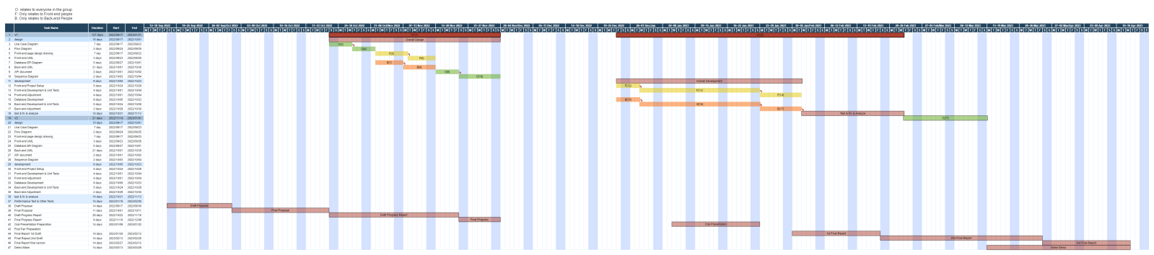

Figure 7.1: Time Table

# 8. Risks and Mitigation

As a graduate project, the system will be built by our group, so one of the biggest risks will be information security. Because of this, anything that might have a connection with the money or the bank will not be included in the project. Such as money transfers, sending gift cards and in-app purchases. And some other security coding methods will be added to the system to protect the personal information provided during the registration.

To avoid the system that might be overwhelmed by the amount of data, a backup plan is needed, for example, a bigger and higher functional database is to be found. By using a better database, this problem will be solved for now.

As a backup plan, if we are not able to follow the proposal to finish this Web app, in our timetable, we have some blank space that is used to let the team member have some break. If we realized that we are not able to finish this project, we will use this time to catch up. If after that we are still not able to finish the project, we will choose to give up some of the add-on functions and keeps the basic functions only to make sure this Web-app can be used by the public as a messaging application.

# 9. Progress, Updates, and Upcoming Challenges

## 9.1 Changes to Objectives

In the section 4.1 - Functional requirements, the original subsections: 4.1.1 Identity and Relationship Functions and 4.1.2 Communication Functions are divided into 5 different subsections (4.1.1 - 4.1.5). The original vague requirements are described more clearly, making the entries more numerous. After intense discussion, we decided to focus on text and image chat messages and statuses for the time being the C&C system is so complex that we thought we should wait until the basic functionality had been designed and implemented before looking at other type of chat messages and statuses. Optional functions are added as a new sub-section, where an original designed rule is described. These features are designed to improve the fun and originality of the software, as the software can function even without this part, so this part of the requirement is classified as an optional requirement.

A new subsection (4.1.6) for administrator functions is added in functional requirement section. We realized that as social software, administrators are needed to manage users' improper actions. Administrators should be able to block users who misbehave without violating the privacy of any user. This is why the only actions the administrator can perform on the user are searching, blocking and unblocking.

We would like to take this opportunity to observe users' behaviour more visually and without invading their privacy, and to produce statistics. This is the reason of adding requirement 2 in subsection 4.1.6.

To add original features and make the program more interesting, a new subsection(4.1.8) for Optional functions is added in the functional requirement section. The sub-section describes the rule of Camp Grouping, which includes technical challenges such as identity creation, rights management, chat encryption and decryption of information and timed tasks. These functions are considered optional and will only be implemented after all other functions are implemented and tested.

In section 4.2, the only change is that the requirement of viewing all group member’s avatar list while in a group chat room is removed. Since users can neither mute/hide/unset a non-friend user nor chat with the user, it is unnecessary to list all group member the whole time. This is the reason we remove the requirement.

## 9.2 Progress

Up to now, we have completed all the design and preparation work related to the project. We have completed the use case diagram and design diagram of the front end and back end. We designed the basic and non basic functions of this project. We designed the API interface for front-end and back-end communication. We have found and learned the technology needed to handle the project. Next, we will enter the formal production stage of the project.

In the progress report, we summarized our current work progress. We summarized the functional and nonfunctional requirements of the project. We designed the basic framework of the project, completed the front-end and back-end use case diagrams, flow charts, front-end vision pages, back-end program structure and database structure. We also designed the API interface for front-end and back-end communication. We have made it clear that the technologies needed to complete the project include java, spring, MySQL, Redis, HTTP, etc. In each technical description section, we briefly explained the advantages of these technologies and the reasons why we chose them. We also summarized the challenges to be faced in the future. We have clarified everyone's contribution in this report.

## 9.3 Upcoming Challenges

We are looking forward to finding a highly efficient way to support the instance message sending, such as WebSocket, and apply it on C&C. At the same time, a cloud data storage needs to be found to store the photos. The API connection between the front and back end needs to be figured out.

Even though we already have a relatively complete plan for the whole system, we might face more unexpected difficulties and accidents while we are writing the code. To solve those future problems, we will do more research and learn more techniques as time passes

# 10. Conclusions and Reflections

C&C is aimed to build a public, fun, peaceful and attractive web communication tool for everybody. People can upload everything with no worries and talk to friends or strangers to have a good time. To achieve this goal, we will build C&C from basic functions: texting, grouping, muting people, deleting people and sending pictures. After that, we will find some way to make strangers able to talk to each other, so people can have a chance to know more people. C&C might also add some functions that can let users be able to do their diaries and show out their life.

# References

[1]“Discord Developer Portal — API Docs for Bots and Developers,” *Discord Developer Portal*, 2022. https://discord.com/developers/docs/intro (accessed Oct. 11, 2022).

[2]“MySQL :: MySQL 8.0 Reference Manual :: 3 Tutorial,” *Mysql.com*, 2022. https://dev.mysql.com/doc/refman/8.0/en/tutorial.html (accessed Oct. 11, 2022).

[3] “WhatsApp Features,” *WhatsApp.com*, 2022. https://www.whatsapp.com/features (accessed Oct. 11, 2022).

[4]“WhatsApp Business Platform - Documentation - Facebook for Developers,” *Facebook.com*, 2022. https://developers.facebook.com/docs/whatsapp/ (accessed Oct. 11, 2022).

[5]“Authentication - Marketing API - Documentation - Facebook for Developers,” *Facebook.com*, 2022. https://developers.facebook.com/docs/marketing-apis/overview/authentication (accessed Oct. 11, 2022).

[6]“What is a REST API?,” *Redhat.com*, 2022. https://www.redhat.com/en/topics/api/what-is-a-rest-api (accessed Oct. 11, 2022).

[7]“Overview - WhatsApp Business Platform On-Premises API - Documentation - Facebook for Developers,” *Facebook.com*, 2022. https://developers.facebook.com/docs/whatsapp/on-premises/overview (accessed Oct. 11, 2022).

[8]“Client Architecture - WhatsApp Business Platform On-Premises API - Documentation - Facebook for Developers,” *Facebook.com*, 2022. https://developers.facebook.com/docs/whatsapp/on-premises/overview/client-architecture (accessed Oct. 11, 2022).

[9]“Security - WhatsApp Business Platform On-Premises API - Documentation - Facebook for Developers,” *Facebook.com*, 2022. https://developers.facebook.com/docs/whatsapp/on-premises/overview/security (accessed Oct. 11, 2022).

[10]“Reference - WhatsApp Business Platform On-Premises API - Documentation - Facebook for Developers,” *Facebook.com*, 2022. https://developers.facebook.com/docs/whatsapp/on-premises/reference (accessed Oct. 11, 2022).

[11]WEB-NART, “NART/whatsapp.md at main · WEB-NART/NART,” *GitHub*, Oct. 09, 2022. https://github.com/WEB-NART/NART/blob/main/doc/whatsapp.md (accessed Oct. 11, 2022).

‌[12]“Messenger – Apps on Google Play,” *Google*. [Online]. Available: https://play.google.com/store/apps/details?id=com.facebook.orca&hl=en_CA&gl=US. [Accessed: 11-Oct-2022].

[13]E. Moreau, “Facebook Messenger: Everything you need to know,” *Lifewire*, 30-Dec-2021. [Online]. Available: https://www.lifewire.com/facebook-messenger-4103719. [Accessed: 11-Oct-2022].

[14]“Messenger,” *Facebook*. [Online]. Available: https://www.messenger.com/features?locale=en_GB. [Accessed: 11-Oct-2022].

[15]“HTML introduction,” *Introduction to HTML*. [Online]. Available: https://www.w3schools.com/html/html_intro.asp. [Accessed: 19-Oct-2022].

[16]“What is CSS? - learn web development: MDN,” *Learn web development | MDN*. [Online]. Available: https://developer.mozilla.org/en-US/docs/Learn/CSS/First_steps/What_is_CSS. [Accessed: 19-Oct-2022].

[17]“What is javascript? - learn web development: MDN,” *Learn web development | MDN*. [Online]. Available: https://developer.mozilla.org/en-US/docs/Learn/JavaScript/First_steps/What_is_JavaScript. [Accessed: 19-Oct-2022].

[18]“Introduction | Vue.js,” *Vuejs.org*, 2022. https://vuejs.org/guide/introduction.html (accessed Oct. 18, 2022).

[19]*Java.com*, 2022. https://www.java.com/en/download/help/whatis_java.html (accessed Oct. 18, 2022).

[20]“MySQL,” *Mysql.com*, 2022. https://www.mysql.com/ (accessed Oct. 18, 2022).

[21]Redis, “Redis,” *Redis*, 2022. https://redis.io/ (accessed Oct. 18, 2022).

[22] “Where the world builds software,” *GitHub*. [Online]. Available: https://github.com/. [Accessed: 18-Oct-2022].

[23]Web-Nart, “Web-Nart/NART,” *GitHub*. [Online]. Available: https://github.com/WEB-NART/NART. [Accessed: 19-Oct-2022].

[24]Oloruntoba, S. (2021, November 30). Solid: The first 5 principles of object oriented design. DigitalOcean. Retrieved November 26, 2022, from https://www.digitalocean.com/community/conceptual-articles/s-o-l-i-d-the-first-five-principles-of-object-oriented-design

[25]Learn java. Dev.java: The Destination for Java Developers. (n.d.). Retrieved November 24, 2022, from https://dev.java/learn/

[26]Learn about spring. Spring. (n.d.). Retrieved November 24, 2022, from https://spring.io/learn

[27]Quickly develop cloud applications with mysql heatwave. Oracle Canada. (n.d.). Retrieved November 24, 2022, from https://www.oracle.com/ca-en/mysql/

[28]“MongoDB Vs. Redis Comparison: Pros And Cons,” MongoDB, 2022. https://www.mongodb.com/compare/mongodb-vs-redis (accessed Nov. 19, 2022).

[29]“Redis vs MongoDB: Which is Better? MongoDB & Redis 101 | Redis,” Redis, Sep. 19, 2022. https://redis.com/docs/why-your-mongodb-needs-redis/ (accessed Nov. 19, 2022).

[30]“Vue.js - The Progressive JavaScript Framework | Vue.js,” *Vuejs.org*, 2014. https://vuejs.org/ (accessed Nov. 26, 2022).

‌[31]“A Vue 3 UI Framework | Element Plus,” *Element-plus.org*, 2022. https://element-plus.org/en-US/#hybrid-layout (accessed Nov. 26, 2022).

‌

[32]“Tailwind CSS - Rapidly build modern websites without ever leaving your HTML.,” *Tailwindcss.com*, Nov. 15, 2020. https://tailwindcss.com/ (accessed Nov. 26, 2022).

‌

[33]“HTTP | MDN,” *Mozilla.org*, Sep. 13, 2022. https://developer.mozilla.org/en-US/docs/Web/HTTP (accessed Nov. 19, 2022).

‌[34]“JSON,” *Json.org*, 2022. https://www.json.org/json-en.html (accessed Nov. 19, 2022).

[35]“The WebSocket API (WebSockets) - Web APIs | MDN,” *Mozilla.org*, Sep. 09, 2022. https://developer.mozilla.org/en-US/docs/Web/API/WebSockets_API (accessed Nov. 19, 2022).

[36]“WebRTC API - Web APIs | MDN,” *Mozilla.org*, Oct. 30, 2022. https://developer.mozilla.org/en-US/docs/Web/API/WebRTC_API (accessed Nov. 19, 2022).

[37]L. Rosencrance, G. Lawton, and C. Moozakis, “User Datagram Protocol (UDP),” *SearchNetworking*, 2021. https://www.techtarget.com/searchnetworking/definition/UDP-User-Datagram-Protocol#:~:text=User%20Datagram%20Protocol%20(UDP)%20is,provided%20by%20the%20receiving%20party. (accessed Nov. 19, 2022).

‌[38]B. Lutkevich, “Transmission Control Protocol (TCP),” *SearchNetworking*, 2021. https://www.techtarget.com/searchnetworking/definition/TCP#:~:text=Transmission%20Control%20Protocol%20(TCP)%20is,of%20data%20to%20each%20other. (accessed Nov. 19, 2022).

[39]J. Juviler, “REST APIs: How They Work and What You Need to Know,” *Hubspot.com*, Aug. 30, 2022. https://blog.hubspot.com/website/what-is-rest-api (accessed Nov. 19, 2022).

[40]“SOAP vs REST APIs: Which Is Right For You? | SoapUI,” *Soapui.org*, 2014. https://www.soapui.org/learn/api/soap-vs-rest-api/ (accessed Nov. 19, 2022).

[41]J. Juviler, “4 Types of APIs All Marketers Should Know,” *Hubspot.com*, Aug. 26, 2021. https://blog.hubspot.com/website/types-of-apis#:~:text=There%20are%20four%20widely%20agreed,internal%20APIs%2C%20and%20composite%20APIs. (accessed Nov. 19, 2022).

[42]“Figma,” *Figma*, 2022. https://www.figma.com/file/0CA3CWW1COcWTyDnwkJmKk/Untitled?node-id=0%3A1&t=IRd0f2at4CaO30X1-0 (accessed Dec. 07, 2022).

‌

‌‌‌

# Appendix 1. Definition, Acronyms, and Abbreviations

C&C --- The Come And Chat Instant Messaging Software System.

Message --- Information in text, image, audio, video, link, or hybrid.

Friend --- A relationship between users that gives both parties a quick link to each other.

Status --- A message posted by a user that the user’s friends can only see.

Chat --- A connection tube between two users.

Group Chat --- A connection tube among three or more users.

The system --- represents the C&C Instant Messaging Software system.

IM --- represents Instant Messaging.

API --- application programming interface, which is a software intermediary that allows two applications to talk to each other.

HTTP --- The Hypertext Transfer Protocol is an application layer protocol in the Internet protocol suite model for distributed, collaborative, hypermedia information systems.

DDoS --- A distributed denial-of-service (DDoS) attack is a malicious attempt to disrupt the normal traffic of a targeted server, service or network by overwhelming the target or its surrounding infrastructure with a flood of Internet traffic.

Guild --- A server that can accommodate multiple users to communicate at the same time

Instance --- A format used by the back end to contain the data transmitted by the front end. Usually, instances can also be added, deleted, modified, and searched for database records.

SYSC 2004 --- Object-Oriented Software Development (BlueJ Java)

SYSC 3020 --- Intro. to Software Engineering

SYSC 3110 --- Software Development Project

SYSC 3303 --- Real-Time Concurrent Systems

SYSC 3310 --- Introduction to Real-time Systems

SYSC 2100 --- Algorithm and Data Structures

COMP 3005 --- Database Management Systems

SYSC 3120 --- Software Requirements Engineering

SYSC 4106 --- The Software Economy and Project Management

SYSC 4101 --- Software Validation

SYSC 4801 --- Intro. to Network and Software Security

ECOR 2050 --- Design & Analysis of Engineering Experiments

ECOR 4995 --- Professional Practice

CCDP 2100 --- Communication Skills for Engineering Students

SYSC 4806 --- Software Engineering Lab

SYSC 4120 --- Software Architecture & Design

‌

# Appendix 2. Source Documents

[Use Case Diagram Version 1](https://github.com/WEB-NART/NART/blob/main/doc/design/useCase_V1.0.png)

[Use Case Diagram Version 2](https://github.com/WEB-NART/NART/blob/main/doc/design/useCase_V1.1.png)

[Use Case Diagram Version 3](https://github.com/WEB-NART/NART/blob/main/doc/design/useCase_V1.2.png)

[Use Case Diagram Version 4](https://github.com/WEB-NART/NART/blob/main/doc/design/useCase_V1.3.png)

[Use Case Description Version 1](https://github.com/WEB-NART/NART/blob/main/doc/design/user%20case%20description%201st%20draft.pdf)

[Use Case Description Version 2](https://github.com/WEB-NART/NART/blob/main/doc/design/user%20case%20description%202st%20draft.pdf)

[User FlowDiagram Version 1](https://github.com/WEB-NART/NART/blob/main/doc/design/user_flowDiagram_v1.0.png)

[User FlowDiagram Version 2](https://github.com/WEB-NART/NART/blob/main/doc/design/user_flowDiagram_v1.1.png)

[User FlowDiagram Version 3](https://github.com/WEB-NART/NART/blob/main/doc/design/user_flowDiagram_v1.2.png)

[Admin FlowDiagram Version 1](https://github.com/WEB-NART/NART/blob/main/doc/design/admin_flowDiagram.png)

[Module UML](https://github.com/WEB-NART/NART/blob/main/doc/design/user_moduleUML_v1.0.png)

[ERDiagram Version 1](https://github.com/WEB-NART/NART/blob/main/doc/design/ERDiagram_v1.0.png)

[ERDiagram Version 2](https://github.com/WEB-NART/NART/blob/main/doc/design/ERDiagram_v1.1.png)

[ERDiagram Version 3](https://github.com/WEB-NART/NART/blob/main/doc/design/ERDiagram_v1.2.png)

[ERDiagram Version 4](https://github.com/WEB-NART/NART/blob/main/doc/design/ERDiagram_v1.3-erDiagram.drawio.png)

[User Front Page Prototype](https://github.com/WEB-NART/NART/blob/main/doc/design/user_pageDesign.png)

[User Front Page Prototype Detail](https://github.com/WEB-NART/NART/tree/main/doc/design/pages)

[User Front Page Structure](https://github.com/WEB-NART/NART/blob/main/doc/design/user_pageStructure.md)

[User Front-End UML](https://github.com/WEB-NART/NART/blob/main/doc/design/user_frontend_uml_v1.0.png)

[User Back-End UML Version 1](https://github.com/WEB-NART/NART/blob/main/doc/design/user_backend_uml_v1.0.png)

[User Back-End UML Version 2](https://github.com/WEB-NART/NART/blob/main/doc/design/user_backend_uml_v1.1.png)

[Admin Front Page Prototype](https://github.com/WEB-NART/NART/blob/main/doc/design/admin_pageDesign.png)

[Admin Front-End UML](https://github.com/WEB-NART/NART/blob/main/doc/design/admin_frontend_uml.png)

[API Specification Document Version 1](https://github.com/WEB-NART/NART/blob/main/doc/design/api_v1.2.md)

[API Specification Document Version 2](https://github.com/WEB-NART/NART/blob/main/doc/design/api_v1.3.md)

[API Specification Document Version 3](https://github.com/WEB-NART/NART/blob/main/doc/design/api_v1.4.md)

[Overall C&C Structure](https://github.com/WEB-NART/NART/blob/main/doc/design/Overall.png)

# [Appendix 3. Proposal](https://github.com/WEB-NART/NART/blob/main/doc/design/Overall.png)

# [‌](https://github.com/WEB-NART/NART/blob/main/doc/design/Overall.png)