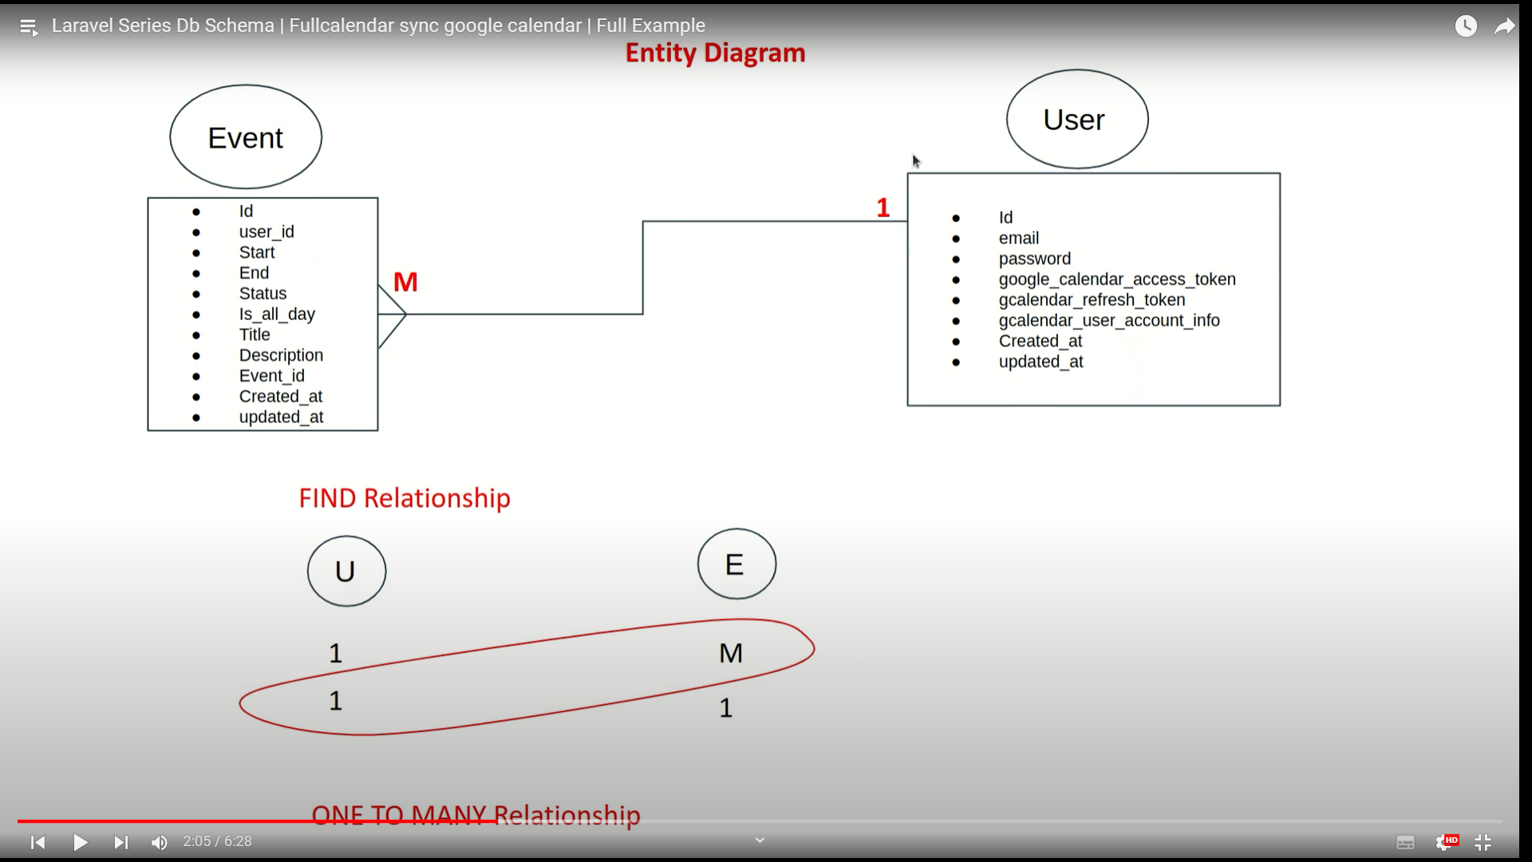

Google Calender : <https://www.youtube.com/watch?v=f6BUWVAhb10&list=PLC3enylPm5dxOo8Vq7iZXISjsWl-MhcFN&index=4>