

**American International University- Bangladesh**

**CSC 3215: Web Technologies**

**CO1 and CO3 Evaluation**

**Project Report**

**Spring 2019-2020**

**Project Title: CareerJet**

**Section: M**

**Github link:** <https://github.com/WEB-TECHNOLOGIES-M>

|  |  |
| --- | --- |
| Student Name | Student Id |
| SAIMON, MD. ZILLUR RAHMAN | **17-34006-1** |
| MAHABOBUR RAHAMAN POLLOB | **17-33983-1** |
| MAHMUD, MD. TAREK | **17-34046-1** |

**Introduction:**

**CareerJet** is a job search engine designed to make the process of finding a job on the internet easier for the user. It maps the huge selection of job offerings available on the internet in one extensive database by referencing job listings originating from job boards, recruitment agency websites. This project aims to mitigate the problem by creating a common platform for seeking and publishing jobs.

**Background Study**

* **bdjobs.com:** bdjobs is a popular online job portal in Bangladesh. It provides facilities to search and download regional job circulars in Bangladesh.
* **monster.com:** monster.com is an international job portal which provides extra career building facilities like career advice, resume checkup, as well as salary tools beside the main job searching features.
* **glassdoor.com: g**lassdoor.com is an online job portal provides free versatile tools for job seekers as well as employers to meet their requirements.

**Requirement Analysis:**

1. **User Category:**

There are 3-types of Users here. They are:

* Admin
* Employer
* Job Seeker

1. **Feature List:**

In this project the “Admin” has the following features:

* Approve and Reject the new user’s registration.
* Approve and Reject the posted Jobs by the Employer.
* Manage posted Jobs.
* Manage Employer or Job Seekers.

In this project the “Employer” has the following features:

* Post Jobs.
* Search Employees by their specific requirements.
* Approve and reject Job Applications.
* Gets notifications.

In this project the “Job Seeker” has the following features:

* Search jobs by their skills.
* Apply for the job.
* Report Employer.

**Design:**

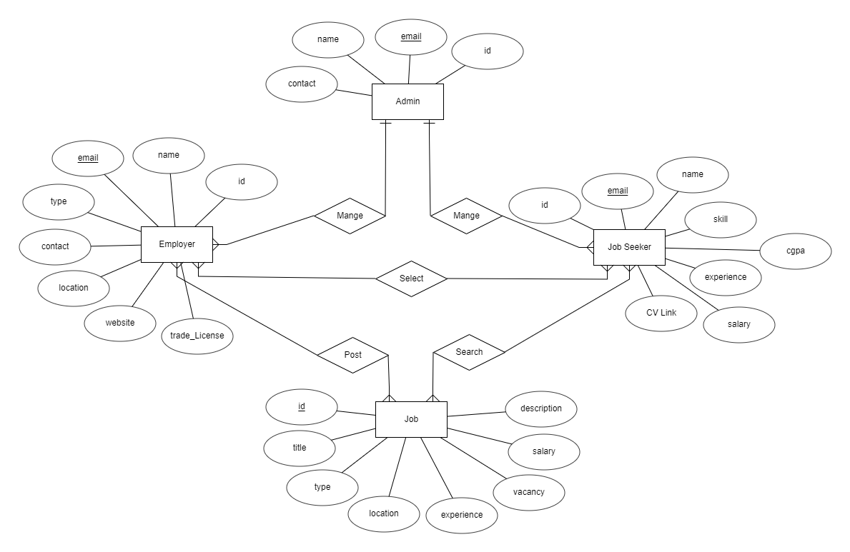

**Tools Used:**

To develop this project, we have used the following:

• Visual Studio Code [**1.43**](https://code.visualstudio.com/updates)

• Notepad++ [**7.8.5**](https://notepad-plus-plus.org/downloads/v7.8.5/)

• XAMPP [**7.4.3**](https://notepad-plus-plus.org/downloads/v7.8.5/)

• ERD Plus (Entity Diagram)

• Adobe XD

**System Images against the Specification:**

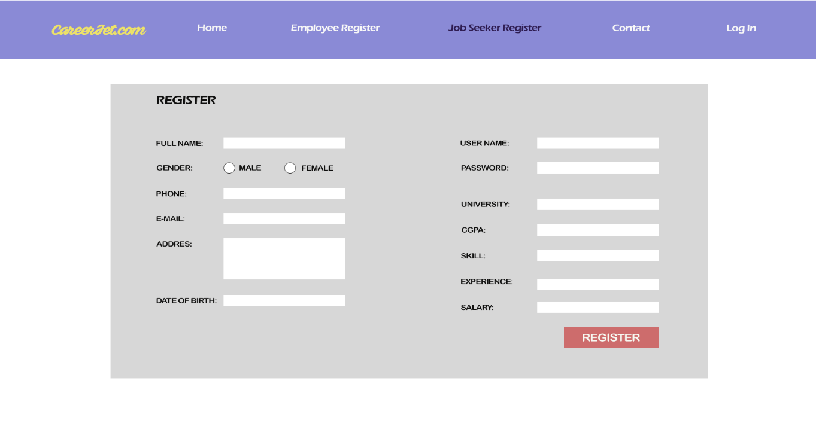

**Fig: Job Seeker Registration page**

This is the page the users are greeted with when they try to register as a Job Seeker. They need to fill out the necessary information in order to register.

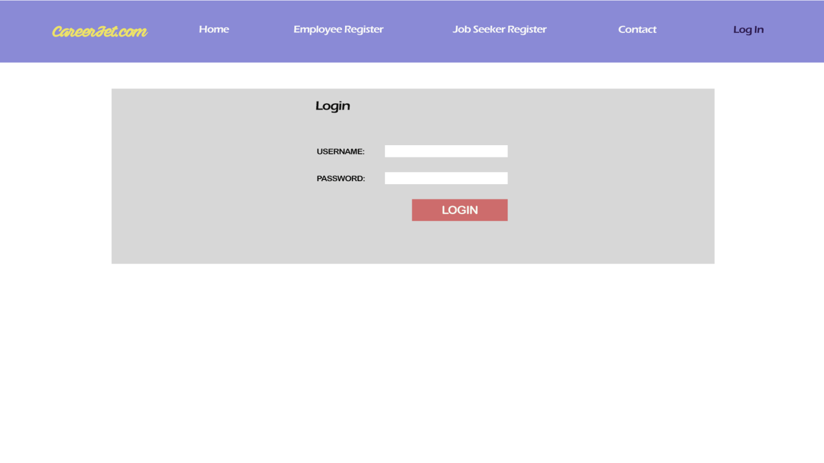

**Fig: Login page**

This is the page the users are greeted with when they try to login to the system.

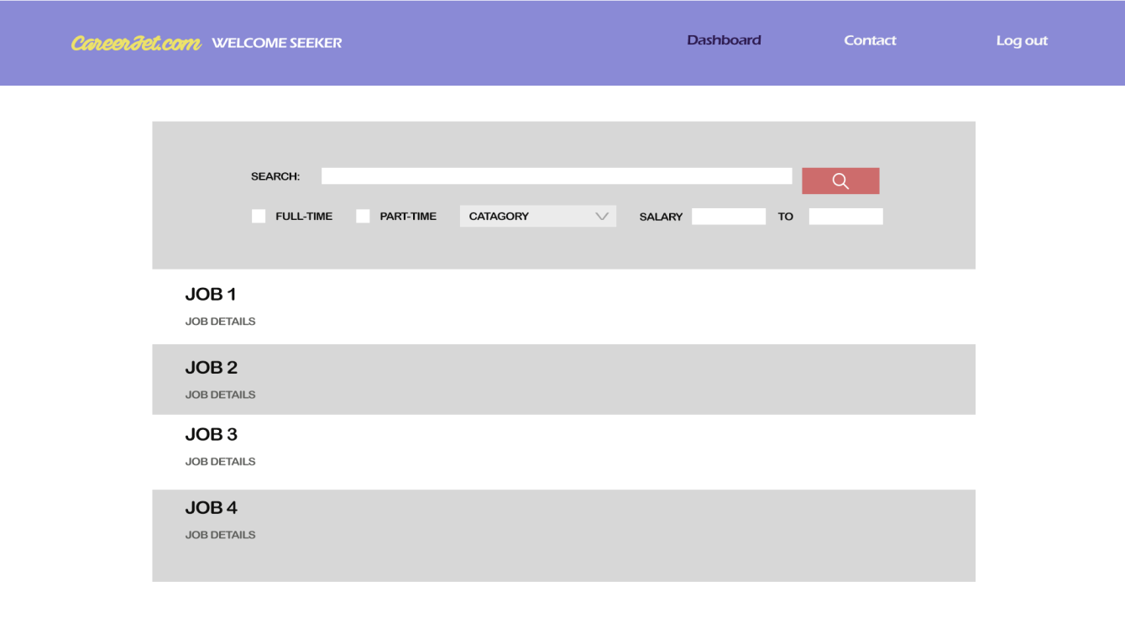

**Fig: Job Searching page**

This page has the features related to searching for a job under certain criteria. This page is only available to Job Seekers.

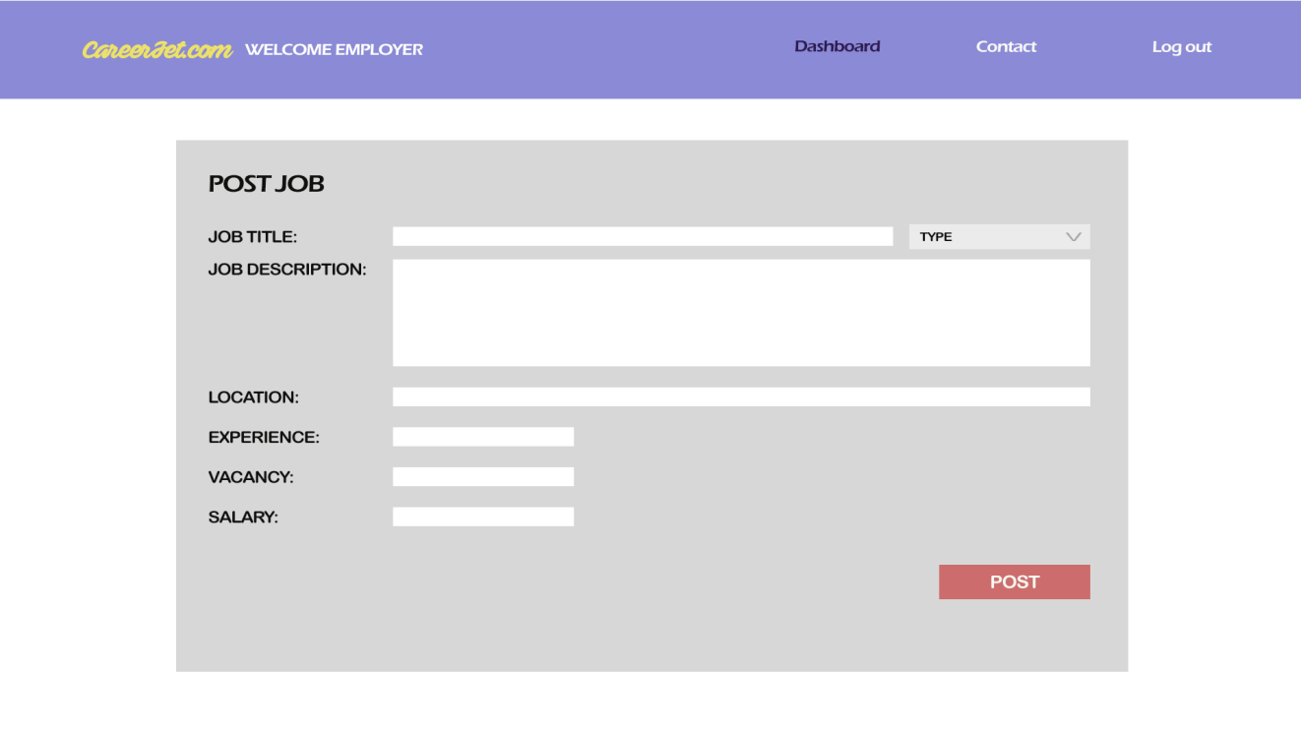

**Fig: Job Posting page**

This is the page for the Employers to post a job. They must provide all information regarding the job to post it successfully.

**Impact of this Project:**

As time moves forward, the population increases. This increase in population creates a scarcity of job opportunities in the market. This makes it hard for the unemployed to search for their desired jobs in the traditional method. This project will streamline the job searching method and also provide the job seeker with versatility to find the job they are most suited for. Job portals are a simple, but effective tool. They create space for employers and employees and provide easier access to a wide array of jobs in different sectors and skill levels. They also reduce job-matching costs and fees associated with middlemen and head-hunters, as well as close the communication gap between the employers and the job seekers.

**Limitations and Possible Future Improvements:**

The user can only access online Job Portal from any computer/mobile that has internet connection and internet browsing capabilities. The Interface is provided only in English. So, the user should know English. The size of the database increases day-by-day, increasing the load on the database back up and data maintenance activity.

Live Chat messenger, where the employers and job seekers can communicate with each other. Customized CV system may be implemented to keep a consistent format. Automated job suggestions according to the job seekers interests and CV.

|  |  |  |  |  |  |
| --- | --- | --- | --- | --- | --- |
| **CO1 and CO3 Evaluation: Project Report Evaluation** | | | | | |
| **Project Proposal**  **(5)** | **Background**  **Study**  **(5)** | **Requirement Analysis**  **(5)** | **Entity**  **Diagram**  **(5)** | **System Images**  **against the**  **Specification (5)** | **Total (25)** |
|  |  |  |  |  |  |
|  | | | | | |