

**American International University- Bangladesh**

**CSC 3215: Web Technologies**

**CO2 and CO4 Evaluation**

**Finished Project Report**

**Spring 2019-2020**

**Project Title: JobPortal**

**Section: M**

|  |  |
| --- | --- |
| Student Name | Student Id |
| SAIMON,MD.ZILUR RAHMAN | **17-34006-1** |
| MAHMUD,MD.TAREK | **17-34046-1** |
| MAHBOBUR RAHMAN POLLOB | **17-33983-1** |

**Project Description:**

**JobPortal** is a job search engine designed to make the process of finding a job on the internet easier for the user. It maps the huge selection of job offerings available on the internet in one extensive database by referencing job listings originating from job boards, recruitment agency websites. This project aims to mitigate the problem by creating a common platform for seeking and publishing jobs.

There are 3-types of Users here. They are:

* Admin
* Employer
* Job Seeker

In this project the “Admin” has the following features:

* Approve and Reject the new user’s registration.
* Approve and Reject the posted Jobs by the Employer.
* Manage posted Jobs.
* Manage Employer or Job Seekers.

In this project the “Employer” has the following features:

* Post Jobs.
* Approve and reject Job Applications.
* Gets notifications.

In this project the “Job Seeker” has the following features:

* Search jobs by their skills.
* Apply for the job.

**Project Folder Structure:**

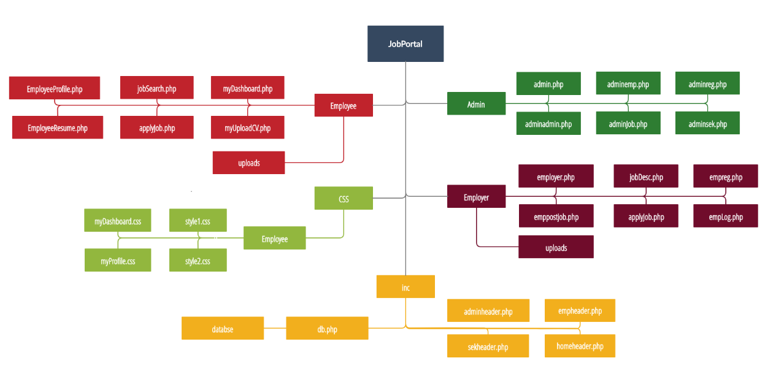

**Core Modules of the Project:**

***JobSearch.php***

*$('#searchBTN').click(function() {*

*nextClick = 0;*

*i = 2;*

*j = 0;*

*$("#err").html('');*

*if ($('#search-location').val() == '' || $('#search-categories').val() == '' || $('input[name="type"]:checked').length == 0 || $('input[name="salary"]:checked').length == 0 || $('input[name="exp"]:checked').length == 0) {*

*alert("Fill up all The Requirments!!");*

*} else {*

*var location = document.getElementById('search-location').value.toLowerCase();*

*var type = document.querySelector('input[name="type"]:checked').value;*

*var catagory = document.getElementById('search-categories').value;*

*var salary = document.querySelector('input[name="salary"]:checked').value;*

*var exp = document.querySelector('input[name="exp"]:checked').value;*

*var email = '<?php echo $email ?>';*

*$("#prevBtn").show();*

*$("#nextBtn").show();*

*$("#resPerPage").show();*

*$("#resPerPage").val("Result Per Page");*

*document.getElementById('prevBtn').disabled = true;*

*var postData = 'location=' + location + '&type=' + type + '&catagory=' + catagory + '&salary=' + salary + '&exp=' + exp + '&email=' + email + '&resPerPage=' + 3;*

*$.ajax({*

*url: "jobSearchResultSession.php",*

*type: "POST",*

*data: postData,*

*success: function(data, status, xhr) {*

*np1 = data;*

*if (np1 == 0) {*

*$("#prevBtn").hide();*

*$("#nextBtn").hide();*

*$("#resPerPage").hide();*

*$("#err").html(" No Matching Job Found");*

*}*

*if (nextClick == (np1 - 1)) {*

*$("#prevBtn").hide();*

*$("#nextBtn").hide();*

*} else {*

*document.getElementById('nextBtn').disabled = false;*

*} },*

*error: function(jqXHR, status, errorThrown) {*

*alert("errr");*

*} });*

*$('#searchResult').load('jobSearchResult.php', {*

*location: location,*

*type: type,*

*catagory: document.getElementById('search-categories').value,*

*salary: document.querySelector('input[name="salary"]:checked').value,*

*email: email,*

*resPerPage: 3,*

*exp: document.querySelector('input[name="exp"]:checked').value*

*});*

*return false;*

*} });*

***EmployeeResume.php***

*<?php*

*include "includes/db_connect.php";*

*session_start();*

*if (!isset($_SESSION["email"])) {*

*header("Location: ../logout.php");*

*}else{*

*$email = $_SESSION['email'];}*

*$sqlUserCheck = "SELECT email,cgpa,name,title,aboutMe,gender,facebook,linkedin,twitter,google,address,city,phone,website,age,salary,experience,picture,file_name FROM seekerinfo WHERE email = '$email'";*

*$result = mysqli_query($conn, $sqlUserCheck);*

*while ($row = mysqli_fetch_assoc($result)) {*

*$name = $row['name'];*

*$cgpa = $row['cgpa'];*

*$title = $row['title'];*

*$aboutMe = $row['aboutMe'];*

*$facebook = $row['facebook'];*

*$linkedn = $row['linkedin'];*

*$twitter = $row['twitter'];*

*$google = $row['google'];*

*$email = $row['email'];*

*$gender = $row['gender'];*

*$address = $row['address'];*

*$city = $row['city'];*

*$phone = $row['phone'];*

*$website = $row['website'];*

*$age = $row['age'];*

*$salary = $row['salary'];*

*$experience = $row['experience'];*

*$picture = $row['picture'];*

*$file_name = $row['file_name'];*

*}*

*?>*

*<!DOCTYPE html>*

*<html lang="en">*

*<head>*

*<meta charset="UTF-8">*

*<meta name="viewport" content="width=device-width, initial-scale=1.0">*

*<title>Employee Profile</title>*

*<link rel="stylesheet" href="../css/Employee/style1.css">*

*<link rel="stylesheet" href="../css/Employee/bootstrap.css">*

*<link rel="stylesheet" href="../css/Employee/fonts.css">*

*</head>*

*<body>*

*<div class="cv">*

*<?php if ($file_name == "") {*

*}else{?>*

*<a href="/uploads/<?php echo $file_name ?>" download class="btn btn-primary btn-lg active" role="button" aria-pressed="true" style="*

*width: 100%;">Download CV</a>*

*<?php } ?>*

*</div>*

*</div>*

*<div class="profile-divider"></div>*

*<br>*

*<div class="personalInfo_div" style="display: flex">*

*<div class="personalInfo">*

*<div class="aboutMe">*

*<p class="heading">About Me</p>*

*<hr style="*

*margin-bottom: 15px;*

*margin-top: 5px;">*

*<p class="text-style-1" style="font-size: 14px;margin-bottom: 20px;"> <?php echo $aboutMe ?> </p>*

*</div>*

*<!-- Professional Skill -->*

*<div class="professionalSkill">*

*<p class="heading">Professional skills</p>*

*<hr style="*

*margin-bottom: 15px;*

*margin-top: 5px;">*

*<div class="proskill" id="proskill" style="margin-bottom: 20px;">*

*<?php*

*$sqlUserCheck = "SELECT skill FROM seekerskill WHERE email = '$email' ";*

*$result = mysqli_query($conn, $sqlUserCheck);*

*while ($row = mysqli_fetch_array($result)) {*

*$res = $row['skill'];*

*$subR = explode(',', $res);*

*$count = count($subR);*

*for ($x = 0; $x < ($count - 1); $x++) {*

*$r = explode(';', $subR[$x]); ?>*

*<div class="pskill-1" style="margin-right: 25px;">*

*<article class="progress-linear progress-bar-secondary animated" style="display: flex">*

*<div class="progress-linear-header" style="width:25%;">*

*<p class="progress-linear-title"><?php echo $r[0] ?></p>*

*</div>*

*<div class="progress" style="background-color: #9a9191; width:75%">*

*<div class="progress-bar progress-bar-warning " role="progressbar" style="width: <?php echo $r[1] ?>%;" aria-valuenow="25" aria-valuemin="0" aria-valuemax="100"><?php echo $r[1] ?>%</div>*

*</div>*

*</article>*

*</div>*

*<?php }*

*}*

*?>*

*</div>*

*</div>*

*</body>*

***emppostjob.php***

*<html style="background-color: white">*

*<?php*

*session_start();*

*include_once "inc/empheader.php";*

*include "inc/db.php";*

*if(isset($_SESSION['editjobID'])){*

*if(!empty($_SESSION['editjobID'])){*

*$jobID=$_SESSION['editjobID'];*

*$editsql="SELECT * FROM job WHERE ID=$jobID;";*

*$editresult=mysqli_query($conn, $editsql);*

*while($editrows=mysqli_fetch_assoc($editresult)){*

*$title=$editrows['title'];*

*$type=$editrows['type'];*

*$loc=$editrows['location'];*

*$catagory=$editrows['catagory'];*

*$exp=$editrows['experience'];*

*$vac=$editrows['vacancy'];*

*$salary=$editrows['salary'];*

*$desc=$editrows['description'];*

*}}}*

*if ($_SERVER['REQUEST_METHOD'] === 'POST'){*

*if(isset($_POST['jobpost'])){*

*if(!empty($_POST['title'])){*

*$title=$_POST['title'];}else {$terr="No title given!";}*

*if(!empty($_POST['type'])){*

*$type=$_POST['type'];*

*}else {$typeerr="No type given!";}*

*if(!empty($_POST['location'])){*

*$loc=$_POST['location'];*

*}else $locerr="No location given!";}*

*if(!empty($_POST['catagory']){*

*$catagory=$_POST['catagory'];*

*}else {$caterr="No catagory given!";}*

*if(!empty($_POST['exp'])){*

*$exp=$_POST['exp'];*

*}else {$experr="No experience given!";}*

*if(!empty($_POST['vacancy'])){*

*$vac=$_POST['vacancy'];*

*}else {$vacerr="No vacancy given!";}*

*if(!empty($_POST['salary'])){*

*$salary=$_POST['salary'];*

*}else {$salerr="No salary given!";}*

*if(!empty($_POST['desc'])){*

*$desc=$_POST['desc'];*

*}else {$descerr="No description given!";}*

*if($terr==""&&$typeerr==""&&$locerr==""&&$caterr==""&&$experr==""&&$vacerr==""&&$salerr==""&&$descerr==""){*

*if(!empty($jobID)){*

*$user=$_SESSION['username'];*

*$sql2 = "UPDATE job SET employer='$user',title='$title',type='$type',location='$loc',catagory='$catagory',experience='$exp',vacancy='$vac',salary='$salary',description='$desc' WHERE ID='$jobID';";*

*mysqli_query($conn, $sql2);*

*$_SESSION['jobpost']="Successful";*

*$title=$type=$loc=$catagory=$exp=$vac=$salary=$desc="";*

*$_SESSION['msg']="Job Updated!";*

*unset($_SESSION['editjobID']);*

*header('Location: employer.php');*

*}*

*else{*

*$user=$_SESSION['username'];*

*$sql2 = "INSERT INTO job (employer,title,type,location,catagory,experience,vacancy,salary,description)*

*VALUES ('$user','$title','$type','$loc','$catagory','$exp','$vac','$salary','$desc');";*

*mysqli_query($conn, $sql2);*

*$_SESSION['jobpost']="Successful";*

*echo mysqli_error($conn);*

*?>*

*<!-- Catagory -->*

*<tr>*

*<td width="210px"><label style="color:black">Catagory: &nbsp</label></td>*

*<td style="display: flex;"><select name="catagory" required style="font-size:20px;">*

*<option value="accounting" <?php if($catagory=="accounting"){echo "selected";} elseif($catagory==""){echo "selected";} ?>>Accounting</option>*

*<option value="banking" <?php if($catagory=="banking"){echo "selected";} ?>>Banking</option>*

*<option value="development" <?php if($catagory=="development"){echo "selected";} ?>>Development</option>*

*<option value="insurance" <?php if($catagory=="insurance"){echo "selected";} ?>>Insurance</option>*

*<option value="it" <?php if($catagory=="it"){echo "selected";} ?>>IT</option>*

*<option value="healthcare" <?php if($catagory=="healthcare"){echo "selected";} ?>>Healthcare</option>*

*<option value="marketing" <?php if($catagory=="marketing"){echo "selected";} ?>>Marketing</option>*

*<option value="management" <?php if($catagory=="management"){echo "selected";} ?>>Management</option>*

*</select>*

*</td>*

*<!-- <td style="display: flex;"><input type="text" width="100%" name="catagory" maxlength="50" required style="font-size:20px; flex: 1;"></td> -->*

*</tr>*

*<tr>*

*<td></td>*

*<td style="font-size: 15px; color: red;"><?php echo $caterr ?></td>*

*</tr>*

*<!-- Experience -->*

*<tr>*

*<td><label style="color:black">Experience: &nbsp</label></td>*

*<td style="display: flex;"><input type="number" width="100%" name="exp" maxlength="2" required style="font-size:20px; flex: 1;" value="<?php echo $exp ?>"></td>*

*</tr>*

*<tr>*

*<td></td>*

*<td style="font-size: 15px; color: red;"><?php echo $experr ?></td>*

*</tr>*

*<!-- Vacancy -->*

*<tr>*

*<td><label style="color:black">Vacancy: &nbsp</label></td>*

*<td style="display: flex;"><input type="number" width="100%" name="vacancy" maxlength="5" required style="font-size:20px; flex: 1;" value="<?php echo $vac ?>"></td>*

*</tr>*

*<tr>*

*<td></td>*

*<td style="font-size: 15px; color: red;"><?php echo $vacerr ?></td>*

*</tr>*

|  |  |  |  |  |  |
| --- | --- | --- | --- | --- | --- |
| **CO2 and CO4 Evaluation: Project Report Evaluation** | | | | | |
| **Completeness**  **(5)** | **Validation**  **(5)** | **Feature Implementation**  **(5)** | **Concept Understanding**  **(5)** | **Promptness (5)** | **Total (25)** |
|  |  |  |  |  |  |
|  | | | | | |