let's build this whatsapp automations for Inian SMEs [🛠️ Technical Implementation (Your Stack) Core Tech Stack
text
Backend: - Node.js (Express) for API endpoints - n8n for workflow orchestration (your existing skill) [cite:3] Database: - PostgreSQL (for patient records, appointments) - OR Notion API (for smaller clinics, faster setup) [cite:1][cite:3] WhatsApp: - Meta WhatsApp Business API (Cloud API) - Or third-party: Twilio, Gupshup, Interakt (India-friendly) AI: - Claude API or ChatGPT for WhatsApp bot responses - n8n for prompt orchestration Deployment: - VPS (DigitalOcean ₹800/month) or Hostinger - GitHub Actions for CI/CD [cite:3] Workflow Example: Appointment Booking Flow
text
Patient message: "Hi" on WhatsApp ↓ n8n webhook → Check if existing patient ↓ If new: Send intake form (Google Form or Typeform) If existing: Show available slots for next 7 days ↓ Patient picks slot → Confirm in database ↓ Send WhatsApp confirmation with: - Date/time - Doctor name - Clinic address (Google Maps link) - "Reply R to reschedule, C to cancel" ↓ 24hr before: Auto-send reminder ↓ 2hr before: Final reminder + "Running late? Reply L" ↓ After visit: Send review request + bill]
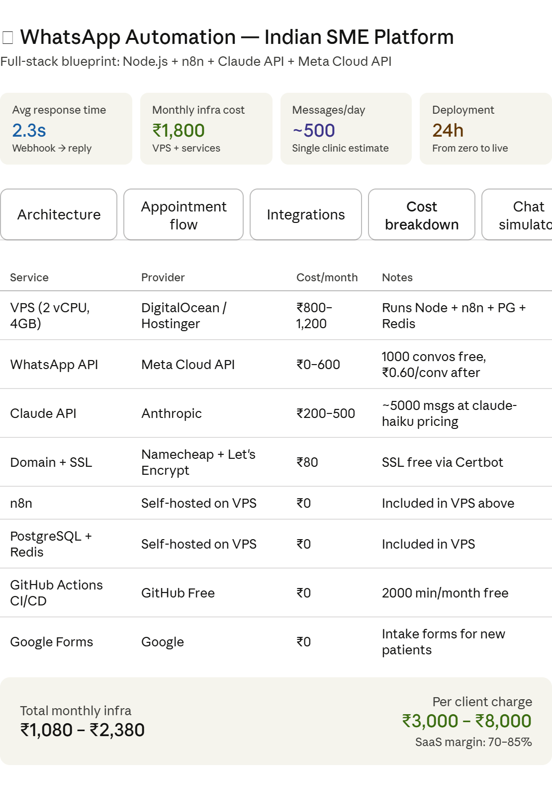 Architecture

Backend (Node.js)
- Express.js — webhook endpoints
- Webhook signature verify
- Session store (Redis)
- Queue: Bull/BullMQ
- REST → n8n trigger

n8n Orchestration
- Webhook → route by intent
- New vs existing patient branch
- Slot availability check
- Reminder scheduler (CRON)
- Post-visit review trigger

Database Layer
- PostgreSQL — patients, appts
- Redis — session + rate limit
- OR Notion API (smaller SMEs)
- Google Sheets fallback

AI Layer
- Claude API — intent parsing
- Multilingual (Hindi/English)
- Prompt orchestration via n8n
- Fallback: GPT-4o mini

WhatsApp Layer
- Meta Cloud API (free tier)
- Interakt / Gupshup (India)
- Template messages (HSM)
- Interactive buttons/lists

Deployment
- DigitalOcean / Hostinger VPS
- Docker Compose (all services)
- GitHub Actions CI/CD
- Nginx reverse proxy + SSL
Data flow: Patient sends WhatsApp message → Meta webhooks POST to your Express endpoint → Node.js verifies signature + pushes to BullMQ → n8n workflow triggered → AI parses intent → DB query → WhatsApp reply via Meta Cloud API. Redis holds session state between multi-turn conversations.
Appointment
1
Patient sends "Hi"
Any message triggers the webhook on your Express server
Meta Webhook
2
New vs existing patient check
Query PostgreSQL by phone number — branch workflow accordingly
n8n branch PostgreSQL
3
New → intake form / Existing → show slots
New: send Google Form link. Existing: interactive list of next 7 days' slots
WA Interactive List
4
AI intent parsing
Claude API parses "Sunday 11 baje" → structured slot object {date, time, doctor_id}
Claude API
5
Confirm booking in DB + send confirmation
Insert appointment row → WhatsApp template with date, doctor, Maps link, R/C commands
PostgreSQL HSM Template
6
24h reminder (CRON job)
n8n scheduled trigger fires — sends reminder with date/time + reschedule option
n8n CRON Auto
7
2h reminder + "Running late?"
Final reminder — patient replies L to flag delay, system notifies clinic staff
n8n CRON Auto
8
Post-visit: review + bill
4h after appointment → send review request link + PDF bill via WhatsApp document
Auto WA Document

Integrations

WhatsApp Provider
Meta Cloud APIRecommended
InteraktIndia-best
GupshupIndia alt
TwilioGlobal
AiSensyIndia alt

AI Provider
Claude API (claude-sonnet)Best quality
GPT-4o miniCost alt
Gemini Flash 2.0Cost alt
Llama 3 (self-host)₹0/token

Database Options
PostgreSQL (self-host)Full control
Supabase (PostgreSQL)Managed
Notion APISmall SMEs
Google Sheets APIZero cost

Calendar / Scheduling
Google Calendar APIRecommended
Calendly APIAlt
Custom slots in PGBest fit
Zoho BookingsIndia-friendly
Indian SME sweet spot: Meta Cloud API (free up to 1000 conversations/month) + Interakt for managed dashboard + Claude API for Hindi/English multilingual parsing + PostgreSQL on your VPS. For a clinic doing 20–30 appts/day, total AI cost will be under ₹500/month.

Cost breakdown
Service | Provider | Cost/month | Notes
VPS (2 vCPU, 4GB) | DigitalOcean / Hostinger | ₹800–1,200 | Runs Node + n8n + PG + Redis
WhatsApp API | Meta Cloud API | ₹0–600 | 1000 convos free, ₹0.60/conv after
Claude API | Anthropic | ₹200–500 | ~5000 msgs at claude-haiku pricing
Domain + SSL | Namecheap + Let's Encrypt | ₹80 | SSL free via Certbot
n8n | Self-hosted on VPS | ₹0 | Included in VPS above
PostgreSQL + Redis | Self-hosted on VPS | ₹0 | Included in VPS
GitHub Actions CI/CD | GitHub Free | ₹0 | 2000 min/month free
Google Forms | Google | ₹0 | Intake forms for new patients
Total monthly infra
₹1,080 – ₹2,380
Per client charge
₹3,000 – ₹8,000
SaaS margin: 70–85%

Chat simulator

WhatsApp chat preview
Today • Clinic Bot

Pick a scenario
👤 New patient (Hi) 📅 Book appointment 🔄 Reschedule (R) ❌ Cancel (C) ⏰ Running late (L)

