Kelly Compton

Week 3 Complete Assignment: The New Avengers

1. Show all of the information on the Avengers.

**Query:** SELECT * FROM avengers.avengers;

**Columns:** name, url, appearances, current, gender, probationaryIntro, fullAvengersIntro, year, yearsSinceJoining, honorary, death1, return1, death2, return2, death3, return3, death4, return4, death5, return5, notes

**Expected row count:** 171

**Screenshot:**

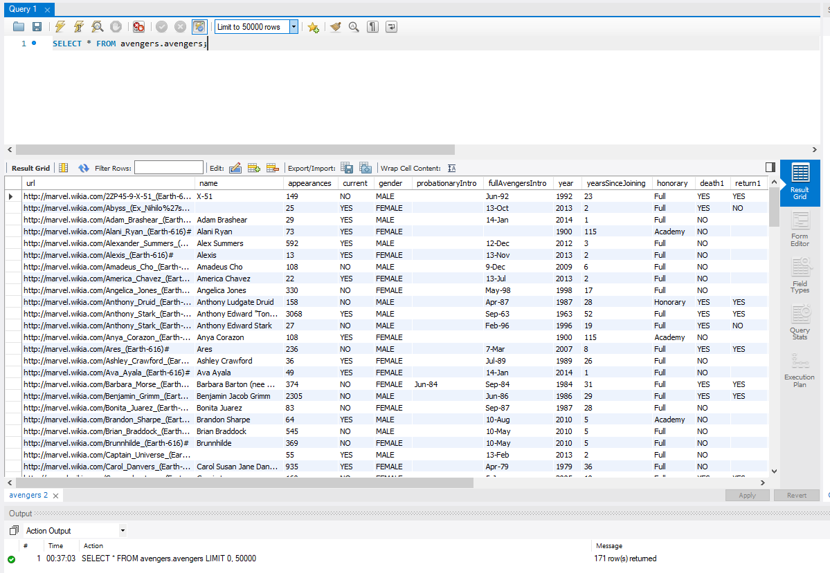

1. Create a new table with information from another superhero group [can be imported from elsewhere or fictitious]. Make sure there is an appropriate header and must be at least 30 rows.

**Query:**

CREATE TABLE IF NOT EXISTS DCHEROS (HEROS_GENDER varchar(6) DEFAULT NULL, HEROS_NAME varchar(100) DEFAULT NULL, HEROS_POWER int(10) DEFAULT NULL, HEROS_ID int(100) NOT NULL, PRIMARY KEY (HEROS_ID));

INSERT INTO DCHEROS (HEROS_GENDER, HEROS_NAME, HEROS_POWER, HEROS_ID) VALUES('Female', 'Amethyst', '4', '1'),('Male', 'Aquaman', '6', '2'),('Male', 'Arsenal', '5','3'),('Female', 'Atlanna', '7', '4'),('Male', 'Atom', '8', '5'),('Female', 'Batgirl', '7', '6'),('Male', 'Batman', '10', '7'),('Female', 'Batwoman', '10', '8'),('Female', 'Black Canary', '9', '9'),('Male', 'Black Lightning', '8', '10'),('Male', 'Firestorm', '7', '11'),('Female', 'Bumblebee', '3', '12'),('Male', 'Green Arrow', '6', '13'),('Male', 'Green Lantern', '2', '14'),('Female', 'Hawkgirl', '1', '15'),('Male', 'Hawkman', '2', '16'),('Female', 'Huntress', '3', '17'),('Male', 'Flash', '4', '18'),('Female', 'Katana', '5', '19'),('Female', 'Mera', '6', '20'),('Male', 'Monitor', '5', '21'),('Male', 'Nightwing', '9', '22'),('Male', 'Plastic Man', '4', '23'),('Female', 'Raven', '8', '24'),('Male', 'Superman', '10', '25'),('Female', 'Superwoman', '10', '26'),('Female', 'Stargirl', '7', '27'),('Male', 'Robin', '7', '28'),('Female', 'Vixen', '10', '29'),('Female', 'Wonder Woman', '10', '30');

**Columns:** HEROS_GENDER, HEROS_NAME, HEROS_POWER, HEROS_ID

**Expected row count:** 30

**Screenshot:** 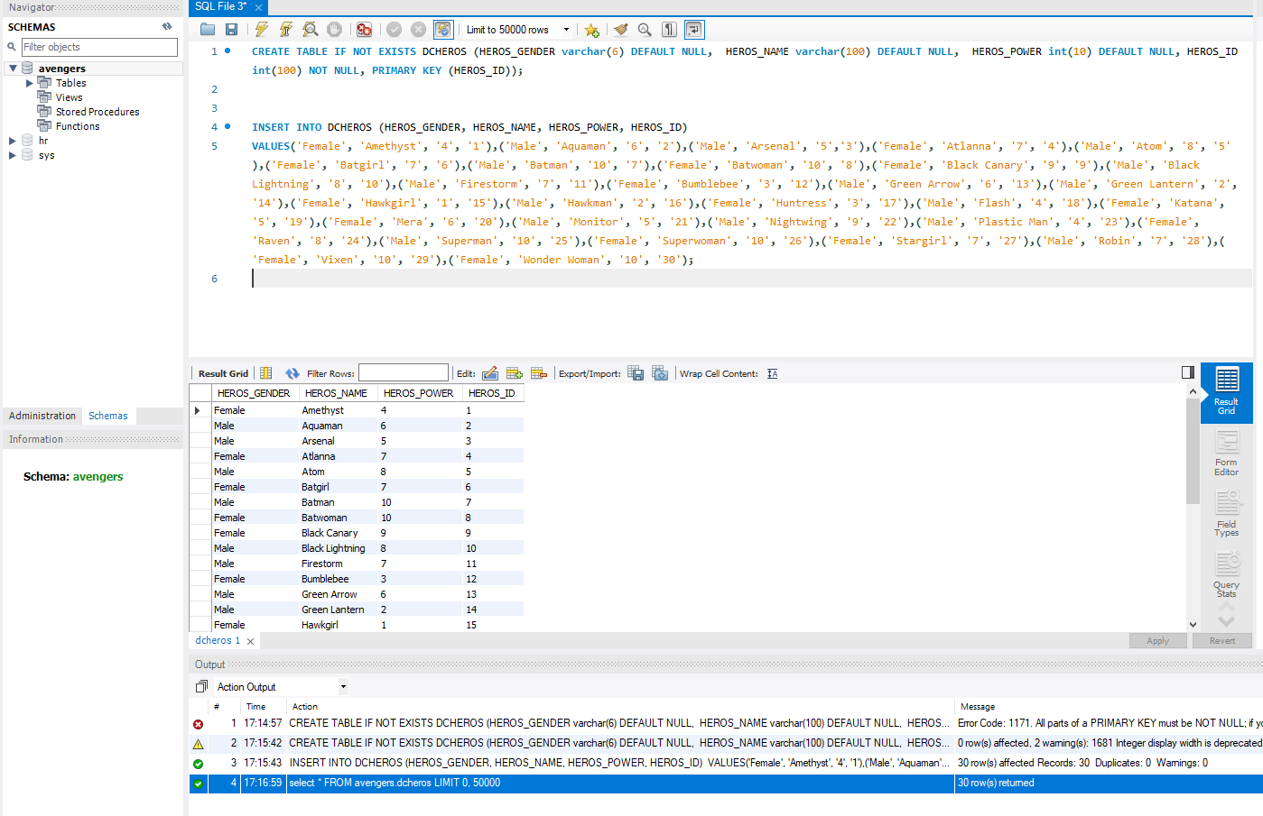

1. Add a column to your new table (the new superheroes) for those who are interested in joining the Avengers. Make this be randomly assigned.

**Query:**

ALTER TABLE DCHEROS ADD JOINING_AVENGERS VARCHAR(3);

UPDATE dcheros SET joining_avengers = (CASE FLOOR(RAND()*2) WHEN 0 THEN 'no' WHEN 1 THEN 'yes' END);

**Columns:** HEROS_GENDER, HEROS_NAME, HEROS_POWER, HEROS_ID, JOINING_AVENGERS

**Expected row count:** 30

**Screenshot:**

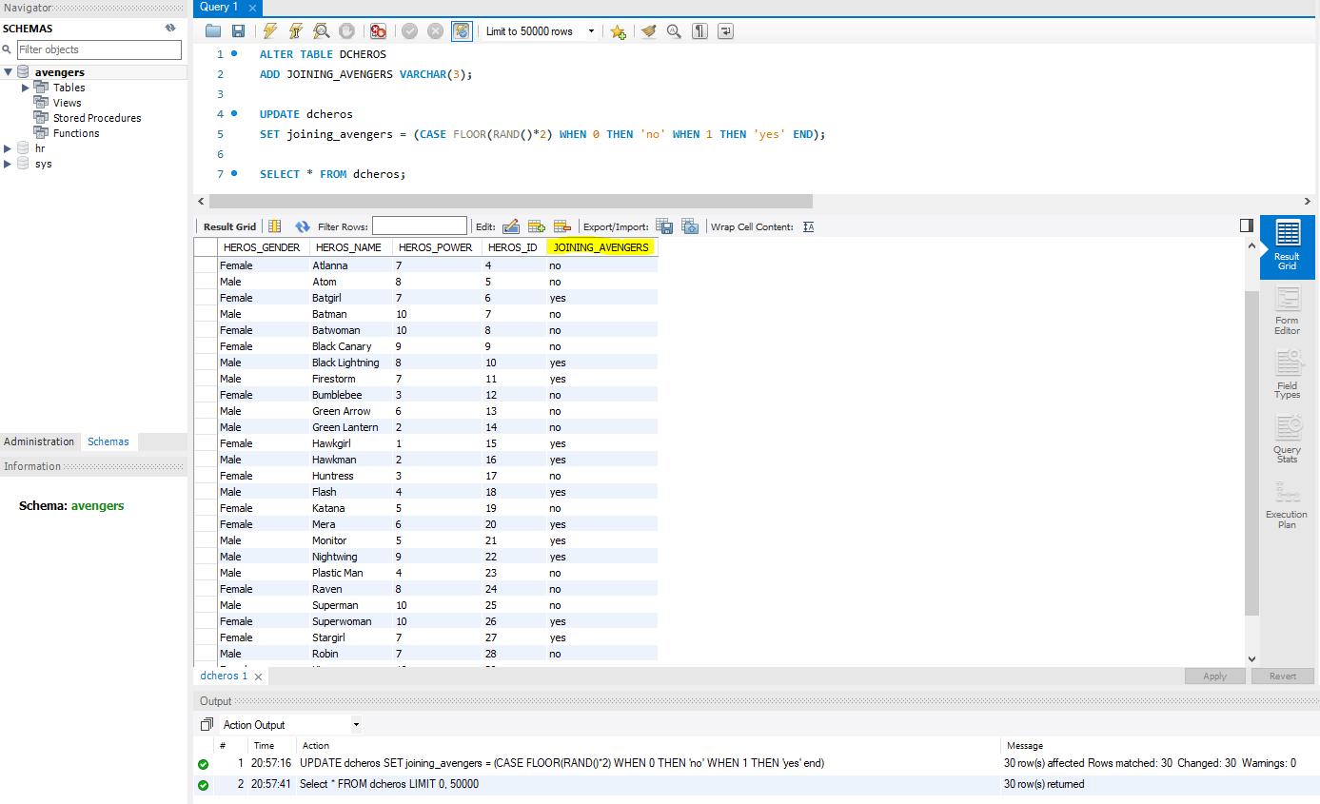

1. Add a column to your new table (the new superheros) for their favorite Avenger (have it randomly choose between Anthony Edward "Tony" Stark, Robert Bruce Banner, & Victor Shade).

**Query:**

ALTER TABLE DCHEROS ADD FAVORITE_AVENGER varchar(100);

UPDATE DCHEROS

SET FAVORITE_AVENGER = (CASE FLOOR(RAND()*4) WHEN 0 THEN ‘Anthony Edward' WHEN 1 THEN 'Tony Stark' WHEN 2 THEN 'Robert Bruce Banner' WHEN 3 THEN 'Victor Shade' END);

**Columns:** HEROS_GENDER, HEROS_NAME, HEROS_POWER, HEROS_ID, JOINING_AVENGERS, FAVORITE_AVENGER

**Expected row count: 30**

**Screenshot:** 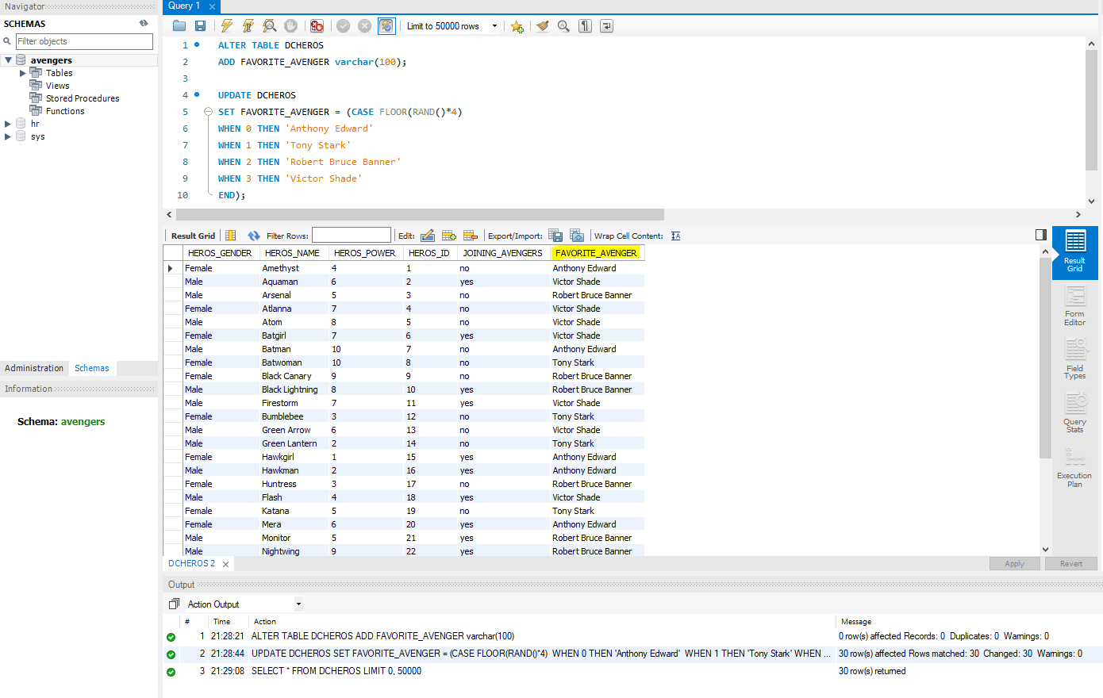

1. Create an association between the two tables for who is interested in joining the Avengers.

**Query:**

USE avengers;

SELECT DISTINCT * FROM avengers.avengers

CROSS JOIN dcheros

WHERE JOINING_AVENGERS = 'yes'

**Columns:** url, name, appearances, current, gender, probationaryIntro, fullAvengersIntro, year, yearsSinceJoining, honorary, death1, return1, death2, return2, death3, return3, death4, return4, death5, return5, notes, HEROS_GENDER, HEROS_NAME, HEROS_POWER, HEROS_ID, JOINING_AVENGERS, FAVORITE_AVENGER

**Expected row count:** 2223

**Screenshot:** 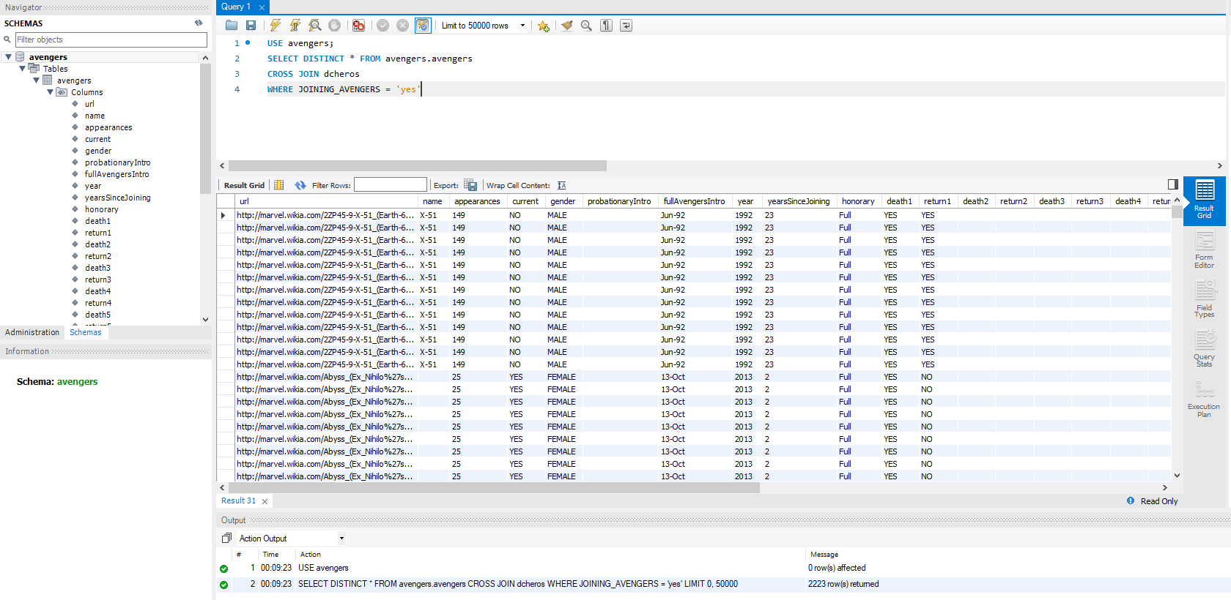

1. Show your association and create a new table for that association.

**Query:**

CREATE TABLE IF NOT EXISTS NEW_AVENGERS (ALL_AVENGERS varchar(100) DEFAULT NULL);

SELECT * FROM NEW_AVENGERS;

**Columns: ALL_AVENGERS**

**Expected row count: 0**

**Screenshot:** 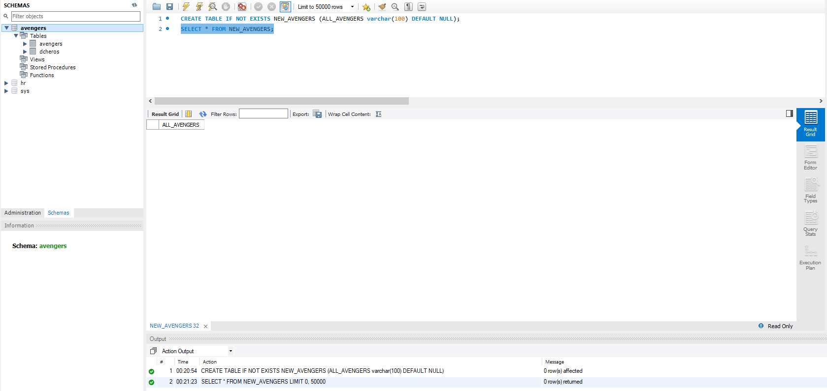

1. List all Avengers who have more than 1000 appearances in alphabetic order.

**Query:**

SELECT name, appearances

FROM avengers

WHERE appearances > 1000

ORDER BY name ASC;

**Columns:** name, appearances

**Expected row count: 20**

**Screenshot:**

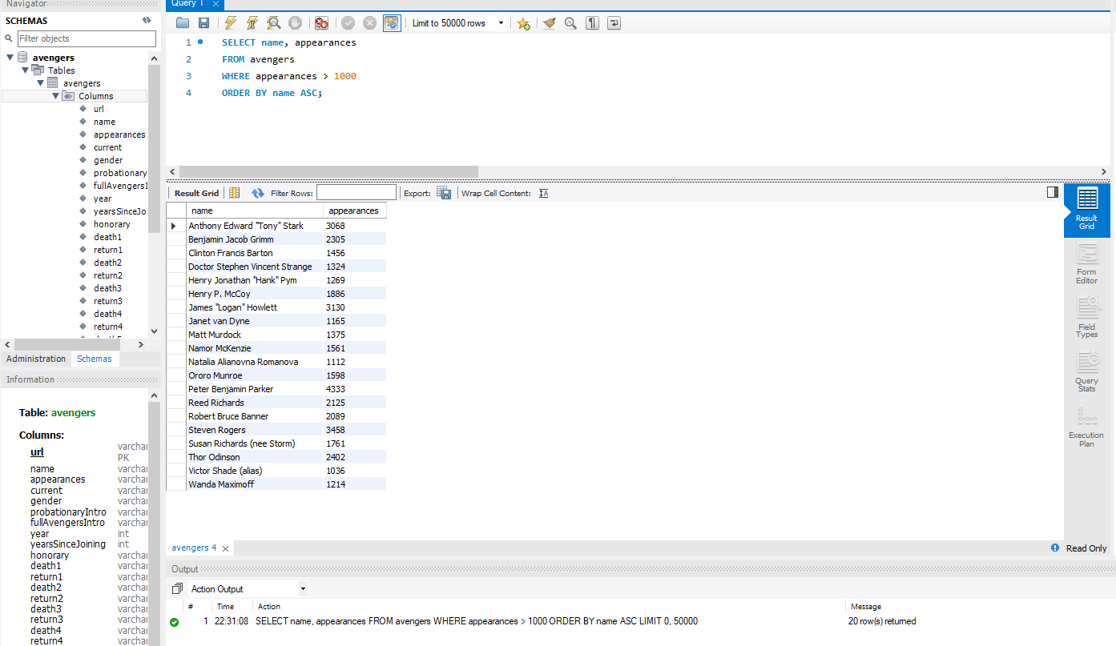

1. What Avengers do not have more than 1000 appearances?

**Query:**

SELECT name, appearances

FROM avengers

WHERE appearances <= 1000;

**Columns:** name, appearances

**Expected row count: 151**

**Screenshot:**

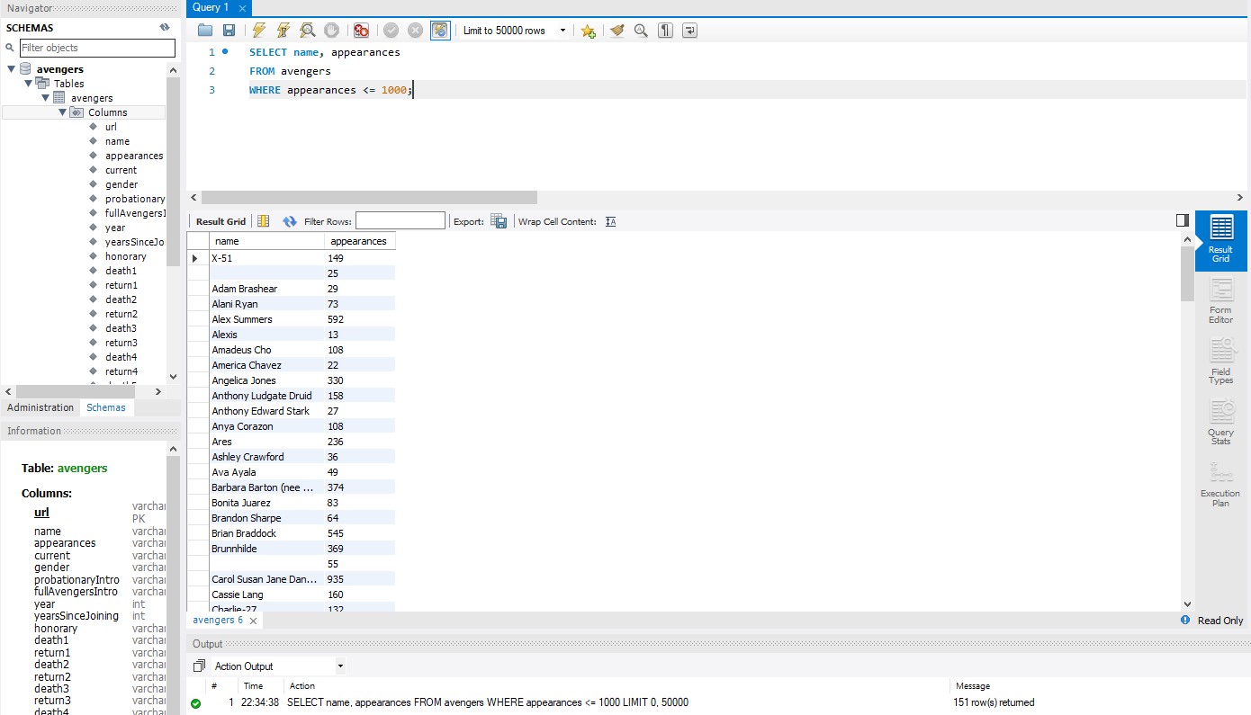

1. Not more than 500?

**Query:**

SELECT name, appearances

FROM avengers

WHERE appearances <= 500;

**Columns:** name, appearances

**Expected row count:** 128

**Screenshot:**

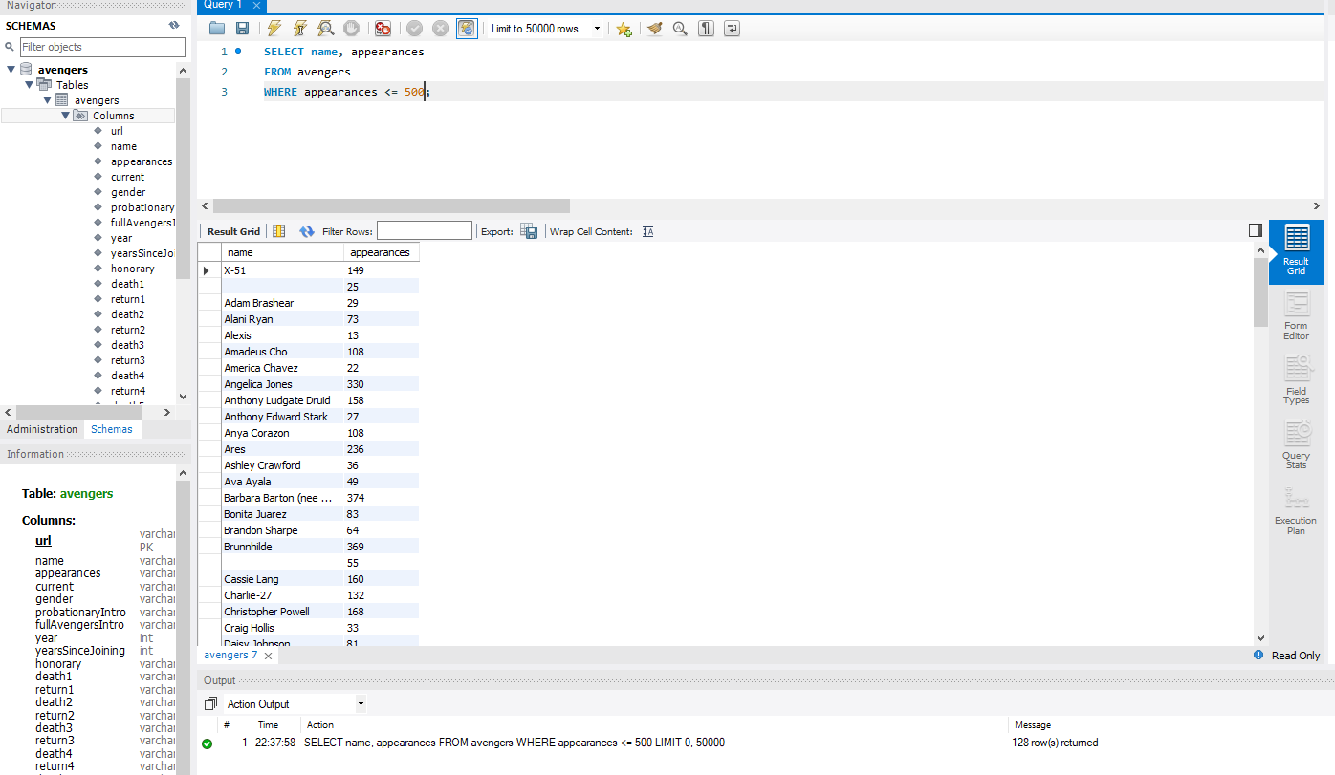

1. Not more than 50?

**Query:**

SELECT name, appearances

FROM avengers

WHERE appearances <= 50;

**Columns:** name, appearances

**Expected row count: 41**

**Screenshot:**

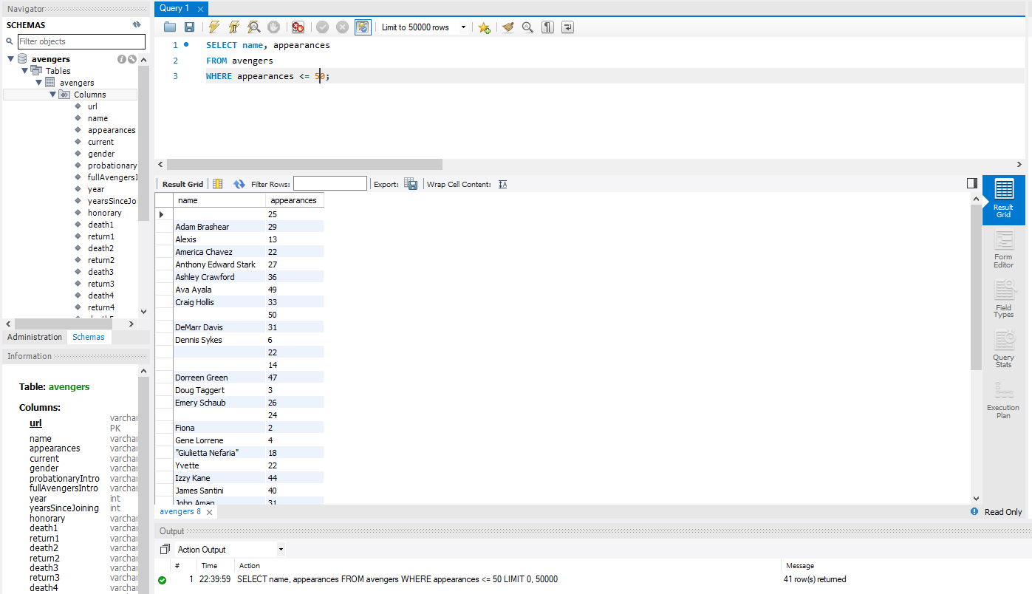

1. Not more than 50 and female?

**Query:**

SELECT name, appearances, gender

FROM avengers

WHERE appearances <= 50 AND gender = 'FEMALE';

**Columns:** name, appearances, gender

**Expected row count:** 19

**Screenshot:**

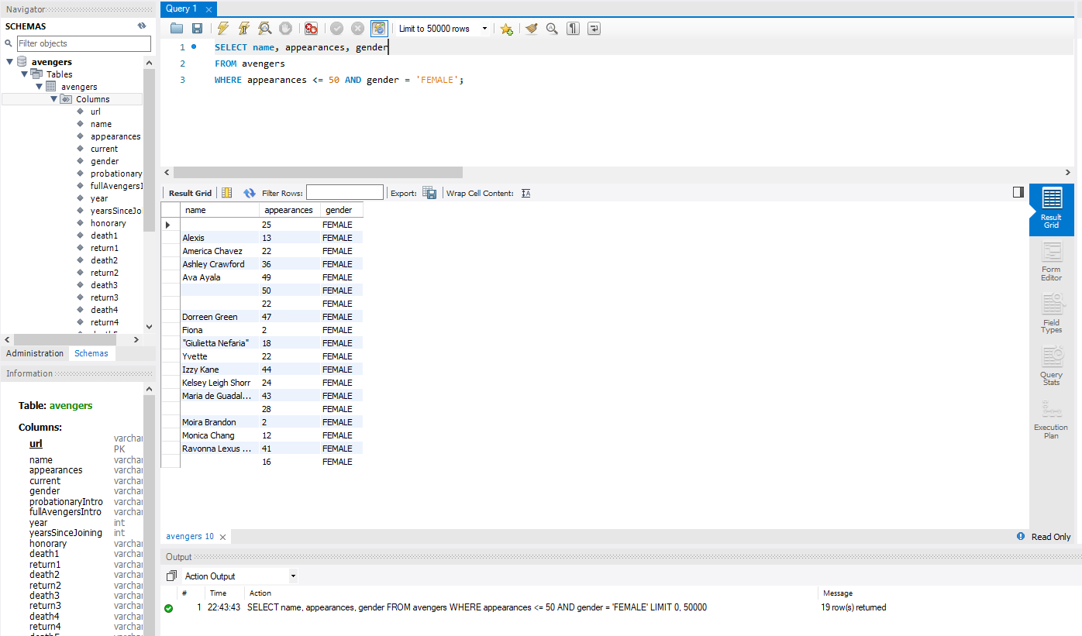

1. More than 150, male, and are full members?

**Query:**

SELECT name, appearances, gender, honorary

FROM avengers

WHERE appearances > 150 AND gender = 'MALE' AND honorary = 'Full';

**Columns:** name, appearances, gender, honorary

**Expected row count:** 51

**Screenshot:** 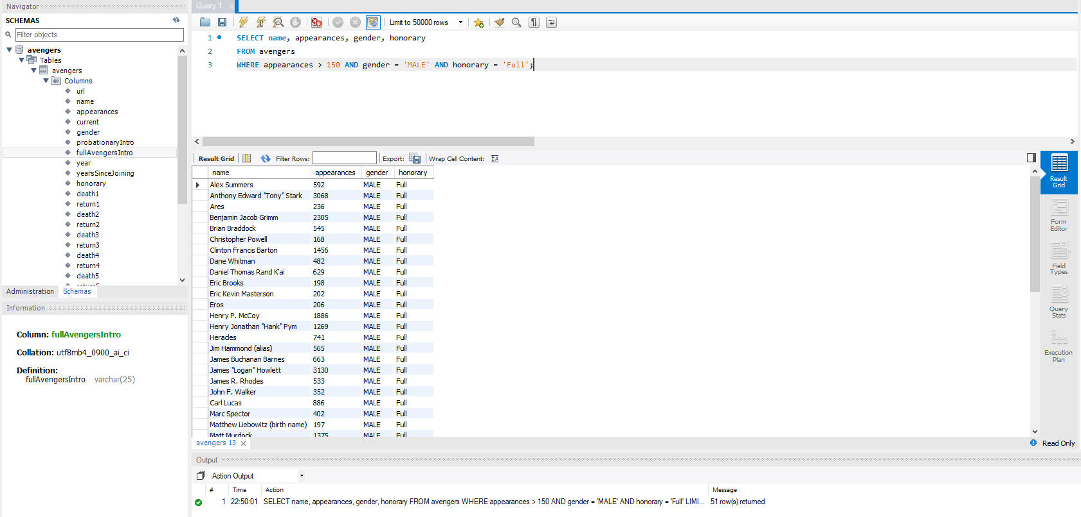

1. Write a function that can add a new superhero to the Avengers if they are interested in becoming an Avenger and if their favorite Avenger is Victor Shade.

**Query:**

SELECT *

FROM dcheros

WHERE JOINING_AVENGERS = 'yes' AND FAVORITE_AVENGER = 'Victor Shade';

**Columns:** HEROS_GENDER, HEROS_NAME, HEROS_POWER, HEROS_ID, JOINING_AVENGERS, FAVORITE_AVENGER

**Expected row count:** 6

**Screenshot:**

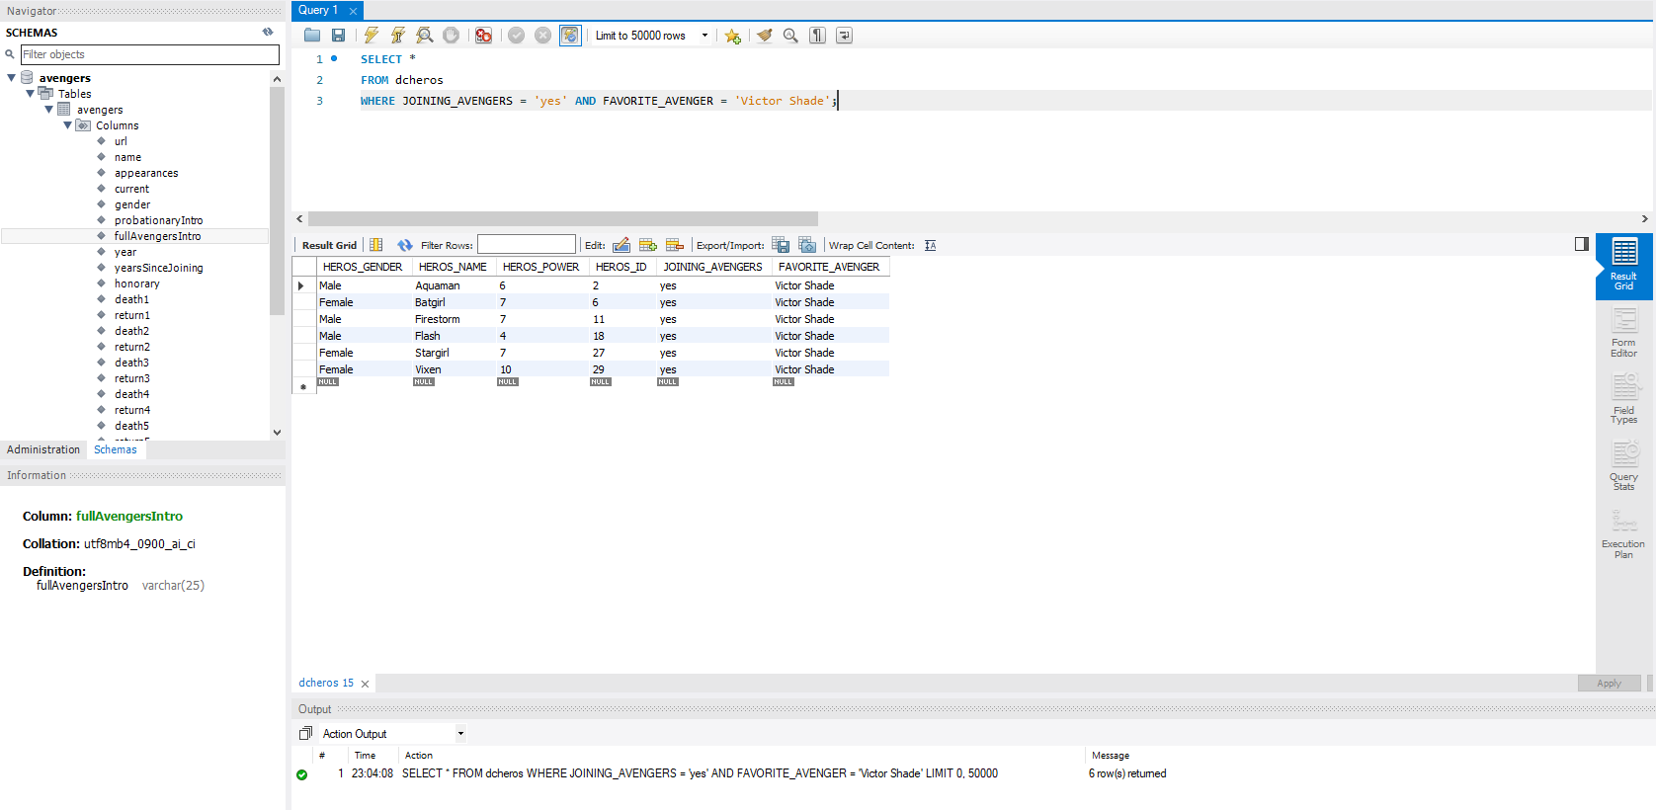

1. Write a "totalRecords" function that counts the total amount of records(rows/entries) in a given table.

**Query:**

SELECT COUNT(*) AS totalRecords

FROM DCHEROS;

**Columns:** totalRecords

**Expected row count:** 30

**Screenshot:** 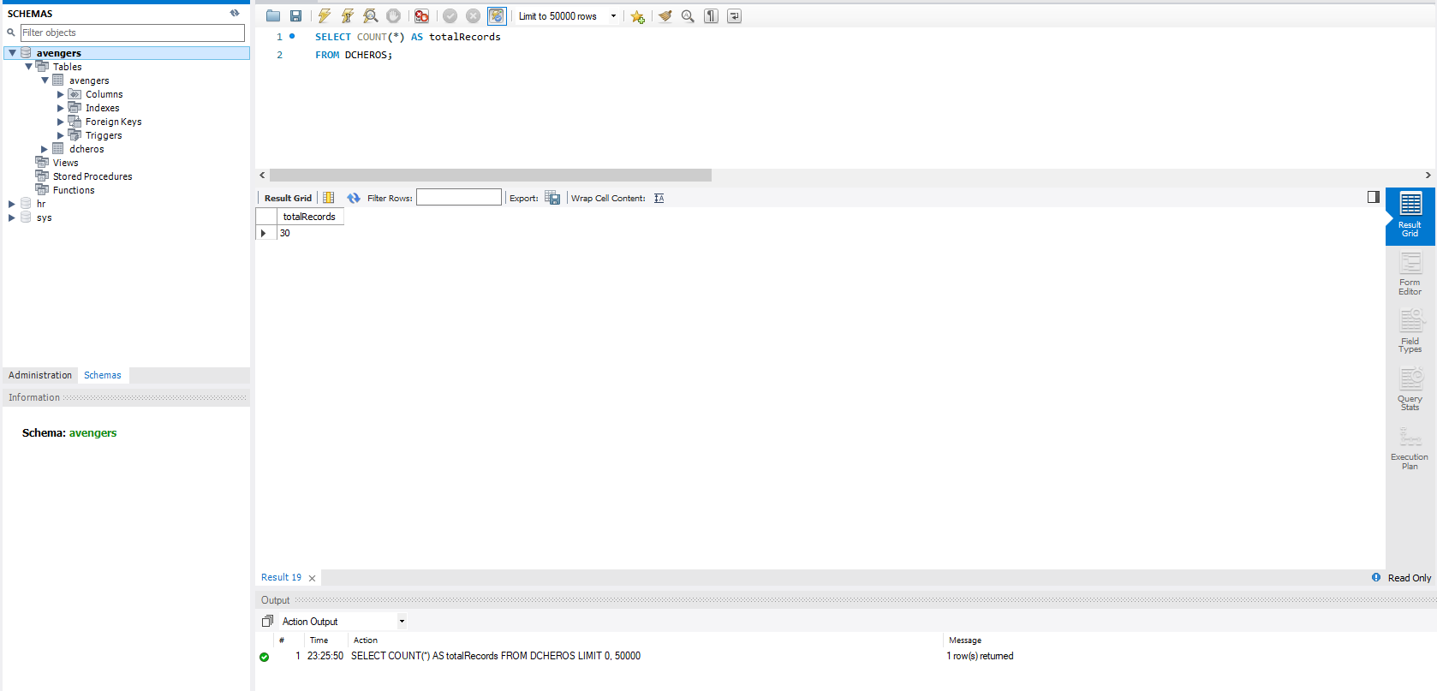

1. Call your totalRecords function on the avengers table. What is the output?

**Query:**

SELECT COUNT(*) AS totalRecords

FROM avengers;

**Columns:** totalRecords

**Expected row count:** 171

**Screenshot:** 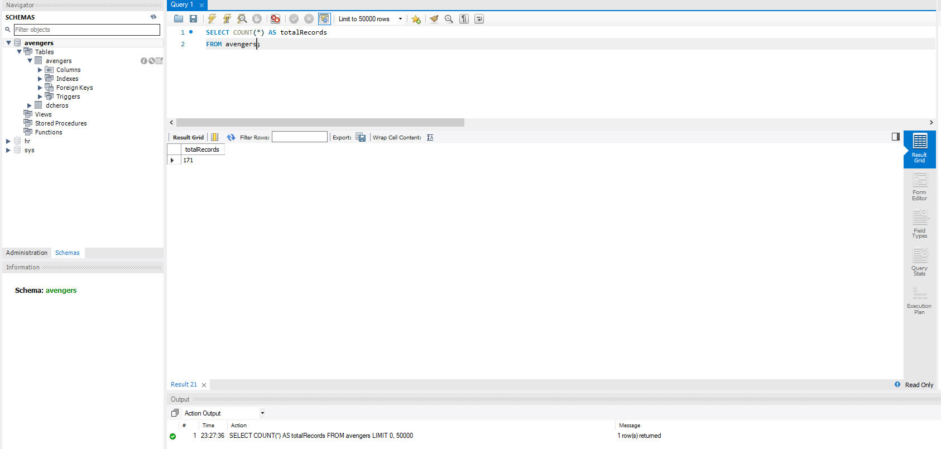

1. There is room for 3 new Avengers so invoke your newMember function 3 times to add 3 new members to the Avengers.

**Query:**

INSERT INTO DCHEROS (HEROS_GENDER, HEROS_NAME, HEROS_POWER, HEROS_ID)

VALUES ('FEMALE', 'Storm', '6', '31'), ('Male', 'Magneto', '9', '32'), ('Male', 'Wolverine', '10', '33');

**Columns:** HEROS_GENDER, HEROS_NAME, HEROS_POWER, HEROS_ID

**Expected row count:** 3

**Screenshot:** 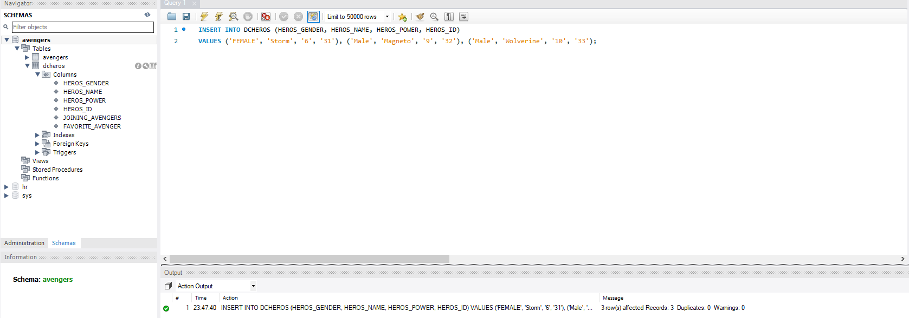

1. Show that the addition of new members was successful.

**Query:** SELECT * FROM DCHEROS;

**Columns:** HEROS_GENDER, HEROS_NAME, HEROS_POWER, HEROS_ID, JOINING_AVENGERS, FAVORITE_AVENGER

**Expected row count:** 33

**Screenshot:** 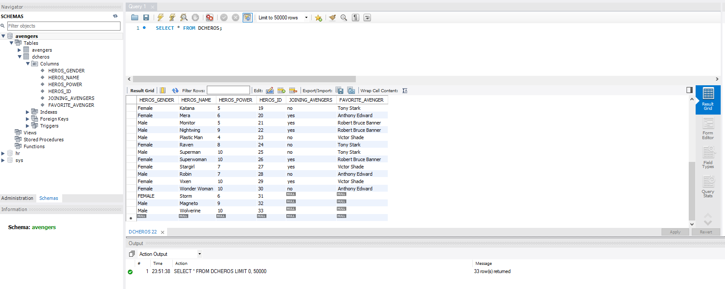

1. Remove any tables that are not the original avengers table and prove that they have been removed.

**Query:**

DROP TABLE dcheros;

DROP TABLE new_avengers;

**Columns:** ALL

**Expected row count:** 0

**Screenshot:**

