Agency OS — Beta Onboarding
15-minute live walkthrough · facilitator guide

The goal for this session
Every user leaves with 1 client added, their brand on it, and a live report on screen. That is the “aha.” Everything else is secondary.
Say up front: “This is a working beta. A couple of features are labeled Beta on purpose. Your job today is to get set up and start poking — the checklist on your dashboard is our map for the next 15 minutes.”

A quick tour of Agency OS
A 60-second orientation before we start. This is your left-hand menu — here’s what lives where:
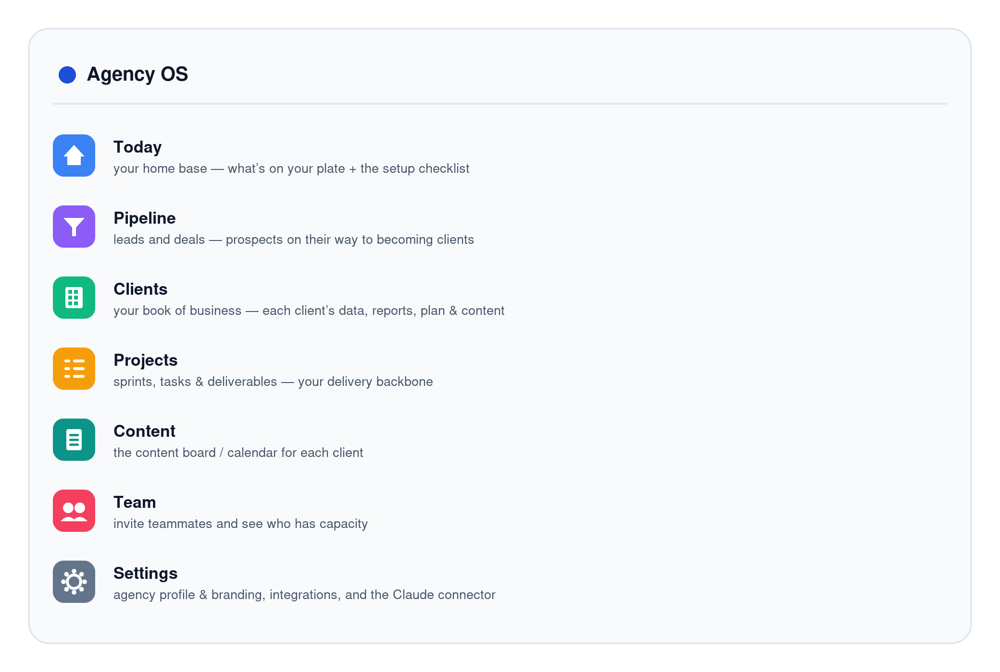
You’ll live mostly in two spots today: Clients (each client’s data, reports and plan) and Settings (branding, integrations, and the Claude connector). Everything on the checklist maps to one of these menu items.

How the platform connects
Agency OS is the hub. Your data tools feed it live metrics, your team runs the agency inside it, it produces white-label reports for your clients, and it connects to your own Claude for chat control and AI analysis. One picture:
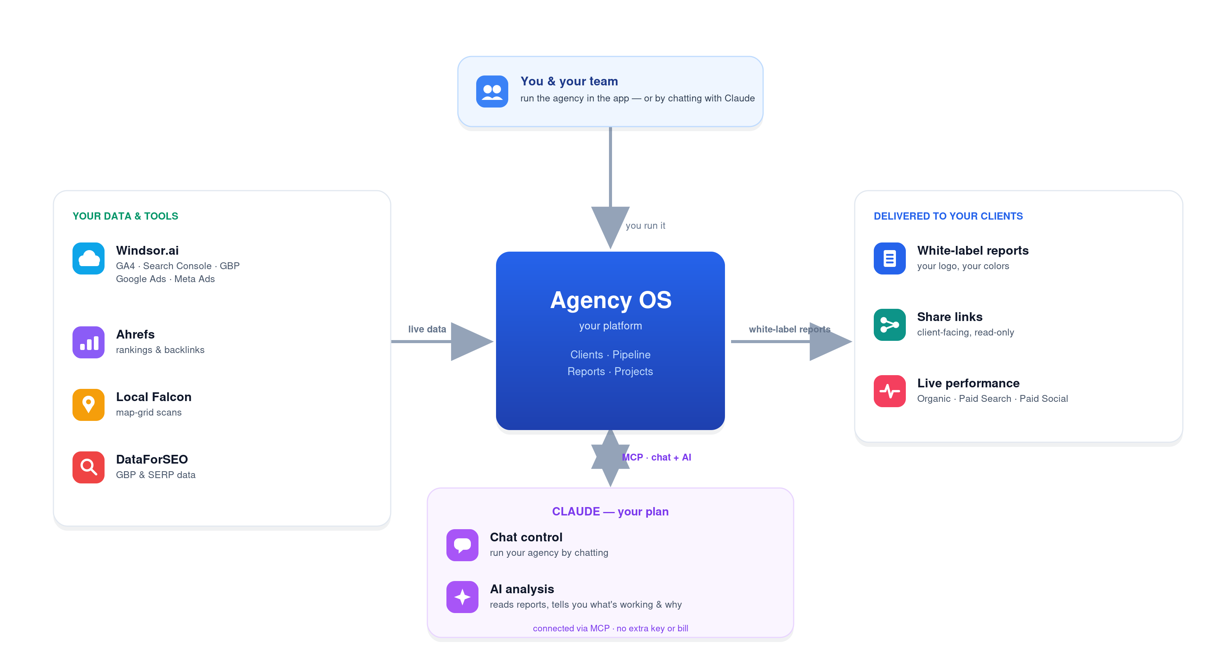
How Agency OS connects your data, your team, your clients, and Claude.
The one thing to stress: Agency OS doesn’t pull data on its own — it reads what you’ve connected in Windsor (and Ahrefs/Local Falcon/DataForSEO). If a report section is empty, it’s almost always “not connected in that tool,” not a bug.

Before the call — what to have ready
How to sign up: use a work email you’ll keep — Google sign-in or email + password both work, no Google account required. Whatever email you use, add that same email under Settings → Team so your “Me” view matches. Your reporting data (GA4 / Search Console / GBP) comes through Windsor, not your login, so Microsoft / Outlook users lose nothing.
Then send this the day before so the live session doesn’t stall:
- Windsor.ai account with at least one client’s GA4 + Search Console + GBP already connected inside Windsor (the #1 thing that blocks reports).
- One real client to set up — name, website, and the account IDs (GA4 property, GSC property, GBP location, Google Ads, Meta).
- Logo file + brand hex color for white-label.
- A spreadsheet / CRM export of clients if they want to bulk-import.
- Nothing extra for AI analysis — it runs on their own Claude plan once they connect Claude (Step 7). No separate key or bill.

The onboarding journey
The dashboard shows this as a 7-step checklist with a progress bar. Walk it in order:
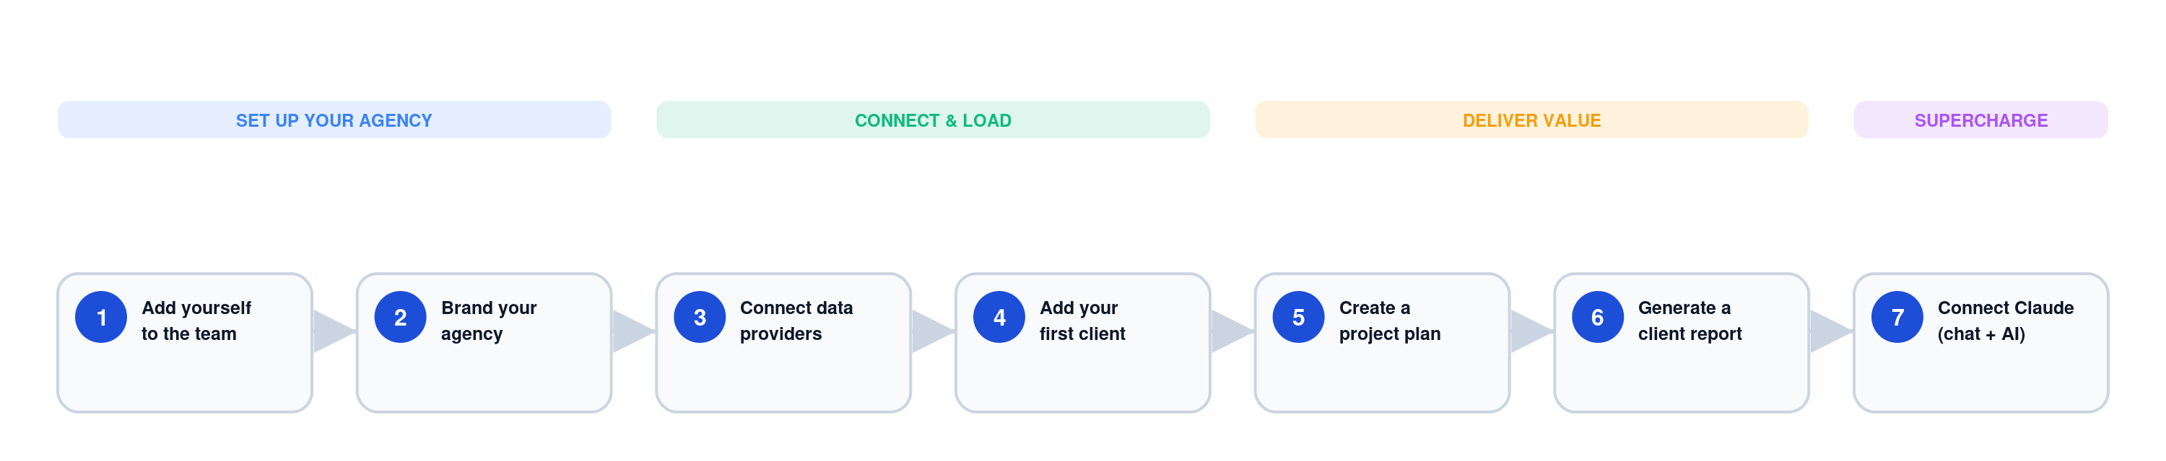
The 7-step Get-started checklist users complete on their dashboard.

Deep dive — the onboarding spreadsheet
The fastest way to load a client’s whole book of business is the template + Claude. Here’s the loop, then the detail on each step:
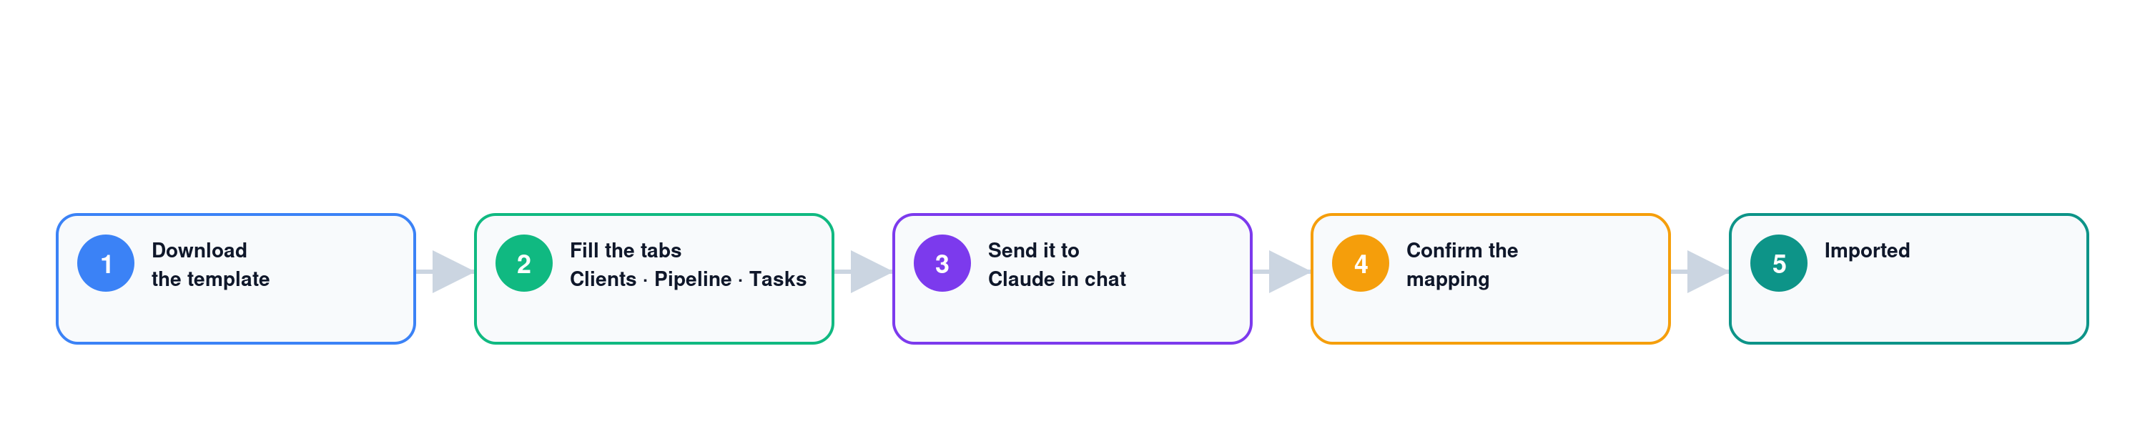
Download → fill the tabs → hand it to Claude → confirm the mapping → imported.
1. Get the template. On the Add your first client screen (or Settings → Import), click Download the onboarding template. It’s one Excel file with three tabs — Clients, Pipeline (Leads), and Client Tasks — plus a How-to tab that lists every valid value.
2. Fill it in. One row per item. Column-by-column:
- Clients tab — Company Name*, Contact, Email, Website*, Service (SEO / PPC / LSA / Meta Ads / Social Media / Website Design, or your own), Monthly Retainer, Status (active / paused / inactive).
- Pipeline (Leads) tab — Company*, Contact, Email, Phone, Website, Source, Stage, Expected Deal Value (numbers only), Notes. Use your OWN stage names — Claude maps them to ours.
- Client Tasks tab — optional, for custom tasks only (most come from the plan template). Client (must match a Clients row), Task Name*, Description, Type, Owner (‘claude’ or a teammate), Due Date, Est. Hours, Status, Depends On.
Rules of thumb: delete the two grey example rows on each tab, only columns marked * are required, and leave anything you don’t have blank — Claude fills the gaps.
3. Hand it back to Claude. Make sure the Agency OS connector is enabled in your Claude chat (Step 7). Paste the “Onboard clients with Claude” prompt from the Import screen, then attach the filled spreadsheet (or just paste the rows).
4. Confirm the mapping. Claude shows how it will map your columns onto Agency OS fields, and — for the pipeline — a “your stage → Agency OS stage” table. Check it and fix anything before you say go. Nothing is created until you confirm.
5. It imports. Claude creates the clients (applying each service’s plan template), the pipeline leads in the right stages, and any tasks — matching existing records by domain/email instead of duplicating — then shows a summary table of everything it created or updated.

Run of show (~15 minutes)
0:00–2:00 · Sign up → name your agency → land on the dashboard
- They sign up, then hit “Name your agency” (that name is their workspace).
- Point at the Get started card: “7 steps, progress bar up top. We do these together now.”
2:00–3:00 · Step 1 — Add yourself to the team
- Settings → Team, add yourself with the exact email you signed in with.
- Say why: it powers your personal Me view, task assignments, and @mentions. Skip it and the dashboard nags you.
3:00–4:30 · Step 2 — Brand your agency (white-label)
- Settings → Agency profile: upload logo + set brand color.
- Payoff: “Every client report and the app accent now carry your brand, not ours.”
4:30–7:30 · Step 3 — Connect your data providers (go slow here)
- Settings → Integrations. Add Windsor.ai first, then Ahrefs / Local Falcon / DataForSEO as they have them.
- Say the gotcha out loud: “Typing an account ID into Agency OS does not connect it — it only tells us which Windsor account to read. The source has to already be connected inside Windsor.”
7:30–9:30 · Step 4 — Add your first client
- Import: onboard with Claude (paste the prompt, it maps a spreadsheet/CRM export), use the template, or add one manually.
- For the demo, add one client by hand so everyone sees the fields.
- On the client’s Data tab, set the report type (lead-gen vs e-commerce) and paste the account IDs.
9:30–11:00 · Step 5 — Create a project plan
- Apply a plan template to the client → sprints, tasks, deliverables auto-schedule.
- This is your delivery backbone — it feeds the Today dashboard.
11:00–13:30 · Step 6 — Generate a client report (the money moment)
- Open the client → report. Hit ↻ Refresh to pull live from Windsor (first pull takes a bit — set expectations).
- Show off: sub-tabs (Organic / Paid Search / Paid Social), date-range presets, branded vs non-branded search tabs, the Sections filter, and the white-label Share link.
- Point at Generate analysis (Beta): it runs on your own Claude plan (no key/bill) and needs Claude connected — Step 7 — so we’ll run it in a minute.
13:30–14:30 · Step 7 — Connect Claude in chat
- Settings → Connectors: add the MCP URL to Claude Desktop / claude.ai.
- “Run the whole agency by chatting — ‘pull me the report for X’, ‘add this client.’”
- It also powers Generate analysis — AI report analysis on your own Claude plan. Jump back and run one now so they see the payoff.
14:30–15:00 · Wrap
- “Finish any unchecked steps this week with a second real client — the card tracks your progress.”
- Tell them how to send feedback.
- Name the Beta edges (below) so nothing surprises them.

Gotchas to pre-empt (keep handy)
- Empty report section = “not connected in Windsor,” not broken. Connect the source in Windsor first.
- Reports read from a cache — new data/settings show after you hit Refresh (and after a deploy for new features).
- “Me” view blank = your login email doesn’t match a team member. Fix in Settings → Team.
- AI analysis runs on your connected Claude plan (via Step 7 — no separate key or bill). It’s Beta — sanity-check before sending output to clients.
- An ad account (e.g. LSA) not pulling? It has to be connected in Windsor like everything else.
- Search Console history tops out ~15 months (Google’s limit), so the longest date preset is capped there.

What “fully onboarded” looks like
All 7 checklist items green: you’re on the team, branded, data connected, one client in, a plan applied, a live report generated, and Claude connected in chat.

