Assignment: Personal Website Project (PWP) Pt. 2
  - WECIB | Mr. Gardner
Objective
Students will create a simple personal profile webpage using HTML and CSS.
This 2nd submission will now incorporate CSS.
The CSS Styling of your website should be coherent, stylish, and visually appealing. Your website should align with UI / UX Design Principles. This means NO:
- comic sans
- clashing colors
- overlapping elements.
- Anything else that was explicitly stated or implied in class that goes against UI / UX principles.

Requirements
The webpage should contain a professional profile picture, or a placeholder if you do not have one yet. Please adjust your profile picture to be professional from this point forward.
By now you should already have
- A 3-paragraph bio section in your index.html
- A skills section in your index.html
- A projects section in your index.html
- An interests section in your interests.html
- A contact section in your contact.html
- A blank style.css or styles.css file to store your CSS stylings.
Styling should be done using in style.css or styles.css, including basic layout, colors, and fonts for all applicable HTML elements.

Instructions
CSS Styling for index.html. Your Home Page
- Use the Split Editor button to open your .html and .css files side-by-side if you would like.
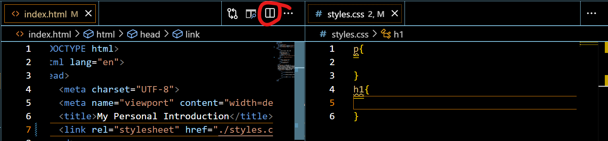
- Link to your styles.css stylesheet by including
<link rel=“stylesheet” href=./styles.css”> in your <head> section of each .html file.
- Inside styles.css, add this code to apply border-box to all elements on the page:
* {
box-sizing: border-box;
}
- Find a color palette you enjoy via one of the sites listed below:
  - colormind.io/bootstrap
  - https://www.realtimecolors.com/
- Follow the guide on this site by scrolling down to find out which colors should apply where. Continue scrolling through the page to find out what colors should go where in what circumstances.
  - Example:
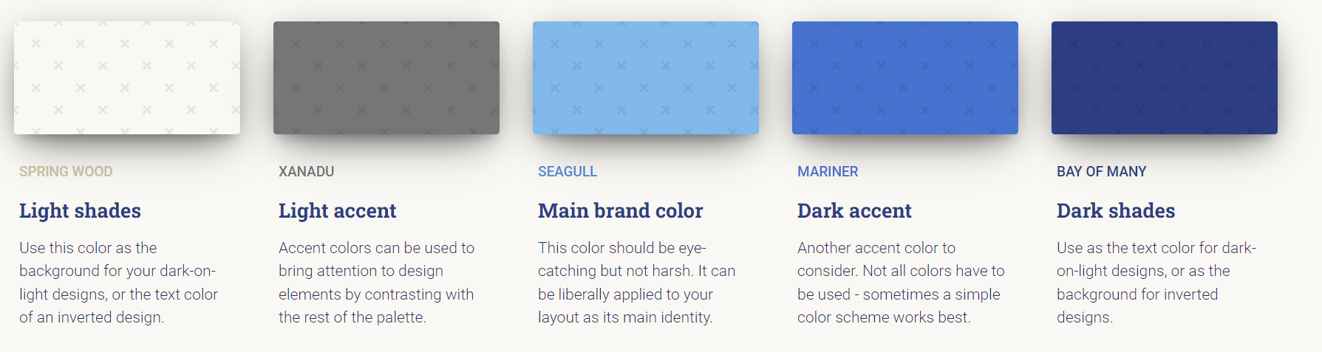

  - Copy-Paste this (commented) template into your .css file to keep track of your colors. Your hex color codes will be different than the example below:
/* Color Palette:
Light Shades: #fcfcfd;
Light Accent: #ebc06c;
Main Brand Color: #e96663;
Dark Accent: #aaacb3;
Dark Shades: #475671;
*/
  - Don’t forget the hashtags for your hex codes!
  - git add .
  - git commit -m "color palette chosen"
  - git push
- Give your name a class='name' in index.html
- Define a ruleset for .name in your styles.css file.
  - Declare a color. VS Code will give you a drop-down of color options.
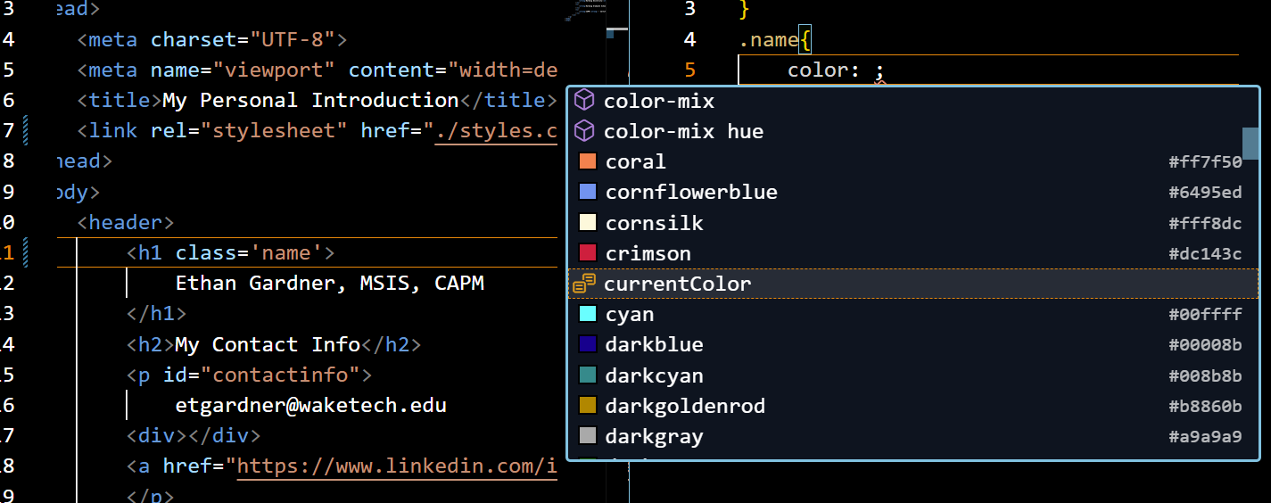
  - Declare a font-family
VS Code will give you a drop-down of font-family options.
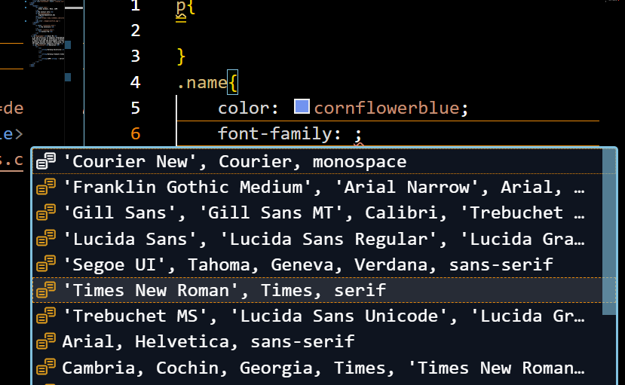
  - Declare a font-size
VS Code will give you a drop-down of options.
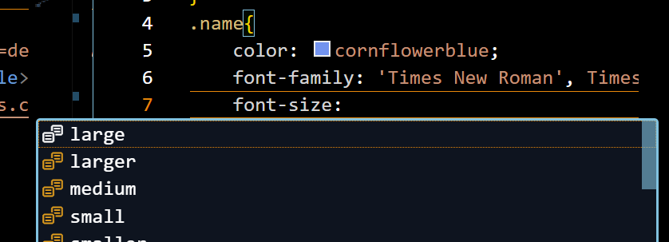
- Ensure you have a set color, font, and font-size for all elements across your pages, aligning with your chosen color palette. Your font sizes should be set in px (pixels) and align with this resource: Font Size Guidelines for Responsive Websites (2024 Update) (https://www.learnui.design/blog/mobile-desktop-website-font-size-guidelines.html)

Fixing the Profile Picture
- Use display: inline-block; to set your profile picture on the same line as your name.
- Style it with border-radius: __%;
- Resize with width: __px; where the ___ is the number of px.
- git add .
- git commit –m "profile pic"
- git push

Creating the Navigation Bar
- Create a <nav> section to begin creating a Navigation Bar to link to your interests.html and contact.html pages.
- Inside your <nav>, create a <ul> to contain a list of our links.
  - Each <li> list item needs to <a> link to a page on our website.
  - Go ahead and create a <li> that links to index.html INSIDE of the index.html Nav Bar to keep the Nav Bar consistent across all pages.
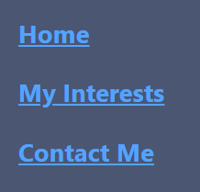
- Give this <ul> a class="navbar" and create a ruleset in style.css with the rules:
  - list-style-type: none; /* This removes bullets */
  - margin: 0;
  - padding: 0;
- You will create one of the two Options, tailoring it to your custom color palette and formatting specifications for your specific needs.
  - Option 1: Vertical Navigation Bar
    - Follow this tutorial: CSS Vertical Navigation Bar
  - Option 2: Horizontal Navigation Bar
    - Follow this tutorial: CSS Horizontal Navigation Bar
- Copy the <link> tag from your <head> in index.html and paste to the <head> of interests.html and contact.html. This will apply style.css to your other files.
- Copy <nav> from index.html and paste it into your other pages to give them the nav bar as well.
- If you cannot get the NavBar to “stick”, that is okay. Try your best, and we can troubleshoot it later. I want to see the effort, though.
- git add .
- git commit -m "navbar"
- git push
(My written content looks different from yours because I’m the instructor, and you’re the student.)
Example of where you should approximately be at this point (ignore the grammar mistakes and outdated info ):
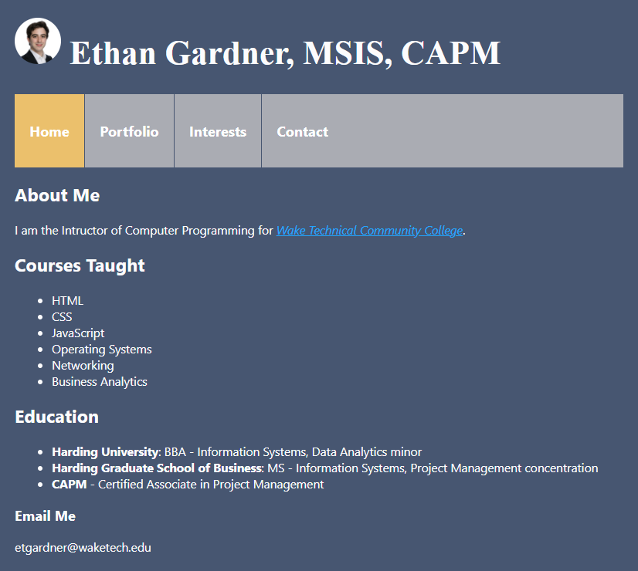

Establishing a Website Layout
- We will be following this documentation: CSS Website Layout
A website is often divided into headers, menus, content and a footer:
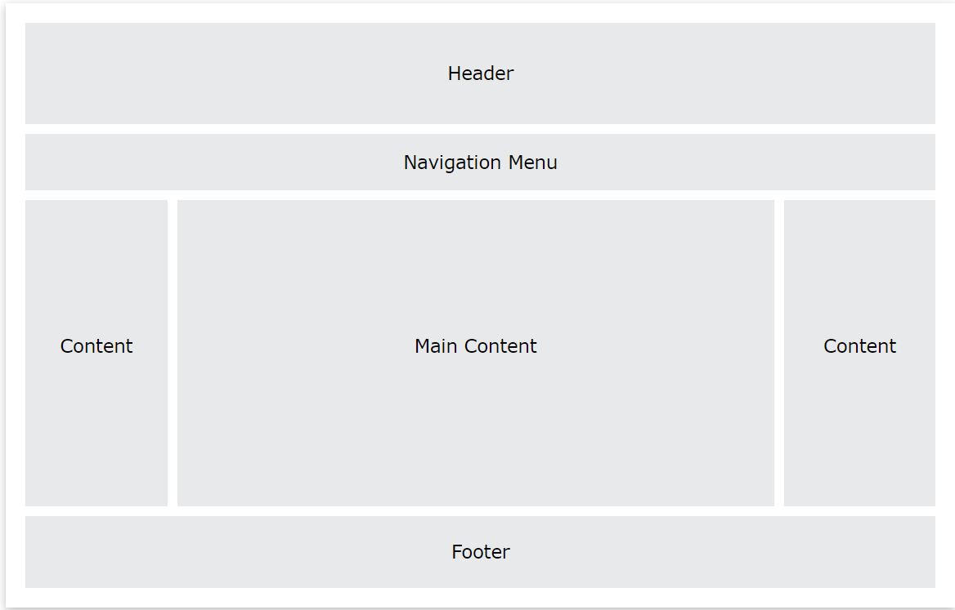
- Establish a Header section with your name and profile picture.
- Ignore the Navigation Menu section, because we’ve already done that. BUT make it look good and be just below or above your Header, depending on your preferences and the layout you have in mind.
- Choose a 3-column layout.
  - Use this code as a guide if you'd like:
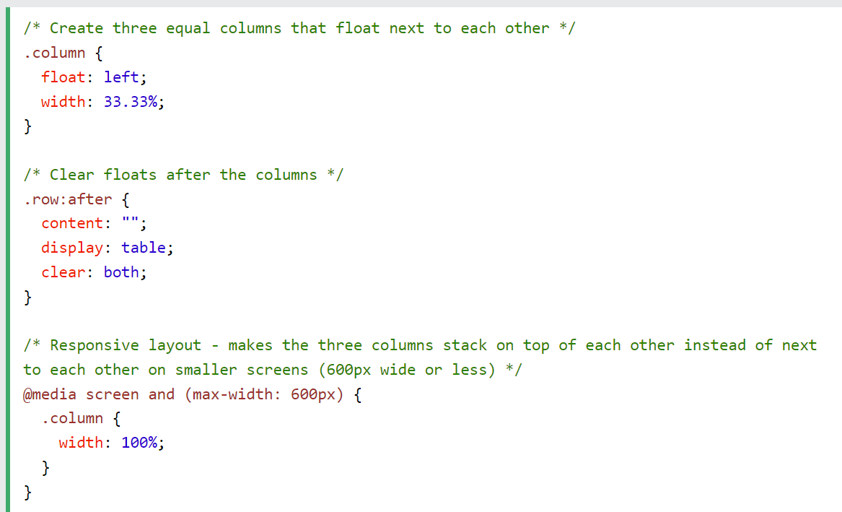
  - When choosing a 3-column layout, you should have 1 column each for:
    - Bio section
    - your skills,
    - and your projects.
  - The middle column must be bigger than the 2 side-columns.
  - The middle column should be your 3-paragraph bio section.
  - Alternate background-color for each column.
  - Ex. black-white-black
- In the Footer, provide your email address and use an HTML entity to create a copyright symbol like: © 2025, Mr. Gardner.
- git add .
- git commit -m "3-column layout"
- git push

Expectations for your Website
- If you have any phone numbers across your site, remove them. I only have my office phone in mine because I’m a professor here and office phones are safer to give out than mobile cell phone numbers.
- Git commits need to align with git commits required in this document.
- The layout should be simple but clean.
- Add some padding, margin, and font styling to make it visually appealing.
- Use a simple color palette (be creative but also aesthetically pleasing. No ugly color combos.
- Create a consistent typography using web-safe fonts.
- Ensure the page is responsive on small screens (using max-width).
- Make your column layout using CSS Flexbox (Flexible Box). CSS Flexbox Explained (8min YouTube video)
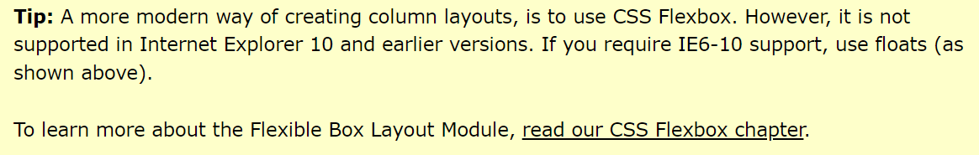
- Check Rubric on Blackboard for additional scoring information.

Student Examples: 