RIA Final Project
Topic:

E-Commerce with RIA

Team Member:

Yan Liu (w0122904)
Minsu Lee (w0293156)
Paddy Vaughan (w0277831)

Team Organization:
Team Member | Yan Liu, Minsu Lee, Paddy Vaughan
Project Manager | Minsu Lee
Instructor | Ronan

Project Background:

The Team LVL will make an e-commerce sample application based on the REST API server, while utilizing AJAX calls. The backend server will be using NodeJS for the web application, and the web application will work on an IIS server. The web application will consist of two html pages. The first page is for employees to manage product details such as name, category, description, stock, price and date. This allows the employee utilize some CRUD operations (create and update). The second page is meant to show the products to the customers. Customer can see product images, and upon choosing a product, the product details will be displayed. To design website we intend on using bootstrap, as well as jQuery visual effects. We will also utilize the free portfolio template served by Start Bootstrap (https://startbootstrap.com/template-categories/portfolios/). For our Javascript files, JQuery will be used.

Objectives:
- Use JavaScript to make AJAX calls to pass JSON data.
- Use REST server and a separate Frontend and Backend server.
- Use CRUD operations to manage data.
- Use GitHub for SVC.
- Use Scrum minutes for development methodology.
Scope:
- CRUD will work on the employee side page.
- The customer page will reflect data from the employee page.
- IIS server and NodeJS communication without collapse.

Constraints:
- Project will only have a simple button for login and logout
- Project does not store image data directly on backend server.
- Project only stores image filenames by JSON on backend server.
- Images have been brought from image file on localhost.

Schedule:
 | Description of Work | Start and End Dates
Phase One | Create Project Proposal and Design,  Set up GitHub and assign team members,  Update Journal,  Approval by instructor | March 24 – March 29
Phase Two | Coding and Debug:  Create the Web application based on the Wireframe  Create functionality for CRUD operations  Set up sample data in JSON file  Set up validation  Update Journal | March 29 – April 3
Phase Three | Finalize and Test:  Check all CRUD operations working properly,  Check web application design and validations,  Update Journal | April 3 – April 5

Wireframe:
Manage.html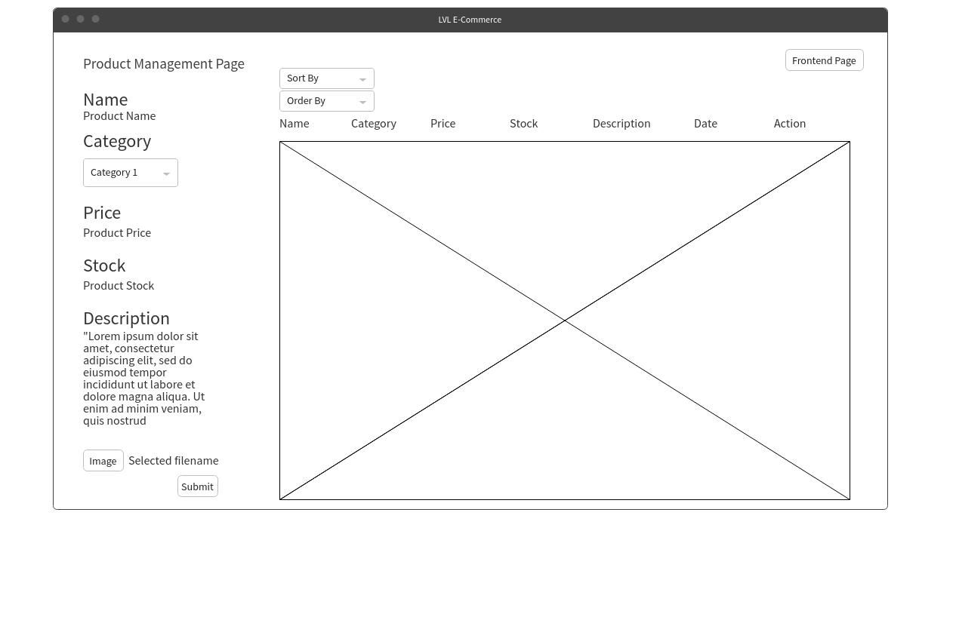

Index.html
