NAME : Chantel Cumbane
Student No. :ST10526161
Subject Code :WED5020
Subject name : Web Development
Group : 04
Catalog
Chanty cakes 2
REFERENCES 5
PROPOSAL 2 6
1.1 NAME OF ORGANISATION 6
1.2 HISTORY 6
1.3 MISSION AND VISION 6
1.4 TARGET AUDIENCE 6
REFERENCES 8

  - ORGANIZATIONS NAME

Chanty cakes

1.2 HISTORY OF ORGANISATION
Chanty cakes was established in 2020 by Chantel Cumbane,a dedicated home baker who discovered her passion during the COVID-19 pandemic.What began as a hobby baking for family soon evolved into a business, supported by encouragement from friends and the local community.
Initially focusing on birthday cakes.Chanty Cakes gained recognition through social media and word of mouth for distinctive designs, quality ingredients and personalized services. Today, the business specializes in custom-made cakes for birthdays, weddings and special occasions.

1.3 MISSION
Our mission is to provide our community with affordable, freshly baked cakes that provide flavor ,quality and hospitality.And to bring people together with our crafted fresh cakes using locally sourced ingredients.

VISION
Our vision is to be recognized as a leading bakery brand in our community, by delivering beautifully delicious baked creations that exceed expectations that our customers can always count on.

1.4 TARGET AUDIENCE
- parents celebrating kids aged 1-12 years with fun ,themed designs
- young adults who love trendy and modern aesthetic cakes
- couples looking for simple modern wedding cakes for intimate celebrations

2.1 SPECIFIC GOALS FOR THE WEBSITE
To create online visibility of the business, showcasing products and allowing customers to place orders and building brand awareness.

2.2 PRESENT KEY INDICATORS
- Total number of completed orders through the website(measured monthly)
- Number of enquiries received via website or contact forms(measured monthly)
- Growth in social media followers and engagement (measured quarterly)

3.1 STRENGTH
Social media helps promote the business by attracting new customers and allowing existing customers to share and recommend products.This helps increase awareness at low cost.
WEAKNESS
However, not having a website may reduce customer trust and make the business appear less established. It also makes it harder for new customers to find detailed information about products, prices and ordering, which could limit overall sales.

4.1 PROPOSED WEBSITE FEATURES AND FUNCTIONALTY
Our webpage will include :
Homepage : provides the brief introduction of the baking business and guides visitors to other sections of the website
About Us :explains the background of the business and includes the businesses mission and vision and also the team members
Services :this page displays the range of baked goods and services offered including prices also, inform customers about what they can order.
Contact :contact us page provides the businesses details, such as phone numbers ,email address ,physical location and social media links
Enquiry :the page allows customers to submit questions or place custom cakes by entering their details.
FAQ : provides answers to common questions customers may have ,such as ordering process ,payment methods and more, providing quick and clear information without needing direct contact.

5.1 DESIGN AND USER EXPERIENCE
The website uses a simple navigation menu at the top of each page to allow users to move easily between sections.By making it easy to navigate.The homepage is designed to be visually appealing with images of baked cakes to attract customer interest and encourage further browsing.The content is structured in clear sections with headings and short paragraphs to make information easy to read.

- TECHNICAL REQUIREMENTS
The website will be developed using HTML that will provide the structure of the website organizing content such as text, images, buttons and forms in different pages it creates the structure of the business .CSS to control the appearance of the website, styling the fonts, layouts and spacing. JAVASCRIPTS that will add functionality,used for features such as checking if enquiry forms were filled correctly ,pop ups and image sliders.

- TIMELINE
Week 1: 01April - 07 April Finalize business proposal and submission.
Week2 :08 April - 12 April receiving proposal feedback from supervisor and creating basic wire frames and data collection
Week 3: 13-19 April -create the structure of each website page using html, adding content such as text ,images and links
Week 4: 21-27 April- apply colors and layout styling

- BUDGET
- for the domain ,registering a web address R100-R200 per year
-Reliable shared hosting R800-R1 500 per year
-Logo and quality product images R300-R1 000
-Fixes, updates and small improvements R500-R1 200

5 WIREFRAME.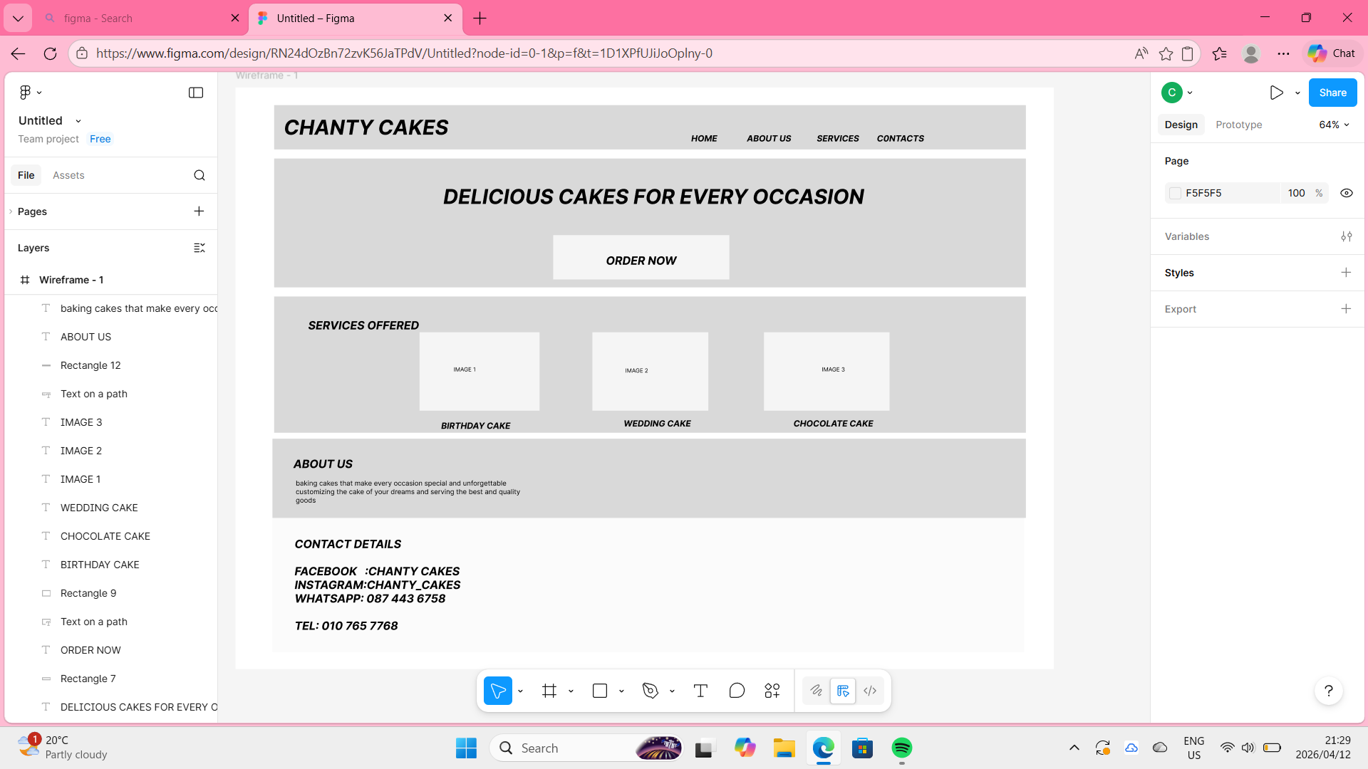

REFERENCES

HOSTAFRICA.(2026). Web hosting and domain services.Available at:https://hostafrica.co.za (Accessed: 09 April 2026)

HELPFULPROFESSER. (2023) 55 Vision and Mission statements for bakeries.Available at:https://helpfulprofesser.com/vision-and-mission--statements-for-bakeries/.(Accessed: 09 April 2026)

