**SD211 TP Logistic Regression**

**WEI CHEN**

**weichen@whu.edu.cn**

# **Import**

**import** **cervicalcancerutils** **as** **cancer**

**import** **numpy** **as** **np**

**from** **scipy.optimize** **import** check_grad, line_search

**import** **matplotlib.pyplot** **as** **plt**

**from** **pywt** **import** threshold

filename = 'riskfactorscervicalcancer.csv'

X, y=cancer.load_cervical_cancer(filename)

n,p=X.shape

# **Tikhonov Regularisation**

**Question 1.1 Gradient, Hessian Matrix**

$$f_{1}=\frac{1}{n}\sum_{i=1}^{n}{log⁡(1+exp⁡(-y_{i}(x_{i}^{T}w+w_{0})))}+\frac{ρ}{2}{\left\|w\right\|}_{2}^{2}$$

Note $\overline{w}=(\begin{matrix}w_{0} \\ w\end{matrix})$, ${\overline{x}}_{i}^{T}=[1,x_{i}^{T}]$ and $s=[0,1,…,1]$, then we can rewrite the objective function as

$$f_{1}=\frac{1}{n}\sum_{i=1}^{n}{log⁡(1+\exp\left(-y_{i}{\overline{x}}_{i}^{T}\overline{w}\right))}+\frac{ρ}{2}{\left\|s∘\overline{w}\right\|}_{2}^{2}$$

$$∇_{\overline{w}}f_{1}=\frac{1}{n}\sum_{i=1}^{n}{\frac{-y_{i}{\overline{x}}_{i}^{T}\exp\left(-y_{i}{\overline{x}}_{i}^{T}\overline{w}\right)}{1+\exp\left(-y_{i}{\overline{x}}_{i}^{T}\overline{w}\right)}}+ρ(s∘\overline{w})$$

And $f_{1}(w_{0},w)$ is twice differentiable, and we calculate its Hessian matrix

$$Hessian=∇^{2}f_{1}=\frac{1}{n}\sum_{i=1}^{n}{\frac{y_{i}^{2}{\overline{x}}_{i}{\overline{x}}_{i}^{T}\exp\left(-y_{i}{\overline{x}}_{i}^{T}\overline{w}\right)}{{[1+\exp\left(-y_{i}{\overline{x}}_{i}^{T}\overline{w}\right)]}^{2}}}+ρI_{s}$$

$$=\frac{1}{n}A^{T}A+ρI_{s}$$

where $A_{i}=\frac{y_{i}\exp\left(-\frac{1}{2}y_{i}{\overline{x}}_{i}^{T}\overline{w}\right)}{1+\exp\left(-y_{i}{\overline{x}}_{i}^{T}\overline{w}\right)}{\overline{x}}_{i}$ and $I_{s}=diag(s)$

This matrix is definitely positive, so $f_{1}(w_{0},w)$ is convex.

**def** tikhonov(X, y, w0w):

val=0

grad_w=0

grad2_w=np.zeros((p+1,p+1))

**for** i in **range**(n):

x=np.insert(X[i,:],0,1).reshape(p+1,1)

s=np.ones(p+1)

s[0]=0

Is=np.diag(s)

z = np.exp(-y[i]*x.T.dot(w0w)[0])

val=val+1/n*np.log(1+z)+1/n*rho/2*np.sum((s*w0w)**2)

grad_w=grad_w+1/n*(-y[i]*x.T[0])*z/(1+z)+1/n*rho*(s*w0w)

grad2_w=grad2_w+1/n*y[i]**2 * (x.dot(x.T)) * z / (1+z)**2 + 1/n*rho*Is

**return** val, grad_w, grad2_w

**Question 1.2 check_grad**

We want to verify the function defined above is correct, with the help of the function scipy.optimize.check_grad.

**def** f1(w0w):

**return** tikhonov(X, y, w0w)[0]

**def** grad(w0w):

**return** tikhonov(X, y, w0w)[1]

rho=1/n

w0w=np.random.rand(p+1)

print(check_grad(f1, grad, w0w, epsilon=1e-6))

This function will return the 2-norm of the difference between grad(w0w) and the finite difference approximation of *grad* using f1. The result we obtain is

1.60841462877e-07

This difference is small enough, which indicates the gradient of w calculated by function grad is verified.

**Question 1.3 Newton Method**

|  |
| --- |
| $${\overline{w}}^{(k+1)}={\overline{w}}^{(k)}-{\left(∇^{2}f_{1}\left({\overline{w}}^{\left(k\right)}\right)\right)}^{-1}∇f_{1}({\overline{w}}^{\left(k\right)})$$ |

We fix the initial point as $\left(w_{0}^{0},w^{\left(0\right)}\right)=0$, and propose the stop condition as ${\left\|∇f_{1}\left(\overline{w}\right)\right\|}_{2}≤{10}^{-10}$.

**def** newton(w0w,epsilon):

gradient=tikhonov(X, y, w0w)[1]

G=list([])

**while** np.sqrt(np.sum(gradient**2))>=epsilon:

gamma=np.linalg.inv(tikhonov(X, y, w0w)[2])

w0w=w0w-gamma.dot(gradient)

gradient=tikhonov(X, y, w0w)[1]

G.append(np.log10(np.sqrt(np.sum(gradient**2))))

**return** w0w, G

epsilon=1e-10

rho=1/n

w0w=np.zeros(p+1)

w0w_opt,G=newton(w0w,epsilon)

plt.figure()

plt.plot(G,'--o')

plt.xlabel('iteration')

plt.ylabel('logarithmic 2-norm of grad_w')

plt.grid()

plt.show()

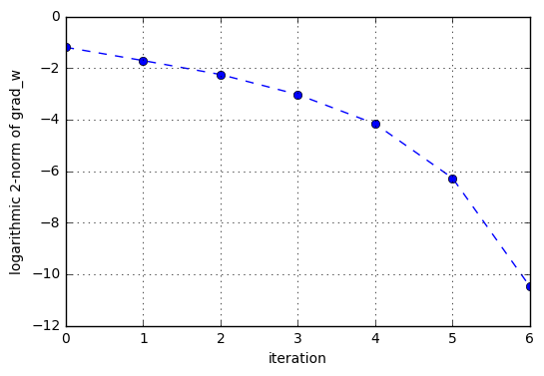

Figure. Evolution of $lg{\left\|∇f_{1}\left(\overline{w}\right)\right\|}_{2}$

**Question 1.4 Newton Method**

If we take the initial point as $\left(w_{0}^{0},w^{\left(0\right)}\right)=0.3e$, we will find the algorithm doesn’t converge.

Because one of the condition to ensure the convergence of Newton method is that the initial point should be chosen close enough to a local minimum $x^{*}$.

We verify that

$${\left\|\left({\overline{w}}^{*}-0\right)\right\|}_{2}^{2}=2.39$$

$${\left\|\left({\overline{w}}^{*}-0.3e\right)\right\|}_{2}^{2}=3.19$$

So we conclude that $0.3e$ is too far from the minimum ${\overline{w}}^{*}$, which doesn’t ensure the convergence.

**Question 1.5 Line Search**

The idea of line search is to choose the pace $γ_{k}$ adaptively using local information. To apply the line search to Newton method, we take

|  |
| --- |
| $$γ_{k}={argmin}_{γ} f_{1}({\overline{w}}^{\left(k\right)}-γ{\left(∇^{2}f_{1}\left({\overline{w}}^{\left(k\right)}\right)\right)}^{-1}∇f_{1}({\overline{w}}^{\left(k\right)}))$$ |

In Armijo’s line search, we choose the pace length in each step as

$$γ_{k}=ba^{l}$$

where $a∈\left(0,1\right), b>0$ and l is the smallest nonnegative integer such that

$$f_{1}\left({\overline{w}}^{+}\left(ba^{l}\right)\right)≤f_{1}\left({\overline{w}}^{\left(k\right)}\right)+β〈{\left(∇^{2}f_{1}\left({\overline{w}}^{\left(k\right)}\right)\right)}^{-1}∇f_{1}({\overline{w}}^{\left(k\right)}),{\overline{w}}^{+}\left(ba^{l}\right)-{\overline{w}}^{\left(k\right)}〉$$

Basically, the larger $β$ is, the larger $γ$ will be; b determines the maximum pace length; $a$ controls the number of levels of pace length. The following two figures show the roles of $β$ and *a*.

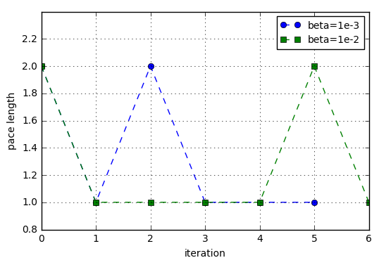

Figure. The larger $β$ is, the more possible $γ$ is selected as large value

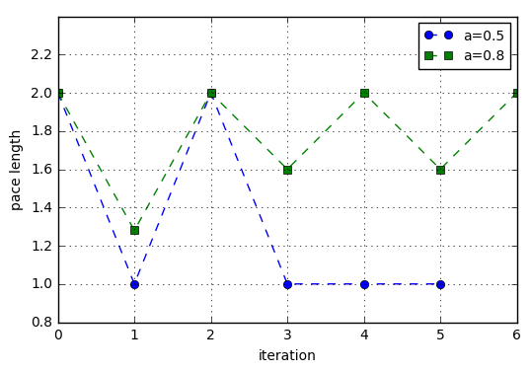

Figure. The smaller $a$ is, the more possible $γ$ is selected as large value

In order to let the algorithm converge as fast as possible, we select $β={10}^{-3}, b=2, a=0.5$.

**def** linesearch(f,grad,w0w):

a=0.5

b=2

beta=1e-3

l=0

direction=np.linalg.inv(tikhonov(X, y, w0w)[2]).dot(tikhonov(X, y, w0w)[1])

w0wplus=w0w-b*a**l*direction

**while** f(w0wplus)>f(w0w)+beta*direction.dot(w0wplus-w0w):

l=l+1

w0wplus=w0w-b*a**l*direction

gamma=b*a**l

**return** gamma

epsilon=1e-10

w0w=np.zeros(p+1)

gradient=grad(w0w)

G=list([])

**while** np.sqrt(np.sum(gradient**2))>=epsilon:

gamma=linesearch(f1,grad,w0w)

direction=np.linalg.inv(tikhonov(X, y, w0w)[2]).dot(gradient)

w0w=w0w-gamma*direction

gradient=grad(w0w)

G.append(np.log10(np.sqrt(np.sum(gradient**2))))

w0w_opt=w0w

plt.figure()

plt.plot(G,'--o')

plt.xlabel('iteration')

plt.ylabel('logarithmic 2-norm of grad_w')

plt.grid()

plt.show()

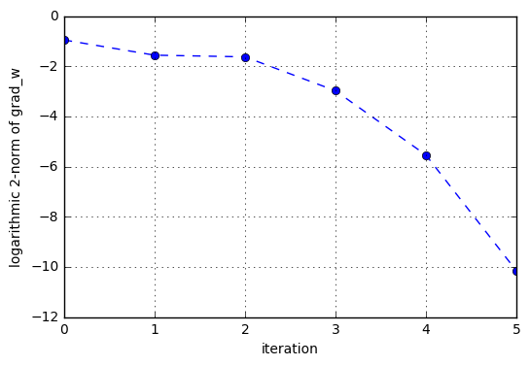

Figure. Evolution of $lg{\left\|∇f_{1}\left(\overline{w}\right)\right\|}_{2}$ with $β={10}^{-3}, b=2, a=0.5, ϵ={10}^{-10}$.

$lg{\left\|∇f_{1}\left(\overline{w}\right)\right\|}_{2}$ converges to ${10}^{-10}$ in 5 iterations.

# **Sparsity Regularisation**

**Question 2.1 Gradient, Hessian Matrix**

$$F_{2}=\frac{1}{n}\sum_{i=1}^{n}{log⁡(1+exp⁡(-y_{i}(x_{i}^{T}w+w_{0})))}+ρ{\left\|w\right\|}_{1}$$

$$∇_{\overline{w}}F_{2}=\frac{1}{n}\sum_{i=1}^{n}{\frac{-y_{i}{\overline{x}}_{i}^{T}\exp\left(-y_{i}{\overline{x}}_{i}^{T}\overline{w}\right)}{1+\exp\left(-y_{i}{\overline{x}}_{i}^{T}\overline{w}\right)}}+ρ∙sign(s∘\overline{w})$$

where $sign\left(x\right)=\left\{\begin{aligned}1, &x>0 \\ [-1,1], &x=0 \\ -1, &x<0\end{aligned}\right.$

Actually, $F_{2}$ is not differentiable at the point $\overline{w}=0$, so we calculate its sub gradient instead.

Newton method requires that the objective function is three times continuously differentiable, however we can see that $∇_{\overline{w}}F_{2}$ is not differentiable at $\overline{w}=0$.So Newton method cannot be applied to this case.

**Question 2.2 Proximal Gradient Method**

Rewrite the objective function as $F_{2}=f_{2}+g_{2}$

where

$$f_{2}=\frac{1}{n}\sum_{i=1}^{n}{log⁡(1+exp⁡(-y_{i}x_{i}^{T}\overline{w}))}$$

and

$$g_{2}=ρ{\left\|w\right\|}_{1}$$

The proximal gradient method is given by

|  |
| --- |
| $$w^{\left(k+1\right)}={prox}_{γ_{k},g_{2}}(w^{\left(k\right)}-γ_{k}∇f_{2}(w^{\left(k\right)}))$$ |

Where ${prox}_{γ_{k},g_{2}}$ is called **soft thresholding function** which is defined by

$${{prox}_{γ_{k},g_{2}}(u)}_{i}=\left\{\begin{aligned}u_{i}-ργ_{k}, u_{i}>ργ_{k} \\ 0, -ργ_{k}≤u_{i}≤ργ_{k} \\ u_{i}+ργ_{k}, u_{i}<ργ_{k}\end{aligned}\right.$$

and the gradient of $f_{2}$

$$∇_{\overline{w}}f_{2}=\frac{1}{n}\sum_{i=1}^{n}{\frac{-y_{i}{\overline{x}}_{i}^{T}\exp\left(-y_{i}{\overline{x}}_{i}^{T}\overline{w}\right)}{1+\exp\left(-y_{i}{\overline{x}}_{i}^{T}\overline{w}\right)}}$$

The Hessian matrix of $F_{2}$

$$∇_{\overline{w}}^{2}F_{2}=\frac{1}{n}\sum_{i=1}^{n}{\frac{y_{i}^{2}{\overline{x}}_{i}{\overline{x}}_{i}^{T}\exp\left(-y_{i}{\overline{x}}_{i}^{T}\overline{w}\right)}{{[1+\exp\left(-y_{i}{\overline{x}}_{i}^{T}\overline{w}\right)]}^{2}}}=\frac{1}{n}A^{T}A$$

We have proved that this matrix is positive definite, so the objective function is convex.

**def** sparse(X, y, w0w):

val=0

grad_w=0

**for** i in range(n):

x=np.insert(X[i,:],0,1).reshape(p+1,1)

s=np.ones(p+1)

s[0]=0

z = np.exp(-y[i]*x.T.dot(w0w)[0])

val=val+1/n*np.log(1+z)

grad_w=grad_w+1/n*(-y[i]*x.T[0])*z/(1+z)

**return** val, grad_w

**Question 2.3 Proximal Gradient with Line Search**

When the divergence between the objective values in two iterations is small enough, we assume the algorithm converges. And the principle of the algorithm is as follows:

|  |
| --- |
| Initialise $k=0,$ $w_{0}^{(0)},w^{\left(0\right)}$  , $ϵ$ |
| repeat   * choose $γ_{k}={argmin}_{γ} f_{2}({\overline{w}}^{\left(k\right)}-γ∇f_{2}({\overline{w}}^{\left(k\right)}))$ $w_{0}^{(k+1)}=w_{0}^{(k)}-γ_{k}∇f_{2}(w_{0}^{(k)})$ $w^{\left(k+1\right)}={prox}_{γ_{k},g_{2}}\left(w^{\left(k\right)}-γ_{k}∇f_{2}\left(w^{\left(k\right)}\right)\right)$ $k=k+1$ |
| until |

**def** f2(w0w):

**return** sparse(X, y, w0w)[0]

**def** F2(w0w):

**return** sparse(X, y, w0w)[0]+rho*np.linalg.norm(w0w[1:],1)

**def** grad(w0w):

**return** sparse(X, y, w0w)[1]

**def** proximal(w0w,epsilon):

gradient=grad(w0w)

C=list([])

k=0

**while** k<2 or np.abs(C[-1]-C[-2])>=epsilon:

gamma=line_search(f2, grad, w0w, -grad(w0w) )[0]

w0w[0]=(w0w-gamma*gradient)[0]

w0w[1:]=threshold(w0w-gamma*gradient,rho*gamma, mode='soft')[1:]

gradient=grad(w0w)

C.append(F2(w0w))

k=k+1

**return** w0w, C

epsilon=1e-6

w0w=np.zeros(p+1)

rho=0.1

w0w_opt,C=proximal(w0w,epsilon)

plt.figure()

plt.plot(C,'--o')

plt.xlabel('iteration')

plt.ylabel('objective value')

plt.grid()

plt.show()

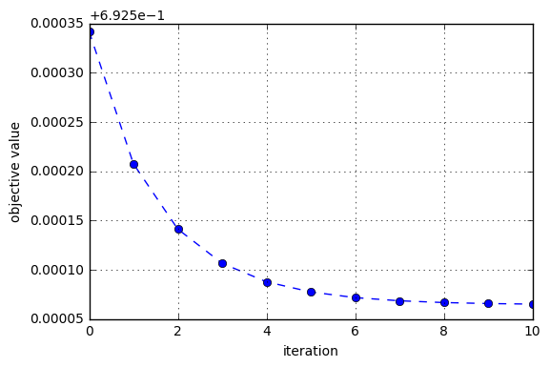

Figure. Evolution of $F_{2}(\overline{w})$ with $ϵ={10}^{-6}$.

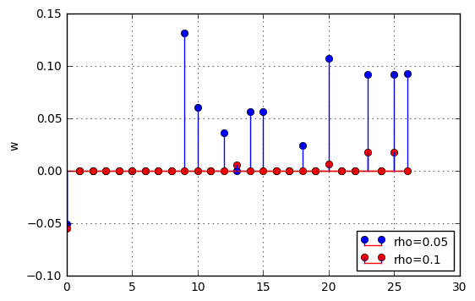

Figure. Solution of $\overline{w}$ with different sparsity level

We find that $l_{1}$-regularization will lead to sparse solution of $\overline{w}$. the sparsity level is determined by $ρ$. Larger $ρ$ will lead to sparser $\overline{w}$.

# **Comparison**

**Question 3.1 Property of the two optimisation problems**

* **Sparsity promotion**

The main difference between $l_{1}$ and $l_{2}$ regularization is that $l_{1}$ can yield sparse models while $l_{2}$ doesn't. Sparse model is a great property to have when dealing with high-dimensional data.

* **Solution of the optimization problem**

$l_{2}$-regularized objective function is smooth. The solution that minimizes the objective function is the stationary point (0-derivative point).

However, $l_{1}$-regularized objective function is non-smooth. It's not differentiable at 0. The optimal solution of a function is either the point with 0-derivative or one of the irregularities (corners, kinks, etc.). So, it's possible that the optimal solution is 0 even if 0 isn't the stationary point.

* **Prediction error**

Typically $l_{2}$ regularization is much better for minimizing prediction error rather than $l_{1}$ regularization. Because when two predictors are highly correlated, $l_{1}$ regularization will simply pick one of the two predictors. In contrast, the $l_{2}$ regularization will keep both of them and jointly shrink the corresponding coefficients a little bit.

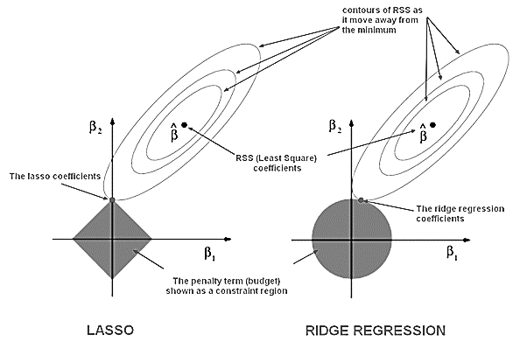

Figure. $l_{1}$ regularization leads to sparse solution, while $l_{2}$ regularization doesn’t.

**Question 3.2 Solution resulted from two types of regularisation**

We fix the regularisation parameter $ρ$ the same in two objective functions: $ρ=\frac{1}{n}$**.** Then we obtain the estimated $\overline{w}$ of two problems with different regularisations.

]:

plt.stem(r1,markerfmt='bo',label='Tikhonov regularisation')

plt.stem(r2,markerfmt='ro',label='Sparsity regularisation')

plt.grid()

plt.legend(loc=2,fontsize=10)

plt.ylabel('w')

plt.show()

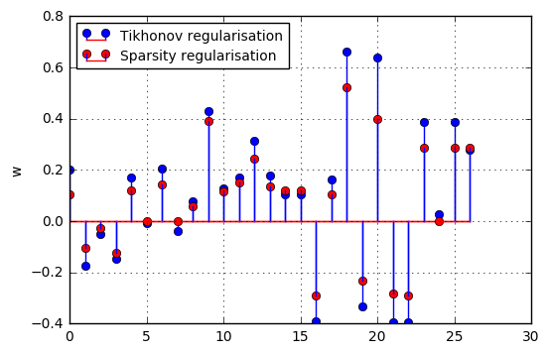

Figure. Solution of $\overline{w}$ of two optimisation problems

In logistic regression,

$$p\left(y_{i}=1 | x_{i}\right)=\frac{1}{1+exp(-{\overline{x}}_{i}^{T}\overline{w})}$$

So we compute the probability based on $\overline{w}$ we estimated from the two problems.

y_est1=np.zeros(n)

y_est2=np.zeros(n)

**for** i in range(n):

x=np.insert(X[i,:],0,1).reshape(p+1,1)

y_est1[i]=1/(1+np.exp(-x.T.dot(r1)))

y_est2[i]=1/(1+np.exp(-x.T.dot(r2)))

y_est0=y*0.5+0.5

plt.figure()

plt.scatter(range(n),y_est0,c='black')

plt.scatter(range(n),y_est1,label='Tikhonov regularisation')

plt.scatter(range(n),y_est2,c='r',label='Sparsity regularisation')

plt.axhline(y=0.5,linestyle='--',color='black')

plt.grid()

plt.xlabel('i')

plt.ylabel('p(y=1|X,w)')

plt.legend(loc=1,fontsize=10)

plt.show()

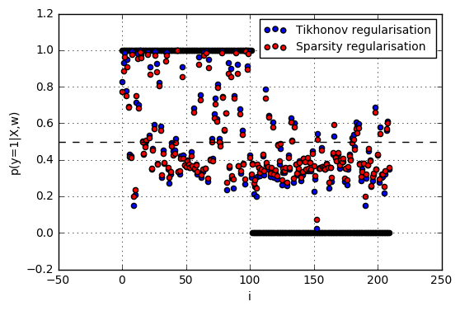

Figure. Estimated $p(y=1|X)$ of two optimisation problems

We can conclude that both of this two regularizations will lead to a lot of prediction errors. Regarding this, it is very possible that the data set is not linear separable.