FIT5032 Studio9

Name and Student Id: JIAQI WEI 29144108

Self-Evaluation:

|  |  |  |  |  |  |
| --- | --- | --- | --- | --- | --- |
| Need Help | Work in Progress | Pass | Credit | Distinction | High Distinction |

Tutor Evaluation:

|  |  |  |  |  |  |
| --- | --- | --- | --- | --- | --- |
| Incomplete | Needs improvement | Pass | Credit | Distinction | High Distinction |

**TASK 9.1**

the screenshot of demonstration of using Responsive Images

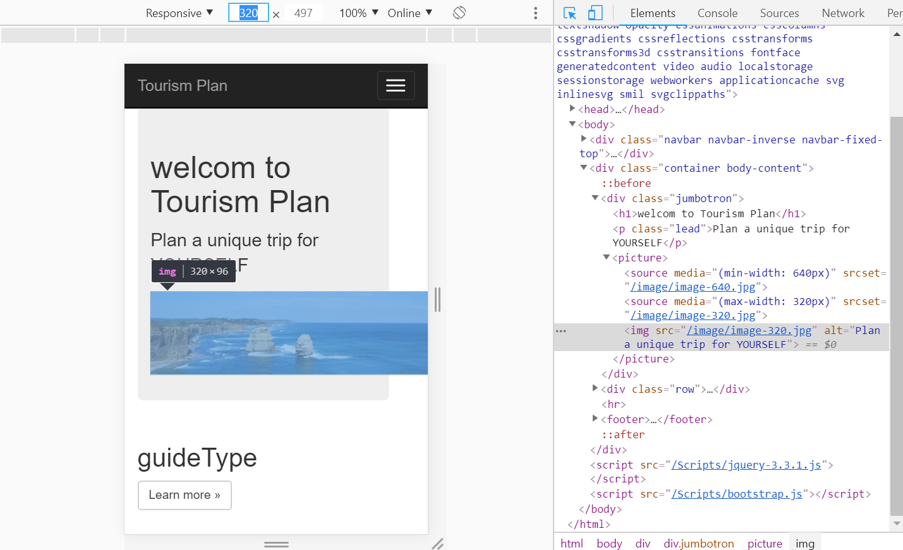



The screenshot of code

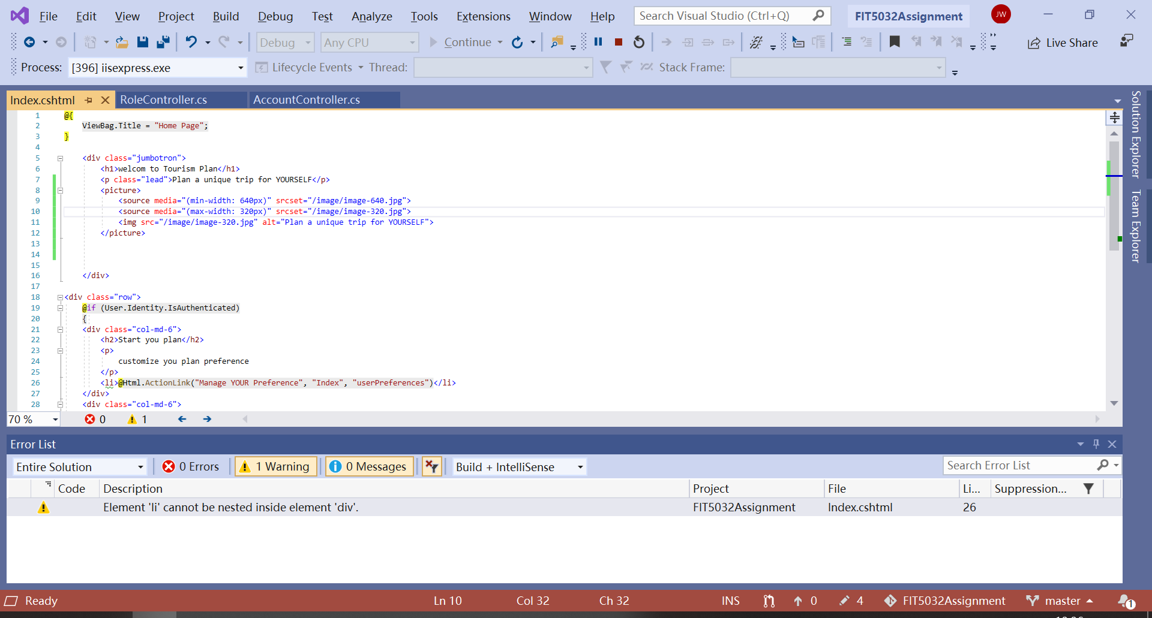

the difference between .woff and .woff2 font

WOFF refers to Web Open Font Format. It is a font format for use in web pages. WOFF is a basically OTF or TTF with metadata and compression supported by all major browsers. It was created to live on the web. They load faster because the fonts are compressed.

WOFF2 is the next generation of WOFF. It is based on experience with WOFF1.0. It is deployed to provide the improvement compression the decrease uses of network bandwidth. At the same time, it also allows decompression quickly on mobile devices. The WOFF2 format offers a 30% average compression gain over the original WOFF. WOFF 2.0 is available since Chrome 36 and Opera 23. WOFF 2.0 can be implemented by all major browsers and used by production websites widely. It also supports TrueType and OpenType specifications which include Variable fonts, Chromatic fonts, and font Collections.

**TASK 9.2**

1)

new feature of .NET Core

The newest .NET Core is .NET Core 3.0 which is smarter than previous versions. It has many improvements which including adding Windows Forms and WPF, adding new JSON APIs, support for ARM64 and improving performance across the board. It also supports C＃8.0, such as nullable, async streams, and more patterns. New features also include F# 4.7 and focused on relaxing syntax and targeting .NET Standard 2.0.

2)

3 differences with ASP.NET Framework web application

1. .NET Core does have a learning curve.
2. **The .NET Framework** supports Windows and Web applications. .NET Core is the new open-source and cross-platform framework to build applications for all operating systems including Windows, Mac, and Linux. .NET Core supports UWP and ASP.NET Core only.

3. there are some features of .NET Framework cannot be implemented in .NET Core such as Visual Basic, and F#.