韦覃子茜 2020011395

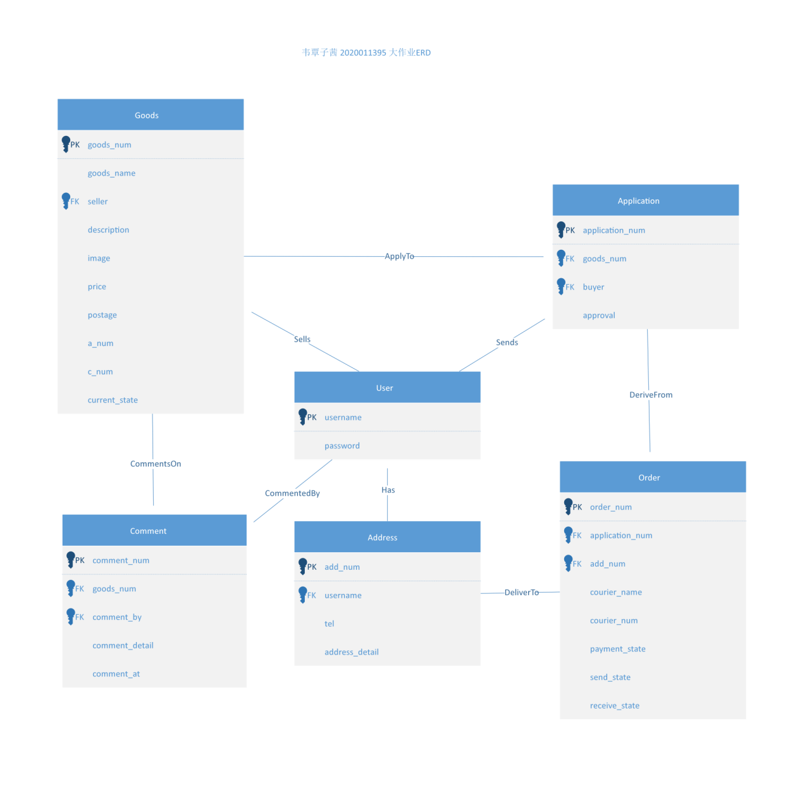

User (username, password)

Goods (goods_num, goods_name, seller, description, image, price, postage, a_num, c_num, current_state)

Application (application_num, goods-num, buyer, approval)

Order(order_num, application_num, add_num, courier_name, courier_num, payment_state, send_state, receive_state)

Comment (comment_num, goods_num, comment_by, comment_detail, comment_at)

Address (add_num, username, tel, address_detail)

注：上面的ERD是svg格式向量图，助教老师看不清的话可以下载下来在本地放大。