韦覃子茜 2020011395

1. CODE:

SELECT COUNT(DISTINCT company_name) AS NumOfCompanies

FROM company

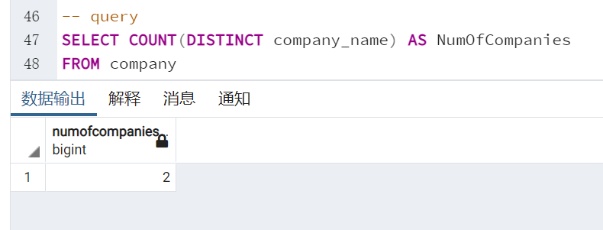

1. CODE:

SELECT employee_name

FROM works

WHERE company_name='First Bank Corporation'

ORDER BY salary ASC

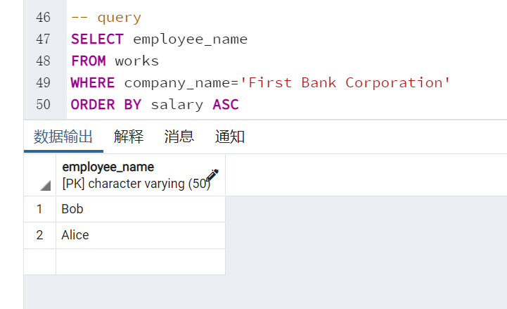

1. CODE:

SELECT e.*

FROM employee e JOIN works w ON e.employee_name=w.employee_name

WHERE w.company_name='First Bank Corporation'

AND w.salary>=10000;

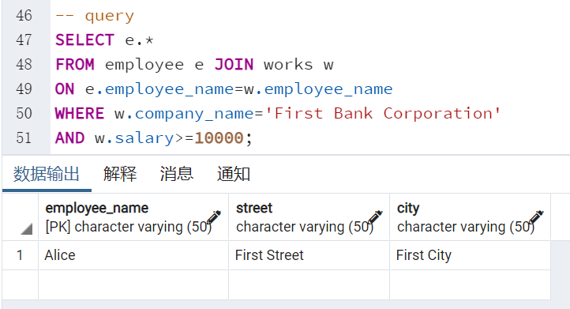

1. CODE：

SELECT DISTINCT company_name, salary AS highest_salary

FROM works

WHERE salary=(SELECT MAX(salary)

FROM works i WHERE i.company_name=works.company_name)

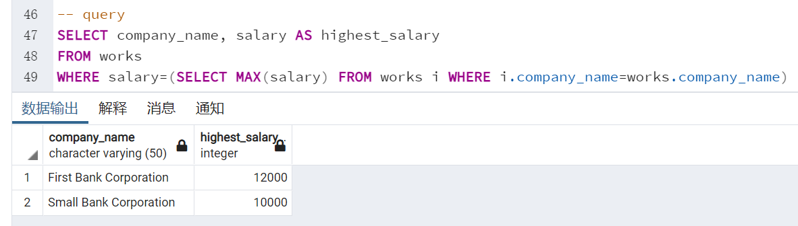

1. CODE:

SELECT w.company_name,c.city

FROM works w JOIN company c

USING (company_name)

GROUP BY c.city ,w.company_name

HAVING AVG(w.salary)>10000

