


UNIVERSITY OF INFORMATION TECHNOLOGY – VNU-HCM
FACULTY OF COMPUTER NETWORKS AND COMMUNICATIONS

1. Networking Concepts and Static Routing

NETWORKING TECHNOLOGIES– v1.2025

PHỤC VỤ MỤC ĐÍCH GIÁO DỤC
FOR EDUCATIONAL PURPOSE ONLY

Name: Huỳnh Ân

MSSV: 24560064

OVERVIEW

Learning objective
The learning objective of this lab is to get familiar with network devices, how they work together, and the concepts of routing. Moreover, students may practice on physical networking devices or simulation networking applications such as Cisco Packet Tracer. This lab will cover the following topics:
    - Introduction to popular networking devices
    - How to configure networking devices
    - The routing concepts and static routing

Practice Environment

Netacad account
Students need an account at https://www.netacad.com/ to download the necessary resources and use applications released by Cisco. It’s free to create a new account here.

Cisco Packet Tracer
2
Packet Tracer is a simulation, visualization, and collaboration tool for learning networking. It allows students to construct their own model or virtual networks, obtain access to important graphical representations of those networks, animate those networks by adding their data packets, and finally annotate and save their creations.
You need to download the newest version or the recent stable version of Packet Tracer Tool at https://skillsforall.com/resources/lab-downloads. Furthermore, you may enroll in the “Getting Started with Cisco Packet Tracer course” at https://skillsforall.com/topics/cisco-packet-tracer to familiarize yourself with the usage of the Packet Tracer Tool under the instruction of Cisco Academy.

LAB TASKS
3

Basic router configuration and static routing
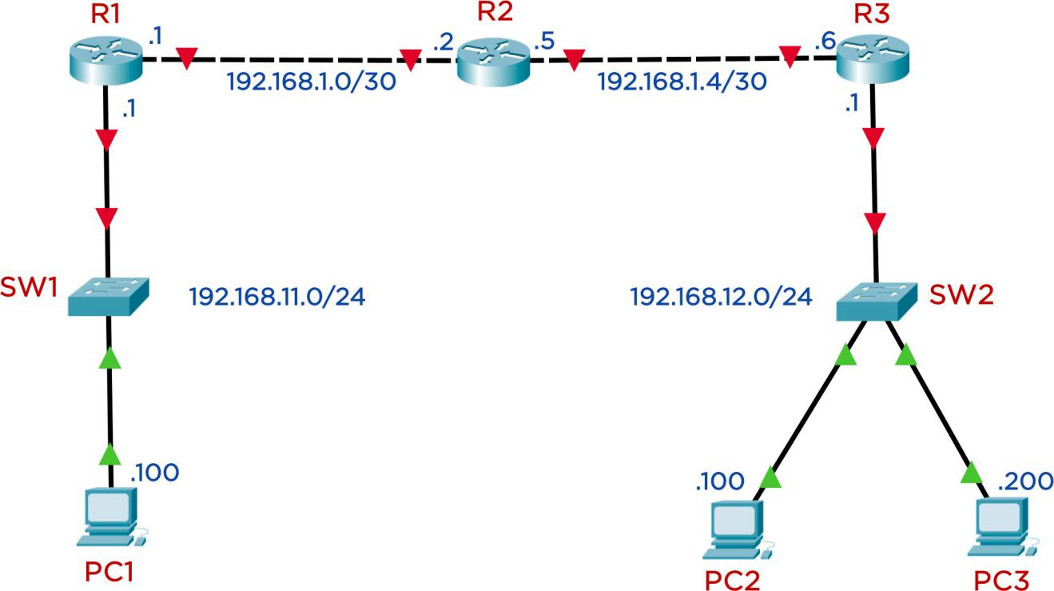
The network topology is shown in the Figure 1 below. We use 3 routers, 2 switches, and 3 PCs (or laptops). You need to choose the necessary devices and cables, then set up the network as shown in the topology.

Figure 1: Network topology for Task 1 Table 1: The IP Address for devices on task 1

Device | Interface | IPv4 Address | Subnet Mask | Default Gateway
R1 | G0/0/0 | 192.168.11.1 | 255.255.255.0 | None
 | G0/0/1 | 192.168.1.1 | 255.255.255.252 | None
R2 | G0/0/0 | 192.168.1.2 | 255.255.255.252 | None
 | G0/0/1 | 192.168.1.5 | 255.255.255.252 | None
R3 | G0/0/0 | 192.168.12.1 | 255.255.255.0 | None
 | G0/0/1 | 192.168.1.6 | 255.255.255.252 | None
PC1 | NIC | 192.168.11.100 | 255.255.255.0 | 192.168.11.1
PC2 | NIC | 192.168.12.100 | 255.255.255.0 | 192.168.12.1
PC3 | NIC | 192.168.12.200 | 255.255.255.0 | 192.168.12.1

4

Requirements:
- Identify the network devices and network cables to be used and connect according to the topology.
- Set the corresponding hostname to all devices.
- Set Banner Motd as “Warning: Authorized Access Only to <StudentID>”
(<StudentId> is your student ID) to all routes.
- On each router, set the password uitcisco for the privileged mode, the user EXEC mode.
You should encrypt password to enhance the security.
- Assign IP address to all necessary interfaces of routers and PCs.
- Allow users to configure via telnet all routers remotely.
- (Advanced) Apply the static routing technique to suitable devices so that all PCs can communicate with each other.
You should frequently copy the Running-configuration to the Startup-configuration to avoid losing configuration when the device unexpectedly reboots.

Subnetting and static routing
5
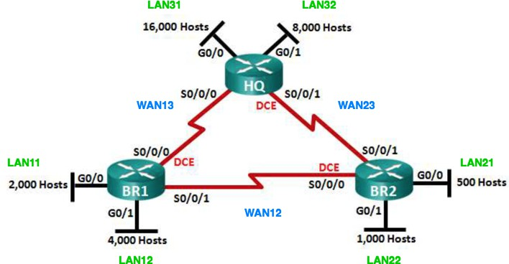
Figure 2: Network topology for task 3
A company needs to set up the network infrastructure as shown in the Figure 2. You need to subneting the network 172.16.0.0/16 into suitable subnets using VLSM1 method.

Requirements:
    - Subnetting the given network and filling out the result to the Table 2. You need to briefly explain how to get that result.
    - Basic configure on router devices:
      - Set the hostname to all devices.
      - Set the password uitcisco on all routers for privileged EXEC, user EXEC, and Telnet remote access.
      - Set the Banner motd for all routers: “Warning: Authorized Access Only on Router X”
    - Assign the IP address to the routers' interfaces. The subnet's first usable IP address is reserved for the router's interface in each LAN zone. You need to fill out this information for Table 3.
    - All routers need to configure static routing. So that all devices can communicate with each other.
    - Configure any redundancy routes to ensure the Router BR1 and BR2 can communicate with each other even if the direct link (link WAN12) fails.
Tips: You can use the floating static route to achieve this goal.
Note:
      - To avoid losing your configuration, you should copy Running-configuration to Startup-configuration before shutdown or close network topology on Packet Tracer Tool.
      - Remember to include the topology file (.PKT) in your submission.

¹ Variable Length Subnet Mask method

Table 2: Subnets information
6

Subnet | Network Addres (CIDR) | First IP Address | Broadcast Address
LAN11 | 172.16.112.0/21 | 172.16.112.1 | 172.16.119.255
LAN12 | 172.16.96.0/20 | 172.16.96.1 | 172.16.111.255
LAN21 | 172.16.124.0/23 | 172.16.124.1 | 172.16.125.255
LAN22 | 172.16.120.0/22 | 172.16.120.1 | 172.16.123.255
LAN31 | 172.16.0.0/18 | 172.16.0.1 | 172.16.63.255
LAN32 | 172.16.64.0/19 | 172.16.64.1 | 172.16.95.255
WAN12 | 172.16.126.0/30 | 172.16.126.1 | 172.16.126.3
WAN13 | 172.16.126.4/30 | 172.16.126.5 | 172.16.126.7
WAN23 | 172.16.126.8/30 | 172.16.126.9 | 172.16.126.11

Table 3: Interfaces’ address

Device | Interface | IP Address | Subnet Mask | Default Gateway
HQ | S0/0/0 | 172.16.126.5 | 255.255.255.252
 | S0/0/1 | 172.16.126.9 | 255.255.255.252
 | G0/0 | 172.16.0.1 | 255.255.192.0
 | G0/1 | 172.16.64.1 | 255.255.224.0
BR1 | S0/0/0 | 172.16.126.6 | 255.255.255.252
 | S0/0/1 | 172.16.126.1 | 255.255.255.252
 | G0/0 | 172.16.112.1 | 255.255.248.0
 | G0/1 | 172.16.96.1 | 255.255.240.0
BR2 | S0/0/0 | 172.16.126.2 | 255.255.255.252
 | S0/0/1 | 172.16.126.10 | 255.255.255.252

7
 | G0/0 | 172.16.124.1 | 255.255.254.0
 | G0/1 | 172.16.120.1 | 255.255.252.0
PC11  (LAN11) |  | 172.16.112.2 | 255.255.248.0 | 172.16.112.1
PC12  (LAN12) |  | 172.16.96.2 | 255.255.240.0 | 172.16.96.1
PC21  (LAN21) |  | 172.16.124.2 | 255.255.254.0 | 172.16.124.1
PC22  (LAN22) |  | 172.16.120.2 | 255.255.252.0 | 172.16.120.1
PC31  (LAN31) |  | 172.16.0.2 | 255.255.192.0 | 172.16.0.1
PC32  (LAN32) |  | 172.16.64.2 | 255.255.224.0 | 172.16.64.1
Server  (LAN31) |  | 172.16.0.3 | 255.255.192.0 | 172.16.0.1

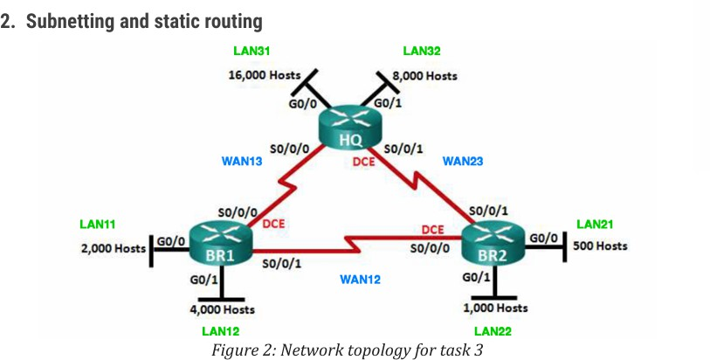

Firstly, you need to determine host requirements for subnets to provides more efficient use of addresses that based on number of subnets required and number of host addresses required. In the Figure 2, you can see many LANs and WANs known as subnet and number of host addresses. Let summaries its in the table in descending order.

Subnet | Devices Needed
LAN31 | 16,000
LAN32 | 8,000
LAN12 | 4,000
LAN11 | 2,000
LAN22 | 1,000
LAN21 | 500
After summarized in the table, we start from 172.16.0.0/16 and assign the largest subnets by VLSMs method. Assigning the largest subnet into a set of smaller subnets by borrowing Bits to create new subnets for needed IPs, which is LAN31 need 16, 000 hosts. There is a formula to determine number of usable hosts ( 2n − 2 ), where n is a remaining host bits in subnet mask 32Bits). We need borrow n bit until 2n − 2 = approximately and more than the required value,
like
2¹⁴ − 2 = 16382 and now we know there are 14 host bits we needed. Next, identified the network bits by 32 − n host bits = network bits, such as
32 − 14 = 18. Now we known the network bits, denoted prefix length (e.g.
/16, /18 ). After compared them, we can see the difference that 18 larger than 162 bits and if we want to assign LAN31 for 16, 000 hosts, we need to borrow 2 bits and create 2 new subnets, but before doing that, we need to change the decimal address to binary number, for saving time we just change to binary the octet we work with.

172.16.0.0/16 → 172.16.00000000.0/16
we borrowing 2 bits →

172.16.xx’000000.0/18
and now we convert it into 2 new subnets
+
172.16.00’000000.0/18 → 172.16.0.0/18 this new subnet enough for
16, 000 hosts

+
172.16.01’000000.0/18 → 172.16.64.0/18 this new subnet will be used to divide the remaining subnets.
When we have the network address of new subnet, we also need to identify the first IP address and Broadcast address. Therefore, we use the subnet mask CIDR (prefix length) and use AND and OR function for network address and broadcast address found. Small description that AND function use subnet mask and priority to 0, but the OR function use inverse subnet mask and priority to 1. Take an example, /16 with subnet mask is
11111111.11111111.00000000.00000000 and inverse subnet mask is

00000000.00000000.11111111.11111111.
Starting with 172.16.0.0/18

Subnet | 1010 1100.0001 0000.0000 0000.0000 0000
Subnet mask | 1111 1111.1111 1111.1100 0000.0000 0000
AND 0 | 1010 1100.0001 0000.0000 0000.0000 0000
Network address | 172.16.0.0/18
Inverse subnet mask | 0000 0000.0000 0000.0011 1111.1111 1111
OR 1 | 1010 1100.0001 0000.0011 1111.1111 1111
Broadcast address | 172.16.63.255/18
The first ip address for use is next to the network address which is

172.16.0.1/18
After implemented and repeated these steps until satisfy the devices needed that we achieved table result.

REQUIREMENTS
You are expected to complete all tasks in section B (Lab tasks). Advanced tasks are optional, and you could get bonus points for completing those tasks.
Your submission must meet the following requirements:
- You need to submit a detailed lab report in .docx (Word Document) format,
using the report template provided on the UIT Courses website.
- A report written in English is required.
- When it comes to programming tasks (require you to write an application or script), please attach all source-code and executable files (if any) in your submission. Please also list the important code snippets followed by explanations and screenshots when running your application in your report. Simply attaching code without any explanation will not receive points.

- Submit work you are proud of – don’t be sloppy and lazy!
8
Your submissions must be your own. You are free to discuss with other classmates to find the solution. However, copying reports is prohibited, even if only a part of your report. Both reports of the owner and the copier will be rejected. Please remember to cite any source of the material (website, book,…) that influences your solution.
Notice: Combine your lab report and all related files into a single ZIP file (.zip), name it as follow:
StudentID _ReportLabX.zip

