


UNIVERSITY OF INFORMATION TECHNOLOGY – VNU-HCM
FACULTY OF COMPUTER NETWORKS AND COMMUNICATIONS

2. Dynamic Routing

NETWORKING TECHNOLOGIES– v1.2025

PHỤC VỤ MỤC ĐÍCH GIÁO DỤC
FOR EDUCATIONAL PURPOSE ONLY

OVERVIEW

Learning objective
The learning objective of this lab is to understand how to dynamically exchange routing information between routers. Students will configure, observe, and troubleshoot the Routing Information Protocol1 (RIP) and the Open Shortest Path First2 (OSPF).

Practice Environment
    - Practicing with physical networking devices
    - Cisco Packet Tracer

¹ Distance Vector Routing algorithm
² Link State Routing algorithm

2

LAB TASKS

Dynamic Routing theory
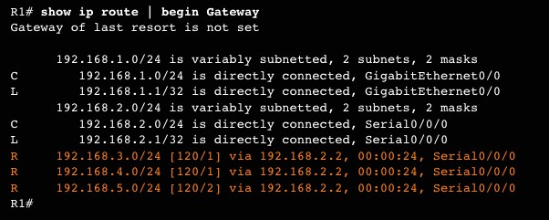
Before practicing, let’s find the answer to the following questions:
- What is the difference between Classful and Classless?
- We usually use the command no auto-summary when configuring RIP. Why do we need to use this command? What will happen if we configure RIPv2 without that command?
- What do the C, L, and R (shown in Figure 1) stand for?

Figure 1: Example of the routing table

Dynamic Routing – RIP
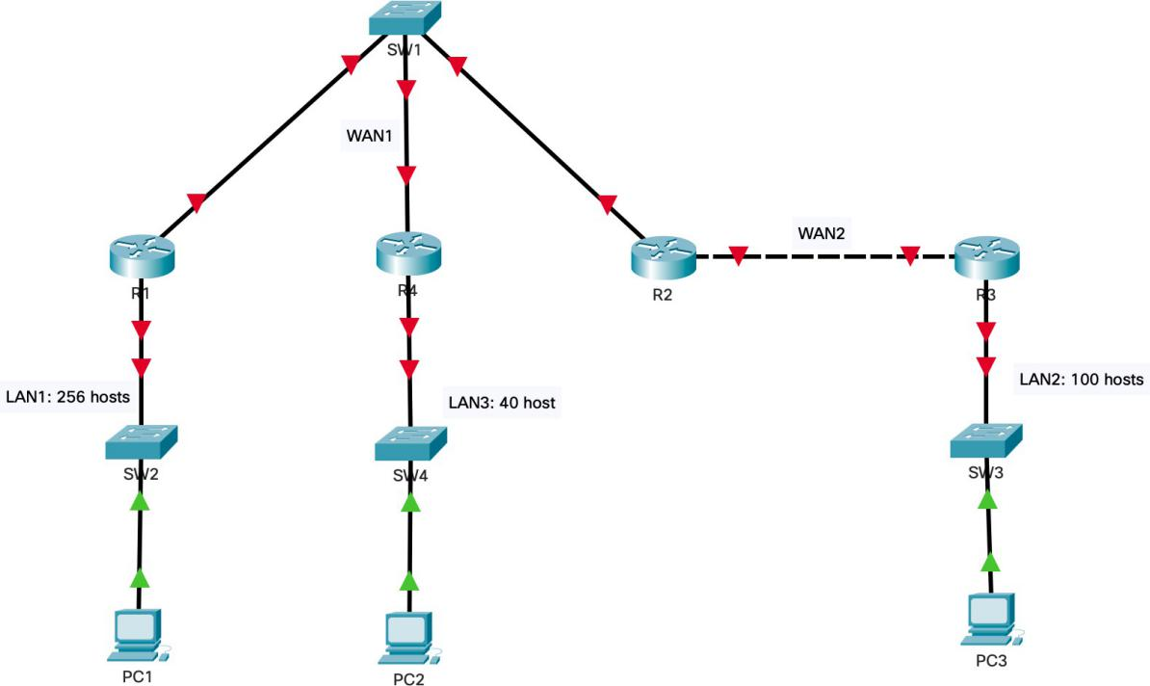

Figure 2: The topology diagram for Task 2

3

In this task, you will learn how to configure a small network with dynamic routing algorithms.
You are giving a topology diagram as shown in the figure above and network address 172.16.0.0/16.
Requirements:
- You need to divide the given network into suitable subnets for LAN networks and WAN networks. Then, fill out the result in Subnetting table (refer to Table 1). The VLSM method is recommended.
- Set the hostname on all devices to match the topology diagram.
- Set Banner Motd as “Warning: Authorized Access Only on Router Rx” (Rx is the name of Routers) on all routes.
- Configure IP addresses and masks on all devices. You need to fill out this information in the IP Assignment table (refer to Table 2).
- Configure the routers to run RIPv2.
- Enable Tenet Remote Access on all routers.
You should frequently copy the Running-configuration to the Startup-configuration to avoid configuration losing when the device unexpectedly reboots.

Table 1: Example of Subnetting Table

Subnet | Network Address/CIDR | First IP Address | Broadcast Address
LAN1 | 172.16.0.0/23 | 172.16.0.1 | 172.16.1.255
LAN2 | 172.16.2.0/25 | 172.16.2.1 | 172.16.2.127
LAN3 | 172.16.2.128/26 | 172.16.2.129 | 172.16.2.191
WAN1 | 172.16.2.192/29 | 172.16.2.193 | 172.16.2.199
WAN2 | 172.16.2.200/30 | 172.16.2.201 | 172.16.2.203

Table 2: Example of addressing table

Device | Interface | IP Address | Subnet Mask | Default Gateway
R1 | Gig0/0 | 172.16.2.193 | 255.255.255.248
 | Gig0/1 | 172.16.0.1 | 255.255.254.0
R2 | Gig0/0 | 172.16.2.195 | 255.255.255.248
 | Gig0/1 | 172.16.2.201 | 255.255.255.252

4

R3 | Gig0/0 | 172.16.2.1 | 255.255.255.128
 | Gig0/1 | 172.16.2.202 | 255.255.255.252
PC1 | NIC | 172.16.0.2 | 255.255.254.0 | 172.16.0.1
PC2 | NIC | 172.16.2.130 | 255.255.255.192 | 172.16.2.129
PC3 | NIC | 172.16.2.2 | 255.255.255.128 | 172.16.2.1
R4 | Gig0/0 | 172.16.2.194 | 255.255.255.248
 | Gig0/1 | 172.16.2.129 | 255.255.255.192

Dynamic routing – OSPF
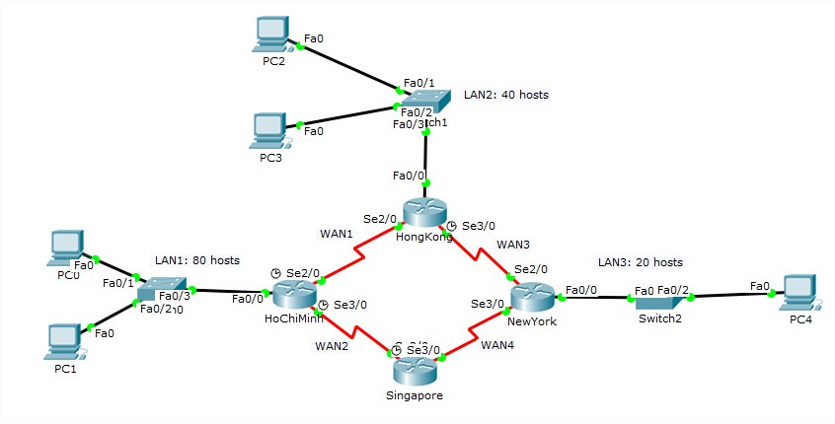
Figure 3: The topology diagram for Task 3
Requirements: You are given the network topology as shown in the figure above and network address 172.16.0.0/16 (with X standing for your group’s ID).
- You need to divide the allocated network into suitable subnets for LAN and WAN networks. Then, fill out the result in Subnetting table (refer to Table 1). The VLSM method is recommended.
- Set the hostname on all devices.
- Set Banner Motd as “Warning: Authorized Access Only on Router Rx” (Rx is the name of Routers) on all Routes.
- Assign the IP address for all necessary interfaces of devices. You need to fill out this information in the IP Assignment table (refer to Table 2).
- Configure OSPF routing to all routers so that all hosts among networks can communicate with each other.
Please note that you should frequently save the Running-configuration to the Startup- configuration in case of unexpected device rebooting.

5

Subnet | Network Address/CIDR | First IP Address | Broadcast Address
LAN1 | 172.16.0.0/25 | 172.16.0.1 | 172.16.0.127
LAN2 | 172.16.0.128/26 | 172.16.0.129 | 172.16.0.191
LAN3 | 172.16.0.192/27 | 172.16.0.193 | 172.16.0.223
WAN1 | 172.16.0.224/30 | 172.16.0.225 | 172.16.0.227
WAN2 | 172.16.0.228/30 | 172.16.0.229 | 172.16.0.231
WAN3 | 172.16.0.232/30 | 172.16.0.233 | 172.16.0.235
WAN4 | 172.16.0.236/30 | 172.16.0.237 | 172.16.0.239

Device | Interface | IP Address | Subnet Mask | Default Gateway
R1(Ho Chi Minh) | G0/0 | 172.16.0.1 | 255.255.255.128
 | S0/0/0 | 172.16.0.225 | 255.255.255.252
 | S0/0/1 | 172.16.0.229 | 255.255.255.252
R2(Hong Kong) | G0/0 | 172.16.0.129 | 255.255.255.192
 | S0/0/0 | 172.16.0.226 | 255.255.255.252
 | S0/0/1 | 172.16.0.233 | 255.255.255.252
R3(New York) | G0/0 | 172.16.0.193 | 255.255.255.224
 | S0/0/0 | 172.16.0.237 | 255.255.255.252
 | S0/0/1 | 172.16.0.234 | 255.255.255.252
R4(Singapore) | G0/0
 | S0/0/0 | 172.16.0.238 | 255.255.255.252
 | S0/0/1 | 172.16.0.230 | 255.255.255.252
PC0 | NIC | 172.16.0.2 | 255.255.255.128 | 172.16.0.1
PC1 | NIC | 172.16.0.3 | 255.255.255.128 | 172.16.0.1
PC2 | NIC | 172.16.0.130 | 255.255.255.192 | 172.16.0.129
PC3 | NIC | 172.16.0.131 | 255.255.255.192 | 172.16.0.129
PC4 | NIC | 172.16.0.194 | 255.255.255.224 | 172.16.0.193

Subnetting the network

172.16.0.0/16

into suitable subnets using VLSM method

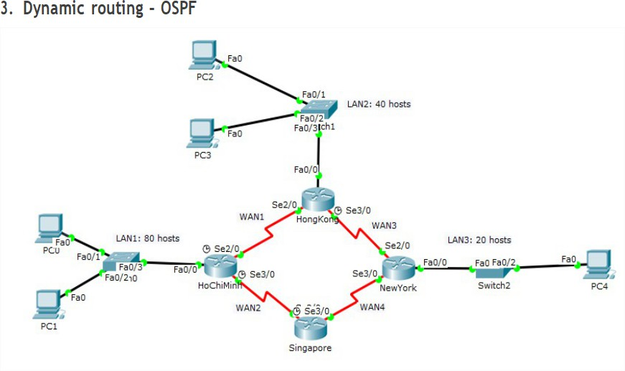

Firstly, you need to determine host requirements for subnets to provides more efficient use of addresses that based on number of subnets required and number of host addresses required. In the Figure 2, you can see many LANs and WANs known as subnet and number of host addresses. Let summaries its in the table in descending order.

Subnet | Devices Needed
LAN1 | 80
LAN2 | 40
LAN3 | 20
WAN1 | 2
WAN2 | 2
WAN3 | 2
After summarized in the table, we start from 172.16.0.0/16 and assign the largest subnets by VLSMs method. Assigning the largest subnet into a set of smaller subnets by borrowing Bits to create new subnets for needed IPs, which is LAN1 need 80 hosts. There is a formula to determine number of usable hosts ( 2n − 2 ), where n is a remaining host bits in subnet mask
(32-Bits). We need borrow n bit until 2n − 2 = approximately and more than the required value,
like

2⁷ − 2 = 126 and now we know there are 14 host bits we needed. Next, identified the network bits by 32 − n host bits = network bits, such as
32 − 7 = 25. Now we known the network bits, denoted prefix length (e.g.
/16, /18 ). After compared them, we can see the difference that 25 larger than 16 bits and if we want to assign LAN1 for 80 hosts, we need to borrow 9 bits and create 2 new subnets, but before doing that, we need to change the decimal address to binary number, for saving time we just change to binary the octet we work with.

172.16.0.0/16 → 172.16.0.0000 0000/16
we borrowing 9 bits →
172.16.xxxx xxxx.x′000 0000/25
and now we convert it into 2 new subnets
+
172.16.0000 0000.0′000 0000/25 → 172.16.0.0/25 this new subnet enough for 80 hosts
+
172.16.0000 0000.1′000 0000/25 → 172.16.0.128/25 this new subnet will be used to divide the remaining subnets.
When we have the network address of new subnet, we also need to identify the first IP address and Broadcast address. Therefore, we use the subnet
mask (CIDR) (prefix length) and use AND and OR function for network address and broadcast address found. Small description that AND function use subnet mask and priority to 0, but the OR function use inverse subnet
mask and priority to 1. Take an example, /16 with subnet mask is
11111111.11111111.00000000.00000000 and inverse subnet mask is

00000000.00000000.11111111.11111111.
Starting with 172.16.0.0/25

Subnet | 1010 1100.0001 0000.0000 0000.0000 0000
Subnet mask | 1111 1111.1111 1111.1111 1111.1000 0000
AND (0) | 1010 1100.0001 0000.0000 0000.0000 0000
Network address | 172.16.0.0/25
Inverse subnet mask | 0000 0000.0000 0000.0000 0000.0111 1111
OR (1) | 1010 1100.0001 0000.0000 0000.0111 1111
Broadcast address | 172.16.0.127/25

The first ip address for use is next to the network address which is

172.16.0.1/25
After implemented and repeated these steps until satisfy the devices needed that we achieved table result

REQUIREMENTS
You are expected to complete all tasks in section B (Lab tasks). Advanced tasks are optional, and you could get bonus points for completing those tasks.
Your submission must meet the following requirements:

Notice: Combine your lab report and all related files into a single ZIP file (.zip), name it as follow:
StudentID _ReportLabX.zip

