Automatic Backup

WEM Auto Backup is a program that copies a list of files to sub-directories at a prescribed hour of the day. The list of files, as well as what hour the copy occurs are all configurable by the end user.

At the prescribed hour, the files specified will be copied to one of seven directories, depending on the day of the week. The seven sub-directories are named ‘1’ for Sunday, ‘2’ for Monday up to ‘7’ for Saturday.

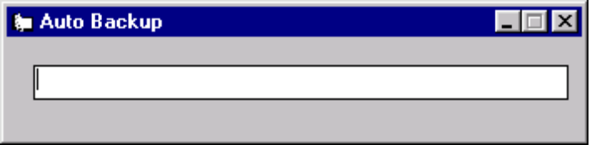

After installation, two text files need to be customized. The first file is the .ini that tells the program where the files to backup are located, where the auto backup program is installed, and at what hour the files should be backed up.

The .ini file will be located in the windows directory and is called:
AutoBack.ini

Editing this shows the following entries

[WEMBACKUP]
MDBDIRECTORY=c:\ws\wem\data
INSTALLDIRECTORY=c:\wem\autoback
BACKUPHOUR=23

MDBDIRECTORY is where the files are located to be backed up. This is also the directory where the ‘day’ sub-directories will be created. Files that are not in this directory can also be backed up by specifying the complete path in the list of files to be backed up.

INSTALLDIRECTORY is where the backup program has been installed. The program looks in this directory for ‘copyfile.txt’ which is a text file containing all of the files that should be copied.

BACKUPHOUR is the hour that the copy should occur, from 0 to 23, meaning 12:00 AM to 11:00 PM.

The file ‘Copyfile.txt’ specifies the files that should be copied. There should always be pairs of filenames, the first one is the source file, the second is the destination file. The destination file does not have to be the same name as the source. If a path is not specified for the source file, the MDBDIRECTORY will be used as the path. If a path is specified along with the file name, that file will be copied.

Example ‘copyfile.txt’

wem.mdb,wem.sav
c:\winnt\file.txt,save.txt

Up to 250 files can be specified to be copied. The files can be in use when the copy occurs.

