## the step-by-step guidance for ST001237

Abundance table: merged_metab.txt

Metadata file: final_meta.txt

Step i) Select module. Open the web page, enter the search page (a) nd select the "Batch analysis of multiple metabolites" module (b).

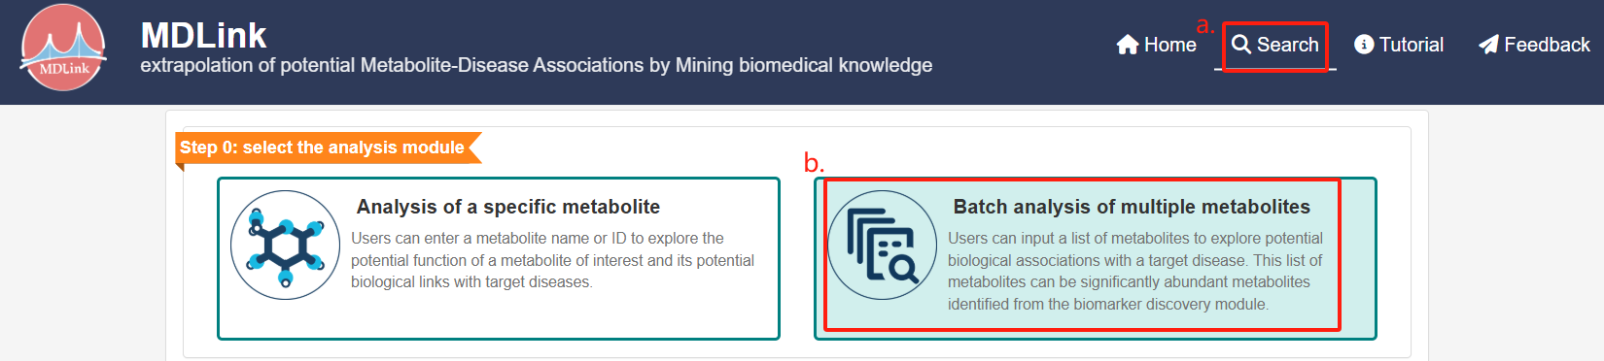

Step ii) Input multiple metabolites.

(a) Select the option “2.Use significantly differential abundant metabolites from biomarker discovery module as input”,

(b) browse and upload the abundance table and (c) metadata file.

(d) once both files have been successfully uploaded, click “Search” to proceed.

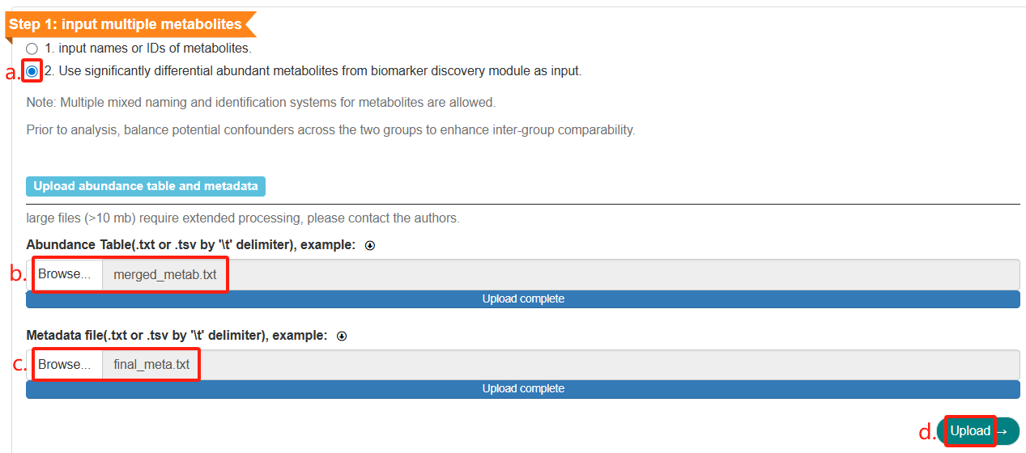

Select the normalization methods: choose “None” for data transformation (a) and “Mean-centering and unit variance scaling” for data scaling (b). Then, click “Proceed” to continue (c).

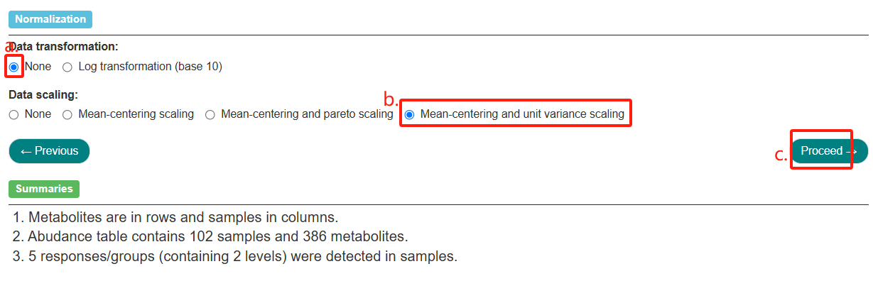

Set parameters for differential abundance analysis as follows, then click “Run” to start.

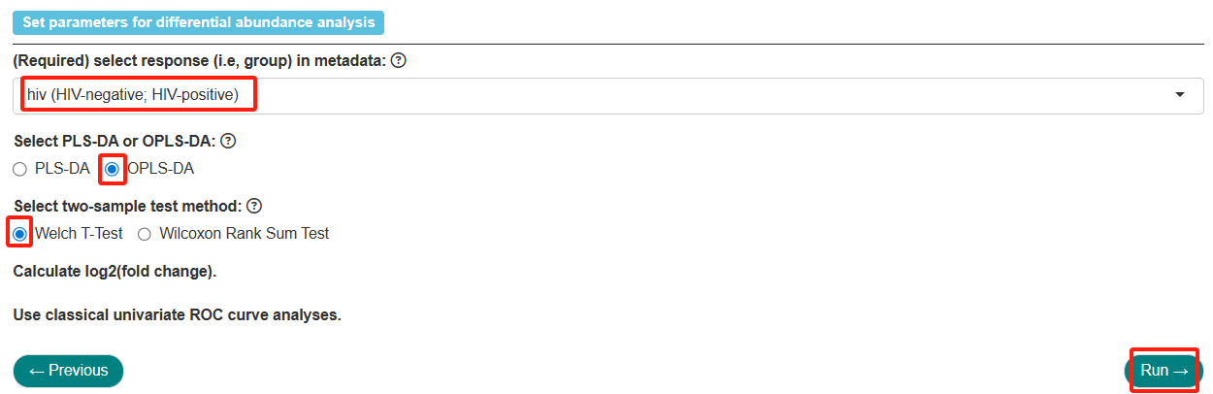

Set thresholds to define metabolite biomarkers, then click “Filter” to continue.

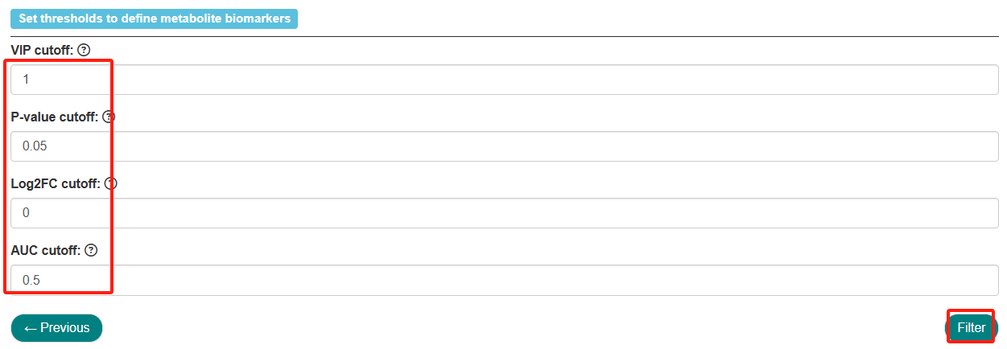

The summaries describing the analytical methodology will be shown, followed by statistical results.

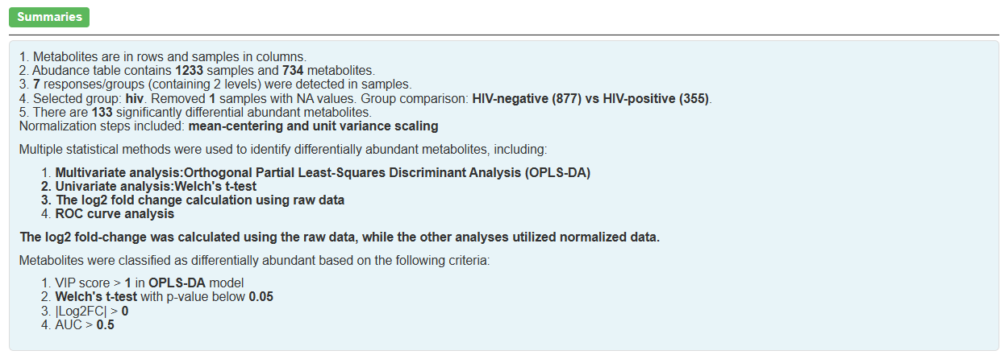

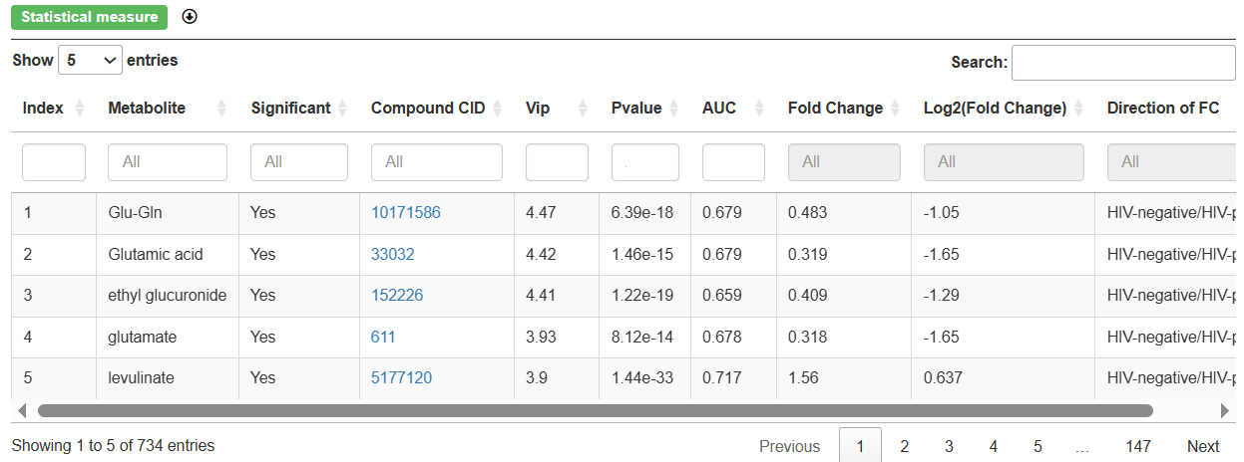

Step iii) Input the target disease.

(a) Choose “1.input the name or DOID of the disease”,

(b) input human immunodeficiency virus,

(c) click “Search” to move forward.

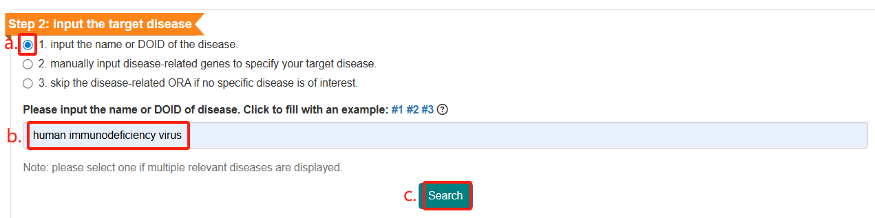

The queried disease and disease-related genes will be presented.

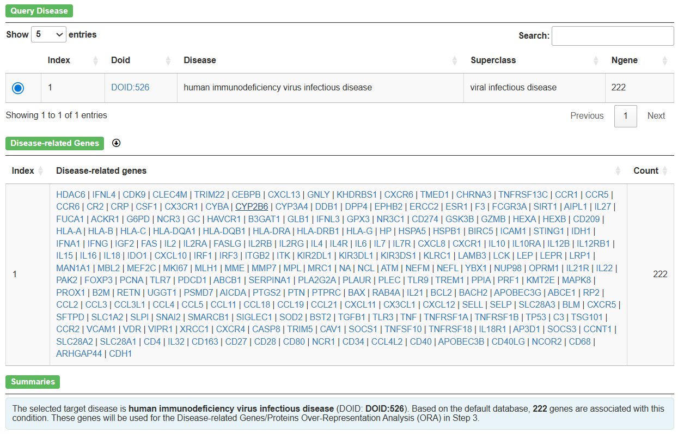

Step iv) Set parameters for three branches as follows, then click “Search” to proceed.

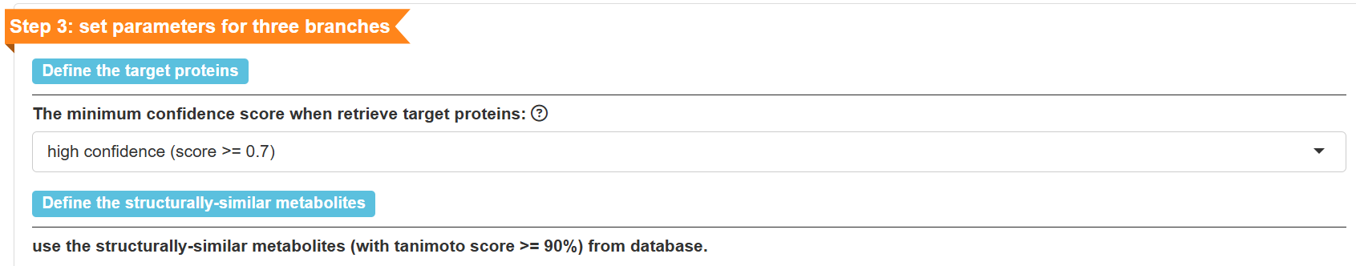

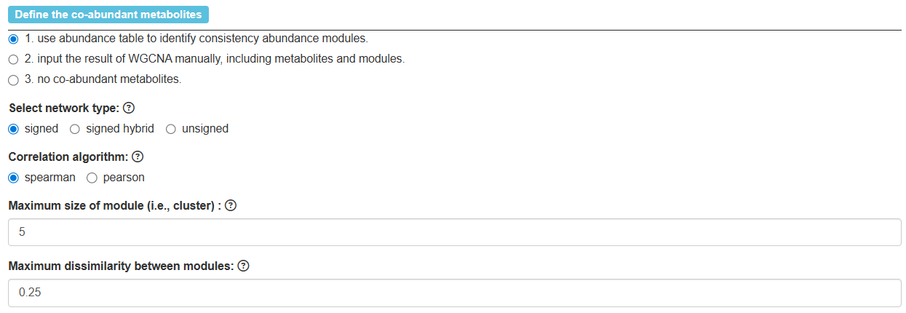

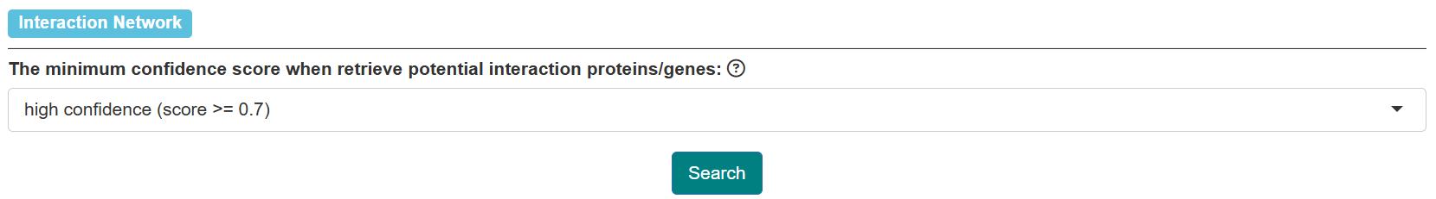

The co-abundant metabolites (i.e., consistency abundance module) and disease-related genes/proteins ORA results will be displayed.

